Slide 1

Commonwealth of Massachusetts
Executive Office of Health and Human Services (EOHHS)
EOHHS Quality Measure alignment taskforce
Meeting #31
December 9, 2019

Slide 2

Agenda
- Welcome
- Revisit the process for considering non-endorsed measures
- Quality Catalogue analysis of non-aligned measures
- Continue the annual review of the Aligned Measure Set
- Next steps

Slide 3

Legislative Update
- During the 11/19 Taskforce meeting, the Taskforce decided to finalize its charter once “Problem Statement” was changed to “The Case for Advancing a Coordinated Quality Strategy.”
- Prior to today’s meeting, we distributed the finalized charter reflecting that change.

Slide 4

Agenda
- Welcome
- Revisit the process for considering non-endorsed measures
- Quality Catalogue analysis of non-aligned measures
- Continue the annual review of the Aligned Measure Set
- Next steps

Slide 5

Revisit the Process for Considering Non-endorsed Measures
- Taskforce staff developed draft criteria for the review of non-endorsed measures. Those draft criteria were initially distributed to the Taskforce for comment on 9/19, with feedback requested by 10/9.
- After staff incorporated feedback, the Taskforce discussed the criteria during the 11/19 Taskforce meeting.
- Prior to today, Taskforce staff distributed further revised criteria for your review.
- Is the Taskforce comfortable adopting the updated criteria?
- For consistency, would the Taskforce prefer to use the term “criteria or “principles” going forward?

Slide 6

Agenda
- Welcome
- Revisit the process for considering non-endorsed measures
- Quality Catalogue analysis of non-aligned measures
- Continue the annual review of the Aligned Measure Set
- Next steps

Slide 7

Quality Catalogue Analysis of Non-Aligned Measures
- During the 11/19 Taskforce meeting, Taskforce staff shared results from the fall 2019 Quality Measure Catalogue collection of measures that will be used in 2020 global budget-based risk contracts.
- A Taskforce member requested analysis of how many non-aligned measures have been endorsed by a nationally recognized body.
- The next slide displays the 11/19 results and the following slide displays results of the additional analysis.

Slide 8

Plans Report Continued Use of Non-Aligned Quality Measures and Developmental/Monitoring Measures in Global Budget Contracts
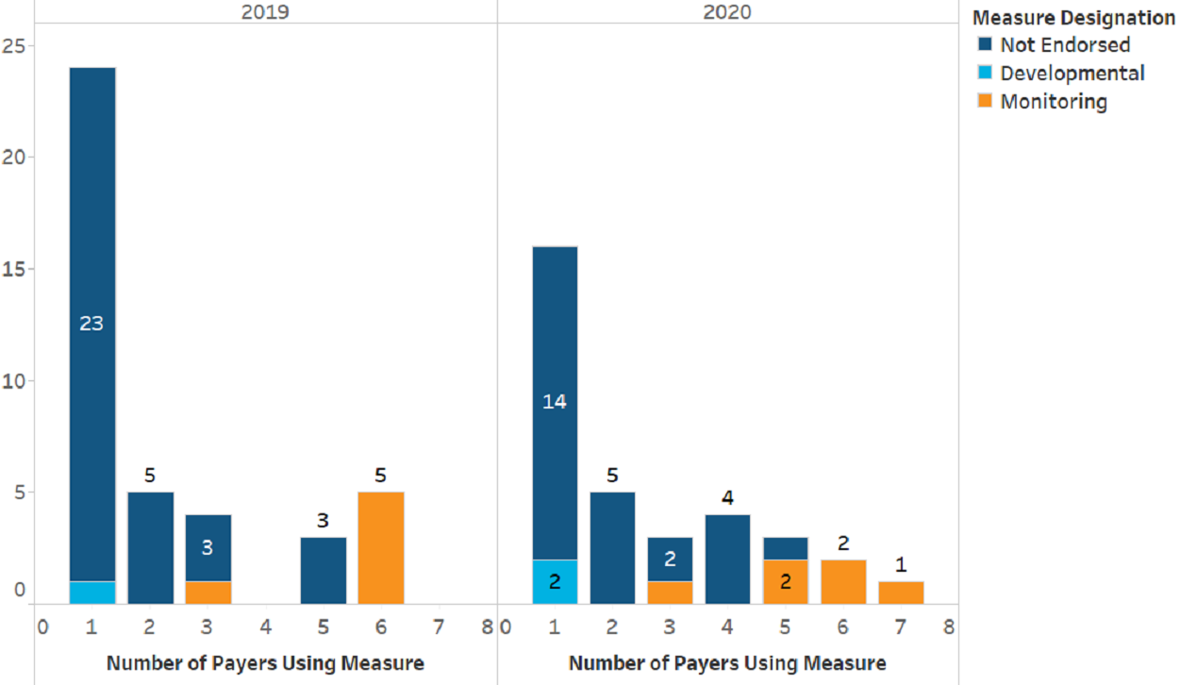
Figure Summary:
- Depicts count of measures in use that are not part of the Core and Menu sets by number of payers using the measure for 2019 and 2020. Measures were reviewed by the Taskforce and either not endorsed (NE), or categorized as Developmental or Monitoring measures.
  - For 2019:
    - Single payer – 24 measures; 23 NE, 1 developmental
    - Two payers – 5 measures; all NE
    - Three payers – 4 measures; 3 NE, 1 monitoring
    - Four payers – none
    - Five payers – 3 measures; all NE
    - Six payers – 5 measures; all monitoring
    - Seven payers – none
  - For 2020:
    - Single payer – 16 measures; 14 NE, 2 developmental
    - Two payers – 5 measures; all NE
    - Three payers – 3 measures; 2 NE, 1 monitoring
    - Four payers – 4 measures; all NE
    - Five payers – 3 measures; 1 NE, 2 monitoring
    - Six payers – 2 measures; both monitoring
    - Seven payers – 1 measure; monitoring
    - Eight payers - none
Key Findings:
- Many non-aligned measures continue to be included in global budget-based contracts, though fewer in 2020 than in 2019.
- 26 non-endorsed measures are in use in contracts in 2020 (down from 34 in 2019), and 14 by only a single payer (down from 23 in 2019)
- Developmental measures include: Community Tenure, Joint Replacement Patient Reported Outcome Measure, and Depression Remission or Response for Adolescents and Adults (2020 only)

Slide 9

Breakout of Measures Not Endorsed in the Aligned Measure Set by National Endorsement Status
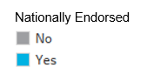
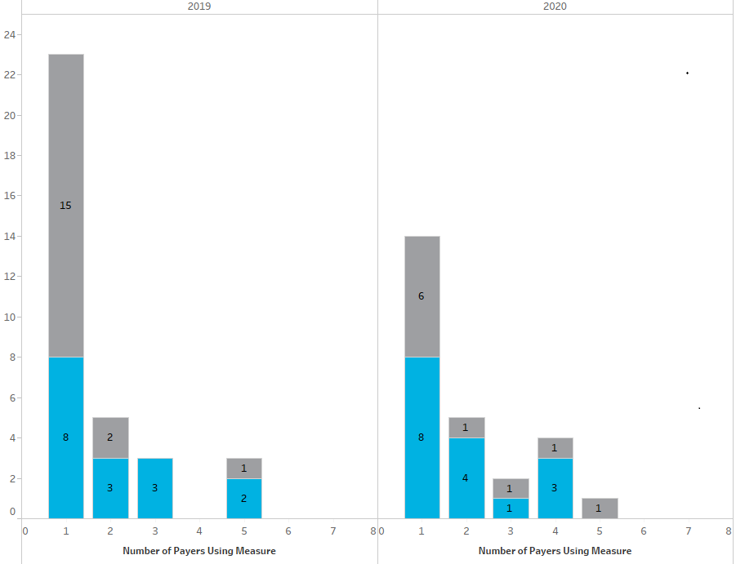
Figure Summary
- Depicts use of measures that were not endorsed (NE) for inclusion in the Aligned Measure Set, broken out by whether or not they have national endorsement.
  - For 2019:
    - Single payer – 23 NE measures, 8 nationally endorsed, 15 not nationally endorsed
    - Two payers – 5 NE measures, 3 nationally endorsed, 2 not nationally endorsed
    - Three payers – 3 NE measures, all nationally endorsed
    - Four payers – none
    - Five payers – 3 NE measures, 2 nationally endorsed, 1 not nationally endorsed
    - Six payers – none
    - Seven payers – none
  - For 2020:
    - Single payer – 14 NE measures, 8 nationally endorsed, 6 not nationally endorsed
    - Two payers – five NE measures, 4 nationally endorsed, 1 not nationally endorsed
    - Three payers – 2 NE measures, 1 nationally endorsed, 1 not nationally endorsed
    - Four payers – 3 nationally endorsed, 1 not nationally endorsed
    - Five payers – 1 NE measure, not nationally endorsed
    - Six payers – none
    - Seven payers – none
    - Eight payers - none
Key Findings:
- Of the 26 measures in use in contracts in 2020 that were not endorsed by the Taskforce for inclusion in the Aligned Measure Set, approximately 2⁄3 have national endorsement (16 measures)
- In 2019, approximately 1⁄2 of non-endorsed measures that were in use had national endorsement (16/34 measures)

Slide 10

Agenda
- Welcome
- Revisit the process for considering non-endorsed measures
- Quality Catalogue analysis of non-aligned measures
- Continue the annual review of the Aligned Measure Set
- Next steps

Slide 11

Continue the Annual Review of the Aligned Measure Set
- Today, we will continue the annual review of the Aligned Measure Set. Specifically we will:
- Revisit guiding principles
- Discuss Taskforce member proposals for additions, subtractions and replacements for 2021
- Conduct an initial review of new measures/topics
- Review the 2020 Aligned Measure Set for possible changes for 2021

Slide 12

Annual Review Process
Background
- Revisit guiding principles

Slide 13

Taskforce Guiding Principles
- During the 11/19 meeting, Taskforce members recommended a number of changes to the Guiding Principles.
- The next few slides show changes made to the Guiding Principles based on Taskforce member feedback.
  - Note: These edits do not reflect the 11/20 emailed recommendation by Arlene Ash. Those recommended changes can be discussed today.
- We will allocate up to 30 minutes for this conversation today, mindful that we need to commence discussions of the 2021 set today if we are to meet our deadline of a March recommendation to the EOHHS Secretary.
  - If additional time is needed, we can continue discussion during the January meeting.

Slide 14

Principles Applied to Individual Measures
- Evidence-based, scientifically acceptable, nationally endorsed and valid and reliable at the level at which it is being used (ACO-level in particular).
- Required data should be either readily available, not overly burdensome to collect, or, if burdensome, of demonstrable value for improving patient care.
- Represents an opportunity for improvement to improve population health at the total population and/or subpopulation level.
- Is important to consumers and supports the triple aim of better care, better health and lower cost.

Slide 15

Principles to be Applied to the Measure Set
- Prioritize health outcomes, including measures sourced from clinical and patient-reported data.
- Provide a largely complete and holistic view of the entity being evaluated (e.g., ACO, primary care practice, hospital).
- The measure set should strive for parsimony.
- Taken as a whole, high performance on the proposed measure set should significantly advance the delivery system toward the goals of safe, timely, effective, efficient, equitable, patient-centered (STEEEP) care.
- Promotes value for consumers patients, purchasers, and providers and supports the triple aim of better care, better health, and lower cost.

Slide 16

Principles to be Applied to Core Measures
- No more than five in number
- Outcomes-oriented
- At least one measure is focused on behavioral health
- Universally applicable to the greatest extent possible
- Crucial from a public health perspective
- Comprised of measures that are highly aligned across existing payer global budget-based risk contract measures
- Enhances value

Slide 17

Annual Review Process
- Solicit Proposals for Additions, Subtractions and Replacements for 2021

Slide 18

Solicit Proposals for Additions, Subtractions and Replacements for 2021
- We will begin our review by asking you for your recommended additions, subtractions and replacements for the 2021 Aligned Measure Set.
  - Do you have any recommended changes you wish to voice now?
  - If you have additional thoughts, please email Justine with your recommendations at jzayhowski@bailit-health.com by 12/27.
- We will also seek public input on recommended changes to the Aligned Measure Set.
- We will discuss any recommended changes during the January Taskforce meeting.

Slide 19

Annual Review Process
Initial Review of New Measures/Topics
- Consider whether to add hospital measures for 2021
- Review candidate pediatric measures for further consideration
- Consider other new measure topics
- Review new HEDIS measures
- Review new Medicaid Core Set measures

Slide 20

Initial Review of New Topics and Measures
- We will now consider new topics and new measures for consideration.
- For the topics of hospital measures and pediatric measures, we seek your initial feedback on inclusion of the topic or particular measures.
  - Following initial feedback, Taskforce staff will pull together specifications and performance, where available, for further consideration at a future meeting.
- For new HEDIS measures and recommended new Medicaid Core Set measures, we seek your feedback on whether the new measures should be adopted into the Aligned Measure Set.

Slide 21

Consider Whether to Add Hospital Measures for 2021
- Previously, the Taskforce recommended deferring discussion of possibly including inpatient measures in the Aligned Measure Set until the 2019 annual review process.
  - The rationale at that time was that only one payer was using hospital measures in global budget-based risk contracts.
- The most recent Quality Measure Catalogue results show that five payers are now using hospital measures in global budget-based risk contracts in 2019.
- We heard from Cory King in October that Rhode Island includes hospital measures in its aligned ACO measure set.
- Does the Taskforce recommend adding hospital measures to the Aligned Measure Set for 2021?

Slide 22

Pediatric Measures
- During the 10/18 Taskforce meeting, a few Taskforce members recommended adding additional pediatric measures to the Aligned Measure Set.
- Prior to November’s meeting, we distributed a crosswalk of candidate pediatric measures for your consideration.
- Today, we request that you flag any candidate (or other) pediatric measures you wish the Taskforce to consider.
  - After initial discussion, Taskforce staff will pull together specifications and performance data, where available, for a more in-depth review during a future meeting.

Slide 23

Consideration of Other New Measure Topics/Special Populations
- Are there other topics or subpopulations the Taskforce wishes to consider?
  - Previously, one member of the Taskforce expressed interest in explicitly considering other special populations, including pregnant/post-partum women.
- Should there be any additional topics, Taskforce staff will pull together specifications and performance, where available, for further consideration at a future meeting.

Slide 24

New HEDIS Measures Introduced in HEDIS 2019 and 2020
- During our last (abbreviated) annual review, conducted during early 2019, the Taskforce did not consider new HEDIS measures.
- Therefore, we will review new HEDIS 2019 and HEDIS 2020 measures for your consideration during this year’s annual review.
  - Benchmark data are not available from NCQA for first-year measures.
- As we review each measure, please indicate if you are interested in potentially adding the measure to the Aligned Measure Set.
Note: We did not include Hospitalization Following Discharge from a Skilled Nursing Facility as it is a Medicare-only measure.

Slide 25

What are ECDS Measures?
- A number of the new HEDIS measures use Electronic Clinical Data System (ECDS) as their reporting standard.
  - These measures use electronic databases arranged so that queries can extract information both efficiently and accurately.
- Data systems eligible for HEDIS ECDS reporting include:

  - member eligibility files
  - EHRs
  - clinical registries
  - HIEs
  - administrative claims systems
  - electronic laboratory reports
  - electronic pharmacy systems
  - immunization information systems
  - disease/case management registries

https://www.ncqa.org/hedis/the-future-of-hedis/hedis-electronic-clinical-data-system-ecds-reporting/

Slide 26

New HEDIS Measures Introduced in HEDIS 2019 and 2020 (cont’d)
Measure | LOB | Data Source | Description
Adult Immunization Status –proposed for addition to CMS ACOs in 2020 | Comm., Medicaid, Medicare | ECDS | The percentage of adults 19 years and older who are up to date on recommended routine vaccines for influenza, tetanus and diphtheria (Td) or tetanus, Tdap, herpes zoster and pneumococcal.
Prenatal Immunization Status | Comm., Medicaid | ECDS | The percentage of deliveries on or after 37 gestational weeks in which women received influenza and diphtheria and pertussis (Tdap) vaccines.

Slide 27

New HEDIS Measures Introduced in HEDIS 2019 and 2020 (cont’d)
Measure | LOB | Data Source | Description
Prenatal Depression Screening and Follow-up* | Comm., Medicaid | ECDS | The percentage of deliveries in which members were screened for clinical depression while pregnant and, if screened positive, received follow-up care. Two rates are reported.
Post-partum Depression Screening and Follow-up* | Comm., Medicaid | ECDS | The percentage of deliveries in which members were screened for clinical depression during the postpartum period, and if screened positive, received follow-up care.

Slide 28

New HEDIS Measures – Introduced in HEDIS 2019 and 2020 (cont’d)
Measure | LOB | Data Source | Description
Follow-Up After High-Intensity Care for Substance Use Disorder* | Comm., Medicaid, Medicare | Admin | The percentage of acute inpatient hospitalizations, residential treatment or detoxification visits for a diagnosis of substance use disorder among members 13 years of age and older that result in a follow-up visit or service for substance use disorder.
Pharmaco-therapy for Opioid Use Disorder*¹ | Comm., Medicaid, Medicare | Admin | The percentage of new opioid use disorder (OUD) pharmacotherapy events with OUD pharmacotherapy for 180 or more days among members age 16 and older with a diagnosis of OUD.
Risk of Continued Opioid Use | Comm., Medicaid, Medicare | Admin | The percentage of members 18 years and older who have a new episode of opioid use that puts them at risk for continued use.

*indicates new for HEDIS 2020
¹Differences between this measure and the Continuity of Pharmacotherapy for Opioid Use Disorder are described on the next slide.

Slide 29

Comparison of CMS and NCQA Pharmacotherapy Measures
Topic | CMS MIPS | HEDIS | MA Aligned Set
Name | Continuity of Pharmacotherapy for Opioid Use Disorder | Pharmacotherapy for Opioid Use Disorder | Continuity of Pharmacotherapy for Opioid Use Disorder
Steward | Developer: RAND  Steward: U. of Southern California | NCQA | RAND
Description | Percentage of adults aged 18 years and older with pharmacotherapy for opioid  use disorder (OUD) who have at least 180 days of continuous treatment | Percentage of new opioid use disorder (OUD) pharmacotherapy events with OUD pharmacotherapy for 180 or more days among members age 16 and older with a diagnosis of OUD. | Percentage of adults 18-64 years of age with pharmacotherapy for opioid use disorder (OUD) who have at least 180 days of continuous treatment
Major Adapta-tions from CMS Version | The NCQA version of the measure included two major adaptations:  - a focus on “new,” or incident episodes of OUD pharmacotherapy, and  - the inclusion of adolescents 16 and 17 years of age, for whom certain OUD pharmacotherapies have been FDA-approved to treat OUD (source)

Slide 30

New Medicaid Core Set Measures
- On 11/19, CMS released its 2020 updates to the Medicaid and CHIP Child and Medicaid Adult Core Sets.1 CMS added three new measures:
  - One of these measures, Metabolic Monitoring for Children and Adolescents on Antipsychotics, is already a Menu measure.
  - Another of these measures, National Core Indicators (NCI) addresses the experience and outcomes of individuals with intellectual and developmental disabilities, populations primarily covered by Medicaid, and is therefore not well-suited for an aligned set spanning commercial and Medicaid contracts.
- As we review the remaining measure, please consider whether you recommend adding the measure to the Aligned Measure Set, should it be adopted for the 2020 Medicaid Core.
- Following review of the new measures, we will review other changes made to the Core Sets.
1 www.medicaid.gov/federal-policy-guidance/downloads/cib111919.pdf

Slide 31

New Medicaid Core Set Measures (cont’d)
Measure | Steward | Data Source | Description | Rationale for Addition
Use of Pharmaco-therapy for Opioid Use Disorder* | CMS | Admin | The percentage of Medicaid beneficiaries ages 18 to 64 with an OUD who filled a prescription for or were administered or ordered an FDA-approved medication for the disorder during the measure year. | - Fill measure gap by tracking appropriate treatment of OUDs  - Good first step, tracking initiation of medication- assisted treatment
*The Aligned Measure Set currently has Continuity of Pharmacotherapy for Opioid Use Disorder in the Menu Set.
Note: DPH and other substance use stakeholders now use medication for opioid use disorder instead of medication- assisted treatment.

Slide 32

Annual Review Process
Review the 2020 Aligned Measure Set
- Review adoption in global budget-based risk contracts
- Review substantive HEDIS changes
- Review CMS-driven changes to existing measures in the MassHealth ACO, Medicaid Core, and Medicare ACO Sets
- Review performance of Core, Menu, and Monitoring measures

Slide 33

Quality Measure Catalogue: Background
- The next several slides display Core and Menu measures. When you consider whether these measures should remain in the 2021 Aligned Measure Set, please consider:
  - Use in global budget-based risk contracts
    - Source: Quality Catalogue Fall 2019
  - Substantive changes to the measures
Topic | Source
HEDIS | NCQA Summary of HEDIS 2020 Changes  - These changes were reviewed with the Taskforce via survey in the spring of 2019. At the time, the Taskforce recommended adopting all changes once finalized.
MassHealth | MassHealth  - There are no CMS-driven changes to the MassHealth slate.  - There are no new measures moving to payment for 2021.
Medicaid Core | Changes from CMS’ 2020 Updates to the Child and Adult Core Health Care Quality Measurement Sets
CMS ACOs | No changes noted in the QPP Final Rule

Slide 34

Review of the 2020 Aligned Measure Set
- Performance:
  - Source: Taskforce staff reviewed performance using data from NCQA’s Quality Compass product and from MassHealth.
  - We compared commercial performance for the three largest plans to national commercial ALOB benchmarks.
  - We compared MassHealth performance (MCO and PCC Plan combined) to national Medicaid HMO benchmarks.
  - While the next set of slides only displays 2018 performance, 2016 through 2018 performance can be found in the appendix.
Key:
<25th | 25th - 50th | 50th - 75th | 75th - 90th | ≥90th

Slide 35

2020 Core Measures
Measure | Contract Use 2020 | Substantive Change | 2018 Performance
 |  |  | Comm. | MH
CG-CAHPS (MHQP Version) | 4 payers
Comprehensive Diabetes Care: Hemoglobin A1c (HbA1c) Poor Control (>9.0%) | 5 payers |  | 22.3* | 31.6*
Controlling High Blood Pressure | 4 payers |  | 74.3** | 66.7*
Depression Screening and Follow-Up for Adolescents and Adults (NCQA) | 0 payers
Depression Response at Six or Twelve Months -Progress Towards Remission (MNCM) | 0 payers
Depression Remission at Six or Twelve Months (MNCM) | 1 payer
Depression Remission and Response for Adolescents and Adults (NCQA) | 1 payer
Screening for Depression and Follow-up Plan (CMS)¹ | 2 payers

**25th - 50th
*75th - 90th
¹Recommended as a Core Measure for 2021.

Slide 36

Overview of Quality Measures in Use in Any Global Budget Contract by Commercial Payers
Measure | Contract Use 2020 | Substantive Change | 2018 Performance
 |  |  | Comm. | MH
Initiation and Engagement of Alcohol and Other Drug Dependence Treatment - Initiation | 4 payers |  | 34.4 | 47.5
Initiation and Engagement of Alcohol and Other Drug Dependence Treatment - Engagement | 4 payers |  | 12.8 | 18.9

**25th - 50th
*75th - 90th

Slide 37

Menu Measures
Measure | Contract Use 2020 | Substantive Change | 2018 Performance
 |  |  | Comm. | MH
Asthma Medication Ratio | 4 payers |  | 75.5² | 58.7³
Breast Cancer Screening | 7 payers |  | 83.1⁶ | 68.5⁵
Cervical Cancer Screening | 7 payers | HEDIS 2020 Change* | 84.2⁶ | 70.8⁵
Child and Adolescent Major Depressive Disorder: Suicide Risk Assessment | 0 payers
Childhood Immunization Status (Combo 10) | 3 payers |  | 71.8⁶ | 50.6⁶
Chlamydia Screening - Ages 16-24 | 6 payers |  | 74.2⁶ | 72.1⁶
Colorectal Cancer Screening | 5 payers |  | 79.0⁶ | N/A
Comprehensive Diabetes Care: Eye Exam | 5 payers |  | 73.1⁶ | 68.0⁵
Comprehensive Diabetes Care: Blood Pressure Control (<140/90 mm Hg) | 6 payers |  | 76.3⁵ | ¹69.0³
Continuity of Pharmacotherapy for Opioid Use Disorder | 1 payer

*Added primary screening with a high-risk human papillomavirus test as a screening option.
¹One MCO did not do medical record review (resulting in a rate of 0%), likely pulling down the MassHealth rate by 3-4 percentage points.
²<25th
³25th - 50th
⁴50th - 75th
⁵75th - 90th
⁶≥90th

Slide 38

Menu Measures (cont’d)
Measure | Contract Use 2020 | Substantive Change | 2018 Performance
 |  |  | Comm. | MH
Follow-up After Emergency Department Visit for Mental Health (7-Day) | 1 payer |  | 69.7⁶ | 76.6⁶
Follow-Up After Hospitalization for Mental Illness (FUH) (7-Day) | 2 payers |  | 58.6⁵ | 49.0⁵
Follow-Up After Hospitalization for Mental Illness (FUH) (30-Day) | 0 payers |  | 78.3⁶ | 70.1⁵
Immunizations for Adolescents (Combo 2) | 5 payers |  | 29.3³ | 36.0³
Influenza Immunization | 1 payer
Metabolic Monitoring for Children and Adolescents on Antipsychotics | 1 payer | Add to Medicaid Core;  HEDIS 2020 Change* | 40.2³ | 37.9³
Use of Imaging Studies for Low Back Pain | 4 payers |  | 82.2⁵ | 76.7⁵

*Added blood glucose and cholesterol indicators and combined the 1–5 years and 6–11 years age strata.
²<25th
³25th - 50th
⁴50th - 75th
⁵75th - 90th
⁶≥90th

Slide 39

Monitoring Measures
- As a reminder, Monitoring measures are intended to be used for performance tracking to ensure performance does not decline.
  - If performance does decline, the Monitoring Set measures may be reconsidered by the Taskforce for inclusion in the Core and Menu Sets.
- The next slide displays performance over time on the Monitoring measures.
- Please indicate if you think change in performance warrants reconsideration for inclusion in the Core or Menu Sets.

Slide 40

Monitoring Measure Performance
Measure | Commercial |  |  | MassHealth
 | 2016 | 2017 | 2018 | 2016 | 2017 | 2018
Adolescent Well-Care Visits | 78.0⁶ | 77.6⁶ | 78.3⁶ | 68.5⁶ | 67.8⁶ | 68.6⁶
Comprehensive Diabetes Care - HbA1c Testing | 94.6⁶ | 94.5⁶ | 94.6⁶ | 90.9⁶ | 90.7⁶ | 90.3⁴
Comprehensive Diabetes Care - Medical Attention for Nephropathy | 92.5⁶ | 93.2⁶ | 91.8⁶ | 90.3⁴ | 90.5⁴ | 92.3⁶
Prenatal and Postpartum Care - Timeliness of Prenatal Care | 93.9⁶ | 93.6⁶ | 95.4⁶ | 87.8⁴ | 86.5⁴ | 86.3⁴
Well-Child-Visits in the 3rd, 4th, 5th, and 6th Years of Life | 93.1⁶ | 92.6⁶ | 93.1⁶ | 81.6⁶ | 81.9⁶ | 81.1⁶
Well-Child Visits in the first 15 months of life (6 or more visits) | 93.8⁶ | 94.5⁶ | 93.9⁶ | 86.9⁶ | 83.3⁶ | 81.6⁶

Key:
<25th² | 25th - 50th³ | 50th - 75th⁴ | 75th - 90th⁵ | ≥90th⁶

Note: Data not provided for Incidence of Episiotomy and Contraceptive Care – Postpartum.

Slide 41

Agenda
- Welcome
- Revisit the process for considering non-endorsed measures
- Quality Catalogue analysis of non-aligned measures
- Continue the annual review of the Aligned Measure Set
- Next steps

Slide 42

Next Meeting
- January 22
  - Continue annual review of the Aligned Measure Set

Slide 43

Appendix
- References slides follow.

Slide 44

Core Measure Performance
Measure | Commercial |  |  | Medicaid
 | 2016 | 2017 | 2018 | 2016 | 2017 | 2018
Comprehensive Diabetes Care: Hemoglobin A1c (HbA1c) Poor Control (>9.0%) | 21.1⁶ | 20.8⁶ | 22.3⁵ | 32.3⁵ | 35.0⁴ | 31.6⁵
Controlling High Blood Pressure | 77.2 | 74.1⁵ | 74.3⁶ | 68.4⁵ | 66.3⁵ | 66.7⁵
Initiation and Engagement of Alcohol and Other Drug Abuse or Dependence Treatment- Initiation of AOD | 33.3⁴ | 64.5⁶ | 34.4³ | 43.0⁴ | 44.3⁴ | 47.5⁵
Initiation and Engagement of Alcohol and Other Drug Abuse or Dependence Treatment- Engagement of AOD | 12.5⁴ | 15.7⁴ | 12.8³ | 17.7⁵ | 19.5⁵ | 18.9⁵

Key:
<25th² | 25th - 50th³ | 50th - 75th⁴ | 75th - 90th⁵ | ≥90th⁶

Note: Data are not provided for: CG-CAHPS, Depression Remission and Response, Depression Remission, Depression Response, Depression Screening and Follow-up.

Slide 45

Core Measure Performance
Measure | Commercial |  |  | MassHealth
 | 2016 | 2017 | 2018 | 2016 | 2017
Asthma Medication Ratio | 76.6³ | 76.1² | 75.5² | 52.0² | 57.8³ | 58.7³
Breast Cancer Screening | 83.8⁶ | 83.3⁶ | 83.1⁶ | 74.1⁶ | 69.6⁶ | 68.5⁵
Cervical Cancer Screening | 86.1⁶ | 85.4⁶ | 84.2⁶ | 70.6⁵ | 71.5⁶ | 70.8⁵
Childhood Immunization Status (Combo 10) | 73.0⁶ | 70.3⁶ | 71.8⁶ | 51.9⁶ | 52.0⁶ | 50.6⁶
Chlamydia Screening - Ages 16-24 | 72.9⁶ | 73.7⁶ | 74.2⁶ | 71.5⁶ | 72.3⁶ | 72.1⁶
Colorectal Cancer Screening | 76.6⁶ | 77.2⁶ | 79.0⁶ | NA - SCO only
Comprehensive Diabetes Care: Blood Pressure Control (<140/90 mm Hg) | 80.6⁶ | 76.7⁶ | 76.3⁵ | 72.9⁵ | 71.1⁵ |  | ¹69.0⁴
Comprehensive Diabetes Care: Eye Exam | 74.7⁶ | 74.6⁶ | 73.1⁶ | 63.4⁵ | 66.1⁵ |  | 68.0⁵
Follow-up After Emergency Department Visit for Mental Illness (7-Day) | No data | 70.9⁶ | 69.7⁶ | No data | 78.3⁶ |  | 76.6⁶

Key:
<25th² | 25th - 50th³ | 50th - 75th⁴ | 75th - 90th⁵ | ≥90th⁶

¹One MCO did not do medical record review (resulting in a rate of 0%), likely pulling down the MassHealth rate by 3-4 percentage points.
Note: Data are not provided for: Child and Adolescent Major Depressive Disorder: Suicide Risk Assessment, Continuity of Pharmacotherapy for Opioid Use Disorder, Influenza Immunization

Slide 46

Menu Measure Performance (2 of 2)
Measure | Commercial |  |  | MassHealth
 | 2016 | 2017 | 2018 | 2016 | 2017 | 2018
Follow-Up After Hospitalization for Mental Illness (30-Day) | 87.9⁶ | 83.7⁶ | 78.3⁶ | 81.7⁶ | 74.9⁶ | 70.1
Follow-Up After Hospitalization for Mental Illness (7-Day) | 74.6⁶ | 65.8⁶ | 58.6 | 65.8⁶ | 53.6 | 49.0
Immunizations for Adolescents (Combo 2) | 15.5⁴ | 23.0⁴ | 29.3⁴ | 20.7⁴ | 33.5⁴ | 36.0⁴
Metabolic Monitoring for Children and Adolescents on Antipsychotics | 39.6 | 38.7⁴ | 40.2⁴ | 37.9 | 39.0⁴ | 37.9⁴
Use of Imaging Studies for Low Back Pain | 81.7 | 82.2 | 82.2 | 77.4 | 76.8 | 76.7

Key:
<25th² | 25th - 50th³ | 50th - 75th⁴ | 75th - 90th⁵ | ≥90th⁶

Note: Data are not provided for: Child and Adolescent Major Depressive Disorder: Suicide Risk Assessment, Continuity of Pharmacotherapy for Opioid Use Disorder, Influenza Immunization

