**INDOOR AIR QUALITY ASSESSMENT**

**Quarry Hill Community School Pool Area**

**43 Margaret Street**

**Monson, Massachusetts**

Photo of Pool Area, Quarry Hill Community School, 43 Margaret Street, Monson, Massachusetts


Prepared by:

Massachusetts Department of Public Health

Bureau of Environmental Health

Indoor Air Quality Program

August 2017

**BACKGROUND**

|  |  |
| --- | --- |
| **Building:** | Quarry Hill Community School pool (QHCS) |
| **Address:** | 43 Margaret Street, Monson, Massachusetts |
| **Assessment Requested by:** | Monson Public Schools |
| **Reason for Request:** | Water damage concerns and general indoor air quality (IAQ) concerns |
| **Date(s) of Assessment:** | August 4, 2017 |
| **Massachusetts Department of Public Health/Bureau of Environmental Health (MDPH/BEH) Staff Conducting Assessment:** | Mike Feeney, Director, IAQ Program |
| **Date of Building Construction:** | 1990 |
| **Building/Site Description:** | One-story brick section of the QHCS with flat roof |
| **Windows:** | Openable |

**METHODS**

Please refer to the IAQ Manual for methods, sampling procedures, and interpretation of results (MDPH, 2015).

# RESULTS and DISCUSSION

The following is a summary of indoor air testing results (Table 1).

* ***Temperature*** was above the MDPH recommended range of 70°F to 78°F in all areas tested.
* ***Relative humidity*** was above the MDPH recommended range of 40 to 60% in all areas tested.

## Heat Index

Thermal comfort is also dependent on the perception of heat by an individual, which can be expressed as the heat index. The body cools by producing sweat to reduce internal body heat through the skin. When relative humidity increases, the ability of moisture to evaporate from skin decreases, therefore preventing heat loss and increasing an individual’s discomfort. The heat index is a description of how hot a person feels as temperature in combination with relative humidity rises. The following chart produced by the National Weather Service (NWS) shows the heat index that corresponds to the air temperature and relative humidity.

## Table 1: Heat Index

Table 1: Heat Index - National Weather Service shows the heat index that corresponds to the air temperature and relative humidity.


This chart is based upon shady, light wind conditions. **Exposure to direct sunlight can increase the heat index by up to 15°F.** Due to the nature of the heat index calculation, the values in the tables below have an error +/- 1.3ºF (NWS, 2005).

Using this chart as a guide, when the heat index indoors ***exceeds 88°F***, methods to increase the thermal comfort of building occupants should be employed.

IAQ staff measured temperature and relative humidity in the locker rooms and the pool deck. The pool had a temperature of 85°F and a relative humidity of 83%, which would result in a heat index of ***approximately 96°F.*** Using the heat index chart, the conditions of the pool deck could result in individuals who are active experiencing heat cramps and/or heat exhaustion. Please note that some building occupants may be particularly susceptible to heat related problems, even those swimming in the pool. Individuals who are at greater risk include:

* Infants and children up to four years of age;
* People over 65 years of age;
* Individuals who are overweight;
* Individuals who overexert due to exercise; and
* Individuals who are physically ill, especially those with heart disease or high blood pressure, or who take certain medications, such as for depression, insomnia or poor circulation (CDC, 2006).

Given that the pool is open to the general public, it is highly likely the individuals using the pool may have one or more of the above-named conditions that may make them more susceptible to heat-related illness. Using this chart as a guide, the IAQ Program recommends at if the heat index indoors exceeds 88°F, methods to reduce temperature and/or relative humidity should be employed.

## Ventilation

The QHCS, including the pool, does not have the means to provide cooled air (air conditioning) by the mechanical ventilation system; therefore there is *no means* in to pool area to reduce temperature. The sole means to reduce relative humidity would be by removing water vapor from the pool area by the mechanical exhaust system components.

IAQ staff examined the pool mechanical room and found air handling units (AHU) that service the men’s and women’s locker rooms that provide both fresh air and exhaust ventilation. These systems appear to be deactivated. The pool deck has a Dectron DRY-O-TRON®, which is a dehumidification system. According to the manufacturer:

*Dectron pioneered the indoor pool dehumidification market by trying to resolve a problem found in all buildings with Indoor Pools: “Structural Damage due to Humidity”. In this pursuit, the Engineers at Dectron designed and manufactured the very first DRY-O-TRON®, a mechanical dehumidification system to control humidity, and at the same time, use the same energy by-products to increase comfort by controlling both pool and air temperature within the enclosure* (Dectron, 2017).

The dehumidifier has two coils: an evaporator to heat air to reduce humidity, and a reheat coil to further reduce humidity. Neither of these coils were operating and were at room temperature at the time of the visit, and therefore were not providing any dehumidification. The louvers inside the dehumidifier adjust fresh air intake as well as exhaust ventilation, however the actuators were found rusted and frozen shut. As it functioned the day of this assessment, the dehumidifier recirculates air to the pool deck without removal of water vapor by either dehumidification or exhaust ventilation. This condition is confirmed by the finding that relative humidity on the pool deck was 20 percent higher than the hallway outside the pool area.

## Microbial/Moisture Concerns

Pool treatment/chlorine odors were detected outside of the indoor pool area (Table 1). The purpose of the dehumidification system is to provide air with some moisture removed, creating positive pressure. The exhaust system must remove air at an adequate rate to balance the flow of supplied air. Without adequate exhaust ventilation, air from the pool area can penetrate other portions of the QHCS. The following conditions and air measurements indicate that the pool area is not properly vented:

* Pool-related odors in the central lobby (a distance estimated to be ~ 100 feet).
* Exterior doors show signs of corrosion and mold colonization from water condensation and drippage.
* Exterior walls of the pool have efflorescence (Pictures 1 through 3).

Efflorescence is a characteristic sign of water damage to building materials, but it is not mold growth. As moisture penetrates and works its way through building materials (e.g., brick and mortar), water-soluble compounds dissolve, creating a solution. As this solution moves to the surface, the water evaporates, leaving behind white, powdery mineral deposits. This would indicate that the action of the dehumidifier in its current condition and configuration may be driving moisture through the exterior wall, causing this pattern of efflorescence.

It appears that the dehumidification system may be pressurizing the pool area, forcing air into the pool locker rooms and through outdoor vents to the main hallway that leads to the central lobby. Strong consideration should be given to balancing the HVAC equipment in this area to prevent movement of pool odors to other portions of the building. Also note that under Massachusetts state regulations, the pool is considered a “semi-public” pool that should be operated and maintained in accordance with 105 CMR 435.29, Minimum Standards for Swimming Pools (State Sanitary Code: Chapter V).

# CONCLUSION AND RECOMMENDATIONS

The design of a pool building as advised by Dectron for use of its equipment is specified in its DRY-O-TRON® technical document, which recommends rigid polystyrene, a vapor retarder, in order to control the dew point which is vital to arrest condensation that can result in mold growth (Dectron, 2017). It is unclear whether the pool building walls were constructed in this manner, however the efflorescence seen on the north, east and south walls indicate that water vapor is passing through the exterior brickwork. In addition, since the HVAC equipment does not provide a means to reduce temperature during hot, humid weather, it is likely that the pool was not designed for use during summer months, especially in hot, humid weather. In view of the findings at the time of the visit, the following recommendations are made:

1. If the pool is to be used during summer months, both temperature and relative humidity should be monitored to determine the dew point. If the dew point in 88°F or above, measures should be taken to decrease temperature, relative humidity or both to reduce the chance of pool users developing heat cramps or heat exhaustion. If no measures can be taken to reduce the heat index, then closing the pool until weather conditions improve is recommended.
2. Repair all equipment capable of providing exhaust ventilation to the pool. Once repaired, all exhaust ventilation in the pool in recommended to operate 24 hours a day to eject water vapor from the building.
3. Replace all water-damaged gypsum wallboard in the locker rooms.
4. Due to the efflorescence noted in this assessment, consider consulting with a ventilation engineer for the best methods to improve HVAC operation in the pool area.
5. Refer to resource manual and other related indoor air quality documents located on the MDPH’s website for further building-wide evaluations and advice on maintaining public buildings. These documents are available at <http://mass.gov/dph/iaq>.

# REFERENCES

ACGIH. 1989. Guidelines for the Assessment of Bioaerosols in the Indoor Environment. American Conference of Governmental Industrial Hygienists, Cincinnati, OH.

CDC. 2006. Extreme Heat: A Prevention Guide to Promote Your Personal Health and Safety. Centers for Disease Control & Prevention, Office of Emergency Preparedness and Response, Atlanta, GA. <https://www.cdc.gov/disasters/extremeheat/index.html>.

Dectron. 2017. Dectron DRY-O-TRON® website. Dectron, St. Laurent, Quebec, Canada. <http://www.dectron.com/brands/indoor-pool-dehumidification-dry-o-tron>.

MDPH. 2015. Massachusetts Department of Public Health. Indoor Air Quality Manual: Chapters I-III. Available at: <http://www.mass.gov/eohhs/gov/departments/dph/programs/environmental-health/exposure-topics/iaq/iaq-manual/>.

**Picture 1**

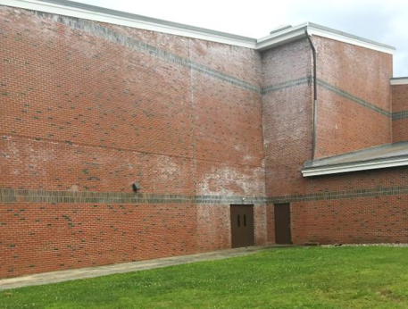

**Efflorescence on the northwest-facing wall of the pool**

**Picture 2**

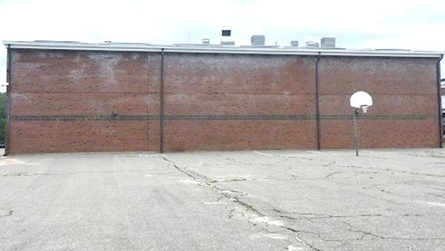

**Efflorescence on the northeast-facing wall of the pool**

**Picture 3**

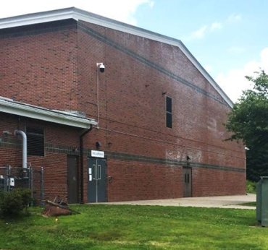

**Efflorescence on the southeast facing wall of the pool**

| Location | Temp  (°F) | Relative  Humidity  (%) | Dew Point  (°F) | Ventilation | | Remarks |
| --- | --- | --- | --- | --- | --- | --- |
| Supply | Exhaust |
| Background | 81 | 68 | 69 |  |  |  |
| Hallway | 83 | 63 | 69 |  |  | Pool odor |
| Pool | 84 | 83 | 79 |  |  | Pool odor |
| Men’s locker room | 85 | 69 | 74 | Y off | Y off | Pool odor |
| Women’s locker room | 85 | 71 | 75 | Y | Y off | Pool odor, water-damaged gypsum wallboard |
| Office | 85 | 68 | 74 | Y | Y off | Pool odor |
| Mechanical room | 84 | 62 | 70 | N | N | No pool odor |