INDOOR AIR QUALITY ASSESSMENT

Quarry Hill Community School
43 Margaret Street
Monson, Massachusetts

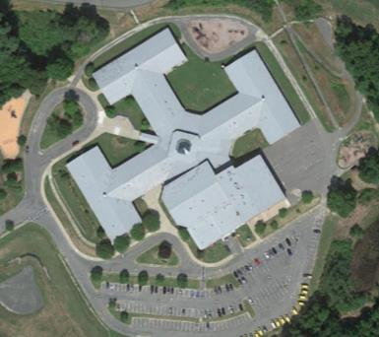

Prepared by:
Massachusetts Department of Public Health
Bureau of Environmental Health
Indoor Air Quality Program
December 2018

BACKGROUND
Building: | Quarry Hill Community School (QHCS)
Address: | 43 Margaret Street, Monson, MA
Assessment Requested by: | Monson Public Schools
Reason for Request: | Impact of indoor swimming pool on the general indoor air quality (IAQ) in the QHCS
Massachusetts Department of Public Health/Bureau of Environmental Health (MDPH/BEH) Staff Conducting Assessment: | Mike Feeney, Director, IAQ Program
Date(s) of Assessment: | September 28, 2018
Date of Building Construction: | 1990
Building/Site Description: | One-story brick building
Windows: | Openable

BACKGROUND
The IAQ Program has previously visited the QHCS to assess the general conditions and the impact of operating an indoor swimming pool. The IAQ Program returned to the QHCS to ascertain if the operation of the indoor swimming pool was continuing to affect the non-pool areas of the building. Recommendations made in the previous report are included as Appendix A.

METHODS
Please refer to the IAQ Manual for methods, sampling procedures, and interpretation of results (MDPH, 2015).

RESULTS and DISCUSSION
The following is a summary of indoor air testing results (Table 1).
- Carbon dioxide levels were above 800 parts per million (ppm) in almost a third of areas assessed.
- Temperature was within the recommended range of 70°F to 78°F in all but pool areas.
- Relative humidity was within the recommended range of 40% to 60% in all areas.
- Carbon monoxide levels were non-detectable (ND) in all areas assessed.
- Fine particulate matter (PM2.5) concentrations measured were below the National Ambient Air Quality Standard (NAAQS) level of 35 micrograms per cubic meter (μg/m³) in all areas assessed.

Ventilation
Fresh air in classrooms is supplied by unit ventilator (univent) systems. A univent draws air from outdoors through a fresh air intake located on the exterior wall of the building and returns air through an air intake located at the base of the unit (Figure 1). Fresh and return air are mixed, filtered, heated, and provided to classrooms through a fresh air diffuser located in the top of the unit.
To maximize air exchange, the MDPH recommends that both supply and exhaust ventilation operate continuously during periods of school occupancy. In order to have proper ventilation with a mechanical supply and exhaust system, the systems must be balanced to provide an adequate amount of fresh air to the interior of a room while removing stale air from the room. It is recommended that HVAC systems be re-balanced every five years to ensure adequate air systems function (SMACNA, 1994).
Of note is the measurement of relative humidity and temperature throughout classrooms and other non-pool areas. On the day of the assessment, outdoor air temperature of 63°F and relative humidity was 55%. Inside the QHCS, temperature was measured in a range of 72-75°F and had a range of relative humidity of 49-59 % in classrooms. Heating of outdoor air to the temperature of the QHCS would be expected to reduce indoor relative humidity approximately 20%. Based on these measurements, a significant water vapor source is present within the building. The water vapor source is likely the pool and its degraded/poorly functioning HVAC equipment. Increased indoor humidity can cause discomfort and moisten porous materials that sustain mold growth. Water vapor from pools should be vented directly outdoors to prevent movement to other indoor locations. Water vapor with pool treatment chemicals can be irritating to the eyes, nose, and respiratory system.

Microbial/Moisture Concerns
In addition to the water vapor from the pool, New England an unprecedented period of extended hot, humid weather. According to the Washington Post, “[d]ata…show[s]…cities in the Northeast have witnessed such humidity levels for record-challenging duration...[i]ncluding Albany, Boston, Burlington Portland and Providence” during the summer of 2018 (WP, 2018). “Boston and nearby locations… [saw]…historic numbers of those warm nights with low temperatures at or above 70 degrees…Providence and Blue Hill Observatory have already broken their annual records” (WP, 2018). If a building does not have adequate exhaust ventilation and air chilling capacity to remove/reduce relative humidity from outside air, then hot, moist air can be introduced into a building and linger to increase occupant discomfort as well as possibly moisten materials that may lead to mold growth.
Of note were the conditions of carpeting and ceiling tiles. Wall-to-wall carpeting in a number of locations were found rippled (Picture 1), which indicated water exposure. Ceiling tiles were bowed in numerous areas from extended exposure to high humidity (Table 1).

Conditions in the Swimming Pool Area and Heat Index
Thermal comfort is also dependent on the perception of heat by an individual, which can be expressed as the heat index. The body cools by producing sweat to reduce internal body heat through the skin. When relative humidity increases, the ability of moisture to evaporate from skin decreases, therefore preventing heat loss and increasing an individual’s discomfort. The heat index is a description of how hot a person feels as temperature as relative humidity rises. The following chart produced by the National Weather Service (NWS) shows the heat index that corresponds to the air temperature and relative humidity.

Table 1: Heat Index
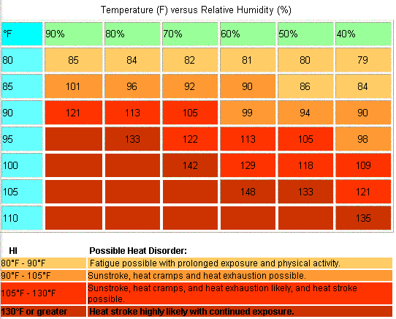
This chart is based upon shady, light wind conditions. Exposure to direct sunlight can increase the heat index by up to 15°F. Due to the nature of the heat index calculation, the values in the tables below have an error +/- 1.3ºF (NWS, 2005).

Using this chart as a guide, when the heat index indoors exceeds 88°F, methods to increase the thermal comfort of building occupants should be employed.

IAQ staff measured temperature and relative humidity in the pool deck. The pool room had an air temperature of 91°F and a relative humidity of 46%, which would result in a heat index of approximately 95°F. IAQ staff used a laser thermometer to measure the temperature of various surfaces in the pool, which had temperatures over 90°F (Picture 2). The pool was covered during these measurements, which reduces the amount of water vapor emitted. Without a pool cover the relative humidity would be expected to increase.
Using the heat index chart, the conditions of the pool deck could result in individuals who are active experiencing heat cramps and/or heat exhaustion. IAQ staff noted a thermohygrometer (a device to measure temperature and relative humidity) leaned on the widow frame of the pool office (Picture 3); it showed a temperature of 72°F and a relative humidity of 38%. In this location, the thermohygrometer was measuring the temperature of the window pane/frame and the relative humidity of the window ledge, not the temperature and relative humidity of the air on the pool deck.
The purpose of a pool dehumidification system is to provide air with less moisture and create a positive pressure. The exhaust system must remove air at an adequate rate to balance the flow of supplied air. Without adequate exhaust ventilation, air from the pool area can penetrate other portions of the QHCS. The following conditions and air measurements indicate that the pool area is not properly vented:
- Exterior doors show signs of corrosion and mold colonization from water condensation and drippage.
- Exterior walls of the pool have efflorescence (Pictures 4 through 9).
Efflorescence is a characteristic sign of water damage to building materials, but it is not mold growth. As moisture penetrates and works its way through building materials (e.g., brick and mortar), water-soluble compounds dissolve, creating a solution. As this solution moves to the surface, the water evaporates, leaving behind white, powdery mineral deposits. This would indicate that the action of the dehumidifier in its current condition and configuration may be driving moisture through the exterior wall, causing this pattern of efflorescence.
It appears that the dehumidification system may be pressurizing the pool area, forcing air into the pool locker rooms and through outdoor vents to the main hallway that leads to the central lobby. Strong consideration should be given to balancing the HVAC equipment in this area to prevent movement of pool odors to other portions of the building. Also note that under Massachusetts state regulations, the pool is considered a “semi-public” pool that should be operated and maintained in accordance with 105 CMR 435.29, Minimum Standards for Swimming Pools (State Sanitary Code: Chapter V).

CONCLUSION AND RECOMMENDATIONS
In view of the findings at the time of the visit, the following is recommended:
- Locate thermohygrometer in a location that measures the pool deck temperature and relative humidity properly.
- Continue with recommendations made in the August 2017 Pool report (MDPH, 2017).
- Operate all supply and exhaust ventilation equipment continuously during occupied periods.
- Consideration should be given to replace watter damaged carpeting throughout the building.
- Consider adopting the US EPA (2000) document, “Tools for Schools,” as an instrument for maintaining a good IAQ environment in the building available at: http://www.epa.gov/iaq/schools/index.html.
- Refer to resource manual and other related indoor air quality documents located on the MDPH’s website for further building-wide evaluations and advice on maintaining public buildings. These documents are available at http://mass.gov/dph/iaq.

REFERENCES
MDPH. 2004. Indoor Air Quality Assessment: Quarry Hill Community School. Massachusetts Department of Public Health, Bureau of Environmental Health, Indoor Air Quality program. Boston, MA.
MDPH. 2015. Massachusetts Department of Public Health. Indoor Air Quality Manual: Chapters I-III. Available at: http://www.mass.gov/eohhs/gov/departments/dph/programs/environmental-health/exposure-topics/iaq/iaq-manual/.
MDPH. 2017. Indoor Air Quality Assessment: Quarry Hill Community School, Pool Area. Massachusetts Department of Public Health, Bureau of Environmental Health, Indoor Air Quality program. Boston, MA.
SMACNA. 1994. HVAC Systems Commissioning Manual. 1st ed. Sheet Metal and Air Conditioning Contractors’ National Association, Inc., Chantilly, VA.
US EPA. 1993. Radon Measurement in Schools, Revised Edition. Office of Air and Radiation, Office of Radiation and Indoor Air, Indoor Environments Division (6609J). EPA 402-R-92-014. https://www.epa.gov/sites/production/files/2014-08/documents/radon_measurement_in_schools.pdf.
US EPA. 2000. Tools for Schools. Office of Air and Radiation, Office of Radiation and Indoor Air, Indoor Environments Division (6609J). EPA 402-K-95-001, Second Edition. http://www.epa.gov/iaq/schools/index.html.
Picture 1
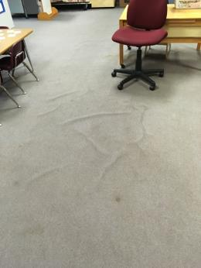
Rippled carpet
Picture 2
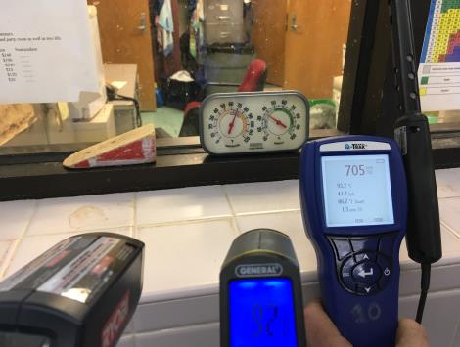
Temperature and relative humidity measurements
Picture 3
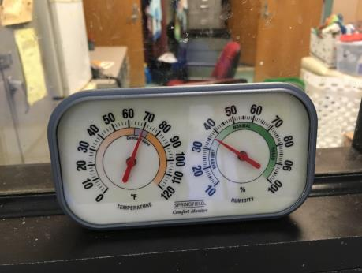
Thermohygrometer leaned against pool office window pane
Picture 4
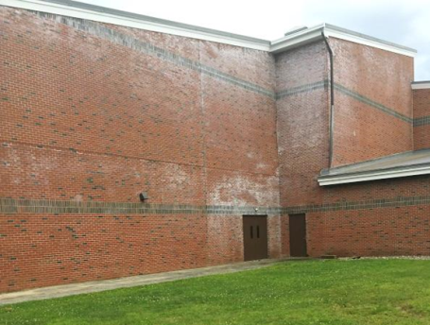
Efflorescence on the northwest-facing wall of the pool 2017
Picture 5
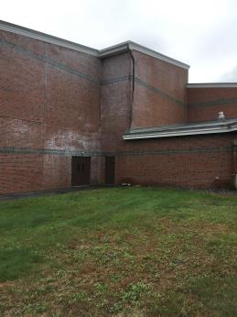
Efflorescence on the northwest-facing wall of the pool 2018
Picture 6
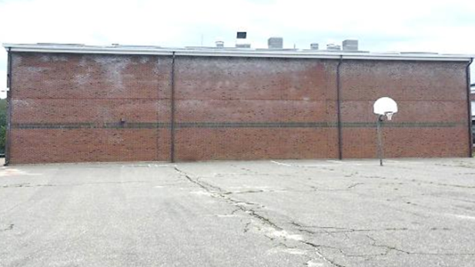
Efflorescence on the northeast-facing wall of the pool 2017
Picture 7
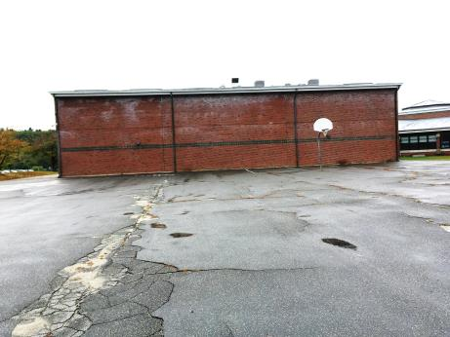
Efflorescence on the northeast-facing wall of the pool 2017
Picture 8
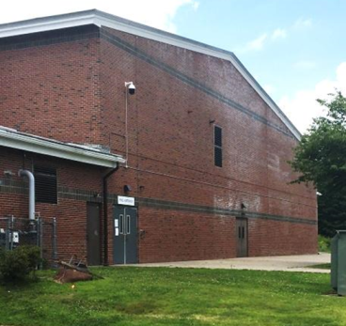
Efflorescence on the southeast facing wall of the pool 2017
Picture 9
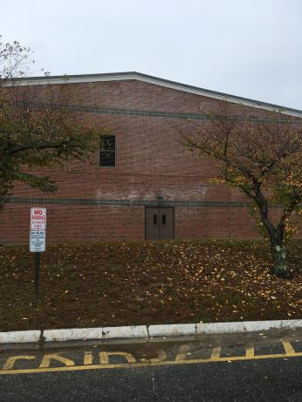
Efflorescence on the southeast facing wall of the pool 2018

Location | Carbon  Dioxide  (ppm) | Carbon Monoxide  (ppm) | Temp  (°F) | Relative  Humidity  (%) | PM2.5  (µg/m³) | Occupants  in Room | Windows  Openable | Ventilation |  | Remarks
 |  |  |  |  |  |  |  | Supply | Exhaust
Background | 423 | ND | 63 | 55 | 2
Art room | 822 | ND | 75 | 51 | 4 | 1 | N | Y | Y | 1 WD CT, bowed CT
Asst. principal | 828 | ND | 75 | 56 | 2 | 1 | N | N | Y
Break | 763 | ND | 75 | 57 | 3 | 2 | Y | N | Y | Bowed CT
Cafeteria | 738 | ND | 75 | 65 | 3 | 100+ | N | Y | Y
Computers | 677 | ND | 75 | 53 | 3 | 0 | Y | Y | Y | Bowed CT
Conference | 750 | ND | 75 | 55 | 2 | 1 | N | Y | Y | 1 WD CT
Copy room | 727 | ND | 75 | 55 | 2 | 0 | N | Y | Y
Counselling | 786 | ND | 75 | 55 | 2 | 1 | N | Y | Y | 1 WD CT
Gym | 576 | ND | 74 | 73 | 3 | 0 | N | Y | Y
Library | 710 | ND | 74 | 55 | 2 | 0 | Y | Y | Y | Carpet, bowed CT
Main office | 759 | ND | 75 | 55 | 2 | 1 | N | Y | Y
Pool | 539 | ND | 91 | 46 | 5 |  |  |  |  | Pool Cover on
Pool hall | 651 | ND | 76 | 53 | 33 | 0 | N
Pool office | 527 | ND | 79 | 53 | 8
Principal | 801 | ND | 75 | 56 | 3 | 2 | N | N | Y
Science lab | 619 | ND | 73 | 56 | 2 | 0 | Y | Y | Y | Carpet, bowed CT
Teacher’s lounge | 804 | ND | 76 | 54 | 5 | 0 | Y | Y | Y | Bowed CT
Teacher’s lounge | 852 | ND | 74 | 57 | 5 | 2 | Y | Y | Y | Carpet, bowed CT
Teacher’s room | 705 | ND | 76 | 53 | 3 | 0 | N | Y | Y
Transportation office | 538 | ND | 81 | 38 | 16 | 4 |  | Y | Y | AC
Workroom | 846 | ND | 76 | 59 | 4 | 4 | Y | N | Y | Bowed CT
Band room | 1124 | ND | 74 | 55 | 4 | 0 | N | Y | Y | 10+ WD CT, bowed CT
205 | 1034 | ND | 74 | 55 | 3 | 17 | Y | Y | Y | Carpet, bowed CT
206 | 1048 | ND | 75 | 54 | 14 | 20 | Y | N | Y | Carpet, bowed CT
207 | 1070 | ND | 74 | 56 | 8 | 1 | N | Y | Y | Carpet, bowed CT
212 | 1283 | ND | 73 | 59 | 6 | 19 | Y | Y | Y | Carpet, bowed CT
213 | 810 | ND | 72 | 52 | 12 | 22 | Y | Y | Y | Carpet, bowed CT
217 | 863 | ND | 75 | 54 | 4 | 20 | Y | Y | Y | Carpet, bowed CT
218 | 561 | ND | 75 | 56 |  | 3 | Y | Y | Y | Carpet, 1 WD CT
228 | 771 | ND | 75 | 55 | 7 | 1 | N | Y | Y
232 | 651 | ND | 75 | 49 | 3 | 1 | Y | Y | Y | AC
233 | 690 | ND | 75 | 50 | 4 | 1 |  | N | Y | Carpet, AC, bowed CT
305 | 728 | ND | 74 | 54 | 3 | 3 | Y | Y | Y | Carpet, bowed CT
306 | 598 | ND | 74 | 54 | 3 | 1 | Y | Y | Y | Bowed CT
307 | 568 | ND | 73 | 51 | 3 | 1 | Y | Y | Y | Bowed CT
308 | 689 | ND | 73 | 52 | 4 | 3 | Y | Y | Y | Carpet
312 | 781 | ND | 72 | 55 | 5 | 0 | Y | Y | Y | Carpet
313 | 786 | ND | 73 | 57 | 3 | 0 | Y | Y | Y | Carpet
314 | 772 | ND | 72 | 55 | 2 | 0 | Y | Y | Y | Carpet
315 | 843 | ND | 72 | 55 | 3 | 0 | Y | Y | Y
316 | 797 | ND | 73 | 54 | 4 | 24 | Y open | Y | Y
317 | 890 | ND | 73 | 55 | 3 | 4 | Y | Y | Y | Carpet, 3 WD CT, bowed CT
318 | 954 | ND | 73 | 52 | 3 | 21 | Y | Y | Y | Carpet, 4 WD CT, bowed CT
319 | 812 | ND | 72 | 55 | 5 | 0 | Y | Y | Y | Carpet, bowed CT
320 | 574 | ND | 73 | 51 | 2 | 1 | Y | Y | Y | Carpet, bowed CT
321 | 609 | ND | 74 | 53 | 4 | 2 | Y | Y | Y | Carpet, bowed CT
326 | 646 | ND | 73 | 58 | 5 | 3 | Y | Y | Y | Carpet
327 | 665 | ND | 74 | 57 | 2 | 0 | Y | Y | Y | Carpet
328 | 702 | ND | 73 | 55 | 3 | 1 | Y | Y | Y | Carpet, bowed CT
407 | 521 | ND | 75 | 49 | 2 | 0 | N | Y | Y
408 | 546 | ND | 75 | 51 | 2 | 0 | N | Y | Y
412 | 1094 | ND | 75 | 52 | 3 | 2 | N | Y | Y | Bowed CT
413 | 875 | ND | 74 | 51 | 3 | 25 | Y | Y | Y | Bowed CT, 2 WD CT
414 | 935 | ND | 74 | 52 | 4 | 20 | Y | Y | Y | Bowed CT
415 | 860 | ND | 75 | 53 | 2 | 1 | Y | Y | Y | Bowed CT
416 | 1192 | ND | 74 | 55 | 5 | 24 | Y | Y | Y | Bowed CT
417 | 835 | ND | 74 | 53 | 3 | 1 | Y | Y | Y | Bowed CT
418 | 863 | ND | 74 | 54 | 4 | 1 | Y | Y | Y | Bowed CT
419 | 879 | ND | 74 | 55 | 2 | 1 | Y | Y | Y | Bowed CT
420 | 642 | ND | 74 | 51 | 3 | 0 | Y | Y | Y | Bowed CT
422 | 693 | ND | 75 | 54 | 2 | 0 | Y | Y | Y | Carpet, bowed CT, WD CT
425 | 531 | ND | 75 | 57 | 1 | 0 | Y | Y | Y | Carpet, bowed CT
426 | 661 | ND | 75 | 51 | 3 | 0 | Y | Y | Y | Carpet, bowed CT
428 | 871 | ND | 75 | 54 | 2 | 23 | Y | Y | Y | Bowed CT

