INDOOR AIR QUALITY ASSESSMENT

Quarry Hill Community School
43 Margaret Street
Monson, Massachusetts

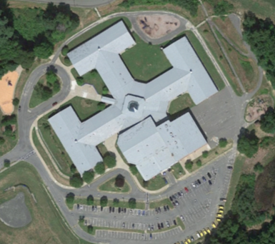

Prepared by:
Massachusetts Department of Public Health
Bureau of Environmental Health
Indoor Air Quality Program
November 2017

BACKGROUND
Building: | Quarry Hill Community School (QHCS)
Address: | 43 Margaret Street, Monson, MA
Assessment Requested by: | Monson Public Schools
Reason for Request: | Water damage and general indoor air quality (IAQ) concerns
Massachusetts Department of Public Health/Bureau of Environmental Health (MDPH/BEH) Staff Conducting Assessment: | Mike Feeney, Director, IAQ Program  Sharon Lee, Environmental Analyst, IAQ Program
Date(s) of Assessment: | September 8, 2017  The IAQ Program previously assessed conditions in the pool area. A report providing recommendations was issued August 2017.
Date of Building Construction: | 1990
Building/Site Description: | One-story brick building
Windows: | Openable

METHODS
Please refer to the IAQ Manual for methods, sampling procedures, and interpretation of results (MDPH, 2015).

RESULTS and DISCUSSION
The following is a summary of indoor air testing results (Table 1).
- Carbon dioxide levels were below 800 parts per million (ppm) in nine of 62 areas assessed.
- Temperature was within the recommended range of 70°F to 78°F in all but pool areas.
- Relative humidity was within the recommended range of 40% to 60% in all but pool areas.
- Carbon monoxide levels were non-detectable in most areas, with a few slight readings
< 2 ppm in a few areas.
- Fine particulate matter (PM2.5) concentrations measured were below the National Ambient Air Quality Standard (NAAQS) level of 35 micrograms per cubic meter (μg/m³).

Ventilation
Fresh air in classrooms is supplied by unit ventilator (univent) systems (Picture 1). A univent draws air from outdoors through a fresh air intake located on the exterior wall of the building (Picture 2) and returns air through an air intake located at the base of the unit (Figure 1). Fresh and return air are mixed, filtered, heated, and provided to classrooms through a fresh air diffuser located in the top of the unit. BEH/IAQ staff spot checked univent cabinets in a few areas. Each univent has a pleated filter. Spaces were observed between the univent cabinet and the post filtration component of the univent, which results in the distribution of unfiltered/unconditioned air into the classroom (Picture 3). Additionally, dust and debris were noted within the univent air chambers, and filter changes did not appear recent (Picture 4).
Univents were found deactivated in classrooms throughout the school. Obstructions to airflow, such as papers and books stored on univents and bookcases and/or carts and desks located in front of univent returns, were also observed in a few classrooms (Picture 1). In order for univents to provide fresh air as designed, intakes must remain free of obstructions; importantly these units must remain “on” and allowed to operate while rooms are occupied. Some items on top of or near the univent (e.g., plastic, crayons) can become sources of odor when heated.
Mechanical exhaust is provided by ceiling-mounted exhaust vents that are ducted to rooftop exhaust vents. The location of some exhaust vents near classroom doors can limit exhaust efficiency. When a classroom door is open, exhaust vents will tend to draw air from both the hallway and the classroom. The open hallway door reduces the effectiveness of the exhaust vent to remove common environmental pollutants from classrooms.
To maximize air exchange, the MDPH recommends that both supply and exhaust ventilation operate continuously during periods of school occupancy. In order to have proper ventilation with a mechanical supply and exhaust system, the systems must be balanced to provide an adequate amount of fresh air to the interior of a room while removing stale air from the room. It is recommended that HVAC systems be re-balanced every five years to ensure adequate air systems function (SMACNA, 1994).
Window-mounted and portable air-conditioning (AC) units were observed in a number of areas (Picture 5). These units can provide fresh, filtered air when used in the fan mode. Filters should be cleaned per manufacturer’s recommendations or more routinely if used on a regular basis. In some instances, receptacles were placed under these units to collect condensate; however, debris was observed in these buckets (Picture 6). Such material can be a source mold growth and odors.

Microbial/Moisture Concerns
On August 4, 2017, the BEH/IAQ Program conducted an assessment of the pool and adjacent areas (MPDH, 2017). This report noted the likelihood of the pool HVAC system operation contributing to the overall increased relative humidity in the school portion of the QHCS complex. A previous IAQ assessment of the QHCS conducted in 2004 (MDPH, 2004) recommended repairs be made to the pool HVAC system.
As part of an IAQ investigation, temperature and relative humidity measurements are taken indoors in occupied rooms/areas, as well as outdoors. These measurements are also useful for identifying whether water vapor from the pool is traveling to other sections of the building. Under normal operation of the HVAC system during the non-heating season, classroom univents introduce unconditioned air from outdoors as would open windows. In the experience of the BEH/IAQ Program, relative humidity indoors would be expected to be either equal to or less than background (outdoor) relative humidity measurements taken the day of assessment. During this assessment, outdoor humidity was 44 %. Over 60 locations in the QHCS had relative humidity measurements greater than the outdoor measurement, ranging from 2 to 41% (Picture 7, Table 2). When indoor temperatures are lower than the outdoor temperature, the indoor relative humidity is higher as the air volume would decrease in relation to water vapor volume. However, on the day of assessment, all temperatures measured indoors were higher than the outdoor temperature; this discounts temperature difference as a source for increased humidity.
Higher temperature lowers relative humidity levels if water vapor levels remain consistent. This relationship was demonstrated by temperature and relative humidity levels measured during the 2004 visit, which had only 1 area greater the +2% than outdoor background measurements (Picture 8, Table 3).
Based on these measurements, a significant water vapor source is present within the building. The water vapor source is likely the pool and its degraded/poorly functioning HVAC equipment. Increased indoor humidity can moisten porous materials that sustain mold growth. Water vapor from pools should be vented directly outdoors to prevent movement to other indoor locations. Water vapor with pool treatment chemicals can be irritating to the eyes, nose, and respiratory system.
Plant growth was observed in gutters around the school (Picture 9). Such growth indicates that the gutters have not been cleared of debris in some time. Buildup of debris and growth of plants can prevent water from draining off the roof and away from the building, which can lead to water damage to the building. Gutters should be cleaned regularly to ensure proper drainage.
Weep holes around the building exterior appeared clogged (Picture 10). Weep holes are important in the drainage of brick buildings. Clogs can occur as a result of salt and mineral deposits carried by moisture that is draining out of the building. Weep holes should be cleared to allow for adequate drainage.
Water-damaged and missing ceiling tiles were observed in a number of areas throughout the school (Picture 11). These are indications of pipe and/or roof leaks. Measures should be taken to replace water-damaged ceiling tiles once leaks are repaired.
Open seams between the sink countertop and backsplash were observed in several rooms (Table 1). If seams are not watertight, water can penetrate the seam, causing water damage. Water penetration and chronic exposure of porous and wood-based materials can cause these materials to swell, show signs of water damage, and lead to potential mold growth. Damage beneath sink cabinets was observed in some areas (Picture 12). Some of the sinks had cabinets beneath them containing large amounts of items, including porous items. The area underneath sinks is a moist environment and should not be used to store items that can become colonized with mold. Large amounts of items stored under sinks can also make detecting leaks difficult.
Indoor plants were observed in several areas (Table 1). Plants, soil, and drip pans can serve as sources of mold/bacterial growth. Plants should be properly maintained, over-watering of plants should be avoided, and drip pans should be inspected periodically for mold growth. In addition, plants should not be placed on top of or in the airstream of HVAC equipment such as univents.

Volatile Organic Compounds (VOCs)
Exposure to low levels of total VOCs (TVOCs) may produce eye, nose, throat, and/or respiratory irritation in some sensitive individuals. BEH/IAQ staff examined rooms for products containing VOCs. BEH/IAQ staff noted hand sanitizers, cleaners, air deodorizers, and dry erase materials in use within the building (Table 1). All of these products have the potential to be irritants to the eyes, nose, throat, and respiratory system of sensitive individuals.
Photocopiers were located in the teacher’s work room. Photocopiers can emit ozone and TVOCs, especially when they are older or heavily used.

Other IAQ Evaluations
The building was constructed on slab. As confirmed by school department officials, the building slab has settled over time, and the building is shifting. The types of movement experienced by the building have resulted in cracks in floors and the foundation (Pictures 13 to 15). Shifts in the slab can also facilitate the movement of moisture from earth (beneath the slab) through cracks into classroom areas. Increases in moisture can degrade glues used to adhere carpeting; these conditions likely contribute to the rippled carpeting observed throughout the school (Picture 16). Lastly, portions of the building’s exterior brick wall appeared to bow out beyond the footprint of the building’s foundation. This type of lateral movement can create fissures and cracks in the brick, which can allow moisture and pests to enter the building. Over time, water trapped in brickwork can cause spalling and other damage. At the time, school department officials reported that these shifts were being monitored.
Shifts in the building have also damaged the window frames. Many windows are no longer plumb, resulting in gaps and failing components, such as gaskets. Windows not square to the casing can allow moisture into the building (Picture 17). These gaps have also allowed insects to nest in the building (Picture 18). Hornets’ nests were observed on the exterior portion of a number of windows around the school. These nests should be removed to prevent injury. The building exterior should be examined periodically to ensure that insect or bird nests are identified and promptly removed.
Dust was found settled or adhering to ceiling tiles around ceiling-mounted supply diffusers (Picture 19), classroom exhaust vents, personal fans, and flat surfaces. Dust can be reaerosolized and cause irritation. The aforementioned surfaces and items should be cleaned regularly with a high-efficiency particulate arresting (HEPA) vacuum or wet wiped.
In many areas, accumulated items, including books, papers, toys and decorative items were observed on floors, windowsills, tabletops, counters, bookcases, and desks, which can make it more difficult for custodial staff to clean.
Note that the Environmental Protection Agency (EPA) conducted a National School Radon Survey in which it discovered nearly one in five schools had “…at least one frequently occupied ground contact room with short-term radon levels above 4 [picocuries per liter] pCi/L” (US EPA 1993). The BEH/IAQ Program therefore recommends that every school be tested for radon, and that this testing be conducted during the heating season while school is in session in a manner consistent with USEPA radon testing guidelines. Radon measurement specialists and other information can be found at www.nrsb.org and http://aarst-nrpp.com/wp, with additional information at: http://www.mass.gov/eohhs/gov/departments/dph/programs/environmental-health/exposure-topics/iaq/radon.

CONCLUSION AND RECOMMENDATIONS
In view of the findings at the time of the visit, the following is recommended:
- Continue with recommendations made in the August 2017 Pool report (MDPH, 2017).
- Operate all supply and exhaust ventilation equipment continuously during occupied periods.
- Seal breaches in the univent cabinets to prevent unfiltered air from being distributed by the units.
- Change univent/HVAC filters regularly.
- Remove any blockages to univents, including items placed on top of the units. Plastic and wax-based materials should not be placed on these units, since heating these items can create odors.
- Ensure all exhaust vents are operating. Check exhaust vents for air draw periodically. Efforts should be made to keep classroom doors closed to increase exhaust efficacy.
- Ensure filters to window-mounted and portable air-conditioning units are cleaned regularly.
- Use openable windows and/or the fan mode of window-mounted air-conditioning units to supplement fresh air during temperate weather. Ensure all windows are tightly closed at the end of the day.
- Consider adopting a balancing schedule of every 5 years for all mechanical ventilation systems, as recommended by ventilation industrial standards (SMACNA, 1994).
- For buildings in New England, periods of low relative humidity during the winter are often unavoidable. Therefore, scrupulous cleaning practices should be adopted to minimize common indoor air contaminants whose irritant effects can be enhanced when the relative humidity is low. To control for dusts, a high efficiency particulate arrestance (HEPA) filter equipped vacuum cleaner in conjunction with wet wiping of all surfaces is recommended. Avoid the use of feather dusters. Drinking water during the day can help ease some symptoms associated with a dry environment (throat and sinus irritations).
- Investigate and make repairs to leaks damaging ceiling tiles. Replace water-damaged ceiling tiles.
- Seal seams between sink countertop and backslash to prevent damage to cabinets and items stored below, as well as wall surfaces behind unit.
- Indoor plants should be properly maintained and equipped with drip pans to prevent water damage to porous building materials and be located away from ventilation sources to prevent the aerosolization of dirt, pollen, or mold. Do not rest plants on porous materials (e.g., cloth, paper).
- Empty and clean the dehumidifier regularly to prevent odors and growth of bacteria in condensate receptacle. Similarly, empty and clean receptacles used for collecting condensate from portable ACs.
- Reduce use of use of air deodorizers, cleaning products, sanitizers, and other products containing VOCs; only use in well-ventilated areas. Avoid the use of air freshening products including plug-ins and sprays. Considering adopting green cleaning procedures. Ensure cleaning products are properly labeled, and keep material safety sheets on file.
- Ensure exhaust ventilation is operating in areas with photocopiers.
- Regularly clean/vacuum univent cabinets, supply/return vents and fans to avoid aerosolizing accumulated particulate matter.
- Consider reducing the amount of items stored in classrooms to make cleaning easier. Periodically move items to clean flat surfaces.
- Clean window and portable AC filters prior to and periodically/as needed during the cooling season.
- Continue to monitor shifts and changes in the building closely as a means for identifying potential for damage that can lead to water infiltration or building material deterioration.
- Cracks in floors/ripples in carpeting should be made flush (e.g., sealed, smoothed, or cut and re-glued) to prevent tripping hazards and moisture/insect penetration.
- Examine windows gaskets, and replace as needed to prevent moisture in windows.
- Periodically check window closure/tightness to prevent water entry and insects from building nests in the openings. Consider caulking material to seal windows during heating season.
- Ensure exhaust ventilation is operating in areas with photocopiers to remove excess heat and odors.
- Contact a pest company to implement integrated pest management practices for removing and reducing hornet nesting around building.
- Consider adopting the US EPA (2000) document, “Tools for Schools,” as an instrument for maintaining a good IAQ environment in the building available at: http://www.epa.gov/iaq/schools/index.html.
- The school should be tested for radon by a certified radon measurement specialist during the heating season when school is in session. Radon measurement specialists and other information can be found at: www.nrsb.org, and http://aarst-nrpp.com/wp/.
- Refer to resource manual and other related indoor air quality documents located on the MDPH’s website for further building-wide evaluations and advice on maintaining public buildings. These documents are available at http://mass.gov/dph/iaq.

REFERENCES
MDPH. 2004. Indoor Air Quality Assessment: Quarry Hill Community School. Massachusetts Department of Public Health, Bureau of Environmental Health, Indoor Air Quality program. Boston, MA.
MDPH. 2015. Massachusetts Department of Public Health. Indoor Air Quality Manual: Chapters I-III. Available at: http://www.mass.gov/eohhs/gov/departments/dph/programs/environmental-health/exposure-topics/iaq/iaq-manual/.
MDPH. 2017. Indoor Air Quality Assessment: Quarry Hill Community School, Pool Area. Massachusetts Department of Public Health, Bureau of Environmental Health, Indoor Air Quality program. Boston, MA.
SMACNA. 1994. HVAC Systems Commissioning Manual. 1st ed. Sheet Metal and Air Conditioning Contractors’ National Association, Inc., Chantilly, VA.
US EPA. 1993. Radon Measurement in Schools, Revised Edition. Office of Air and Radiation, Office of Radiation and Indoor Air, Indoor Environments Division (6609J). EPA 402-R-92-014. https://www.epa.gov/sites/production/files/2014-08/documents/radon_measurement_in_schools.pdf.
US EPA. 2000. Tools for Schools. Office of Air and Radiation, Office of Radiation and Indoor Air, Indoor Environments Division (6609J). EPA 402-K-95-001, Second Edition. http://www.epa.gov/iaq/schools/index.html.
Picture

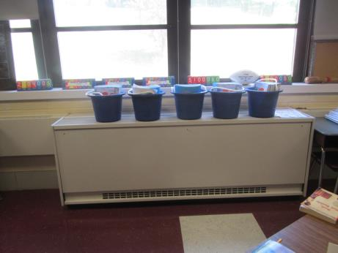

Classroom univent, note plastic buckets placed on top of unit

Picture

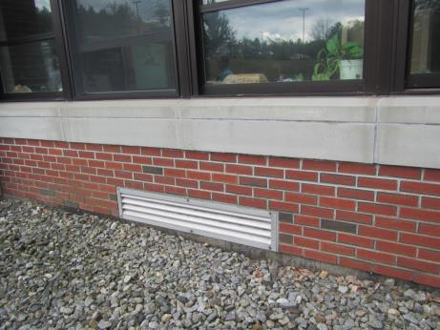

Univent fresh air intake
Picture

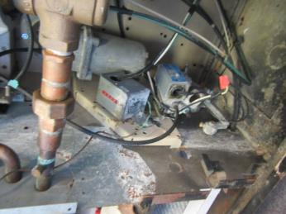

Breaches in univent cabinet; air drawn into unit can by-pass filtration

Picture
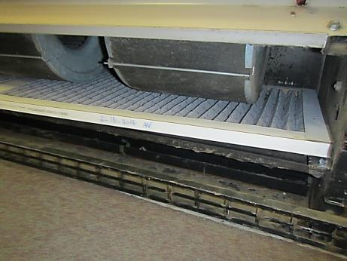

Pleated univent filter with last change date is February 2016; note air by-pass

Picture

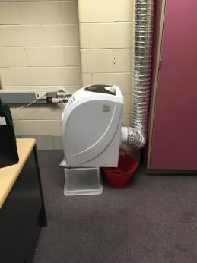

Portable classroom AC unit

Picture

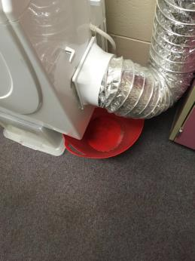

Note debris in water receptacle located below portable AC
Picture

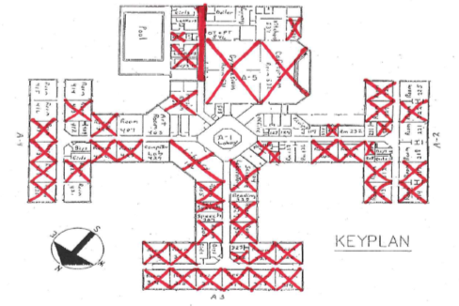

Locations with relative humidity >2 % over outdoor relative humidity measurements on 9/8/2017

Picture

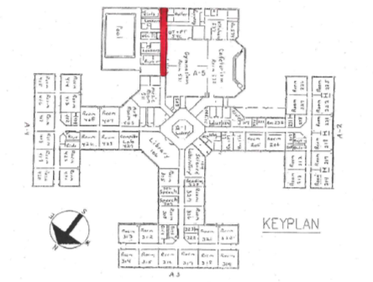

Locations with relative humidity >2 % over outdoor relative humidity measurements on 5/28/2004
Picture

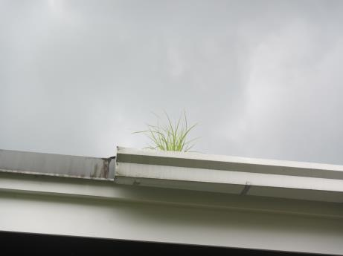

Plant growth in gutter

Picture

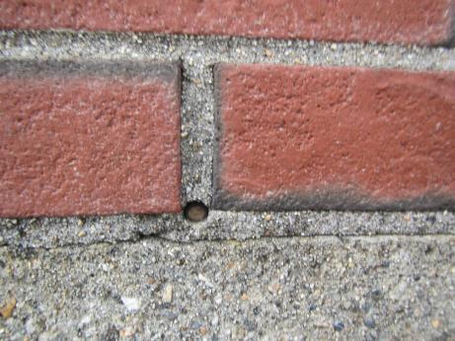

Clogged weep hole
Picture

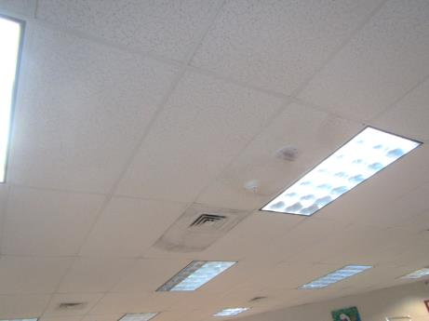

Water-damaged ceiling tiles

Picture

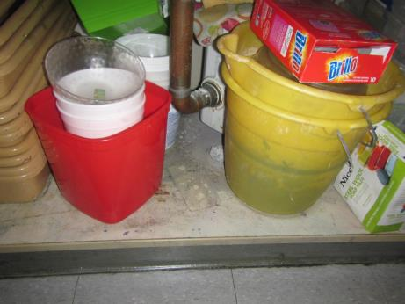

Water damage in sink cabinet
Picture

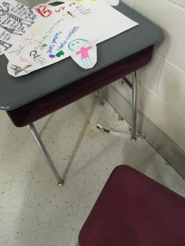

Cracks/damage to classroom floor

Picture
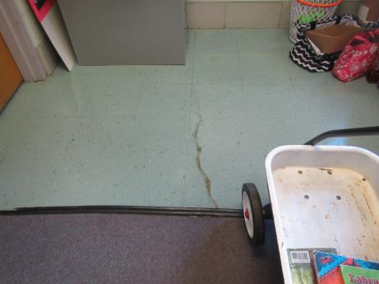

Cracks/damage to classroom floor

Picture

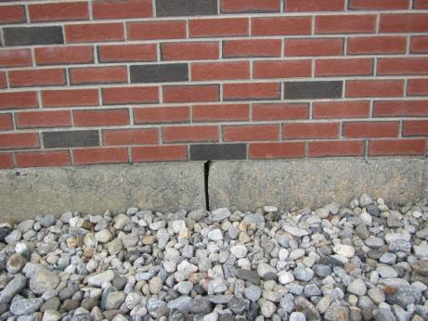

Cracks in foundation

Picture

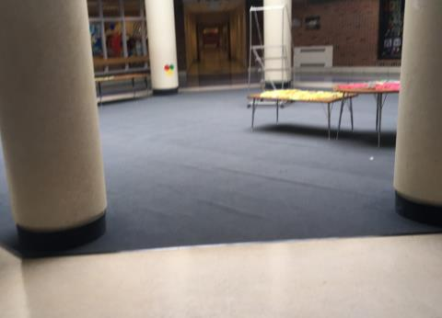

Rippled carpet
Picture

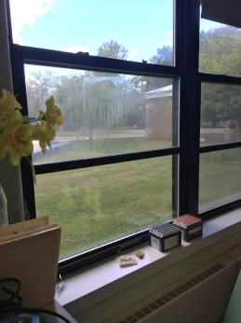

Condensation in window

Picture

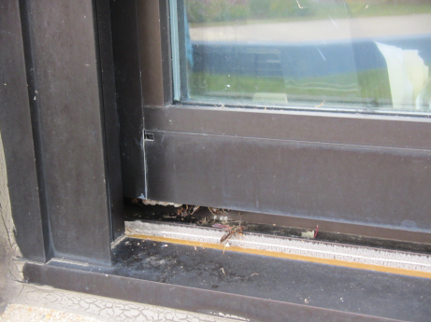

Hornets and nest in damaged window frame
Picture

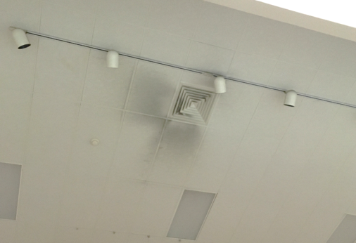

Dust accumulated on ceiling tiles around supply diffusers

Location | Carbon  Dioxide  (ppm) | Carbon Monoxide  (ppm) | Temp  (°F) | Relative  Humidity  (%) | PM2.5  (µg/m³) | Occupants  in Room | Windows  Openable | Ventilation |  | Remarks
 |  |  |  |  |  |  |  | Supply | Exhaust
Background | 400 | ND | 72 | 44 | 10 |  |  |  |  | Sunny
405 | 410 | ND | 76 | 43 | 12 | 0 | Y  2/4 open | Y | Y | PF, damaged floor tiles, 7 WD-CTs, DO, WD under sink
407 | 460 | ND | 75 | 43 | 11 | 0 | Y | Y  off | Y | RC, portable AC-on, AC filter dirty, 3 WD-CTs
408 | 474 | ND | 76 | 48 | 10 | 0 | Y | Y  off | Y | 1 MT
Teachers’ lounge | 845 | ND | 77 | 50 | 12 | 3 | N | Y | Y
413 | 433 | ND | 75 | 50 | 9 | 0 | Y  1/3 open | Y  off | Y | Carpet, WAC, PF, DO, 8 WD-CTs
414 | 542 | ND | 73 | 44 | 9 | 2 | Y | Y | Y | WAC-on, RC, DO, 2 WD-CTs, CPs, PF
417 | 520 | ND | 74 | 48 | 12 | 0 | Y | Y  items, off | Y | DEM, DO, pencil sharpener
418 | 1688 | ND | 74 | 48 | 13 | 23 | Y | Y  off | Y | WAC-on, PF, CPs, HS
419 | 1226 | ND | 76 | 54 | 11 | 24 | Y | Y  off | Y | DO, HS, PF
420 | 724 | ND | 75 | 48 | 11 | 21 | Y  2/3 open | Y  Off | Y | Breach between sink and backsplash, PF- dusty
422 | 517 | ND | 74 | 47 | 6 | 0 | Y | Y  Off | Y | RC
426 | 698 | ND | 75 | 52 | 13 | 0 | Y | Y  Off | Y | RC
428 | 782 | ND | 76 | 48 | 10 | 26 | Y  ¼ open | Y  Off | Y | PF, DO, sink
427 | 641 | ND | 75 | 48 | 9 | 0 | Y | Y | Y | WAC, 32 computers
Library | 618 | ND | 76 | 49 | 8 | 01 | Y | Y | Y | 10 WD-CTs
Library office | 616 | ND | 76 | 51 | 8 | 1 | N | Y | N | DO
305 | 413 | ND | 75 | 48 | 7 | 2 | Y | Y | Y | Grass odors, PF, plant, CPs
306 | 381 | ND | 74 | 49 | 8 | 0 | Y  1/2 open | Y | Y | 2 WD-CTs
308 | 575 | ND | 74 | 50 | 9 | 0 | Y | Y  Off | Y | PF, cloudy window from broken window seal
312 | 1078 | ND | 78 | 52 | 7 | 18 | Y  2/4 open | Y | Y | Breach between sink/backsplash, CPs, RC
313 | 1116 | ND | 78 | 52 | 7 | 17 | Y | Y | Y | RC, CPs, DO
314 | 819 | ND | 76 | 48 | 7 | 17 | Y | Y | Y | PF. DO, RC, CPs
315 | 821 | ND | 75 | 49 | 6 | 17 | Y | Y | Y | PF, plants, RC, DO, HS
316 | 999 | ND | 75 | 53 | 7 | 0 | Y | Y | Y | Cloudy window from broken window seal, CPs, PF, DO, HS
Science Lab | 426 | ND | 75 | 48 | 2 | 0 | Y | Y | Y | >10 WD-CTs
624 | 481 | ND | 75 | 47 | 2 | 0 | Y | Y | Y
327 | 440 | ND | 74 | 49 | 3 | 4 | Y | Y | Y
326 | 446 | ND | 74 | 50 | 3 | 0 | Y | Y | Y | RC
Teacher’s lounge | 446 | ND | 74 | 50 | 3 | 0 | Y | Y | Y | Insects
322 | 619 | ND | 75 | 52 | 5 | 0 | N | Y | Y | 10 WD-CTs
321 | 555 | ND | 75 | 50 | 4 | 0 | N | Y | Y
320 | 332 | ND | 75 | 51 | 3 | 0 | Y | Y | Y | RC
319 | 750 | ND | 75 | 51 | 4 | 0 | Y | Y | Y | 5 WD-CTs
318 | 600 | ND | 74 | 50 | 4 | 0 | Y | Y | Y | 4 WD-CTs, RC
317 | 624 | ND | 76 | 51 | 3 | 0 | Y | Y | Y | 3 WD-CTs, RC
222 | 464 | 1.4 | 74 | 48 | 3 | 0 | Y | Y  Off | Y | RC
223 | 436 | .7 | 74 | 46 | 3 | 0 | Y | Y  Off | Y | RC, plants
218 | 480 |  |  |  |  | 0 | Y | Y  Off | Y | Broken window seal, 1 WD-CT, RC
217 | 644 | .8 | 75 | 50 | 4 |  |  |  |  | Broken window seal, RC, 8 WD-CTs
214 | 467 | .5 | 74 | 52 | 2 | 0 | Y  Open | Y  Off | Y | Broken window seal, RC
213 | 469 |  | 74 | 50 | 3 | 1 | Y  Open | Y  Off | Y | RC
212 | 576 | .7 | 74 | 51 | 3 | 0 | Y | Y  Off | Y | RC
226 | 447 |  | 74 | 46 | 3 | 1 | Y | Y  Off | Y | WAC, RC
227 | 450 | ND | 75 | 48 | 2 | 0 | Y | Y | Y | RC
228 | 652 | ND | 76 | 46 | 3 | 1 | Y | Y  Off | Y | Photocopier, dehumidifier, 2 WD-CTs
Teacher’s lounge | 510 | ND | 76 | 47 | 4 | 0 | N | Y | Y | Refrigerator
207 | 763 | ND | 77 | 49 | 5 | 1 | N | Y | Y | RC, PF
232 | 529 | ND | 76 | 44 | 3 | 2 | Y | Y | Y
206 | 534 | ND | 75 | 47 | 3 | 2 | Y | Y | Y | RC
205 | 489 | ND | 74 | 48 | 4 | 0 | Y | Y | Y | RC
233 | 499 | .8 | 74 | 47 | 4 | 1 | Y | N | Y
Teachers’ work room | 556 | ND | 75 | 50 | 4 | 1 | Y | Y | Y | Photocopier
Teacher’s lounge | 623 | ND | 75 | 51 | 4 | 1 | Y | N | N
Guidance | 559 | ND | 74 | 50 | 2 | 0 | Y | N | N
Nurse’s inner office | 544 | ND | 75 | 50 | 4 | 0 | N | Y | Y
Nurse’s outer office | 561 | ND | 74 | 51 | 4 | 1 | N | Y | Y | 2 WD-CTs
Cafeteria | 632 | ND | 75 | 51 | 5 | 20 | N | Y  Dusty | Y
Teachers’ dining room | 459 | ND | 75 | 46 | 5 | 1 | Y | Y | Y
Gym | 611 | ND | 75 | 47 | 9 | 22 | N | Y  Dusty CTs | Y | AT
Boy’s locker room |  | ND | 76 | 62 |  | 0 | N | Y | Y
Gym office | 572 | ND | 76 | 47 | 32 | 1 | N | WAC | N | CPs
Pool hallway |  |  | 80 | 85 | 12
Pool office | 871 | ND | 80 | 63 | 10 | 0 | N
Pool Boy’s locker room |  |  | 83 | 50 | 20 | 0 | N | Y | Y | DO, passive door vent
Music room | 702 | ND | 78 | 46 | 8 | 20 | Y  4/4 open | Y | Y | 2 WD-CT

Location | Temperature  (°F) | Relative Humidity (%)
407 | 75 | 43
405 | 76 | 43
Background (outdoors) | 72 | 44
414 | 73 | 44
232 | 76 | 44
223 | 74 | 46
226 | 74 | 46
Teachers’ dining room | 75 | 46
228 | 76 | 46
Music room | 78 | 46
422 | 74 | 47
233 | 74 | 47
624 | 75 | 47
206 | 75 | 47
Gym | 75 | 47
Teacher’s lounge | 76 | 47
Gym office | 76 | 47
417 | 74 | 48
418 | 74 | 48
222 | 74 | 48
205 | 74 | 48
420 | 75 | 48
427 | 75 | 48
305 | 75 | 48
Science Lab | 75 | 48
227 | 75 | 48
408 | 76 | 48
428 | 76 | 48
314 | 76 | 48
306 | 74 | 49
327 | 74 | 49
315 | 75 | 49
Library | 76 | 49
207 | 77 | 49
308 | 74 | 50
326 | 74 | 50
Teacher’s lounge | 74 | 50
318 | 74 | 50
213 | 74 | 50
Guidance | 74 | 50
413 | 75 | 50
321 | 75 | 50
217 | 75 | 50
Teachers’ work room | 75 | 50
Nurse’s inner office | 75 | 50
Teachers’ lounge | 77 | 50
Pool Boy’s locker room | 83 | 50
212 | 74 | 51
Nurse’s outer office | 74 | 51
320 | 75 | 51
319 | 75 | 51
Teacher’s lounge | 75 | 51
Cafeteria | 75 | 51
Library office | 76 | 51
317 | 76 | 51
214 | 74 | 52
426 | 75 | 52
322 | 75 | 52
312 | 78 | 52
313 | 78 | 52
316 | 75 | 53
419 | 76 | 54
Boy’s locker room | 76 | 62
Pool office | 80 | 63
Pool hallway | 80 | 85

Location | Temperature  (°F) | Relative Humidity  (%)
Pool Hallway | 74 | 65
426 | 71 | 59
Background (Outdoors) | 68 | 58
328 | 72 | 58
306 | 72 | 58
318 | 72 | 58
319 | 72 | 58
Cafeteria | 73 | 58
320 | 73 | 58
214 | 74 | 58
314 | 74 | 58
417 | 70 | 57
428 | 72 | 57
321 | 72 | 57
308 | 73 | 57
104 | 73 | 57
218 | 74 | 57
221 | 74 | 57
225 | 74 | 57
Gym | 74 | 57
217 | 76 | 57
232 | 73 | 56
414 | 73 | 56
312 | 73 | 56
313 | 73 | 56
222 | 74 | 56
226 | 74 | 56
415 | 74 | 56
326 | 72 | 55
307 | 72 | 55
422 | 72 | 55
408 | 72 | 55
277 | 73 | 55
413 | 73 | 55
Art Room | 72 | 54
Library | 72 | 54
420 | 72 | 54
421 | 72 | 54
417 | 78 | 54
316 | 72 | 53
213 | 73 | 53
418 | 73 | 53
419 | 73 | 53
PT & OT | 77 | 53
418 | 77 | 53
419 | 77 | 53
318 | 71 | 52
317 | 72 | 52
212 | 74 | 52
416 | 78 | 52

Please note that 105 CMR 435.03 (10): Minimum Standards For Swimming Pools (State Sanitary Code: Chapter V) requires that “[a]ll rooms housing indoor swimming pools and all bathhouses dressing rooms, shower rooms, and toilets at both indoor and outdoor pools shall be properly and adequately ventilated.” (emphasis added).

