
Notes
Quick Start Guide for
City and Town Clerks: Registering Records

Vitals Information Partnership (VIP)
Electronic Death Registration System (EDRS)
Revision July 17, 2014
Notes
Use this page to make notes about your own workflows and processes, which may differ by facility and practice.

Summary of Steps
You may want to print the summary of steps for quick reference. Note that this summary includes steps for typical scenarios and your own process may vary somewhat depending on internal workflow.
Summary of Steps
Review and Register Records
1 | Select the record to register from the Death: Register queue or use the menu path DeathRegister to search for the record you wish to register.
2 | Review information tabs and look for required documentation.
2a | Was there a pronouncement? If Pronouncement = Y on the Record Details Page, Tab 1: Decedent Info, you should find a pronouncement form attached to the bottom of the page under Available Documents.
2b | Did the certifier certify by attestation form? If Case access = FAX SERVER on the Record Details Page, Tab 9: Certification Info, you should find an attestation form attached to the bottom of the page under Available Documents.
3 | Go to the Registration tabs by selecting Continue at the bottom of the Record Details Page.
4 | Check if the SSN was verified. Check the SSN Verification status on Tab 1: Decedent Info. You may review the entire record in the death certificate printed format by selecting View Certificate. Check for other problems on the record such as typos.
5 | If you want to Return the Record to the funeral home for correction, go to Tab 12: Record Actions. Select the checkbox in the Return Record section on the top left side of the page. Tab to the New Comment tab and enter the specific reason why the record is being returned. Tab to enable the Check when new comments are complete checkbox and select the box. Skip to Finish and Save as Pending.
6 | If you are ready to Register the record, go to Tab 11: Registration Info by clicking on the tab label or selecting the Next button.
10 | Select Ready to register? = Yes. Select the current Clerk’s Name, enter Registration number and Date of Record. Volume and Page are optional.
11 | Select the Finish button at the bottom of the page. (If you returned the record to the funeral home, you will receive the VIP Warning Page. Scroll down and Save as Pending.)
12 | If you registered the record, on the Successful Transaction Page in the Print Confirmation section, unselect Print Fax Coversheet if you do not want to generate a fax coversheet. Make sure that Print Archival Copy is selected. Click on the Print button.
13 | Click on the Generate Document button. The Archival Copy will be loaded into Adobe Acrobat. Print the Archival Copy in Adobe Acrobat by selecting FilePrint or clicking on your print icon.
14 | To print certified copies, select DeathPrintCertified Copies from the main menu. Search for the record you wish to print and select the Details link on the Returned Records page. Scroll to the bottom of the Records Detail Page and select Continue.
15 | If you want to print the attestation and signature at the bottom of the certified copies, select the Signature box and click Continue.
16 | The Certified Copy will be loaded into Adobe Acrobat. Print the Certified Copy in Adobe Acrobat by selecting FilePrint or clicking on your print icon.

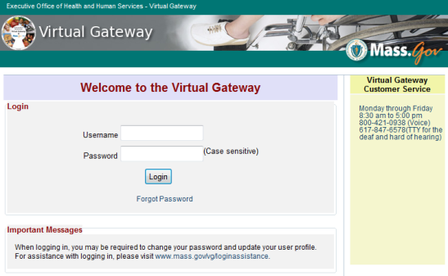
Accessing and Using EDRS
The Electronic Death Registration System (EDRS) is a module of the larger Vitals Information Partnership (VIP) system hosted in the Commonwealth’s secure Virtual Gateway environment. If you have not yet applied for and received a VG account, please go to www.mass.gov/dph/vip to obtain enrollment forms and a guide specific to your user role.
Access EDRS on the Web. EDRS can be accessed anywhere you have a computer and Internet access. The system works best with the Microsoft Internet Explorer (IE) browser or with Firefox. If you are a Mac user, it is recommended that you download the Firefox browser on your computer.
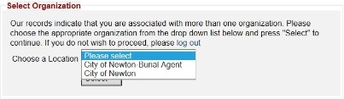
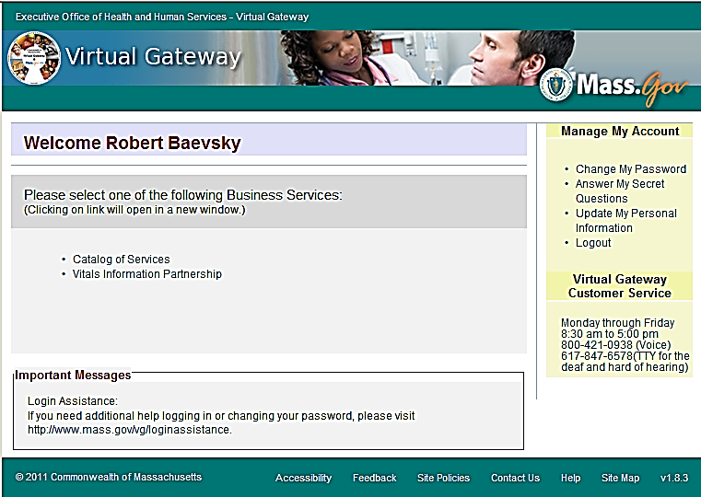
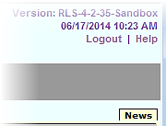
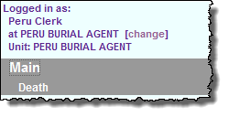
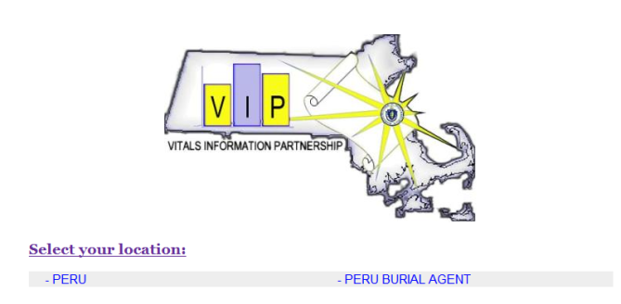
Log in at http://mass.gov/vg. You must have a valid Commonwealth Virtual Gateway account, as well as a VIP account to log in to EDRS. If you have a VG account for another application, you will then have a choice of applications when you log in. If you are a City or Town Clerk that is also a burial agent, then you will get a choice of role.

Additionally, City and Town Clerks that are burial agents may “Change” role within VIP (at the top left
You should also Logout at the right-hand corner.

Tips & Tricks
Accessing & Using EDRS
Save! – EDRS will time out after 15 minutes. While your portion of the death record should take less than five minutes to enter, if you expect to be interrupted or if you are just learning the system, click “Finish,” then “Save as Pending” frequently. You may then click “Return to Record” without risk of losing any information. EDRS does not save information automatically.
No abbreviations -- The system will prompt you if you use recognized abbreviations; you should spell out full medical terminology into each field. For example, on Tab 7**Certifier Cause of Death, spell out “COPD” as “Chronic Obstructive Pulmonary Disease.”

Tab & Mouse -- Use the Tab key on your computer keyboard to advance through each field in EDRS. You may also use your mouse to navigate Tabs or to temporarily skip sections. Do not use Backspace or Enter, except within fields as necessary.
Alerts – Take advantage of system validation messages and warnings. Use the spell check icon on the Certifier Cause of Death Tab. EDRS helps users get information in accurately and completely from the start.
Color Coding – White fields on each screen in EDRS will accept information; the yellow fields are disabled based on selections made in the system. A blue field indicates which field you are on now.
Shortcuts – EDRS accepts military time. Alt-T enters today’s date. Colons are not necessary in Time fields and slashes are not necessary in date fields. Enter the first few letters of a selection on a drop-down to narrow the list quickly. “Next” will move you from Tab to Tab, but you can click on the Tab labels as well.
Need Help? Contact the Registry at vip@state.ma.us or 617-740-2600.

Navigation
How you navigate the EDRS will depend largely on your office workflow. Records that you access, create or amend may also be accessed and viewed by authorized burial agents, medical certifiers, hospital support and data entry staff, as well as representatives from designated funeral homes. When you log in as a city or town clerk, EDRS features two general methods of navigation: work queues and a menu bar.
Log in & Navigation

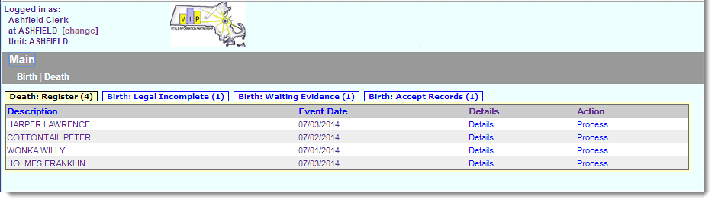
Work queues display records that are waiting for completion. For city and town clerks, death records in a queue may be listed alongside those for births (depending on the number of records awaiting attention). Death Queues are prefaced by “Death” and Birth Queues are prefaced by “Birth.” All records in your Death Queues are awaiting some action by you, such as registering or accepting a record.
Click on the hyperlink “Process” to retrieve the record from a queue.
The gray menu bar allows access to all authorized EDRS functions for the user type that is logged in. The most common options will be Search, Register, Modify and Print.
The Print menu option allows you to print EDRS forms including the Archival and Certified Copies of the registered death certificate. The most common paths will be:
- Death Search (to locate and view (read-only) an existing death record)
- DeathSearchRegister (to register the record)
- DeathSearch Modify (to adjust or amend a record)
- DeathSearchPrint (to print Archival and Certified Copies of the death certificate as well as the Fax Coversheet for evidence)

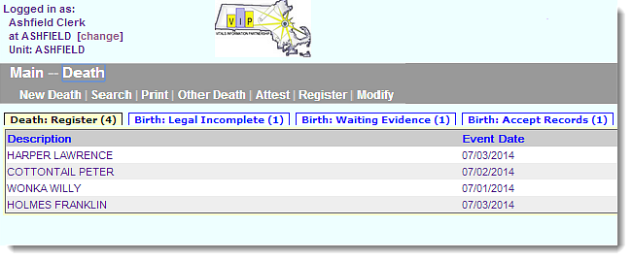
Process Overview
Navigational pathways act as “breadcrumbs.”
The registration and issuance process in EDRS begins with the City/Town Clerk in the community of death occurrence and a review of a record along with any supporting documentation. Records that have been certified by a physician or nurse practitioner without an account in EDRS should contain a signed and dated Death Certificate Attestation form. If a nurse pronouncement form was completed, in the absence of a certifying physician or nurse practitioner, this form will also be attached to the record for your review. Deaths where a nurse pronouncement was not performed, and those that have been certified by an online physician or nurse practitioner may have no attachments, or may have only an informant verification form.
Navigation & Overview

In the event that the Clerk of occurrence finds an error in a record prior to registration, whether administrative or medical in nature, EDRS allows the Clerk to send the record back with explanatory comments. When returned, a record is displayed in the designated funeral home’s work queues to allow the funeral home to make necessary corrections or obtain medical corrections from an online or offline certifier. The record would be released again to the burial agent’s work queue, to notify the burial agent of the changes. The burial agent will release the record to the clerk for registration. After successful review, the clerk will register the record. Once a registered record is saved, the record is automatically released to the clerk of residence and the Registry of Vital Records and Statistics (RVRS) for registration. The clerk of residence and the RVRS registers the record with a date and registration number. After registration, you may print the Archival Copy and Certified Copies.
Processing amendments and creating a record for a family not using a funeral home (special designee) will be covered in a separate guide.

Review the Record
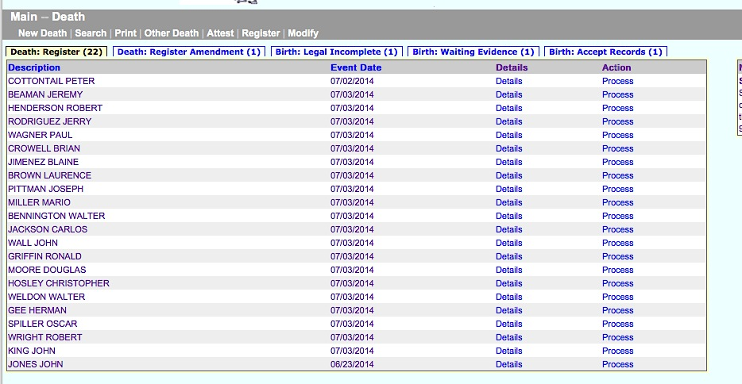
Records that have been released to you and appear in your work queue must be examined for accuracy and completeness before they can be registered. Supporting evidence, such as attestation forms and RN/PA/NP pronouncement forms, must also be examined. If errors are found, you may need to return the record to the funeral home for corrections. Up to 50 records are displayed in your work queues. Locate the record in your Death: Register queue, and click Process, or go to the DeathRegister menu path to search for the record.
Click on the Process link to access the full record that you will review.
Review Record

After clicking on the Process link, the Record Details will be displayed. By default, you will be on Tab 1. You should begin your review of the personal and medical information as well as any evidence used to support the facts of the record in EDRS on the Record Details screens.
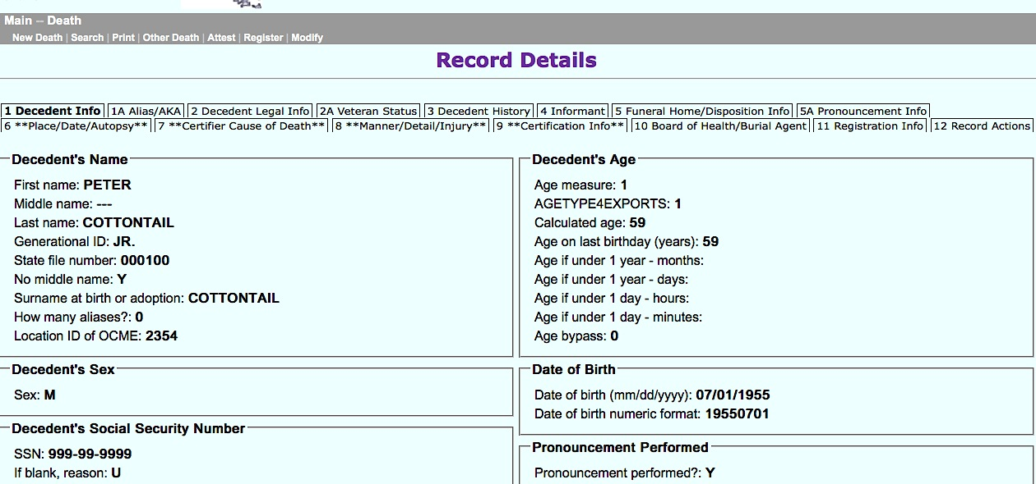
Evidence to support the record may include a signed and dated Death Certificate Attestation (if the medical certifier is not online) and an RN/PA/NP Pronouncement form. Scroll to the bottom of the Records Details screen to see any attached evidence, under Available Documents. The attached documents will be in .pdf format for you to view. Click on the button on the right to view the .pdf.
This record should have a pronouncement form attached because the “Pronouncement performed” field is “Y.”

Compare the details of the pronouncement form to the pronouncement tab 5A.

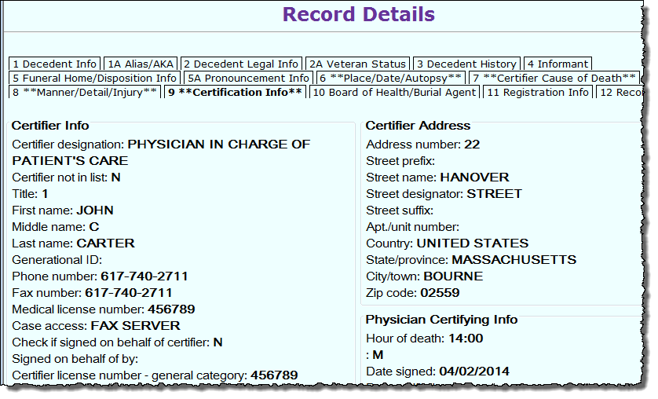
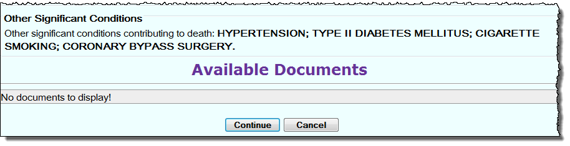
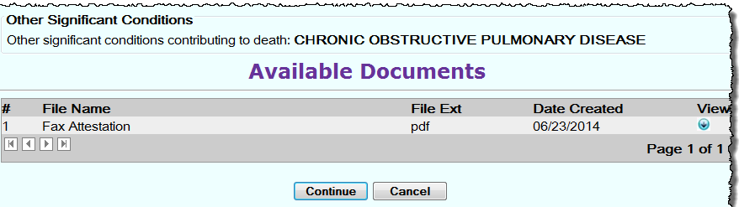
- Check tab 1 – was there a nurse/physician assistant pronouncement performed? If yes, check that the correct pronouncement form was attached, signed and dated. The pronouncement form information should also match what was entered on tab 5A.
Quick tip – To quickly scroll to the bottom of a Records Details screen, click the [Ctrl]+[End] keys.
Check Tab 9: if Case Access = FAX SERVER, the attestation form should be in Available Documents at the bottom of the page.
Click the view button to bring up the .pdf.
- Check tab 9 – is the certifier “FAX SERVER”? If so, check that the correct attestation form was attached, signed and dated.
Records Details

While VIP EDRS will check all fields for completeness and validity, there are still some types of things you can look for:
- Are there any common spelling errors? VIP EDRS has a spell-checker for cause of death, but it is optional. Other free-text fields, such as City/Town of Birth for foreign countries cannot be validated by VIP EDRS. If you see many of these types of errors, encourage funeral homes to use the Informant Verification form which allows informants to review the information that will appear on a death certificate prior to submission.
- Should the death have been referred to the Medical Examiner? Check tab 6 to see if the death was already referred and tab 7 for cause of death.
Press the Continue button at the bottom of the Records Action page to continue to the Registration tabs.

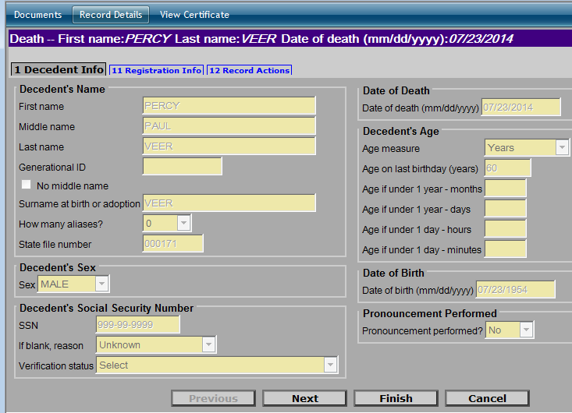
Registration Tabs Overview
The registration tabs are limited to tabs 1 (Decedent Info), 11 (Registration Info) and 12 (Record Actions).
Click on the link at the top of the page to review the attached Documents, the Record Details Page, or to View Certificate to see a preview of the death certificate.

On tab 1, you will now be better able to see whether the decedent’s social security number was verified. (On Records Details, you see only a code). If the SSN Verification Status is not “Verified,” you may want to discuss with the funeral home, to see if the record should be returned for a correction prior to registration. Once registered, any changes will need to be made following the formal amendment process.
Check whether SSN was verified.

SSN Verification - Record Actions - Return Record

Proceed to tab 11, if you are ready to register the record; or to tab 12 if you want to return this record to the funeral home, or add a comment.

Return a Record to the Funeral Home
If you find incomplete or incorrect information, you may need to send the record back to the funeral home (where the record can be returned to the medical certifier if necessary).
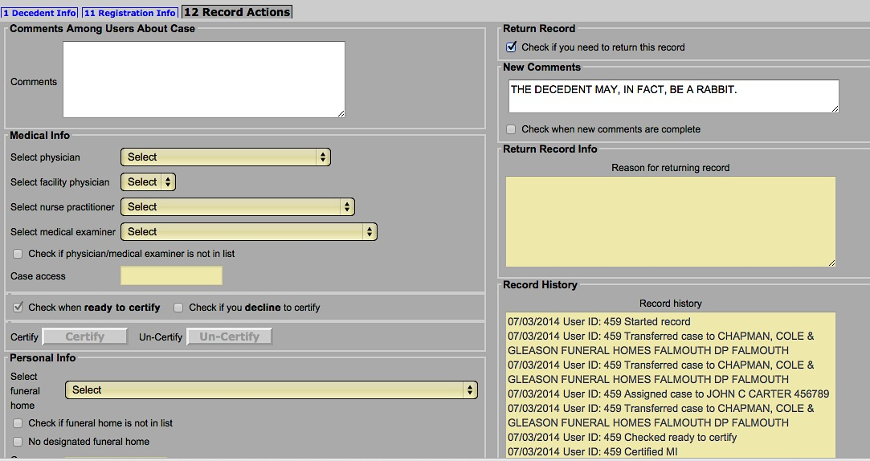
To do this, skip to Tab 12: Record Actions. Select the Check if you need to return the record checkbox. Use the tab key to access the New Comments field and explain the reason that the record needs to be returned.
Checking the return record box enables the New Comments field where you enter in reasons for the change. Tab out of the New comments field to Check when new comments are complete.

Use the tab key to leave the New Comments field, and select the Check when new comments are complete checkbox.
Click Finish. When you save, this record will be removed from your queues and will appear in the designated funeral home’s work queues for correction. Once corrected, the record will be released to the burial agent to notify them of the change. After the burial agent releases the record for registration, the record will again appear in your registration queue. Records History on the Record Actions tab, will keep track of the movement of the record.
Click Finish at the bottom of the screen that you are working on.

Registration Info tab
When a record is reviewed, complete and ready to register, you will go to the Tab 11: Registration Info tab on the record.
Here, you select “Yes” for Ready to register record. Selecting “Yes” will enable the City/Town of Occurrence section and fields to become active. Enter information into the fields.
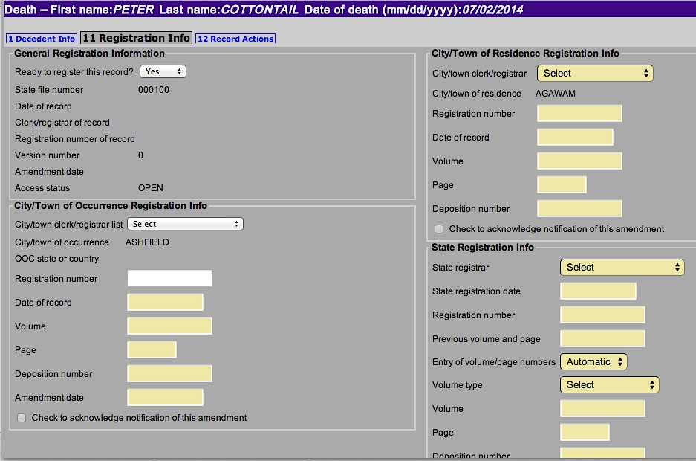
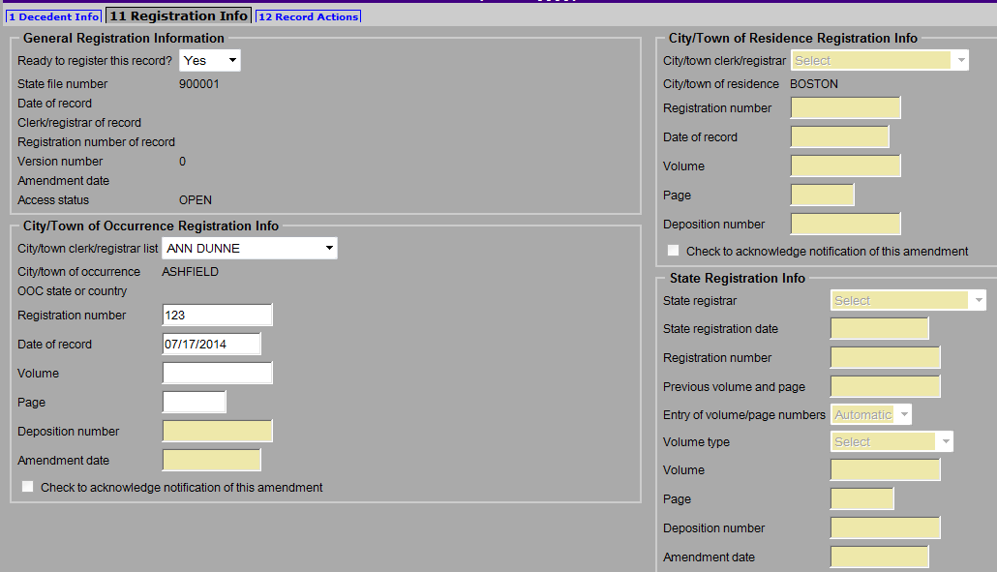
Registration Info Tab

Enter the Registration number, [Tab] out and enter the Date of record. Volume and Page are optional.
Select the current Clerk. Usually typing the first letter of the first name will be sufficient. Then [Tab] key to move to next field.
Selecting “Yes” will enable registration fields.
The Clerk name, Registration number, and Date of record are required fields. EDRS will give you a warning if you forget to enter information into these fields for Registration
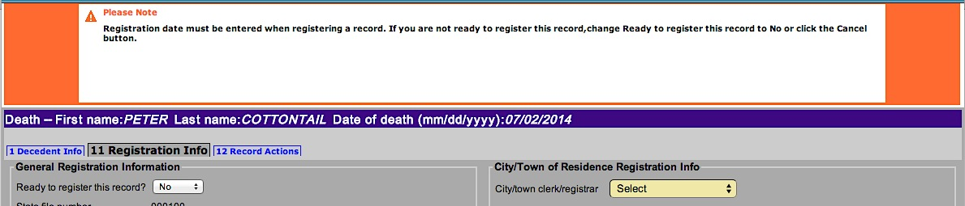
Once you have entered in all the information, click the Finish button. This will result in a Successful Transaction page, where you will have the option to Print an archival copy of your record as you have processed it through registration.
Archival Copies

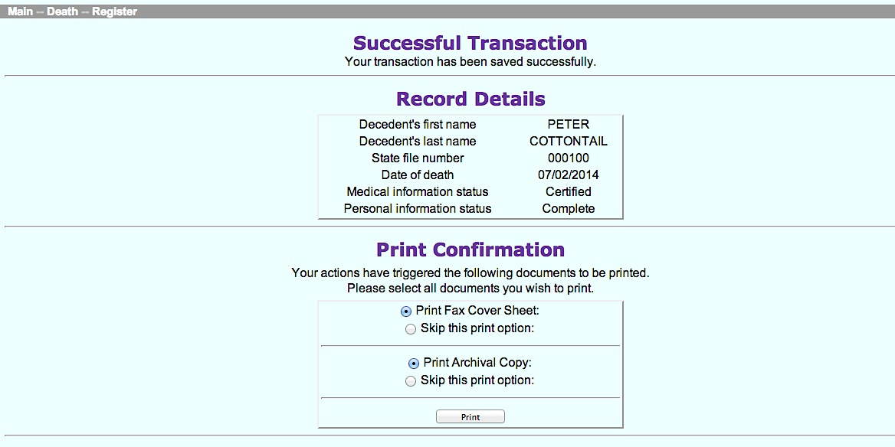
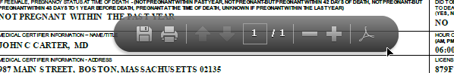
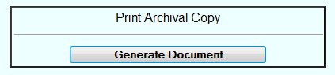
When you return to your work queues, you will notice that the record is no longer listed in your Register queue. The record is now available to the Clerk of Residence (if applicable) and the Registry.

Print an Archival Copy
Once you pressed Finish, you will have the option to print an Archival Copy of the record that you have registered.
When printing from the Successful Transaction page, EDRS will display a Generate Document button. Clicking on Generate Document will load a PDF document that you will print from the Adobe Acrobat print function.
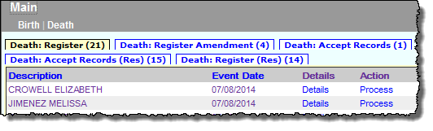
Most users will find the print function within Adobe Acrobat on a navigation bar at the top of the page or by hovering the cursor near the bottom of the page.
These records are residence community copies awaiting registration.

Residence Copy Registration
Records that have been registered by the Clerk of Occurrence will appear in the Register queue for the Clerk of Residence (if the decedent died in a city or town that was not his/her residence).
The process for registering the record as the Clerk of Residence is the same, except that the fields that will be open for editing are City/Town of Residence Registration Info. Residence communities may not return records to the funeral home.
Print Certified Copies
You may print certified copies of the death certificate for all registered records as either the Clerk of occurrence or the Clerk of residence.

To print, use the menu path Death Print Certified Copies. Specify search criteria to find the record. Select the record by clicking on the Details link. On the Record Details Page scroll to the bottom of the page and click Continue. You will be asked to specify if the attestation and signature should be printed at the bottom of the page.
Certified Copies

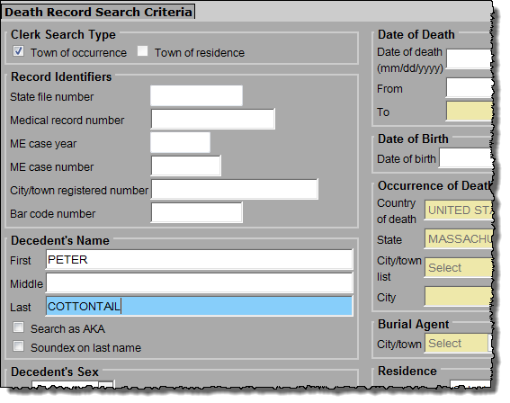

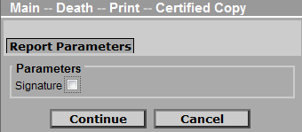
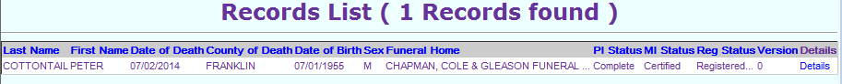
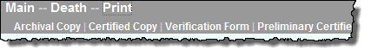

Click on the Signature box to print the attestation and signature at the bottom of the Certified Copy. If you do not want this printed, leave the checkbox blank. EDRS will load a PDF document that you will print from the Adobe Acrobat print function (as described in the Archival Copy section).
Note that the certified copy is a two-sided form. The Registry of Vital Records and Statistics does plan to print both sides of the form for each routine certified copy; however, the front side does contain the statutorily required elements, and may be printed on its own, upon request.

