Quick Start Guide for Funeral Homes

Vitals Information Partnership (VIP)
Electronic Death Registration System (EDRS)
Revision August 1, 2014

Notes
Notes
Use this page to make notes about your own workflows and processes, which often differ by organization and location(s).

Summary of Steps
Summary of Steps

You may want to print this page as a quick reference sheet. Note that this summary includes steps in typical scenarios and your own process may vary somewhat depending on the certifier/facility workflow or the order and manner in which you receive information about a decedent.
1 | Obtain Certifier Worksheet, if entering for an offline certifier, or Pronouncement form, if applicable.
2 | Create a New Case (DeathNew DeathCreate Case). This process will also find existing records that an online certifier or hospital may have started.
3 | Enter Decedent Info (Tab 1)
4 | Assign Certifier (Tab 12 – Records Actions) if known and not already assigned.  - Do this ONLY ONCE unless changing certifiers. The certifier pick lists will revert back to “Select” once chosen, and will delete the medical information if a new certifier is selected or same certifier is re-selected.
5 | If entering on behalf of an offline certifier, enter tabs 6-9 (Medical Information) and tab 5A (Pronouncement info) if applicable, then Finish, and Save (as Pending) at the bottom of the VIPS Warning Page.  - If medical information is complete, Return to Record, on tab 12 check Ready to Certify, Finish, Save, and fax/print the Attestation Form.  - If you only have a pronouncement form, Finish, Save, and send a Preliminary Certifier Worksheet to obtain the medical information.
6 | Enter tabs 1-5 (Decedent’s legal and personal information). Finish, Save. This is a good time to print a Fax Coversheet, and fax in the nurse pronouncement form, if any (but you may do this earlier, or at any point in the process, once a record is saved).
7 | If entering on behalf of an offline certifier, upon receipt of the Attestation form (record should be in the Fax Received queue), on tab 12 check Ready to Certify, then enter certifier date signed in tab 9, and click the Certify button on tab 12. Finish, Save.
8 | If all information is complete, on the Successful Transaction page, print an Informant Verification form so that the information entered can be reviewed by the funeral director and informant.
9 | Retrieve record, enter Verification form date signed or check the box if you are not using the Verification form, and Check when ready to review.
10 | If ready to submit to Burial Agent (all fields must be complete), click the Release button, then Finish.
11 | Print a permit from the menu (DeathPrintPermits).  - If a community is “opt-in,” you may print immediately after releasing.  - If a community is “opt-out,” you may print after the burial agent enters local permit information.

Overview

This Guide
This quick start guide is intended to orient funeral directors and funeral home staff with the basic steps to using the Vitals Information Partnership (VIP) electronic death registration system (EDRS). Other training material is also available to provide more detail where necessary.
Overview

Changes with Electronic Death Record System (EDRS)
- EDRS enables multiple stakeholders (physicians, nurse practitioners, medical data entry staff, burial agents, and others) to enter information online about a decedent’s case. The only users that may start (Create) a new death record are: the certifier, authorized medical staff, funeral homes and, in rare circumstances, the City or Town Clerk and the Registry of Vital Records and Statistics (RVRS).
- While most stakeholders will access EDRS, some medical certifiers (physicians and nurse practitioners) will not use EDRS but instead use a more process commonly known as “fax attestation.” Therefore, you will work both with medical certifiers who are “offline” and those who are “online” using EDRS. Offline certifiers will rely on medical data entry staff or funeral homes to enter data from a worksheet into EDRS. Workflows will differ by facility and practice, and will change over time as more certifiers and facilities move to electronic certification.
- EDRS will eventually include verification of a decedent’s Social Security Number (SSN) to The Social Security Administration (SSA). You should temporarily continue to use the SSA form 721, even after the EDRS is implemented. The Registry of Vital Records and Statistics (RVRS) will notify all users when SSN certification is fully functional in EDRS, at which time the form 721 will no longer be necessary.
- Funeral homes will submit EDRS records to burial agents; however, the permits may be printed at your office. Some towns will also allow “e-permits” that will allow printing of a permit as soon as a record is complete and released to the burial agent (“opt-in”).
- Out-of-state funeral homes (and a few Massachusetts funeral homes that do not have VIP EDRS accounts) will need to work with online funeral homes via a “trade service call.” In these scenarios, other funeral homes may make arrangements with you to enter information into EDRS on their behalf.

Support
By email: vip@state.ma.us

By phone:
For technical problems using VIP or for enrollment help, call 617-740-2675.
For forms, data entry, or policy and procedure help, call 617-740-2674.
For forgotten usernames and passwords, call Virtual Gateway at 1-800-421-0938.

Accessing and Using EDRS
Accessing & Using EDRS
The Electronic Death Registration System (EDRS) is a module of the larger Vitals Information Partnership (VIP) system that is hosted in the Commonwealth’s secure Virtual Gateway environment.
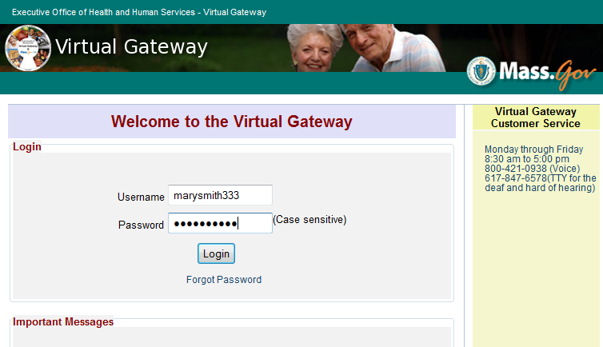
Access EDRS on the web. EDRS can be accessed anywhere you have a computer and internet access. The system works best with the Microsoft Internet Explorer (IE) browser. If you are a Mac user, it is recommended that you download the IE or Firefox browser on your computer.
Log in at http://mass.gov/vg. You must have a valid Commonwealth Virtual Gateway account and have completed the forms for access to the VIP EDRS. If you use a single sign-on for more than one VG application, you will then have a choice of applications when you log in. If you are a funeral director that is also a burial agent, then you will get a choice of role. (Funeral homes that do not have accounts must use a “trade service call” with an online funeral home).
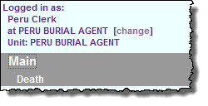
Additionally, funeral directors or staff that are burial agents or work in more than one funeral home may “Change” role within VIP (at the top left hand corner of the main screen).
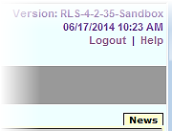
Logout at the top right-hand corner of the VIP screen. To completely exit the system, also logout on the right-hand panel of the VG screen.

Tips & Tricks
Tab & Mouse -- Use the Tab key on your computer keyboard to advance through each field in EDRS. You may also use your mouse to navigate tabs or to temporarily skip sections. Do not use Backspace or Enter, except within fields as necessary.
Save! – EDRS will time out after 15 minutes. While your portion of the death record should take less than 10 minutes to enter, if you expect to be interrupted or if you are just learning the system, click Finish, then Save (as Pending) frequently. You may then click Return to Record without risk of losing any information. EDRS does not save information automatically.
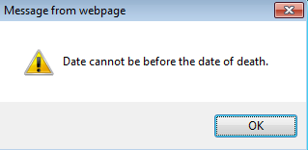
Alerts – Take advantage of system validation messages and warnings. EDRS will help users get information in accurately and completely right from the start; this will save you from time-consuming corrections later.
Color Coding – White fields on each screen in EDRS will accept information; the yellow fields are disabled based on selections made in the system.
Accessing & Using EDRS, Navigation
Shortcuts – Alt-T enters today’s date. EDRS accepts military time. Colons are not necessary in time fields and slashes are not necessary in date fields. Enter the first few letters of a selection on a drop- down list to narrow the list quickly. Next will move you from tab to tab, but you can click on the tab labels as well. The [Spacebar] will complete a checkbox if you are tabbing through fields.

Navigation
EDRS has two general methods of navigation: work queues and a menu bar.
Work queues display records that are waiting for completion or release. For funeral directors, there are only four possible queues:
- Pending PI -- Records for which the personal and demographic information is waiting to be completed. This will include records that the funeral home started and records that an online certifier initiated and assigned to the funeral home;
- Pending MI -- Records for which the medical information is waiting to be completed. This will include records that are waiting on data entry, fax attestation, or online medical certification;
- Release -- Records that have both personal and medical information fully complete, but are waiting on a release to the burial agent (usually for funeral home workflows where staff complete information on a record, but require a final review and release from a funeral director); and
- Fax Received – Records for which a document image has been attached. This is where funeral homes will look to finish records that required a fax attestation form.

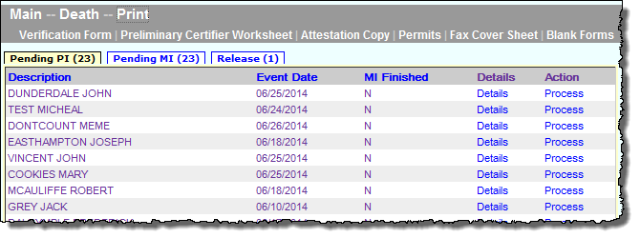
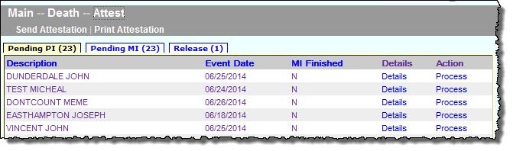
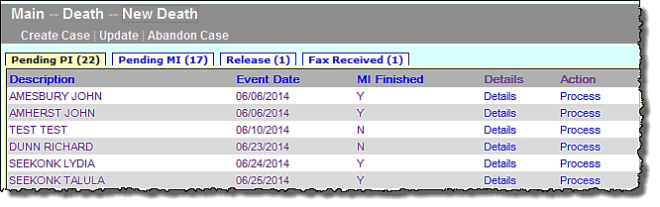
Menu Bar The gray menu bar allows access to all available functions and records (in comparison to the work queues that access limited functions for only those records in states of partial completion). For instance, you may start a new record, print the disposition permit, search for records to view completed pending records from the medical examiner, or re-send a fax attestation form.
Menu Bar, Forms

Forms
Below is a brief description of the forms you may encounter. Not all forms are needed for each case.

Death Certificate Certifier Worksheet (“Certifier Worksheet”)
Offline certifiers (certifiers that do not log in to EDRS directly) will use this form to provide medical information for data entry into EDRS. This form will be provided to online medical data entry staff, if available, or to the funeral home. This will vary by facility or practice. If it provided to the funeral home, this form is adequate for transport of the decedent. (This form may optionally be attached to the electronic record by using an EDRS fax cover sheet).

Death Certificate Attestation Form (“Attestation Form”, “Fax Attestation”)
Once medical information is entered into EDRS on behalf of an offline certifier, the EDRS system will generate an Attestation Form. The form may be automatically faxed by the system to the certifier’s fax number, or printed. The delivery method will depend on facility/practice/funeral home internal workflows. The certifier must review this form and attest that the information was entered correctly into EDRS. This barcoded form must be attached to the electronic record by faxing to the number on the form, which is an automated imaging system (not a physical fax machine). A PDF image of the form will then be available on the Records Details preview pages of the EDRS record.

Death Certificate Attestation Copy Form (“Attestation Form”, “Fax Attestation”)
Once medical information is certified in EDRS, users may generate an Attestation Copy Form. This form will be provided to funeral homes for transportation of the decedent when a medical facility has certified the record. Funeral homes users will print this form to provide to the crematories in support of cremation, instead of a copy of the paper death certificate.

Preliminary Death Certificate Medical Certifier Worksheet (“Preliminary Worksheet”)
This form is generated by EDRS for funeral homes and online medical staff to provide a partially-completed worksheet to offline certifiers. A typical use is when a funeral home receives a nurse pronouncement form and the funeral home starts a record in EDRS with this information. The form may be faxed by the system to the certifier’s fax number or printed and delivered in another manner, depending on the funeral home internal procedures. The certifier will complete the remaining items for data entry on this form, and fax it (or deliver it) to the funeral home. The form is uniquely barcoded, and does not require an EDRS fax cover sheet. If faxed, a PDF image is automatically attached to the EDRS record. After the remaining data entry, the process is completed by sending an Attestation Form, as described above.

Informant Worksheet
The Registry provides an Informant Worksheet for use by funeral homes either on paper or as a form-fillable PDF. This form is optional, but does contain all personal data items in the correct format for entry into EDRS.

Create a New Case (or Accept an Existing Case)
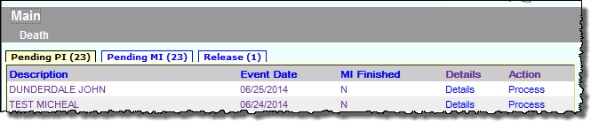
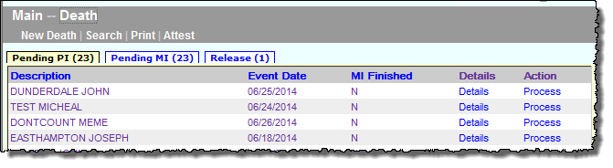
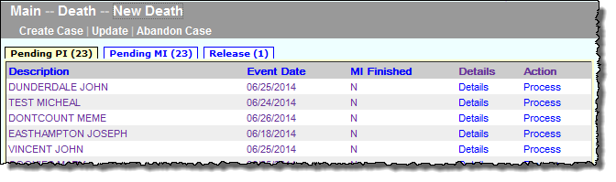
If the funeral home is starting a record, entering on behalf of a fax attestation certifier, or if the funeral home needs to claim a case that was started by an online certifier (or by medical staff), the first step will be to create a case. The gray bar in VIP is a menu bar. Click on Death to access VIP menu options. To create a new case, click on Death, then New Death, then Create Case.
1
2
3
The menu bar keeps navigation “bread crumbs.” You may click on any option within the trail to return to a previous step.
Create or Accept a New Case
To begin a record you will need Decedent’s First and Last Name, Sex, Date of Death and Date of Birth. If you are searching for a record that was started by an online certifier, be sure to enter the information exactly as it appears (even if it is not correct) on the attestation copy form (the form that will usually be given to a funeral director for transport). Enter this information into each field, then press Search.
Enter dates as MMDDYYYY or MM/DD/YYYY. For most date fields, “9”s are acceptable for unknown portions. E.g., 03991961 indicates unknown day.
When you start a new record in EDRS, the system runs a check to see if the record may have been started by another user, such as an online certifier, medical data entry staff from a hospital, nursing home or other healthcare facility. The system will then display potential matches.
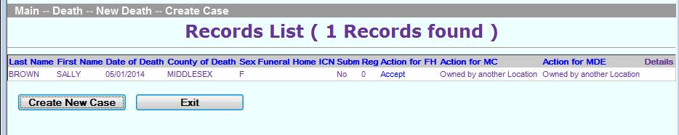
Depending on whether a match is found, these are examples of two possible resulting screens and the typical actions that you will take:
- If no matching records are found, you can begin the process of establishing a new record by choosing Create New Case.
- If a match is found, you may choose to Accept. Selecting Accept will bring you the Record Details where you can review information on the record to ensure this is your record. If the record is not the record you were looking for, select Cancel at the bottom of the Record Details page.
- If the record is assigned to another funeral home, “owned by another location” will be displayed. You will not be able to immediate claim this case if it was incorrectly assigned. The listed funeral home should reassign the record to you, or the certifier/medical staff that prepared the online record may also reassign. If the neither is available to reassign, contact the Registry at vip@state.ma.us or 617-740-2674.
- If the resulting match is a different decedent, then choose Create New Case.
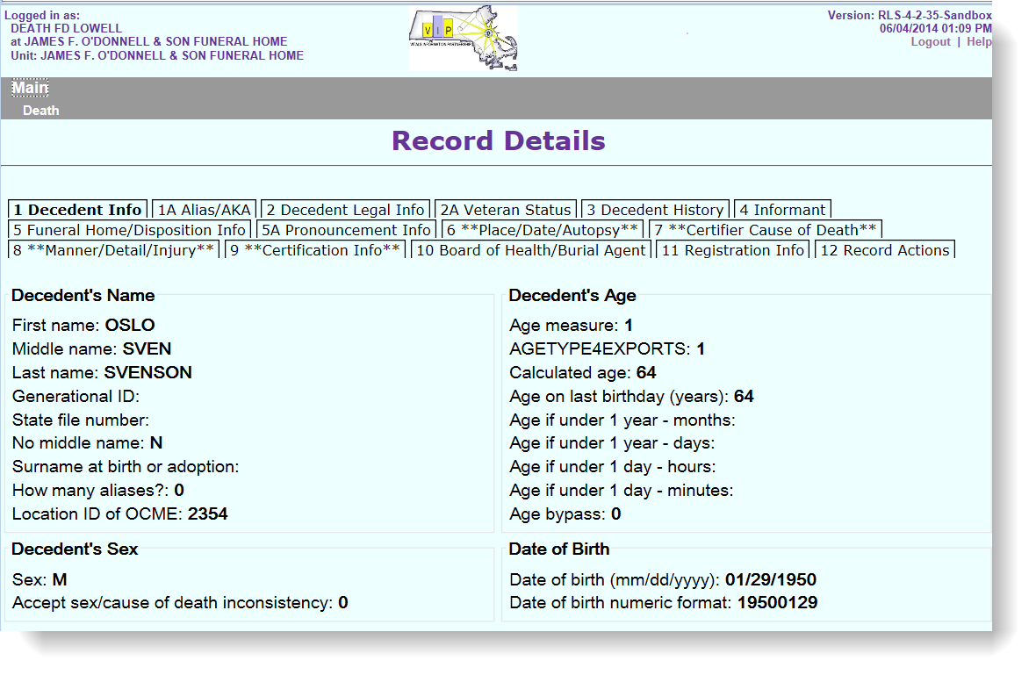
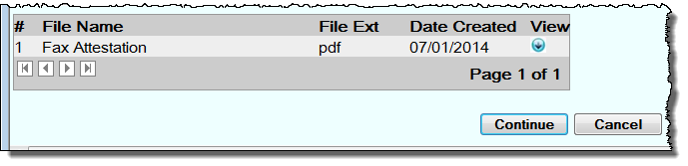
If a record was already started, upon clicking Accept (or Process from within a queue), you will be able to preview information already entered and view any attached documents.
At the bottom of each tab on the Records Details, you will find a button to continue to the record, or to Cancel without making changes to the record.
Create or Accept a New Case

Entering Decedent Information
All authorized users may view all information “tabs” in a death record and will be brought to Tab 1 initially. You must complete tab 1 before moving on to other tabs.
Decedent Information
Under Tabs 1 – 4 you will enter information about the decedent, including legal and personal information, normally provided by an informant. Tab 5 is specific to your funeral home and also collects disposition information.
When entering medical information for a manual attestation certifier, you will also complete Tabs 6-9. Tab 12 is used both to assign a certifier, when appropriate, and as a final step for verification of the record as complete and ready for release to a burial agent.
Funeral homes will always complete Tabs 1-5 and 12, and if entering on behalf of a certifier, will also complete Tabs 6-9.

Tab 1 & 1A. Decedent Information
An Informant Worksheet is available from the RVRS. Funeral homes may choose to use this worksheet to accurately collect the personal information about the decedent. If funeral homes choose to use their own worksheets, then fields and appropriate responses must be updated to match the items on the new death certificate when it goes into effect.
Hidden tabs are enabled only when necessary. For example, if “How Many Aliases?” is more than zero, Tab 1A will appear after you click NEXT to move on to the next tab. Here you may enter up to 4 different Aliases/AKAs for the decedent.
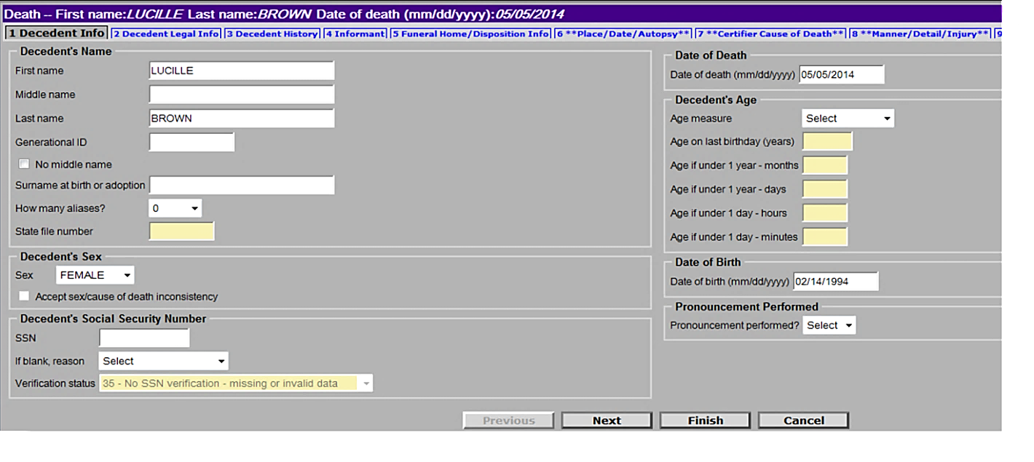
Tab 1A is only enabled if the decedent used alias names.
Check No middle name if none or unknown. (Or enter three dashes in the middle name field).

If the SSN is unknown or the decedent does not have one, you should enter 999999999 into the field and then select the appropriate reason below.

Selected Field Notes:
Decedent Legal Information
Name of Decedent | Enter the full legal name as provided by the informant. Generational ID is a name suffix, such as “Jr.” Surname at birth or adoption is required of all decedents, male or female, and is commonly known as “maiden” surname. If there is no middle name, check the “No middle name” checkbox, or enter three dashes (---).
How many aliases? | If the decedent had aliases (“Also Known As” or “AKA” names), enter the number of names you would like to add. A new tab will be enabled that will allow you to enter those names.
Social Security # | Enter as NNNNNNNNN. If a SSN is not known, enter 999999999 and provide a reason from the pick list. When EDRS is linked to the SSA verification system, saving the record will transmit the information to and from SSA. The verification status will only appear after a save and return to the record.
Age Measure & Age | Enter a measure first (e.g. “Years,” “Months/Days,” “Hours/Minutes”), then enter the units of age in the appropriate category(-ies). EDRS does not autopopulate the calculated age, but will verify that date of birth is valid for age and date of death.
Pronouncement performed | This field refers to the manual RN/PA/NP pronouncement form that you may receive, typically in deaths that occur in a residence or nursing home. If yes, a new tab will be enabled to enter pronouncement form information. Online pronouncement for RNs, PAs and NPs is not a current EDRS feature, but some long term facilities will be piloting. Pilot sites will print a preliminary worksheet in lieu of the pronouncement form, and the record will have been started in EDRS.
Note: While this guide presents the tabs in order, many funeral directors and staff may prefer to jump to tab 12 at this point to assign the medical certifier right away, so that the rest of the data entry will follow in order. Otherwise, selecting an offline medical certifier will need to be done before completing tab 6.

Tab 2. Decedent Legal Information
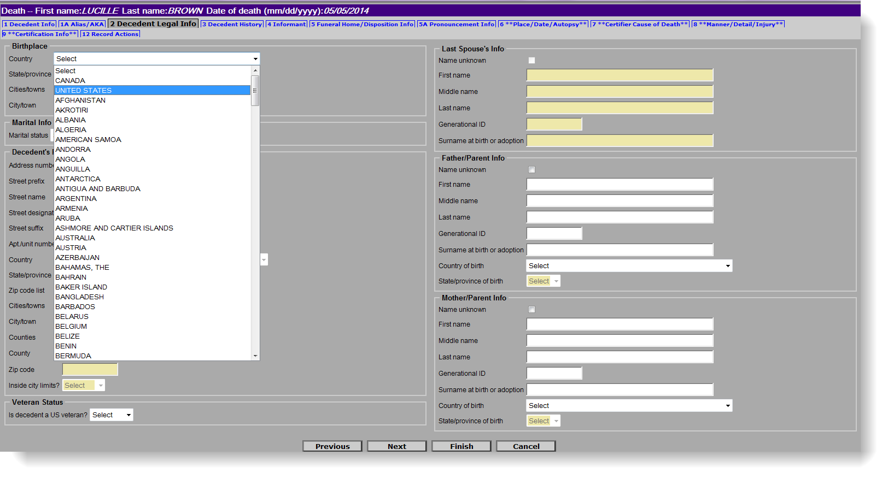
You may use the Informant Worksheet or other sources that you have on hand to enter in details about the decedent’s Birthplace, Marital Info, Residential Address, Veteran Status, Last Spouse’s Info, Father/Parent Info, and or Mother/Parent Information. EDRS will enable or disable certain fields depending on the responses given. Use “unknown” only if absolutely necessary, as the death certificate is a permanent le gal and informational document that has value to subsequent generations of family members in addition to its immediate legal value. If the informant needs to research items, they should be encouraged to do so within timeframes that allow for the preparation of the record in advance of disposition.
Shortcut: Both UNITED STATES and MASSACHUSETTS are listed at the top of the long drop-down lists, eliminating the need to scroll down. Type “U” or “M” and [tab] to quickly populate these fields.
Tip: Depending on your computer’s display, you may need to scroll down to this field. It can be easy to miss.
EDRS enables and disables fields depending on the response to previous fields. For instance, choosing “never married” disables Last Spouse’s Info.
Decedent Legal Information
Use “unknown” only when information cannot be obtained in time. Note that even if a parent’s name is unknown, an informant may be aware of the place of birth, and these fields are to be answered separately.
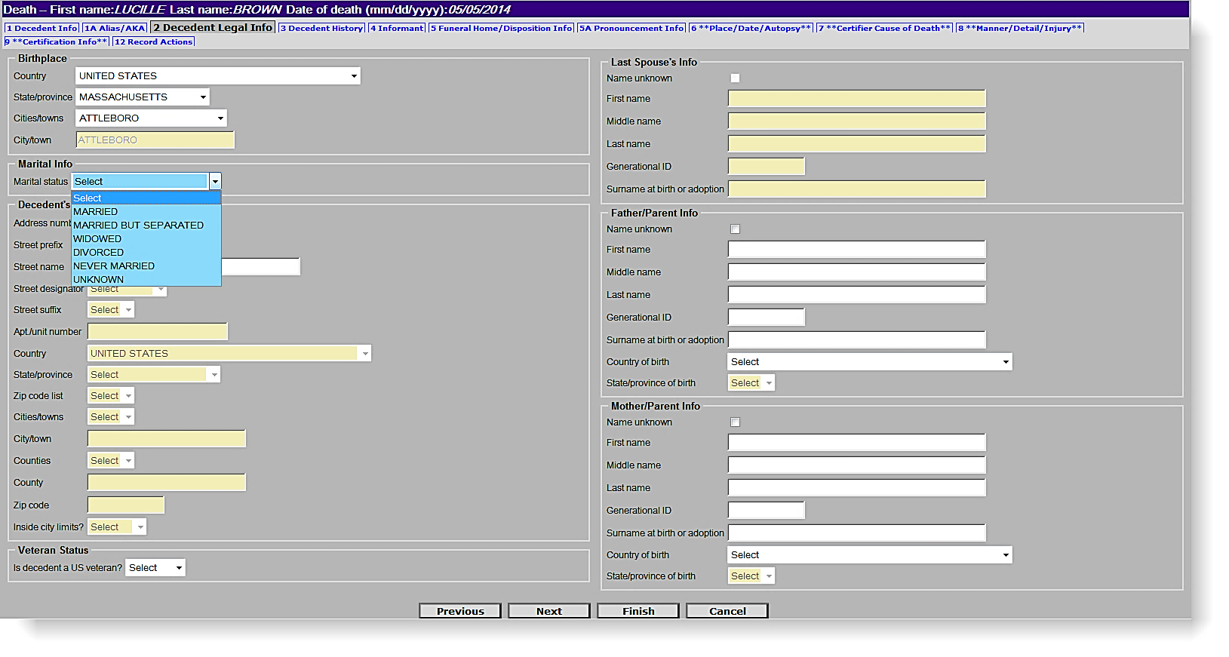
Enter a few letters to quickly select from a pick list, then [tab] to the next field. Tip: wait a second to let the field populate before pressing [tab].

Selected Field Notes:
Birthplace | Each pick list will help to narrow the choices in subsequent lists. For United States, type U, [Tab] wait for the state list to populate, then type M, and [Tab] to rapidly enter Massachusetts. For other choices, enter the first few letters to quickly skip to the correct entry or scroll through the pick list. State/Province is required for U.S., Canada and Mexico. For non-U.S. states, enter the country and city/town (or other legal jurisdiction that maintains the decedent’s birth certificate).
Marital Status | The choice you make in the Marital Status drop-down list will determine if the Last Spouse Info fields on the right hand side of the page are enabled or disabled.
Residence | Enter the decedent’s last legal residence address. Each element of the address is parsed for precise geographical coding. For instance, “Main Street South” is entered into three different fields. State/Province is required for U.S., Canada and Mexico. The zip code list is available for Massachusetts and several New England states, and will narrow the subsequent pick lists to proper cities and towns.
Veteran Status | Answer Y or N to “Was decedent a U.S. veteran?” Note that this field is no longer limited to “war” veteran. If yes, then a new tab will be enabled to enter veteran information.
Last Spouse | If marital status is anything other than “never married,” you will enter the information for the last known spouse: legal first and last name and surname at birth or adoption, which is required for both males and females (formerly “maiden” surname). Enter middle name if known.
Parents | For each parent, enter the legal first and last names, as well as the surname at birth or adoption, which is required for both males and females (formerly “maiden” surname). Enter middle name if known. Labels on the death certificate are Mother/Parent and Father/Parent for all parents, regardless of sex of parent.

Tab 2A. Veteran Status
Enter in the zip code first to pre-populate town/city information.
Choosing Yes to the Veteran’s Status question will open “hidden” Tab 2A.
This tab is usually hidden. Only if you select “YES” to the veteran status question on Tab 2, will Tab 2A be enabled for editing.
Veteran Status
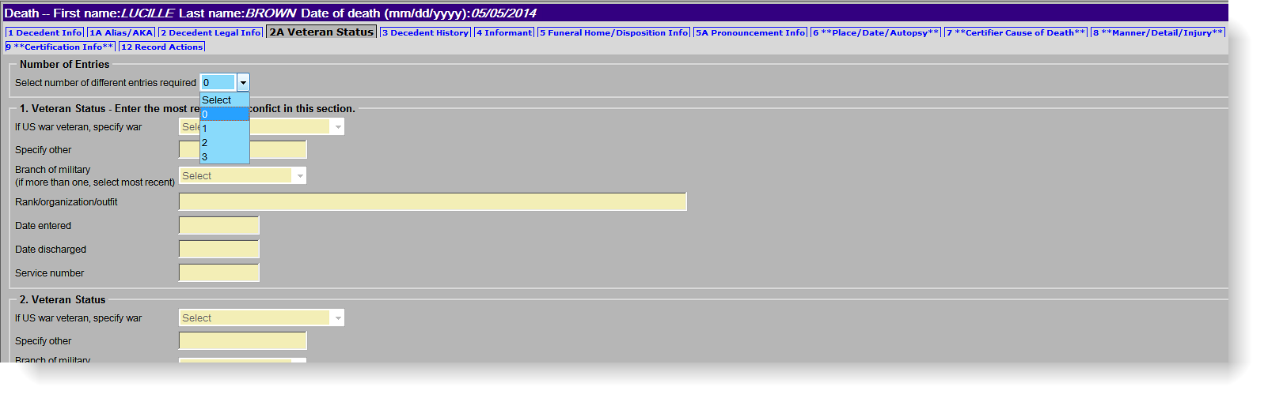
You may enter up to three (3) different war/branch of military combinations for the decedent. Enter all information available to you. At minimum, you must enter “War” (which also includes a selection for “Peacetime”) and Branch of military, although more detail should be specified when available. The most recent war (the one listed first) will appear on the front of the death certificate, and the additional information will appear on the reverse of the death certificate (which is now normally included as part of a certified copy).
If the decedent served in more than one war, you will enter information into additional sections for Veteran Status. Start with the most recent war and service and work backwards in chronological order.
Selected Field Notes:
War | Select the most recent war in which the decedent served as a U.S. veteran from the pick-list. If the veteran was a peacetime veteran, choose “Peacetime.” If the conflict is not listed, you may choose “Other” and specify. This field and Branch of Service are the only two required fields for veterans.
Branch of Service | Select the most recent U.S. branch of service in which the veteran served. This field and “War” are the only two required fields for veterans.
Rank/Organization/Outfit | Enter the rank that corresponds to the war entry. If there were more than one rank achieved, enter the highest rank. You may also add any additional information about the veteran’s military organization, detail or outfit.
Date Entered/ Date Discharged | Enter in MMDDYYYY format. If any portion of the date is unknown, enter 9s. E.g., for unknown month and day, enter 99991965; for unknown day, enter 03991965.

Tab 3. Decedent History
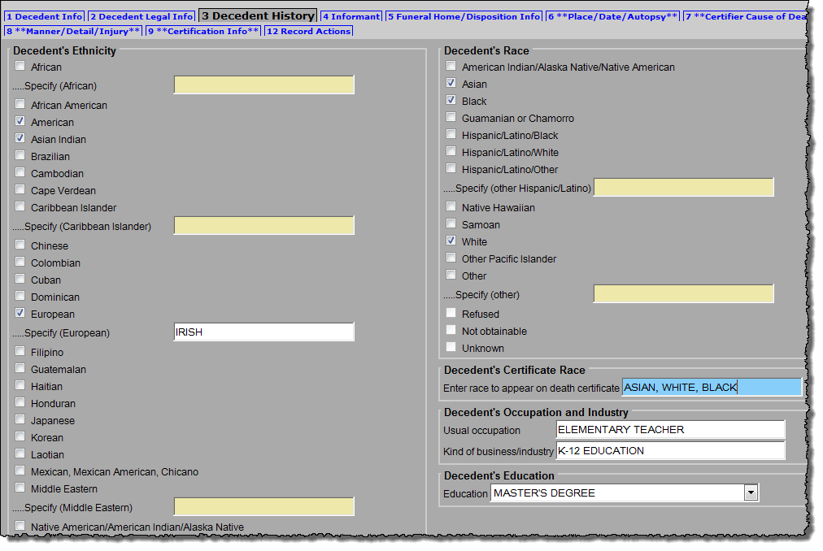
You must check at least one (1) selection in both the Decedent’s Ethnicity and Decedent’s Race sections, but more than one selection can be made in each column, if applicable. This conforms to national standards that allow for reporting of multiple races and ethnicities. Because it is possible that multiple races will not fit neatly on the death certificate, an additional field, Decedent’s Death Certificate Race, is required such that the informant may specify how they would like the race to print on the front of the death certificate. All other race and ethnicity information will appear on the reverse of the death certificate.
This field will be printed on the face of the certified death certificate; listing what the informant feels is the best brief description.
Decedent History
Selected Field Notes:
Decedent’s Ethnicity and Race | In each of these fields, mark at least one entry, but multiple races and ethnicities may be selected to conform with national standards of reporting. The races and ethnicities selected in these fields will appear on the reverse of the death certificate.
Decedent’s Certificate Race | Because multiple races may not neatly fit on the face of the death certificate, this field captures the race(s) that the informant would like printed on the face of the death certificate.
Decedent’s Occupation and Industry | Enter detail about the decedent’s latest occupation and industry. Do not enter “retired” or “not working.” Enter “Retired Mechanical Engineer” or “State K-9 Police Officer.” You may refer to this handbook if you need guidance on entering occupation and industry:  http://www.cdc.gov/niosh/docs/2012-149/pdfs/2012-149.pdf.
Decedent’s Education | This field is a pick-list to choose a category that best represents the decedent’s level of education. If the decedent was not educated in the United States, ask the informant to select the category that most closely reflects the educational level achieved.

Tab 4. Informant
Enter in information about the decedent’s known occupation and industry as well as education level.
The system may prompt for more accurate and specific data when you enter information about the Decedent’s Occupation and Industry. If the decedent is an infant or child, put “INFANT” or “CHILD” in the Occupation and Industry fields.

An informant is the individual that provided the legal and personal information about the decedent. An informant worksheet is available from the Registry for use by funeral homes. Use of the worksheet is not required, but it can help to capture the information in the new death certificate format. Enter this information in Tab 4:
Informant
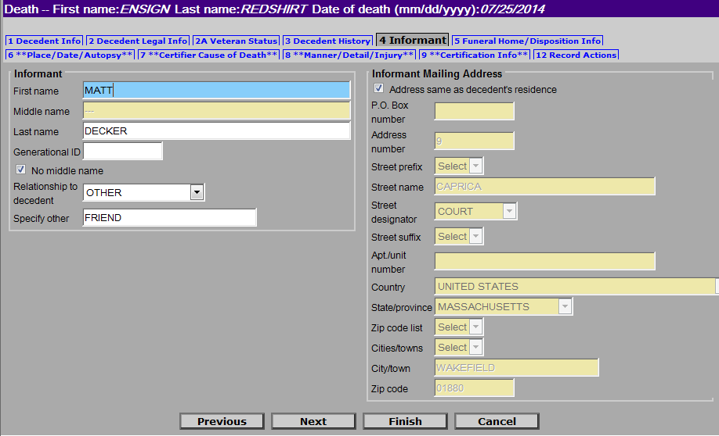
Note that if the Informant Mailing Address is the same as the decedent’s address entered on Tab 2, then you will check the box for Address same as decedent’s residence, which is located above the mailing address. The address fields will populate automatically. If the address of the informant is different, fill out the fields with the address information.
If the informant’s mailing address is the same as the decedent, click the box for Address same as decedent’s residence. The address will then be entered for you, upon leaving the screen.
For most pick-lists, there is an option for “other,” if none of the available choices are appropriate.
A P.O. Box is acceptable for the informant’s address

Selected Field Notes:
Name of Informant | Enter the current name of the informant. Generational ID is a name suffix, such as “Jr.” If there is no middle name, check the “No middle name” box, or enter three dashes (---).
Relationship to Decedent | The pick list contains many of the most common types of relationships; but, if there is a relationship not on the list, you may choose other and specify in the free text field.
Address | Enter the informant’s mailing address. As with decedent’s address, each element is parsed. For instance, “Main Street South” is entered into three different fields. State/Province is required for U.S., Canada and Mexico. The zip code list is available for Massachusetts and several New England states, and will narrow the subsequent pick lists to proper cities and towns. A post office box is acceptable for informant’s address.
If there is no middle name, select the No middle name checkbox, otherwise the field is required

Tab 5. Funeral Home/Disposition Info
If the relationship is something other than those listed, you can pick “OTHER” and fill in the field below the list
Funeral Home/ Disposition Info
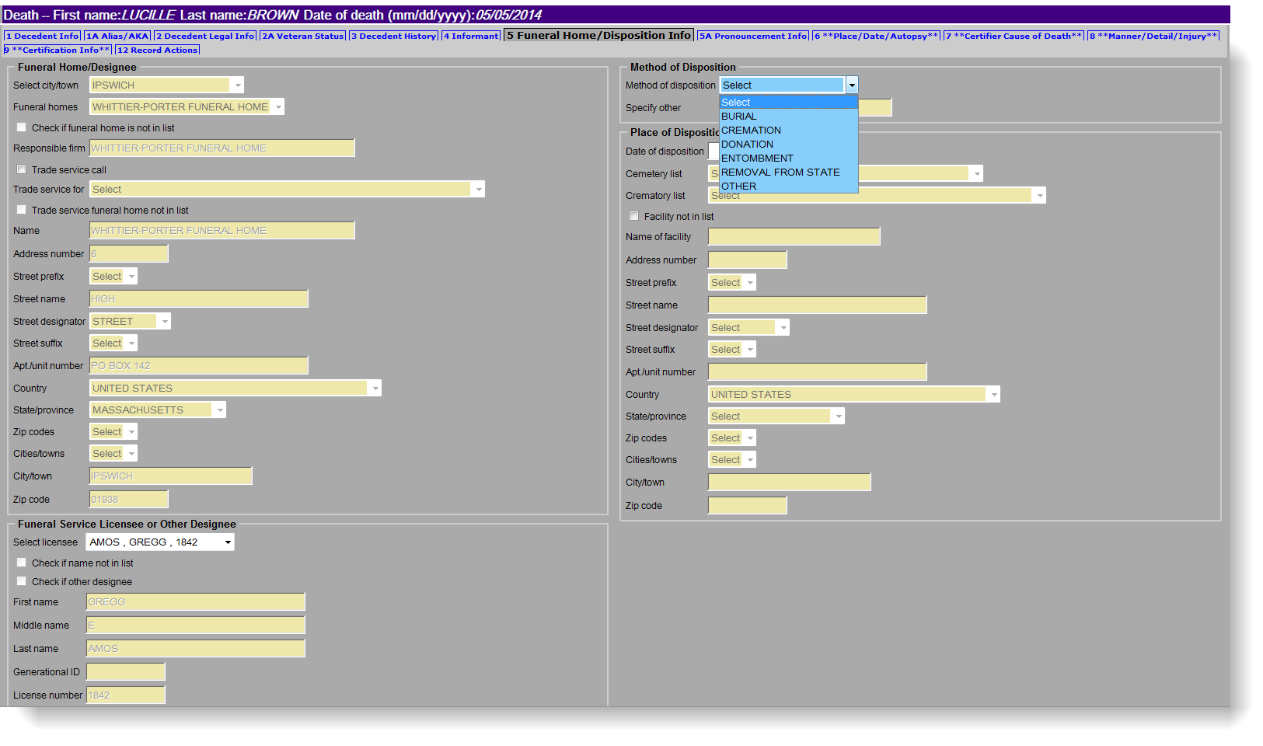
The name and address of your funeral home will be pre-populated with the information provided to RVRS on your organization’s enrollment forms. You will also select the Type 3 Licensee/Designee, Method of Disposition and associated Place of Disposition.
Choosing the Method of Disposition will enable additional drop-down lists of choices. E.g., selecting Cremation will enable the list of Crematories. You can also choose “Other” and specify (e.g., “Holding).

Select the Type 3 Licensee from the drop-down list of pre-populated information. You can “Check if a name is not in the list” to add a new licensee not yet added to the pick list.

Check here if you are performing a Trade service call* on behalf of another funeral home.
*Note: A trade service call in EDRS is used to describe when one funeral home processes the electronic death record for another funeral home not yet online with EDRS, or for one that is outside of Massachusetts. While you, the online funeral home, will create and process the record, the offline funeral home’s name and information will be printed on the death certificate. Separate instructions are available for trade service calls.

Selected Field Notes:
Field | Description
Name of Funeral Home/ Address | This information should be pre-populated upon log in. The name and address are linked to your funeral home account. If not correct, contact the Registry to make necessary adjustments.
Licensee/  Designee | This is the field to indicate which of your facility’s type 3 licensees is reviewing/authorizing this death record. Even if you are the type 3 licensee, a name must be chosen. If there is a type 3 licensee for your facility that is not in the list, use the field “Check if a name is not in the list” to add a name and license number. “Other designee” is used typically when a funeral home is not involved, and is more commonly used by a City/Town Clerk.
Method of Disposition | Indicate the immediate disposition of the decedent. Note that if “Donation” is marked, you will need to check “facility not in list” to add the name and address of the donation facility. (8/1/14 - This is flagged for a future EDRS enhancement). If not in list, check “Other” and type in an appropriate disposition (e.g., “Holding”).
Date of Disposition | This should be the date of the expected immediate disposition. Enter as MMDDYYYY. If “holding” enter the date released to the burial agent or the date the decedent is moved to the holding facility (do not enter a date prior to release to the burial agent, else a permit cannot be issued).
Address of facility | This is pre-populated if a location is chosen from Cemetery or Crematory pick-lists. Check “Facility not in list” and manually enter the address if the place of immediate disposition is not in the pick list, or if the disposition is “Donation” or “Other.” Enter the physical location, not a mailing address.

Tab 5A. Pronouncement Info
If the facility is not in the list, you can add it to the record.
Pronouncement Info
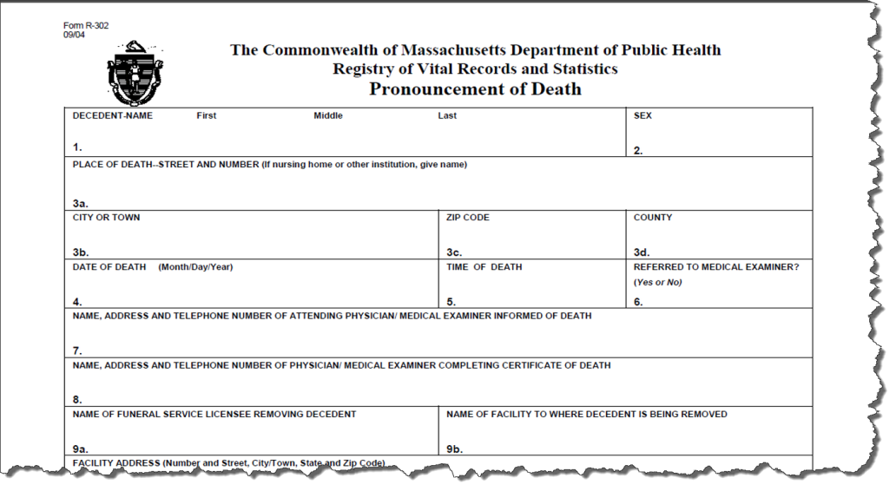
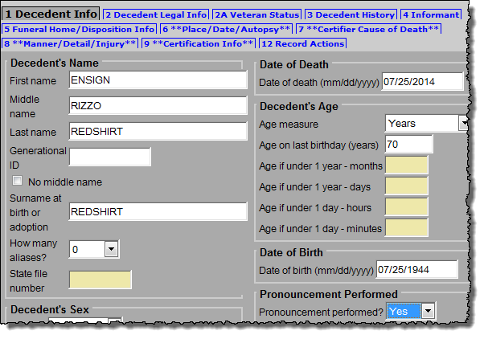
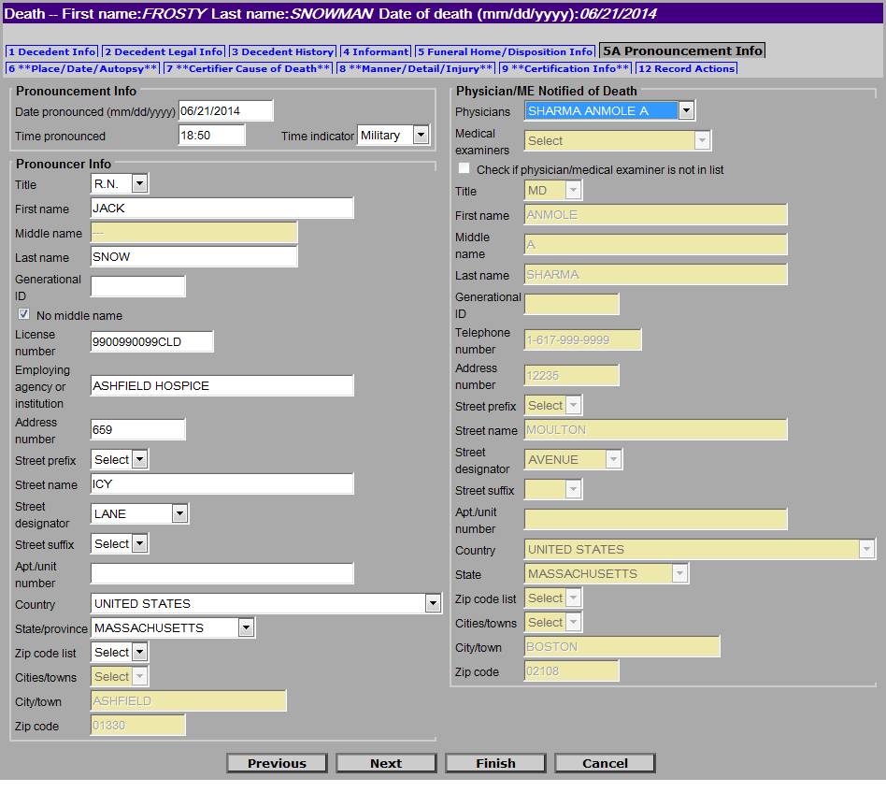
You will receive a paper Pronouncement form (“nurse pronouncement”) when a nurse, physician assistant, or nurse practitioner (who is not certifying the death) pronounces death in certain circumstances where a physician or medical examiner is not available -- common in deaths that occur with home hospice and in nursing homes.
If you do not see the name of the physician or medical examiner, you can Check if physician/medical examiner is not in list. This will open the address fields for editing.
If chosen from list, EDRS auto-populates the address of the physician/ME notified.

Note: You may start a record for medical certification with just a pronouncement form. It is fine to enter just Tab 1, Tab 5A, and, optionally, Tab 12 (Records Actions) to assign a certifier, and save the remaining data entry for later. This will allow an online certifier to find the record and complete the medical certification while you gather other information from the informant. You should fax the nurse pronouncement form into the system for the certifier to view (see fax instructions in the Attaching Documents section, later in this guide). EDRS also allows you to fax or print a Preliminary Certifier Worksheet, to provide an offline certifier with the information already entered on the record, including pronouncement information.
Tab 5A is only enabled for editing if you selected “Y” in the pronouncement performed field (on Tab 1). Enter all required information from the form, including the Physician/ME Notified of Death. The drop-down list is pre-populated with the names of physicians and medical examiners.
Prior to releasing this record to the burial agent (if not sooner), you will fax this form with a VIP fax cover sheet which will attach a scanned image to the record. Pronouncement forms will no longer be delivered to the city/town clerk for the registration of the record. Instead, keep the original in your funeral home’s case file for the decedent.

Tab 12. Records Actions, Part 1: Assign Medical Certifier
Offline Certifier - If you are working with an offline certifier, and have not already designated the certifier on tab 12, you will need to do so before you can enter information into tabs 6-9 (medical information and certification). You may also perform this step after completing tab 1.
Records Actions, Part I: Assign Medical Certifier
Online Certifier - If you are working with an online certifier that has not already started or accessed this record, you may assign that certifier to the record. The record would then appear in the certifier’s Pending MI queue.
If you are not sure who will be certifying, wait. An online certifier will not be able to update a record that has been assigned to a different certifier; the funeral home (or medical data entry staff, if applicable) would need to reassign the certifier. If you do not assign an online certifier, that certifier will still be able to find, your record when he/she goes through Create New Case.
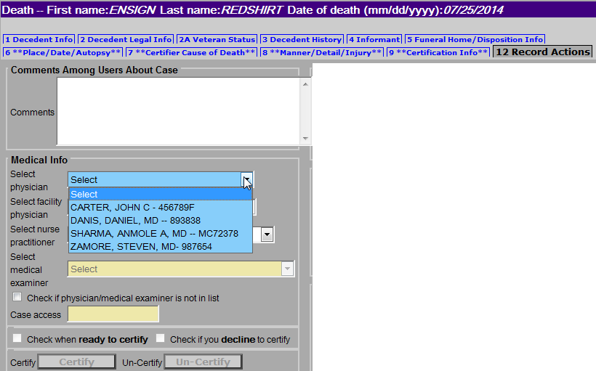
Note: If this is a medical examiner case, you will not assign a medical examiner.
Select the name of the physician or nurse practitioner certifier from the pre-populated list.
If you are working with an offline certifier, you will later return to this screen when the record is complete and ready to certify.
Enter helpful comments, if appropriate.
Important Note: Do this ONLY ONCE unless changing certifiers. The certifier pick lists will revert back to “Select” once chosen, and will delete the medical information if a new certifier is selected or same certifier is re-selected.
If the medical certifier is not on the list - Mark the checkbox Certifier not in list, which will enable the name and address fields for data entry in Tab 9 (Certification Info).

Tab 6. Place/Date/Autopsy
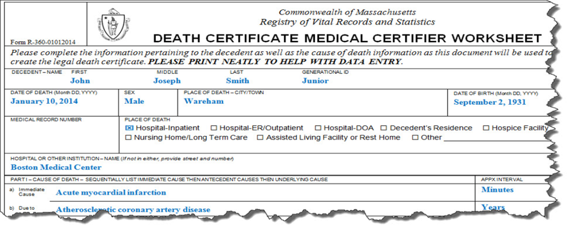
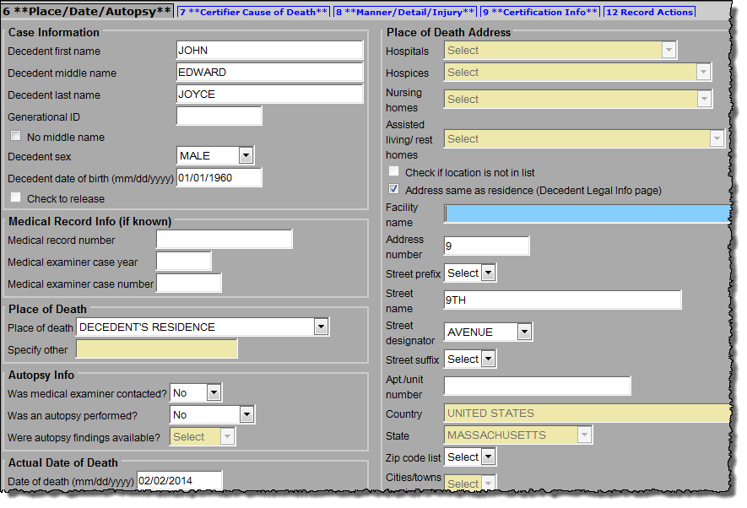
Funeral homes will complete Tabs 6-9 only when the medical certifier is offline. When the certifier is offline, you will obtain the facts of death necessary to complete these tabs by having the certifier complete the Death Certificate Medical Certifier Worksheet (“Certifier Worksheet”) or other method of information transmittal. You will then enter the information provided into the EDRS.
Medical Record Info is optional, but helpful for follow-ups.
If you check Address same as residence, the decedent’s address will auto-populate (if you already completed tab 2).
Shortcut: Type the first few letters to quickly select an item from any drop-down list. e.g., “ANN” would quickly narrow the list to “Anna Jaques Hospital.”
Place/ Date/ Autopsy
In Tab 6, the name and dates of birth and death will be pre-populated with information that was entered on Tab 1, from when the case was created. On this tab (Tab 6), you should enter the information about the place of death, whether the medical examiner was notified, and whether there was an autopsy. Select a Place of Death option to enter the type of location from the drop-down.
Certain selections in EDRS will cause other fields to become active. For example, if the decedent died in an emergency room, after you select “Hospital – ER/Outpatient” as place of death, the hospital drop-down list will become enabled for selection. EDRS provides lists of hospitals, hospice care facilities, nursing homes, assisted living or rest homes, eliminating the need to type the name and address (the address fields will become disabled).
Selected Field Notes:
Decedent’s Name, DOB and DOD | When entering for an offline certifier, the decedent’s name, dates of birth and death will be defaulted to the information entered into Tab 1. If an online certifier begins a record, these fields are disabled, and it might happen that the name is different than what you will enter as the correct legal name on Tab 1. Check that Tab 1 is accurate, as these will be the names that print on the death certificate. Certifiers may not always have the correct legal names for their patients.
Check to Release | This field is always disabled and is for medical examiner use only.
Medical Record Info | Medical record number, medical examiner case year and case number are optional. If they were provided on the Certifier Worksheet, please enter this information.
Place of Death | Select a Place of Death option to enter the type of location where the death took place. Then, choose the specific facility from the drop-down list. For hospital and nursing home medical staff doing data entry, the facility name and address are defaulted.  Place/ Date/ Autopsy  Note that “Decedent’s residence” is to be used only for his/her own residence that is not a nursing home, hospice facility, assisted living or rest home. Home hospice may be entered as “Decedent’s residence.” Another person’s residence should be marked “Other.”  - Not on the list? If the facility where the death took place is not listed in EDRS, you can use the option “Check if location is not in list” to enter in a new location.  - Residence? For a death occurring at the decedent’s own residence, the address fields are all open for editing. If you already entered address information in Tab 2, then you may check the “same as residence” checkbox to automatically populate residence address.  - Nursing Home/Assisted Living? If a decedent was living at a nursing home, assisted living or rest home, do not choose “decedent’s residence,” but choose the appropriate facility type instead. Look for facilities in other facility types, if not found on the pick list. What you may think to be a nursing home may be licensed as assisted living.  - Hospice? If the decedent was receiving home hospice care in his/her own home, choose “decedent’s residence.” This category should only be used for hospice facilities.
Autopsy Info | Answer Was medical examiner contacted? yes or no as it appears on the worksheet. If the medical examiner was not contacted, but should have been, it is your responsibility to refer the case to the medical examiner; then select “Yes.” Note that the system send an error message when the place of death is not a medical facility; if this is not a death that requires medical examiner notification, simply click “OK.” (This edit will be refined in a later EDRS update).  Was an autopsy performed? - For records where you are entering information for an offline certifier, the appropriate response will usually be “Yes- Private” for any non-M.E. autopsy or “No.” Were autopsy findings available? should be answered “Yes” if the certifier used the autopsy results to determine cause of death. Enter as it appears on the worksheet.
Actual Date of Death | Date of death will default to the information entered on Tab 1. Do not change this field, unless it was entered incorrectly when the record was started and you have double-checked the date with the certifier. Tab 1 should also be corrected in this case.
Place of Death Address | Choosing a facility from a drop-down list will automatically populate the address. Checking Same as decedent’s address will automatically populate the address that was previously entered into Tab 2. If you need to enter a new address, note that the address component fields are separated for geocoding: e.g., “9 Main Street South” is entered into four different fields.

Tab 7. Certifier Cause of Death
These fields are enabled only if you are entering information on behalf of an offline certifier. If the certifier or medical facility staff members are online, then information about cause of death will be entered into EDRS for you.
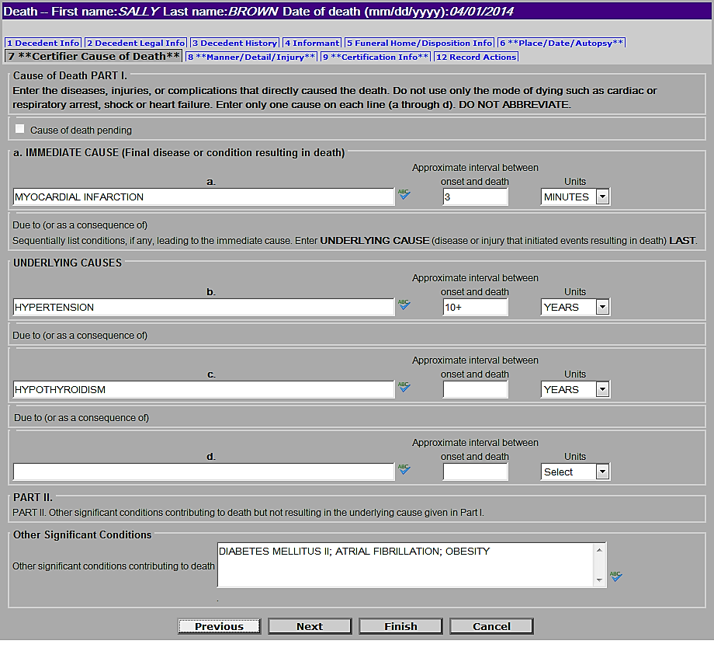
Enter cause of death information as it appears on the Certifier Worksheet (or other means of information transmittal). The EDRS will prompt for abbreviations, rare causes, mechanistic causes and other potentially improper entries but will not prevent them in this release. Do try to spell out abbreviations when prompted; and it is good practice to relay information to certifiers about edit messages whenever possible, such that the quality will improve in the future. If certifiers have questions about proper completion of cause of death, note that the Massachusetts Medical Society is hosting a free online Cause of Death tutorial (http://www.massmed.org/cme/causeofdeath).
Take advantage of the built-in spell checker.
Intervals are always approximate; however, a certifier may enter units without exact intervals when an estimate is not possible.
EDRS will prompt you to spell out abbreviations, elaborate on cancer sites, and help you to avoid writing improper mechanistic causes.
Enter other contributing factors in a continuous line, separated by semicolons (“;”).
List one condition at a time, starting with Immediate Cause and sequentially list intermediate causes with the Underlying Cause last.
Certifier Cause of Death

Selected Field Notes:
ield | Description
Cause of Death | List one cause per line, as provided by the certifier. Line (a) should list the immediate (final) condition directly causing death. Other lines list diseases or complications that gave rise to the immediate cause. If there are more conditions than lines, you may list more than one cause on lines (b)-(d) by writing “due to” between conditions.  Manner/ Detail/ Injury
Approximate Intervals | Enter an approximate interval for each condition listed in the cause of death sequence, as provided by the certifier. You may enter in many different ways depending on the information available to you. E.g., “8 minutes,” “>10 years.” A certifier may enter units without exact intervals when an estimate is not possible. E.g. “Years” (number of units is then left blank).
Other significant conditions | List other diseases and conditions that may have contributed to death, as provided by the certifier, in a continuous line with each condition separated by a semicolon (“;”). If none, leave blank.

Tab 8. Manner/Detail/Injury
Funeral directors and non-medical examiner certifiers, will complete just three questions on this tab. Use the information provided to you from the Certifier Worksheet (or other means of information transmittal) to fill out the information about Manner of Death, Pregnancy Status, and Tobacco exposure. Funeral directors and non-medical examiner certifiers will not complete death certificates for manners other than natural, and will not need to complete the injury information fields.

Selected Field Notes:
ield | Description
Manner | “Natural” manner of death is your only option. If a certifier indicates a manner other than natural, the case must be referred to the medical examiner.
Pregnancy Status | This is a new question to comply with the Centers for Disease Control and Prevention (CDC) national standard. The certifier will indicate whether a female, between 5 and 75, was pregnant at death or any time in the last year. Specific checkbox categories break down the pregnancy intervals to “at death,” “within 42 days,” and “43 days to one year.”
Did tobacco contribute to death? | Also a new CDC question, this collects information about whether use or exposure to tobacco contributed, or may have contributed, to death. Possible answers are “Yes,” “No,” “Probably,” and “Unknown.”
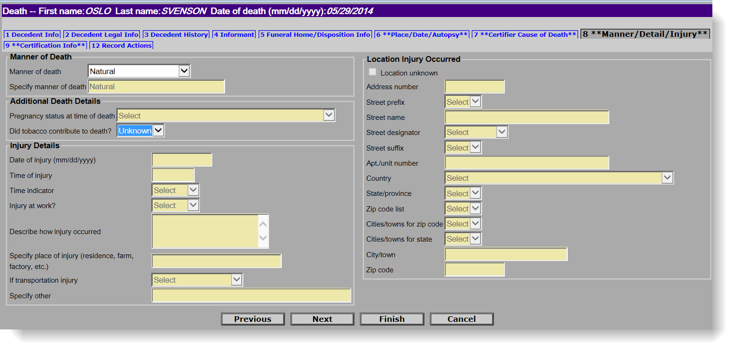
Shortcut: Type in “N” for Natural.
For a male decedent, the pregnancy question is disabled (yellow).

Tab 9. Certification Info
Certification Info
For typical cases, you will enter these items on behalf of an offline certifier: Certifier Designation, Physician in Charge of Patient’s Care, Hour of Death and Date Signed. Other fields may be necessary depending on differing circumstances.
Certifier Name, Title, Fax Number, Address –
- For funeral directors (and medical data entry staff) entering on behalf of an offline certifier – This information is populated from the certifier information that you selected in tab 12 (Records Actions tab – see p. 18). If the Certifier is not on the list (or if the information is incorrect on the list) -- Mark the checkbox Certifier not in list on tab 12, which will enable the name and address fields for data entry. Note: If the updated information should be a permanent change to the pick list, also mark the checkbox Update certifier info and flag for database change on tab 9 (Certification Info).
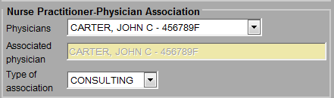
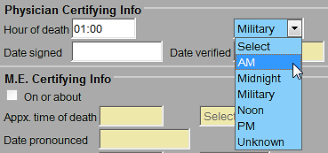
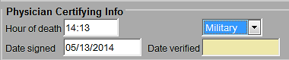
- For online certifiers entering their own data, EDRS will auto-populate name, title, license number, phone and fax number, and address. You will not enter or change this information.
If you enter a new certifier or edit an offline certifier’s information, and this should be a permanent change to the pick list, mark the checkbox Update certifier info and flag for database change.
If the certifier does not know the primary provider, but the informant does; confer with the certifier whether to add it.
Certifiers may use military (24-hour) time. EDRS will convert this to AM/PM for printing on the death certificate.
Finish and Save. After completing this tab, Finish and Save (as Pending). You must finish and save prior to printing/sending an attestation form, entering date signed, and certifying on the Records Actions tab. Both steps are necessary before you may certify the record. (The VIP system needs to validate all screens before it determines that it is ready to certify.)
- Click Finish at the bottom of the tab you are working on.
- You will then review the VIPS Warning page. Prior to printing/faxing an attestation form, or certifying the record for an offline certifier, only three fields in the Medical Info section will still be “incomplete;” Physician Certifying Info - date signed, Medical Info - Ready to certify, and Certify. If there are other fields listed in the medical portion, you may click on the hyperlink to return to the appropriate tab to complete.
- Click on the Save (as Pending) button. Next, you will be on the “Successful Transaction” page, where you may Return to Record to mark that the record is ready to certify (see Records Actions, Part 2 section).

Selected Field Notes:
ield | Description
Certifier Designation | Enter the Certifier designation as listed on the Certifier Worksheet (or through another means of information transmittal). A provider that pronounced death or was in attendance at the time of death, but were not part of the decedent’s own health care team, should select “Certifier in Attendance at Time of Death” (Physicians) or “Nurse Practitioner in Attendance at the Time of Death.” Otherwise, the certifier should choose either Physician (or Nurse Practitioner) in Charge of Patient’s Care.
Physician in Charge of Patient’s Care | This set of fields are enabled only when the certifier is “Certifier [or Nurse Practitioner] in attendance at time of death.” The certifier should provide you with the decedent’s primary practitioner. If not on the pick list, mark the checkbox Physician not in list. You may enter the physician’s name and title (or Nurse Practitioner, if applicable). If the decedent had no primary practitioner preceding death, then mark the checkbox No primary care physician provided.
Nurse Practitioner - Associated Physician | For nurse practitioners that are certifying death - their Associated Physician should be selected from the pick list when applicable, and the Type of association should be selected as either “Consulting” or “Supervisory.” The physician may or may not be the same as the Physician in Charge of Patient’s Care.
Hour of Death | Hour of death may be entered as AM or PM, or as military time. Colons are not needed (e.g., 1412). If the hour of death is from 1300-2400, or 0000, then the time designation is completed as military automatically and will be converted to AM/PM for printing on the death certificate. When entering 1200, you may select “Noon” or “Midnight.” Note that “midnight” (12:00AM, 2400, 0000) is considered to be the start of a new day.  Certification Info
Date Signed | Date signed is to be completed only after receiving the signed fax attestation and checking that the record is ready to certify (See Records Actions, Part 2). All medical information tabs must be complete, and the record saved, before this field becomes enabled. Dates should be entered as numeric. Dates will be converted to formal format when the record is registered and printed by the City/Town Clerk. Enter as MMDDYYYY or MM/DD/YYYY.
Date Verified | This field is disabled and is for use by RVRS only (for certificates that have been entered from paper during the grace period).

Tab 12. Records Actions, Part 2: Ready to Certify, Certify, Informant Verification, Release to Burial Agent
The Records Actions tab (Tab 12) is used primarily to assign a Certifier (as described in Records Actions, Part 1) and to move the record through stages: to indicate a record is ready to certify in preparation for printing or faxing the Attestation Form, to indicate a record is certified upon receiving a signed Attestation Form, and to release a record to the Burial Agent upon completion of all fields. You may also use the Records Actions tab to enter comments, read comments on a record has been returned to you for correction, and view record history.
Records Actions, Part 2: Ready to Certify

Ready to Certify
If you are entering information on behalf of an offline certifier, you will mark Ready to Certify prior to printing or faxing the Attestation Form. This field is disabled until all required fields in tabs 6 through 9 are completed, and the record has been validated by clicking Finish and Save (as Pending). While this may seem to be an extra step, EDRS needs to validate all fields prior to enabling a final Attestation form. (Online certifiers will complete these steps for you).
- Complete tabs 6 through 9; then Finish;
- On the VIPS Warning Page, verify that only the following fields are still listed in the Medical Information section: Physician Certifying Info - date signed, Medical Info - Ready to certify, and Certify. If there are other medical information fields to complete, you may click on the hyperlink to return to the appropriate tab in the record. Then, Save (as Pending) to fully validate the record;
- Return to Record on the Successful Transaction page.
- Click Ready to Certify on the Records Actions tab, then Finish, and Save (as Pending) again.
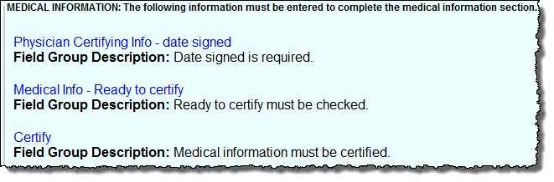
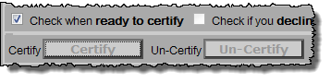
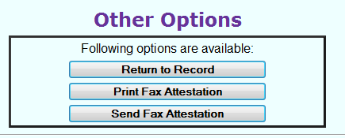
Now, you may print or fax the Attestation form from the Successful Transaction page, or through the Death Attest menu path.
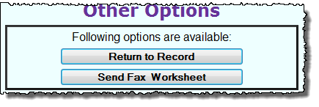
Note that if there were missing fields in the medical portion of the record, you may send a Fax Worksheet (Preliminary Certifier Worksheet) instead, which will allow the certifier to provide you with any missing items.

Certify
Once you have received a signed and dated Attestation Form from an offline certifier, you will then certify the record on his/her behalf. If the certifier faxed the form into the VIP EDRS system, you will find the record in the Fax Received queue on your main page. If the paper form was returned to you in some other manner, you should fax the Attestation Form into the VIP EDRS system first and then select the record from the Fax Received queue.
Certify, Release to Burial Agent
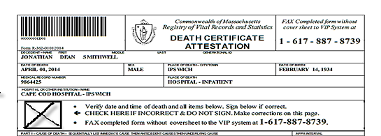
- Upon selecting the record from a queue (or finding it through the menu path DeathNew DeathUpdate), find the form at the bottom of the Records Details screen, under Available Documents. To ensure that the Attestation form was completed and attached successfully, view the form to verify that it was signed and dated, and that the form matches the decedent. Click Continue. (If the certifier did not sign and date, but instead made corrections, make the necessary corrections and follow the Ready to Certify procedure again.)
Check!! This form indicates corrections need to be made and a new Attestation form obtained prior to certification.
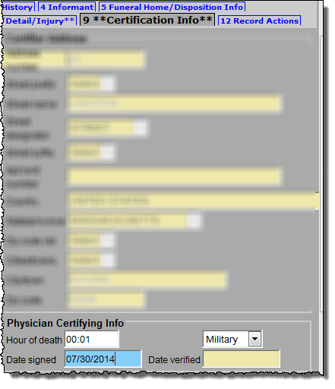
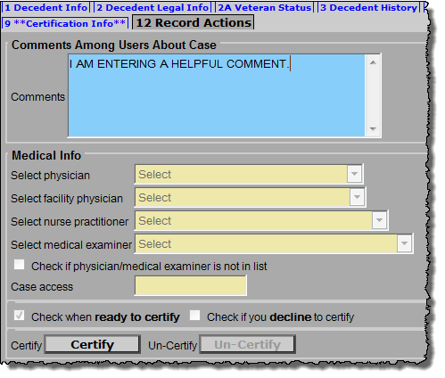
- Click on Tab 12 and check the Ready to certify checkbox, then go to Tab 9 (Certification Info) and enter the Date signed.
- Click Next or directly on Tab 12 (Records Actions). Click on the Certify button, which should now be enabled.
- Finish and Save (as Pending). Note that the Save button will always say “as Pending” even when all items are complete.
Informant Verification - Once all personal information from tabs 1 through 5, and all information from the medical information tabs 6 through 9, are complete, it is recommended that you print an Informant Verification form from the Successful Transaction page (or through the menu path DeathPrint) prior to releasing to the Burial Agent.
- This will allow both you and the informant to review the information in a printed format, and make any necessary corrections prior to obtaining a permit and registration of the record.

Release to Burial Agent
All required personal and medical information must be complete before releasing to the Burial Agent, regardless of whether a community is “opt-in” to ePermits or not. EDRS must validate the items prior to release.
Once all items are complete, including all required fields and tabs, the Certify button, and the Informant verification section:
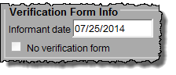
- If an Informant verification form was signed, enter the Informant date. If not, mark “no verification form.”
Release to Burial Agent, Print Permit
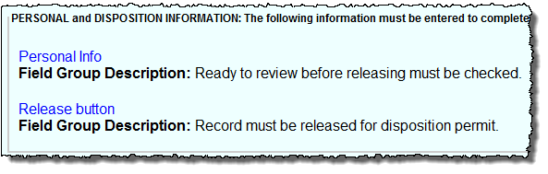
- On the VIPS Warning Page, you should have only two warnings: Personal Info and Release button. If there are others, click on the hyperlink(s) to complete those items. You must then Save (as Pending) to allow the EDRS system to fully validate the record.
- On the Successful Transaction screen, click Return to Record (or find the record later through the queue or menu path DeathNew DeathUpdate).
- On tab 12 (the Records Actions tab) mark the checkbox Check when ready for review before releasing.
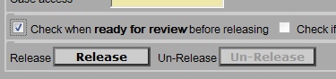
  - Note that an individual with a funeral home data entry staff role may not release a record; instead, the staff member will Finish at this point. Then, an individual with a funeral director role must retrieve the record and complete the remaining steps, if applicable.
- Then, when you have completed all fields and steps, click the Release button when you are ready to send the record to the burial agent, then, Finish.
Upon release to the burial agent, when you are able to print your permit will depend on whether the community is “opt-out” or “opt-in” to ePermits:
- If opt-out, the record is now in the Pending Permit queue for the burial agent to review and issue local permit information. After the burial agent enters permit information, you will be able to print the permit from EDRS.
- If opt-in, you may print the permit immediately. The record is also in the Pending Permit queue for the burial agent to review and issue local permit information, but this can occur after you print your ePermit.

Print Permit
To print a permit, navigate through the menu path DeathPrintPermits. Enter search criteria, including city/town of death occurrence.
- If the record cannot be found, that means a city/town is opt-out and has not yet issued the permit.
Permits, Searching, Faxing
- If opt-in, the record will be found immediately after you release to the burial agent and an ePermit may be printed.
- If opt-out, the record will be found once the burial agent has completed the permit information on the decedent’s record.
The permanent copy of the permit (that will be signed and returned by the place of disposition) must be printed on archival-quality bond paper.

Searching for a Record
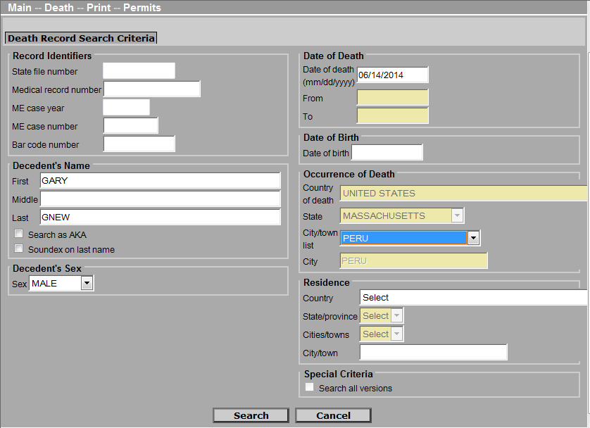
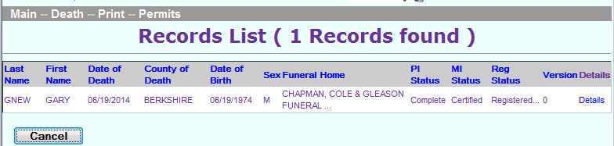
If you are searching for a record to view, update or print a form, the search screen will always look similar. Enter at least a few fields to narrow down the search. This will help EDRS find the record easily and improve system performance for all users.
Permits - You must enter the city/town of death occurrence in the search criteria when you are printing disposition permits.
Enter at least a few fields to narrow the search. This will improve system performance.
Soundex will help find last names that sound alike but are spelled differently. If you are not sure if the decedent’s last name is Smith or Smythe, check the Soundex checkbox.
Click on Details to bring up the Records Details screen, where you can verify that the record or form that you about to retrieve is the correct one.

Faxing
Forms with bar codes do not need cover sheets. A fax cover sheet must be printed for any non-bar-coded documents, such as nurse pronouncement forms. Fax documents to 1-617-887-8739, which is an automated imaging system that attaches a PDF to the electronic record. (This “fax” never arrives at an office fax machine, and the image can only be viewed by authorized EDRS users).

