Administrative Activities (Indirect Services)
MassHealth reimburses for 8 types of activities that support the provision of Direct Services. There is no interim billing for these activities. They are captured in the Random Moment Time Study (RMTS)*

- Outreach -- Informing eligible or potentially eligible individuals or families about MassHealth and how to access it.
- Application assistance -- Assisting individuals or families to apply for MassHealth.
- Provider Networking/Program Planning/Interagency Coordination--Participating in activities to develop strategies to improve the delivery of Covered Services, including when performing collaborative activities with other agencies regarding health-related services.
- Individual Care Planning, Monitoring, Coordination and Referral to Covered Services-- Making referrals to health services, coordinating, or monitoring the delivery of Covered Services.
- Transportation – Arranging for an individual to obtain MassHealth-covered transportation.
- Translation/Interpretation – Arranging or providing when required to access covered services.
- Training – Participating in and coordinating/providing training related to Medicaid topics.
- Public Health Guidance -- Participating in activities that are guided by state or federal public health guidance, including infection control, contact tracing, and immunization tracking

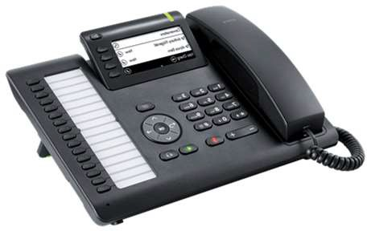
*Visit the SBMP Trainings page for Module 9: LEA RMTS Participants Performing Administrative Activities. You can view the module and download the training slides.

08/2023
School-Based Medicaid Program www.mass.gov/masshealth/schools

