Notes
Quick Start Guide for
Burial Agents

Vitals Information Partnership (VIP)
Electronic Death Registration System (EDRS)
Revision July 1, 2014
Notes
Use this page to make notes about your own workflows and processes, which may differ by community and location.

Summary of Steps
You may want to print this page as a quick reference sheet. This is a summary of steps for a typical scenario that are explained in more detail later in the document. After logging into VIP:
1 | To review a new death record and/or complete or update permit information on a record that is not yet registered by the City/Town Clerk, choose a record from the work queue by clicking on Process.
2a | Review information by clicking through the information tabs on the Records Details. View any attached documents at the bottom of the tabs. Click Continue when ready to proceed.
3 | Click on tab 10, complete the date issued, local permit number, and select the current burial agent from the pick list.
4 | - If you are ready to release to the City/Town Clerk for registration, click on tab 12 or Next. Click the Release button and click Finish.  - If you do not want to release for registration yet, click Finish. Then, on the VIPS Warning Page, press the [End] key to skip to the bottom of the page and click Save as Pending. You will find this record in the Pending Release queue for later completion.
5 | If permit information was completed, you may now print a permit for your records or to provide to a funeral home or other family designee. The funeral home will also be able to print the permit. If you have released to the City/Town Clerk, you will have the print option at the Successful Transaction screen. If you have not released to the City/Town Clerk, you will need to use the menu to print.
6 | Repeat the process by clicking on Main Menu; or logout at the top right-hand corner of the VIP screen, then logout on the VG screen as well.

Accessing and Using EDRS
Summary of Steps, Accessing EDRS

The Electronic Death Registration System (EDRS) is a module of the larger Vitals Information Partnership (VIP) system that is hosted in the Commonwealth’s secure Virtual Gateway environment.
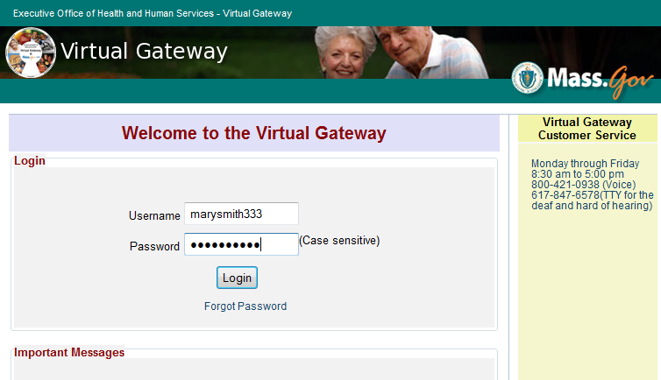
Access EDRS on the web. EDRS can be accessed anywhere you have a computer and internet access. The system works best with the Microsoft Internet Explorer (IE) browser. If you are a Mac user, it is recommended that you download the Firefox browser on your computer.
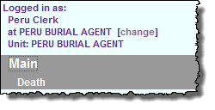
Log in at http://mass.gov/vg. You must have a valid Commonwealth Virtual Gateway account, as well as a VIP account to log in to EDRS. If you use a single sign-on for more than one VG application, you will then have a choice of applications when you log in. If you are a City or Town Clerk that is also a burial agent, then you will get a choice of role.
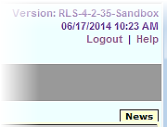
Additionally, City and Town Clerks that are burial agents may “Change” role within VIP (at the top left hand corner of the main screen).
Logout at the top right-hand corner of the VIP screen. To completely exit the system, also logout on the right-hand panel of the VG screen.
Accessing & Using EDRS, Navigation

Tips & Tricks
Save! – EDRS will time out after 15 minutes. While your portion of the death record should take less than three minutes to enter, if you expect to be interrupted or if you are just learning the system, click Finish, then Save (as Pending). You may then click Return to Record without risk of losing any information. EDRS does not save information automatically.
Tab & Mouse -- Use the Tab key on your computer keyboard to advance through each field in EDRS. You may also use your mouse to navigate tabs or to temporarily skip sections. Do not use Backspace or Enter, except within fields as necessary.
Color Coding – White fields on each screen in EDRS will accept information; the yellow fields are disabled based on selections made in the system. A blue field indicates which field you are on now.
Shortcuts – Alt-T enters today’s date. Slashes are not necessary in date fields. Enter the first few letters of a selection on a picklist to narrow the list quickly. “Next” will move you from tab to tab, but you can click on the tab labels as well. The [Spacebar] will complete a checkbox if you are tabbing through fields.
Slow? – It takes time to load PDF burial permits, and some slowness may occur intermittently depending on number of users on the system. Wait. Clicking repeatedly will boot you out of VIP. If this happens, close the white screen and log in again.

Need Help?
Contact the Registry at vip@state.ma.us or 617-740-2600

Navigation
EDRS has two general methods of navigation: work queues and a menu bar.
Work queues display records that are waiting for completion. For burial agents, there are only two possible queues:
- Records for which the local permit information has not yet been completed (Pending Permit); or
- Records for which the local permit information was completed, but that are being held for later release to the City/Town Clerk for registration (Pending Release).
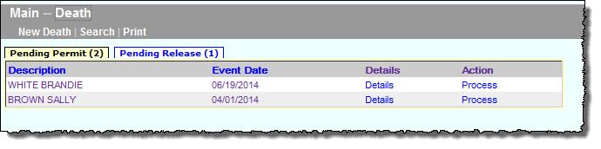
The menu bar keeps navigation “bread crumbs.” You may click on any option within the trail to return to a previous step.
Queues contain only records that require an action. You will not see any queues if there are no records waiting to be processed.
The gray menu bar allows access to all authorized EDRS functions for the user type that is logged in. For burial agents, the most common options will be “Print,” which will allow for printing of the disposition permit in your office, and “Search,” where you can review any death record and view history or updates (such as medical examiner completed records). The most common menu paths will be:
- DeathPrintPermits (to print disposition permits)
- DeathSearch (to view all authorized death records)

Review a Submitted Death Record
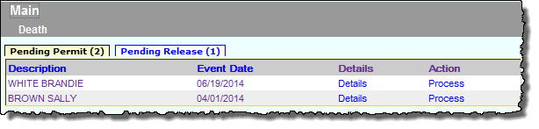
Newly submitted records will appear on the main VIP page in a “Pending Permit” queue. If there are no queues, then there are no records that require an action on your part.
Navigation, Review a Death Record
Choose a record from the queue by clicking on the Process link.
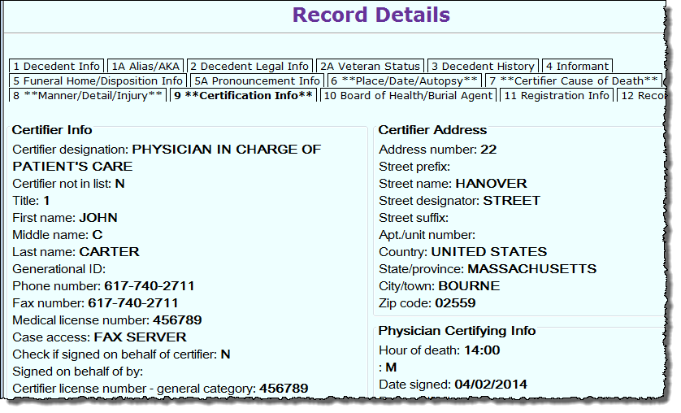
Next, review the information on the record by clicking on individual tabs on the Records Details screen.
At the bottom of each tab, you will see attached PDF documents under “Available Documents,” such as the certifier’s Attestation Form.
While VIP EDRS will check all fields for completeness and validity, there are still some types of things you can look for:
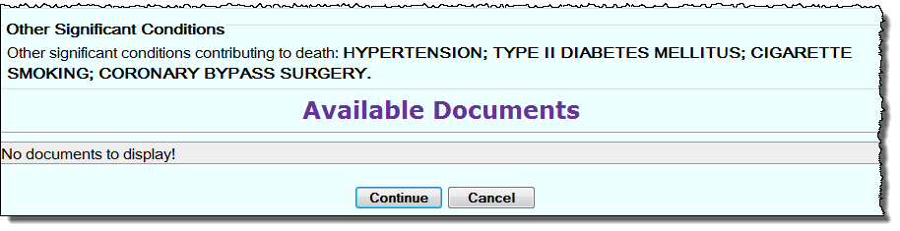
- If the certifier is a fax attestation certifier (as listed on tab 9), is the attestation form attached and does it match the listed certifier?
Quick tip – To quickly scroll to the bottom of a Records Details screen, click the [Ctrl]+[End] keys.
- Are there any common spelling errors? VIP EDRS has a spell-checker for cause of death, but it is optional. Other free-text fields, such as City/Town of Birth for foreign countries cannot be validated by VIP EDRS. If you see many of these types of errors, encourage funeral homes to use the Informant Verification form which allows informants to review the information that will appear on a death certificate prior to submission.
- Should the death have been referred to the Medical Examiner? Check tab 6 to see if the death was already referred and tab 7 for cause of death.
Entering Permit Information
Once you have completed your review and are ready to process the record, click Continue.

Entering Permit Information
All authorized users may view all information “tabs” in a death record, and you will be brought to Tab 1 initially. However, as a burial agent, you are responsible only for tab 10 and relevant portions of tab 12. You may skip all other tabs (although you may always continue to review information on any tab at this stage as well).

Tab 10. Board of Health/Burial Agent
This tab is where you will enter local permit information.
Enter the date the local permit was issued in the format MMDDYYYY or MM/DD/YYYY. Next, enter the local permit number in any format that you normally use.
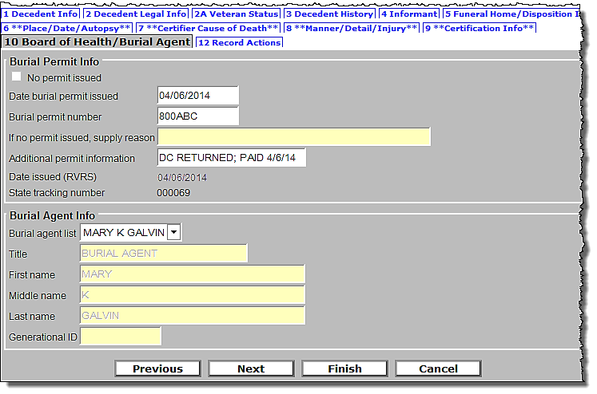
If no permit was issued, you may check the No permit issued checkbox, which will disable date and permit number and will enable the text box to enter a brief explanation of the reason.
A state tracking number and date submitted to the burial agent will appear here whether or not your community opts-in to e-permitting.
The Additional permit information field is optional. However, you may enter any free text, such as “waiting on payment” or that the death certificate was returned.
In Burial Agent Info, click on the current primary burial agent from the pick list, or type in the first few letters of the name as it appears on the list.
Click Next or the Records Actions tab label to continue to the next tab.
- Alternatively, even if you have issued a permit by completing tab 10, but do not wish to release for registration at this time (such as while waiting for payment), you may click Finish, then Save as Pending on the next screen, now. The record will then appear in the Pending Release queue.
Records Actions

Tab 12. Records Actions
On the Records Actions tab, you may release the record for legal registration, return a record for correction to the funeral home, and enter comments on a record.
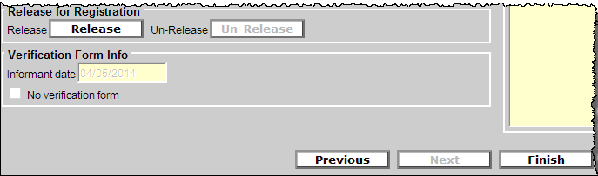
For most records, there is only one button to complete on the Records Actions tab. If you are ready to release the record to the City or Town Clerk, click on the Release button near the bottom of the page, and click Finish.
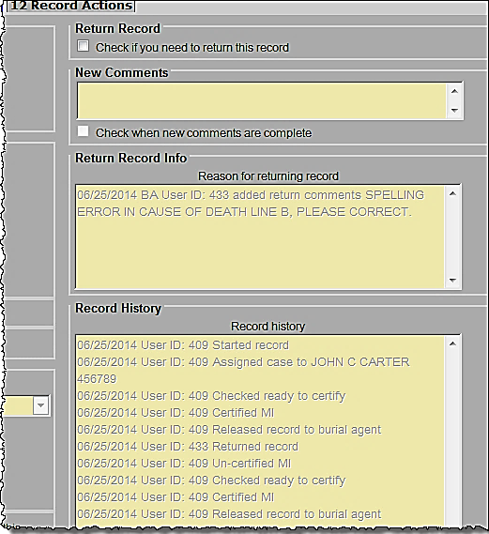
For records that need to be returned for correction – Click the checkbox labeled Check if you need to return this record, then enter information in the New Comments box, and click the checkbox labeled Check when new comments are complete. Then, click Finish at the bottom of the screen.
When returning a record, the reason for return will be visible to the funeral home.
The history of the record is visible to all users. In this example, the record was returned and re-submitted to the burial agent.
Note that you may issue a disposition permit before you return the record for correction; but, you may not release the record for registration until you receive the record back. For e-Permitting communities (“opt-in”), even though the e-Permit might have been already issued, you as burial agent may still return the record for correction prior to submission for legal registration.

VIPS Warning Page
You will rarely see this page. Unless you are holding up the release of a record for registration, you will not see this page. Other users, such as funeral directors and certifiers will see a list of fields waiting to be completed while a record is in progress. Because the record may not be released to the burial agent until all fields are complete, you will not normally see a warning page unless you have not completed the permit information or you have not released the record to the City/Town Clerk.
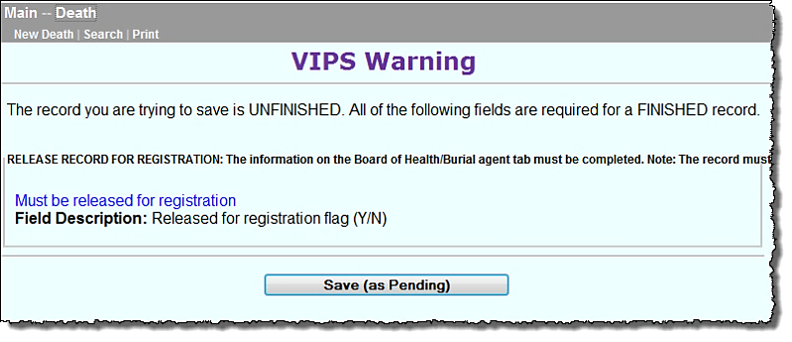
Forgot to release? If you have simply forgotten to release for registration, you may click on the hyperlink Must be released for registration to quickly return to the Records Actions page. Else, click Save (as Pending) to save the record for later.
VIP Warning Page, Successful Transaction

Successful Transaction
Once the record is complete (or saved as Pending), you will receive the Successful Transaction page. Here you may print a copy of the Permit for your files or for the funeral director (or other family designee). The permit may also be printed at any time from the menu bar (DeathPrintPermits).
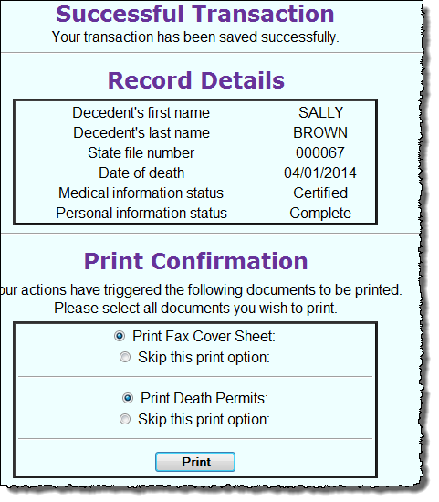
If there are additional documents that you would like to attach to the electronic record, you may also print a Fax Cover Sheet, which is a bar-coded cover sheet. When your document is faxed with the cover sheet, a PDF image of the document will be attached to the record.

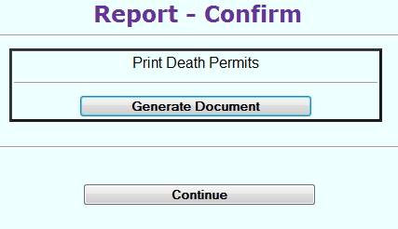
2
1

