INDOOR AIR QUALITY ASSESSMENT

Quincy District Court
District Court of Eastern Norfolk
One Dennis F. Ryan Parkway
Quincy, Massachusetts

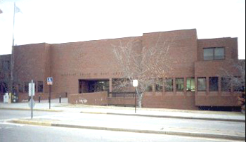

Prepared by:
Massachusetts Department of Public Health
Bureau of Environmental Health
Indoor Air Quality Program
May 2013

Background/Introduction
In response to a referral from both the Occupational Safety and Health Administration (OSHA) and the Massachusetts Department of Labor and Standards, Division of Occupational Safety (DOS), the Massachusetts Department of Public Health (MDPH), Bureau of Environmental Health (BEH) provided assistance and consultation regarding indoor air quality (IAQ) concerns at the Quincy District Court (QDC) located at One Dennis F. Ryan Parkway, Quincy, MA. The assessment was coordinated through Mr. Christopher McQuade, Administrative Attorney, Administrative Office of the Trial Court (AOTC) and Mr. Bruce Tebo, Project Manager, Division of Capital Asset Management (DCAM).
On December 21, 2012, a visit to conduct an assessment was made to this building by Cory Holmes, Environmental Analyst/Regional Inspector for BEH’s IAQ Program. The assessment was prompted by concerns of respiratory symptoms, mold growth and chronic complaints of poor conditions throughout the building.
The BEH/IAQ program previously visited this building in 2002 and issued an IAQ report detailing conditions observed at that time, with recommendations to improve air quality (MDPH, 2012). Actions taken on recommendations made in that report are listed in Appendix A.

Methods
Air tests for carbon dioxide, carbon monoxide, temperature and relative humidity were taken with the TSI, Q-Trak, IAQ Monitor 7565. Air tests for airborne particle matter with a diameter less than 2.5 micrometers were taken with the TSI, DUSTTRAK™ Aerosol Monitor Model 8520. BEH/IAQ staff also performed visual inspection of building materials for water damage and/or microbial growth.

Results
The QDC has an employee population of approximately 140 and can reportedly be visited by up to a 1,000 members of the public on a daily basis. The tests were taken during normal operations. Test results appear in Table 1.

Discussion

Ventilation
It can be seen from Table 1 that carbon dioxide levels were below 800 parts per million (ppm) in thirty-eight of forty-one areas, indicating adequate air exchange in the large majority of areas surveyed at the time of assessment. The heating, ventilation and air conditioning (HVAC) system is made up of air-handling units (AHUs) located in a mechanical room (Pictures 1 and 2). Conditioned air is supplied by ducted ceiling-mounted fresh air diffusers (Pictures 3 through 5). The supply diffuser in the Juvenile Probation Office was reportedly removed, in an attempt to improve airflow (Picture 6). Although there were two occupants in this small basement office at the time of testing they reported that at times up to eight individuals occupy the space. Air is exhausted from the occupied space through ceiling mounted return vents (Picture 7). The law library has no means of mechanical ventilation or openable windows.
To maximize air exchange, the MDPH recommends that both supply and exhaust ventilation operate continuously during periods of occupancy. In order to have proper ventilation with a mechanical supply and exhaust system, the systems must be balanced to provide an adequate amount of fresh air to the interior of a room while removing stale air from the room. It is recommended that HVAC systems be re-balanced every five years to ensure adequate air systems function (SMACNA, 1994). The system was reportedly balanced within the last year.
Minimum design ventilation rates are mandated by the Massachusetts State Building Code (MSBC). Until 2011, the minimum ventilation rate in Massachusetts was higher for both occupied office spaces and general classrooms, with similar requirements for other occupied spaces (BOCA, 1993). The current version of the MSBC, promulgated in 2011 by the State Board of Building Regulations and Standards (SBBRS), adopted the 2009 International Mechanical Code (IMC) to set minimum ventilation rates. Please note that the MSBC is a minimum standard that is not health-based. At lower rates of cubic feet per minute (cfm) per occupant of fresh air, carbon dioxide levels would be expected to rise significantly. A ventilation rate of 20 cfm per occupant of fresh air provides optimal air exchange resulting in carbon dioxide levels at or below 800 ppm in the indoor environment in each area measured. MDPH recommends that carbon dioxide levels be maintained at 800 ppm or below. This is because most environmental and occupational health scientists involved with research on IAQ and health effects have documented significant increases in indoor air quality complaints and/or health effects when carbon dioxide levels rise above the MDPH guidelines of 800 ppm for schools, office buildings and other occupied spaces (Sundell et al., 2011). The ventilation must be on at all times that the room is occupied. Providing adequate fresh air ventilation with open windows and maintaining the temperature in the comfort range during the cold weather season is impractical. Mechanical ventilation is usually required to provide adequate fresh air ventilation.
Carbon dioxide is not a problem in and of itself. It is used as an indicator of the adequacy of the fresh air ventilation. As carbon dioxide levels rise, it indicates that the ventilating system is malfunctioning or the design occupancy of the room is being exceeded. When this happens, a buildup of common indoor air pollutants can occur, leading to discomfort or health complaints. The Occupational Safety and Health Administration (OSHA) standard for carbon dioxide is 5,000 parts per million parts of air (ppm). Workers may be exposed to this level for 40 hours/week, based on a time-weighted average (OSHA, 1997).
The MDPH uses a guideline of 800 ppm for publicly occupied buildings. A guideline of 600 ppm or less is preferred in schools due to the fact that the majority of occupants are young and considered to be a more sensitive population in the evaluation of environmental health status. Inadequate ventilation and/or elevated temperatures are major causes of complaints such as respiratory, eye, nose and throat irritation, lethargy and headaches. For more information concerning carbon dioxide, please see Appendix B.
Temperature readings ranged from 71º F to 75º F during the assessment, which were within the MDPH recommended comfort guidelines. The MDPH recommends that indoor air temperatures be maintained in a range of 70º F to 78º F in order to provide for the comfort of building occupants. In many cases concerning indoor air quality, fluctuations of temperature in occupied spaces are typically experienced, even in a building with an adequate fresh air supply. To supplement the HVAC system, the building utilizes fan coil units (FCUs) to provide heating and cooling. The majority of FCUs throughout the building were deactivated at the time of assessment.
The relative humidity measured during the assessment ranged from 34 to 49 percent, which was within or close to the lower end of the MDPH recommended comfort range in all areas surveyed. The MDPH recommends a comfort range of 40 to 60 percent for indoor air relative humidity. Relative humidity levels in the building would be expected to drop during the winter months due to heating.

Microbial/Moisture Concerns
A number of areas had water-damaged ceiling tiles (Table 1; Pictures 8 through 12). Water-damaged ceiling tiles indicate leaks from either the roof or plumbing system and can provide a source for mold growth. Water-damaged ceiling tiles should be replaced after a water leak is discovered and repaired. Active leaks were observed in two areas during the assessment, the Juvenile Clerk’s office (Pictures 13 and 14) and Probation Office, which reportedly occurred during heavy wind-driven rain conditions (Pictures 15 through 18).
The US Environmental Protection Agency (US EPA) and the American Conference of Governmental Industrial Hygienists (ACGIH) recommend that porous materials be dried with fans and heating within 24 to 48 hours of becoming wet (US EPA, 2001; ACGIH, 1989). If not dried within this time frame, mold growth may occur. Once mold has colonized porous materials, they are difficult to clean and should be removed.
Indoor air quality can be negatively influenced by the presence of respiratory irritants, such as products of combustion. The process of combustion produces a number of pollutants. Common combustion emissions include carbon monoxide, carbon dioxide, water vapor and smoke (fine airborne particle material). Of these materials, exposure to carbon monoxide and particulate matter with a diameter of 2.5 micrometers (μm) or less (PM2.5) can produce immediate, acute health effects upon exposure. To determine whether combustion products were present in the indoor environment, BEH/IAQ staff obtained measurements for carbon monoxide and PM2.5.

Carbon Monoxide
Carbon monoxide is a by-product of incomplete combustion of organic matter (e.g., gasoline, wood and tobacco). Exposure to carbon monoxide can produce immediate and acute health effects. Several air quality standards have been established to address carbon monoxide and prevent symptoms from exposure to these substances. The MDPH established a corrective action level concerning carbon monoxide in ice skating rinks that use fossil-fueled ice resurfacing equipment. If an operator of an indoor ice rink measures a carbon monoxide level over 30 ppm, taken 20 minutes after resurfacing within a rink, that operator must take actions to reduce carbon monoxide levels (MDPH, 1997).
The American Society of Heating Refrigeration and Air-Conditioning Engineers (ASHRAE) has adopted the National Ambient Air Quality Standards (NAAQS) as one set of criteria for assessing indoor air quality and monitoring of fresh air introduced by HVAC systems (ASHRAE, 1989). The NAAQS are standards established by the US EPA to protect the public health from six criteria pollutants, including carbon monoxide and particulate matter (US EPA, 2006). As recommended by ASHRAE, pollutant levels of fresh air introduced to a building should not exceed the NAAQS levels (ASHRAE, 1989). The NAAQS were adopted by reference in the Building Officials & Code Administrators (BOCA) National Mechanical Code of 1993 (BOCA, 1993), which is now an HVAC standard included in the Massachusetts State Building Code (SBBRS, 2011). According to the NAAQS, carbon monoxide levels in outdoor air should not exceed 9 ppm in an eight-hour average (US EPA, 2006).
Carbon monoxide should not be present in a typical, indoor environment. If it is present, indoor carbon monoxide levels should be less than or equal to outdoor levels. On the day of the assessment, outdoor carbon monoxide concentrations were non-detect (ND) (Table 1). No measurable levels of carbon monoxide were detected inside the building (Table 1).

Particulate Matter
The US EPA has established NAAQS limits for exposure to particulate matter. Particulate matter includes airborne solids that can be irritating to the eyes, nose and throat. The NAAQS originally established exposure limits to PM with a diameter of 10 μm or less (PM10). In 1997, US EPA established a more protective standard for fine airborne particulate matter with a diameter of 2.5 μm or less (PM2.5). This more stringent PM2.5 standard requires outdoor air particle levels be maintained below 35 μg/m³ over a 24-hour average (US EPA, 2006). Although both the ASHRAE standard and BOCA Code adopted the PM10 standard for evaluating air quality, MDPH uses the more protective PM2.5 standard for evaluating airborne PM concentrations in the indoor environment.
Outdoor PM2.5 concentrations were measured at 7 μg/m³ (Table 1). PM2.5 levels measured indoors ranged from 1 to 5 μg/m³ (Table 1), which were below the NAAQS PM2.5 level of 35 μg/m³. Frequently, indoor air levels of particulates (including PM2.5) can be at higher levels than those measured outdoors. A number of mechanical devices and/or activities that occur indoors can generate particulate during normal operations. Sources of indoor airborne particulates may include but are not limited to particles generated during the operation of fan belts in the HVAC system, use of stoves and/or microwave ovens in kitchen areas; use of photocopiers, fax machines and computer printing devices; operation of an ordinary vacuum cleaner and heavy foot traffic indoors.

Other Conditions
Other conditions that can affect indoor air quality were observed during the assessment. The HVAC filters installed at the QDC are high efficiency-pleated filters (Picture 19) that are reportedly changed four times a year under a preventative maintenance plan by a private HVAC engineering firm. Although filters were clean and appeared to have been recently changed, a number of the filters access panels were in disrepair, did not close properly and/or were missing latching mechanisms (Pictures 2, 19 and 20). Open/improperly closing access panels will render the AHU casing non-airtight and draw air from the mechanical room into the unit. As air bypasses filters, the opportunity exists for airborne dirt, dust, odors, particulates and in this case, damaged fiberglass insulation (Picture 20), to be drawn into the HVAC system and be distributed to occupied areas. Aerosolized dust, particulates and odors can provide a source of eye, skin and respiratory irritation to certain individuals. In addition, these materials can accumulate on flat surfaces in occupied areas and subsequently be re-aerosolized causing further irritation.
Missing/damaged ceiling tiles were noted in a number of areas throughout the building, where fiberglass insulation was exposed (Pictures 8, 9, 10 and 13). Missing ceiling tiles and open holes in floors/walls can provide a means of transport for odors, fumes, dusts and vapors between rooms and floors. Fiberglass insulation can be a source of skin, eye and respiratory irritation. As previously mentioned, the supply vent in the basement Juvenile Probation Office was removed (Picture 6), which allows air from the duct to disturb dust, debris and particles in the ceiling plenum.
A number of flat surfaces (e.g., shelving, carpeting), air diffusers, exhaust, return vents and, in some cases, adjacent ceiling tiles/surfaces throughout the building were observed to have accumulated dust/debris (Pictures 3 through 7). If exhaust/return vents are not functioning, backdrafting can occur, which can re-aerosolize accumulated dust particles. Re-activated supply vents can reaerosolize dust accumulated on louvers and adjacent surfaces causing further irritation.
Several areas had wall-to-wall carpeting. The Institute of Inspection, Cleaning and Restoration Certification (IICRC), recommends that carpeting be cleaned annually (or semi-annually in soiled high traffic areas) (IICRC, 2005).
Ceiling-mounted florescent light fixtures were missing covers in a number of areas throughout the building (Table 1, Picture 21). Fixtures should be equipped with access covers installed with bulbs fully secured in their sockets to prevent accidental breakage. Breakage of glass can cause injuries and may release mercury and/or other hazardous compounds.
Finally, exposed insulation material around pipes that may contain asbestos was observed in the HVAC mechanical rooms (Pictures 22 through 24). Although exposed, the material appeared to be intact. Intact asbestos-containing material (ACM) does not pose a health hazard. If damaged, ACM can be rendered friable and become aerosolized. Friable asbestos is a chronic (long-term) health hazard, but will not produce acute (short-term) health effects (e.g., headaches) typically associated with buildings believed to have indoor air quality problems. Where asbestos-containing materials are found damaged, these materials should be removed or remediated in a manner consistent with Massachusetts asbestos remediation laws (MDLI, 1993). At the time of the assessment, BEH/IAQ staff strongly recommended that this material be encapsulated by a licensed asbestos remediation firm or other qualified personnel as soon as possible.

Conclusions/Recommendations
In light of the chronic complaints about building conditions, lack of progress on previous MDPH recommendations (MDPH, 2002) and referrals from both OSHA DOS, the Massachusetts BEH/IAQ Program highly recommends that the following recommendations are made to improve IAQ/comfort conditions in the building:
- Implement recommendations listed in MDPH’s previous IAQ assessment (MDPH, 2002).
- Improve communication between building management/maintenance and QDC staff regarding general building maintenance needs. Consider creating a log book for staff to submit specific cleaning/maintenance requests. Make log book available for staff/management in a central location. Cleaning/maintenance requests should include date, requester, a detailed description of where and what the issue is as well as a section for cleaning/maintenance personnel to sign off or document progress of request.
- Contact an HVAC engineering firm to repair/replace filter access panels on AHUs, to ensure they close tightly to prevent bypass of unfiltered air.
- Do not store items on top of AHUs/ductwork (Picture 25).
- Work with building management to develop a preventative maintenance program for all HVAC equipment, including FCUs throughout the building.
- Operate all ventilation systems (e.g., AHUs) throughout the building continuously during occupied periods. Operate FCUs for heating/cooling as needed.
- Have building management consult with an HVAC engineer to determine whether supply and exhaust ventilation can be retrofitted into the law library using the existing mechanical ventilation system.
- Replace supply diffuser in Juvenile Probation Office.
- Due to reported overcrowding, staff from the Juvenile Probation Office should work with building management and QDC administration to discuss possible alternative space options.
- Consider adopting a balancing schedule of every 5 years for all mechanical ventilation systems, as recommended by ventilation industry standards (SMACNA, 1994).
- For buildings in New England, periods of low relative humidity during the winter are often unavoidable. Therefore, scrupulous cleaning practices should be adopted to minimize common indoor air contaminants whose irritant effects can be enhanced when the relative humidity is low. To control for dusts, a high efficiency particulate arrestance (HEPA) filter equipped vacuum cleaner in conjunction with wet wiping of all surfaces is recommended. Drinking water during the day can help ease some symptoms associated with a dry environment (throat and sinus irritations).
- Consult a building engineer/building envelope specialist about possible options to eliminate water infiltration in areas of chronic leaks (e.g., Probation and Juvenile Clerk’s Offices).
- Continue to monitor areas of the building for roof/building envelope leaks, replace or make repairs to water-damaged building materials (e.g., ceilings and walls). Examine the area above and around these areas for mold growth. Disinfect areas of water leaks with an appropriate antimicrobial as needed. Avoid placing/storing porous and sensitive materials (e.g., power strips) in areas where leaks are known to occur.
- Consider removing carpeting in areas of leaks and replacing with a non-porous surface (e.g., tile).
- Ensure that all missing/damaged ceiling tiles are replaced and that they fit snugly within their frames.
- Make repairs to holes/breaches in wall cavities to eliminate potential pollutant paths of migration.
- Clean air diffusers, exhaust, return vents and surrounding ceiling tiles/surfaces periodically of accumulated dust/debris. If soiled ceiling tiles cannot be cleaned replace.
- Replace covers for florescent light fixtures.
- If not already addressed, contact a licensed asbestos abatement contractor/or qualified personnel to identify and remediate exposed pipe insulation in mechanical rooms in conformance with all applicable Massachusetts asbestos abatement and hazardous materials disposal laws.
- Clean carpeting annually or semi-annually in soiled high traffic areas as per the recommendations of the Institute of Inspection, Cleaning and Restoration Certification (IICRC). Copies of the IICRC fact sheet can be downloaded at: http://1.cleancareseminars.net/?page_id=185 (IICRC, 2005).
- Refer to resource manuals and other related indoor air quality documents for further building-wide evaluations and advice on maintaining public buildings. Copies of these materials are located on the MDPH’s website: http://mass.gov/dph/iaq.

References
ACGIH. 1989. Guidelines for the Assessment of Bioaerosols in the Indoor Environment. American Conference of Governmental Industrial Hygienists, Cincinnati, OH.
ASHRAE. 1989. Ventilation for Acceptable Indoor Air Quality. American Society of Heating, Refrigeration and Air Conditioning Engineers. ANSI/ASHRAE 62-1989.
BOCA. 1993. The BOCA National Mechanical Code/1993. 8th ed. Building Officials and Code Administrators International, Inc., Country Club Hill, IL. Section M-308.1.1.
IMC. 2009. 2009 International Mechanical Code. International Code Council Inc., Country Club Hills, IL.
IICRC. 2005. Carpet Cleaning FAQ 4 Institute of Inspection, Cleaning and Restoration Certification. Institute of Inspection Cleaning and Restoration, Vancouver, WA.
MDLI. 1993. Regulation of the Removal, Containment or Encapsulation of Asbestos, Appendix 2. 453 CMR 6,92(I)(i).
MDPH. 1997. Requirements to Maintain Air Quality in Indoor Skating Rinks (State Sanitary Code, Chapter XI). 105 CMR 675.000. Massachusetts Department of Public Health, Boston, MA.
MDPH. 2002. Indoor Air Quality Assessment, Quincy District Court. Dated April 2002. Massachusetts Department of Public Health, Bureau of Environmental Health, Boston, MA.
OSHA. 1997. Limits for Air Contaminants. Occupational Safety and Health Administration. Code of Federal Regulations. 29 C.F.R 1910.1000 Table Z-1-A.
SBBRS. 2011. Mechanical Ventilation. State Board of Building Regulations and Standards. Code of Massachusetts Regulations, 8th edition. 780 CMR 1209.0.
SMACNA. 1994. HVAC Systems Commissioning Manual. 1st ed. Sheet Metal and Air Conditioning Contractors’ National Association, Inc., Chantilly, VA.
Sundell. 2011. Sundell, J., H. Levin, W. W. Nazaroff, W. S. Cain, W. J. Fisk, D. T. Grimsrud, F. Gyntelberg, Y. Li, A. K. Persily, A. C. Pickering, J. M. Samet, J. D. Spengler, S. T. Taylor, and C. J. Weschler. Ventilation rates and health: multidisciplinary review of the scientific literature. Indoor Air, Volume 21: pp 191–204.
US EPA. 2001. Mold Remediation in Schools and Commercial Buildings. US Environmental Protection Agency, Office of Air and Radiation, Indoor Environments Division, Washington, DC. EPA 402-K-01-001. March 2001.
US EPA. 2006. National Ambient Air Quality Standards (NAAQS). US Environmental Protection Agency, Office of Air Quality Planning and Standards, Washington, DC. http://www.epa.gov/air/criteria.html.
Picture 1

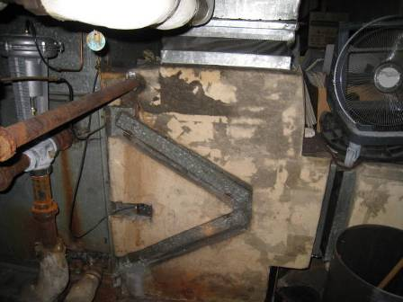

Air handling unit in mechanical room

Picture 2

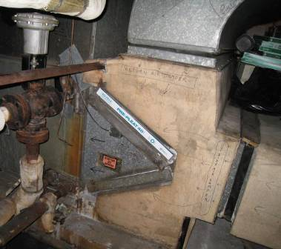

Air handling unit in mechanical room, note open filter access panel

Picture 3

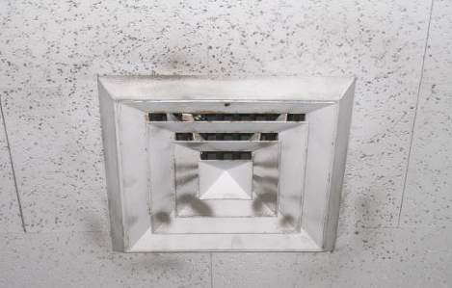

Ceiling-mounted supply diffuser, note accumulated dust/debris on vent
and surrounding ceiling tiles

Picture 4

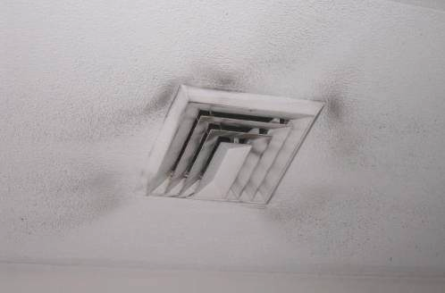

Ceiling-mounted supply diffuser, note accumulated dust/debris on vent
and surrounding ceiling tiles

Picture 5

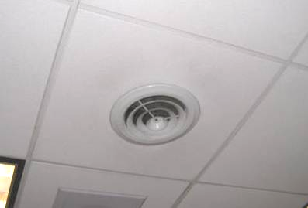

Ceiling-mounted supply diffuser

Picture 6

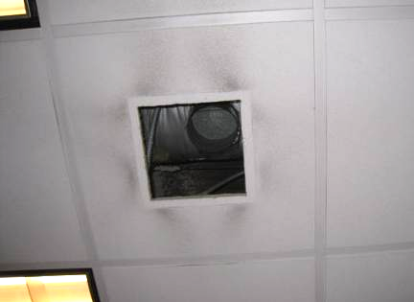

Missing ceiling-mounted supply diffuser in juvenile probation department, note accumulated dust/debris on surrounding ceiling tiles

Picture 7

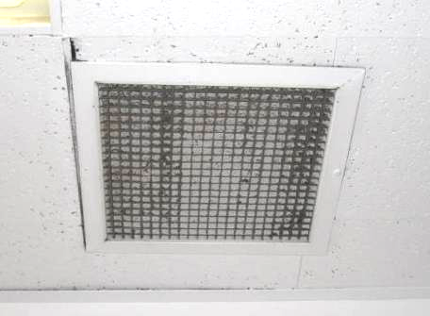

Ceiling-mounted return vent, note accumulated dust/debris

Picture 8

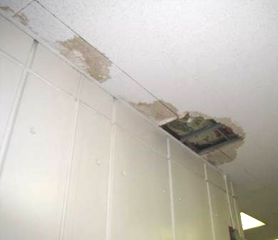

Missing/water-damaged ceiling tiles in 2nd floor hallway, note exposed fiberglass insulation

Picture 9

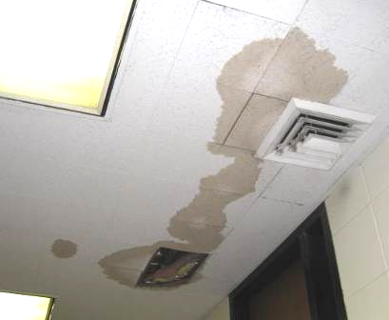

Missing/water-damaged ceiling tiles in 2nd floor hallway, note exposed fiberglass insulation

Picture 10

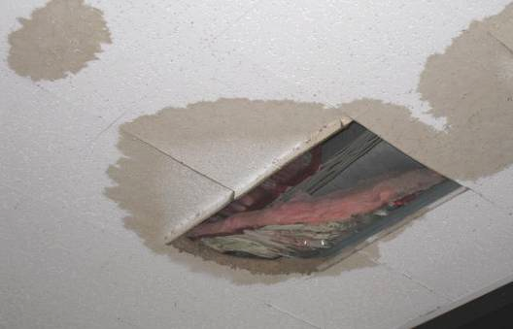

Missing/water-damaged ceiling tiles in 2nd floor hallway, note exposed fiberglass insulation

Picture 11

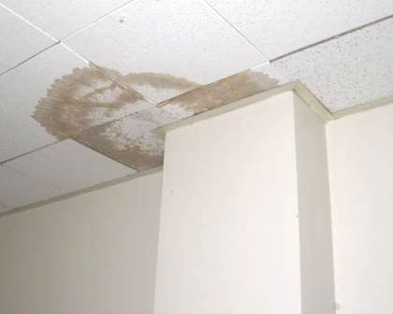

Water-damaged ceiling tiles

Picture 12

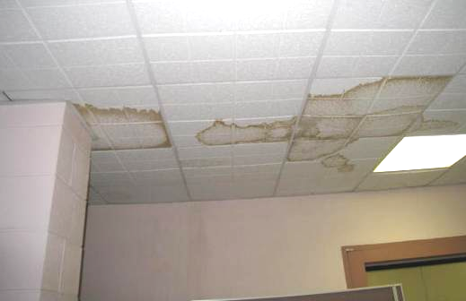

Water-damaged ceiling tiles

Picture 13

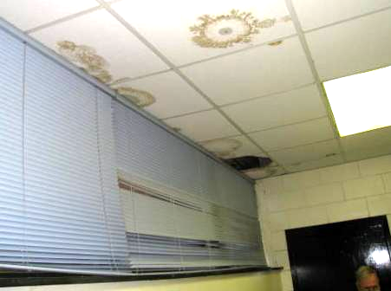

Water-damaged ceiling tiles, site of active leak in Juvenile Clerk’s Office

Picture 14

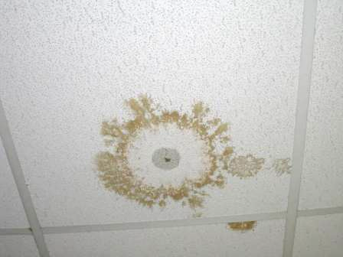

Active leak in Juvenile Clerk’s Office

Picture 15

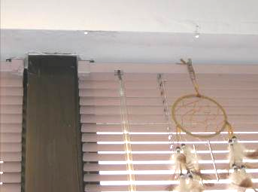

Active leaks in Probation Office, note water dripping from above windows (arrows)

Picture 16

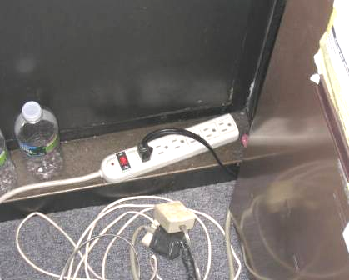

Active leak in Probation Office dripping on power strip and carpeting

Picture 17

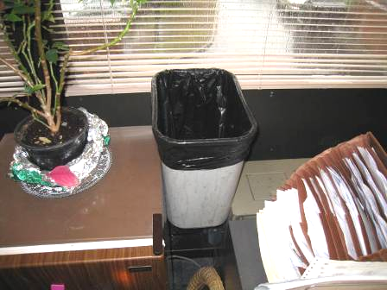

Waste basket catching leaking water in Probation Office

Picture 18

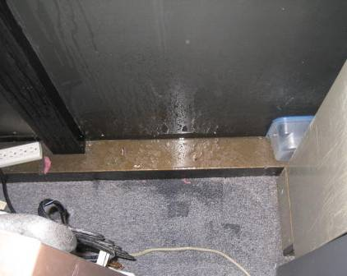

Wet carpeting and wall from leak in Probation Office

Picture 19

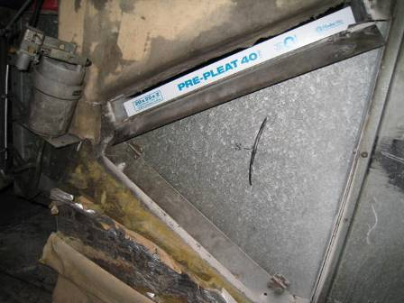

Filter access panel left open

Picture 20

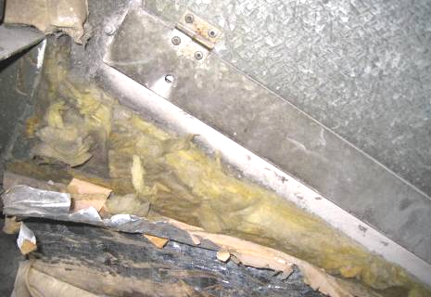

Filter access panel ajar due to missing latching mechanism (arrow), note damaged fiberglass insulation directly below open access panel

Picture 21

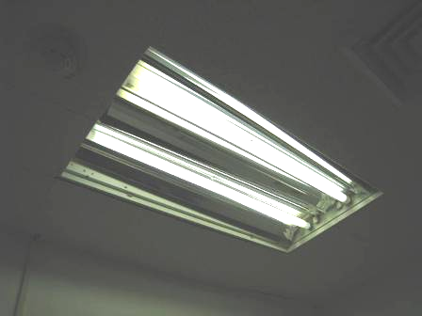

Florescent light fixture missing protective panel

Picture 22

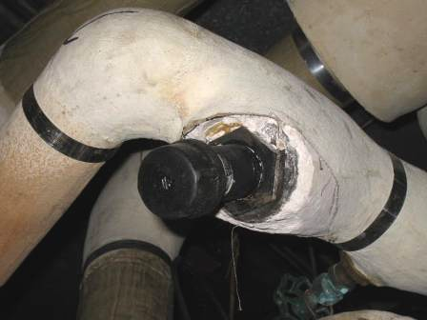

Exposed insulation material around pipes in HVAC mechanical room

Picture 23

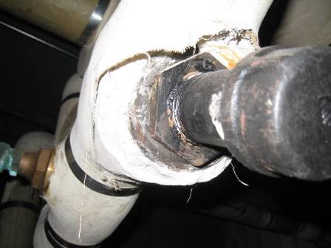

Exposed insulation material around pipes in HVAC mechanical room

Picture 24

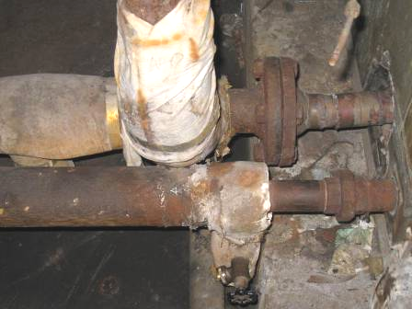

Exposed insulation material around pipes in HVAC mechanical room

Picture 25

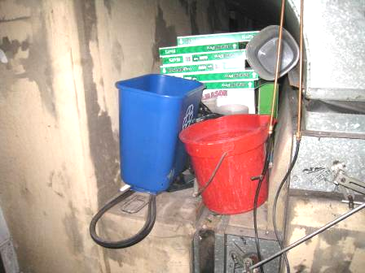

Various items stored on top of AHU/ductwork in mechanical room

Location | Carbon  Dioxide  (*ppm) | Temp  (°F) | Relative  Humidity  (%) | Carbon  Monoxide  (*ppm) | PM2.5  (µg/m³) | Occupants  in Room | Windows  Openable | Ventilation |  | Remarks
Background | 365 | 42 | 100 | ND | 7 |  |  |  |  | Moderate to heavy rains, winds SSE 21-39 mph, gusts up to 49 mph
2nd floor hallway |  |  |  |  |  |  |  |  |  | MT/WD CTs-exposed fiberglass insulation, dust/debris on vents
4th Session Court Room | 574 | 73 | 43 | ND | 5 | 0 | N | Y | Y | Dust/debris on vents/soiled CTs, worm/damaged carpeting
Conference Room 6 | 611 | 73 | 42 | ND | 1 | 0 | N | Y | Y | Dust/debris on vents, missing light covers
2nd Session Court Room | 552 | 74 | 41 | ND | 2 | 0 | N | Y | Y
DA’s Office (Inner) | 705 | 74 | 43 | ND | 2 | 3 | N | Y | N | DO
DA’s Office (Outer) | 824 | 75 | 43 | ND | 2 | 3 | N | Y | Y | Dust/debris on vents, DO
Police Prosecutor’s Office | 1060 | 74 | 43 | ND | 2 | 2 | N | Y | Y | Missing light covers
Conference Room 2 | 650 | 74 | 41 | ND | 2 | 0 | N | Y | Y
Jury Staff Office | 539 | 74 | 41 | ND | 3 | 0 | N | Y | Y
Jury Deliberation | 544 | 74 | 41 | ND | 1 | 0 | N | Y | Y
Judge’s Lobby Hallway |  |  |  |  |  |  |  |  |  | WD CT/MT
Judge Moriarty Lobby | 607 | 73 | 40 | ND | 2 | 0 | Y | Y | Y | MT
Law Library | 586 | 74 | 34 | ND | 3 | 0 | N | N | N | Vintage books/volumes, MT, exposed fiberglass insulation, air purifier, FCU-off
Jury B Court Room | 717 | 75 | 43 | ND | 1 | 35 | N | Y | Y | Dust/debris on vents
Jury Room B/Judge’s Lobby | 762 | 75 | 42 | ND | 2 | 0 | Y | N | N | MT
Judge Coven Lobby | 749 | 74 | 40 | ND | 1 | 0 | Y | N | N | WD CT, WD CT/MT in restroom
Judge Coven Reception Office | 625 | 74 | 40 | ND | 1 | 0 | Y | N | N | 5 WD CT
Probation Office | 548 | 75 | 39 | ND | 1 | 1 | Y | Y | N | Active leak over windows observed, wet gypsum drywall and carpeting
Adult Probation | 564 | 74 | 42 | ND | 3 | 10 | Y | Y | Y | Dust/debris on vents, MT
Lounge | 518 | 73 | 42 | ND | 2 | 0 | N | Y | Y | Dust/debris on vents, missing light covers
Clerk’s Office | 533 | 73 | 42 | ND | 2 | 10 | N | Y | Y | WD CT/MT, missing light covers
Vault/Clerk’s Office | 608 | 74 | 38 | ND | 2 | 1 | N | Y
Assistant Clerk’s Office | 656 | 74 | 41 | ND | 1 | 0 | Y | N | N | 7 WD CT-corner
1st Session Court Room | 717 | 74 | 46 | ND | 3 | ~100 | N | Y | Y | Dust/debris on ceiling grates, missing light covers
HR Office | 528 | 73 | 40 | ND | 1 | 0 | Y | N | N
Galvin Office | 583 | 73 | 40 | ND | 2 | 0 | Y | N | N | WD CT
Basement
Magistrate Common Area | 636 | 72 | 38 | ND | 3 | 2 | N | Y | Y | WD CT/MT
Magistrate Office | 676 | 73 | 42 | ND | 1 | 2 | Y | N | N | 5 WD CT
Court Officers | 749 | 72 | 46 | ND | 3 | 2 | N | Y | N | WD CT/MT, dust/debris on vents
Court Officers Office | 740 | 71 | 46 | ND | 2 | 1 | N | Y | N | MT corner, dust/debris on vents
Women’s Lock-up | 716 | 72 | 45 | ND | 1 | 2 | N | Y | N | WD CT/MT
Men’s Lock-up | 1080 | 72 | 49 | ND | 3 | 5 | N | Y | Y | MT
Juvenile Clerk’s Office | 656 | 73 | 44 | ND | 2 | 2 | Y | Y | Y | Active leaks along windows, WD/wet CT
Basement Probation Office | 700 | 73 | 44 | ND | 2 | 2 | N | Y | N | MT, DO
Basement Hallway |  |  |  |  |  |  |  |  |  | WD CT/MT
Small Claims | 571 | 72 | 41 | ND | 2 | 1 | N | Y |  | Missing light covers, dust/debris on vents
Restraining Order Office | 596 | 72 | 41 | ND | 2 | 1 | Y | Y |  | 2 WD CT, dust/debris on vents
Bookkeeping | 621 | 73 | 43 | ND | 2 | 1 | N | Y |  | Dust/debris on vents
Juvenile Probation Office | 616 | 74 | 42 | ND | 3 | 2 | N | Y |  | Missing supply diffuser/open to ceiling plenum, small space is reportedly occupied by up to 8 individuals, DO
Drug Court Office | 576 | 75 | 41 | ND | 2 | 1 | N | Y |  | DO
Probation Dept (Kennedy/McDonough) | 587 | 74 | 40 | ND | 1 | 0 | Y | Y | N
DA Break Room | 552 | 75 | 41 | ND | 1 | 0 | Y | Y | N | Dust/debris on vents
Juvenile Judge’s Lobby | 582 | 75 | 37 | ND | 1 | 0 | Y | Y | N | 2 WD CT
Juvenile Court Room | 561 | 74 | 41 | ND | 1 | 4 | N | Y | Y | Dust/debris on vents, MT

Actions on MDPH Recommendations, Quincy District Court
On February 12, 2012 MDPH’s IAQ Program requested detailed information regarding the Norfolk County Court Administration’s actions on recommendations made in the 2002 MDPH IAQ assessment, no information was provided. After a number of repeated attempts by Christopher McQuade, Administrative Attorney, Administrative Office of the Trial Court (AOTC), Norfolk County facility management officials have not provided any information regarding actions taken in response to recommendation made in the previous MDPH IAQ assessment as of the date of the issuance of this assessment. The following is a status report of action(s) taken on MDPH recommendations (in bold) based on a follow-up site visit, photographs and MDPH staff observations.

Short-Term Recommendations
- Contact the manufacturer to identify the proper procedure to disinfect FCU drain pans. Examine whether plastic liners can be replaced to prevent microbial growth.
  - Action: No information on this recommendation was provided at the time of the current assessment.
- Clean the interior of FCUs.
  - Action: No information on this recommendation was provided at the time of the current assessment..
- Once cleaned and operational, operate FCUs during business hours to enhance exhaust of air from private offices.
  - Action: The majority of the FCUs were not operating at the time of the assessment.
- Remove water damaged materials from the juvenile probation office, including carpeting.
  - Action: Water-damaged materials were reportedly removed/replaced.
- In order to decrease aerosolized particulates, disposable filters with an increased dust spot efficiency can be installed in FCUs. Ensure that installed filters are of a proper size and installed in a manner to eliminate particle bypass of the filter. Note that increased filtration can reduce airflow produced by the FCUs by increased resistance. Prior to any increase of filtration, each unit should be evaluated by a ventilation engineer as to whether they can maintain function with more efficient filters.
  - Action: Disposable filters were in place and appeared to be clean at the time of the assessment.
- Render airtight all open pipes and spaces around pipes in FCU cabinets.
  - Action: No information on this recommendation was provided at the time of the current assessment.

Long-Term Recommendations
- Runoff rainwater from the exterior wall must be prevented from entering the brick junction. The most efficient method to prevent rainwater penetration would be to remove all plants from this seam and install a flashing system over the brick to direct rainwater onto the building apron. Consider consulting a building engineer to examine this or other feasible options to prevent water penetration. Once rainwater penetration is remediated, repair the foundation wall in the juvenile probation office and remove ant infestation.
  - Action: No information on this recommendation was provided at the time of the current assessment.
- Water-damaged ceiling tiles should be replaced. These ceiling tiles can be a source of microbial growth and should be removed. Source(s) of water leaks (e.g., window frames and roof) should be identified and repaired. Examine the non-porous surface beneath the removed ceiling tiles and disinfect with an appropriate antimicrobial.
  - Action: Water-damaged ceiling tiles were observed in many areas throughout the building. Repairs have reportedly been made to alleviate leaks from the building exterior; however, chronic leaks remain and resulted in further water damage.
- Consideration should be given to installing/extending exhaust ventilation to all occupied areas in the basement.
  - Action: This action was not taken.
- Consider replacing vinyl wallpaper around windows with an alternative covering that is water permeable. Repair water damaged plaster once window leaks are remediated.
  - Action: Damaged plaster was repaired; however, vinyl wallpaper remains in place.

