INDOOR AIR QUALITY ASSESSMENT

Quincy Health Department
1585 Hancock Street
Quincy, Massachusetts

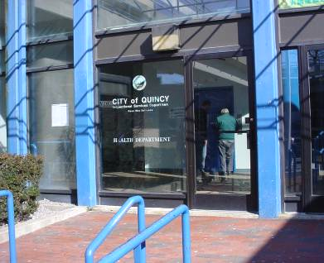

Prepared by:
Massachusetts Department of Public Health
Bureau of Environmental Health
Indoor Air Quality Program
March 2008

Background/Introduction
At the request of the Quincy Health Department (QHD), the Massachusetts Department of Public Health (MDPH), Bureau of Environmental Health (BEH), provided assistance and consultation regarding indoor air quality concerns at the QHD offices located at 1585 Hancock Street, Quincy, Massachusetts. The request was prompted by indoor air quality complaints of odors and eye/respiratory irritation.
On February 11, 2008, a visit to the QHD to conduct an indoor air quality assessment was made by Cory Holmes, an Environmental Analyst in BEH’s Indoor Air Quality (IAQ) Program. The QHD is located on the first floor of a mall at 1585 Hancock Street. This building is a two story steel frame and plaster structure built in the 1970s. The Quincy Health Department reports that the building in scheduled for demolition to make way for a road project. The second floor of this building contains unoccupied office space, a restaurant and a former movie theater. The QHD is located at the front of the building on the first floor, and is bordered by a barber school. The basement level can be accessed from the first floor by escalators and an elevator. The QHD does not have openable windows and is entirely reliant on the heating, ventilation and air-conditioning (HVAC) system for air exchange.

Methods
Air tests for carbon monoxide, carbon dioxide, temperature and relative humidity were conducted with the TSI, Q-Trak, IAQ Monitor, Model 8551. Air tests for airborne particle matter with a diameter less than 2.5 micrometers were taken with the TSI, DUSTTRAK™ Aerosol Monitor Model 8520. MDPH staff also performed visual inspection of building materials for water damage and/or microbial growth. Moisture content of porous building materials (e.g., gypsum wallboard, ceiling tiles, carpet) was measured with Delmhorst, BD-2000 Model, Moisture Detector with a Delmhorst Standard Probe.

Results
The QHD has an employee population of approximately 15 and is visited by a number of members of the public daily. The tests were taken during normal operations. Test results appear in Table 1.

Discussion
Ventilation
It can be seen from Table 1 that carbon dioxide levels were below 800 ppm (parts per million) in all areas surveyed, indicating adequate air exchange at the time of the assessment. The HVAC system consists of a rooftop air handling unit (AHU) (Picture 1), which draws in outside air through an air intake and feeds it into the building where it is re-heated/cooled by (two) heat pumps located in mechanical closets (Picture 2). Heat pumps distribute conditioned air through ducted ceiling/wall vents (Pictures 3 and 4).
Return air appears to migrate into an above ceiling plenum through plastic ceiling grates (Picture 5). Once air from occupied areas migrates into the ceiling plenum it is usually drawn to the outside via a mechanical exhaust vent. BEH staff could not identify a mechanical exhaust vent in the plenum. However, the rooftop AHU appeared to have the capacity to exhaust air. Exhaust ventilation is necessary to remove stale air from the interior of the QHD and to circulate air. BEH staff observed conditions above the ceiling in the reception area and found open utility holes (Pictures 6 and 7), which can compromise the integrity of the exhaust plenum. In addition, these breaches can provide a pathway for drafts, odors and pests into QHD space.
Thermostats that control the HVAC system have fan settings of “on” and “automatic”. The “automatic” setting on the thermostat activates the HVAC system at a preset temperature. Once the preset temperature is reached, the HVAC system is deactivated. Both thermostats in the QHD space were operating in the fan “on” mode (Picture 8), providing continuous airflow, which is recommended by the MDPH.
To maximize air exchange, the MDPH recommends that both supply and exhaust ventilation operate continuously during periods of occupancy. In order to have proper ventilation with a mechanical ventilation system, the systems must be balanced subsequent to installation to provide an adequate amount of fresh air to the interior of a room while removing stale air from the room. It is recommended that HVAC systems be re-balanced every five years to ensure adequate air systems function (SMACNA, 1994). The date of the last balancing of these systems was not available at the time of the assessment but should have occurred prior to occupancy by the QHD in 2000.
The Massachusetts Building Code requires that each room have a minimum ventilation rate of 20 cubic feet per minute (cfm) per occupant of fresh outside air or openable windows (SBBRS, 1997; BOCA, 1993). The ventilation must be on at all times that the room is occupied. Providing adequate fresh air ventilation with open windows and maintaining the temperature in the comfort range during the cold weather season is impractical. Mechanical ventilation is usually required to provide adequate fresh air ventilation.
Carbon dioxide is not a problem in and of itself. It is used as an indicator of the adequacy of the fresh air ventilation. As carbon dioxide levels rise, it indicates that the ventilating system is malfunctioning or the design occupancy of the room is being exceeded. When this happens, a buildup of common indoor air pollutants can occur, leading to discomfort or health complaints. The Occupational Safety and Health Administration (OSHA) standard for carbon dioxide is 5,000 parts per million parts of air (ppm). Workers may be exposed to this level for 40 hours/week, based on a time-weighted average (OSHA, 1997).
The Department of Public Health uses a guideline of 800 ppm for publicly occupied buildings. A guideline of 600 ppm or less is preferred in schools due to the fact that the majority of occupants are young and considered to be a more sensitive population in the evaluation of environmental health status. Inadequate ventilation and/or elevated temperatures are major causes of complaints such as respiratory, eye, nose and throat irritation, lethargy and headaches. For more information concerning carbon dioxide, please see Appendix A.
Temperature readings ranged from 71º F to 72 º F, which were within the MDPH recommended comfort guidelines the day of the assessment. The MDPH recommends that indoor air temperatures be maintained in a range of 70 º F to 78 º F in order to provide for the comfort of building occupants. In many cases concerning indoor air quality, fluctuations of temperature in occupied spaces are typically experienced, even in a building with an adequate fresh air supply.
The relative humidity measurements in the building ranged from 17 to 19 percent, which were below the MDPH comfort range in all areas during the assessment. The MDPH recommends a comfort range of 40 to 60 percent for indoor air relative humidity. Relative humidity levels in the building would be expected to drop during the winter months due to heating. The sensation of dryness and irritation is common in a low relative humidity environment. Low relative humidity is a very common problem during the heating season in the northeast part of the United States.

Microbial/Moisture Concerns
Several areas had water-damaged ceiling tiles (Picture 9/Table 1), which are evidence of previous leaks from the roof or plumbing system. Water-damaged ceiling tiles can provide a source of mold and should be replaced after a moisture source or leak is discovered and repaired. BEH staff removed ceiling tiles in a number of areas to examine conditions above the ceiling plenum. All areas appeared dry and no visible mold growth and/or associated odors were observed/detected, with one exception. A small amount of visible mold was observed on a two-inch area of gypsum wallboard (GW) above water damaged ceiling tiles in the main lobby (Pictures 9 and 10).
In addition, BEH staff also conducted moisture testing of carpeting and GW in areas that QHD staff reported had become wet due to previous plumbing leaks. In order for building materials to support mold growth, a source of water exposure is necessary. Identification and elimination of water moistening building materials is necessary to control mold growth. Materials with increased moisture content over normal concentrations may indicate the possible presence of mold growth. All porous materials testing in these areas were found to have low moisture at the time of the assessment. Moisture content of materials measured is a real-time measurement of the conditions present at the time of the assessment.
Visible mold growth however was observed on GW behind several file cabinets in the central inspector’s area (Picture 11). Although this area was dry at the time of the assessment, it appears that the GW in this area had remained moistened long enough for mold to grow, most likely due to moisture being trapped by the file cabinets which were pushed directly against the exterior wall (Picture 12). In contrast, BEH staff examined cabinets in the nurse’s office that had at least one to two-inches of space between the cabinet and wall where flooding had previously occurred and found no mold growth on the wall.
The US Environmental Protection Agency and the American Conference of Governmental Industrial Hygienists (ACGIH) recommends that porous materials (carpeting, ceiling tiles, etc.) be dried with fans and heating within 24 to 48 hours of becoming wet (US EPA, 2001; ACGIH, 1989). If porous materials are not dried within this time frame, mold growth may occur. Water-damaged porous materials cannot be adequately cleaned to remove mold growth. The application of a mildewcide to moldy porous materials is not recommended. Water damaged boxes and porous items were also observed in areas that have had leaks in the past (Pictures 13 and 14). As stated above water damaged porous materials should be discarded, in addition porous items should be relocated away from areas that are susceptible to moisture.
On previous assessments concerning GW mold growth, BEH personnel have consulted with Dr. Harriet Burge, formerly the Department Chair, (currently an Adjunct Senior Lecturer on Environmental Microbiology) of the Department of Environmental Health at the Harvard School of Public Health. The reoccurrence of mold growth on GW after the application of bleach is common. Bleach consists of sodium hypochlorite in a 5 percent concentration mixed with water. Mold colonization of GW can penetrate through its entire structure. When applied to moldy GW, the water of the bleach solution penetrates into the moldy GW, but the sodium hypochlorite remains on the surface. The sodium hypochlorite disinfects the surface mold that it comes in contact with on the GW surface, but not the mold beneath the surface. The additional water added to the subsurface fuels a spurt in mold growth, which increases mold colonization of the GW. As a result, mold colonies reappear on the surface of treated GW shortly after the application of bleach (personal communication, Burge, 1999).

Other IAQ Evaluations
Indoor air quality can be negatively influenced by the presence of respiratory irritants, such as products of combustion. The process of combustion produces a number of pollutants. Common combustion emissions include carbon monoxide, carbon dioxide, water vapor and smoke (fine airborne particle material). Of these materials, exposure to carbon monoxide and particulate matter with a diameter of 2.5 micrometers (μm) or less (PM2.5) can produce immediate, acute health effects upon exposure. To determine whether combustion products were present in the school environment, BEH staff obtained measurements for carbon monoxide and PM2.5.
Carbon monoxide is a by-product of incomplete combustion of organic matter (e.g., gasoline, wood and tobacco). Exposure to carbon monoxide can produce immediate and acute health affects. Several air quality standards have been established to address carbon monoxide and prevent symptoms from exposure to these substances. The MDPH established a corrective action level concerning carbon monoxide in ice skating rinks that use fossil-fueled ice resurfacing equipment. If an operator of an indoor ice rink measures a carbon monoxide level over 30 ppm, taken 20 minutes after resurfacing within a rink, that operator must take actions to reduce carbon monoxide levels (MDPH, 1997).
The American Society of Heating Refrigeration and Air-Conditioning Engineers (ASHRAE) has adopted the National Ambient Air Quality Standards (NAAQS) as one set of criteria for assessing indoor air quality and monitoring of fresh air introduced by HVAC systems (ASHRAE, 1989). The NAAQS are standards established by the US EPA to protect the public health from six criteria pollutants, including carbon monoxide and particulate matter (US EPA, 2006). As recommended by ASHRAE, pollutant levels of fresh air introduced to a building should not exceed the NAAQS levels (ASHRAE, 1989). The NAAQS were adopted by reference in the Building Officials & Code Administrators (BOCA) National Mechanical Code of 1993 (BOCA, 1993), which is now an HVAC standard included in the Massachusetts State Building Code (SBBRS, 1997). According to the NAAQS, carbon monoxide levels in outdoor air should not exceed 9 ppm in an eight-hour average (US EPA, 2006).
Carbon monoxide should not be present in a typical, indoor environment. If it is present, indoor carbon monoxide levels should be less than or equal to outdoor levels. On the day of assessment, outdoor carbon monoxide concentrations were non-detect (ND) (Table 1). Carbon monoxide levels measured in the building were also ND.
The US EPA has established NAAQS limits for exposure to particulate matter. Particulate matter is airborne solids that can be irritating to the eyes, nose and throat. The NAAQS originally established exposure limits to particulate matter with a diameter of 10 μm or less (PM10). According to the NAAQS, PM10 levels should not exceed 150 microgram per cubic meter (μg/m³) in a 24-hour average (US EPA, 2006). These standards were adopted by both ASHRAE and BOCA. Since the issuance of the ASHRAE standard and BOCA Code, US EPA established a more protective standard for fine airborne particles. This more stringent PM2.5 standard requires outdoor air particle levels be maintained below 35 μg/m³ over a 24-hour average (US EPA, 2006). Although both the ASHRAE standard and BOCA Code adopted the PM10 standard for evaluating air quality, MDPH uses the more protective PM2.5 standard for evaluating airborne particulate matter concentrations in the indoor environment.
Outdoor PM2.5 concentrations were measured at 6 μg/m³ (Table 1). PM2.5 levels measured in the QHD were between 3 to 6 μg/m³ (Table 1), which were below the NAAQS PM2.5 level of 35 μg/m³. Frequently, indoor air levels of particulates (including PM2.5) can be at higher levels than those measured outdoors. A number of mechanical devices and/or activities that occur in buildings can generate particulate during normal operations. Sources of indoor airborne particulates may include but are not limited to particles generated during the operation of fan belts in the HVAC system, cooking in stoves and microwave ovens; use of photocopiers, fax machines and computer printing devices; operation of an ordinary vacuum cleaner and heavy foot traffic indoors.
Several other conditions that can potentially affect indoor air quality were also identified. Of note was the amount of materials stored inside the QHD. Items were observed on windowsills, tabletops, counters, bookcases and desks. The large number of items stored provides a source for dusts to accumulate. These items, (e.g., papers, folders, boxes) make it difficult for custodial staff to clean. Dust can be irritating to eyes, nose and respiratory tract. Items should be relocated and/or be cleaned periodically to avoid excessive dust build up.
Open spaces were observed in the filter slot of the heat pumps (Picture 15). As air flows through the heat pump/filter bank it creates negative pressure that can draw dust and other airborne pollutants into the HVAC system through these spaces, where they can be distributed to occupied areas. The spaces around filters are usually sealed (Pictures 16 and 17).
A bleach-soaked mop was observed in a bucket in the kitchen area (Picture 18). The mop/bucket is stored in this area reportedly due to a lack of custodial space. These items should not be stored in occupied areas and preferably be stored in a custodial closet equipped with a local exhaust vent. Bleach odors were prevalent, which can provide a source of eye and respiratory irritation. In addition, because the HVAC system recirculates a percentage of air, these irritants can be distributed to occupied areas of the building continuously. Another source of irritation was observed in the storage room in the form of exposed fiberglass insulation (Picture 19). Fiberglass is a eye, skin and respiratory irritant.
Occupants expressed concern regarding the condition and cleaning of carpeting and could not recall if a carpet cleaning program was in place. The Institute of Inspection, Cleaning and Restoration Certification (IICRC), recommends that carpeting be cleaned annually or semi-annually in soiled high traffic areas (IICRC, 2005). In addition, the MDPH recommends regular vacuuming of carpets using a high efficiency particulate arrestance (HEPA) filter equipped vacuum cleaner. HEPA filters remove at least 99.97% of airborne particles 0.3 micrometers (µm) in diameter including pollen and dust mite feces, which can trigger allergy and asthma symptoms. The vacuum cleaner in use at the QHD is a commercial grade bag vacuum (Picture 20) and not equipped with HEPA filtration.

Conclusions/Recommendations
In view of the findings at the time of the visit, the following recommendations are made:
- Remove and replace mold contaminated/water damaged GW in central inspectors’ area and above water damaged ceiling tiles in reception lobby. This measure will remove actively growing mold colonies that may be present. Remove mold contaminated materials in a manner consistent with recommendations found in “Mold Remediation in Schools and Commercial Buildings” published by the US Environmental Protection Agency (US EPA, 2001). Copies of this document can be downloaded from the US EPA website at: http://www.epa.gov/iaq/molds/mold_remediation.html.
- Ensure work is done during unoccupied periods to prevent/minimize exposure.
- Ensure HVAC system is deactivated and vents are sealed (e.g., plastic and duct tape) in the area to prevent entrainment of mold spores.
- Seal mold-contaminated materials in plastic garbage bags to prevent tracking debris when being removed.
- Once remediation is completed, ensure area is thoroughly cleaned using a HEPA filtered vacuum and wet wiping of flat (non-porous) surfaces.
  - Continue to operate the HVAC system continuously in the fan “on” mode during periods of occupancy to maximize air exchange. Consult the buildings’ heating, ventilation and air conditioning (HVAC) vendor concerning the presence/location of exhaust vents above the ceiling tile system.
  - Consult a ventilation engineer concerning re-balancing of the ventilation systems. Ventilation industrial standards recommend that mechanical ventilation systems be balanced every five years (SMACNA, 1994).
  - For buildings in New England, periods of low relative humidity during the winter are often unavoidable. Therefore, scrupulous cleaning practices should be adopted to minimize common indoor air contaminants whose irritant effects can be enhanced when the relative humidity is low. To control for dusts, a high efficiency particulate arrestance (HEPA) filter equipped vacuum cleaner in conjunction with wet wiping of all surfaces is recommended. Drinking water during the day can help ease some symptoms associated with a dry environment (e.g., throat and sinus irritations).
  - Continue to repair any water leaks as they may occur and replace any remaining water damaged ceiling tiles. Examine the areas above and behind these areas for mold growth. Disinfect areas of water leaks with an appropriate antimicrobial.
  - Discard water damaged items. Do not store porous materials (e.g., cardboard, paper) in areas prone to water damage.
  - Remove bleach-soaked mop and bucket from kitchen. These items should not be stored in occupied areas and should preferably be stored in a custodial closet equipped with a local exhaust vent.
  - Repair loose damaged ceiling tile in storage room to prevent exposure to fiberglass insulation.
  - Seal spaces around filters in heat pumps to prevent entrainment of airborne pollutants.
  - Relocate or consider reducing the amount of materials stored in common areas to allow for more thorough cleaning. Clean items regularly with a wet cloth or sponge to prevent excessive dust build-up.
  - Install shelving units or obtain additional storage cabinets to provide proper storage of items.
  - Consider storing paper/folders/records in plastic sealable containers.
  - Consult with building owner/maintenance and leasing officer regarding changing of filters and preventative maintenance on HVAC equipment for the QHD.
  - Refer to resource manuals and other related indoor air quality documents located on Clean/change filters for air handling equipment as per the manufactures instructions or more frequently if needed. the MDPH’s website for further building-wide evaluations and advice on maintaining public buildings. These documents are available at: http://www.state.ma.us/dph/MDPH/iaq/iaqhome.htm.

References
ACGIH. 1989. Guidelines for the Assessment of Bioaerosols in the Indoor Environment. American Conference of Governmental Industrial Hygienists, Cincinnati, OH.

ASHRAE. 1989. Ventilation for Acceptable Indoor Air Quality. American Society of Heating, Refrigeration and Air Conditioning Engineers. ANSI/ASHRAE 62-1989
BOCA. 1993. The BOCA National Mechanical Code/1993. 8th ed. Building Officials & Code Administrators International, Inc., Country Club Hills, IL.

Burge, H. 1999. Personal Conversation with Dr. Harriet Burge, Harvard School of Public Health. December 13th, 1999.

IICRC. 2005. Carpet Cleaning FAQ 4 Institute of Inspection, Cleaning and Restoration Certification. Institute of Inspection Cleaning and Restoration, Vancouver, WA.

MDPH. 1997. Requirements to Maintain Air Quality in Indoor Skating Rinks (State Sanitary Code, Chapter XI). 105 CMR 675.000. Massachusetts Department of Public Health, Boston, MA.
OSHA. 1997. Limits for Air Contaminants. Occupational Safety and Health Administration. Code of Federal Regulations. 29 C.F.R 1910.1000 Table Z-1-A.

SBBRS. 1997. Mechanical Ventilation. State Board of Building Regulations and Standards. Code of Massachusetts Regulations. 780 CMR 1209.0

SMACNA. 1994. HVAC Systems Commissioning Manual. 1st ed. Sheet Metal and Air Conditioning Contractors’ National Association, Inc., Chantilly, VA.

US EPA. 2001. “Mold Remediation in Schools and Commercial Buildings”. Office of Air and Radiation, Indoor Environments Division, Washington, DC. EPA 402-K-01-001. March 2001. Available at: http://www.epa.gov/iaq/molds/mold_remediation.html

US EPA. 2006. National Ambient Air Quality Standards (NAAQS). US Environmental Protection Agency, Office of Air Quality Planning and Standards, Washington, DC. http://www.epa.gov/air/criteria.html.
Picture 1

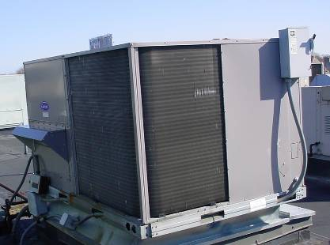

Rooftop AHU

Picture 2

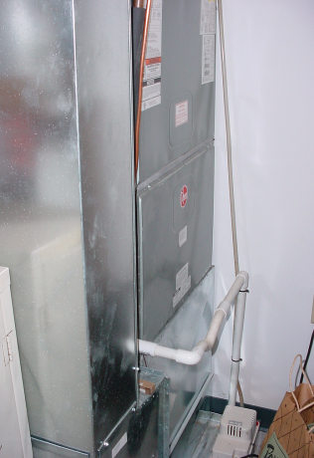

One of Two Heat Pumps Located in Mechanical Closets
Picture 3

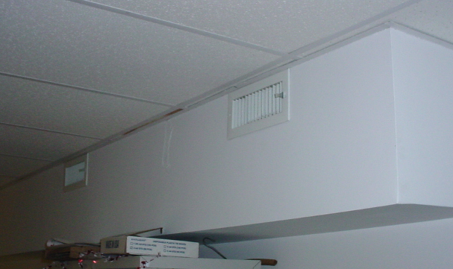

Ducted Supply Diffusers

Picture 4

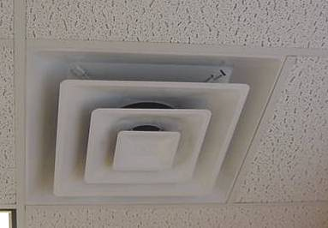

Example of Ceiling-Mounted Supply Air Diffuser
Picture 5

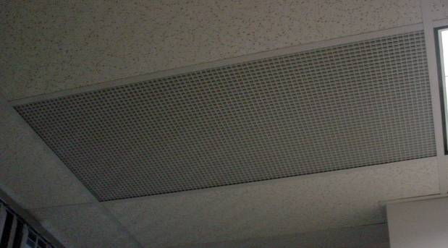

Return Grate to Ceiling Plenum

Picture 6

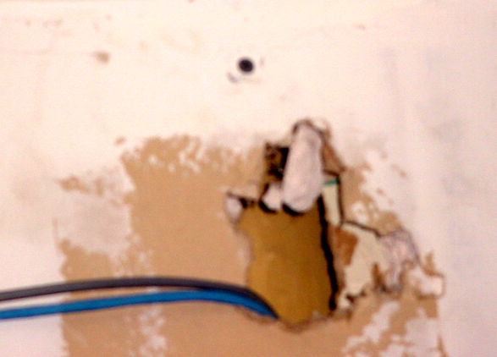

Open Utility Hole above Ceiling Plenum in Reception Area
Picture 7

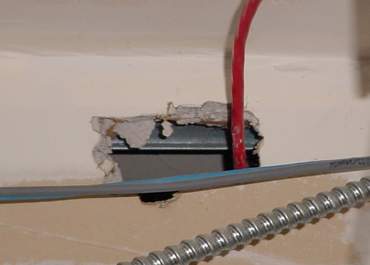

Open Utility Hole above Ceiling Plenum in Reception Area

Picture 8

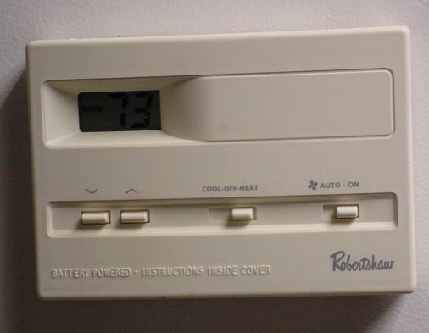

Thermostat With Fan in “On” Mode
Picture 9

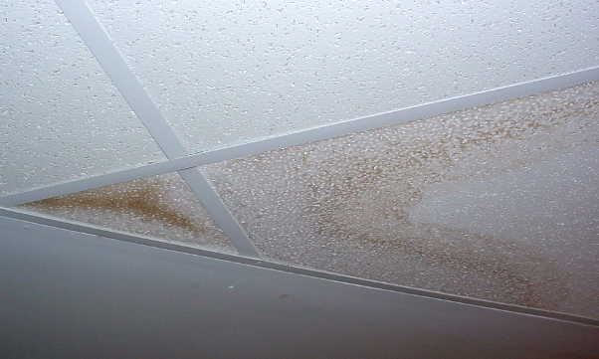

Water Damaged Ceiling Tiles in Reception Area Lobby

Picture 10

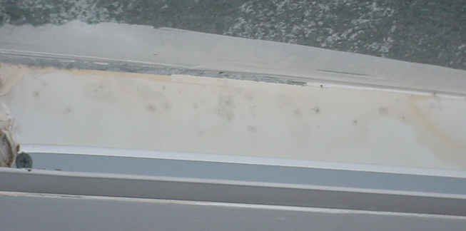

Visible Mold Growth (as Indicted by Dark Stains) on GW above Water Damaged Ceiling Tiles in Reception Area Lobby, Shown in Preceding Picture
Picture 11

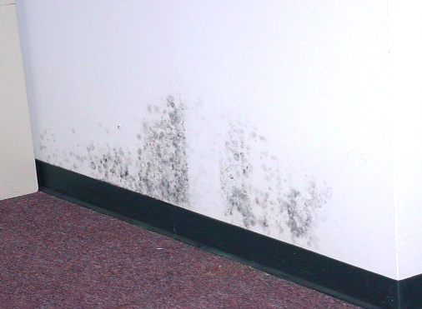

Visible Mold Growth (as Indicted by Dark Stains) on GW behind File Cabinets
in Central Inspector’s Area

Picture 12

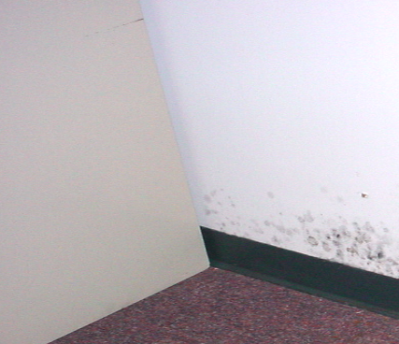

Close-Up of File Cabinets Directly against Wall in Central Inspector’s Area
Picture 13

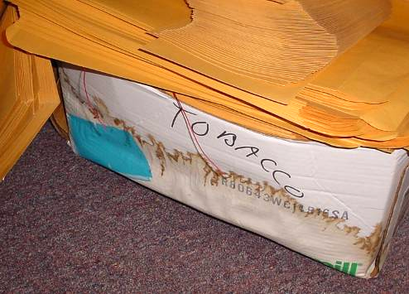

Water Damaged Cardboard Box Stored in Area of Historic Water Damage

Picture 14

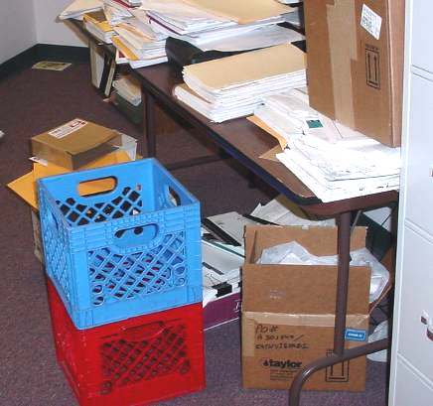

Porous Materials (Boxes, Papers) Stored in Area of Historic Water Damage
Picture 15

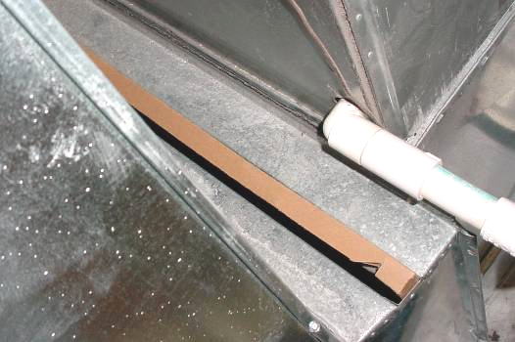

Open Spaces around Cardboard Filter for Heat Pump

Picture 16

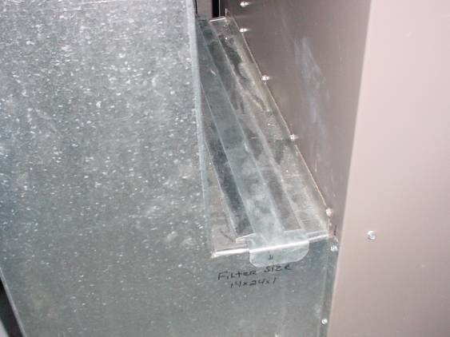

Example of Heat Pump Filter Slot Sealed With Sheet Metal Tab
Picture 17

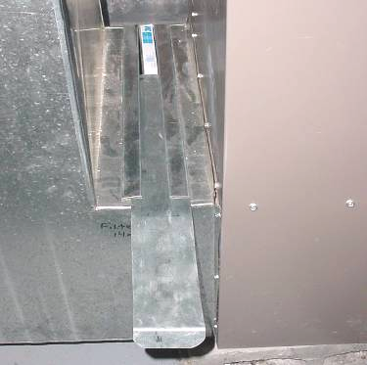

Example of Heat Pump Filter Slot Sealed With Sheet Metal Tab

Picture 18

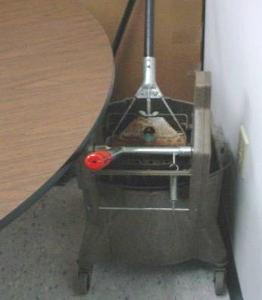

Mop Soaked in Bleach Stored in Kitchen
Picture 19

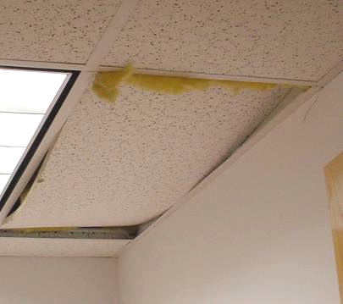

Exposed Fiberglass Insulation in Storage Room

Picture 20

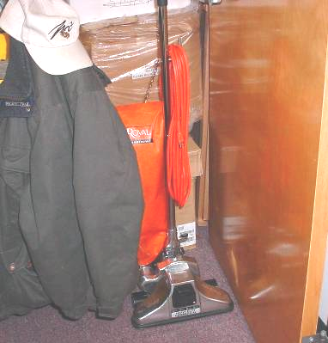

Commercial-Grade Bag Vacuum Used at the QHD
Location/ Room | Occupants  in Room | Temp  (°F) | Relative  Humidity  (%) | Carbon  Dioxide  (ppm) | Carbon Monoxide  (ppm) | PM2.5  (µg/m3) | Windows  Openable | Ventilation |  | Remarks
 |  |  |  |  |  |  |  | Supply | Exhaust | Remarks
background |  | <32 | 20 | 350 | ND | 6 |  |  |  | Cold-below freezing, winds WNW 22-31, with gusts up to 48 mph
Reception Lobby | 0 | 72 | 18 | 678 | ND | 5 | N | Y | N | 2 WD CT, visible mold growth (light) on surface of GW above CTs-low (i.e., normal) moisture
Reception | 3 | 72 | 18 | 692 | ND | 3 | N | Y | Y | 1 WD CT rear wall-low (i.e., normal) moisture, GW-low (i.e., normal) moisture
Inspectors Central | 0 | 72 | 18 | 647 | ND | 4 | N | Y | Y | Thermostat fan “on”, no WD above CT
Inspectors File Area | 0 | 72 | 18 | 760 | ND | 4 | N | Y | Y | Historic water damage, carpet/GW-low (i.e., normal) moisture, visible mold growth behind file cabinets, 1 WD CT
Chief Sanitarian | 1 | 72 | 18 | 659 | ND | 3 | N | Y | Y | Site of previous flooding-sprinkler burst, carpet/GW-low (i.e., normal) moisture, carpet lifted-no vis mold/WD, porous materials stored on floor along wall, WD box
Heat Pump Room |  |  |  |  |  |  |  |  |  | Used for storage, spaces around filter-not sealed
Commish Office | 0 | 71 | 18 | 690 | ND | 5 | N | Y | Y | DO
Conference Room | 0 | 71 | 17 | 595 | ND | 5 | N | Y | N
Hallway |  |  |  |  |  |  |  |  |  | Bleach odors, WD CT outside women’s room
Kitchen | 0 | 71 | 18 | 608 | ND | 4 | N | Y | N | 1 WD CT, mop/bucket soaked in bleach-odors
Storeroom | 0 | 71 | 19 | 588 | ND | 4 | N | Y | Y | Exposed fiberglass insulation-dislodged CT, old vacuum-bag-no HEPA
Nurse’s Office | 1 | 71 | 19 | 585 | ND | 6 | N | Y | Y | Previous flooding-file cabinets moved-no vis mold, GW/carpet-low (i.e., normal) moisture
Inoculation Room | 0 | 71 | 19 | 576 | ND | 3 | N | Y | Y

