INDOOR AIR QUALITY ASSESSMENT

Quincy Housing Authority
Tobin Towers
80 Clay Street
Quincy, MA 02170

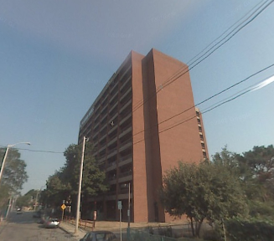

Prepared by:
Massachusetts Department of Public Health
Bureau of Environmental Health
Indoor Air Quality Program
November 2009

Background/Introduction
At the request of Andrew Scheele, Public Health Commissioner, Quincy Health Department, the Massachusetts Department of Public Health (DPH), Bureau of Environmental Health (BEH) provided assistance and consultation regarding indoor air quality concerns at the Quincy Housing Authority’s (QHA) Tobin Towers, 80 Clay Street, Quincy, Massachusetts. On October 22, 2008, a visit to conduct an assessment was made to this building by Sharon Lee, an Environmental Analyst/Inspector within BEH’s Indoor Air Quality (IAQ) Program. The assessment was prompted by a concerns related to indoor air quality and health. During the assessment, Ms. Lee was accompanied by Mr. Scheele and Dave Ferris, Superintendent of Maintenance, QHA.
The Tobin Towers is a 12-story, T-shaped, red brick building constructed in 1976. The building serves as an elderly housing complex predominantly for senior citizens. The first floor consists of offices, the second through eleventh floors each contain 20 apartment units, and the twelfth floor houses a social hall, kitchen, and various activity rooms. Windows in each apartment are openable.
Methods
Air tests for carbon monoxide, carbon dioxide, temperature and relative humidity were conducted with the TSI, Q-Trak, IAQ Monitor, Model 8554. Air tests for airborne particle matter with a diameter less than 2.5 micrometers were taken with the TSI, DUSTTRAK™ Aerosol Monitor Model 8520. Screening for total volatile organic compounds (TVOCs) was conducted using a MiniRAE 2000 Portable VOC Monitor, Model PGM 7600. BEH staff also performed visual inspection of building materials for water damage and/or microbial growth. Tests/observations were made in shared common spaces (i.e. dining area, workout room, library, pool/billiards room) and access areas (i.e. hallways, stairwells, and trash rooms). BEH staff did not assess conditions within individual units.
Results
The Tobin Towers has an employee population of approximately 15 and currently houses approximately 300 residents. Test results appear in Table 1.
Discussion

Ventilation

Shared common spaces
It can be seen from Table 1 that carbon dioxide levels were below 800 parts per million (ppm) in all 12th floor activity areas (i.e. dining room, workout room, library, and pool/billiards room), indicating adequate air exchange in these areas of the building at the time of the assessment. It is important to note that these areas were empty/sparsely populated, which can greatly reduce carbon dioxide levels. Carbon dioxide levels would be expected to be higher with increased occupancy and windows closed.
Fresh air is supplied to the dining area and workout room by unit ventilator (univent) systems (Picture 1). A univent draws air from the outdoors through a fresh air intake located on the exterior wall of the building and returns air through an air intake located at the base of the unit (Figure 1). Fresh and return air are mixed, filtered, heated and provided to classrooms through an air diffuser located in the top of the unit. All univents were deactivated at the time of assessment. In order for univents to provide fresh air as designed, these units should be activated while rooms are occupied. Obstructions were observed on some univents (Picture 2). Fresh air diffusers should remain unobstructed to allow for proper ventilation and to prevent off-gassing from materials used to obstruct the diffusers.
Exhaust ventilation to these areas is provided by ceiling-mounted exhaust vents ducted to an exhaust fan located on the roof of the building (Picture 3). The exhaust system appeared to be operating at the time of assessment. As with univents, the exhaust system should be activated while rooms are occupied.
A number of ceiling fans (Picture 4) and/or window mounted air conditioners (ACs) are also present in the dining area, workout room and library. Ceiling fans are used to aid in air circulation within a room. These fans should be operated in conjunction with the univent system to aid in airflow. Window mounted air conditioners (ACs) typically are used to provide cooling during warmer months. The ACs examined are equipped with a “fan only” setting. Consideration should be given to operating ACs in the “fan only” mode as means to introduce supplemental fresh air.
No mechanical ventilation, either supply or exhaust, could be identified in the pool/billiards room. Consideration should be given to installing a passive vent through either the door or wall shared with the dining room area. A ceiling fan should also be installed in this room. Operation of a ceiling fan in the presence of a passive vent would aid in the draw of air into this room.
The Massachusetts Building Code requires that each room have a minimum ventilation rate of 15 cubic feet per minute (cfm) per occupant of fresh outside air or openable windows (SBBRS, 1997; BOCA, 1993). The ventilation must be on at all times that the room is occupied. Providing adequate fresh air ventilation with open windows and maintaining the temperature in the comfort range during the cold weather season is impractical. Mechanical ventilation is usually required to provide adequate fresh air ventilation.
Carbon dioxide is not a problem in and of itself. It is used as an indicator of the adequacy of the fresh air ventilation. As carbon dioxide levels rise, it indicates that the ventilating system is malfunctioning or the design occupancy of the room is being exceeded. When this happens, a buildup of common indoor air pollutants can occur, leading to discomfort or health complaints. The Occupational Safety and Health Administration (OSHA) standard for carbon dioxide is 5,000 parts per million parts of air (ppm). Workers may be exposed to this level for 40 hours/week, based on a time-weighted average (OSHA, 1997).
The MDPH uses a guideline of 800 ppm for publicly occupied buildings. A guideline of 600 ppm or less is preferred in schools due to the fact that the majority of occupants are young and considered to be a more sensitive population in the evaluation of environmental health status. Inadequate ventilation and/or elevated temperatures are major causes of complaints such as respiratory, eye, nose and throat irritation, lethargy and headaches. For more information concerning carbon dioxide, please see Appendix A.

Access Areas
As discussed, hallways, stairwells, and trash rooms were also examined. Of the 70 areas assessed, carbon dioxide levels were elevated in two hallways, a stairwell, and a trash room. While these are not designed for occupancy, appropriate ventilation is typically provided to prevent accumulation of odors and particles that may occur in these spaces. Air-handling units (AHUs) ducted to ceiling-mounted vents provide fresh air to each of the hallways on each floor (Picture 5), while return vents bring air back to the AHUs (Picture 6). At the time of assessment, the AHU was not operating and no air flow could be detected from either supply or return vents. QHA maintenance staff indicated that the AHUs are operated in the summer to provide make up air, but are turned off in the winter. These AHUs reportedly provide 100 percent fresh air when operating. Consideration should be given to providing fresh air to these areas during the heating season to prevent accumulation of odors and waste heat.
Exhaust vents in the trash disposal rooms did not appear to be operating at the time of assessment. QHA maintenance staff indicated that these may be passive. Equipment for this exhaust system should be examined to ensure proper function. If no equipment exists, consideration should be given to installing a motorized fan to provide mechanical exhaust and removal of odors from the building.

Temperature
Temperature readings in the shared common spaces ranged from 71º F to 73 º F, which were within the MDPH recommended comfort guidelines (Table 1). Temperatures in the access areas ranged from 77º F to79º F, which were within or slightly above the MDPH recommended comfort guideline. The MDPH recommends that indoor air temperatures be maintained in a range of 70 º F to 78 º F in order to provide for the comfort of building occupants. Operation of existing ventilation equipment is necessary to maintaining thermal comfort. In many cases concerning indoor air quality, fluctuations of temperature in occupied spaces are typically experienced, even in a building with an adequate fresh air supply.

Relative Humidity
The relative humidity measurements ranged from 37 to 38 percent in shared common spaces and 28 to 40 percent in access areas, which were below the MDPH recommended comfort range in the majority of areas (Table 1). The MDPH recommends a comfort range of 40 to 60 percent for indoor air relative humidity. Relative humidity levels in the building would be expected to drop during the winter months due to heating. The sensation of dryness and irritation is common in a low relative humidity environment. Low relative humidity is a very common problem during the heating season in the northeast part of the United States.

Microbial/Moisture Sources
Water-damaged plaster and gypsum wallboard (GW) ceiling and walls were observed in a number of hallway areas (Pictures 7 and 8). Plaster exhibits efflorescence when water-damaged, but is not a source for mold growth. As moisture penetrates and works its way through mortar, brick or plaster, water-soluble compounds dissolve, creating a solution. As the solution moves to the surface of the material, the water evaporates, leaving behind white, powdery mineral deposits known as efflorescence. In contrast, water-damaged GW can be a source of mold growth if it becomes saturated.
At the time of assessment, water-damaged GW was not moist. QHA staff indicated that water-damaged materials are replaced after the source of water has been repaired. For example, QHA staff were reportedly repairing a corroded bathroom drain that caused water damage to a GW wall in the hallway. BEH staff observed the hallway where GW had been removed for repairs to the corroded drain; damaged GW had been removed in this hallway and from several other areas at the time of the assessment.
Water-damaged ceiling tiles were observed in some 12th floor areas (i.e. dining, kitchen; Picture 9). QHA staff indicated that water damage is sustained to these areas under driving rain. Ceiling tiles should be replaced after a water leak is discovered and repaired.
Open seams between sink countertops and walls were observed in several rooms (Picture 10). If not watertight, water can penetrate through the seam, causing water damage. Improper drainage or sink overflow can lead to water penetration into the countertop, cabinet interior and areas behind cabinets. Water penetration and chronic exposure of porous and wood-based materials can cause these materials to swell and show signs of water damage. Repeated moistening of porous materials can result in mold growth.
The US Environmental Protection Agency (US EPA) and the American Conference of Governmental Industrial Hygienists (ACGIH) recommend that porous materials be dried with fans and heating within 24 to 48 hours of becoming wet (US EPA, 2001; ACGIH, 1989). If not dried within this time frame, mold growth may occur. Once mold has colonized porous materials, they are difficult to clean and should be removed/discarded.

Point-Source Pollutants
Indoor air quality can be negatively influenced by the presence of respiratory irritants, such as products of combustion. The process of combustion produces a number of pollutants. Common combustion emissions include carbon monoxide, carbon dioxide, water vapor and smoke (fine airborne particle material). Of these materials, exposure to carbon monoxide and particulate matter with a diameter of 2.5 micrometers (μm) or less (PM2.5) can produce immediate, acute health effects upon exposure. To determine whether combustion products were present in the building, BEH staff obtained measurements for carbon monoxide and PM2.5.
Carbon Monoxide
Carbon monoxide is a by-product of incomplete combustion of organic matter (e.g., gasoline, wood and tobacco). Exposure to carbon monoxide can produce immediate and acute health affects. Several air quality standards have been established to address carbon monoxide and prevent symptoms from exposure to these substances. The MDPH established a corrective action level concerning carbon monoxide in ice skating rinks that use fossil-fueled ice resurfacing equipment. If an operator of an indoor ice rink measures a carbon monoxide level over 30 ppm, taken 20 minutes after resurfacing within a rink, that operator must take actions to reduce carbon monoxide levels (MDPH, 1997).
The American Society of Heating Refrigeration and Air-Conditioning Engineers (ASHRAE) has adopted the National Ambient Air Quality Standards (NAAQS) as one set of criteria for assessing indoor air quality and monitoring of fresh air introduced by HVAC systems (ASHRAE, 1989). The NAAQS are standards established by the US EPA to protect the public health from six criteria pollutants, including carbon monoxide and particulate matter (US EPA, 2006). As recommended by ASHRAE, pollutant levels of fresh air introduced to a building should not exceed the NAAQS levels (ASHRAE, 1989). The NAAQS were adopted by reference in the Building Officials & Code Administrators (BOCA) National Mechanical Code of 1993 (BOCA, 1993), which is now an HVAC standard included in the Massachusetts State Building Code (SBBRS, 1997). According to the NAAQS, carbon monoxide levels in outdoor air should not exceed 9 ppm in an eight-hour average (US EPA, 2006).
Carbon monoxide should not be present in a typical, indoor environment. If it is present, indoor carbon monoxide levels should be less than or equal to outdoor levels. On the day of assessment, the outdoor carbon monoxide concentration was 1 ppm (Table 1). No measurable levels of carbon monoxide indoors were detected at the time of the assessment (Table 1).
Particulate Matter (PM2.5)
The US EPA has established NAAQS limits for exposure to particulate matter. Particulate matter is airborne solids that can be irritating to the eyes, nose and throat. The NAAQS originally established exposure limits to particulate matter with a diameter of 10 μm or less (PM10). According to the NAAQS, PM10 levels should not exceed 150 microgram per cubic meter (μg/m³) in a 24-hour average (US EPA, 2006). These standards were adopted by both ASHRAE and BOCA. Since the issuance of the ASHRAE standard and BOCA Code, US EPA established a more protective standard for fine airborne particles. This more stringent PM2.5 standard requires outdoor air particle levels be maintained below 35 μg/m³ over a 24-hour average (US EPA, 2006). Although both the ASHRAE standard and BOCA Code adopted the PM10 standard for evaluating air quality, MDPH uses the more protective PM2.5 standard for evaluating airborne particulate matter concentrations in the indoor environment.
Outdoor PM2.5 concentrations were measured at 15 μg/m³ (Table 1). PM2.5 levels measured on the 12th floor shared common areas ranged from 7 to 10 μg/m³ (Table 1), which were below the outdoor and NAAQS level. PM2.5 levels in access areas ranged from 4 to 122 μg/m³, which were above the NAAQS PM2.5 level of 35 μg/m³ in several areas (Table 1). Smoking and cooking odors were detected in some areas. These activities can increase particulate levels in the indoor environment. However, without adequate ventilation, these elevated PM2.5 levels can persist.
Frequently, indoor air levels of particulates (including PM2.5) can be at higher levels than those measured outdoors. A number of mechanical devices and/or activities that occur in buildings can generate particulate during normal operations. Sources of indoor airborne system, cooking in stoves and microwave ovens; use of photocopiers, fax machines and computer printing devices; operation of an ordinary vacuum cleaner and heavy foot traffic indoors.
Volatile Organic Compounds
Indoor air quality can be negatively influenced by the presence of materials containing volatile organic compounds (VOCs). VOCs are carbon-containing substances that have the ability to evaporate at room temperature. Frequently, exposure to low levels of total VOCs (TVOCs) may produce eye, nose, throat and/or respiratory irritation in some sensitive individuals. For example, chemicals evaporating from a paint can stored at room temperature would most likely contain VOCs. In an effort to determine whether measurable levels of VOCs were present in the building, air monitoring for TVOCs was conducted. An outdoor air sample was taken for comparison. Outdoor TVOC concentrations were ND (Table 1). TVOC measurements in shared common spaces were also ND; however, TVOC levels in several trash rooms and stairwells ranged from ND to 0.5 ppm (Table 1). The low levels detected in the trash rooms can be attributed to materials disposed of by occupants. A lack of adequate exhaust ventilation in the trash room can allow VOCs to persist. VOCs can filtrate from the trash room to other access areas (i.e. hallways) when doors are opened. Providing supply ventilation to hallway areas and exhaust ventilation to the trash room would prevent filtration of VOCs from the trash room to adjoining areas.
Please note, TVOC air measurements are only reflective of the indoor air concentrations present at the time of sampling. Indoor air concentrations can be greatly impacted by the use of TVOC containing products. In an effort to identify materials that can potentially increase indoor TVOC concentrations, BEH staff examined areas for products containing these respiratory irritants. Air fresheners and deodorizing materials were observed in the hallways (Picture 11). Air deodorizers contain chemicals that can be irritating to the eyes, nose and throat of sensitive individuals. Many air fresheners contain 1,4-dichlorobenzene, a VOC which may cause reductions in lung function (NIH, 2006). Furthermore, deodorizing agents do not remove materials causing odors, but rather mask odors that may be present in the area.

Other Conditions
Utility holes and other breaches were observed in the hallway ceiling (Pictures 7 and 12). These breaches should be sealed/repaired to prevent movement of dusts and other materials into occupied areas.
Lastly, asbestos floor tiles were also of concern in the 12th floor areas. BEH staff observed floor tiles in these areas. Some scuff marks were observed on the waxed surfaces, indicating heavy use (Picture 13). The integrity of these tiles should be maintained through appropriate waxing and general maintenance/floor care. Additionally, two damaged floor tiles were observed near a fire door, where the latching mechanism meets the floor (Picture 14). If the mastic or floor tiles are determined to be asbestos containing materials, appropriate measures should be taken to prevent exposure.
Conclusions/Recommendations
In view of findings at the time of the visit, the following recommendations are made:
- Examine floor tiles on the 12th floor for asbestos and remove in accordance with Asbestos Hazard Emergency Response Act (AHERA).
- Operate supply and exhaust ventilation in shared areas (i.e. dining room) when occupied.
- Supplement fresh air by operating window-mounted air conditioners in the "fan only" “fresh air” mode, which introduces outside air by mechanical means.
- Consider installing a passive vent and ceiling fan in the pool/billiards room.
- Operate mechanical ventilation in access areas (i.e. hallways) during the winter months. Consider installing a thermostat for activating the system on a scheduled basis to provide fresh air to dilute indoor pollutants (i.e. smoke odors, VOCs from trash room).
- Examine the exhaust ventilation system for the trash room. If the exhaust ventilation for this area is not mechanized, consider installing an exhaust fan to provide mechanical exhaust ventilation.
- Clean fans, air-conditioners, return/exhaust vents and air diffusers periodically to prevent dust accumulation.
- For buildings in New England, periods of low relative humidity during the winter are often unavoidable. Therefore, scrupulous cleaning practices should be adopted to minimize common indoor air contaminants whose irritant effects can be enhanced when the relative humidity is low. To control for dusts, a high efficiency particulate arrestance (HEPA) filter equipped vacuum cleaner in conjunction with wet wiping of all surfaces is recommended. Drinking water during the day can help ease some symptoms associated with a dry environment (e.g., throat and sinus irritations).
- Remove/repair water-damaged building materials (i.e. GW) once the source of moisture is resolved.
- Remove/replace water damaged ceiling tiles. Examine the areas above and around for mold growth. Disinfect areas of water leaks with an appropriate antimicrobial.
- Consider re-pointing the exterior of the building to prevent water infiltration.
- Seal breaches between sink countertop and backsplash to prevent damage.
- Refrain from using air deodorizers in hallways and other common areas to prevent exposure to VOCs.
- Refer to resource manuals and other related indoor air quality documents for further building-wide evaluations and advice on maintaining public buildings. Copies of these materials are located on the MDPH’s website: http://mass.gov/dph/indoor_air.
References
ACGIH. 1989. Guidelines for the Assessment of Bioaerosols in the Indoor Environment. American Conference of Governmental Industrial Hygienists, Cincinnati, OH.
ASHRAE. 1989. Ventilation for Acceptable Indoor Air Quality. American Society of Heating, Refrigeration and Air Conditioning Engineers. ANSI/ASHRAE 62-1989
BOCA. 1993. The BOCA National Mechanical Code-1993. 8th ed. Building Officials & Code Administrators International, Inc., Country Club Hills, IL.
MDPH. 1997. Requirements to Maintain Air Quality in Indoor Skating Rinks (State Sanitary Code, Chapter XI). 105 CMR 675.000. Massachusetts Department of Public Health, Boston, MA.
NIH. 2006. Chemical in Many Air Fresheners May Reduce Lung Function. NIH News. National Institute of Health. July 27, 2006. http://www.nih.gov/news/pr/jul2006/niehs-27.htm
OSHA. 1997. Limits for Air Contaminants. Occupational Safety and Health Administration. Code of Federal Regulations. 29 C.F.R 1910.1000 Table Z-1-A.
SBBRS. 1997. Mechanical Ventilation. State Board of Building Regulations and Standards. Code of Massachusetts Regulations. 780 CMR 1209.0
US EPA. 2001. “Mold Remediation in Schools and Commercial Buildings”. Office of Air and Radiation, Indoor Environments Division, Washington, DC. EPA 402-K-01-001. March 2001. Available at: http://www.epa.gov/iaq/molds/mold_remediation.html
US EPA. 2006. National Ambient Air Quality Standards (NAAQS). US Environmental Protection Agency, Office of Air Quality Planning and Standards, Washington, DC. http://www.epa.gov/air/criteria.html
Picture 1

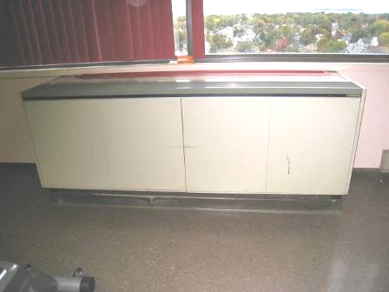

Univent on 12th floor

Picture 2

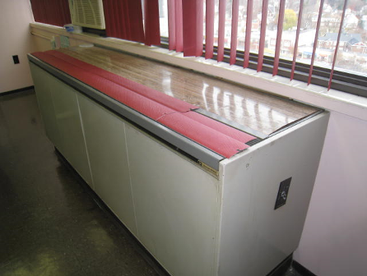

Univent fresh air diffusers obstructed with blinds

Picture 3

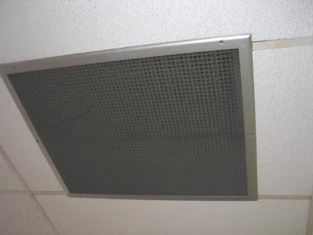

Exhaust vent on 12th floor

Picture 4

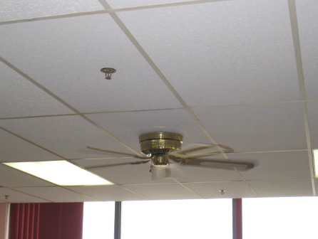

Ceiling fan on 12th floor

Picture 5

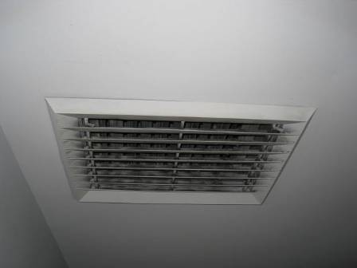

Supply vent in hallway

Picture 6

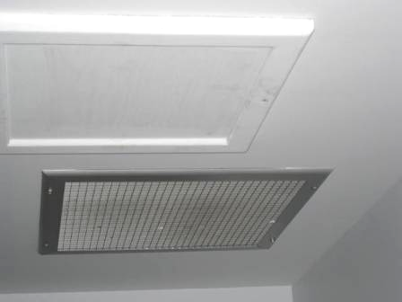

Exhaust vent in hallway

Picture 7

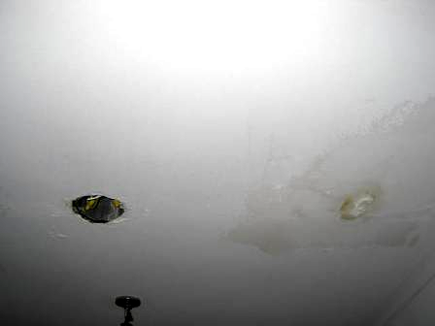

Water-damaged hallway ceiling, note open utility hole

Picture 8

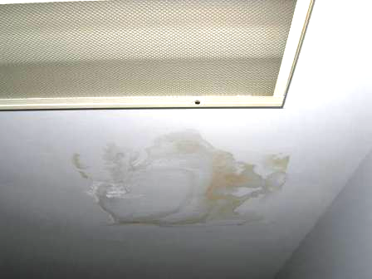

Water-damaged hallway ceiling

Picture 9

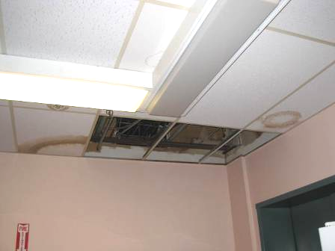

Missing and water-damaged ceiling tiles reportedly the result of wind-driven rain

Picture 10

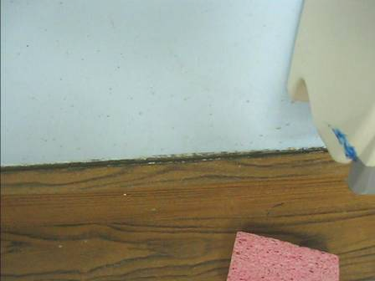

Breach between sink countertop and backsplash

Picture 11

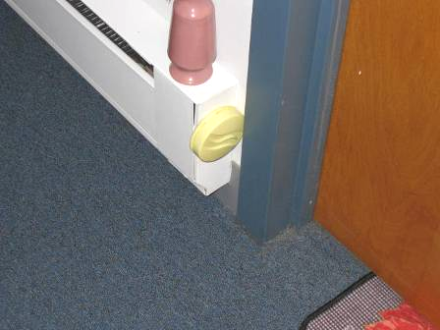

Air fresheners/deodorizers in hallway

Picture 12

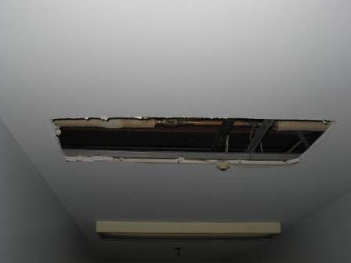

Hole in ceiling

Picture 13

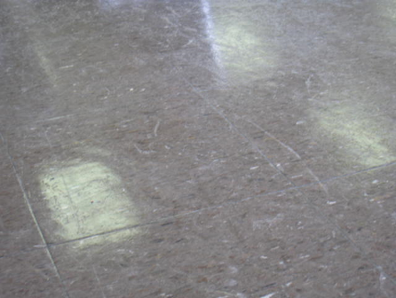

Scuffed floor tiles

Picture 14

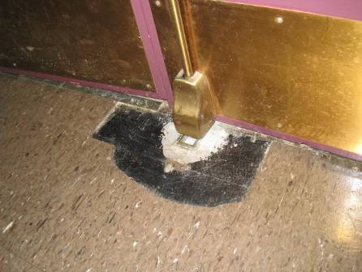

Two damaged floor tiles

Location/ Room | Occupants  in Room | Temp  (°F) | Relative  Humidity  (%) | Carbon  Dioxide  (ppm) | Carbon Monoxide  (ppm) | TVOCs  (ppm) | PM2.5  (µg/m³) | Windows  Openable | Ventilation |  | Remarks
 |  |  |  |  |  |  |  |  | Supply | Exhaust | Remarks
background |  | 62 | 65 | 403 | 1 | ND | 15 |  |  |  | Street traffic, windy, overcast
Dining | 10 | 72 | 38 | 646 | ND | ND | 7 | N | Y (off) | Y | 2 WD CTs, Deactivated UVs; WAC –change filter, consider using fan only setting; CF
Workout | 0 | 72 | 37 | 502 | ND | ND | 7 | N | Y (off) | Y | CF, deactivated UV
Library | 0 | 71 | 37 | 493 | ND | ND | 7 | N | N | Y | WAC, CF
Kitchen | 0 | 73 | 37 | 520 | ND | ND | 10 | N | N | Y | WD from driving rain
Pool room | 0 | 73 | 37 | 528 | ND | ND | 11 | N | N | N
11th floor trash room |  | 77 | 34 | 601 | ND | ND | 10 | N | N | Passive
11th B-wing stairwell |  | 77 | 32 | 519 | ND | ND | 6 | N | Y (off) | Passive
11th B-wing entrance |  | 78 | 33 | 608 | ND | 0.2 | 8 | N | Y (off) | Passive | DO
11th C-wing stair |  | 78 | 31 | 492 | ND | ND | 10 | N | Y (off) | Passive
11th C-wing entrance |  | 77 | 31 | 487 | ND | ND | 13 | N | Y (off) | Passive | DO
11th A wing stair |  | 77 | 31 | 488 | ND | ND | 10 | N | Y (off) | Passive
11th A wing entry |  | 77 | 32 | 489 | ND | ND | 11 | N | Y (off) | Passive | DO
10th trash |  | 78 | 31 | 466 | ND | ND | 16 | N | N | Passive
10th B stair |  | 79 | 28 | 461 | ND | ND | 4 | N | Y (off) | Passive
10th B entry |  | 78 | 29 | 477 | ND | ND | 5 | N | Y (off) | Passive
10th C stair |  | 78 | 31 | 495 | ND | ND | 13 | N | Y (off) | Passive
10th C entry |  | 78 | 31 | 511 | ND | ND | 15 | N | Y (off) | Passive | DO
10th A stair |  | 77 | 32 | 962 | ND | ND | 38 | N | Y (off) | Passive | Cut in ceiling
10th A entry |  | 79 | 35 | 929 | ND | ND | 17 | N | Y (off) | Passive | DO
9th trash |  | 78 | 30 | 979 | ND | 0.1-0.2 | 14 | N | N | Passive | Trash chute 0.2 ppm TVOCs
9th B stair |  | 77 | 31 | 464 | ND | 0.0-0.2 | 14 | N | Y (off) | passive
9th B entry |  | 77 | 33 | 505 | ND | 0.0-0.2 | 13 |  | Y (off) | Passive | DO
9th C stair |  | 77 | 33 | 477 | ND | 0.0-0.1 | 10 |  | Y (off) | Passive | WD – ceiling
9th C entry |  | 78 | 32 | 489 | ND | ND | 12 |  | Y (off) | Passive | DO
9th A stair |  | 77 | 30 | 454 | ND | 0.3 | 8 |  | Y (off) | Passive | AD
9th A entry |  | 77 | 32 | 511 | ND | 0.2 | 10 |  | Y (off) | Passive | DO
8th trash |  | 78 | 31 | 494 | ND | 0.2 | 16 |  | N | Passive
8th B stair |  | 78 | 30 | 477 | ND | ND | 5 |  | Y (off) | Passive | AD
8th B entry |  | 77 | 30 | 475 | ND | ND | 4 |  | Y (off) | passive
8th C stair |  | 77 | 32 | 464 | ND | 0.1 | 10 |  | Y (off) | Passive
8th C entry |  | 78 | 31 | 477 | ND | ND | 11 |  | Y (off) | Passive | DO
8th A stair |  | 77 | 32 | 507 | ND | 0.5 | 7 |  | Y (off) | Passive | AD
8th A entry |  | 78 | 32 | 558 | ND | 0.1 | 7 |  | Y (off) | Passive | DO
7th trash |  | 78 | 30 | 483 | ND | 0.2 | 10 |  | N | Passive | Trash chute 0.3 ppm TVOCs
7th B stair |  | 77 | 31 | 482 | ND | 0.1 | 12 |  | Y (off) | Passive
7th B entry |  | 77 | 30 | 476 | ND | 0.1 | 10 |  | Y (off) | Passive | DO
7th C stair |  | 78 | 31 | 504 | ND | 0.1 | 12 |  | Y (off) | Passive
7th C exit |  | 78 | 31 | 513 | ND | 0.1 | 16 |  | Y (off) | Passive | DO
7th A stair |  | 77 | 31 | 505 | ND | ND | 39 |  | Y (off) | Passive
7th A entry |  | 77 | 32 | 520 | ND | ND | 34 |  | Y (off) | Passive | DO
6th trash |  | 76 | 30 | 604 | ND | 0.1 | 12 |  | N | Passive | trash chute 0.2 ppm TVOCs
6th B stair |  | 77 | 30 | 443 | ND | 0.1 | 13 |  | Y (off) | Passive | Lemon odor
6th B entry |  | 76 | 30 | 440 | ND | 0.1 | 14 |  | Y (off) | Passive | DO
6th C stair |  | 77 | 33 | 606 | ND | 0.1 | 20 |  | Y (off) | Passive
6th C entry |  | 77 | 32 | 923 | ND | 0.1 | 21 |  | Y (off) | Passive
6th A stair |  | 77 | 33 | 531 | ND | 0.1-0.2 | 8 |  | Y (off) | Passive | Damaged ceiling
6th A entry |  | 76 | 32 | 459 | ND | 0.1 | 8 |  | Y (off) | Passive | DO
5th trash |  | 77 | 32 | 520 | ND | 0.1 | 21 |  | N | Passive | DO, Trash chute 0.2 ppm TVOCs
5th B stair |  | 77 | 34 | 573 | ND | 0.2-0.3 | 115 |  | Y (off) | Passive | Cigarette smoke odors
5th B entry |  | 77 | 35 | 552 | ND | 0.1 | 61 |  | Y (off) | Passive | DO
5th C stair |  | 77 | 41 | 556 | ND | 0.2 | 13 |  | Y (off) | Passive
5th C entry |  | 77 | 40 | 560 | ND | 0.1 | 13 |  | Y (off) | Passive | DO
5th A stair |  | 76 | 33 | 485 | ND | 0.1-0.2 | 31 |  | Y (off) | Passive | WD, utility hole
5th A entry |  | 76 | 34 | 529 | ND | 0.1 | 10 |  | Y (off) | Passive | DO
4th trash |  | 77 | 33 | 521 | ND | 0.2 | 67 |  | N | Passive | Trash chute 0.3 ppm TVOCs
4th B stair |  | 77 | 32 | 475 | ND | 0.1 | 4 |  | Y (off) | Passive
4th B entry |  | 77 | 32 | 469 | ND | 0.1 | 4 |  | Y (off) | Passive | DO
4th C stair |  | 77 | 34 | 592 | ND | 0.1 | 10 |  | Y (off) | Passive | Hole in wall, bathroom drain pipe corroded, WD
4th C entry |  | 77 | 32 | 503 | ND | 0.1 | 10 |  | Y (off) | Passive | DO
4th A stair |  | 74 | 31 | 446 | ND | ND-0.1 | 6 |  | Y (off) | Passive | Resident with window open
4th A entry |  | 74 | 33 | 455 | ND | ND | 7 |  | Y (off) | Passive | DO
3rd trash |  | 75 | 35 | 498 | ND | 0.1 | 12 |  | N | Passive | Trash chute 0.2 ppm TVOCs
3rd B stair |  | 76 | 35 | 524 | ND | 0.2 | 122 |  | Y (off) | Passive | DO, cigarette smoke and cooking odors
3rd B entry |  | 76 | 35 | 517 | ND | 0.1 | 81 |  | Y (off) | Passive
3rd C stair |  | 76 | 32 | 602 | ND | 0.2 | 52 |  | Y (off) | Passive | DO
3rd C entry |  | 76 | 35 | 549 | ND | 0.1 | 21 |  | Y (off) | Passive
3rd A stair |  | 76 | 33 | 517 | ND | 0.3 | 15 |  | Y (off) | Passive | DO
3rd A entry |  | 76 | 35 | 527 | ND | 0.1 | 12
2nd trash |  | 77 | 32 | 483 | ND | 0.1 | 6 |  | N | Passive
2nd B stair |  | 76 | 31 | 483 | ND | 0.1 | 4 |  | Y (off) | Passive | DO
2nd B entry |  | 75 | 31 | 511 | ND |  | 4 |  | Y (off) | Passive
2nd C stair |  | 76 | 32 | 503 | ND | 0.2 | 4 |  | Y (off) | Passive
2nd C entry |  | 77 | 33 | 519 | ND | 0.1 | 5 |  | Y (off) | Passive | DO
2nd A stair |  | 77 | 33 | 486 | ND | 0.1 | 6 |  | Y (off) | Passive
2nd A entry |  | 77 | 34 | 543 | ND | 0.1 | 8 |  | Y (off) | Passive | DO

