**WATER DAMAGE ASSESSMENT**

**James M. Quinn Elementary School**

**529 Hawthorn Street**

**Dartmouth MA**

James M. Quinn Elementary School
529 Hawthorn Street
Dartmouth MA


Prepared by:

Massachusetts Department of Public Health

Bureau of Climate and Environmental Health

Indoor Air Quality Program

August 2024

# BACKGROUND

|  |  |
| --- | --- |
| Building: | Quinn Elementary School (QES) |
| Address: | 529 Hawthorn Street, Dartmouth, MA |
| Requestor: | Chris Michaud, Director, Dartmouth Board of Health |
| Reason for Request: | Concerns about mold on walls and ceiling tiles in several classrooms. |
| Dates of Assessment: | August 7 and 13, 2024. Note this assessment occurred over summer break. |
| Massachusetts Department of Public Health/Bureau of Environmental Health (MDPH/BCEH) Staff Conducting Assessment: | Cory Holmes, Assistant Director, Indoor Air Quality (IAQ) Program |
| Building Description: | The QES is a two-story, red-brick building constructed in the late 1960s. The two rooms effected (317 & 319) have tile floors, plaster and concrete block walls, and suspended ceiling tiles. It should be noted that these two classrooms were undergoing asbestos abatement (removal of floor tiles) at the time of the August 7th site visit. Therefore, the two identical/adjacent rooms (314 & 315) as well as several non-effected areas, were examined, with a return visit scheduled on August 13th to inspect rooms 317 & 319, post-abatement. |
| Windows: | Openable |

# METHODS

Please refer to the IAQ Manual for methods, sampling procedures, and interpretation of results (MDPH, 2015).

**RESULTS AND DISCUSSION**

The following is a summary of indoor air testing results (Table 1):

* ***Temperature*** was within or close to the MDPH recommended range of 70°F to 78°F in areas tested on both days of assessment.
* ***Relative Humidity*** was above the MDPH recommended comfort range of 40 to 60% in areas tested on August 7, 2024. On August 13, two rooms (319 and 317) were above the MDPH recommended comfort range of 40 to 60%. If relative humidity exceeds 70%, for extended periods of time, mold growth may occur due to wetting of building materials even in the absence of liquid water.

## Ventilation

Fresh air in the majority of classrooms is supplied by unit ventilators (univents) installed in the 1960s (Pictures 1 and 2). Univents draw air from the outdoors through a fresh air intake located on the exterior wall of the building and return air through an air intake located at the base of the unit. Fresh and return air are mixed, filtered, heated, or cooled, and provided to rooms through an air diffuser located in the top of the unit (Figure 1). It should be noted that univents at QES do not have air conditioning (AC) capacity, which would be useful in reducing relative humidity conditions over the summer. In some classrooms, window mounted ACs are used for cooling during the warm season. Classroom exhaust ventilation is provided by unit exhaust ventilators (Picture 2) or vents in the ceilings of coat closets (Picture 3).

## Microbial/Moisture Concerns

Hot humid summers are becoming more frequent due to climate change. Massachusetts has experienced hot, humid, and rainy summers in 2018, 2021, and 2023. July of 2021 was the wettest ever recorded in Massachusetts, and the three-month period from June through August, known as the meteorological summer, was the fourth wettest on record, according to the National Oceanic and Atmospheric Administration’s (NOAA) Centers for Environmental Information (NOAA, 2021). The summer of 2023 was also hot, and wet, being measured as the second rainiest on record (WBUR, 2023). The summer of 2024 has also had significant stretches of hot, humid weather. These conditions are challenging for buildings, particularly those without central air conditioning.

Under these weather conditions, public buildings experienced extended periods of water vapor exposure from high relative humidity. When exposed to these conditions, porous materials such as gypsum wallboard, cardboard, and other materials may become moistened and colonized with mold, particularly if located in areas that are prone to developing condensation, such as floors and walls in contact with the ground (e.g., below grade space).

As mentioned previously, the assessment was requested due to the presence of mold on classroom walls and ceiling tiles. At the time of both the August 7th and 13th visits all ceiling tiles in effected classrooms were removed (Pictures 4 and 5) and new tiles were ordered for replacement. No water-damaged, moldy, or musty materials were found on walls or items in any of the rooms examined, with the exception of light mold growth on the interior surface of wooden closet doors in classroom 328 (Picture 6). At the time of the August 7th and 13th visits IAQ Program staff recommended that this material be removed through cleaning. On August 14th, IAQ Staff received an email with pictorial confirmation from James A. Kiely, Assistant Superintendent of Finance and Operations, Dartmouth Public Schools (DPS) that the mold was cleaned (Picture 7).

The guideline “Preventing Mold Growth In Schools During Hot, Humid Weather” <https://www.mass.gov/info-details/preventing-mold-growth-in-massachusetts-schools-during-hot-humid-weather> should be used to minimize the impact of such weather on classroom materials. This includes use of air conditioning and dehumidifiers, ensuring exhaust vents are on and operable, keeping windows closed, and ensuring air can circulate around porous materials.

It is also important to note that there were several efforts taken by DPS Facilities staff to mitigate the potential for mold growth, these include:

* The deployment of large industrial fans in main corridors to circulate air and increase drying (Picture 8).
* The filters inside univents have a minimum efficiency rating value (MERV rating) of 8 (Picture 9) and are reportedly changed twice a year. The MDPH/IAQ Program recommends a minimum of a MERV 8 filter, which is adequate to filter out *pollen and* *mold spores* (ASHRAE, 2012).
* High-efficiency particulate arrestance (HEPA) air purifiers (Picture 10), are available for use in classrooms. HEPA units remove up to 99% of airborne contaminants as small as 0.1 microns including airborne mold spores.

A key concept in dealing with condensation-related water damage is that of “dew point.” The dew point temperature is the temperature at which air with a given amount of water becomes saturated with water and water begins to condense out as a liquid. For example, at 75°F and 70% relative humidity, the dew point temperature would be 64°F. That means that any surface at or below that temperature in contact with that air will start to generate condensation. In very humid conditions, surfaces do not have to be cooled much below ambient temperature to go below the dew point. Dehumidification, either through air conditioning or through stand-alone dehumidifiers, can reduce the chances of condensation. Monitoring areas of the building that may be colder than the rest of the room (e.g., floors, exterior walls in shade, and chilled plumbing and HVAC components) can lead to discovery of the areas that are most likely to be a problem during humid weather.

**Other Conditions**

IAQ Program staff were asked to evaluate ceiling tiles in several 2nd floor classrooms. No visible signs of water damage or mold growth were observed. However, ceiling tiles directly over univents were lightly soiled from dust/debris (Pictures 11 and 12). The location of these tiles *directly over the airstream* of mechanical ventilation makes them more susceptible to soiling due to constant airflow over the porous surface of the tile, which can catch debris. Other tiles were also noted to be discolored, which in this case was from the installation of ceiling lighting fixtures, that have since been removed (Picture 12). It is also interesting to note that it was reported these are likely the original ceiling tiles installed when the school was opened in 1967, which makes them over fifty years old.

# CONCLUSIONS/RECOMMENDATIONS

The following are recommendations to improve and maintain IAQ:

## Ventilation Recommendations

1. Implement the following methods to promote increased airflow:
   * Limit outside air intake during periods of elevated relative humidity (>70%) for extended periods of time. Operate HVAC systems not equipped with chilling components (e.g., unit ventilators, or univents) with the fresh air intake vents *closed*.
   * Operate general exhaust ventilation system normally.
   * Open all interior doors between rooms and closets.
   * Arrange floor fans in hallways to circulate air.
2. Continue with regular filter changes for HVAC equipment using MERV 8 filters or the best quality/highest MERV-rating that can be used. During filter changes, vacuum debris from univent and air handling unit (AHU) cabinets.

## Water Damage Recommendations

1. Management of buildings in extreme relative humidity and rain can be challenging. The following documents can provide guidance that can be used to reduce the impact of hot, humid weather in buildings: Mold Growth Prevention During Hot, Humid Weather <https://www.mass.gov/service-details/preventing-mold-growth-in-massachusetts-schools-during-hot-humid-weather> and Remediation and Prevention of Mold Growth and Water Damage in Public Schools <https://www.mass.gov/service-details/remediation-and-prevention-of-mold-growth-and-water-damage-in-public-schools-and>.
2. Over the summer, conduct regular walkthroughs to observe conditions in the building, paying close attention to walls, ceiling tiles, and flat surfaces for signs of moisture and/or mold growth.
3. If porous items (e.g., books, papers, cardboard) are colonized with mold and the mold does not easily wipe off, the items should be discarded. Non-porous/smooth, solid items can be cleaned.
4. Monitor weather through extended forecasts to determine if hot, humid weather for more than two days is predicted. Many web-based weather services will provide a dew point listing.
5. Consider installing/using indoor air sensors. As indoor air sensors become more sophisticated and less expensive, they can be placed in classrooms to measure and provide accurate, real-time information via an application or web-based dashboard, eliminating the need for personnel to take measurements with hand-held equipment.
6. Monitor temperature of condensation-prone building components with a laser thermometer. If the temperature of the building component is below the dew point during hot, humid weather, steps should be taken to decrease humidity levels.
7. Ensure that all windows are closed when air conditioning is operating, particularly during periods of hot, humid weather.
8. Avoid storing porous materials in contact with the floors, particularly during periods of high humidity.
9. Use dehumidifiers in combination with fans and ACs during summer months/periods of elevated relative humidity.
10. Clean and maintain portable dehumidifying units in accordance with manufacturers’ recommendations or drain into sinks to reduce daily maintenance.
11. Clean filters in AC units prior to and as needed during the cooling season. During filter cleaning examine cooling fins for dust/debris and clean/vacuum as needed to ensure efficient operation and to prevent mold growth and associated odors.
12. The following measures can be used to reduce fungal growth on porous materials:
    * Avoid placing wall-to-wall carpeting or other porous materials on slab in contact with soil or on floors in below-grade areas.
    * Avoid placing porous materials on temperature bridges. A temperature bridge is a structure that allows cooler temperatures to transfer between two areas. Furniture made of metal is more likely to be susceptible to temperature fluctuations. Avoid storing porous materials on metal objects that are low and in contact with floor or foundation walls.
    * Store porous materials in airtight, hard plastic containers.
    * Avoid placing porous materials between fresh air supply vents and exhaust vents. The air between this equipment is likely to hold moisture since these systems are used to remove water vapor from a building interior.
    * Move furniture such as bookcases and file cabinets at least 1-inch from walls to create airflow and prevent trapping moisture that can lead to mold growth on walls.
    * Roll up and remove area rugs over the summer.
13. For more information on mold consult with the US EPA’s “Mold Remediation in Schools and Commercial Buildings”. Available at: <http://www.epa.gov/mold/mold-remediation-schools-and-commercial-buildings-guide> (US EPA, 2008).

## Other Recommendations

1. Maintain air purifiers in accordance with manufacturer's instructions. Avoid using any air purifiers that may produce ozone (e.g., ionizers). Consider locating air purifiers so the outlet of the units is in the breathing zone of occupants.
2. After the installation of new ceiling tiles/prior to re-occupancy, conduct a thorough cleaning of furniture and other items, as well as wet wiping of all surfaces.
3. Periodically vacuum accumulated dust/debris on ceiling tiles over univents.
4. Consider long-term capital plans for ceiling tile replacement in areas of discoloration.
5. Refer to resource manual and other related IAQ documents located on the MDPH’s website for further building-wide evaluations and advice on maintaining public buildings. These documents are available at: <http://mass.gov/dph/iaq>.

# REFERENCES

ASHRAE. 2012. American Society of Heating, Refrigeration and Air Conditioning Engineers (ASHRAE) Standard 52.2-2012 – Method of Testing General Ventilation Air-Cleaning Devices for Removal Efficiency by Particle Size (ANSI Approved).

HG. 2021. Mold keeps South Hadley High School shuttered. Hampshire Gazette. <https://archive.gazettenet.com/South-Hadley-High-School-still-closed-amid-mold-remediation-42413519>

MDPH. 2015. Massachusetts Department of Public Health. Indoor Air Quality Manual: Chapters I-III. Available at: <https://www.mass.gov/lists/indoor-air-quality-manual-and-appendices#indoor-air-quality-manual->.

NOAA. 2021. Summer 2021 neck and neck with Dust Bowl summer for hottest on record. National Oceanic and Atmospheric Administration, 1401 Constitution Avenue NW, Room 5128, Washington, DC 20230 <https://www.noaa.gov/news/summer-2021-neck-and-neck-with-dust-bowl-summer-for-hottest-on-record>.

US EPA. 2008. “Mold Remediation in Schools and Commercial Buildings”. Office of Air and Radiation, Indoor Environments Division, Washington, DC. EPA 402-K-01-001. September 2008. Available at: <http://www.epa.gov/mold/mold-remediation-schools-and-commercial-buildings-guide>.

WBUR. 2023. “It's been a summer of rain and flooding misery in Mass.” WBUR local news. September 12, 2023. <https://www.wbur.org/news/2023/09/12/summer-flooding-rain-massachusetts>

**Figure 1: Unit Ventilator (Univent)**

**Picture 1**

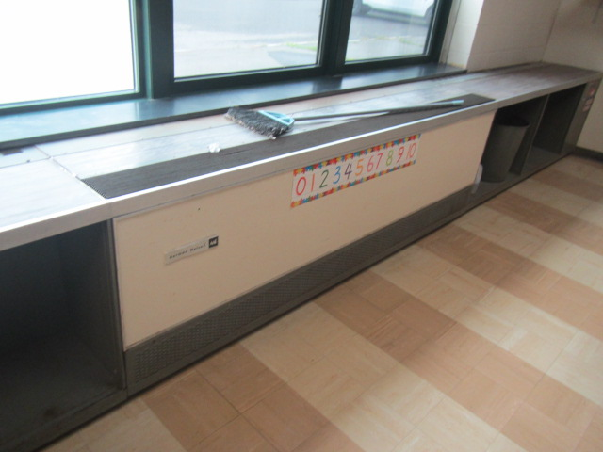

**Typical classroom univent (1960’s vintage)**

**Picture 2**

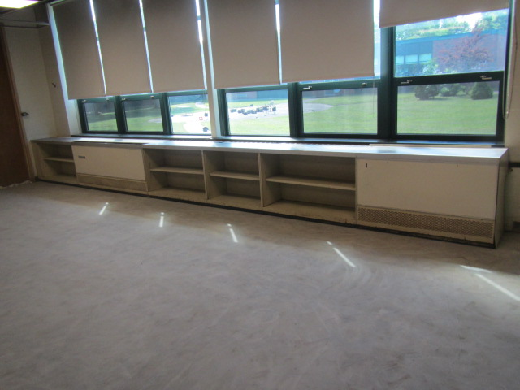

**Classroom univent (right) and unit exhaust vent (left)**

**Picture 3**

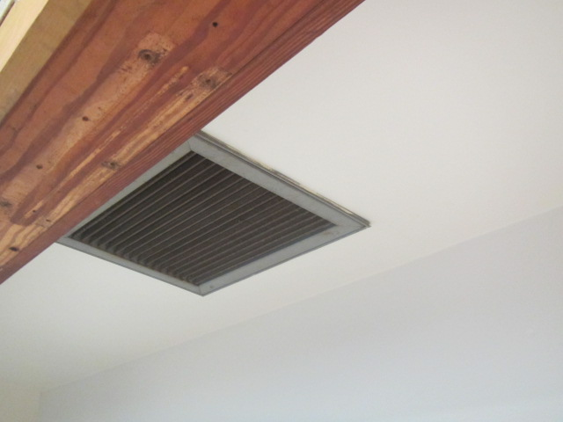

**Exhaust vent in the ceiling of classroom coat closet**

**Picture 4**

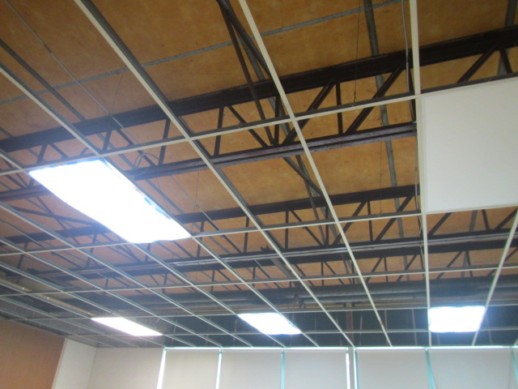

**Classroom ceiling tiles removed**

**Picture 5**

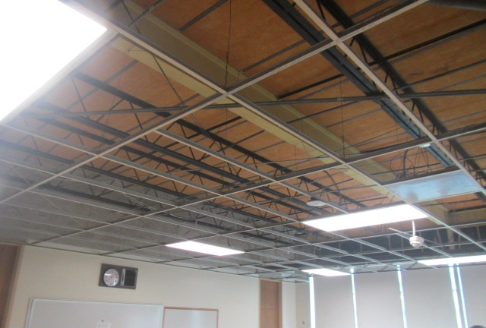

**Classroom ceiling tiles removed**

**Picture 6**

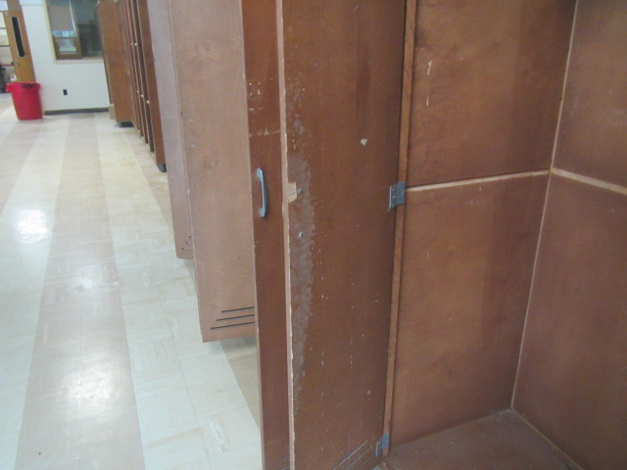

**Mold growth (white staining) on the interior of classroom 328 cabinet**

**Picture 7**

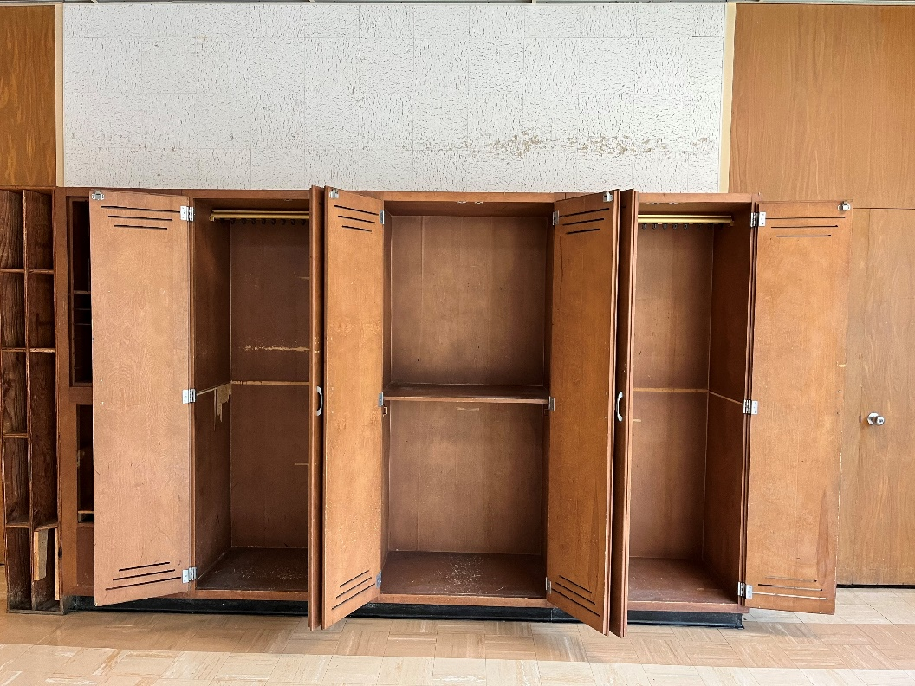

**Cabinet doors cleaned of mold growth (Picture provided by James A. Kiely, Assistant Superintendent of Finance and Operations, Dartmouth Public Schools)**

**Picture 8**

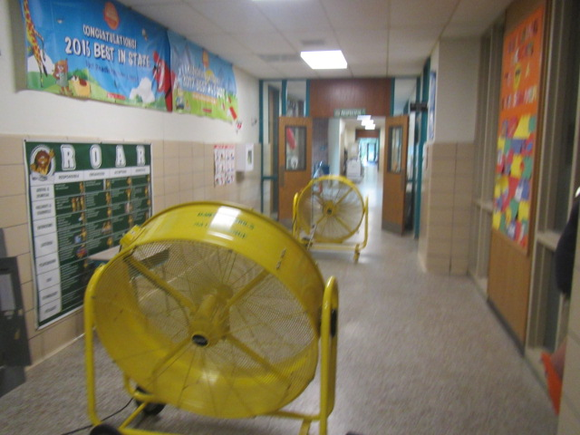

**Large industrial fans used to circulate air in corridors**

**Picture 9**

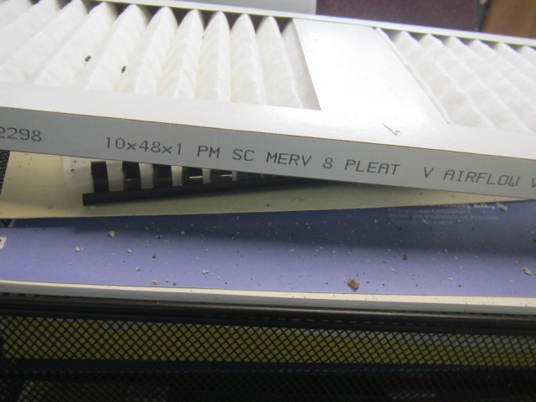

**MERV 8 filters used in univents at Quinn Elementary School**

**Picture 10**

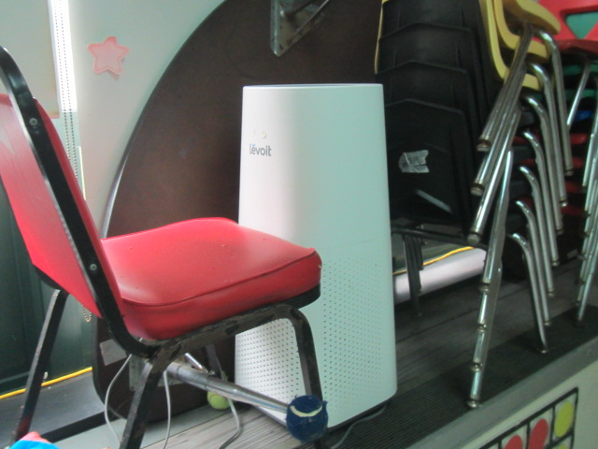

**Classroom air purifier**

**Picture 11**

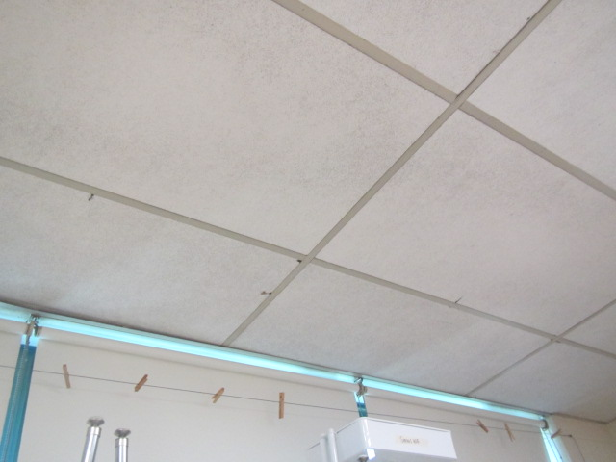

**Lightly soiled ceiling tiles directly over classroom univent**

**Picture 12**

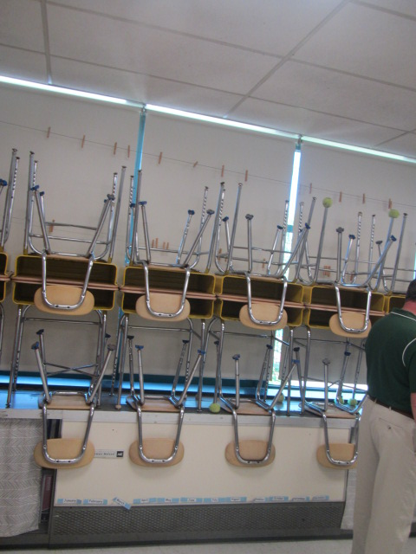

**Soiled ceiling tiles directly over classroom univent**

**Picture 13**

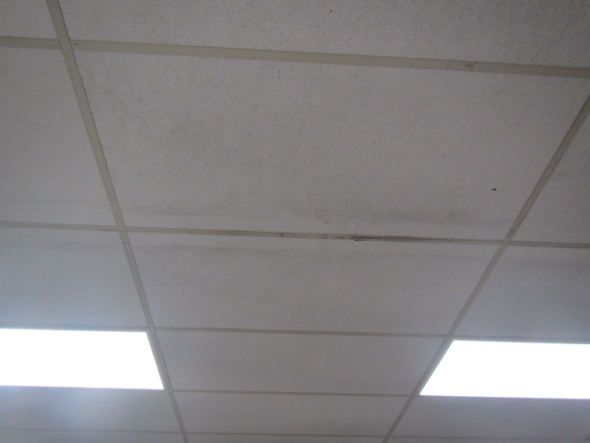

**Discolored ceiling tiles where lighting fixates were removed**

| **Location** | **Temp**  **(°F)** | **Relative**  **Humidity**  **(%)** | **Windows**  **Openable** | **Ventilation** | | **Remarks** |
| --- | --- | --- | --- | --- | --- | --- |
| **Supply** | **Exhaust** |
| Background | 66 | 78 |  |  |  | 10:00 AM, cloudy, cool, rain overnight, ground wet |
| 301 | 74 | 65 | Y | Y | Y | No visible mold on walls, floors, items |
| 314 | 68 | 69 |  |  |  | No visible mold on walls, floors, items, ceiling tiles removed, window AC |
| 315 | 67 | 65 |  |  |  | No visible mold on walls, floors, items, ceiling tiles removed, window AC |
| 328 | 75 | 62 | Y | Y | Y | Visible mold on inside of wooden cabinets, no visible mold on walls, floors, items, ceiling tiles removed |

| **Location/ Room** | **Temp (°F)** | **Relative Humidity (%)** | **Windows Openable** | **Ventilation** | | **Remarks** | |
| --- | --- | --- | --- | --- | --- | --- | --- |
| **Supply** | **Exhaust** |
| Background | 79 | 53 |  |  |  | 10:30 AM, sunny, warm & breezy |
| 317 | 73 | 66 | Y | Y | Y | No visible mold on walls, floors, items, ceiling tiles removed, tile floor removed |
| 318 Speech | 73 | 60 | Y | Y | Y | No visible mold on walls, floors, items, ceiling tiles removed, tile floor removed |
| 319 | 75 | 64 | Y | Y | y | No visible mold on walls, floors, items, ceiling tiles removed, tile floor removed, window AC |
| 403 | 75 | 59 | Y | Y | Y | No visible mold on walls, floors, items, ceiling tiles lightly soiled (dust/debris) over univents and where former light fixtures were installed |
| 405 | 75 | 59 | Y | Y | Y | No visible mold on walls, floors, items, ceiling tiles lightly soiled (dust/debris) over univents and where former light fixtures were installed |
| 411 | 75 | 58 | Y | Y | Y | No visible mold on walls, floors, items, ceiling tiles lightly soiled (dust/debris) over univents and where former light fixtures were installed |