WATER DAMAGE/MOLD INVESTIGATION

Quinsigamond Community College
5 Optical Drive
Southbridge, Massachusetts

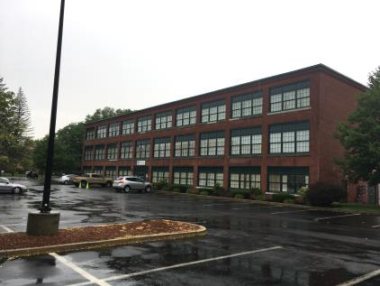

Prepared by:
Massachusetts Department of Public Health
Bureau of Environmental Health
Indoor Air Quality Program
September 2018

BACKGROUND
Building: | Quinsigamond Community College (QCC)
Address: | 5 Optical Drive, Southbridge, MA
Assessment Requested by: | Peter Woodford, DCAMM
Reason for Request: | Mold/water damage concerns
Date of Assessment: | July 6, 2018
Massachusetts Department of Public Health/Bureau of Environmental Health (MDPH/BEH) Staff Conducting Assessment: | Michael Feeney, Director, Indoor Air Quality (IAQ) Program
Building Description: | The QCC occupies a three-story former mill building. The QCC has occupied the space for approximately 10 years. The building contains classrooms, offices and a computer lab.
Windows: | Windows are not openable.

IAQ Testing Results
Please refer to the IAQ Manual for methods, sampling procedures, and interpretation of results (MDPH, 2015). The following is a summary of testing results.
- Moisture Measurements in all locations were found dry, (i.e., within normal parameters) at the time of assessment, with the exception of one wall and water-damaged tables in Room 305.
- Temperature was above the recommended range of 70°F to 78°F at the time of assessment.
- Relative humidity was within the recommended range of 40 to 60% in areas tested at the time of the assessment and lower than outside measurements.

Background and Discussion
The BEH/IAQ Program was asked to examine the QCC building due to water damage caused by an overflowing heating, ventilating and air-conditioning (HVAC) system drip pan above the ceiling in Room 305, which is a computer lab containing a mainframe system. The drip pan overflow occurred after extreme hot/humid weather that occurred during the week of July 4, 2018. The leak reportedly wetted carpeting, a computer table and gypsum wallboard (GW). Efforts to dry materials were reportedly implemented.
At the time of assessment, all carpeting, the computer table, and GW was tested for moisture. Most porous materials tested (i.e., carpet and the GW of three classroom walls) were dry and no visible mold/associated odor was observed/detected. Two laminated computer tables (Picture 1) as well as some GW along the east wall of Room 305 was found to be moistened despite drying efforts (Picture 2). It is important to note that relative humidity levels were within the recommended range of 40 to 60% in all areas tested, suggesting that no sources of lingering moisture were present at the time of assessment.
In general, the US Environmental Protection Agency (US EPA) and the American Conference of Governmental Industrial Hygienists (ACGIH) recommends that porous materials (e.g., GW, carpeting) be dried with fans and heating within 24 to 48 hours of becoming wet (US EPA, 2008; ACGIH, 1989). If porous materials are not dried within this time frame, mold growth may occur.
A condition that may be possibly contributing to the overflow is the location of the thermostat for Room 305, which may be affecting temperature control. A computer mainframe is located inside of a cabinet that has an exhaust fan. The heated air from the mainframe cabinet is directed at the thermostat (Picture 3). The waste heat from the mainframe will cause the thermostat to shut the heat off in the heating season and to cause the HVAC system to continuously chill air during summer months. Without proper thermostat control, the HVAC system cannot provide appropriate heating and cooling of Room 305.

Conclusions/Recommendations
Based on the observations made during the visit, the following recommendations are made:
- Discard water-damaged tables.
- Replace water-damaged GW.
- Add a duct to the mainframe cabinet to direct waste heat away from the thermostat. If feasible, either provide direct exhaust ventilation to the outdoors for the mainframe heat exhaust vent or install appropriate thermal material to connect the mainframe to the exhaust/return system for the HVAC system.
- For more information on mold refer to the US EPA’s “Mold Remediation in Schools and Commercial Buildings”, available at: http://www.epa.gov/mold/mold-remediation-schools-and-commercial-buildings-guide.
- Refer to resource manuals and other related IAQ documents for further building-wide evaluations and advice on maintaining public buildings. Copies of these materials are located on the MDPH’s website: http://mass.gov/dph/iaq.

REFERENCES
ACGIH. 1989. Guidelines for the Assessment of Bioaerosols in the Indoor Environment. American Conference of Governmental Industrial Hygienists, Cincinnati, OH.
MDPH. 2015. Massachusetts Department of Public Health. “Indoor Air Quality Manual: Chapters I-III”. Available at: http://www.mass.gov/eohhs/gov/departments/dph/programs/environmental-health/exposure-topics/iaq/iaq-manual/.
US EPA. 2008. Mold Remediation in Schools and Commercial Buildings. US Environmental Protection Agency, Office of Air and Radiation, Indoor Environments Division, Washington, D.C. EPA 402-K-01-001. http://www.epa.gov/mold/mold-remediation-schools-and-commercial-buildings-guide.
Picture 1
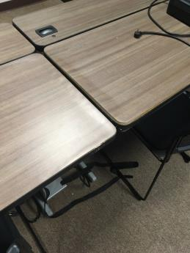
Water-damaged tables
Picture 2
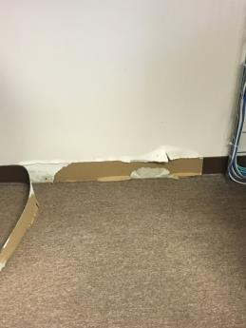
Water-damaged GW
Picture 3
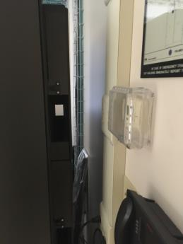
Thermostat heated by mainframe computer exhaust vent (arrow)

