
The Commonwealth of Massachusetts
Department of Education

Office of Child Care Services
Department of Public Health

December 16, 2004

Dear Senators, Representatives, Clerks of the Senate and House, and Early Education and Care Advisory Committee Members:

Chapter 205 of the Acts of 2004 established the Department of Early Education and Care. It provided that the new Department serves “as the lead agency for the administration of all public and private early education and care programs and services …. ” The new Department of Early Education and Care takes effect July 1, 2005. The creation of the new Department of Early Education and Care provides an important opportunity to consolidate, realign, and streamline separately administered early education and care programs in the Commonwealth, and provide families in the Commonwealth with greater opportunity and access to high quality early education and care.

Section 344 of the FY05 budget gave the Early Education and Care Council (comprised of the Commissioners of Education, Office of Child Care Services, and Public Health) the responsibility for developing a comprehensive transition plan to consolidate existing programs of early education and care into the new Department. In addition, the Council was to make recommendations on the new Department’s policies and procedures and submit them to the Joint Committee on Education, the Arts and Humanities, the Clerks of the Senate and House, the Joint Committees on Ways and Means, and the Early Education and Care Advisory Committee by December 15, 2004.

The enclosed report of the Council embodies our joint efforts. In this report, the Council is making recommendations on:
- Developing a comprehensive plan to consolidate and transfer the management and administration of programs, services, and funding for existing early education and care programs and services from our Departments;
- Identifying statutory and regulatory duplication of early education and care programs we administer;
- Recommending standards;
- Setting forth procedures regarding teacher certification;
- Recommending procedures for establishing program licensure and accreditation policies, eligibility criteria, sliding fee scales, reimbursement rates, services, regulations, monitoring, and policies among publicly funded early education and care programs;
- Identifying how the state can best prioritize the needs of low-income families;
- Identifying the proper role of Mass Family Networks, child care resource and referral agencies, and other regional coordination and informational entities; and
- Identifying the appropriate role of local councils in gathering data on local need, identifying providers in need of quality assistance, and serving as a local access point for families in need of services.

Implementing this report’s recommendations will be a challenging, but achievable, task in the new Department’s first year. To aid the new Department in this endeavor, the Council will continue meeting through the end of this

Fiscal Year to assist in the planning for a smooth July 1, 2005 transition to the new Department and to offer its support and collaboration to the newly-appointed Board and Commissioner of Early Education and Care. We look forward to our agencies’ continued collaboration in this important area.

Sincerely,
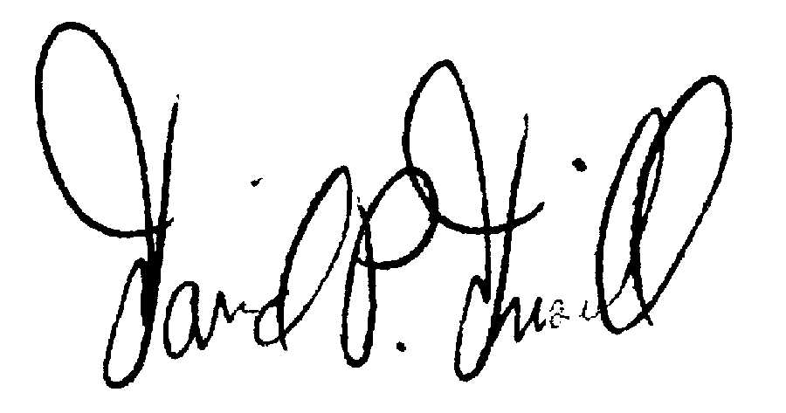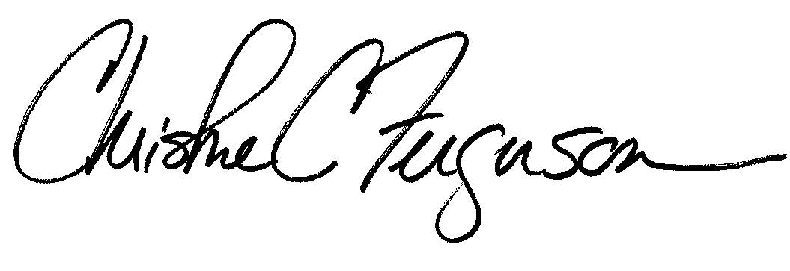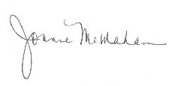
David P. Driscoll Christine Ferguson Joanne McMahan
Commissioner Commissioner Acting Commissioner
Department of Education Department of Public Health Office of Child Care Services

