R3 App Installation on an Android Phone (From the Amazon Appstore)

[These steps were performed on a Google Pixel phone. Steps on other devices may vary slightly.]

These steps will guide you to install the R3 (Report, Recognize, Respond) app on your Android phone.
You will need to download the Amazon Appstore to your device. An Amazon account is required to download the R3 app. You can create one if you do not have one. If you already have the Amazon App Store on your device, you can skip to this section below (where you can also sign in).

Section I: Download Amazon Appstore to your phone

- On your phone home screen, locate and tap Settings.

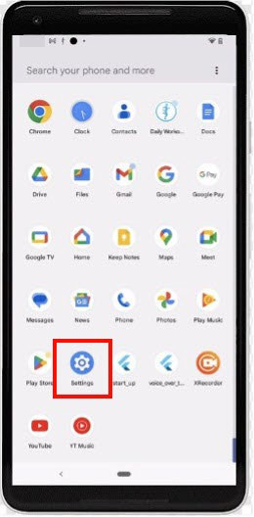

- Scroll down and tap Apps. (Depending on your device, it may also display as Apps and Notifications).

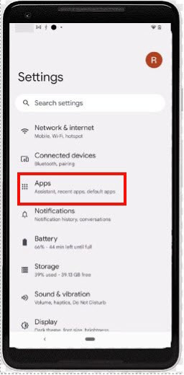

- In Apps, locate and tap Special app access. (Depending on your device, you may have to click Advanced to find this).

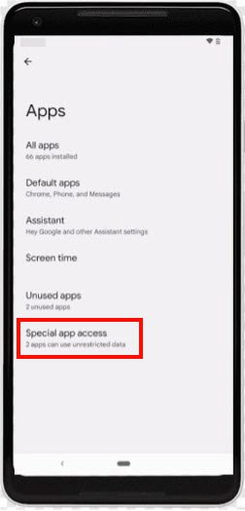

- In Special app access, locate and tap Install unknown apps.

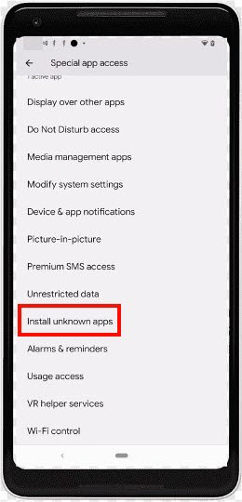

- In Install unknown apps, tap Chrome (or your default browser, if preferred).
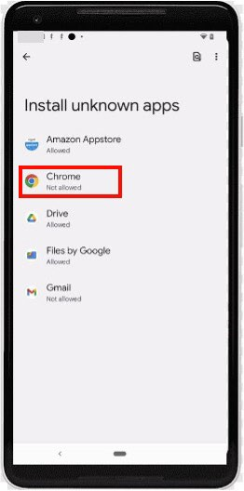

- Tap the toggle so that it shows as active to allow Chrome to install unknown apps.

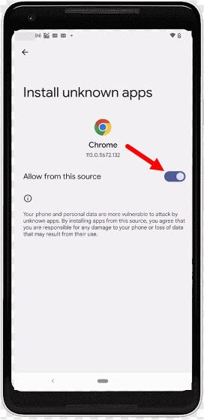

- Go back to your app library or main page and launch Chrome (or the browser you chose in step 5 above) and enter this link in your browser to download the Amazon Appstore: www.amazon.com/getappstore

- Tap the yellow button Get Amazon Appstore.

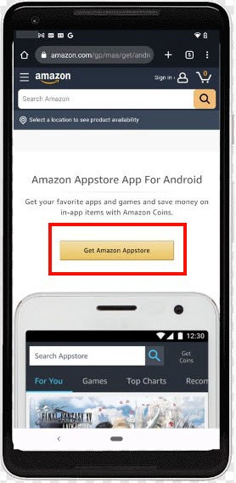

- You should see this screen (if you followed the steps above, you should not have to follow the “Steps to install” in the below screen).

If nothing shows up after 10 seconds, tap Retry download.

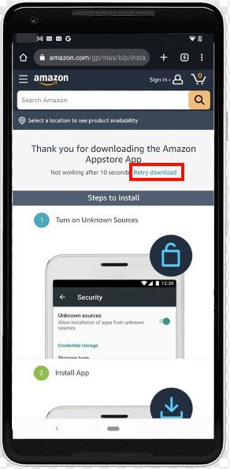

- For any popup messages that appear, you can tap 'Yes,' 'Continue,' or 'Download anyway’.

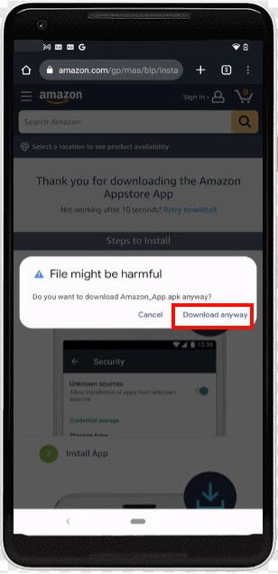

- After the previous step a pop-up appears and asks if you want to install this app (it may take some time). Once this shows up, tap Install.

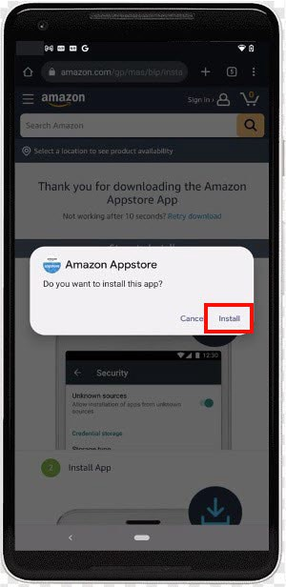

- Once it is done installing, tap Open.

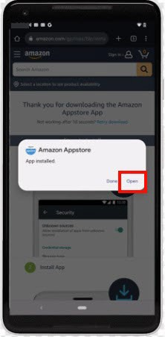

- On the page that appears, it prompts you to either sign into your Amazon account or to create a new account. If you do not have an Amazon account, follow the steps that are given after tapping Create a new Amazon account on your device.

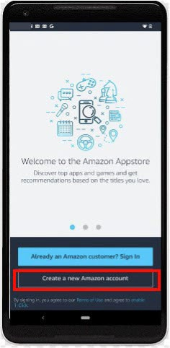

- If the steps above have been completed successfully, you should see a page which looks like this. This is the Amazon Appstore.

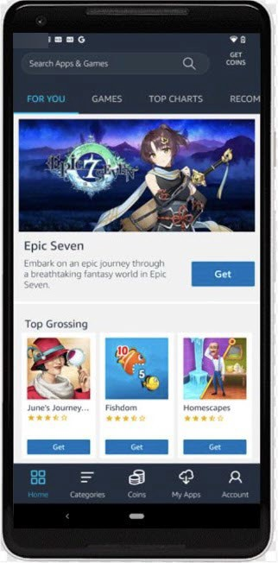

- When finished with the steps above, proceed with the steps below in Section II beginning with step 2.

Section II: Launch Amazon Appstore to Download and Install the R3 App

These steps assume you already have the Amazon Appstore on your phone and you already have an Amazon account. If you do not have the Amazon Appstore, please follow the steps in Section 1 above.

- Tap the Amazon Appstore on your device and be sure to log in if you are not already.

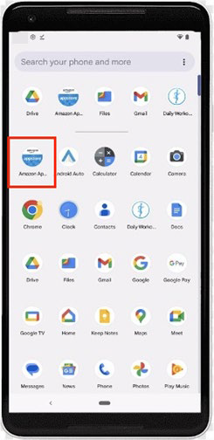

- Search for the R3 app in the Appstore by typing R3 or R3: Recognize, Report, Respond in the search box.

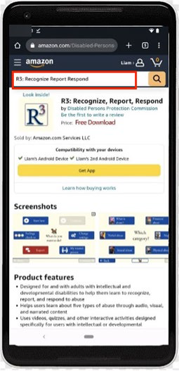

- Once you are on this page, select the Get App button.

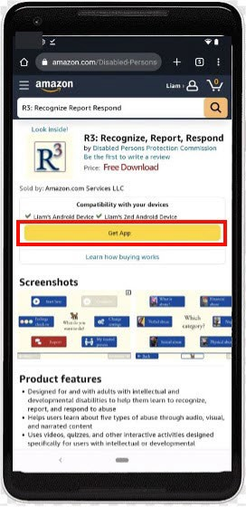

Note: If you have not set up your credit card information, Amazon will ask you to add a payment method even though the R3 app is free.

- The R3 app is now installed on your device! Now, exit out of this tab by clicking the exit icon located at the bottom of the app screen or by swiping up from the bottom to exit.

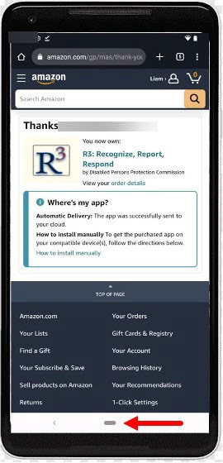

- Locate the Amazon Appstore in your apps and tap it.

- Once you are in the Amazon App Store, tap on the My Apps tab at the bottom of the screen. Once you are here, you should see R3. Tap Install to begin installation.

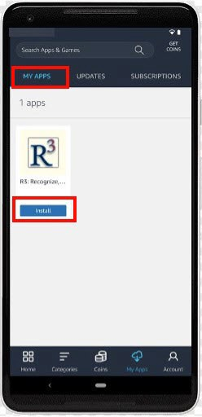

- When this popup appears, tap Continue.

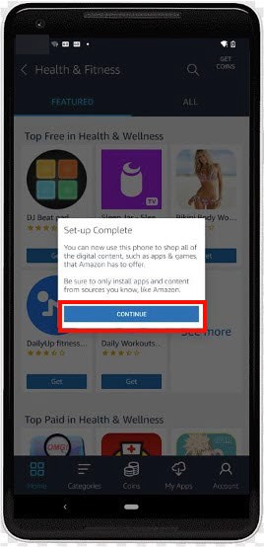

- When a pop-up appears, tap on Go To Settings.

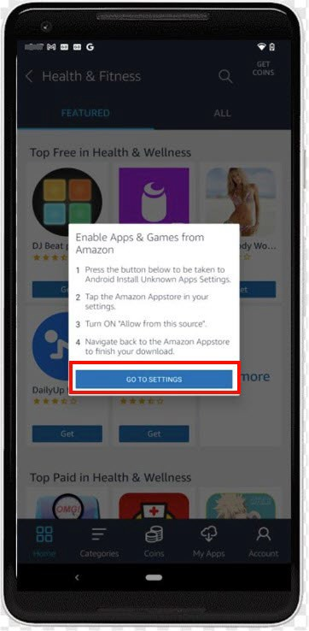

- Once here, tap Amazon Appstore.

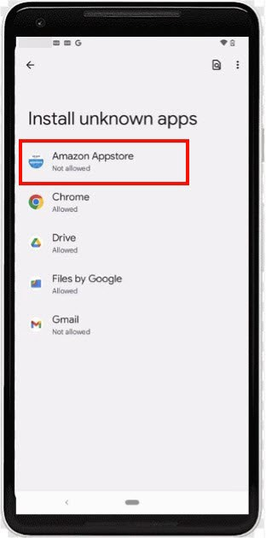

- Tap the toggle that says Allow from this source to allow the AppStore to install unknown apps.

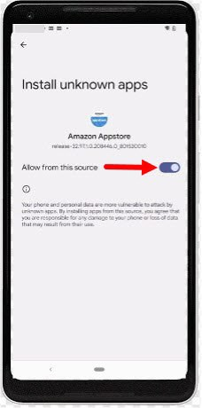

- Press the back arrow in the left-hand corner twice, or until you are brought back to the Amazon Appstore.

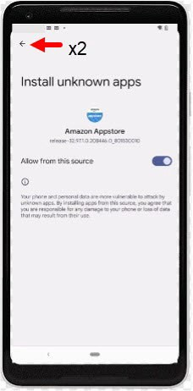

- Once back to the App Store, tap Continue.

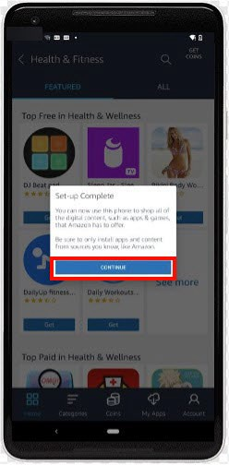

- Tap Install next to the R3 icon. When it asks to install this app, tap
Install.

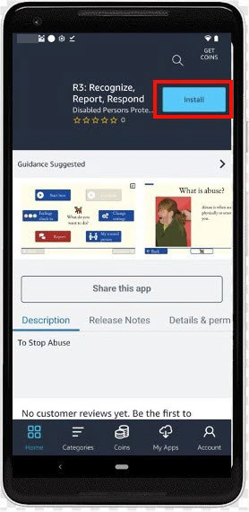

- If this popup appears on your device, select Install anyway.

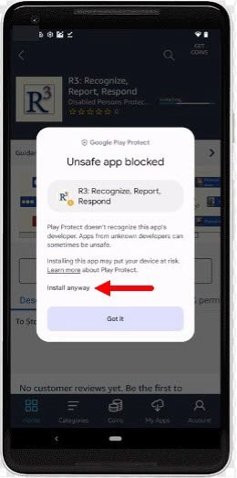

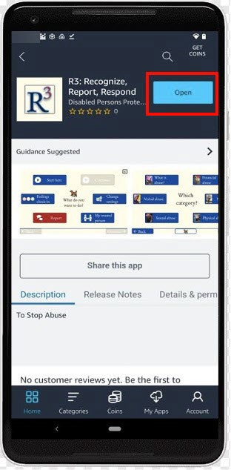
- Select Open to enter the R3 app.

\

- Congratulations! You are now ready to use the R3 App!

Note: Please view the app in landscape view by flipping your phone on its side.
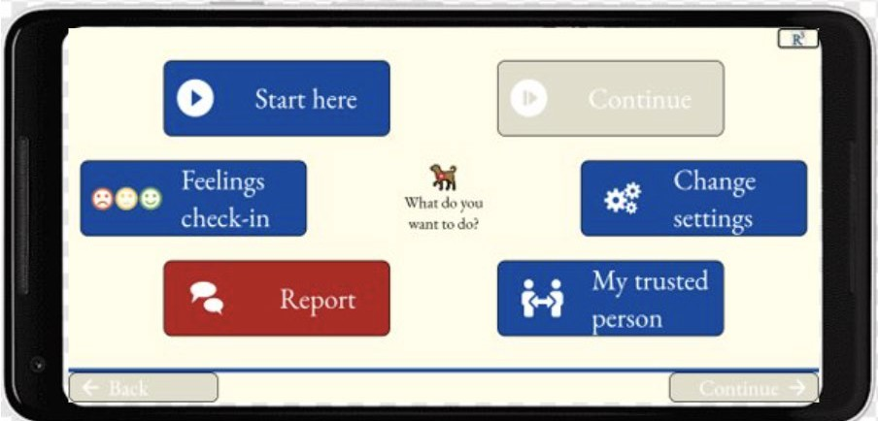

You can find R3 on your home screen, whenever you would like to use it.
