R3 App Installation on an Android Tablet (From the Amazon App Store)

[These steps are performed on a Samsung S7 FE Tablet. Steps on other devices may vary slightly.]

These steps will guide you to install the R3 (Report, Recognize, Respond) app on your Android tablet.

You will need to download the Amazon Appstore to your device. An Amazon account is required to download the R3 app. You can create one if you do not have one. If you already have the Amazon App Store on your device, you can skip to this section below (where you can also sign in).

Section I: Download Amazon App – Download and Install the R3 App.

- On your device home screen, locate and tap Settings.

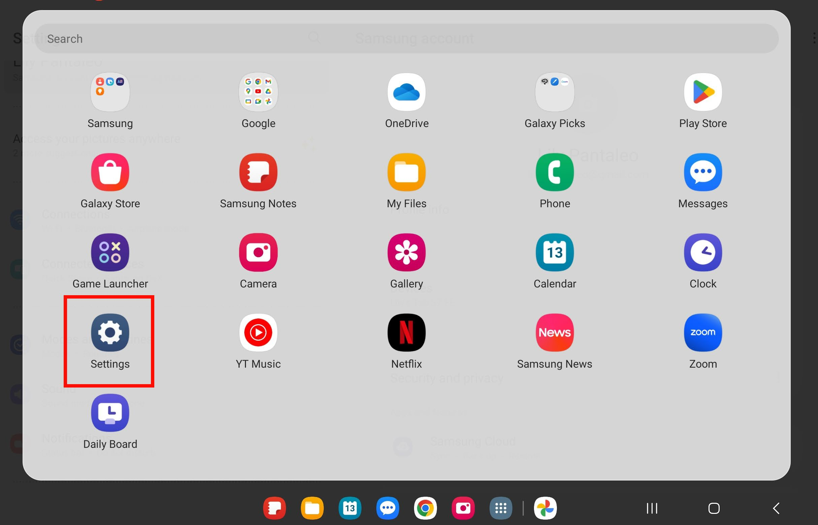

- Scroll down and tap Security and privacy (on some devices this may be called Biometrics and security).
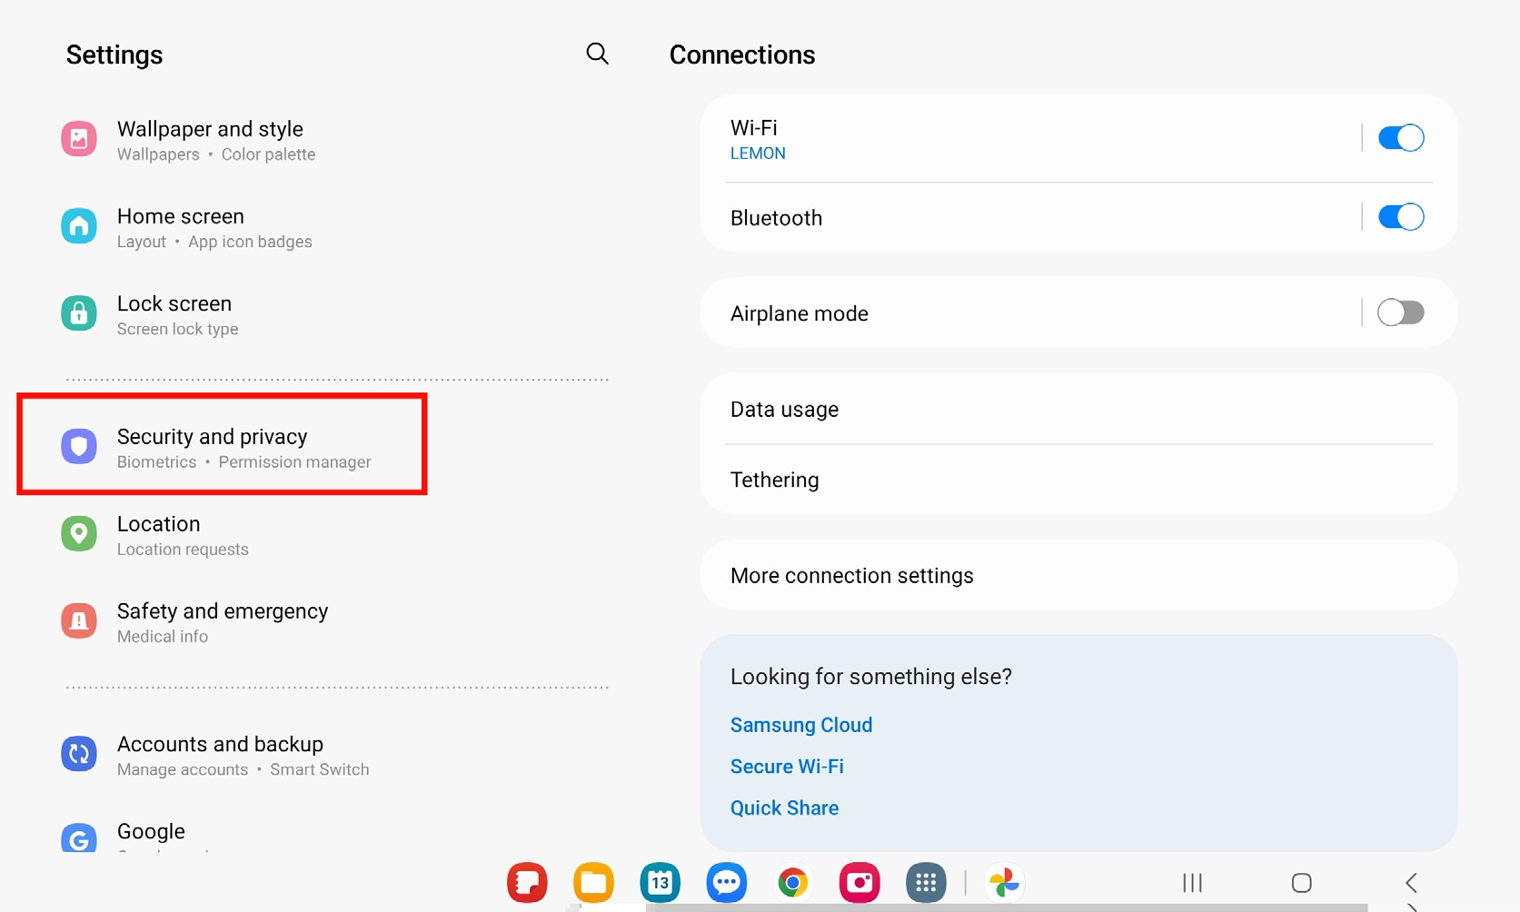

- Locate and tap Install unknown apps.

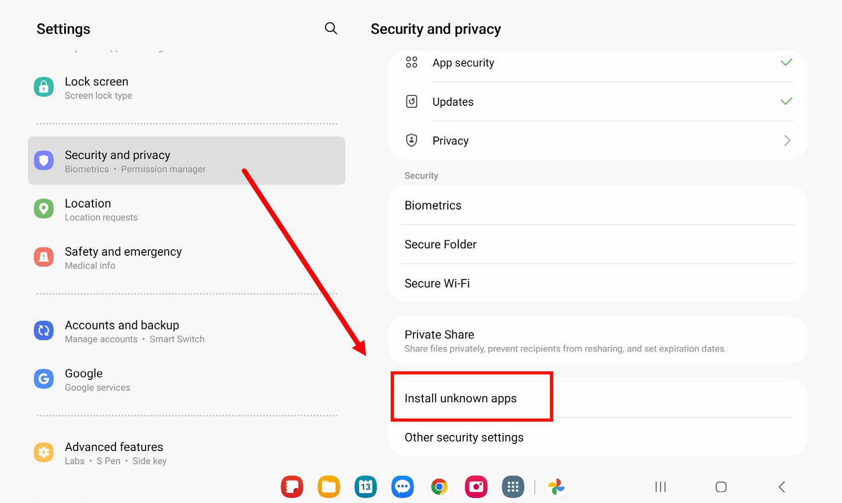

- In the Install unknown apps screen, tap on the toggle next to Chrome so that it is switched on.
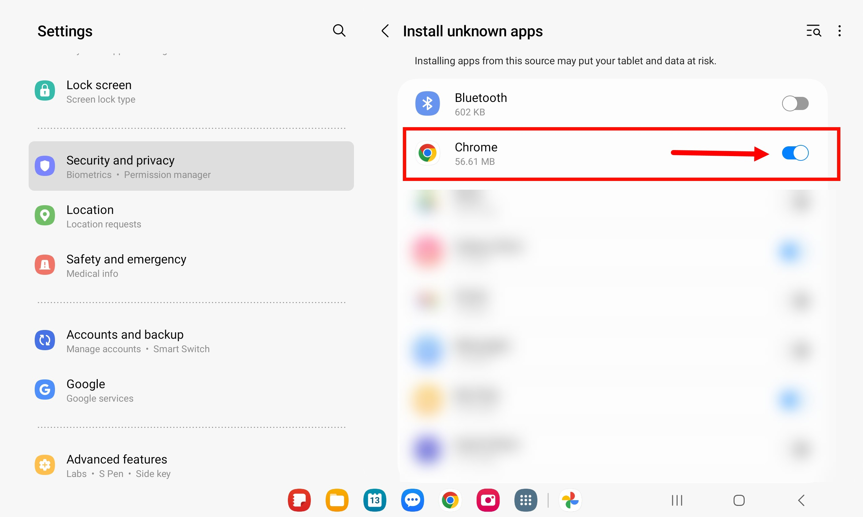

- Navigate to your app library or home screen and launch Chrome and enter this link in your browser’s address bar to download the Amazon Appstore: www.amazon.com/getappstore

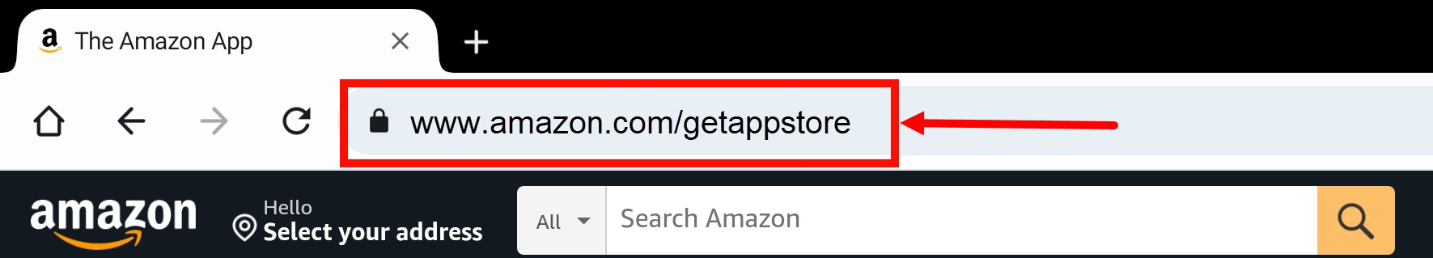

- Tap on the Get Amazon Appstore button.
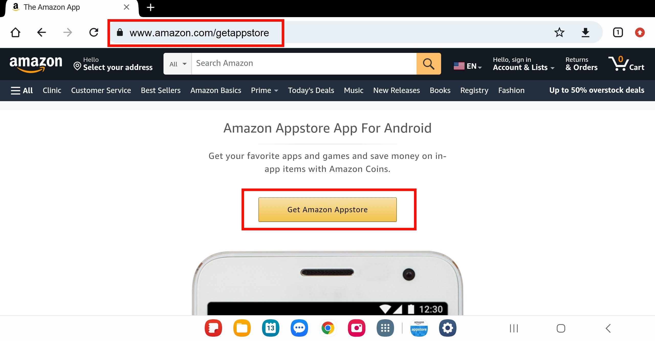

- For any popup messages that appear, you can tap ‘Yes’, ‘Continue’, or ‘Download anyway’.

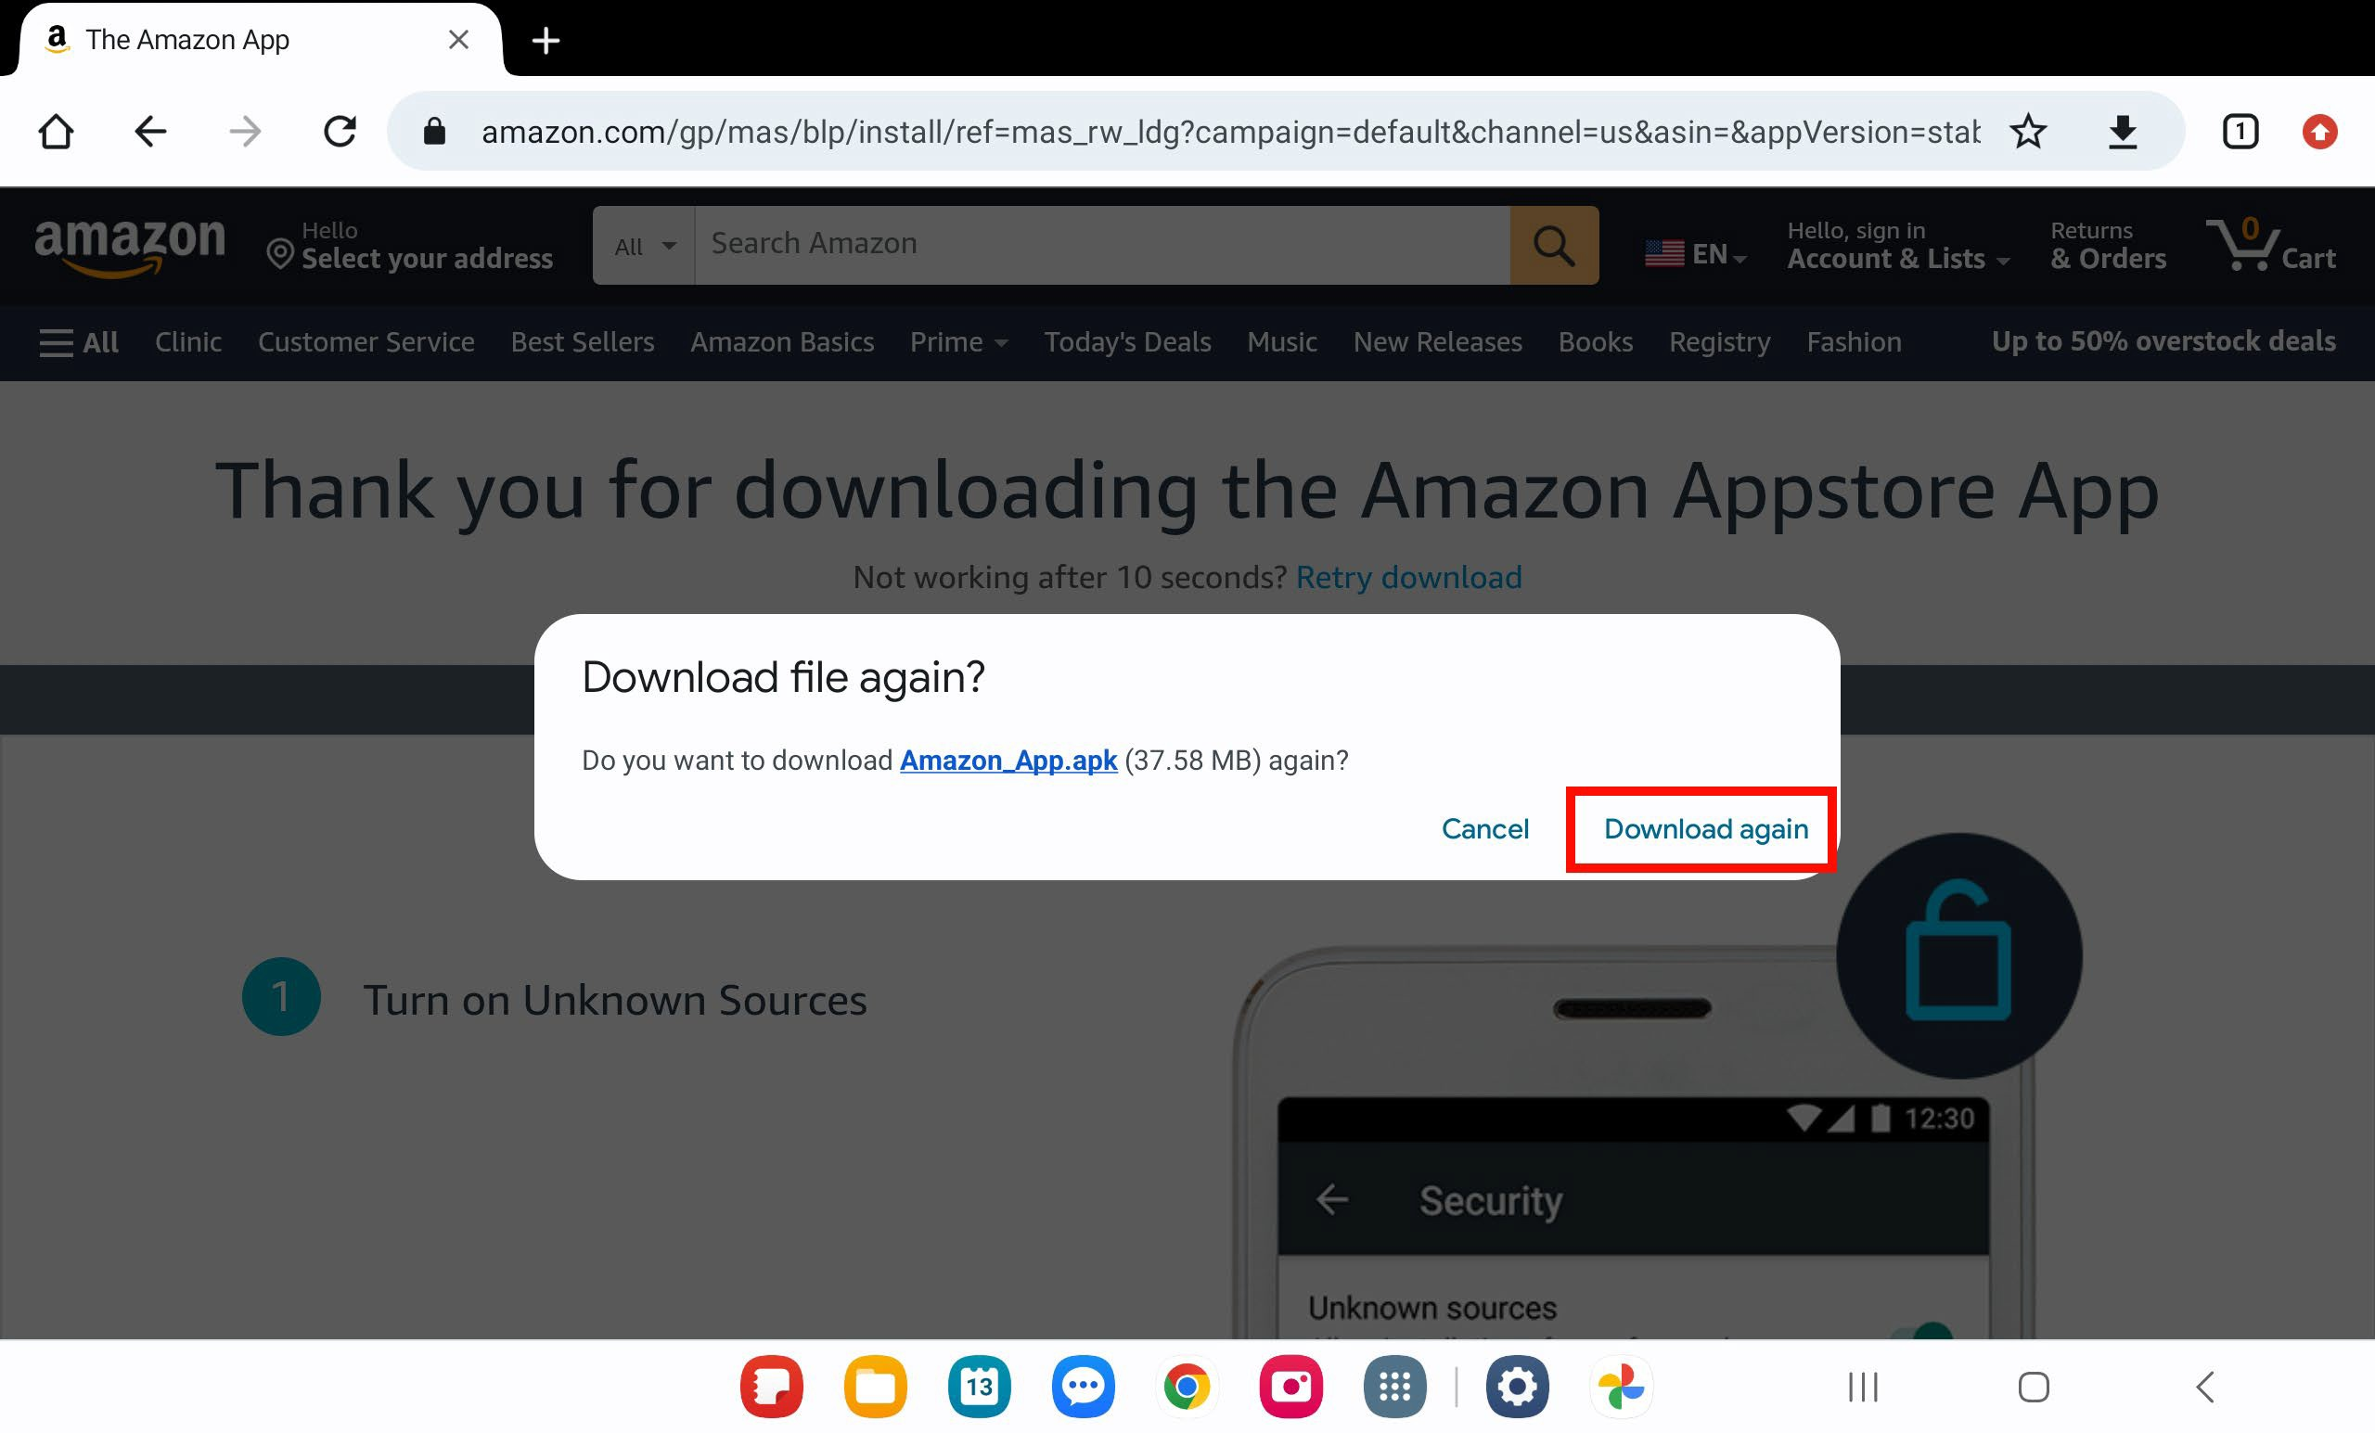

- Navigate to your My Files folder on your device home screen.

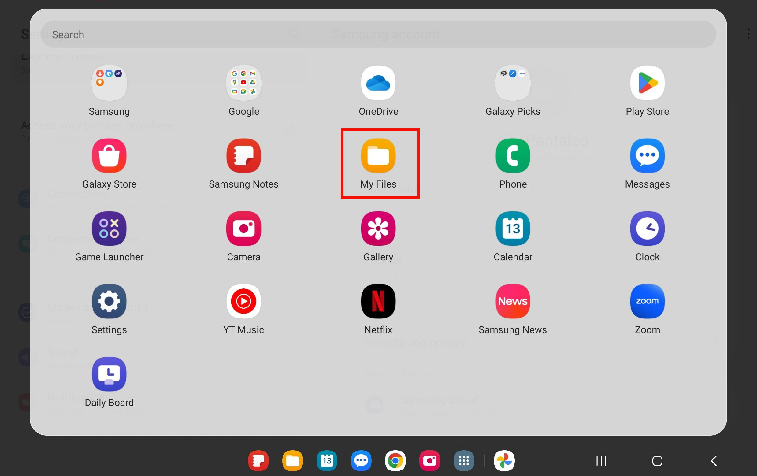

- Tap Installation Files on the left pane and then tap the Amazon Appstore file that you just downloaded.
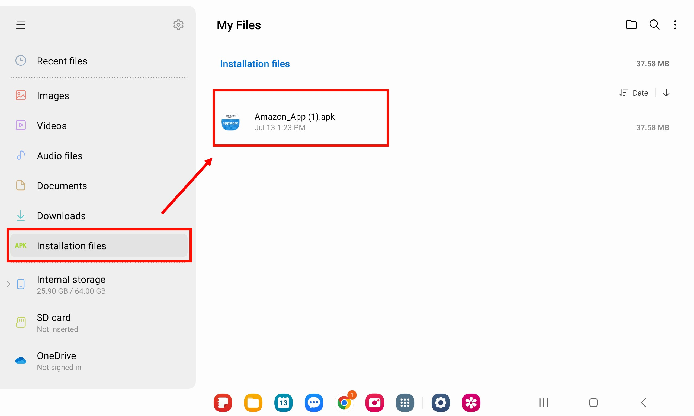

- A popup appears, tap Install to install the Amazon Appstore.

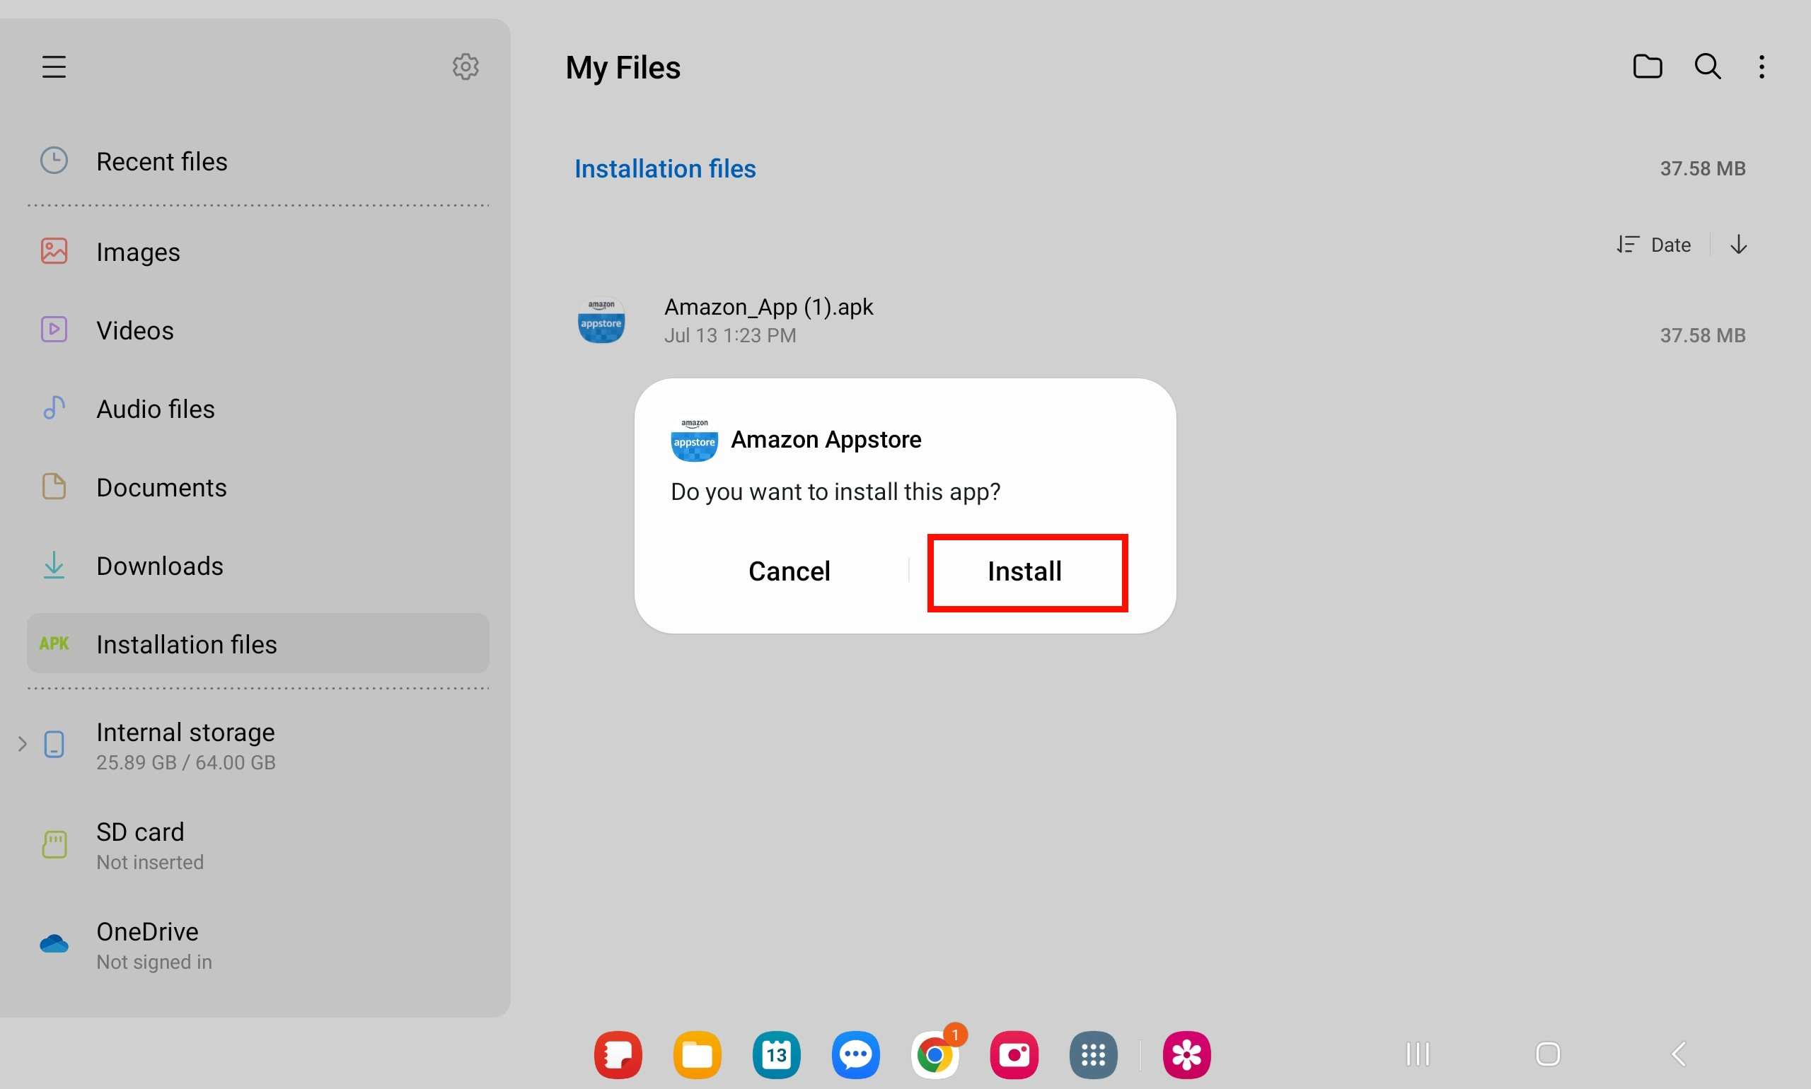

- Once the app is finished installing, tap Open. This will open the Amazon Appstore app.

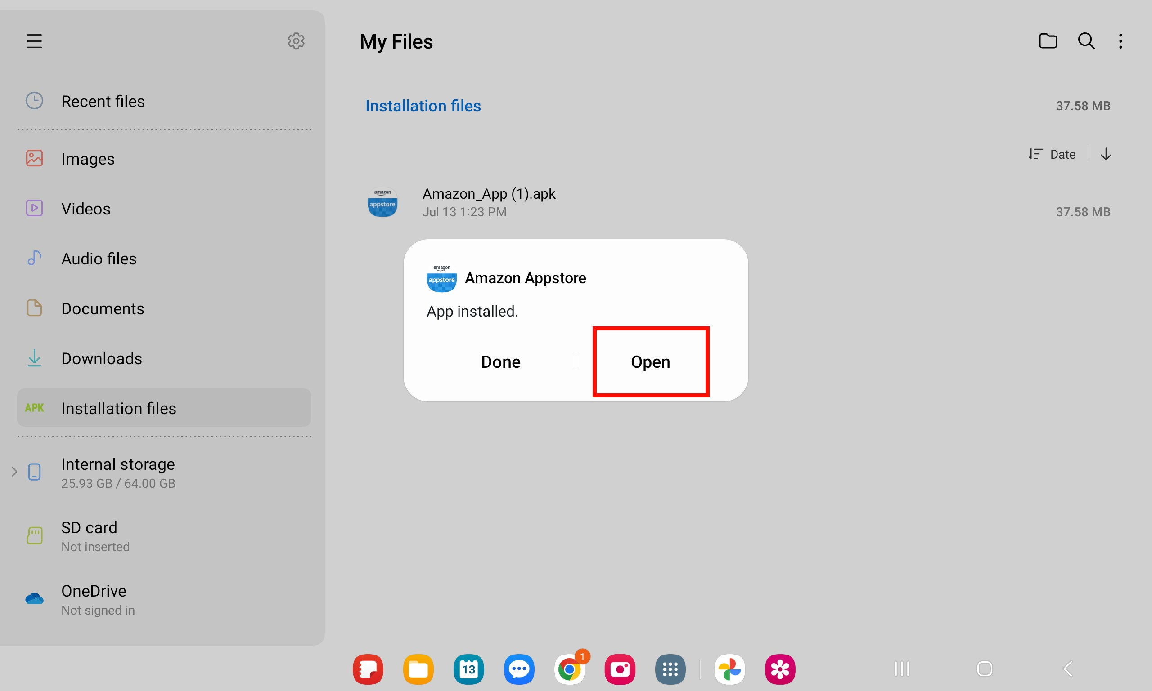

- If you do not have an Amazon account, follow the steps that are given after tapping Create a New Amazon Account.

Note: Some Android screens cannot display the Amazon Appstore in landscape mode, such as this screen.
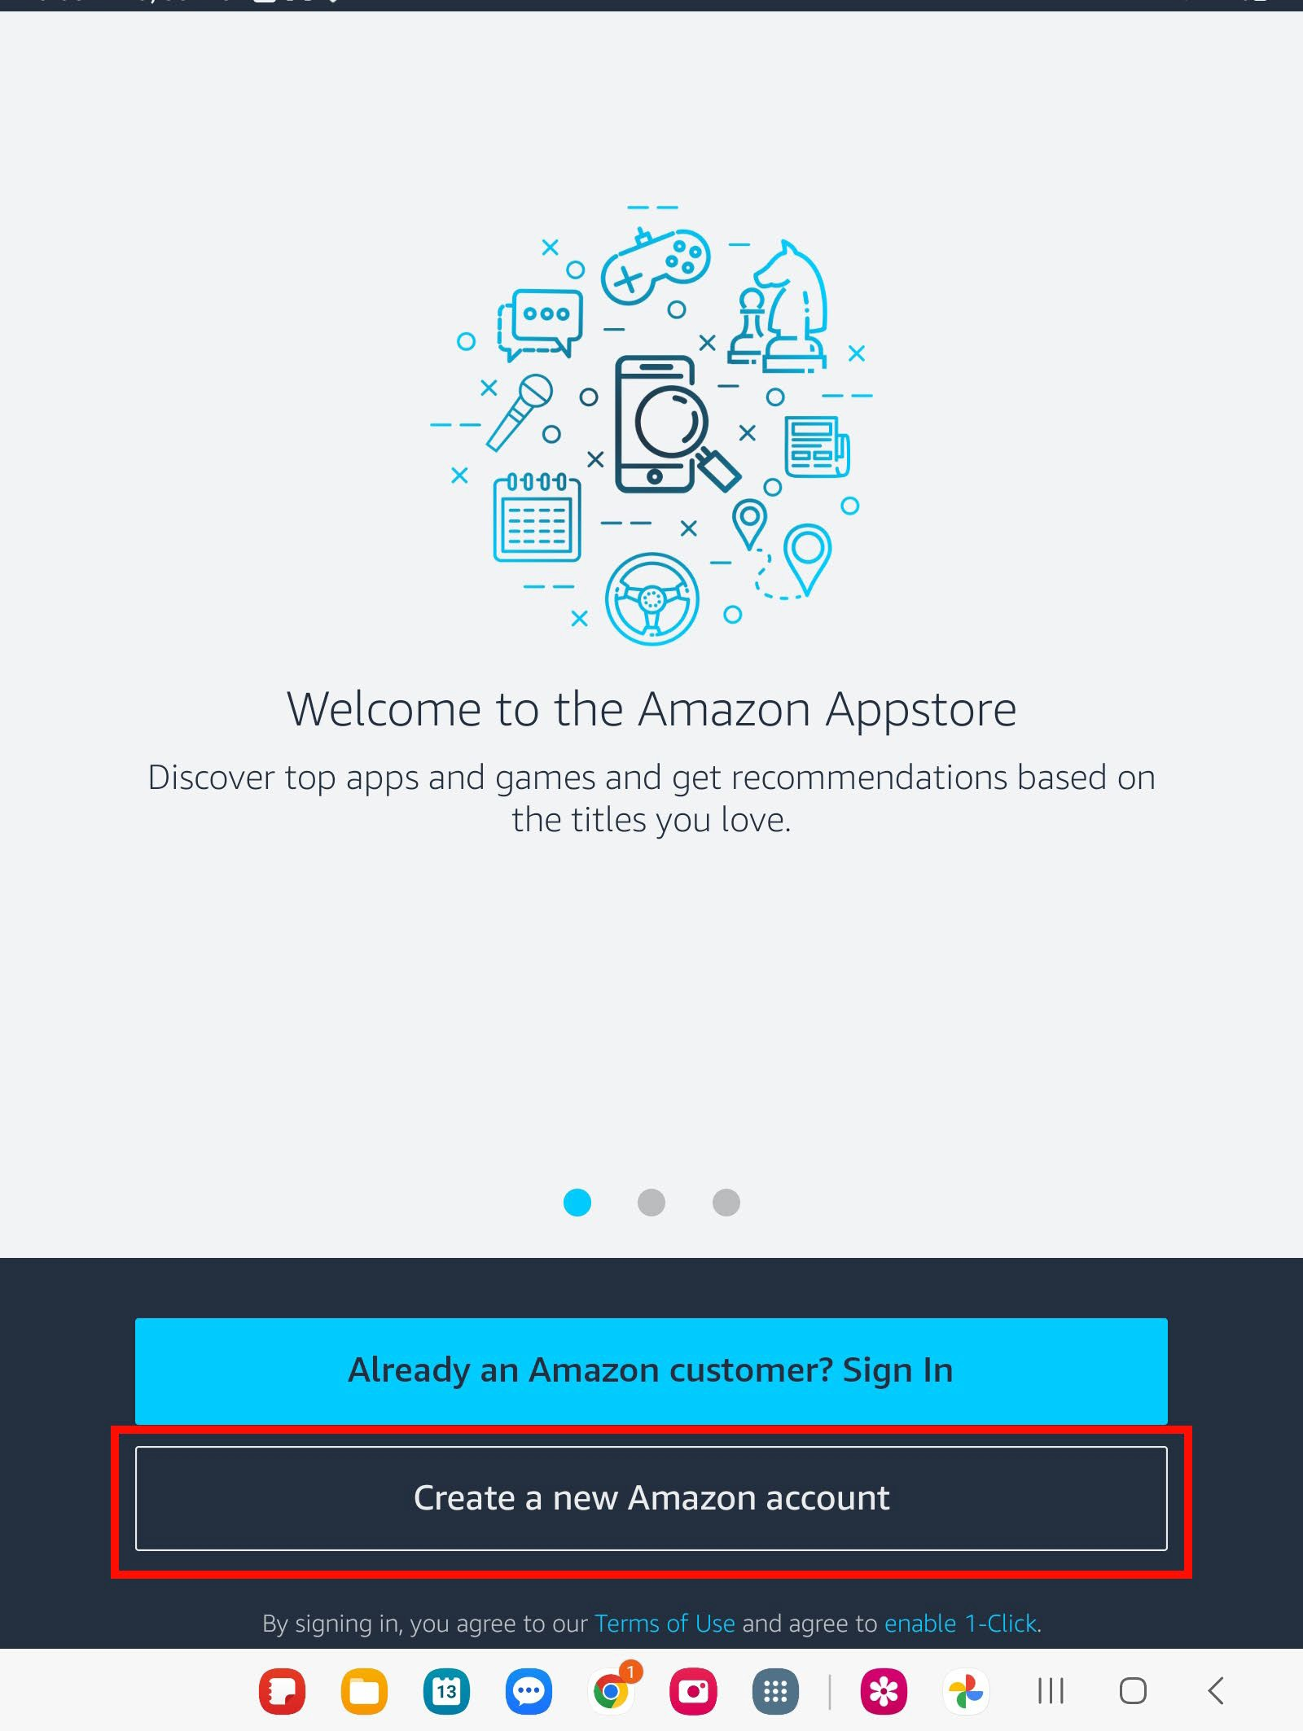

- If the steps above have been completed successfully and you have signed into your Amazon account, you should see a page which looks like this. This is the Amazon Appstore page.
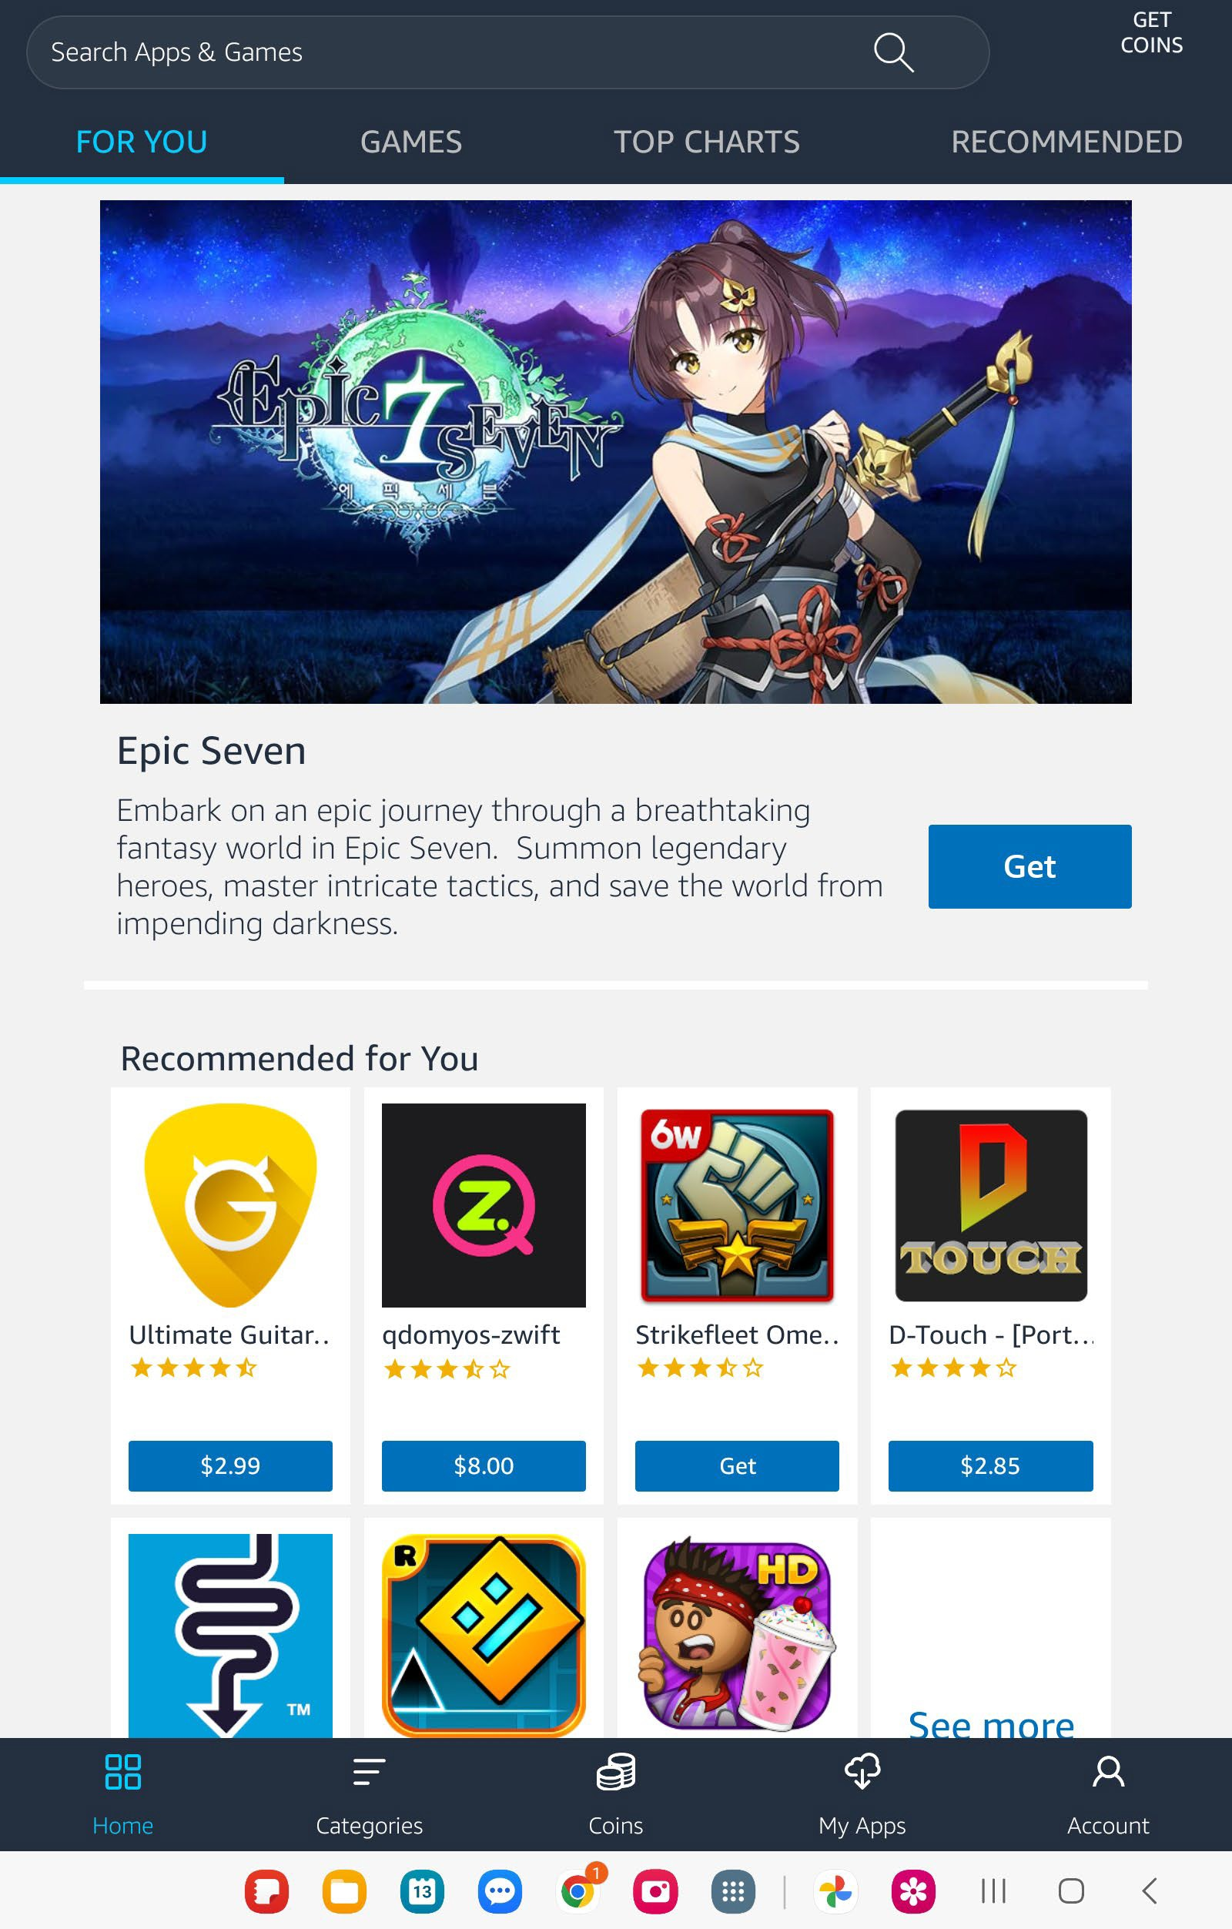

- When finished with the steps above, proceed with the steps below in Section II beginning with step 2.

Section II: Launch Amazon Appstore to Download and Install the R3 App

These steps assume you already have the Amazon Appstore on your phone. If you do not, please follow the steps in Section I above.

- Tap the Amazon Appstore on your device’s home screen and be sure to log in if you are not already.
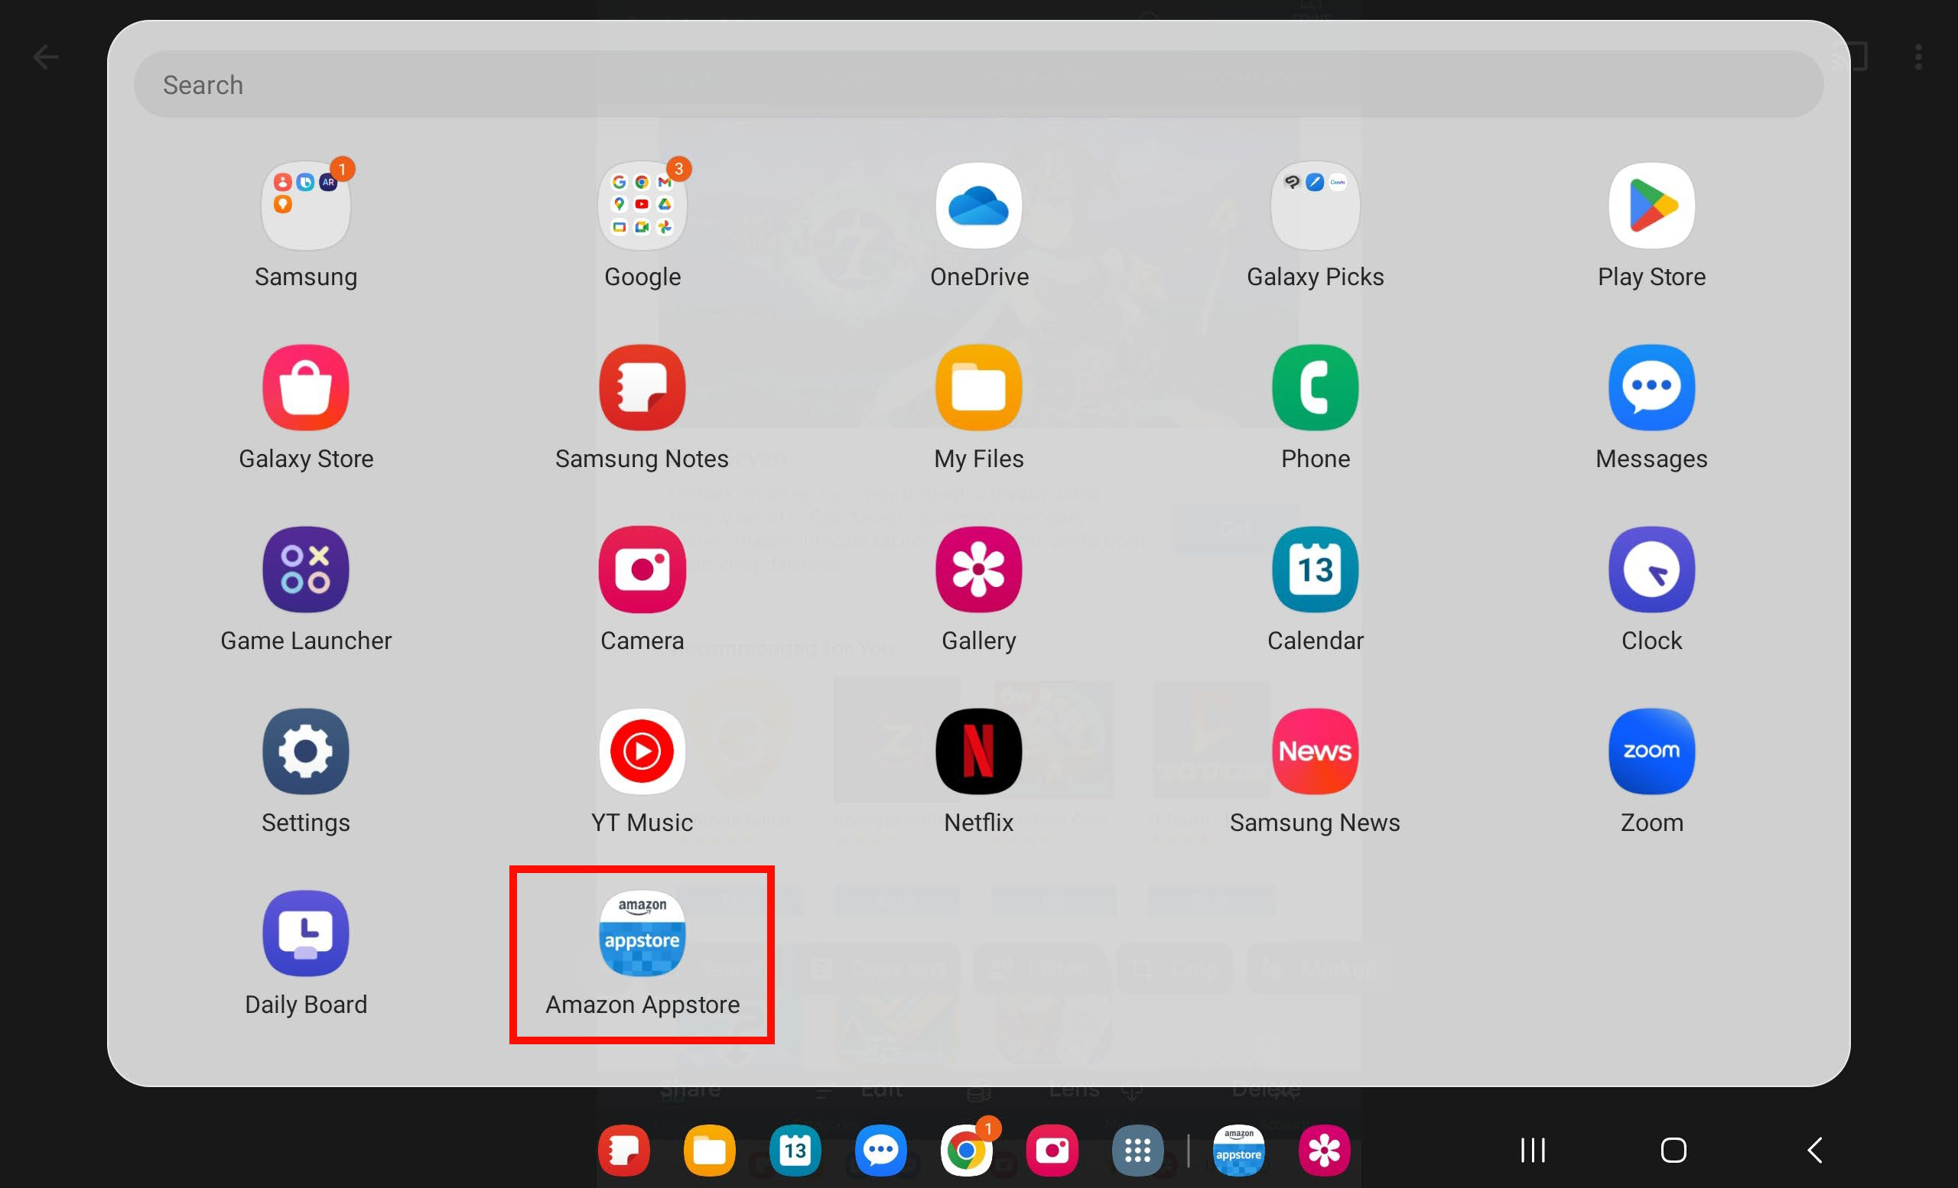

- Search for the R3 app in the Appstore by typing R3 in the search box. In this example, it is the second item on the list called R3: Recognize, Report, Respond. Tap the blue Install button.
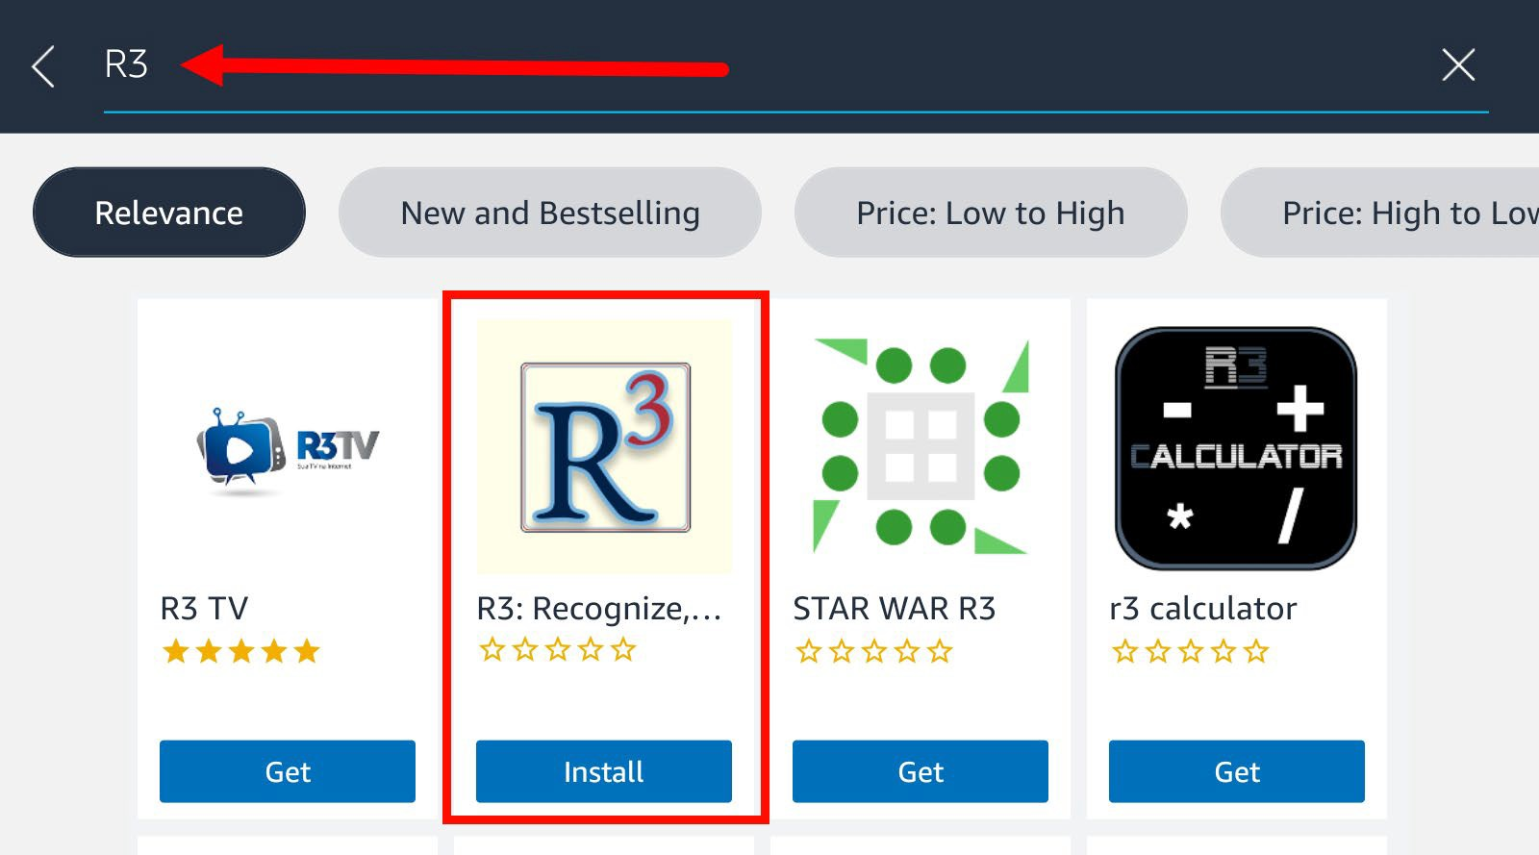

- Tap Install to proceed with the R3 installation. The app will take a few minutes to download to your device.

Note: If you have not set up your credit card information, Amazon will ask you to add a payment method even though the R3 app is free.
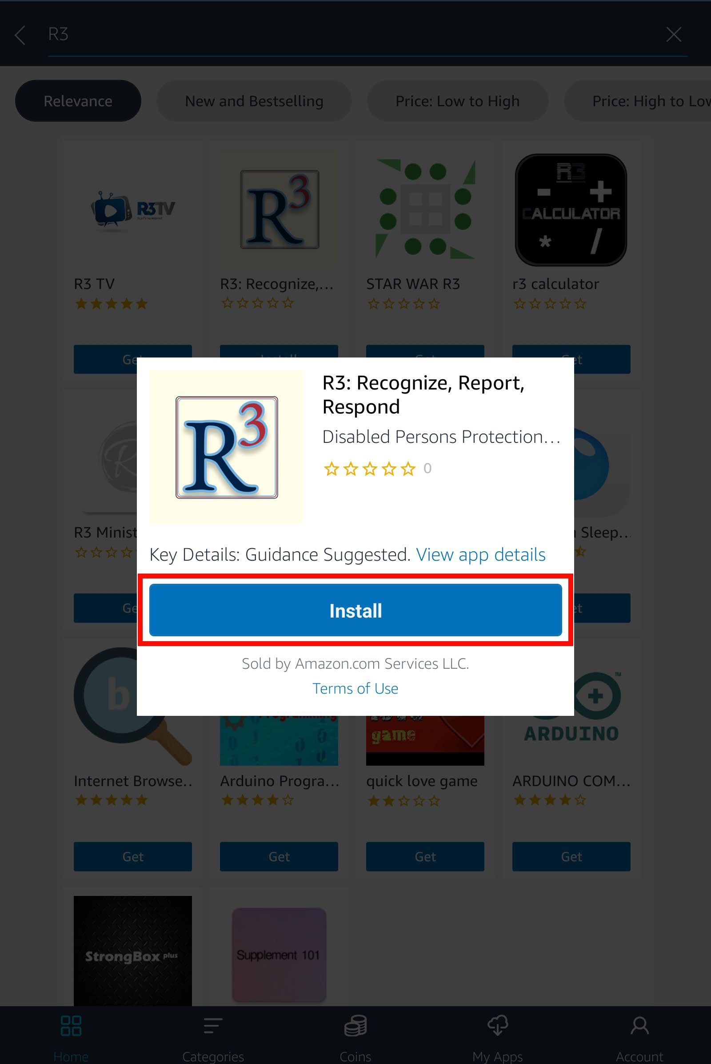

- A popup may appear instructing you to change a toggle to allow Amazon Appstore apps to function on your device. Tap Continue.
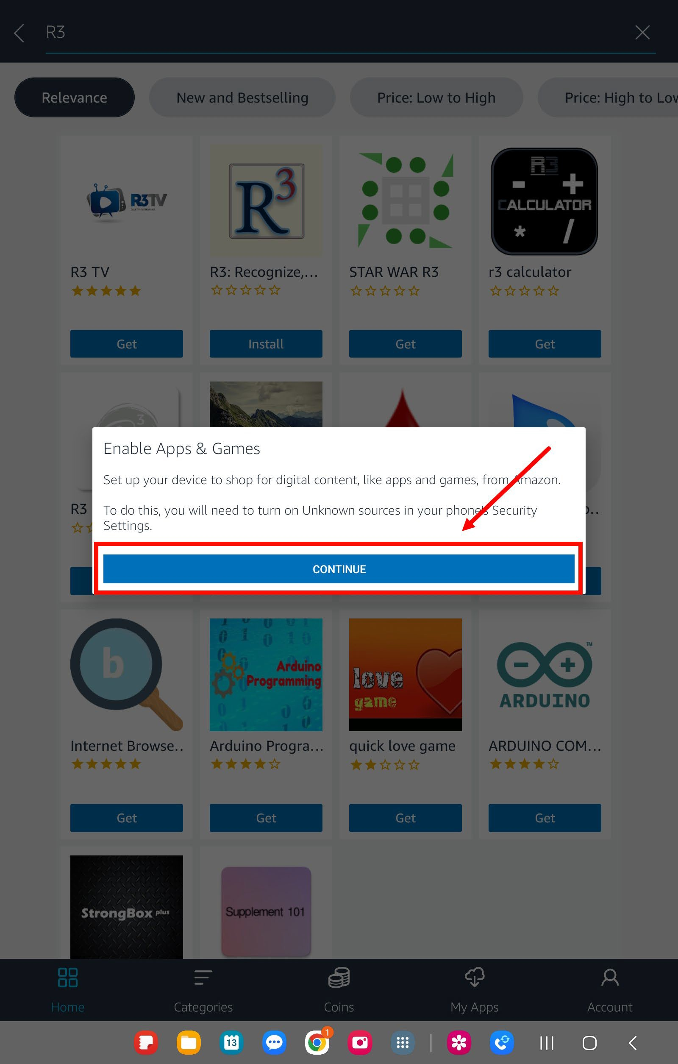

- Tap on Go To Settings.

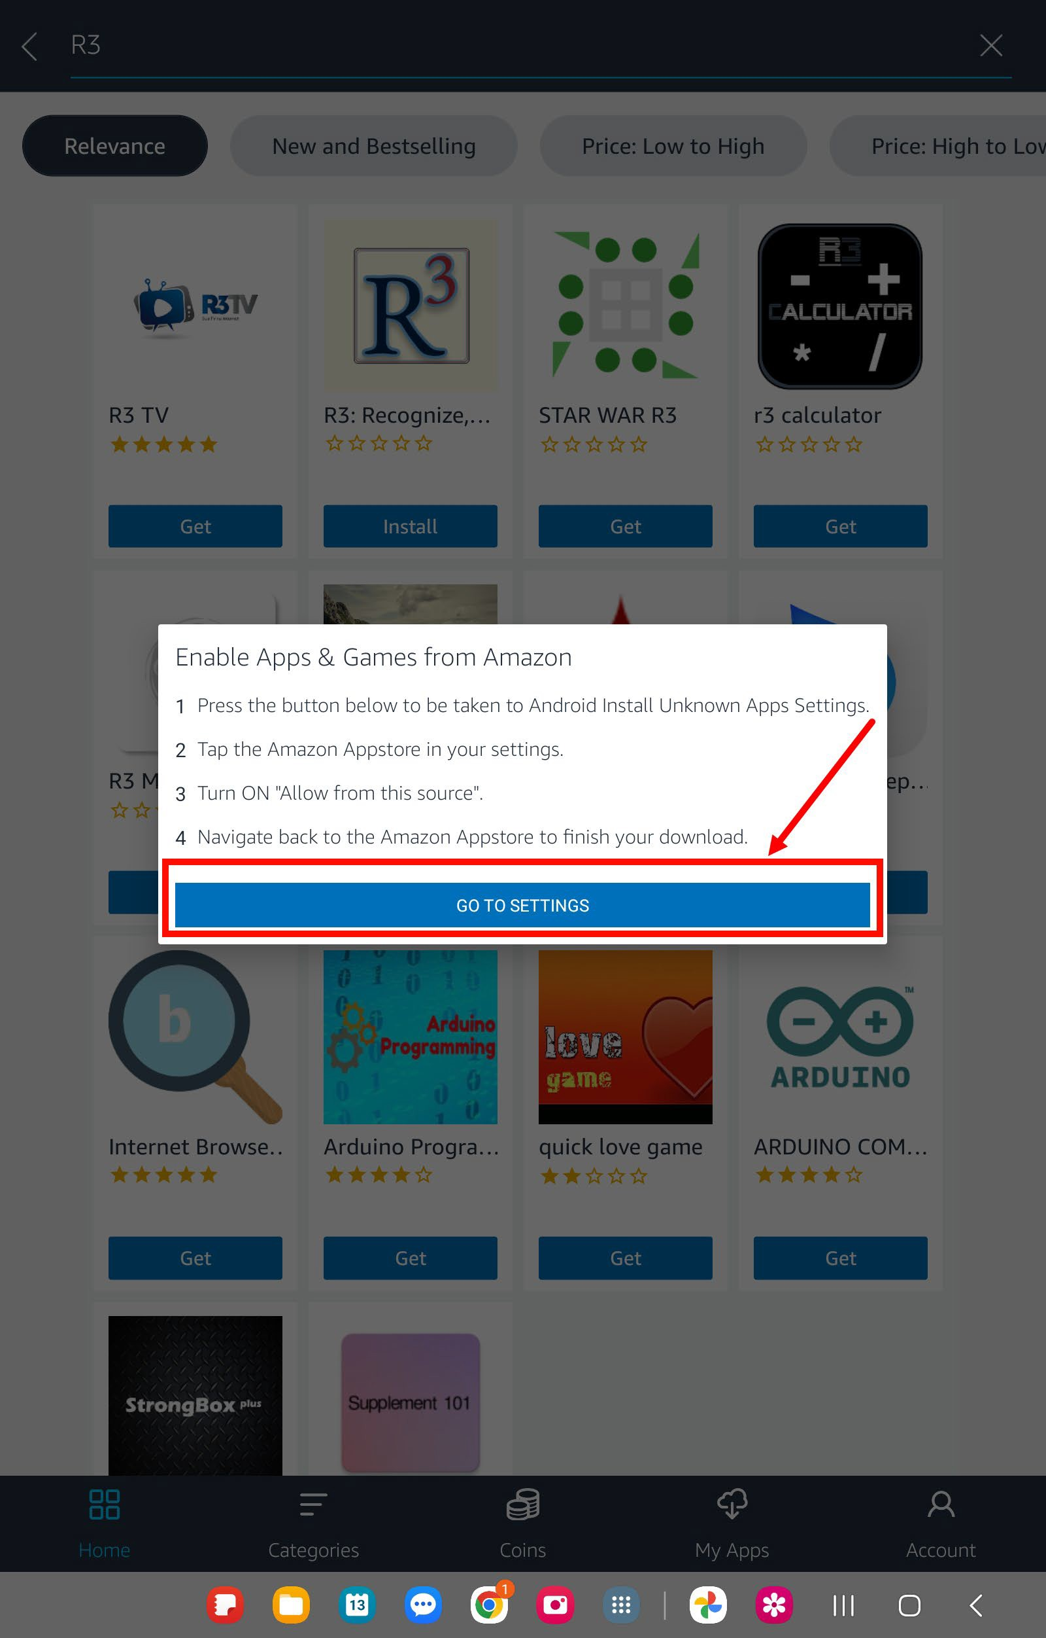

- Once here, from the Install Unknown apps page, tap on the toggle for the Amazon Appstore to enable it.
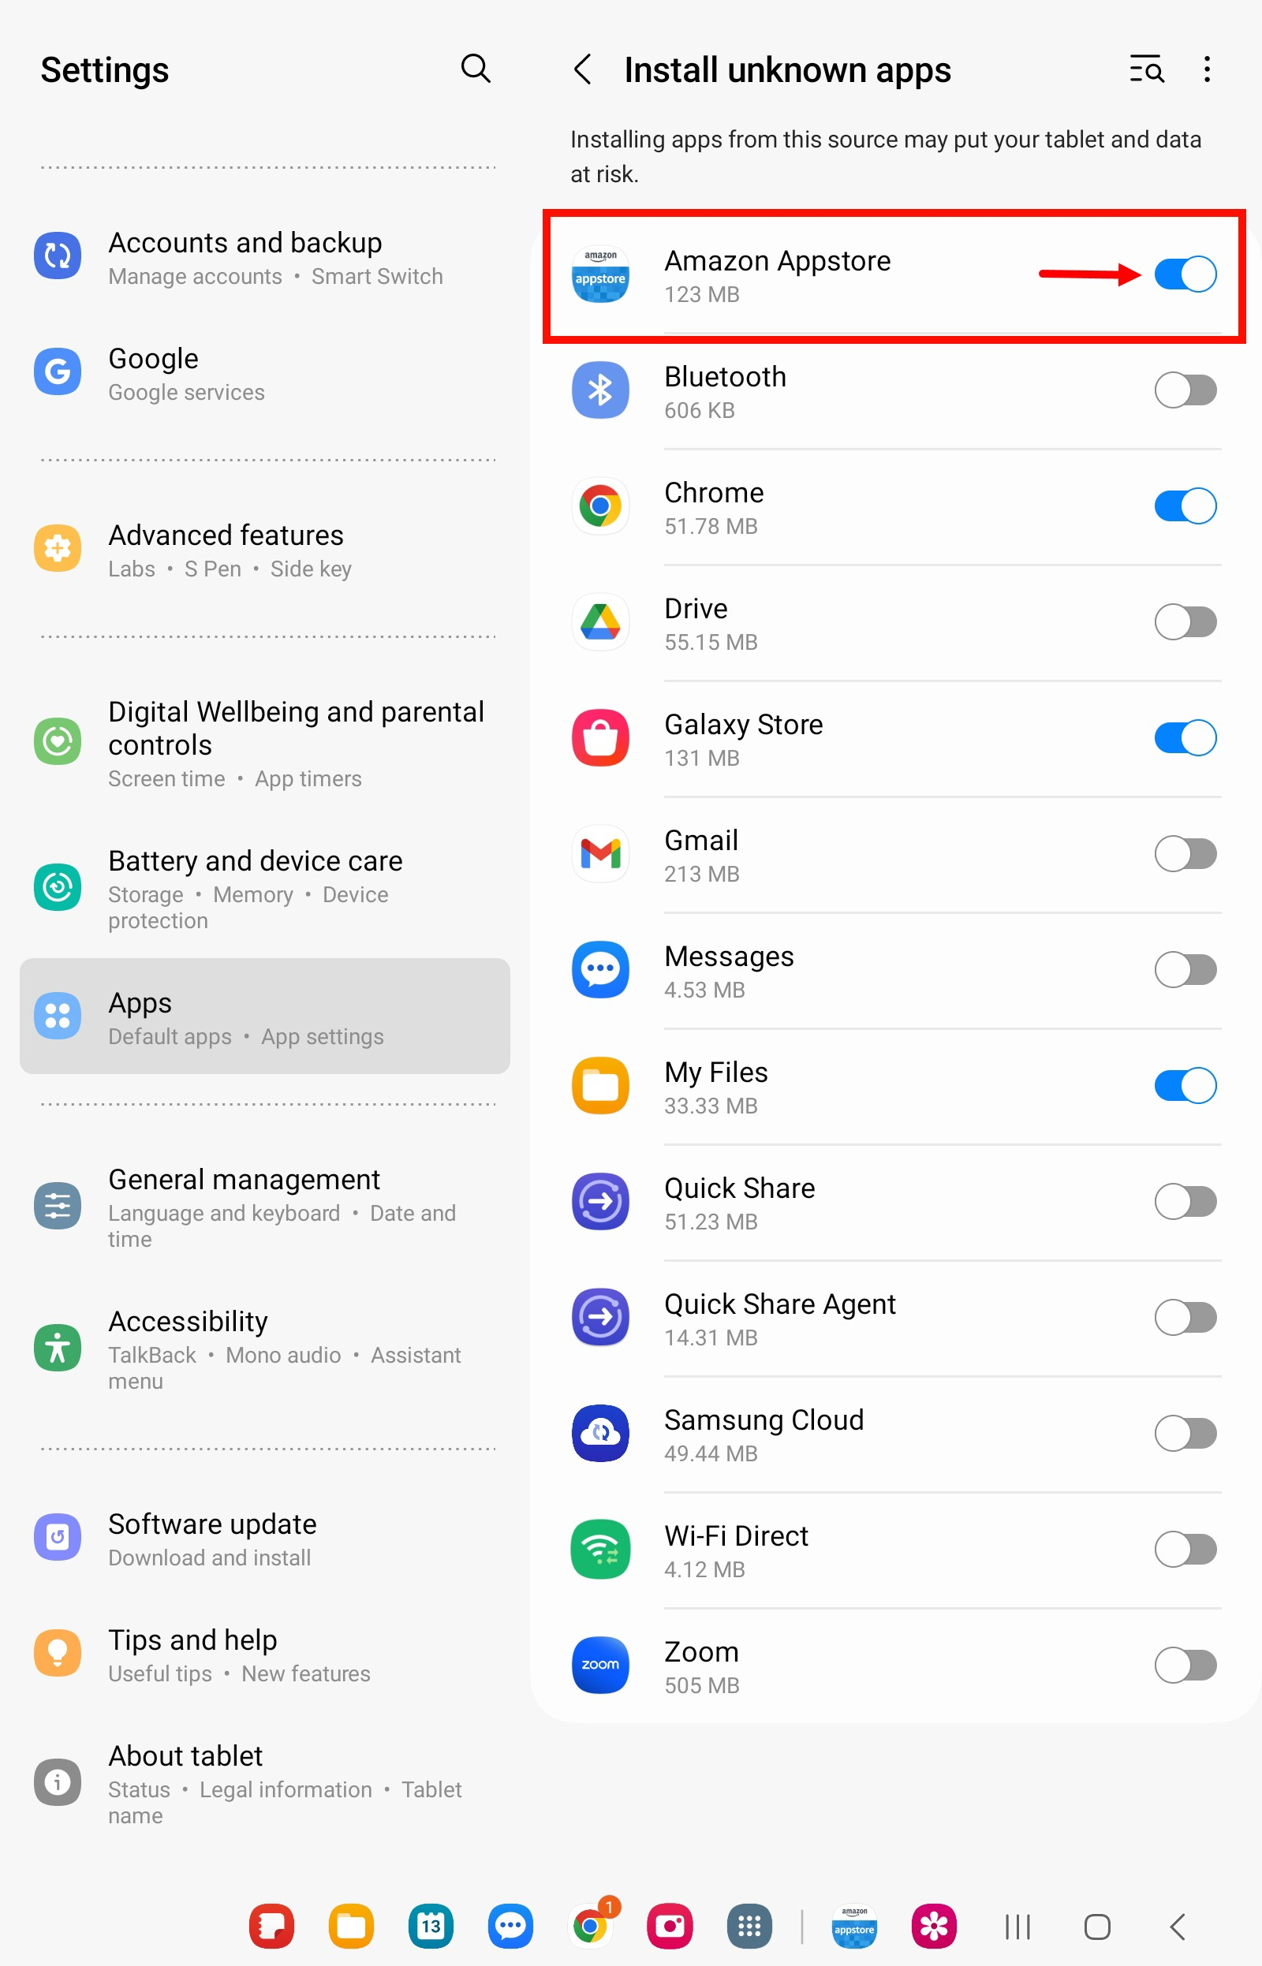

- Navigate to your app library or home screen and tap on Amazon Appstore.
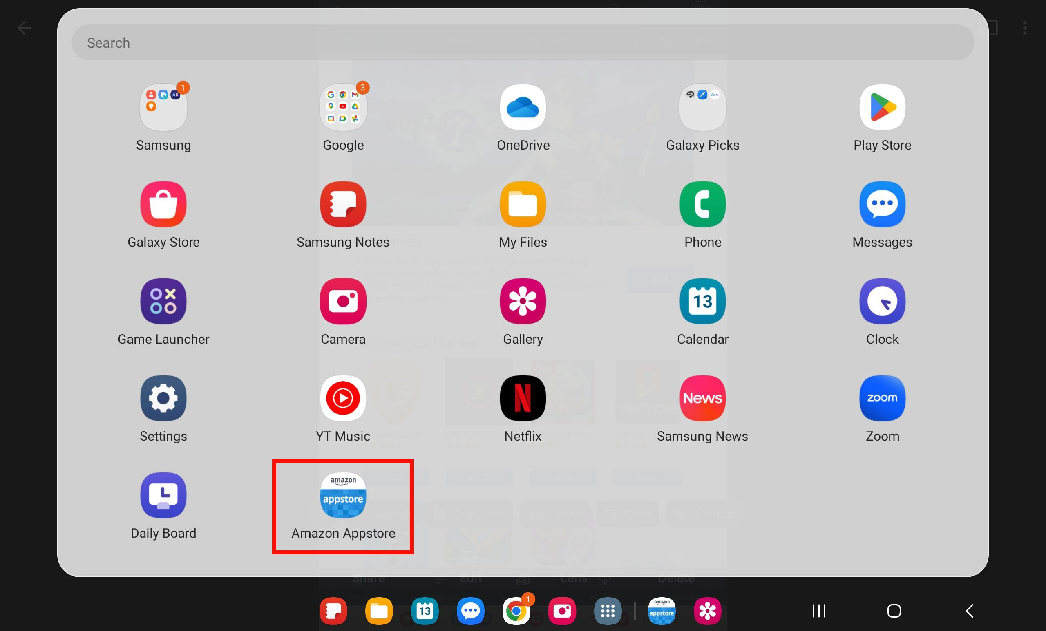

- Once back to the AppStore, tap Continue.

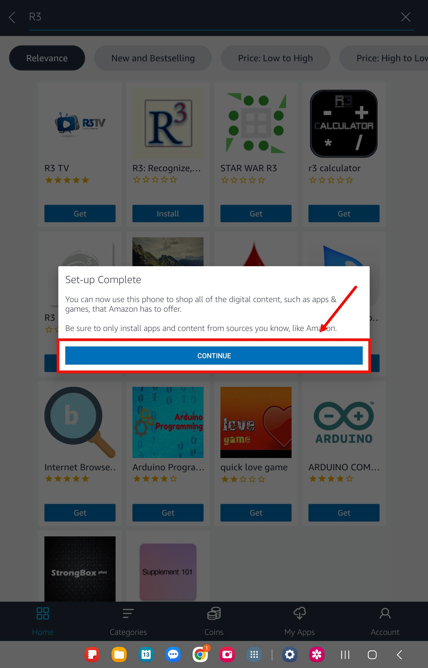

- In the Appstore, click the My Apps tab at the top. Locate the R3 app and tap Install under the R3 app logo.
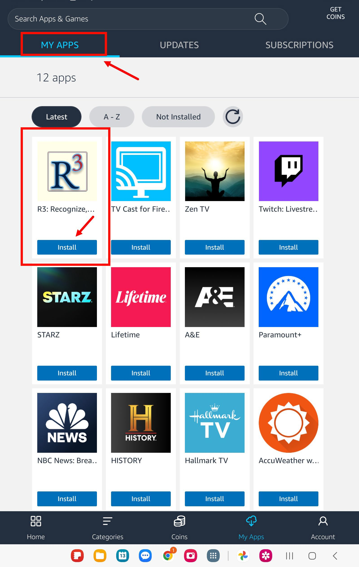

- The R3 app will begin downloading This may take several minutes depending on your Wi-Fi connection.
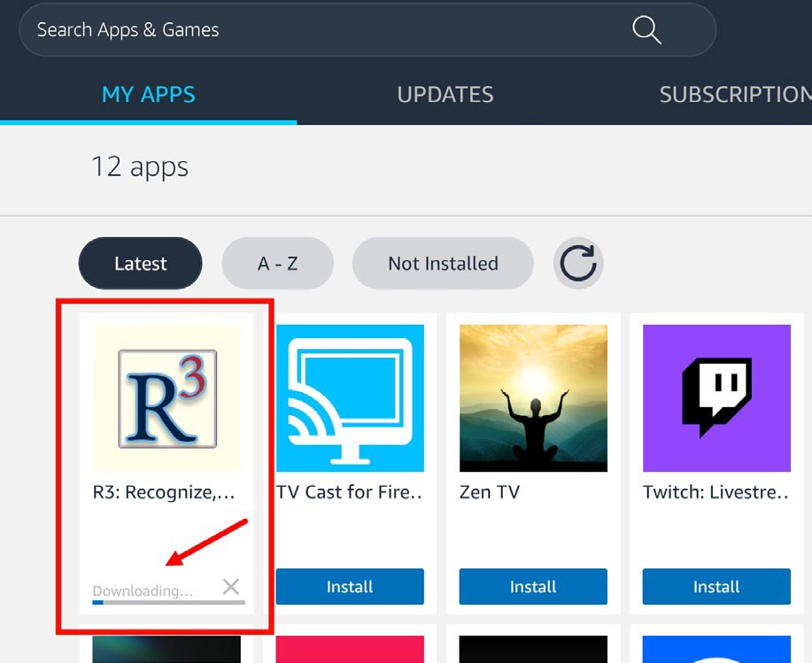

Note: If a second popup appears, tap Install again.

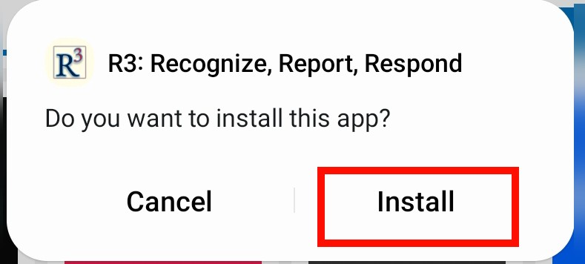

- Once it is done installing, tap Open.

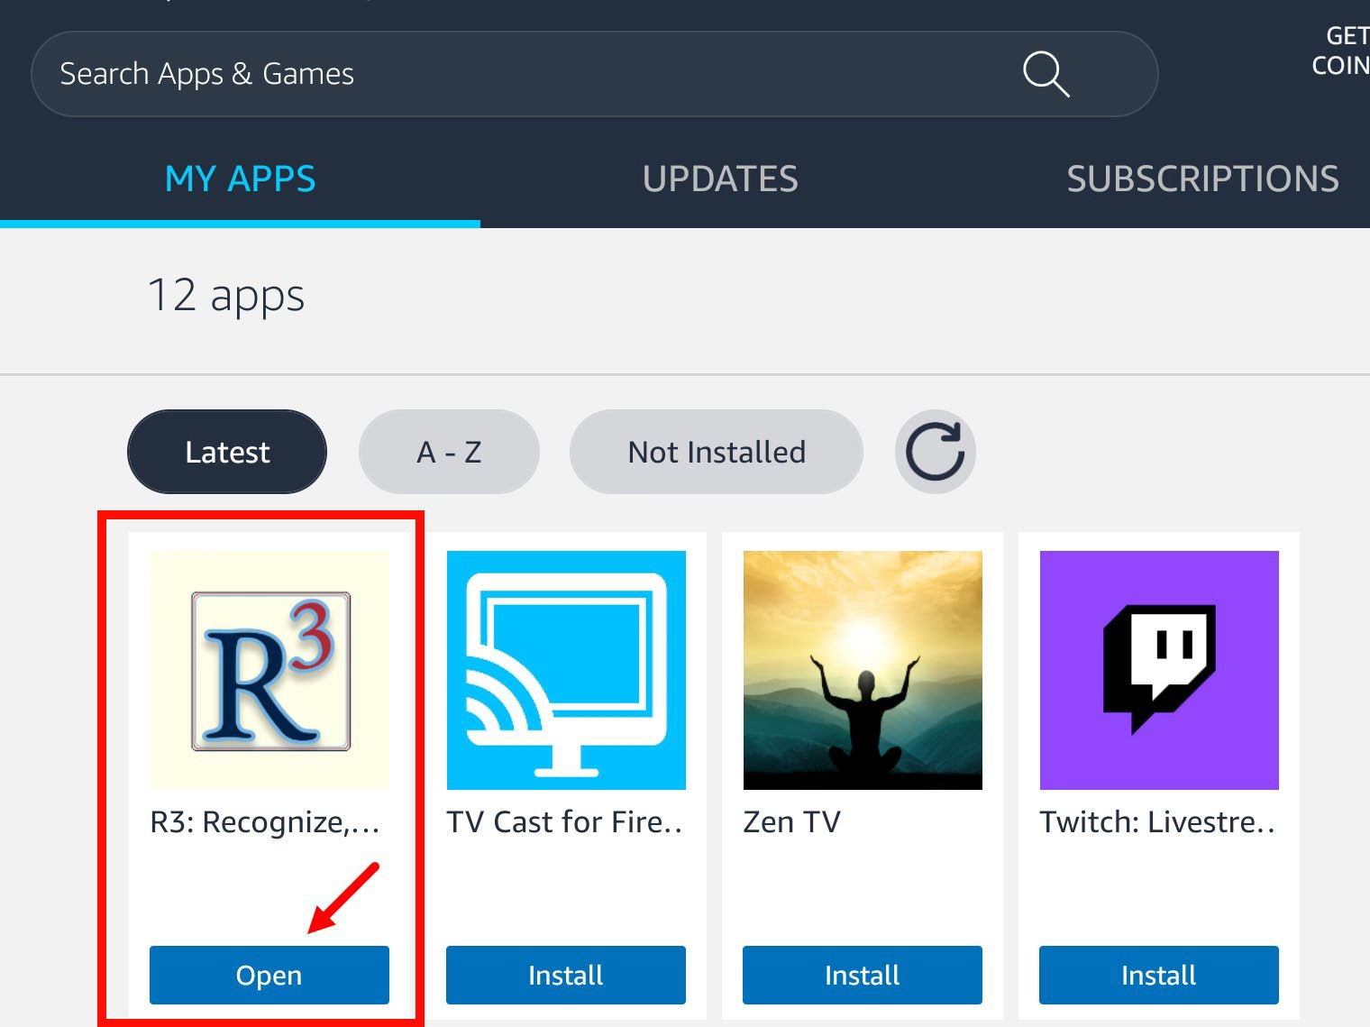

- Congratulations! You can now use the R3 app on your tablet!

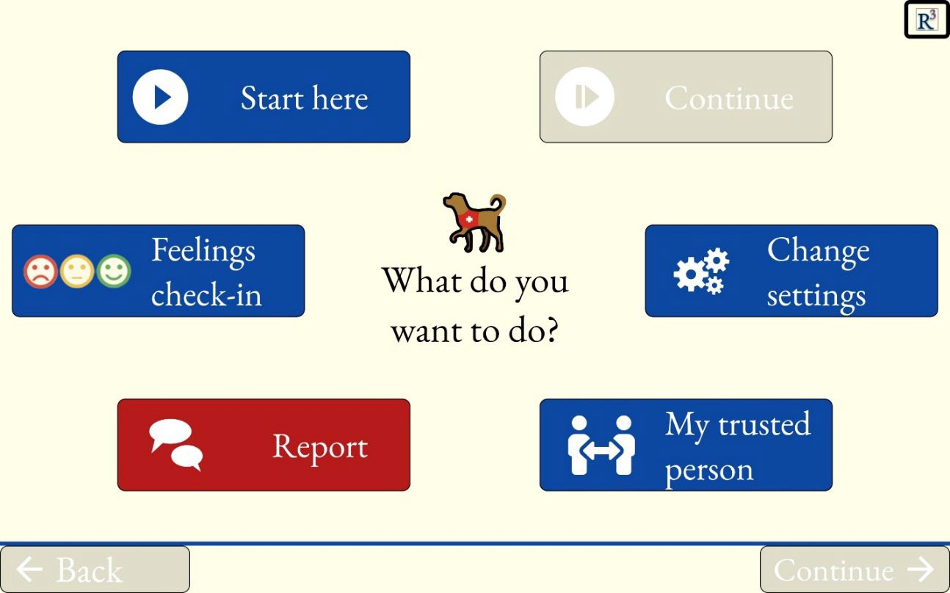

- You can now find R3 on your home screen, whenever you would like to use it.
