2015 Rabies Summary
Massachusetts Department of Public Health

The following summarizes data collected on animal specimens from Massachusetts sent to the Massachusetts State Public Health Laboratory (MASPHL) for rabies testing from January to December 2015. A cumulative report summarizing rabies testing from 1992-2002, and annual reports from 2003 to 2014 are available on the MDPH website at www.mass.gov/dph/rabies.

Number of Submissions and Positive Results by Year
The number and percentage of bats and terrestrial animals that tested positive in 2015 was nearly the same as in the previous year (see Table 1 and Figure 1).

Table 1. Number of Submissions, Positive Results and Percent* Positive by Year and Type of Animal
 | TERRESTRIAL ANIMALS |  |  | BATS
Year | Number Submitted | Number Positive | % Positive | Number Submitted | Number Positive | % Positive
1992 | 926 | 42 | 5% | 143 | 15 | 10%
1993 | 3660 | 698 | 19% | 289 | 22 | 8%
1994 | 4119 | 700 | 17% | 391 | 34 | 9%
1995 | 3175 | 383 | 12% | 241 | 17 | 7%
1996 | 2701 | 103 | 4% | 277 | 12 | 4%
1997 | 2771 | 264 | 10% | 334 | 17 | 5%
1998 | 3483 | 480 | 14% | 439 | 18 | 4%
1999 | 2643 | 205 | 8% | 595 | 21 | 4%
2000 | 2666 | 247 | 9% | 611 | 29 | 5%
2001 | 2615 | 248 | 9% | 710 | 32 | 4%
2002 | 2505 | 267 | 11% | 613 | 36 | 6%
2003 | 2358 | 193 | 8% | 602 | 23 | 4%
2004 | 2842 | 291 | 10% | 600 | 34 | 6%
2005 | 2653 | 296 | 11% | 708 | 33 | 5%
2006 | 2122 | 197 | 9% | 756 | 34 | 5%
2007 | 1988 | 123 | 6% | 787 | 29 | 4%
2008 | 2298 | 135 | 6% | 748 | 19 | 3%
2009 | 1747 | 106 | 6% | 696 | 21 | 3%
2010 | 1740 | 117 | 7% | 678 | 14 | 2%
2011 | 1700 | 90 | 5% | 753 | 20 | 3%
2012 | 1594 | 73 | 5% | 1196 | 38 | 3%
2013 | 1644 | 79 | 5% | 1045 | 18 | 2%
2014 | 1644 | 108 | 7% | 1175 | 40 | 3%
2015 | 1642 | 103 | 6% | 1073 | 39 | 4%
Total | 57,236 | 5,548 | 10% | 15,460 | 615 | 4%
* Calculated to nearest percent

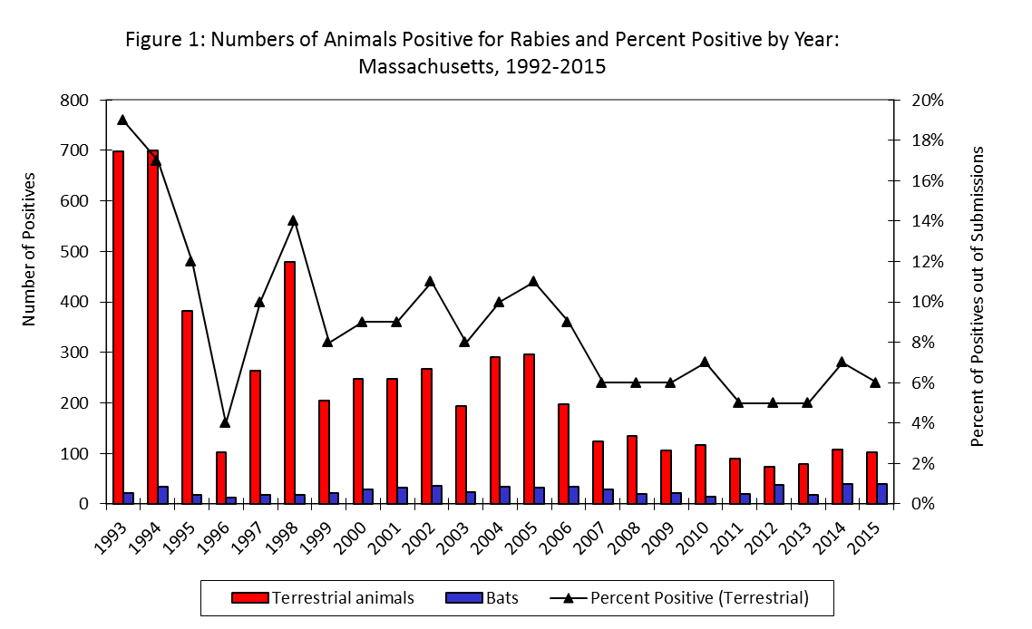
Notable Rabies Situations
In 2015, 2,715 specimens were submitted to the MASPHL for rabies testing. Of these specimens, 142 (5%) tested positive for rabies. Table 2 shows data on positive animals for 2015. In 2015, two domestic animals tested positive; both were cats.

In Hampden County, a one year old, unvaccinated cat developed neurologic symptoms approximately eight weeks after being placed under six month quarantine for wounds of unknown origin. The cat was euthanized and tested positive for rabies. Five individuals at an animal shelter/veterinary facility were bitten or scratched by the cat prior to it being euthanized and all received post-exposure rabies prophylaxis; none had previously received the rabies vaccine series. The cat was one of nine indoor/outdoor cats owned by the same individual. The owner sustained a scratch from the positive cat in the days prior to it being euthanized and received post-exposure rabies prophylaxis. The local Animal Inspector placed the remainder of the cats in the home under quarantine.

In Berkshire County, a stray cat was found in the road by a resident, who presumed it had been hit by a car because it was dragging its hind legs. While waiting for the local animal control officer to arrive, the cat became aggressive and bit the resident. The animal was euthanized and tested positive for rabies. The resident who was bitten by the cat received post-exposure rabies prophylaxis.

A small cluster of rabid animals (raccoons and skunks) was identified on the mainland side of the Cape Cod Canal (see Figure 5). Because oral rabies vaccine baits are now being distributed along the south-east edge of the Cape Cod Canal during the fall and spring, positive animals on the north-west edge are an indication of potential transmission pressure being applied to the geographic barrier of the canal. Several clusters of positive animals were found along the north-west canal edge in the months preceding the first identification of raccoon rabies on Cape Cod in March, 2004.
Number of Submissions and Positive Results by Species
Raccoons, skunks and bats together, accounted for the large majority of rabies positive animals in Massachusetts, although their proportion of all rabies positive animals varied by quarter (Figure 2).

Table 2. Number of Animals Positive for Rabies/Animals Submitted (%), 2015
 | 1st Quarter |  |  | 2nd Quarter |  |  | 3rd Quarter |  |  | 4th Quarter |  |  | Total
Animal | Number Positive | Number Submitted | % | Number Positive | Number Submitted | % | Number Positive | Number Submitted | % | Number Positive | Number Submitted | % | Number Positive | Number Submitted | %
Raccoon | 13 | 18 | 72.2% | 23 | 60 | 38.3% | 11 | 28 | 39.3% | 9 | 16 | 56.3% | 56 | 122 | 45.9%
Skunk | 1 | 7 | 14.3% | 7 | 10 | 70.0% | 11 | 57 | 19.3% | 14 | 23 | 60.9% | 33 | 97 | 34.0%
Cat | 0 | 125 | 0% | 0 | 164 | 0% | 1 | 268 | 0.4% | 1 | 158 | 0.6% | 2 | 715 | 0.3%
Fox | 0 | 4 | 0% | 5 | 7 | 71.4% | 3 | 13 | 23.1% | 0 | 6 | 0% | 8 | 30 | 26.6%
Woodchuck | 0 | 0 | 0% | 2 | 42 | 4.8% | 1 | 37 | 2.7% | 0 | 0 | 0% | 3 | 79 | 3.8%
Bat | 1 | 103 | 1.0% | 12 | 279 | 4.3% | 20 | 643 | 3.1% | 6 | 48 | 12.5% | 39 | 1073 | 3.6%
Cow | 0 | 1 | 0% | 0 | 1 | 0% | 0 | 0 | 0% | 0 | 0 | 0% | 0 | 2 | 0%
Coyote | 0 | 2 | 0% | 1 | 1 | 100% | 0 | 0 | 0% | 0 | 0 | 0% | 1 | 3 | 33.3%
Dog | 0 | 112 | 0% | 0 | 129 | 0% | 0 | 145 | 0% | 0 | 111 | 0% | 0 | 497 | 0%
Other* | 0 | 11 | 0% | 0 | 28 | 0% | 0 | 29 | 0% | 0 | 28 | 0% | 0 | 96 | 0%
Total | 15 | 383 | 3.9% | 50 | 721 | 6.9% | 47 | 1221 | 3.8% | 30 | 390 | 7.7% | 142 | 2715 | 5.2%

* Includes squirrels, rabbits, sheep, pig, goats, horses, chipmunks, bobcat, mink, muskrats, rats, alpacas, deer, mice, otter, seals, weasel, guinea pig, and opossums

Figure 2. Proportion of All Positive Results Represented by Each Species, by Quarter, 2015

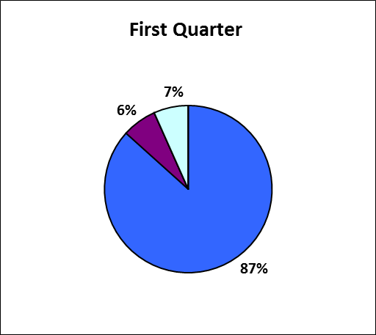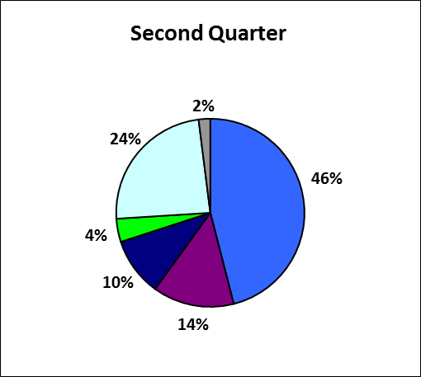
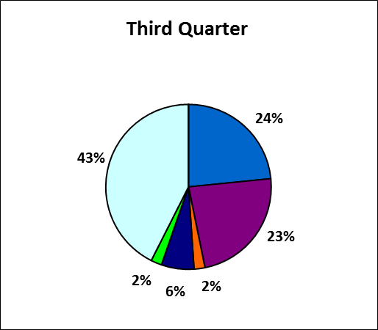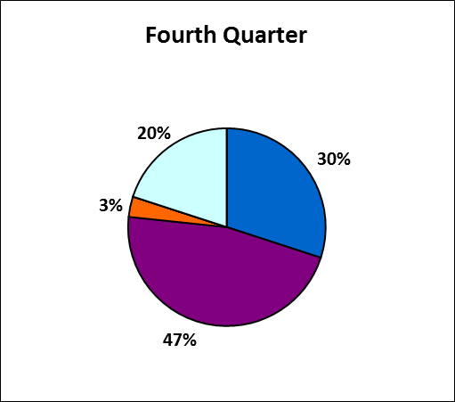

 | Raccoon |  | Skunk |  | Cat |  | Fox |  | Woodchuck |  | Bat
 | Other

*Other: Coyote

Cumulative Submissions and Results by Month
Animal submission numbers fluctuated throughout the year. As might be expected, the highest number of submissions for both terrestrial animals and bats occurred during June, July and August (see Table 3). This same trend is seen annually and is due to the greater activity of wildlife species during the spring and summer months, coinciding with the time that humans increase outdoor activity. These simultaneous events result in more frequent contact between humans and wildlife, and lead to more animal rabies testing.

The proportion of animals testing positive and unsatisfactory for rabies also varies throughout the year, generally showing a consistent pattern from year-to-year (see Table 3 and Figure 3). The change in the percent positive is normally small between years during the same month and significant departures from this seasonal pattern can be used to detect alterations in the intensity of virus circulation in an area.

Table 3. Submissions, Number Positive and Unsatisfactory for Rabies, and Percent* Positive and Unsatisfactory
by Month and Animal Type: 2014 and 2015
 | TERRESTRIAL ANIMALS |  |  |  |  |  |  |  |  |  | BATS
Month | Submitted 2014 | Positive 2014 |  | Unsatisfactory 2014 |  | Submitted 2015 | Positive 2015 |  | Unsatisfactory 2015 |  | Submitted 2014 | Positive 2014 |  | Unsatisfactory 2014 |  | Submitted 2015 | Positive 2015 |  | Unsatisfactory 2015
January | 123 | 9 | 7% | 0 | 0% | 84 | 3 | 4% | 1 | 0% | 45 | 0 | 0% | 3 | 7% | 41 | 0 | 0% | 0 | 0%
February | 93 | 7 | 8% | 1 | 1% | 97 | 4 | 4% | 1 | 1% | 29 | 0 | 0% | 1 | 3% | 25 | 0 | 0% | 5 | 20%
March | 130 | 8 | 6% | 4 | 3% | 99 | 7 | 7% | 4 | 3% | 39 | 1 | 3% | 4 | 10% | 37 | 1 | 3% | 1 | 3%
April | 129 | 11 | 9% | 4 | 3% | 118 | 12 | 10% | 2 | 2% | 43 | 1 | 2% | 7 | 16% | 41 | 1 | 2% | 3 | 7%
May | 149 | 11 | 7% | 4 | 3% | 131 | 14 | 11% | 3 | 2% | 61 | 4 | 7% | 4 | 7% | 98 | 6 | 6% | 15 | 6%
June | 153 | 4 | 3% | 7 | 5% | 193 | 12 | 6% | 10 | 5% | 163 | 6 | 4% | 14 | 9% | 140 | 5 | 4% | 8 | 4%
July | 182 | 6 | 3% | 7 | 4% | 242 | 12 | 5% | 13 | 5% | 192 | 3 | 2% | 15 | 8% | 192 | 4 | 2% | 24 | 13%
August | 182 | 13 | 7% | 7 | 4% | 165 | 6 | 4% | 17 | 10% | 493 | 14 | 3% | 50 | 10% | 428 | 11 | 3% | 49 | 12%
September | 137 | 11 | 8% | 5 | 4% | 171 | 9 | 5% | 10 | 6% | 44 | 5 | 11% | 12 | 27% | 23 | 5 | 22% | 5 | 22%
October | 150 | 16 | 11% | 2 | 1% | 128 | 4 | 3% | 2 | 2% | 24 | 4 | 17% | 3 | 13% | 19 | 3 | 16% | 1 | 5%
November | 104 | 4 | 4% | 2 | 2% | 109 | 16 | 15% | 1 | 1% | 24 | 2 | 8% | 1 | 4% | 10 | 0 | 0% | 2 | 20%
December | 112 | 8 | 7% | 4 | 4% | 105 | 4 | 4% | 2 | 2% | 18 | 0 | 0% | 2 | 11% | 19 | 3 | 16% | 1 | 5%
TOTAL | 1644 | 108 | 7% | 47 | 3% | 1642 | 103 | 6% | 66 | 4% | 1175 | 40 | 3% | 116 | 10% | 1073 | 39 | 4% | 114 | 11%

* Calculated to nearest percent

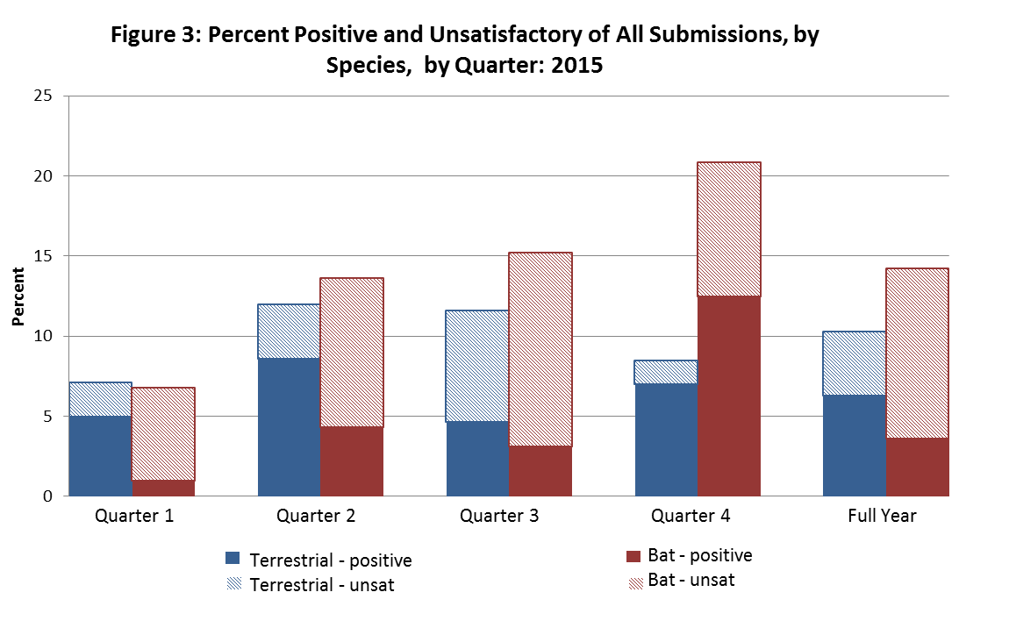

The distribution of results of rabies testing that were positive and of specimens unsatisfactory for testing varies throughout the year and by animal type (terrestrial versus bats) (Figure 3). In every quarter, more bats are unsatisfactory for testing than test positive for rabies. In contrast, the number of unsatisfactory terrestrial animals was less than positive ones in all but the third quarter. Over the course of the year, nearly twice as many terrestrial animals were positive than were unsatisfactory while there were three times as many unsatisfactory bats as there were positive ones.

Submissions and Positive Results by County
In 2015, all counties in Massachusetts submitted at least one animal for rabies testing, and all counties, except Dukes and Nantucket, had at least one animal that tested positive (see Table 4 and Figure 4). Middlesex, Worcester, and Norfolk counties submitted the highest number of animals (n = 649, n = 375, n = 365, respectively). Middlesex, Worcester and Norfolk County also had the highest number of animals that tested positive (n=28, n=19, n=19) and Berkshire County had the highest percentage of submitted animals that tested positive (15.8%).

Table 4. Rabies Testing Data by County- Number of Animals Positive for
Rabies/Number of Animals Submitted (%)

County | 1st Quarter |  | 2nd Quarter |  | 3rd Quarter |  | 4th Quarter |  | Cumulative
Barnstable | 0/10 | (-- %) | 0/30 | (-- %) | 0/43 | (-- %) | 1/19 | (5.3%) | 1/102 | (1.0%)
Berkshire | 0/8 | (-- %) | 3/12 | (0.3%) | 3/25 | (0.1%) | 3/12 | (25.0%) | 9/57 | (15.8%)
Bristol | 0/22 | (-- %) | 5/61 | (8.2%) | 3/71 | (4.2%) | 2/37 | (5.4%) | 10/191 | (5.2%)
Dukes | 0/0 | (-- %) | 0/0 | (-- %) | 0/2 | (-- %) | 0/0 | (-- %) | 0/2 | (-- %)
Essex | 3/43 | (7.0%) | 3/62 | (4.8%) | 4/129 | (3.1%) | 6/46 | (13.0%) | 16/280 | (5.7%)
Franklin | 1/9 | (11.1%) | 1/10 | (10.0%) | 2/19 | (10.5%) | 2/2 | (100.0%) | 6/40 | (15.0%)
Hampden | 1/34 | (2.9%) | 7/48 | (14.6%) | 4/50 | (8.0%) | 3/22 | (13.6%) | 15/154 | (9.7%)
Hampshire | 0/7 | (-- %) | 0/18 | (-- %) | 5/33 | (15.2%) | 1/16 | (6.3%) | 6/74 | (8.1%)
Middlesex | 2/97 | (2.1%) | 12/161 | (7.5%) | 10/313 | (3.2%) | 4/78 | (5.1%) | 28/649 | (4.3%)
Nantucket | 0/0 | (-- %) | 0/1 | (-- %) | 0/0 | (-- %) | 0/0 | (-- %) | 0/1 | (-- %)
Norfolk | 3/50 | (6.0%) | 7/101 | (6.9%) | 7/174 | (4.0%) | 2/40 | (5.0%) | 19/365 | (5.2%)
Plymouth | 2/26 | (7.7%) | 2/61 | (3.3%) | 3/112 | (2.7%) | 0/31 | (-- %) | 7/230 | (3.0%)
Suffolk | 1/29 | (3.4%) | 1/55 | (1.8%) | 3/84 | (3.6%) | 1/27 | (3.7%) | 6/195 | (3.1%)
Worcester | 2/48 | (4.2%) | 9/101 | (8.9%) | 3/166 | (1.8%) | 5/60 | (8.3%) | 19/375 | (5.1%)

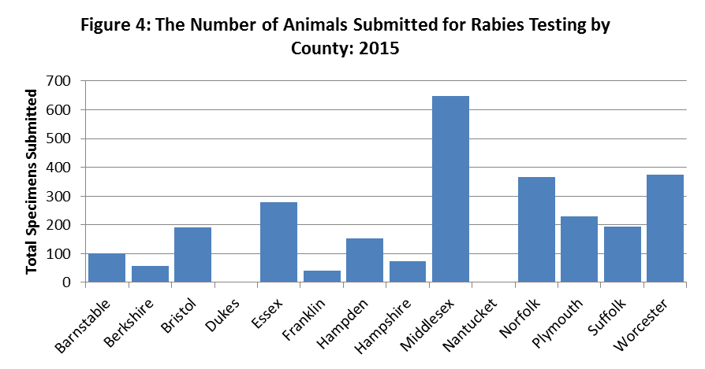

Mapping
MDPH maps rabies-positive terrestrial animals on an annual basis (see Figure 5).
Figure 5.
