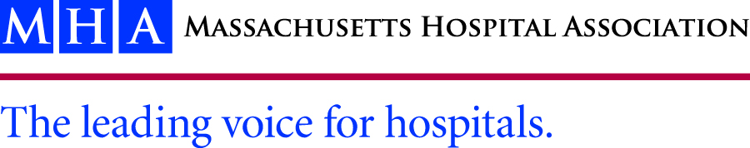

October 1, 2015

Monica Bharel, M.D., MPH

Commissioner

Commonwealth of Massachusetts – Department of Public Health

250 Washington Street

Boston, MA 02108-4619

RE: Comments related to the Drug Formulary Commission and proposed drug formulary strategy

Dear Commissioner Bharel,

On behalf of our member hospitals and health systems, the Massachusetts Hospital Association (MHA) appreciates the opportunity to submit comments to the Department of Public Health (DPH) regarding the Drug Formulary Commission (“Commission”) and its proposed work relating to drug formularies.

MHA and its members are committed to and supportive of establishing safeguards for medications that have proven to pose a heightened public health risk, while ensuring patient safety, proper care, and access to treatment. We support the statutory charge of the Drug Formulary Commission, as set forth in Ch. 258 of the Acts of 2014 and further codified in M.G.L. Ch. 17, §13 which imbues the Commission with authority to develop, “…a drug formulary of chemically equivalent substitutions for drugs that are opiates…” and ask that you consider the following comments and considerations as the Commission moves forward with their work.

The request for comment on the DPH website states, “…we are requesting testifiers to provide commentary on the process of developing a draft formulary of this nature and how they anticipate that it may impact their respective fields.  In addition, the Commission would like to hear suggestions on the factors that should be used in the criteria to determine which opiates should be considered an appropriate, therapeutically equivalent substitute to a drug that has been designated as having a heightened level of public health risk.” (Underline added.) MHA would like DPH and the Commission to clarify exactly what it intends to draft as a formulary, as the website used the term “therapeutically equivalent substitute” and the statute uses the term “chemically equivalent substitute”. As the Department and Commission are aware, these terms do not have the same meaning.

Chemical equivalence, known as pharmaceutical equivalence, are two drugs that contain the same active ingredients, in the same dosage form, route of administration and are identical in strength or concentration. For this equivalence, the drugs must be formulated to have the same amount of active ingredient in the same dosage form, must meet the same standards (i.e. strength, quality, purity, and identity). These drugs may differ on things like the shape, marking, release mechanism, packaging, etc. In short, the two drugs are matched for active ingredient(s), dose form, and strength.

Therapeutic Equivalence does require that the two drugs include the same active ingredients, the same dosage form, same route of administration, same strength/concentration, however therapeutic equivalence allows for limited differences beyond the scope of chemical/pharmaceutical equivalence. To ensure therapeutic equivalence, the FDA and MA regulations require that, there must not be a known or potential bioequivalence problem or that the drug has met an acceptable in vitro standard; or alternatively, that if there is a known or potential problem, the drug has demonstrated that it has met an acceptable bioequivalence standard, among other things.

MHA appreciates that the legislature wants to focus on abuse-deterrent opioid medications and encourage providers to use such medications whenever clinically appropriate instead of a non-abuse deterrent form. As the formulary is developed and set in regulation, we would encourage the Commission to rely on and link to evidence based resources that are already published. The FDA publishes a list of therapeutic equivalents, listed in the Orange Book, which is updated daily. This list is detailed and indicates whether or not there are bioequivalence problems. We would encourage the Commission to use all currently available information in the Orange Book on abuse deterrent medications and their equivalence to non-abuse deterrence forms of opioids; if this resource identifies abuse-deterrent equivalent forms of opioids as they are brought to market, we would encourage the Commission to include a standing reference to all approved equivalents in the formulary and for DPH to adopt a reference into their regulations. This would allow for any new abuse-deterrent equivalent drugs to be incorporated by reference and also would lessen the chance for provider confusion to look at a formulary in Massachusetts and a national resource.

Patient safety and proper treatment should be an overarching guide to the Commission when developing the formulary. We are grateful that the legislature allows providers to write “no substitution” on a prescription in cases where the provider believes that patient safety and treatment warrants a particular drug, regardless of the risk for abuse or misuse. As with any medical care, patient care and treatment is a very individualized matter and can only be assessed by a provider, in that moment. Especially in acute are settings, there will always be cases where exceptions to the general rule are needed. This kind of flexibility is absolutely paramount for good patient care and necessary in certain circumstances.

Last, MHA would like to offer the expertise of its Substance Use Disorder Prevention and Treatment Task Force. The task force was assembled to develop provider focused solutions to the opioid overdose epidemic. Please think of this task force as a resource with a wealth of knowledge and we would be happy to arrange for the Commission to speak with the task force as they continue to develop their work.

Thank you again for the opportunity to comment on the Drug Formulary Commission proposed work. Should you have any questions, please feel free to contact me at (781) 262-6064 or [rmercier@mhalink.org](mailto:rmercier@mhalink.org).

Sincerely,

Rachelle S. Mercier, Esq., MPH

Manager of Health Care Policy and Analysis