Massachusetts HIV Epidemiologic Profile
Data as of 1/1/2023
Population Report: Racial and Ethnic Minorities, Accessible Version
MS Word Version, optimized for screen reader use
Please note that while the content of this report is the same as the pdf version, the format and pagination have been modified significantly to optimize use with screen readers to ensure access for blind or visually impaired audiences.
Suggested citation:
Massachusetts Department of Public Health, Bureau of Infectious Disease and Laboratory Sciences. Massachusetts HIV Epidemiologic Profile: Data as of 1/1/2023, Population Report: Racial and Ethnic Minorities, https://www.mass.gov/lists/hivaids-epidemiologic-profiles Published March 2024. Accessed [date].
Bureau of Infectious Disease and Laboratory Sciences
Massachusetts Department of Public Health
Jamaica Plain Campus/State Public Health Laboratory
305 South Street
Jamaica Plain, MA 02130
Questions about this report
Tel: (617) 983-6560
To reach the Reporting and Partner Services Line
Tel: (617) 983-6999
To speak to the on-call epidemiologist
Tel: (617) 983-6800
Questions about infectious disease reporting
Tel: (617) 983-6801
HIV Data Dashboard
https://www.mass.gov/info-details/hiv-data-dashboard
Requests for additional data
https://www.mass.gov/lists/infectious-disease-data-reports-and-requests
Slide sets for HIV Epidemiologic Profile Reports
https://www.mass.gov/lists/hivaids-epidemiologic-profiles

The racial and ethnic minorities fact sheet focuses on black (non-Hispanic), Hispanic/Latinx, and Asian and Pacific Islander individuals recently diagnosed (2019–2021) and living with HIV infection (as of 12/31/2021) and presents these data alongside data for white (non-Hispanic) individuals recently diagnosed and living with HIV infection to illustrate persistent racial and ethnic health disparities. Analyses for American Indian/Alaskan Native and multiracial individuals are not presented due to small numbers (N=0 and N=38 recent HIV diagnoses, respectively; N=35 and N=259 persons living with HIV infection, respectively).

HIV INCIDENCE AND PREVALENCE AMONG RACIAL/ETHNIC MINORITIES

N = 458, 32% of 1,419 new HIV diagnoses from 2019–2021 were among black (non-Hispanic) individuals
N = 7,035, 30% of 23,393 persons living with HIV infection in MA as of 12/31/2021 were black (non-Hispanic)
N = 384, 27% of 1,419 new HIV diagnoses from 2019–2021 were among Hispanic/Latino individuals
N = 6,346, 27% of 23,393 persons living with HIV infection in MA as of 12/31/2021 were Hispanic/Latino
N = 36, 3% of 1,419 new HIV diagnoses from 2019–2021 were among Asian/Pacific Islander individuals
N = 560, 2% of 23,393 persons living with HIV infection in MA as of 12/31/2021 were Asian/Pacific Islander

RATES PER 100,000 POPULATION
FIGURE 1. Average age-adjusted HIV diagnosis rate per 100,000 population by sex assigned at birth and race/ethnicity, Massachusetts 2019 – 2021 (N=1,419)
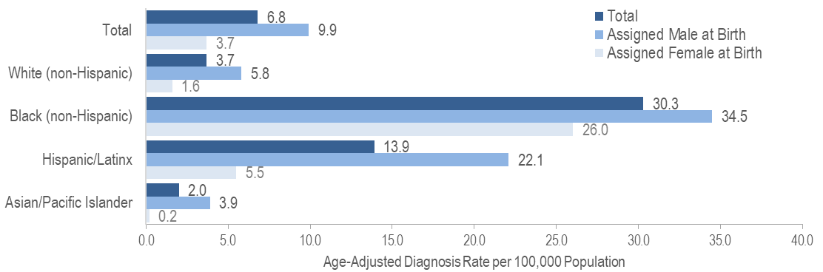
KEY FINDINGS
- There were large disparities in average annual age-adjusted HIV diagnosis rates for 2019 to 2021 by race/ethnicity. Compared to the rate among white (non-Hispanic) individuals, the rate among:
  - black (non-Hispanic) individuals was eight times greater, and
  - Hispanic/Latinx individuals was four times greater.
- With respect to differences based on race/ethnicity and sex assigned at birth, the average annual age-adjusted HIV diagnosis rate for 2019 to 2021 among:
  - black (non-Hispanic) individuals assigned male at birth (AMAB), was six times that of white (non-Hispanic) individuals AMAB,
  - Hispanic/Latinx individuals AMAB was four times that of white (non-Hispanic) individuals AMAB,
  - black (non-Hispanic) individuals assigned female at birth (AFAB) was 16 times that of white (non-Hispanic) individuals AFAB, and
  - Hispanic/Latinx individuals AFAB was three times that of white (non-Hispanic) individuals AFAB.
FIGURE 2. Age-adjusted HIV prevalence rates per 100,000 population by sex assigned at birth and race/ethnicity, Massachusetts 2021 (N= 23,393)
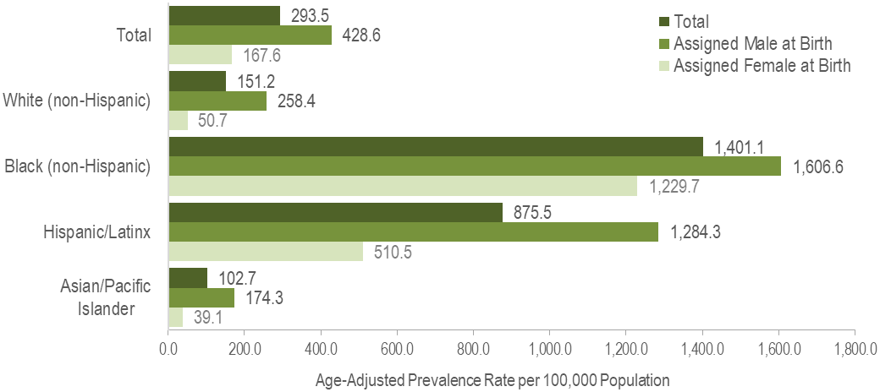
KEY FINDINGS
In 2021, there were large disparities in age-adjusted prevalence rates by race/ethnicity. Compared to the rate among white (non-Hispanic) individuals, the rate among:
  - black (non-Hispanic) individuals was nine times greater, and
  - Hispanic/Latinx individuals was six times greater.
- With respect to differences based on race/ethnicity and sex assigned at birth, the age-adjusted HIV prevalence rate among:
  - black (non-Hispanic) individuals AFAB was 24 times that of white (non-Hispanic) individuals AFAB,
  - Hispanic/Latinx individuals AFAB was 10 times that of white (non-Hispanic) individuals AFAB,
  - black (non-Hispanic) individuals AMAB was six times that of white (non-Hispanic) individuals AMAB, and
  - Hispanic/Latinx individuals AMAB was five times that of white (non-Hispanic) individuals AMAB.

FIGURE 3. Average age-adjusted death rate per 100,000 population among people reported with HIV by race/ethnicity, Massachusetts 2019–2021
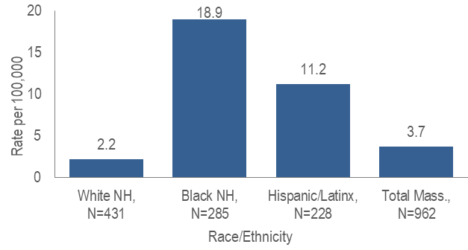
Figure 3 Note: *Total includes API and individuals of other/unknown race/ethnicity (N=18); NH=non-Hispanic; Death rate for Asian/Pacific Islander (API) is not presented because the numerator <12 and therefore must be interpreted with caution.
- The age-adjusted average all-cause death rate from 2019 to 2021 among:
  - black (non-Hispanic) individuals reported with HIV was nine times that of white (non-Hispanic) individuals, and
  - Hispanic/Latinx individuals reported with HIV was five times that of white (non-Hispanic) individuals.

EXPOSURE MODE
FIGURE 4. Individuals diagnosed with HIV infection by exposure mode and race/ethnicity, Massachusetts 2019–2021
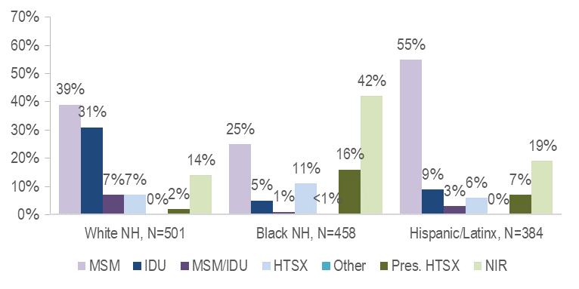
- While the predominant exposure mode among white (non-Hispanic) and Hispanic/Latinx individuals recently diagnosed with HIV infection was MSM (39% and 55%, respectively), the largest proportion of black (non-Hispanic) individuals was assigned no identified risk for exposure mode (42%).
Figure 4 Note: MSM=male-to-male sex; IDU=injection drug use; HTSX=heterosexual sex; Pres. HTSX=presumed heterosexual exposure, includes individuals assigned female at birth with a negative history of injection drug use who report having sex with an individual that identifies as male of unknown HIV status and risk; NIR=no identified risk
FIGURE 5. Individuals AMAB diagnosed with HIV infection by exposure mode and race/ethnicity, Massachusetts 2019–2021
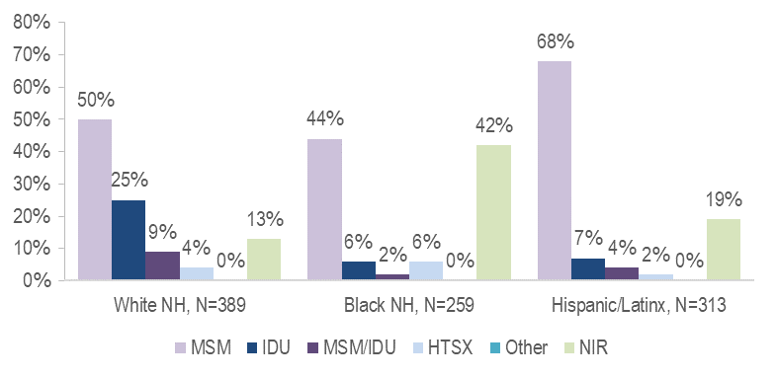
- MSM was the most frequently reported exposure mode among white (non-Hispanic) (50%), black (non-Hispanic) (44%), and Hispanic/Latinx (68%) individuals AMAB. A nearly equal proportion of black (non-Hispanic) individuals AMAB had NIR for exposure mode (42%).
FIGURE 6. Individuals AFAB diagnosed with HIV infection by exposure mode and race/ethnicity, Massachusetts 2019–2021
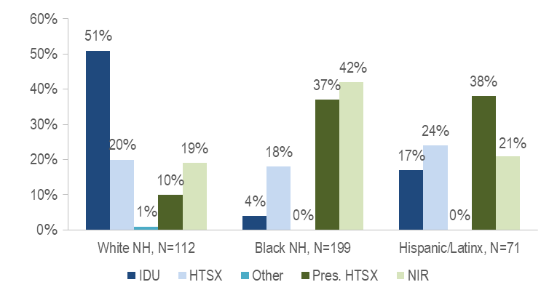
- Injection drug use was the predominant exposure mode among white (non-Hispanic) individuals AFAB recently diagnosed with HIV infection, while NIR, followed by presumed heterosexual sex, accounted for the largest proportions among black (non-Hispanic) individuals AFAB, and presumed heterosexual sex accounted for the largest proportion among Hispanic/Latinx individuals AFAB.

PLACE OF BIRTH
FIGURE 7. Percentage of individuals diagnosed with HIV infection by race/ethnicity and place of birth, Massachusetts 2019–2021
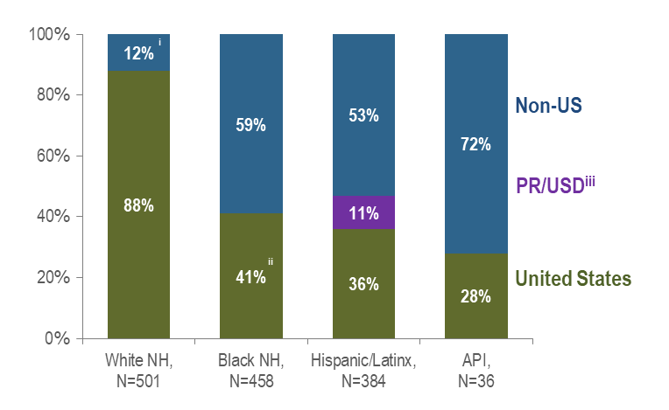
Figure 7 Notes: ^{i} Non-US born and Puerto Rico/USD categories are combined for white non-Hispanic individuals due to small numbers to adhere to cell suppression rules.
^{ii} US born and Puerto Rico/USD categories are combined for black non-Hispanic individuals due to small numbers to adhere to cell suppression rules.
^{iii} All individuals diagnosed with HIV infection from 2019–2021 who were born in a US dependency (USD) were born in Puerto Rico (PR).
API=Asian/Pacific Islander, NH=non-Hispanic

- KEY FINDING: Seventy-two percent of Asian/Pacific Islander individuals diagnosed with HIV infection during 2019–2021 were born outside the US, compared to 59% of black (non-Hispanic) and 53% of Hispanic/Latinx individuals. Twelve percent of white (non-Hispanic) individuals were born outside the US or in Puerto Rico.
- The majority of the 268 non-US born black (non-Hispanic) individuals diagnosed with HIV infection from 2019 to 2021 were from sub-Saharan Africa (54%) or the Caribbean (43%).
- The majority of the 205 non-US born Hispanic/Latinx individuals were from Central and South America (64%) or the Caribbean (34%).

AGE
FIGURE 8. Average age at HIV infection diagnosis by race/ethnicity, Massachusetts 2019–2021
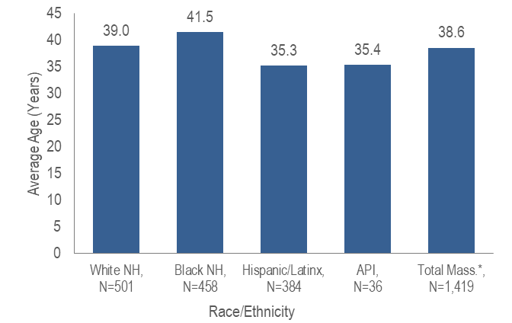
Figure 8 Note: * Total includes individuals of other/unknown race/ethnicity (N=40)
- The average age at HIV diagnosis from 2019 to 2021 was younger for Hispanic/Latinx and Asian/Pacific Islander individuals diagnosed with HIV infection (35.3 and 35.4 years, respectively) compared to black (non-Hispanic) and white (non-Hispanic) individuals (41.5 and 39.0 years, respectively).

PLACE OF RESIDENCE
TABLE 1. Massachusetts cities/towns with the highest percentage of HIV diagnoses among black (non-Hispanic) individuals, 2019–2021

 | HIV Diagnoses Among Black (non-Hispanic) Individuals (N) | HIV Diagnoses Among Black (non-Hispanic) Individuals as Percent of Total HIV Diagnoses in City/Town (%)
Massachusetts Total | 458 | 32%
Top Cities/Towns
Brockton | 42 | 70%
Boston | 151 | 44%
Quincy | 9 | 41%
Everett | 12 | 40%
Springfield | 20 | 39%
Worcester | 31 | 38%
Lowell | 14 | 36%
Lynn | 13 | 30%
Cambridge | 7 | 28%
Framingham | 5 | 24%
All Other Cities/Towns | 154 | 22%
- Among cities and towns with at least 20 reported HIV diagnoses from 2019 to 2021, Brockton had the highest percentage of HIV diagnoses among black (non-Hispanic) individuals at 70%.
TABLE 2. Massachusetts cities/towns with the highest percentage of HIV diagnoses among Hispanic/Latino individuals, 2019–2021
 | HIV Diagnoses Among Hispanic/Latino Individuals (N) | HIV Diagnoses Among Hispanic/Latino Individuals as Percent of Total HIV Diagnoses in City/Town (%)
Massachusetts Total | 384 | 27%
Top Cities/Towns
Lawrence | 33 | 79%
Revere | 13 | 50%
Lynn | 21 | 49%
Framingham | 10 | 48%
Springfield | 24 | 47%
Malden | 11 | 38%
New Bedford | 9 | 33%
Cambridge | 8 | 32%
Worcester | 25 | 30%
Fall River | 6 | 25%
All Other Cities/Towns | 224 | 21%

- Among cities and towns with at least 20 reported HIV diagnoses from 2019 to 2021, Lawrence had the highest percentage of HIV diagnoses among Hispanic/Latinx individuals at 79%.

INFORMATION FROM ADDITIONAL DATA SOURCES
Behavioral Risk Factors: Recent statewide surveys describe sexual and drug use behaviors among racial/ethnic minorities in Massachusetts.
Massachusetts Behavioral Risk Factor Surveillance Survey (BRFSS): An annual, anonymous telephone survey of adults ages 18 and older that collects data on a variety of health risk factors, preventive behaviors, chronic conditions, and emerging public health issues.
- KEY FINDING: Black (non-Hispanic) and Hispanic/Latinx respondents were more likely to report condom use than white (non-Hispanic) respondents.
TABLE 3. Percentage (95% confidence interval) and number of adults ages 18–64 years reporting sexual behaviors by race/ethnicity, Massachusetts 2019–2021
 | White (non-Hispanic) | Black (non-Hispanic) | Hispanic/Latinx
Two or more sexual partners in past year | 9.7% (8.5%–10.9%), n=3,988 | 11.8% (8.0%–15.6%), n=361 | 9.8% (7.1%–12.5%), n=743
Condom use at last sex | 21.4% (19.6%–23.3%), n=2,994 | 30.9% (24.2%–37.7%), n=247 | 30.5% (25.6%–35.5%), n=473
Data Source: Health Survey Program, Office of Data Management and Outcomes Assessment, Massachusetts Behavioral Risk Factor Surveillance System (BRFSS). For more information, see: Health Survey Program, Office of Data Management and Outcomes Assessment, Massachusetts Department of Public Health. A Profile of Health Among Massachusetts Adults, 2021, Results from the Behavioral Risk Factor Surveillance System, January 2023, https://www.mass.gov/doc/a-profile-of-health-among-massachusetts-adults-2021-0/download

Massachusetts Youth Risk Behavior Survey (YRBS): An anonymous survey of public high school students conducted every odd year that collects data on health-related behaviors that may threaten the health and safety of young people.
- KEY FINDING: Hispanic/Latinx respondents were more likely to report having sexual intercourse before age 13 than white (non-Hispanic) respondents.
TABLE 4. Percentage (95% confidence interval) and number of respondents reporting sexual behaviors to the YRBS by race/ethnicity, Massachusetts 2021
 | White (non-Hispanic) | Black (non-Hispanic) | Hispanic/Latinx
Sexual intercourse before age 13 | 1.6% (0.9%–2.2%), n=1,401 | Results not presented for n<100 | 4.9% (3.3%–6.6%), n=656
4 or more lifetime sexual intercourse partners | 3.7% (2.5%–5.0%), n=1,399 | Results not presented for n<100 | 5.9% (4.2%–7.6%), n=648
Condom use at last sexual intercourse | 62.4% (55.4%–69.5%),  n=240 | Results not presented for n<100 | 50.1% (42.0%–58.2%),  n=124
Drank alcohol or used drugs before last sexual intercourse | 20.8% (16.5%–25.0%), n=231 | Results not presented for n<100 | 23.8% (16.9%–30.6%), n=108

Data Source: Office of Data Management and Outcomes Assessment, Department of Public Health and Massachusetts Department of Elementary and Secondary Education. For more information, see https://www.doe.mass.edu/sfs/yrbs/.
HIV Surveillance Data Source: MDPH Bureau of Infectious Disease and Laboratory Sciences, data are current as of 1/1/2023 and may be subject to change.

Providers may use this number to report individuals newly diagnosed with a notifiable sexually transmitted infection, including HIV, or request partner services. Partner services is a free and confidential service for individuals recently diagnosed with a priority infection. The client-centered program offers counseling, linkage to other health and social services, anonymous notification of partners who were exposed and assistance with getting testing and treatment. For more information, see: https://www.mass.gov/service-details/partner-services-program-information-for-healthcare-providers)
Please consider the impact of the COVID-19 pandemic on infectious disease screening, treatment, and surveillance in the interpretation of 2020 and 2021 data.
As of 1/1/2020, BIDLS calculates rates per 100,000 population using denominators estimated by the University of Massachusetts Donahue Institute using a modified Hamilton-Perry model (Strate S, et al. Small Area Population Estimates for 2011 through 2020, report published Oct 2016). Note that rates and trends calculated using previous methods cannot be compared to these. All rates are age-adjusted using the 2000 US standard population.
Please consider the impact of the COVID-19 pandemic on infectious disease screening, treatment, and surveillance in the interpretation of 2020 and 2021 data.
As of 1/1/2020, BIDLS calculates rates per 100,000 population using denominators estimated by the University of Massachusetts Donahue Institute using a modified Hamilton-Perry model. Note that rates and trends calculated using previous methods cannot be compared to these. All rates are age-adjusted using the 2000 US standard population.
Please consider the impact of the COVID-19 pandemic on infectious disease screening, treatment, and surveillance in the interpretation of 2020 and 2021 data.
Death rate for Asian/Pacific Islander (API) is not presented because the numerator is <12 and therefore must be interpreted with caution.
Please consider the impact of the COVID-19 pandemic on infectious disease screening, treatment, and surveillance in the interpretation of 2020 and 2021 data.
Please consider the impact of the COVID-19 pandemic on infectious disease screening, treatment, and surveillance in the interpretation of 2020 and 2021 data.
Please consider the impact of the COVID-19 pandemic on infectious disease screening, treatment, and surveillance in the interpretation of 2020 and 2021 data.
Please consider the impact of the COVID-19 pandemic on infectious disease screening, treatment, and surveillance in the interpretation of 2020 and 2021 data.
City/town is based on residence at HIV infection diagnosis.
All Other Cities/Towns includes individuals diagnosed in a correctional facility.
Please consider the impact of the COVID-19 pandemic on infectious disease screening, treatment, and surveillance in the interpretation of 2020 and 2021 data.
City/town is based on residence at HIV infection diagnosis.
All Other Cities/Towns includes individuals diagnosed in a correctional facility.
% = percent of total responding “yes” to specified question
“Number of sexual partners in past year” is a state-added question administered to a sub-sample of BRFSS respondents and represents the number of people a respondent reports having sex with. Sex was defined by the interviewer as including oral, vaginal, or anal sex.
Only asked of adults reporting sex (including oral, vaginal, or anal sex) in the past year
% = percent of total responding “yes” to specified question
n = total number of respondents (unweighted) by sex of partner for each question. The number of respondents for each question varies because some survey participants do not answer all questions.

