Massachusetts Department of Public Health

Bureau of CLIMATE AND Environmental Health | Indoor Air Quality Program

Radon Fact Sheet

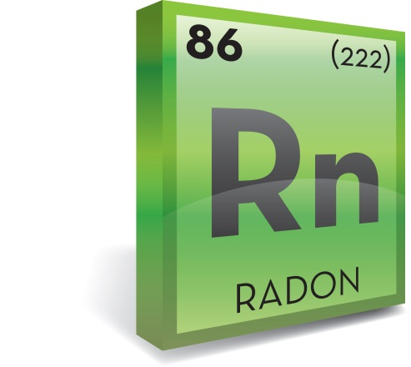

**What is Radon?**

Radon is a colorless, odorless, tasteless, and radioactive gas that originates from the ground. Radon is formed through a naturally occurring process of radioactive decay. Uranium found in the earth’s rock and soil decays into radon. Because it is a gas, radon can move into water or air.

Radon is present outdoors and is normally found at very low levels in outdoor air and in surface water, such as rivers and lakes. It can be found at higher levels in the air in houses and other buildings, as well as in water from underground sources, such as private well water.

Radon gas that moves from under the ground can migrate into indoor spaces, such as basements and crawl spaces. Once inside an enclosed space, such as a home, radon can accumulate. For this reason, radon levels found in a home are typically higher than the average outdoor radon concentration of 0.4 pCi/L (picocuries per liter of air).

**How does radon get into homes?**

Radon is found in homes new or old. It is found in homes with and without basements. It is found in houses built on ledge and houses built on the sands of Cape Cod.

Radon can enter a home in two ways. The primary path radon takes into a home is up through the basement from the ground below.

Radon can enter a home through the following:

*• floor-wall joints*

*• crawl spaces*

*• sump pits, floor drains*

*• block wall foundations*

*• penetrations of utility lines*

*• cracks and crevices in floors and walls*

*• dirt floors*

*The majority of radon exposure in a home is from radon coming up from the ground*. As a result, radon concentrations tend to be highest in the lowest levels of the home. Since indoor air represents the largest exposure to radon, you should test your home to determine if radon is at levels of concern.

The secondary pathway for radon to enter a home is through private well water. Radon can dissolve in groundwater. When well water is used in the home, radon in the water can become airborne. Studies indicate that very few public groundwater supplies contain enough radon to be a significant source of radon in homes. There is very little radon in surface water supplies because the water is exposed to outdoor air, thus decreasing the radon concentrations in water. Homes with well water are a greater source of radon exposure than homes that have other drinking water sources. If you have a private well, you should test your water for radon.

**Is exposure to indoor radon harmful?**

Yes. Radon is a carcinogen, which means it is known to cause cancer in humans. While there are many sources of radiation, radon remains the largest source of exposure. Because we spend so much time indoors, radon in the home represents the biggest exposure and concern.

When radon undergoes radioactive breakdown, it decays into other radioactive elements called radon daughters (or progeny). Radon daughters are solids, not gases, and stick to surfaces such as dust particles in the air. Dust particles carrying radon daughters can move with air. If contaminated dust is inhaled, these particles can adhere to the airways of the lung. As these radioactive dust particles break down further, they release small bursts of energy, which can damage lung tissue. Over time, damaged cells within the lungs can act abnormally and lung cancer may develop. In general, the risk of lung cancer increases as the level of radon and the length of exposure increases.

Radon is the leading cause of lung cancer in people who never smoke, and the second leading cause of lung cancer overall. The greater the exposure to radon, especially if you smoke cigarettes, the greater your chance of developing lung cancer.

The United States Environmental Protection Agency (EPA) estimates that 21,000 radon-related deaths occur annually in the United States. Deaths attributed to radon far exceed annual deaths due to motor vehicle accidents, falls, drownings, and fires.

Radon-related deaths in the U.S. are preventable. Testing air in a home can help identify if radon is a problem within the dwelling.

**What does this mean for Massachusetts residents?**

EPA estimates that 628 radon-related lung cancers occur annually in Massachusetts.

In Massachusetts, it is estimated that 650,000 homes have radon levels that exceed the EPA action guideline of 4 pCi/L.

Approximately 34,000 homes in Massachusetts have radon levels that exceed 20 pCi/L.

**How can I find out if my home has radon?**

Air testing is the only way to know if your home has elevated radon levels. One out of four homes may have radon levels that exceed the EPA action guideline of 4 pCi/L.

**Sources of Radiation Exposure in the United States**

**Source: U.S. Nuclear Regulatory Commission, 2015**

**If my home has elevated radon levels in the air, can it be fixed?**

Yes, in most cases it can. A method called active soil depressurization is typically used to fix or mitigate a home with elevated radon levels. This method creates a zone of low pressure below the slab, which reduces the rate at which radon enters the home. In most (but not all) homes, radon levels can be mitigated to below 2 pCi/L. Although the EPA action guide for radon is 4 pCi/L, EPA also advises that you consider fixing your home if your radon levels are between 2 and 4 pCi/L.

At the present time, Massachusetts does not have any regulations in place to protect owners of existing homes from radon exposure. That is why it is important to test your home and take proper mitigation steps if your home is found to contain elevated levels of radon.

**Where can I obtain more information?**

The Massachusetts Department of Public Health’s Indoor Air Quality Program (IAQ) can advise you on how to get your home tested and can assist you in interpreting results. Please contact the IAQ Program to get more information.

November 2023

|  |  |
| --- | --- |
|  | Seal of the Commonwealth of Massachusetts Department of Public Health |