ODOR INVESTIGATION

O’Maley Middle School
32 Cherry Street
Gloucester, Massachusetts

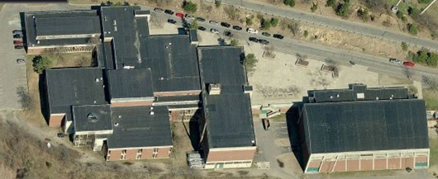

Prepared by:
Massachusetts Department of Public Health
Bureau of Environmental Health
Indoor Air Quality Program
February 2012

Background/Introduction
At the request of Mr. Brian Tarr, Financial Director for Gloucester Public Schools, the Massachusetts Department of Public Health (MDPH), Bureau of Environmental Health (BEH) conducted an indoor air quality (IAQ) assessment at the O’Maley Middle School (OMS), 32 Cherry Street, Gloucester, Massachusetts. This request was prompted by health concerns related to specific areas of the building, located on the ground level. On January 12, 2012, Michael Feeney, Director of BEH’s IAQ Program, made a visit to the OMS to conduct an IAQ assessment. Mr. Feeney was accompanied by Ruth Alfasso, Environmental Engineer/Inspector in BEH’s IAQ Program.
The OMS is a large two-story building with multiple wings and open/common areas. The school has general classrooms, office areas, art and science classrooms, gymnasium, cafeteria and specialty rooms. In addition, the building is connected to an indoor hockey rink via a corridor, off of which are locker rooms (Map 1). Recently, the Gloucester High School hockey teams have been using these locker rooms, which is a notable change in use. Windows in some areas of the building are openable.

Methods
Air tests for carbon monoxide, carbon dioxide, temperature and relative humidity were conducted in selected areas with the TSI, Q-Trak, IAQ Monitor, Model 7565. Air tests for airborne particle matter with a diameter less than 2.5 micrometers were also taken in selected areas with the TSI, DUSTTRAK™ Aerosol Monitor Model 8520. BEH staff also performed visual inspection of building materials for water damage and/or microbial growth.

Results
The OMS houses approximately 750 students in grades 6-8 and has a staff of approximately 50. Tests were taken during normal operations although some areas investigated were sparsely occupied. Results appear in Table 1.

Discussion

Ventilation
It can be seen from Table 1 that carbon dioxide levels were below 800 parts per million (ppm) in 16 out of 19 areas surveyed indicating adequate air exchange in those areas at the time of testing. As mentioned, at the time of the assessment several of the areas investigated were empty, sparsely populated or not typically populated. Carbon dioxide levels would be expected to increase with higher occupancy and/or ventilation equipment deactivated/not functioning.
Fresh air to some classrooms (e.g., 201, 219) is supplied by unit ventilator (univent) systems. A univent draws air from the outdoors through a fresh air intake located on the exterior wall of the building. Return air from the classroom is drawn through an air intake located at the base of the unit (Figure 1). Fresh and return air are mixed, filtered, heated and provided to classrooms through an air diffuser located in the top of the unit. The univent in room 219 was found to be running but open (Picture 1), which not only impedes proper function but may also be a safety hazard. In order for univents to provide fresh air as designed, they must remain “on” and operating while rooms are occupied. Furthermore, units must remain intact and free of obstructions.
Other areas of the building are supplied with mechanical ventilation via supply vents connected to heating, ventilation and air-conditioning (HVAC) systems located in mechanical rooms. Exhaust ventilation in the building is supplied by central exhaust fans through vents located in walls or ceilings. Exhaust vents in some of the areas evaluated did not seem to be functioning, and in room 125, it was unclear which of the two vents had been designed as a supply vent versus an exhaust vent. Airflow was detected coming out of the presumed exhaust vent, which suggests that either the exhaust fan is not functioning and backdrafting is occurring, or the system is not properly connected. In addition, exhaust ventilation in the art rooms (129 and 130) did not appear to be functioning at the time of the assessment. The occupants of these rooms reported that when classrooms are occupied, they often open exterior doors to address concerns regarding ventilation.
To maximize air exchange, the MDPH recommends that both supply and exhaust ventilation operate continuously during periods of occupancy. In order to have proper ventilation with a mechanical supply and exhaust system, the systems must be balanced to provide an adequate amount of fresh air to the interior of a room while removing stale air from the room. It is recommended that HVAC systems be re-balanced every five years to ensure adequate air systems function (SMACNA, 1994). The date of the last balancing of these systems was not available at the time of this assessment.
The Massachusetts Building Code requires that each room have a minimum ventilation rate of 15 cubic feet per minute (cfm) per occupant of fresh outside air or openable windows (SBBRS, 1997; BOCA, 1993). The ventilation must be on at all times that the room is occupied. Providing adequate fresh air ventilation with open windows and maintaining the temperature in the comfort range during the cold weather season is impractical. Mechanical ventilation is usually required to provide adequate fresh air ventilation.
Carbon dioxide is not a problem in and of itself. It is used as an indicator of the adequacy of the fresh air ventilation. As carbon dioxide levels rise, it indicates that the ventilating system is malfunctioning or the design occupancy of the room is being exceeded. When this happens, a buildup of common indoor air pollutants can occur, leading to discomfort or health complaints. The Occupational Safety and Health Administration (OSHA) standard for carbon dioxide is 5,000 parts per million parts of air (ppm). Workers may be exposed to this level for 40 hours/week, based on a time-weighted average (OSHA, 1997).
The MDPH uses a guideline of 800 ppm for publicly occupied buildings. A guideline of 600 ppm or less is preferred in schools due to the fact that the majority of occupants are young and considered to be a more sensitive population in the evaluation of environmental health status. Inadequate ventilation and/or elevated temperatures are major causes of complaints such as respiratory, eye, nose and throat irritation, lethargy and headaches. For more information concerning carbon dioxide, consult Appendix A.
Indoor temperatures ranged from 70º F to 77º F, which were within the MDPH recommended comfort range, apart from the hallway to the ice rink, which was measured at 65º F (Table 1). The ice rink entrance hallway is not a typically occupied space. The MDPH recommends that indoor air temperatures be maintained in a range of 70º F to 78º F in order to provide for the comfort of building occupants. In many cases concerning indoor air quality, fluctuations of temperature in occupied spaces are typically experienced, even in a building with an adequate fresh air supply.
The relative humidity measured in the building ranged from 24 to 34 percent at the time of the assessment, which was below the MDPH recommended comfort level (Table 1). The MDPH recommends a comfort range of 40 to 60 percent for indoor air relative humidity. Relative humidity levels in the building would be expected to drop during the winter months due to heating. The sensation of dryness and irritation is common in a low relative humidity environment. Low relative humidity is a very common problem during the heating season in the northeast part of the United States.

Microbial/Moisture Concerns
The focus of this IAQ assessment was to determine sources of allergens and irritants in specific offices/areas of the building. One prominent area of interest was the potential impact of the ice rink on the air quality in the building. The following problems were noted during the assessment relating to moisture, water damage and mold in the building (see Map 1 for location of areas discussed):
- The doors to the ice rink (Picture 2) do not seal completely, and the passage of cold air was noted through gaps in the doorway during the investigation. The air from the ice rink is influenced by the presence of the ice and contains significant amounts of moisture, which can draw air/moisture/odors from the ice rink through the hallway and into the main building.
- Signs of water damage and mold were noted on ceiling tiles, wallboard and insulation adjacent to the doors leading from the main school building into the ice rink hallway (Pictures 3 and 4). It is likely that roof leaks at the joint in the roof between the two building segments are responsible for this damage but it also may be related to condensation of moist air from the ice rink.
- It was also noted that above the suspended ceiling tile system, pipes connect the main school building with the hallway; the plenum is therefore a continuous pathway for odors and moisture to enter the main school building.
- The hallway to the ice rink is long and poorly insulated along one side which may lead to condensation and water damage along that side of the hallway.
- There was an active water leak noted from above the hallway next to the ice rink door (Picture 5) and additional signs of water damage on the door itself.
- The locker rooms off this hallway could not be investigated directly due to being locked, however it was noted that the doors to the locker rooms were not undercut. Undercutting these doors would allow the exhaust fans inside the locker rooms to function properly in removing carbon dioxide, odors and moisture which is often significant in a locker room with showers. Build-up of moisture from the locker rooms could contribute to the water issues in this area of the building.
- Signs of water infiltration and water damage were also noted in other areas of the school, including:
- Active water leaks and damaged ceiling tiles in the “island house” hallway (Picture 6);
- Active water leaks in classrooms (Table 1); and
- Stained ceiling tiles in various areas of the school.
The US Environmental Protection Agency (US EPA) and the American Conference of Governmental Industrial Hygienists (ACGIH) recommend that porous materials be dried with fans and heating within 24 to 48 hours of becoming wet (US EPA, 2001; ACGIH, 1989). If not dried within this time frame, mold growth may occur. Once mold has colonized porous materials, they are difficult to clean and should be removed and discarded.
As detailed above, airflow and moisture migrating from the ice rink into the building appears to be an on-going issue. Upon examination of the configuration of the building, airflow from the ice rink can result from the following conditions:
- If not or improperly balanced, the HVAC system can create negative pressure in the occupied areas of the school due to the draw of the exhaust system.
- The “stack effect” is created when the heated air rises from the lower floor to the upper floor via the two-story open stairwell in the “Commons” of the building. Air is drawn from the bottom of the staircase up into the adjoining hallway.
- Possible passage of air through hallway doors between the ice rink and the OMS as well as air passage along OMS hallways and ceiling plenum on the ground floor.
Under these conditions, moistened air can migrate into the OMS from the ice rink, which may chronically moisten building materials in the hallway, particularly in and around the hallway doors.

Other IAQ Evaluations
Indoor air quality can be negatively influenced by the presence of respiratory irritants, such as products of combustion. The process of combustion produces a number of pollutants. Common combustion emissions include carbon monoxide, carbon dioxide, water vapor, and smoke (fine airborne particle material). Of these materials, exposure to carbon monoxide and particulate matter with a diameter of 2.5 micrometers (μm) or less (PM2.5) can produce immediate, acute health effects upon exposure. To determine whether combustion products were present in the building environment, BEH staff obtained measurements for carbon monoxide and PM2.5.

Carbon Monoxide
Carbon monoxide is a by-product of incomplete combustion of organic matter (e.g., gasoline, wood and tobacco). Exposure to carbon monoxide can produce immediate and acute health effects. Several air quality standards have been established to address carbon monoxide and prevent symptoms from exposure to these substances. The MDPH established a corrective action level concerning carbon monoxide in ice skating rinks that use fossil-fueled ice resurfacing equipment. If an operator of an indoor ice rink measures a carbon monoxide level over 30 ppm, taken 20 minutes after resurfacing within a rink, that operator must take actions to reduce carbon monoxide levels (MDPH, 1997).
The American Society of Heating Refrigeration and Air-Conditioning Engineers (ASHRAE) has adopted the National Ambient Air Quality Standards (NAAQS) as one set of criteria for assessing indoor air quality and monitoring of fresh air introduced by HVAC systems (ASHRAE, 1989). The NAAQS are standards established by the US EPA to protect the public health from six criteria pollutants, including carbon monoxide and particulate matter (US EPA, 2006). As recommended by ASHRAE, pollutant levels of fresh air introduced to a building should not exceed the NAAQS levels (ASHRAE, 1989). The NAAQS were adopted by reference in the Building Officials & Code Administrators (BOCA) National Mechanical Code of 1993 (BOCA, 1993), which is now an HVAC standard included in the Massachusetts State Building Code (SBBRS, 1997). According to the NAAQS, carbon monoxide levels in outdoor air should not exceed 9 ppm in an eight-hour average (US EPA, 2006).
Carbon monoxide should not be present in a typical, indoor environment. If it is present, indoor carbon monoxide levels should be less than or equal to outdoor levels. Outdoor carbon monoxide concentrations were non-detect (ND) at the time of the assessment (Table 1). No measureable levels of carbon monoxide were detected inside the building during the assessment in the areas tested (Table 1). Note that the ice rink uses mostly electric-powered ice resurfacing equipment, and it does not appear as if the ice rink is causing carbon monoxide problems to the school.

Particulate Matter
The US EPA has established NAAQS limits for exposure to particulate matter. Particulate matter is airborne solids that can be irritating to the eyes, nose and throat. The NAAQS originally established exposure limits to particulate matter with a diameter of 10 μm or less (PM10). According to the NAAQS, PM10 levels should not exceed 150 micrograms per cubic meter (μg/m³) in a 24-hour average (US EPA, 2006). These standards were adopted by both ASHRAE and BOCA. Since the issuance of the ASHRAE standard and BOCA Code, US EPA established a more protective standard for fine airborne particles. This more stringent PM2.5 standard requires outdoor air particle levels be maintained below 35 μg/m³ over a 24-hour average (US EPA, 2006). Although both the ASHRAE standard and BOCA Code adopted the PM10 standard for evaluating air quality, MDPH uses the more protective PM2.5 standard for evaluating airborne particulate matter concentrations in the indoor environment.
Outdoor PM2.5 concentrations the day of the assessment were measured at 5 μg/m³. PM2.5 levels measured inside the building ranged from 3 to 12 μg/m³ in the areas tested (Table 1). Both indoor and outdoor PM 2.5 levels were below the NAAQS PM2.5 level of 35 μg/m³. Frequently, indoor air levels of particulates (including PM2.5) can be at higher levels than those measured outdoors. A number of activities that occur indoors and/or mechanical devices can generate particulate during normal operations. Sources of indoor airborne particulates may include but are not limited to particles generated during the operation of fan belts in the HVAC system, use of stoves and/or microwave ovens in kitchen areas; use of photocopiers, fax machines and computer printing devices; operation of an ordinary vacuum cleaner and heavy foot traffic indoors.

Volatile Organic Compounds
Indoor air concentrations can be greatly impacted by the use of products containing volatile organic compounds (VOCs). VOCs are carbon-containing substances that have the ability to evaporate at room temperature. Frequently, exposure to low levels of total VOCs (TVOCs) may produce eye, nose, throat and/or respiratory irritation in some sensitive individuals. For example, chemicals evaporating from a paint can stored at room temperature would most likely contain VOCs. In an effort to identify materials that can potentially increase VOC concentrations, BEH staff examined classrooms and other areas for products that may contain these respiratory irritants.
The locker rooms have recently been repurposed for the high school hockey teams. As a part of this, rubber mats were placed on the hallway floor in this area (Map 2, Picture 7). At the time of the assessment, the mats had a distinct rubber odor; it was reported that when the mats were first placed down, the odor was much stronger and caused symptoms of irritation. Depending on the materials used to make the rubber mats (e.g., natural rubber, virgin synthetic rubber, or recycled rubber materials including used tires), these materials can off-gas a variety of VOCs including naphthalene, ethylene glycol monobutyl ether, 1-methyl-2-pyrrolidinone, 1,2,4-trimethylbenzene and other VOCs (CAIWMB, 2003), all of which can be irritating to the eyes, nose and respiratory system. Depending on the conditions of use and ventilation, these materials can build up enough to contribute to symptoms in sensitive people as well as producing irritating odors.
Several classrooms contained dry erase boards and related materials (Picture 8). Materials such as dry erase markers and dry erase board cleaners may contain VOCs, such as methyl isobutyl ketone, n-butyl acetate and butyl-cellusolve (Sanford, 1999), which can be irritating to the eyes, nose and throat.

Other Conditions
Other conditions that can affect IAQ were observed during the assessment. Art materials were stored and in use on many surfaces in the art rooms (Picture 9). These materials can be a source of odors, particulates and allergens if not properly stored and/or used without proper ventilation.
A number of supply and exhaust vents had accumulated dust/debris. Supply vents, exhaust vents and univent diffusers should be cleaned to prevent re-aerosolization of dust when equipment is activated.
The conference room/office in room 121 had an area rug, which was in somewhat poor condition (Picture 10). Carpeting should be cleaned regularly to prevent it from becoming a source of dust. The Institute of Inspection, Cleaning and Restoration Certification (IICRC), recommends that carpeting be cleaned annually (or semi-annually in soiled high traffic areas) (IICRC, 2005).
The storage room attached to this conference room had a vacuum cleaner that was not equipped with a high efficiency particle arrestance (HEPA) filter (Picture 11). Vacuum cleaners without HEPA filtration tend to re-aerosolize fine particulate matter rather than removing it. Use of HEPA-equipped vacuum cleaners is recommended.
In several classrooms, items were observed on the floors, windowsills, tabletops, counters, bookcases and desks. The large number of items stored in classrooms provides a source for dusts to accumulate. These items (e.g., papers, folders, boxes) make it difficult for custodial staff to clean. Items should be relocated and/or be cleaned periodically to avoid excessive dust build up. In addition, these materials can accumulate on flat surfaces (e.g., desktops, shelving and carpets) in occupied areas and subsequently be re-aerosolized causing further irritation.

Conclusions/Recommendations
In view of the findings at the time of the visit, the following recommendations are made:
- Examine roofs and repair/patch portions of the roofs to prevent/reduce leaks. Repair/replace water-damaged building materials (e.g., wallboard, insulation, ceiling tiles).
- Isolate the ice rink from the rest of the school through the following actions:
  - Repair the doors leading to the ice rink to reduce/eliminate gaps allowing airflow, including weather stripping as needed;
  - Repair or replace the doors leading from the ice rink hallway to the main school building. Add another set of doors if necessary to reduce/eliminate airflow and increase school security;
  - Consider installing a means to remove air that may be migrating from the ice rink (e.g., mechanical exhaust fan through one of the ice rink hallway windows) into the main school building; and
  - Ensure that exhaust ventilation is present and adequate in the locker rooms (now being used by high school hockey teams). Run exhaust ventilation whenever the locker rooms are in use and, if possible, for a while after they are vacated to remove moisture and odors. Undercut the locker rooms doors to the hallway to allow for proper exhaust operation.
- Operate all ventilation systems throughout the building continuously during occupied periods. However, do not operate univents while they are open, as this may impede function and serve as a safety hazard.
- Make repairs to exhaust vents as needed.
- Remove all blockages from univents and exhaust vents to ensure adequate airflow.
- Use openable windows and doors (e.g., art rooms) in conjunction with mechanical ventilation to facilitate air exchange. Ensure that doors and windows to the outside are properly closed at the end of the school day to prevent freezing of pipes, pest infiltration and security issues.
- Consider adopting a balancing schedule of every 5 years for all mechanical ventilation systems, as recommended by ventilation industrial standards (SMACNA, 1994).
- Perform any required testing for carbon monoxide in the ice rink according to MDPH regulations (MDPH, 1997) as needed.
- For buildings in New England, periods of low relative humidity during the winter are often unavoidable. Therefore, scrupulous cleaning practices should be adopted to minimize common indoor air contaminants whose irritant effects can be enhanced when the relative humidity is low. To control for dusts, a high efficiency particulate arrestance (HEPA) filter equipped vacuum cleaner in conjunction with wet wiping of all surfaces is recommended. Avoid the use of feather dusters. Drinking water during the day can help ease some symptoms associated with a dry environment (throat and sinus irritation).
- Clean carpeting annually or semi-annually in soiled high traffic areas as per the recommendations of the Institute of Inspection, Cleaning and Restoration Certification (IICRC). Copies of the IICRC fact sheet can be downloaded at: http://www.cleancareseminars.com/carpet_cleaning_faq4.htm (IICRC, 2005)
- Consider replacement of area carpet in conference room 121.
- Relocate or consider reducing the amount of materials stored in classrooms to allow for more thorough cleaning of classrooms. Clean items regularly with a wet cloth or sponge to prevent excessive dust build-up.
- Return unused art supplies (i.e., paints) to proper storage container or properly discard when not in use.
- Clean univent air diffusers, return vents/exhaust vents and personal fans, periodically of accumulated dust/debris.
- For future reference, air out rubber mats outdoors for an extended period of time to reduce irritating odors.
- Consider adopting the US EPA (2000) document, “Tools for Schools”, as an instrument for maintaining a good indoor air quality environment in the building. This document is available at: http://www.epa.gov/iaq/schools/index.html.
- Refer to resource manual and other related indoor air quality documents located on the MDPH’s website for further building-wide evaluations and advice on maintaining public buildings. These documents are available at: http://mass.gov/dph/iaq.

References
ACGIH. 1989. Guidelines for the Assessment of Bioaerosols in the Indoor Environment. American Conference of Governmental Industrial Hygienists, Cincinnati, OH.
ASHRAE. 1989. Ventilation for Acceptable Indoor Air Quality. American Society of Heating, Refrigeration and Air Conditioning Engineers. ANSI/ASHRAE 62-1989.
BOCA. 1993. The BOCA National Mechanical Code/1993. 8th ed. Building Officials and Code Administrators International, Inc., Country Club Hill, IL.
CAIWMB. 2003. Building Material Emissions Study. California Integrated Waste Management Board. Sacramento, CA.
IICRC. 2005. Carpet Cleaning FAQ 4 Institute of Inspection, Cleaning and Restoration Certification. Institute of Inspection Cleaning and Restoration, Vancouver, WA.
MDPH. 1997. Requirements to Maintain Air Quality in Indoor Skating Rinks (State Sanitary Code, Chapter XI). 105 CMR 675.000. Massachusetts Department of Public Health, Boston, MA.
OSHA. 1997. Limits for Air Contaminants. Occupational Safety and Health Administration. Code of Federal Regulations. 29 C.F.R 1910.1000 Table Z-1-A.
Sanford. 1999. Material Safety Data Sheet (MSDS No: 198-17). Expo® Dry Erase Markers Bullet, Chisel, and Ultra Fine Tip. Sanford Corporation, Bellwood, IL.
SBBRS. 1997. Mechanical Ventilation. State Board of Building Regulations and Standards. Code of Massachusetts Regulations. 780 CMR 1209.0
SMACNA. 1994. HVAC Systems Commissioning Manual. 1st ed. Sheet Metal and Air Conditioning Contractors’ National Association, Inc., Chantilly, VA.
US EPA. 2000. Tools for Schools. Office of Air and Radiation, Office of Radiation and Indoor Air, Indoor Environments Division (6609J). EPA 402-K-95-001, Second Edition. http://www.epa.gov/iaq/schools/actionkit.html.
US EPA. 2001. “Mold Remediation in Schools and Commercial Buildings”. Office of Air and Radiation, Indoor Environments Division, Washington, DC. EPA 402-K-01-001. March 2001. Available at: http://www.epa.gov/mold/mold_remediation.html.
US EPA. 2006. National Ambient Air Quality Standards (NAAQS). US Environmental Protection Agency, Office of Air Quality Planning and Standards, Washington, DC. http://www.epa.gov/air/criteria.html.
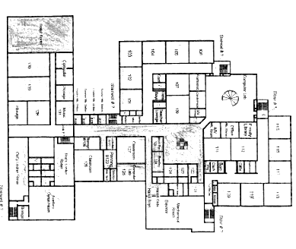
Ice Rink Hallway
Airflow from Rink
Classrooms Examined
Hallway Door
Ice Rink Hallway

Rubber Mat
Hallway Door
Locker Room

Locker Room
Picture 1

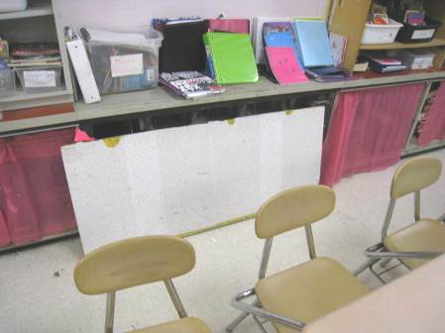

Univent in room 219 open while running

Picture 2

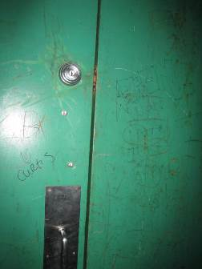

Ice rink doors (note gap where airflow could be detected)

Picture 3

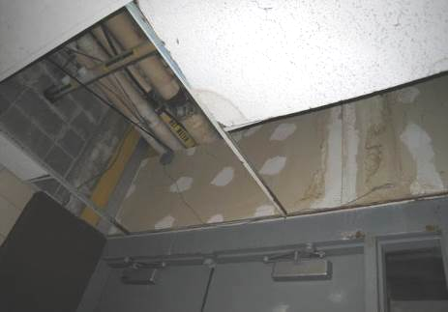

Open ceiling plenum next to ice rink hallway doors, note water-damaged wallboard and ceiling tiles

Picture 4

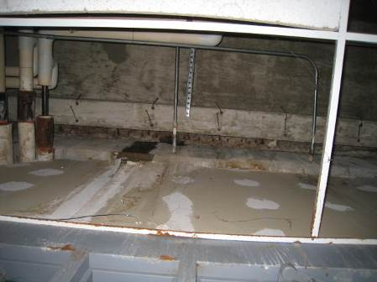

Water-damaged wallboard, wood and insulation above ice rink hallway doors

Picture 5

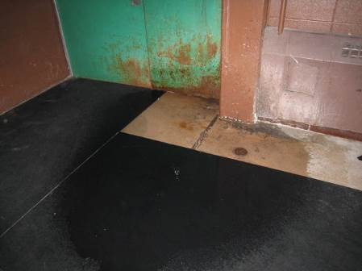

Active water leak adjacent to ice rink doors, note water-damaged door and flooring.

Picture 6

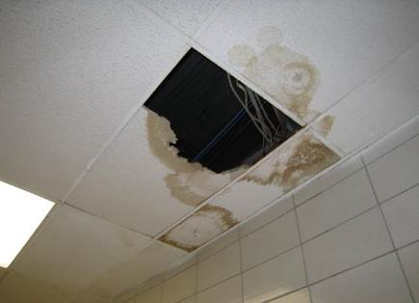

Site of active water leak in “Island House” wing hallway showing
water-damaged/broken ceiling tiles

Picture 7

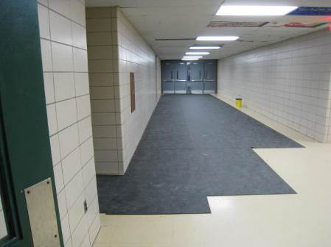

Rubber mat material placed in hallway to ice rink

Picture 8

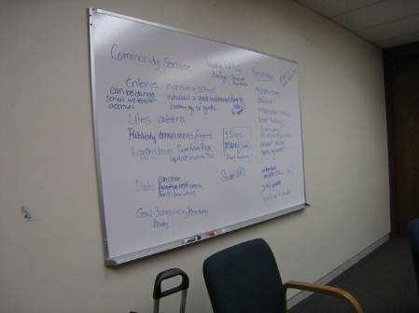

Dry erase board

Picture 9

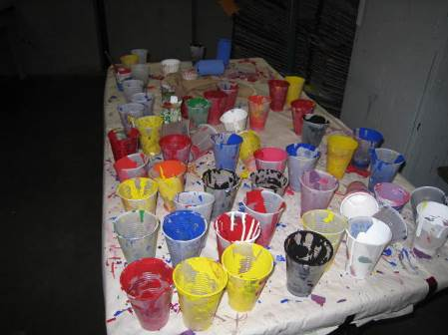

Art supplies in the art room

Picture 10

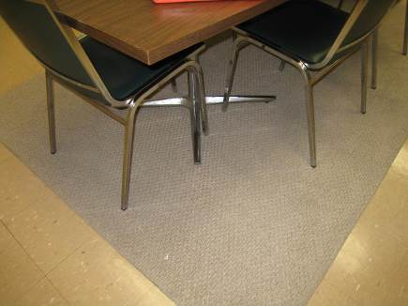

Area rug in 121/122 conference room

Picture 11

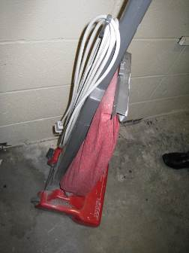

Non HEPA-filtered vacuum cleaner
Location | Carbon  Dioxide  (ppm) | Carbon Monoxide  (ppm) | Temp  (°F) | Relative  Humidity  (%) | PM2.5  (µg/m³) | Occupants  in Room | Windows  Openable | Ventilation |  |  | Remarks
 |  |  |  |  |  |  |  | Supply | Exhaust |  | Remarks
Background | 366 | ND | 50 | 42 | 5 |  |  |  |  |  | Raw, windy, rain/wintry mix (parking lot at 10 am)
Conference room | 905 |  | 73 | 34 | 3 | 10 | N | Y |  | Y | DEM, noisy supply vent
Staff restroom |  |  |  |  |  |  |  |  |  |  | One AT, hand sanitizer in hall
Staff office storage area | 642 | ND | 73 | 29 | 7 | 0 | N | Y |  | N | Food, microwave, little refrigerator
Office | 615
Hallway adjacent to ice rink | 527 | ND | 65 | 27 | 5 |  |  |  |  |  | Door to ice rink has breeze coming out of it
Back of home base room | 633 | ND | 76 | 26 | 5 | 0 | N |  |  | Y | Exhaust backdrafting?
Storage | 674 | ND | 77 | 25 | 6 | 0 | N |  |  | Y  on | Open area in ceiling, items, paper, paint, DO
Vice Principal’s office | 650 | ND | 76 | 24 | 6 | 0 | N | Y |  | Y  closed | DO, AP
Back of VP office | 640 | ND | 75 | 25 | 6 | 0 | N | Y |  | Y
Hill | 718 | ND | 75 | 28 | 7 | 0
1st floor common next to stairway | 772 | ND | 75 | 31 | 10
2nd floor common, top of stairway | 662 | ND | 73 | 29 | 6
Home base room (front 121) | 651 | ND | 76 | 26 | 7 | 1 | N | Y |  | Y
Back room of 121 | 612 | ND | 77 | 26 | 6 | 0 | N | Y  on |  |  | Shredder, area rug (old), DEM, WD-CT Stripper/floor wax stain on door,
122 | 675 | ND | 77 | 27 | 5 | 3 | N |  |  |  | PC, DEM
125 | 670 | ND | 76 | 28 | 6 | 0 | N | Y  closed |  | Y  off | Supply diffuser closed? Backdrafting exhaust?
129 (art) | 608 | ND | 70 | 31 | 12 | 1 | N | Y |  | Y | Paper, paint, items, things hanging from ceiling, DO, back door (reportedly used for ventilation during classes)
130 (art) | 522 | ND | 72 | 27 | 10 | 2 | N | Y |  | Y  off | Paper, paint, items, things hanging from ceiling, DO, back door (reportedly used for ventilation during classes)
201 | 939 | ND | 74 | 32 | 8 | 25 | Y | Y |  |  | UV
219 | 1076 | ND | 72 | 32 | 11 | 0 (occupants left recently) | Y | UV broken |  | Y  off | UV open and running (turned off due to safety hazard), DEM, exhaust backdraft?

