INCIDENT HIGHLIGHTS
DATE:
October 10, 2017
TIME:
12:15 p.m.
VICTIM:
54-year-old male ranch hand
INDUSTRY/NAICS CODE:
Horse Boarding / 115210
EMPLOYER:
Independent Contractor
SAFETY & TRAINING:
No safety and health program and limited on-the-job training
SCENE:
Horse stable in a rural area
LOCATION:
Massachusetts
EVENT TYPE:
Struck by animal

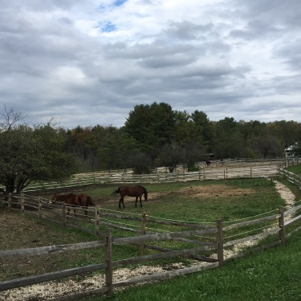

REPORT#: 17MA051 REPORT DATE: February 24, 2019
Ranch Hand Dies After Being Kicked By a Horse—Massachusetts

SUMMARY
On October 10, 2017, a 54-year-old male ranch hand died while inside a paddock with two horses. The ranch hand was inside a paddock throwing hay at the time of the incident when he was kicked in the head by one of the horses. READ THE FULL REPORT> (p.3)

CONTRIBUTING FACTORS
Key contributing factors identified in this investigation include:
- Having to enter the paddock with a horse present to throw hay;
- Unstable footing due to muddy ground;
- No comprehensive safety and health program; and
- Working alone. LEARN MORE> (p.5)

RECOMMENDATIONS
Massachusetts FACE Program concluded that, to help prevent similar occurrences, employers and stable owners should:
- Ensure the task of throwing hay can be completed without having to be inside the paddock with the horses present.
- Ensure dry and stable footing in the areas where workers will be on foot.
- Develop and implement a comprehensive safety and health program that includes training and addresses hazard recognition and avoidance of unsafe conditions.
- Consider developing policies that prevent working alone when performing certain tasks.
In addition, employers should:
- Ensure they are not misclassifying workers as independent contractors by complying with the Massachusetts Independent Contractor Law. LEARN MORE> (p.5)
Fatality Assessment and Control Evaluation (FACE) Program

The Massachusetts Department of Public Health, in cooperation with the National Institute for Occupational Safety and Health (NIOSH), conducts investigations on the causes of work-related fatalities. The goal of this program, known as Massachusetts Fatality Assessment and Control Evaluation (Massachusetts FACE) is to prevent future fatal workplace injuries. Massachusetts FACE aims to achieve this goal by identifying and studying the risk factors that contribute to workplace fatalities, by recommending intervention strategies, and by disseminating prevention information to employers and employees.

NIOSH funded state-based FACE Programs currently include: California, Kentucky, Massachusetts, Michigan, New York, Oregon, and Washington.
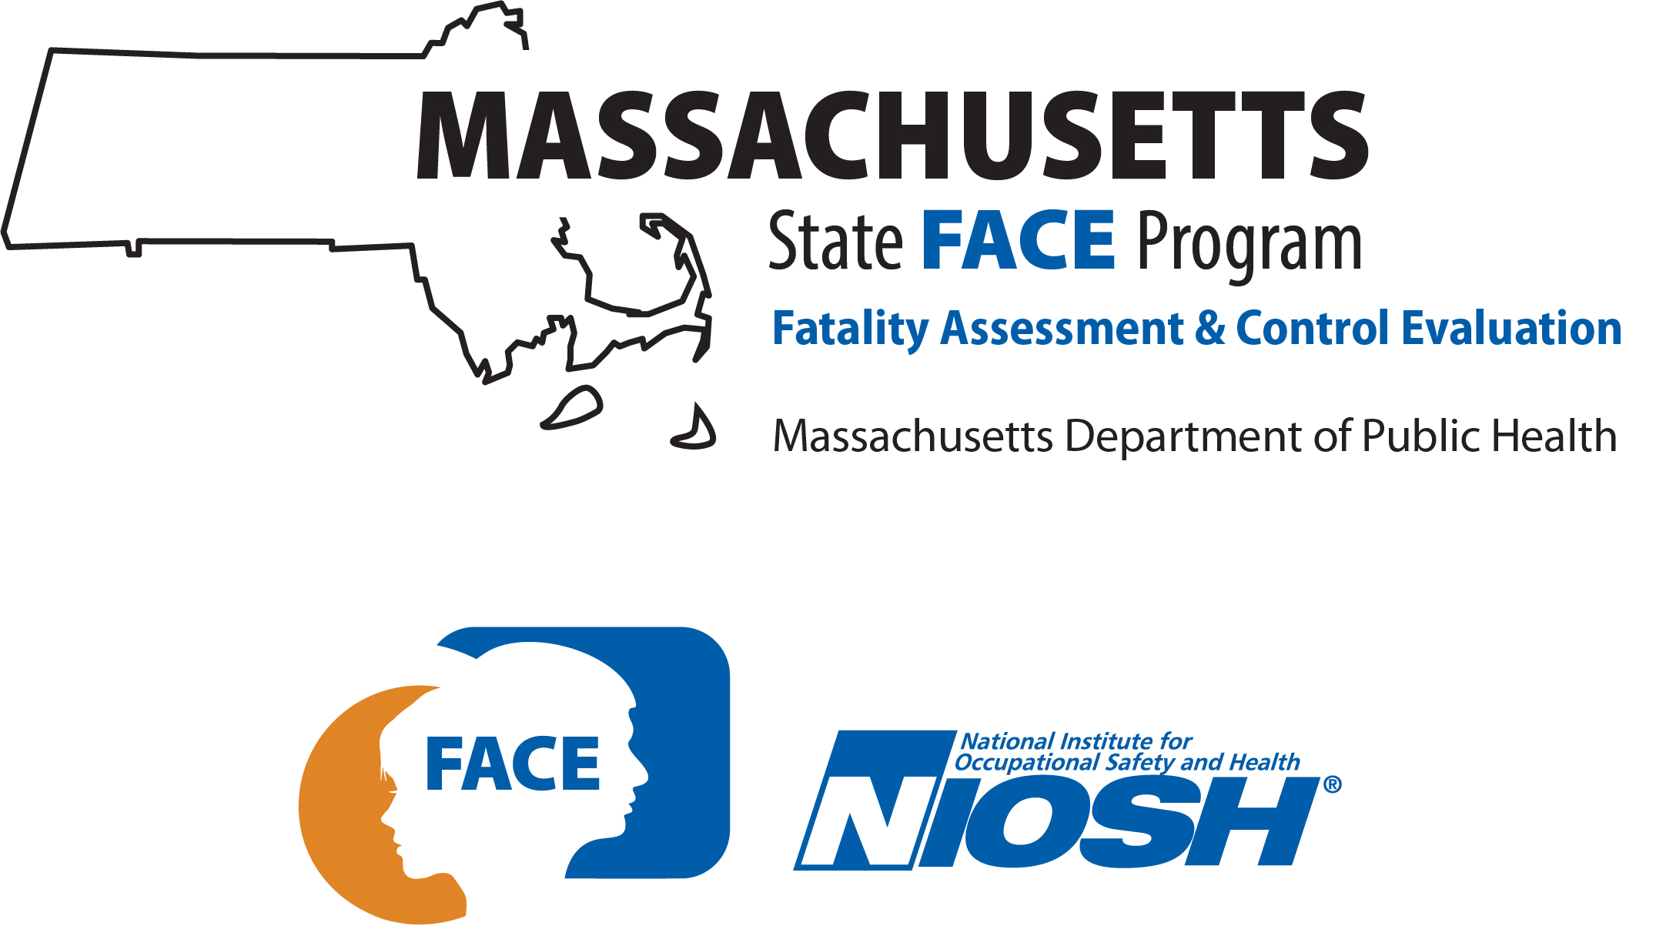

SUMMARY
On October 10, 2017, a 54-year-old ranch hand died while inside a paddock with two horses. At the time of the incident, the ranch hand was inside the paddock throwing hay. The incident was unwitnessed, but it appears that the ranch hand was kicked in the head by one of the horses while inside the paddock. One of the stable owners found the victim laying on his back unconscious inside the paddock and called the other owner. A call was then placed for emergency medical services (EMS) and the victim was transported to a local hospital.

INTRODUCTION
On October 10, 2017, a ranch hand died when he was kicked by a horse. The Massachusetts FACE Program was notified by the local police department about the incident on the same day. On October 11, 2017, a representative from the Massachusetts FACE Program traveled to the stable where the incident occurred and met with the stable owners and the local police department to discuss the incident. The incident location, police report, death certificate, and other information were reviewed.

EMPLOYER
The victim worked as a ranch hand for a horse stable located in a rural section of the state (Figure 1). The stable, which had been in business approximately 10 years, offered numerous services, including boarding, training and riding, and showing lessons. The victim was one of five ranch hands at the stable. It was reported by the stable owners that all of the ranch hands were independent contractors. The ranch hands had set schedules that included both full days and half days. Not all of the ranch hands’ scheduled shifts started and ended at the same time. Typically three workers started their shift in the morning and two workers started their shift in the afternoon. The victim’s schedule was full days Friday through Monday and half days on Tuesday and Thursday.

WRITTEN SAFETY PROGRAMS and TRAINING
At the time of the incident, the stable did not have a comprehensive safety and health program. Workers were routinely hired with previous experience. There was some on the job training when needed.

WORKER INFORMATION
The victim was a 54-year-old White non-Hispanic male ranch hand for the horse stable. The main tasks for the victim included maintaining the stalls and the paddocks, throwing hay, ensuring the horses had enough water, and mucking the stalls. At the time of the incident, the victim had worked at the stable for approximately one year. The victim had over a decade of experience as a ranch hand and previously worked at other local stables.

WEATHER
The weather at the time of the incident was approximately 62 degrees Fahrenheit, 80% humidity, 12 mph average westerly wind speed, and mostly cloudy skies. There was no precipitation on the day of the incident and the day before there was about an inch of rain.¹ The weather on the day of the incident is not believed to have been a factor in this incident, but the rain on the day before most likely contributed to the muddy conditions.

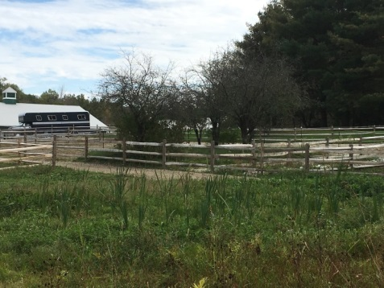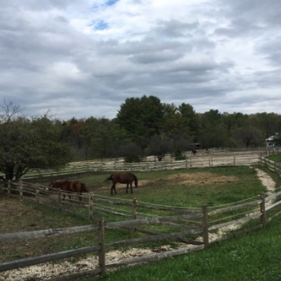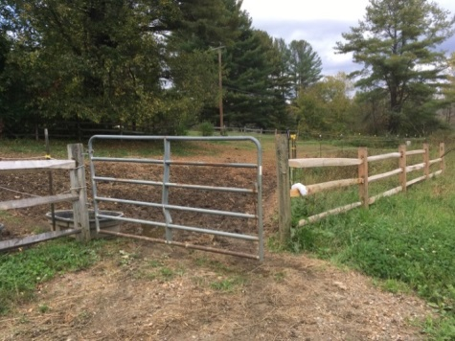
Figure 1 - View of the paddock area and the stable Figure 2 - View of the paddock area Figure 3 - Paddock where the incident occurred

INCIDENT SCENE
The incident occurred at a horse stable in a rural setting with over 11 acres of land (Figure 2). The stable had barn space for boarding horses, paddock space, a barn with training space for jumping and hunter activities, and pasture area for riding. The stable consisted of a barn with 32 stalls, a large indoor riding/training arena, an area for riders to store their belongings, and a tack shop. There were multiple out buildings on the site as well, including a garage and storage buildings for hay and other items. There were 14 outdoor horse paddocks that were enclosed by fence. The paddock where the incident occurred was one of the furthest paddocks from the barn. This paddock had two horses in it at the time of the incident. It was reported by the stable owner that these two horses had been together in the same paddock for the past three months. One of these horses was an Appaloosa halter horse and the other was a Thoroughbred horse.
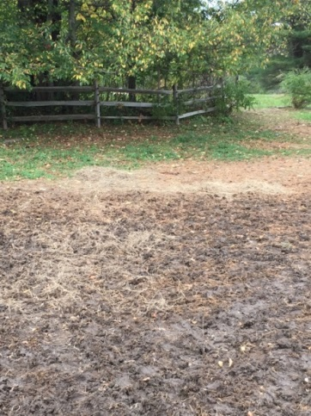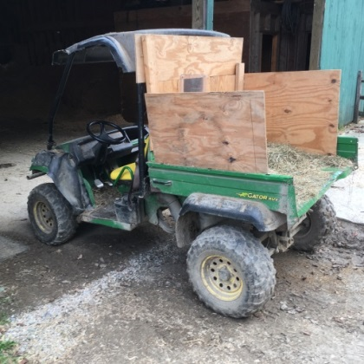
Figure 4 - Muddy area inside the Figure 5 - Farm utility vehicle
paddock where the victim was found
The paddock where the incident occurred was built from a mix of wood and metal fencing and there was a metal gate for access to the paddock (Figure 3). The metal section of fence for this paddock was in the process of being replaced with wood fence. The new wood fence section was being installed outside of the perimeter of the old fence, which at the time of the incident created a gap between the new wood fence and the older metal fence. The ground of the paddock was a combination of areas of dirt, grass and vegetation. The area directly inside the paddock gate was primarily dirt due to the heavy foot traffic. The rain the day before the incident most likely contributed to the mud that was present in this area (Figure 4).

INVESTIGATION
On the day of the incident, which was a Tuesday, a stable worker scheduled to work had called out of work. The stable owners’ then called the victim and asked if he could come into work early, which the victim agreed to do. The victim arrived at the stable around 8:30 a.m., while his normal scheduled shift would have started late afternoon.
At the time of the incident, the victim was throwing hay. The victim loaded the bed of a small farm utility vehicle with hay. This vehicle was used to transport the hay out to the multiple paddocks (Figure 5). Once the victim reached the outer paddock he parked the vehicle and grabbed a couple flakes of hay. The victim then opened the gate and entered the paddock (Figure 3). Since the area immediately inside the area of the paddock gate was muddy he walked about 50 feet into the paddock to get beyond the wet and muddy area (Figure 4). The victim then placed the hay flakes into two piles, one for each horse.
Since the victim was working alone and there were no witnesses it is difficult to know what exactly occurred. It was at this point that it appears the victim had been kicked by one of the horses. One of the stable co-owners arrived at the stable and noticed the farm vehicle parked in the pasture area. The co-owner then went over to the paddock and found the victim. The victim was inside the paddock near the hay he had brought into the paddock. The victim was on the ground unconscious, lying on his back and his cell phone was on the ground next to him. The co-owner immediately called the other co-owner who went to the paddock and then immediately placed a call for emergency medical services (EMS) and started cardiopulmonary resuscitation (CPR). EMS arrived within minutes of the placed call. The victim was transported to a local hospital where he was pronounced dead.

CAUSE OF DEATH
The medical examiner listed the cause of death as complications of intracranial hemorrhages due to blunt force injuries of the head.

CONTRIBUTING FACTORS
Occupational injuries and fatalities are often the result of one or more contributing factors or key events in a larger sequence of events that ultimately result in the injury or fatality. The Massachusetts FACE Program identified the following contributing factors in this incident:
- Having to enter the paddock with a horse present to throw hay;
- Unstable footing due to muddy ground;
- No comprehensive safety and health program; and
- Working alone.

RECOMMENDATIONS/DISCUSSION
Recommendation #1: Employers and stable owners should ensure the task of throwing hay can be completed without having to be inside the paddock with horses present.
Discussion: The stable had multiple paddocks. Some of the paddocks had to be entered to throw hay and some of the paddocks were configured so the throwing hay task could be performed without the worker entering the paddock. The paddock where the incident occurred was one of the paddocks that workers had to enter to throw hay bringing the workers in close proximity to the horses. In locations where workers will have to enter the paddock to throw hay, the task of throwing hay could be performed prior to turning the horses out to the paddock. This could be accomplished by throwing hay in the stalls while the horses are still inside the stalls and/or throwing hay in the paddock before the horses are turned out to the paddock. In both of these throwing hay situations, the worker would not have to enter the paddock with horses present. In locations where the workers would not have to enter the paddock to throw hay, the fencing would act as a physical barrier between the horse and the worker. The fence would reduce the possibility of a worker being kicked or bumped by a horse during the hay throwing task.
In this case, the paddock fencing for where the incident occurred was in the process of being replaced. It was reported by the stable owner that once the new fence was completed, the hay throwing task would be able to be performed without workers having to enter the paddock. Ideally, all paddocks should be designed where workers could throw hay into the paddock without having to physically enter the paddock. Since this is not always feasible, all paddocks should be evaluated with the throwing hay task in mind and specific procedures for throwing hay should be developed for each paddock. These procedures should cover both the paddocks that have to be entered and the paddocks that do not have to be entered for throwing hay.
Recommendation #2: Employers and stable owners should ensure dry and stable footing in the areas where workers will be on foot.
Discussion: In this case, the ground directly inside the gate area of the paddock was muddy. This was a high traffic area that horses, workers, and others, such as riders, would routinely access. It appears that because of the mud, the victim walked further into the paddock through the muddy area to throw the hay on dry ground. This prolonged the amount of time the victim was inside the paddock and with unstable footing.
Employers and stable owners should consider evaluating areas that routinely become muddy and where workers and others will be on foot and come up with solutions that will reduce the muddy conditions.² This includes, if possible, locating gates and access areas to the paddocks on higher ground with good natural drainage. If this is not possible then a French drain that is dug into the ground and filled in with gravel will help create dryer conditions. These evaluations should also take into consideration the footing in the paddock. Since higher traffic areas tend to be the locations that become muddy, extra consideration should be given to these locations. There are many options for footing materials that can be used to create stable non muddy ground in paddocks.² Once the muddy conditions are eliminated, it will create safer footing for workers and potentially will create safer footing for the horses, which could also reduce the health issues associated with horses and muddy conditions.
Recommendation #3: Employers and stable owners should develop and implement a comprehensive safety and health program that includes training and addresses hazard recognition and avoidance of unsafe conditions.
Discussion: Having a safety and health program is an important part of keeping workers at your stable safe and subsequently the program will also keep other people present at the stable and the horses safe as well.³ A safety and health program should include the systematic identification, evaluation, and prevention or control of both general workplace hazards and the hazards of specific jobs and tasks that occur at the facility. The core elements of an effective safety and health program are management leadership, worker participation, hazard identification and assessment, hazard prevention and control, education and training, and program evaluation and improvement.⁴ The program should outline safe work practices workers are expected to adhere to, specific safety protection for all tasks workers perform, how workers can identify and avoid hazards, and who workers should contact when safety and health issues or questions arise.⁴ The program should also include an explanation of the workers’ rights to protection in the workplace.
When developing a safety and health program, employers should start by performing a hazard analysis of all routine tasks performed by workers for potential hazards and incorporate information about any identified hazards and their controls into the program.⁴ When determining potential hazards associated with equipment, information in the manufacturer operator’s manual and on the equipment’s warning labels should be reviewed and incorporated into the safety and health program procedures.
Employers should also use their workers’ expertise throughout the program development process by seeking worker input. Once the program is developed, employers should continue to seek workers’ input during the routine updating of the program. The program should be updated when safety concerns arise and when new equipment, tasks and chemicals are introduced into the workplace. In addition, for locations where large animals, such as horses, are present procedures should be developed about how to properly interact with the horses. These procedures should include how to approach and work next to the horses. Any required tools and personal protective equipment (PPE) needed to complete the tasks should be provided by the employer.
Employers should ensure that they have fully and effectively implemented their safety and health program by routinely performing assessments of tasks and immediately addressing any observed unsafe conditions. As part of the program’s implementation, training should be provided to all workers on the program’s topics and procedures, and should also include hazard recognition and the avoidance of unsafe conditions. All training provided to workers should be documented. In this case, the safety and health program should include a section on proper mower and other equipment selection, use of the equipment, and training.
The Massachusetts Department of Labor Standards (DLS) offers free consultation services to help small employers improve their safety and health programs, identify hazards, and train workers. DLS can be contacted at 508-616-0461. More information about DLS can be found on their website at www.mass.gov/dos/consult.
The Massachusetts Department of Industrial Accidents (DIA) has grants available for providing workplace health and safety training to employers and workers. Any company covered by the Massachusetts Workers’ Compensation Insurance Law is eligible to apply for these grants. More information about these DIA grants can be found on their website at www.mass.gov/dia/safety.
Recommendation #4: Employers and stable owners should consider developing policies that prevent working alone when performing certain tasks.
Discussion: Sometimes animals can have unexpected movements or reactions that result in a worker being bumped or injured. Although not all tasks rise to the level of ensuring that workers are not working alone, some situations might do. If the task involves a location away from other workers and coming in close proximity to large animals without barriers, as in this case, then it might be a good practice to have more than one worker completing the task when possible. Having more than one worker completing a task can shorten the amount of time needed to complete the task. When throwing hay inside a paddock, a second person could help by being aware of the horses’ locations while inside the paddock. In addition, a second person could immediately assist an injured worker and seek help from others, such as placing a call for emergency medical services.
Recommendation #5: Employers should comply with the Massachusetts Independent Contractor Law to ensure they are not misclassifying employees as independent contractors.
Discussion: Workers are sometimes misclassified as independent contractors by their employers when legally these workers should be classified as employees of the company. Employees are entitled to a variety of workplace benefits and protections such as the right to minimum wage, overtime, workers’ compensation insurance coverage, earned sick leave, unemployment benefits and other protections. Misclassifying a worker as an independent contractor not only has an overall negative impact on the misclassified worker, it also negatively impacts taxpayers, the Commonwealth of Massachusetts, and fair business competition for law-abiding employers.
The goal of this investigation was not to determine if the victim was misclassified as an independent contractor and should have been classified as an employee of the stable. Companies should know that the determination as to which workers can be classified as independent contractors is a legal one. An employer who wants to treat someone as an independent contractor rather than an employee has to show that the work is:
- Done without the direction and control of the employer; and
- Performed outside the usual course of the employer’s business; and
- Done by someone who has their own, independent business or trade doing that kind of work.
All three of these elements must exist in order for a worker to be classified as an independent contractor. For more information about the Independent Contractor Law please read the Attorney General’s advisory on the Independent Contractor Law (https://www.mass.gov/files/2017-08/independent-contractor-advisory_1.pdf).⁵

ADDITIONAL RESOURCES
University of Kentucky. Saddle Up Safely. Safety While in the Pasture. https://equine.ca.uky.edu/files/safety-while-in_the-pasture.pdf

DISCLAIMER
Mention of any company or product does not constitute endorsement by the National Institute for Occupational Safety and Health (NIOSH). In addition, citations to websites external to NIOSH do not constitute NIOSH endorsement of the sponsoring organizations or their programs or products. Furthermore, NIOSH is not responsible for the content of these websites. All web addresses referenced in this document were accessible as of the publication date.

REFERENCES
1. Weather Underground. Weather History. Massachusetts: TWC Product and Technology LLC.

2. Horse Journals. Muddy Paddock Footing Fixes. www.horsejournals.com/acreages-stables/management-maintenance/muddy-paddock-footing-fixes. Date accessed: April 10, 2018.

3. WorkSafe – Western Australia. Horse Stables and Track Riding Safety. www.commerce.wa.gov.au/sites/default/files/atoms/files/horse_racing_stables_0.pdf. Date accessed: April 10, 2018.

4. OSHA. Recommended Practices for Safety and Health Programs. OSHA 3885. 2016. www.osha.gov/shpguidelines/. Date accessed: April 10, 2018.

5. MA AGO. An Advisory from the Attorney General’s Fair Labor Division on M.G.L. c. 149, s. 148B. www.mass.gov/files/2017-08/independent-contractor-advisory_1.pdf. Date accessed: April 10, 2018.

