

Primary Care workforce implications of new models of care

RAND Health

David Auerbach, PhD

Mark Friedberg, MD, MPP

Project funding from the Robert Wood Johnson Foundation and the Donaghue Foundation

Workforce Analysis as Usual

Assume we want to continue today’s production function for health care, more or less

Same number of providers of each type per unit population

Look at the pipeline

Trainees

Providers exiting workforce

Account for demographic trends

Voila! Shortage, surplus, or just right

Medical Homes: Changing the Health Care Production Function

Key medical home components:

Better teamwork within practices

Greater coordination in “medical neighborhood”

New capital investment

Reallocation of provider effort

Complex relationships possible between provider quantity, skills, and activities

Argues for a broader view of what “workforce analysis” might include

Medical Home Production Function

Physicians
NPs
Clinical staff
Primary care practices
Capital investments
Specialists, hospitals, and other providers
Activated patients
Efficient, high-quality, patient-centered care

Better Teamwork May Change “Right Mix”

Physicians
NPs
Clinical staff
Primary care practices
Capital investments
Specialists, hospitals, and other providers
Activated patients
Efficient, high-quality, patient-centered care

Better Coordination: Lesser Need for
Specialist and Hospital Care?

Physicians
NPs
Clinical staff
Primary care practices
Capital investments
Specialists, hospitals, and other providers
Activated patients
Efficient, high-quality, patient-centered care

New Capital: Substitute for Labor?

Physicians
NPs
Clinical staff
Primary care practices
Capital investments
Specialists, hospitals, and other providers
Activated patients
Efficient, high-quality, patient-centered care

Controversies in provider laborforce forecasting

Widely differing assumptions about…

Trends in specialty choice

Effect of growth in insurance coverage

HRSA (2008): 7,000 PCP surplus in 2020

AAMC (2013): 45,000 PCP shortage in 2020
Most forecasting models have one major assumption in common:

The number of physicians required to care for a given population is fixed.

What if new models change the numbers of providers needed to care for a population?

New models of care may use different staffing

Patient-Centered Medical Homes

Nurse Managed Health Centers (NMHC)
Our approach

Estimate how new models are staffed
  - Physicians (MD/DO), Nurse Practitioner (NP), Physician’s Assistants (PA)

If different: project provider demand (use) if these models become more prominent

Compare implied provider demand to projected provider supply

1. How does staffing of new models differ?
Data sources

Patient-Centered Medical Home (PCMH)

Literature survey
- Advisory Board Study

Data from Pennsylvania Chronic Care Initiative
- >100 practices in PA (54 currently analyzed with complete data) received extra payments to improve NCQA medical home scores
- RAND evaluation supported by Commonwealth Fund

Nurse-Managed Health Center (NMHC)

Own survey of convenience sample of ~25 NMHC’s

Medical home staffing
(provider mix and panel size)

Advisory Board survey
- Self-designated medical homes use 20% more NP’s per MD/DO and 10% more PA’s, relative to control practices
- Panel sizes similar but Medical Homes expect to grow 20%

Other literature
- Medical homes appear to have smaller panel size

Pennsylvania survey
- Define medical homes two ways (structure/process):
  - Quality tools index (e.g. reminders for chronic disease)
  - Access index (e.g. extended-hours care)
- Compare staffing as a function of ‘medical home-ness’

Pennsylvania PCMH staffing mix

Internal staffing ratio | Number of sites | Initial (NP + PA) per MD/DO | Final (NP + PA) per MD/DO
Sites with a large improvement in medical home quality index | 33 | 0.39 | 0.57
Sites with little or no improvement in medical home quality index | 21 | 0.39* | 0.45
Sites with a large improvement in medical home quality index | 33 | 0.24 | 0.33
Sites with little or no improvement in medical home quality index | 21 | 0.24* | 0.29
*The ‘initial’ number of NPs and PAs per MD/DO was renormalized (proportionally) to the same level as the other sites to make figures more comparable

NMHC staffing

Of 25 practices with complete data:

Typical NP panel sizes are ~ 1000

Staffing ratio: for a 10,000 patient panel:
- 10 NP’s
- 1 MD
- 7 MA’s
- 5 RN’s
- 0 PA’s

MDs appear more likely present in states with restrictive NP scope of practice

Model staffing per 10,000 US residents

Assumptions

PCMH uses~ 10% more NPs and Pas per MD/DO (medium uncertainty)

PCMH panel sizes are roughly the same as non-PCMH (high uncertainty)

Supply vs demand projections

Demand for primary care providers increases 8%

Population aging (6%, Martini et al, HSR, 2007)

Affordable Care Act (2%, CBO “Key Issues…”, 2008)

Default modeling assumptions

Use staffing provider mix as shown

Vary (in alternative forecasts)
- Growth of PCMH (~15% of primary care today)
- Growth of NMHC (~.5% of primary care today)
- PCMH panel size (very uncertain)

Compare demand to projected supply

Current and projected primary care supply

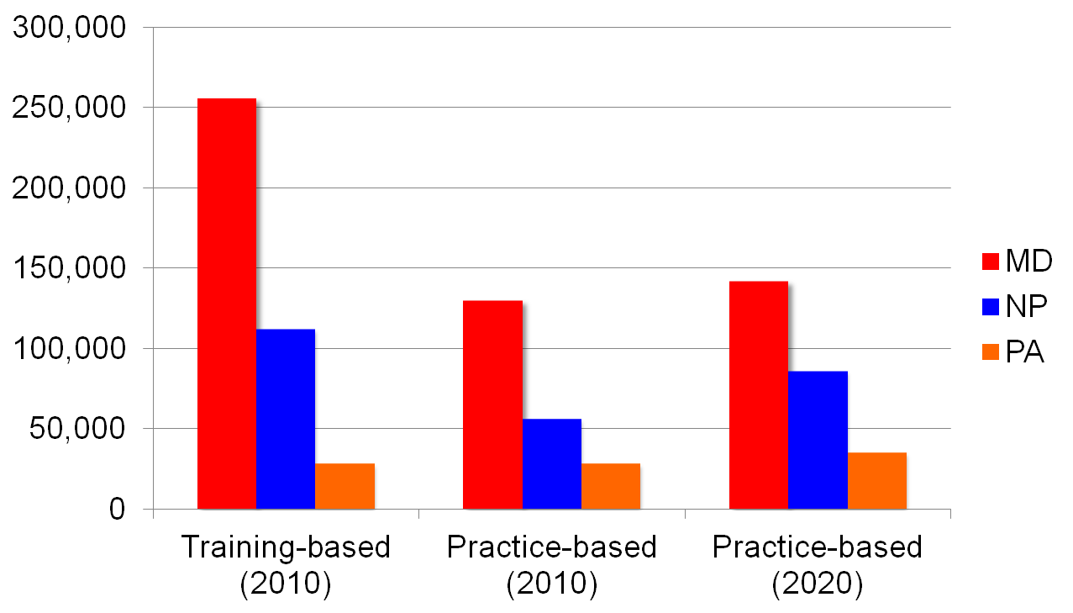

PCP from HRSA, Colwill et al (2008); NP from Auerbach (2012); PA from recent enrollment trends

Shortage forecasts

Primary care provider supply and demand scenarios

Conclusions/questions

Shortage projections are very sensitive to changes in primary care delivery models

Standard laborforce projections don’t account for changing models of primary care delivery

Growth of the PCMH and NHMC models would ameliorate projected provider imbalances

Physician shortage/surplus projections are also highly dependent on PCMH panel size

Physician shortages can be eliminated under various reasonable scenarios without modifying the current “training pipeline” for physicians

Variation in PCMH panel sizes

- Altschuler et al (2012): Ideal panel sizes can vary between 1,387 and 1,947 per physician based on degree of delegation of tasks to non-clinicians
- Group Health Cooperative: Medical home transformation reduced panel sizes 23%
- Rushika Fernandopoulle: Lessons from Iora Health suggest panel sizes could be doubled by maximizing use of technology, etc.

