INDOOR AIR QUALITY ASSESSMENT

Randall Library
25 Crescent Street
Stow, Massachusetts 01775

Prepared by:
Massachusetts Department of Public Health
Bureau of Environmental Health
Indoor Air Quality Program
January 2015

Background/Introduction
At the request of John Wallace, Health Agent for the Town of Stow, the Massachusetts Department of Public Health (MDPH), Bureau of Environmental Health (BEH) provided assistance and consultation regarding indoor air quality (IAQ) at the Randall Library (RL), 19 Crescent Street, Stow, Massachusetts. The request was prompted by health concerns, odors and mold thought to be associated with indoor air quality. On November 6, 2014, a visit to conduct an IAQ assessment was made by Kathleen Gilmore, Environmental Analyst/Regional Inspector for the BEH/IAQ Program. On November 14, 2014, Michael Feeney, Director of the Indoor Air Quality Program, accompanied Ms. Gilmore to the RL to complete the assessment.
The RL is a brick building constructed in 1892 as a free standing two-story structure with a stone foundation basement. In the 1970s, a two-story addition (the addition) was constructed along the south wall of the original building (Map 1). A significant part of the 1892 building basement was converted into occupiable space in the area where the two structures meet, with the installation of a large, sloped window system over this section.
The addition’s ground floor consists of the main library, youth and young adult library and administration areas. The upper floor of the 1970s addition contains a reference library, meeting room and a children’s pre-school area. Floors are carpeted. Most windows are openable.
Three features that were incorporated into the addition’s design are significant due to their impact on the indoor air quality of the building.
- The addition has a combination peaked and flat roofs. The flat portion of the addition’s roof adjacent to the 1892 building serves as a patio/entranceway for the 1892 building.
- The addition has heating, ventilating and air-conditioning (HVAC) system ductwork buried in/beneath its slab.
- The west facing wall of the addition is buried beneath a sloping garden directly beneath the rooftop patio entrance.

Methods
Air tests for carbon dioxide, carbon monoxide, temperature and relative humidity were conducted with the TSI, Q-Trak, IAQ Monitor, Model 7565. Air tests for airborne particle matter with a diameter less than 2.5 micrometers were taken with the TSI, DUSTTRAK™ Aerosol Monitor Model 8520. BEH/IAQ staff also performed visual inspection of building materials for water damage and/or microbial growth.

Results
The RL has an employee population of 6 with 50-100 members of the public visiting on a daily basis. Tests were taken during normal hours of operation. Test results appear in Table 1.

Discussion

Ventilation
It can be seen from Table 1 that carbon dioxide levels were below 800 parts per million (ppm), indicating adequate air exchange in all areas surveyed. Of note, the building was sparsely occupied at the time of the assessment, which can greatly reduce carbon dioxide levels. Carbon dioxide levels would be expected to increase with full occupancy.
Mechanical ventilation is provided by air-handling units (AHUs) located in the mechanical room in the center of the ground floor. Fresh air is drawn through an air intake on the exterior of the building. Of note is that the exterior wall vents that likely serve as fresh air intakes were found blocked with insulation (Picture 1). In this condition, no fresh air to dilute normally occurring environmental pollutants exists. On the upper floor, fresh air is drawn into the AHU and delivered to occupied areas through ceiling-mounted supply vents (Picture 2). Supply ventilation on the ground floor is delivered through the previously-mentioned subterranean ductwork below a concrete slab floor and distributed via floor supply vents (Picture 3). Return air is drawn into wall or ceiling mounted vents. A separate roof-top AHU supplies conditioned air to the building. Exhaust ventilation located in restrooms is activated via a light switch. It is recommended that exhaust ventilation in bathrooms be continuous during occupied hours rather than in response to a light switch.
To maximize air exchange, the MDPH recommends that both supply and exhaust ventilation operate continuously during periods of occupancy. In order to have proper ventilation with a mechanical supply and exhaust system, the systems must be balanced to provide an adequate amount of fresh air to the interior of a room while removing stale air from the room. It is recommended that heating, ventilating and air conditioning (HVAC) systems be re-balanced every five years to ensure adequate air systems function (SMACNA, 1994). The date of the last balancing of these systems was not available at the time of the assessment.
Minimum design ventilation rates are mandated by the Massachusetts State Building Code (MSBC). Until 2011, the minimum ventilation rate in Massachusetts was higher for both occupied office spaces and general classrooms, with similar requirements for other occupied spaces (BOCA, 1993). The current version of the MSBC, promulgated in 2011 by the State Board of Building Regulations and Standards (SBBRS), adopted the 2009 International Mechanical Code (IMC) to set minimum ventilation rates. Please note that the MSBC is a minimum standard that is not health-based. At lower rates of cubic feet per minute (cfm) per occupant of fresh air, carbon dioxide levels would be expected to rise significantly. A ventilation rate of 20 cfm per occupant of fresh air provides optimal air exchange resulting in carbon dioxide levels at or below 800 ppm in the indoor environment in each area measured. MDPH recommends that carbon dioxide levels be maintained at 800 ppm or below. This is because most environmental and occupational health scientists involved with research on IAQ and health effects have documented significant increases in indoor air quality complaints and/or health effects when carbon dioxide levels rise above the MDPH guidelines of 800 ppm for schools, office buildings and other occupied spaces (Sundell et al., 2011). The ventilation must be on at all times that the room is occupied. Providing adequate fresh air ventilation with open windows and maintaining the temperature in the comfort range during the cold weather season is impractical. Mechanical ventilation is usually required to provide adequate fresh air ventilation.
Carbon dioxide is not a problem in and of itself. It is used as an indicator of the adequacy of the fresh air ventilation. As carbon dioxide levels rise, it indicates that the ventilating system is malfunctioning or the design occupancy of the room is being exceeded. When this happens, a buildup of common indoor air pollutants can occur, leading to discomfort or health complaints. The Occupational Safety and Health Administration (OSHA) standard for carbon dioxide is 5,000 parts per million parts of air (ppm). Workers may be exposed to this level for 40 hours/week, based on a time-weighted average (OSHA, 1997).
The MDPH uses a guideline of 800 ppm for publicly occupied buildings. A guideline of 600 ppm or less is preferred in schools due to the fact that the majority of occupants are young and considered to be a more sensitive population in the evaluation of environmental health status. Inadequate ventilation and/or elevated temperatures are major causes of complaints such as respiratory, eye, nose and throat irritation, lethargy and headaches. For more information concerning carbon dioxide, please see Appendix A.
Temperature readings during the assessment ranged from 64° F to 68° F which were below the MDPH recommended comfort range (Table 1). Of note, although the outside temperature was 49° F on the day of the visit (Table1), the heating, ventilation and cooling (HVAC) system was operating in its chilling mode, which would influence temperatures in the building. The MDPH recommends that indoor air temperatures be maintained in a range of 70°F to 78°F in order to provide for the comfort of building occupants. In addition, there were complaints of thermal discomfort in the area of the employee workroom and the circulation desk which is likely due to the close proximity to the book depository which is installed in the exterior wall of the building (Picture 4). In its configuration, the book depository is no different than a window in the building envelope being continually open. Without insulation, the book depository can allow unconditioned outdoor air to enter the RL.
The relative humidity in the building on the day of the assessment ranged from 44 to 51 percent, which was within the MDPH recommended comfort range in all areas evaluated on the day of the assessment (Table 1). The MDPH recommends a comfort range of 40 to 60 percent for indoor air relative humidity. Relative humidity levels in the building would be expected to drop during the winter months due to heating. The sensation of dryness and irritation is common in a low relative humidity environment. Low relative humidity is a very common problem during the heating season in the northeast part of the United States.

Odors and Microbial/Moisture Concerns
Concerns of odors and mold prompted the assessment. As previously mentioned, the RL addition has fresh air supply ductwork buried beneath its slab. As reported by Stow officials, running water was seen after a recent rainstorm on the floor of the supply ductwork in the workroom. BEH staff examined the floor vents in the workroom and observed the floor of the ductwork to be covered with dirt, which indicates that the ductwork is not water tight and is subject to groundwater penetration. The likely source of groundwater impinging on the below grade ductwork is due to the following factors:
- The gradient of the land surrounding the RL slopes from north to south and the south/southwest section of the ground floor is below grade (Pictures 5 and 6).
- The workroom is located directly below the roof patio. Rainwater from the patio empties onto the sloped garden. Components for the patio appeared to be moistened from runoff from the patio days after any previous significant rainfall.
- The sloped garden faces southwest, which receive significant rainwater which would tend to drain against the RL addition west wall and slab, which is in close proximity to the breached below grade ductwork.
BEH/IAQ staff noted a strong, musty odor originating from floor supply vents (Picture 7) in the workroom which is adjacent to the main entrance and directly behind the circulation desk. Town officials reported that episodes of intense odors from the floor vents appear to be associated with rain storms and had observed water intrusion in the subterranean ductwork following heavy rainstorms. Below grade ductwork is a design that is commonly used in locations with little precipitation, such as the southwestern United States. Although BEH/IAQ staff could not observe the design or configuration of the ductwork, the location of the ductwork in any area that is subject to continuous water impingent allows for odors and moisture/mold spores to be distributed by the HVAC system.
Water-damaged gypsum wallboard was noted in the main library, along a wall that is buried beneath the sloped garden directly beneath the patio. It is likely that runoff rainwater has resulted in water penetration and moistened GW. GW is a material that can support mold growth. BEH/IAQ staff were specifically requested to examine conditions of the RL rooftop patio (Picture 8) which is located adjacent to the upper floor of the building and, as mentioned, serves as the roof to a portion of the below-grade ground floor of the building. The patio reportedly has been the source of ongoing chronic water infiltration/damage over the course of years. Prior to the MDPH visit, a drainage system had been installed in the patio to direct rain water away from the building, repairs were made to the support beams and caulking/sealant applied to prevent future breaches and water penetration into the interior of the building. Upon inspection, BEH/IAQ staff observed a separation/gap between the metal support beam of the patio and the flashing on the adjacent perpendicular wall (Pictures 9 and 10). A gap at the juncture where building materials should be joined may create a pathway for rainwater to bypass the drainage system. This condition may result in runoff down the corner/seam of the building and cause water to pool at the below-grade foundation, which can lead to infiltration (Picture 11).
The US EPA and the American Conference of Governmental Industrial Hygienists (ACGIH) recommend that porous materials be dried with fans and heating within 24 to 48 hours of becoming wet (US EPA, 2001; ACGIH, 1989). If porous materials are not dried within this time frame, mold growth may occur. Once mold has colonized porous materials, they are difficult to clean and should be removed and discarded.
Other issues concerning water drainage and penetration were examined. BEH/IAQ examined the exterior of the building to identify breaches in the building envelope and/or other conditions that could provide a source of water penetration. Efflorescence was observed on exterior walls of the building. Efflorescence is a characteristic sign of water damage to building materials such as brick or plaster, but it is not mold growth. As moisture penetrates and works its way through mortar around brick, water-soluble compounds dissolve, creating a solution. As the solution moves to the surface of the brick or mortar, water evaporates, leaving behind white, powdery mineral deposits. This condition indicates that water from the exterior has penetrated into the building.
The building is equipped with weep holes along exterior walls to drain away moisture that enters under the façade (Figure 1). Some weep holes were found blocked with cement or accumulated sediment from bricks/mortar (Picture12) and appeared to not have any mesh covering and/or were covered by mulch. Without a mesh covering, insects such as bees or wasps may enter through the holes into the interior walls of the building. Without appropriate drainage, moisture can build up inside the wall’s drainage plane, resulting in increased water/moisture problems.
Downspouts from gutters terminate at the base of the building and some downspouts were found damaged (Pictures 13 and 14). Gutters/downspouts should be configured to drain water away from the building to prevent pooling/penetration at the foundation.
A glass atrium wall is located on the northeast side of the building (Picture 15). A brick catch basin designed to collect and drain rainwater runoff on the exterior wall contained a tree and debris providing a source for water to accumulate against the base of the wall and provide a means for water penetration (Picture 16). In addition, the downspout along the side of the wall was damaged and terminated at the base of the wall. BEH/IAQ staff observed plants and shrubs in close proximity to the building in numerous areas. Shrubs/trees in close proximity to the building hold moisture against the building exterior and prevent drying (Pictures 17 through 18). The growth of roots against exterior walls can bring moisture in contact with the foundation. Plant roots can eventually penetrate the wall, leading to cracks and/or fissures in the sublevel foundation. Over time, these conditions can undermine the integrity of the building envelope and provide a means of water entry into the building via capillary action through exterior walls, foundation concrete and masonry (Lstiburek & Brennan, 2001). The freezing and thawing action of water during the winter months can create cracks and fissures in the foundation that can result in additional penetration points for both water and pests. Trees and shrubs can also be a source of pollen, debris and mold into univents and windows. Consideration should be given to removing landscaping in close proximity to the building so as to maintain a space of 5 feet between shrubbery and the building.
The upper floor had water-damaged ceiling tiles (Table 1; Picture 19), which may stem from historic roof /plumbing leaks. Water-damaged ceiling tiles can provide a source of mold and should be replaced after a water leak is discovered and repaired.
Water dispensers and a mini refrigerator were found located in carpeted areas, where they can spill or leak and cause water damage to the carpet (Table 1; Picture 20). These appliances should be located on non-porous flooring on or a waterproof mat.
The main entrance door had gaps and was ill-fitting allowing light to be seen through the gaps. These gaps can allow water, drafts, particulate matter and pests into the building. All exterior doors should be checked for light penetration, and damaged/missing weather-stripping and weather sweeps should be repaired/replaced. In addition, it was reported that the exterior handicapped access door is subject to water penetration during wind-driven storms resulting in rotted/deteriorated interior wood flooring at the threshold (Picture 21). The damaged area should be repaired and consideration should be given to replacing the door and ensure that the slope of the ramp directs groundwater away from the base of the door.
In addition, a dehumidifier stored in the workroom had a catch basin with stagnant water and mold growth. Dehumidifiers should be cleaned routinely and dried completely when not in use to prevent mold growth and associated unpleasant odors.

Other Indoor Air Evaluations
Indoor air quality can be negatively influenced by the presence of respiratory irritants, such as products of combustion. The process of combustion produces a number of pollutants. Common combustion emissions include carbon monoxide, carbon dioxide, water vapor, and smoke (fine airborne particle material). Of these materials, exposure to carbon monoxide and particulate matter with a diameter of 2.5 micrometers (μm) or less (PM2.5) can produce immediate, acute health effects upon exposure. To determine whether combustion products were present in the indoor environment, BEH/IAQ staff obtained measurements for carbon monoxide and PM2.5.

Carbon Monoxide
Carbon monoxide is a by-product of incomplete combustion of organic matter (e.g., gasoline, wood and tobacco). Exposure to carbon monoxide can produce immediate and acute health affects. Several air quality standards have been established to address carbon monoxide and prevent symptoms from exposure to these substances. The MDPH established a corrective action level concerning carbon monoxide in ice skating rinks that use fossil-fueled ice resurfacing equipment. If an operator of an indoor ice rink measures a carbon monoxide level over 30 ppm, taken 20 minutes after resurfacing within a rink, that operator must take actions to reduce carbon monoxide levels (MDPH, 1997).
The American Society of Heating Refrigeration and Air-Conditioning Engineers (ASHRAE) has adopted the National Ambient Air Quality Standards (NAAQS) as one set of criteria for assessing indoor air quality and monitoring of fresh air introduced by HVAC systems (ASHRAE, 1989). The NAAQS are standards established by the US EPA to protect the public health from six criteria pollutants, including carbon monoxide and particulate matter (US EPA, 2006). As recommended by ASHRAE, pollutant levels of fresh air introduced to a building should not exceed the NAAQS levels (ASHRAE, 1989). The NAAQS were adopted by reference in the Building Officials & Code Administrators (BOCA) National Mechanical Code of 1993 (BOCA, 1993), which is now an HVAC standard included in the Massachusetts State Building Code (SBBRS, 2011). According to the NAAQS, carbon monoxide levels in outdoor air should not exceed 9 ppm in an eight-hour average (US EPA, 2006).
Carbon monoxide should not be present in a typical, indoor environment. If it is present, indoor carbon monoxide levels should be less than or equal to outdoor levels. Outdoor carbon monoxide concentrations were non-detect (ND) on the day of the assessment (Table 1). No measureable levels of carbon monoxide were detected in the building during the assessment (Table 1).

Particulate Matter
The US EPA has established NAAQS limits for exposure to particulate matter. Particulate matter includes airborne solids, which can result in eye and respiratory irritation if exposure occurs. The NAAQS originally established exposure limits to particulate matter with a diameter of 10 μm or less (PM10). According to the NAAQS, PM10 levels should not exceed 150 micrograms per cubic meter (μg/m³) in a 24-hour average (US EPA, 2006). These standards were adopted by both ASHRAE and BOCA. Since the issuance of the ASHRAE standard and BOCA Code, US EPA established a more protective standard for fine airborne particles. This more stringent PM2.5 standard requires outdoor air particle levels be maintained below 35 μg/m³ over a 24-hour average (US EPA, 2006). Although both the ASHRAE standard and BOCA Code adopted the PM10 standard for evaluating air quality, MDPH uses the more protective PM2.5 standard for evaluating airborne particulate matter concentrations in the indoor environment.
Outdoor PM2.5 was measured at 12 μg/m³ (Table 1) on the day of the visit. PM2.5 levels measured indoors ranged from 5 to 12 μg/m³ (Table 1), which were below the NAAQS PM2.5 level of 35 μg/m³. Frequently, indoor air levels of particulate matter (including PM2.5) can be at higher levels than those measured outdoors. A number of mechanical devices and/or activities that occur in buildings can generate particulate matter during normal operations. Sources of indoor airborne particulate matter may include but are not limited to particles generated during the operation of fan belts in the HVAC system, use of stoves and/or microwave ovens in kitchen areas; use of photocopiers, fax machines and computer printing devices; operation of an ordinary vacuum cleaner and heavy foot traffic indoors.

Volatile Organic Compounds
Indoor air concentrations can be greatly impacted by the use of products containing volatile organic compounds (VOCs). VOCs are carbon-containing substances that have the ability to evaporate at room temperature. Frequently, exposure to low levels of total VOCs (TVOCs) may produce eye, nose, throat and/or respiratory irritation in some sensitive individuals. For example, chemicals evaporating from a paint can stored at room temperature would most likely contain VOCs. In an effort to identify materials that can potentially increase indoor VOC concentrations, BEH/IAQ staff examined the office space for products containing respiratory irritants.
There are several photocopiers in the building (Table 1). Photocopiers can be sources of pollutants such as VOCs, ozone, heat and odors, particularly if the equipment is older and in frequent use. Both VOCs and ozone are respiratory irritants (Schmidt Etkin, 1992). Photocopiers and laminators should be kept in well ventilated rooms, and should be located near windows or exhaust vents.
Hand sanitizer was also observed in some areas (Table 1). Hand sanitizing products may contain ethyl alcohol and/or isopropyl alcohol, which are highly volatile and may be irritating to the eyes and nose, and may also contain fragrances to which some people may be sensitive.

Other Conditions
Of note, the mechanical room also serves as the custodial closet. Numerous chemicals, cleaning products and equipment (i.e.” Shop Vac”) were observed in the room which can be irritating to the eyes, nose and throat of sensitive individuals. If these products are not properly stored (uncapped/unsealed) or the equipment is not cleaned/maintained after use, particulate matter and odors may become entrained in the ventilation system and become distributed throughout the building.
Evidence of rodent activity was observed in the form of mouse traps in several areas, including the attic of the RL. Rodent infestation can result in indoor air quality related symptoms due to materials in their wastes. Mouse urine contains a protein that is a known sensitizer (US EPA, 1992). A sensitizer is a material that can produce symptoms (e.g., running nose or skin rashes) in sensitive individuals after repeated exposure. A three-step approach is necessary to eliminate rodent infestation:
- removal of the rodents;
- cleaning of waste products from the interior of the building; and
- reduction/elimination of pathways/food sources that are attracting rodents.
To eliminate exposure to allergens, rodents must be removed from the building. Please note that removal, even after cleaning, may not provide immediate relief since allergens can exist in the interior for several months after rodents are eliminated (Burge, 1995). Once the infestation is eliminated, a combination of cleaning and increased ventilation and filtration should serve to reduce allergens associated with rodents.
As mentioned, floors in RL are covered by wall-to-wall carpeting. Carpeting was soiled, wrinkled and was water-damaged along some exterior walls and exterior doors. The Institute of Inspection, Cleaning and Restoration Certification (IICRC), recommends that carpeting be cleaned annually (or semi-annually in soiled high traffic areas) (IICRC, 2012). In addition, carpets have a finite life expectancy (10-12 years in general) that can be rapidly reduced due to failure to maintain the carpeting properly. Carpeting is not recommended in below-grade spaces and other areas that may be subject to condensation or chronic moist conditions therefore consideration should be given to replacing the carpeting with new flooring.

Conclusions/Recommendations
The RL presents a number of design problems. The three design features noted: use of below grade HVAC system, the use of roof space as a patio above occupied space and burying exterior walls in occupied space below grade in a wet environment like New England are prone to failure due to water penetration in the experience of the BEH/IAQ Program. In order to rectify these design features, significant efforts would be necessary. Based on findings during the assessment, the BEH/IAQ Program recommends a two-phase approach to improving indoor environmental conditions at the RL. The first consists of short-term measures to improve air quality and the second consists of long-term measures that will require planning and resources to adequately address overall IAQ/building concerns.

Short Term Recommendations
- Consider minimizing the use of the employee workroom and keep the door closed to reduce the intensity of odors emanating from the floor vents. Have a ventilation engineer conduct an examination of the below grade ductwork and make recommendations for repairs.
- Seal the book depository door to reduce temperature fluctuations. Obtain a free-standing book depository.
- Remove insulation in the HVAC system fresh air intake.
- Remove custodial equipment and supplies from the mechanical room and store them in an area away from HVAC systems. Remove all porous materials from the mechanical room.
- Consider adopting a balancing schedule of every 5 years for all mechanical ventilation systems, as recommended by ventilation industry standards (SMACNA, 1994).
- For buildings in New England, periods of low relative humidity during the winter are often unavoidable. Therefore, scrupulous cleaning practices should be adopted to minimize common indoor air contaminants whose irritant effects can be enhanced when the relative humidity is low. To control for dusts, a high efficiency particulate arrestance (HEPA) filter equipped vacuum cleaner in conjunction with wet wiping of all surfaces is recommended. Drinking water during the day can help ease some symptoms associated with a dry environment (throat and sinus irritations).
- Consider removing carpeting from below grade areas of the building.
- Remove water-damaged ceiling tiles and examine for source of water. Monitor for future leaks. After necessary repairs are made, replace any water-damaged ceiling tiles with new ones.
- Consider moving water dispensing equipment to areas with tiled floors instead of carpeting, or installing waterproof mats to prevent leaks/overflow from damaging carpet.
- Ensure proper installation of weather-stripping/door sweeps on exterior doors. Ensure tightness of doors by monitoring for light penetration and drafts around doorframes.
- Repair/replace water-damaged exterior doors and consult with an engineering firm to ensure rain/ground water slopes away from exterior doors.
- Ensure that dehumidifier basins are cleaned/maintained according to manufacturer instructions and dried thoroughly when not in use.
- Remove trees, grass, plants and debris away from the exterior wall/foundation of the building to prevent water penetration into basement and crawlspace. Shrubbery should be at least 5 feet away from the building’s exterior.
- Install gutters and downspouts to direct rainwater at least 5 feet away from the foundation of the building.
- Use the principles of integrated pest management (IPM) to rid this building of pests. Activities that can be used to eliminate pest infestation may include the following:
  - Keep list/inventory of location of all rodent bait/sticky traps, monitor on a regular basis and replace as needed to prevent odors from rodent die off. Do not place rodent traps in the airstream of ventilation equipment;
  - Do not use recycled food containers for other purposes. Seal containers to be recycled in a container with a tight fitting lid to prevent rodent access;
  - Remove non-food items that rodents are consuming or using as bedding;
  - Store foods in tight fitting containers;
  - Avoid eating at workstations. In areas were food is consumed, vacuum periodically to remove crumbs;
  - Regularly clean crumbs and other food residues from toasters, toaster ovens, microwave ovens coffee pots and other food preparation equipment;
  - Examine each room and the exterior walls of the building for means of rodent egress and seal appropriately. Holes as small as ¼” is enough space for rodents to enter an area. If doors do not seal at the bottom, install a weather strip as a barrier to rodents;
  - Reduce harborages (cardboard boxes, paper) where rodents may reside; and
  - Refer to the IPM Guide, which can be obtained at the following Internet address: http://www.mass.gov/eea/docs/agr/pesticides/publications/ipm-kit-for-bldg-mgrs.pdf.
- Clean carpeting annually (or semi-annually in soiled high traffic areas) as per the recommendations of the Institute of Inspection, Cleaning and Restoration Certification (IICRC, 2012). Consider a schedule for replacing worn carpeting that is beyond its service life. Copies of the IICRC fact sheet are available at: http://www.iicrc.org/consumers/care/carpet-cleaning/#faq
- Refer to resource manuals and other related indoor air quality documents for further building-wide evaluations and advice on maintaining public buildings. These materials are located on the MDPH’s website: http://mass.gov/dph/iaq.

Long Term Recommendation
- Consideration should be given to replacing the below grade ductwork.
- Consideration should be given to removing the sloped garden to completely expose the additions exterior wall. This activity would allow for the repair of breaches in this wall and to allow for drying of this wall material. If done, installing a gutter/downspout beneath the edge of the patio would be recommended.
- If repair of the below grade ductwork is not feasible. Examine the feasibility of separating the breached ductwork from the remaining sections. If this is feasible, seal the floor vents in the workroom.
- In order to provide air conditioning to the workroom, consider using the book depository framework for an installation platform.

References
ASHRAE. 1989. Ventilation for Acceptable Indoor Air Quality. American Society of Heating, Refrigeration and Air Conditioning Engineers. ANSI/ASHRAE 62-1989.
BOCA. 1993. The BOCA National Mechanical Code/1993. 8th ed. Building Officials and Code Administrators International, Inc., Country Club Hill, IL.
Burge, H.A. 1995. Bioaerosols. Lewis Publishing Company, Boca Raton, FL.
IICRC. 2000. IICRC S001 Reference Guideline for Professional On-Location Cleaning of Textile Floor Covering Materials Institute of Inspection, Cleaning and Restoration Certification. Institute of Inspection Cleaning and Restoration, Vancouver, WA.
IICRC. 2012. Institute of Inspection, Cleaning and Restoration Certification. Carpet Cleaning: FAQ. Retrieved from http://www.iicrc.org/consumers/care/carpet-cleaning/#faq.
Lstiburek, J. & Brennan, T. 2001. Read This Before You Design, Build or Renovate. Building Science Corporation, Westford, MA. U.S. Department of Housing and Urban Development, Region I, Boston, MA.
MDPH. 1997. Requirements to Maintain Air Quality in Indoor Skating Rinks (State Sanitary Code, Chapter XI). 105 CMR 675.000. Massachusetts Department of Public Health, Boston, MA.
OSHA. 1997. Limits for Air Contaminants. Occupational Safety and Health Administration. Code of Federal Regulations. 29 C.F.R 1910.1000 Table Z-1-A.
SBBRS. 2011. Mechanical Ventilation. State Board of Building Regulations and Standards. Code of Massachusetts Regulations, 8th edition. 780 CMR 1209.0
Schmidt Etkin, D. 1992. Office Furnishings/Equipment & IAQ Health Impacts, Prevention & Mitigation. Cutter Information Corporation, Indoor Air Quality Update, Arlington, MA.
Sundell. 2011. Sundell, J., H. Levin, W. W. Nazaroff, W. S. Cain, W. J. Fisk, D. T. Grimsrud, F. Gyntelberg, Y. Li, A. K. Persily, A. C. Pickering, J. M. Samet, J. D. Spengler, S. T. Taylor, and
US EPA. 1992. Indoor Biological Pollutants. US Environmental Protection Agency, Environmental Criteria and Assessment Office, Office of Health and Environmental Assessment, research Triangle Park, NC. EPA 600/8-91/202. January 1992.
US EPA. 2001. Mold Remediation in Schools and Commercial Buildings. US Environmental Protection Agency, Office of Air and Radiation, Indoor Environments Division, Washington, D.C. EPA 402-K-01-001. March 2001.
US EPA. 2006. National Ambient Air Quality Standards (NAAQS). US Environmental Protection Agency, Office of Air Quality Planning and Standards, Washington, DC. http://www.epa.gov/air/criteria.html.

Map 1

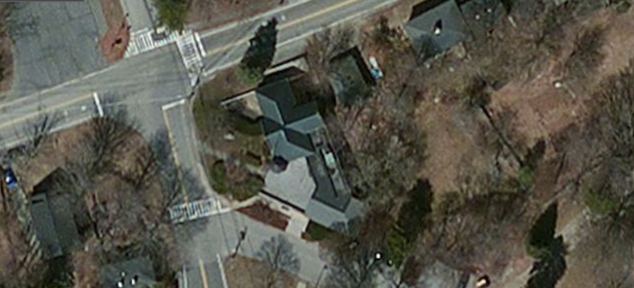

1892 Building

1970’s addition

Picture 1

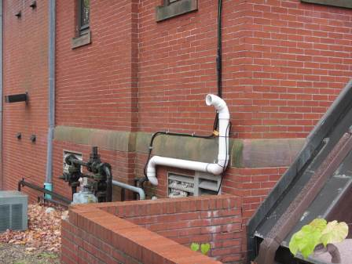

Fresh air intake blocked with insulation

Picture 2

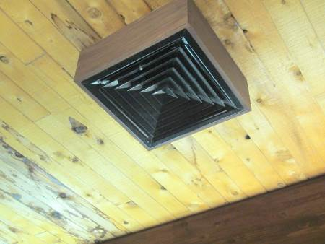

Ceiling-mounted supply vent

Picture 3

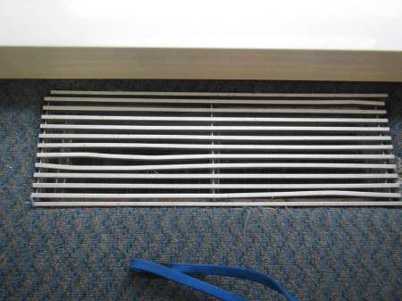

Floor supply vent (note carpeting)

Picture 4

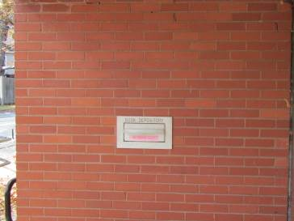

Book depository louver on the exterior wall of workroom

Picture 5

Sloped terrain of the library(arrow indicated sloped garden)

Picture 6

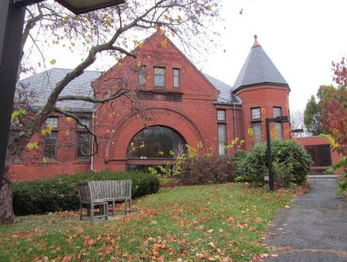

Sloped terrain of library, note shrubbery against building foundation
Picture 7

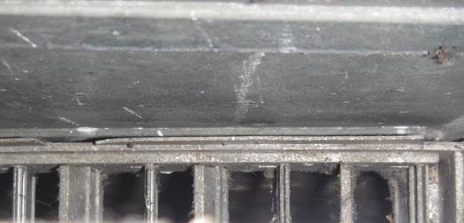

Floor supply vent in employee workroom (cover removed)

Picture 8

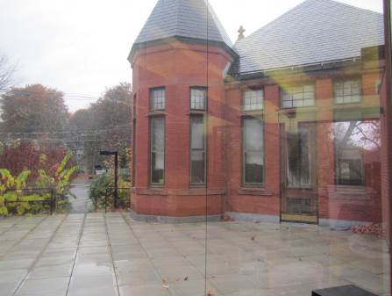

Outdoor patio

Picture 9

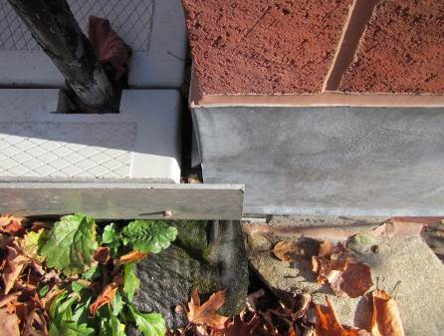

Separation/gap between patio and adjacent exterior wall

Picture 10

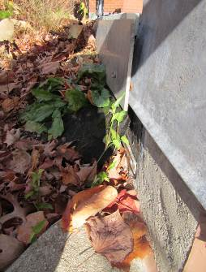

Gap at the juncture of patio support beam and adjacent wall

Picture 11

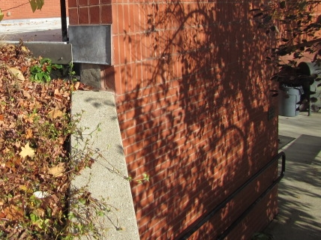

Area of potential rainwater runoff

Picture 12

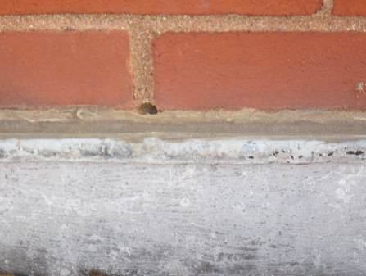

Weep hole blocked with mortar (note: no mesh covering)

Picture 13

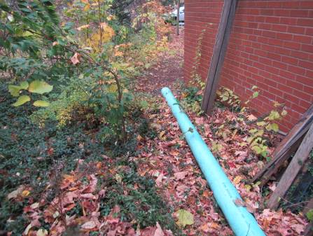

Downspout drain (note: terminates at base of building)

Picture 14

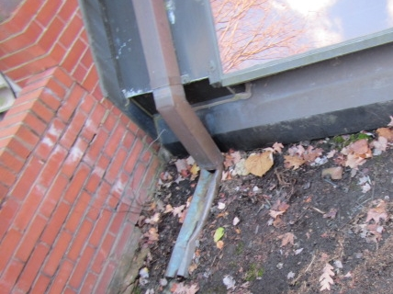

Damaged downspout at the base of atrium wall

Picture 15

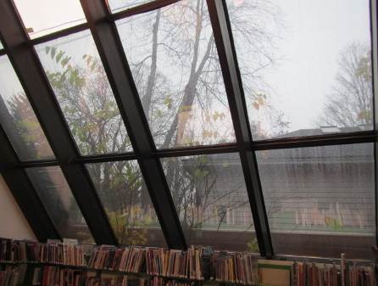

Glass atrium wall

Picture 16

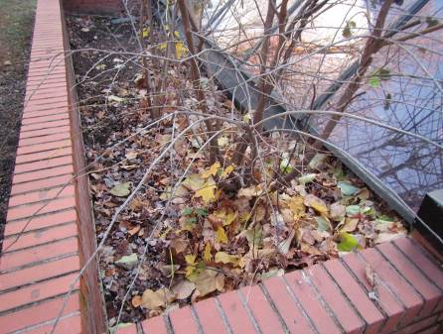

Tree and debris in catch basin at the atrium wall

Picture 17

Landscaped area in close proximity to building

Picture 18

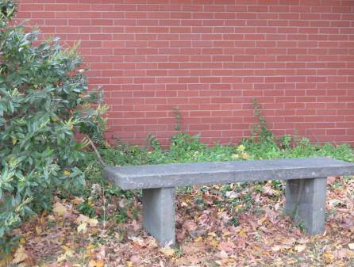

Shrub, plants and leaves against building

Picture 19

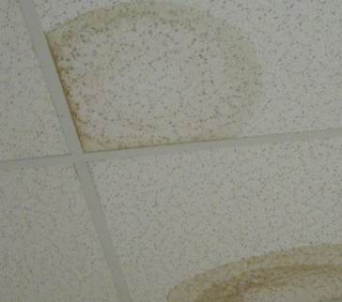

Water-damaged ceiling tiles

Picture 20

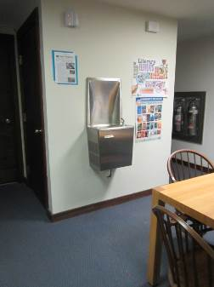

Water dispenser located over carpeting

Picture 21

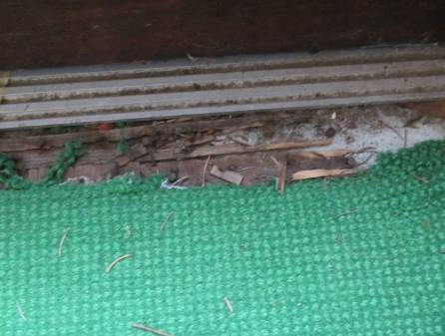

Water damage with rotted/deteriorated wood at threshold of exterior door

Location | Carbon  Dioxide  (ppm) | Carbon Monoxide  (ppm) | Temp  (°F) | Relative  Humidity  (%) | PM2.5  (µg/m3) | Occupants  in Room | Windows  Openable | Ventilation |  | Remarks
 |  |  |  |  |  |  |  | Supply | Exhaust
Background | 561 | ND | 49 | 90 | 12 |  |  |  |  | Moderate rain
Children’s Room | 682 | ND | 65 | 50 | 7 | 5 | Y | Y | Y | WD-CTs, area rug, exterior door with water damage/deteriorated wood, sink, HS
Circulation Desk | 647 | ND | 67 | 47 | 12 | 1 | N | Y | Y
Library Director’s office | 684 | ND | 64 | 51 | 7 | 0 | N | Y | N | DO, clutter
Main Library (first floor) | 655 | ND | 68 | 44 | 8 | 1 | Y | Y | Y | Carpet dirt, worn
Mechanical Room | 691 | ND | 67 | 47 | 12 |  |  |  |  | AHU, gas furnace, used custodial supplies: CP, chemicals, vacuum
Meeting Room | 686 | ND | 66 | 49 | 8 | 0 | Y | Y | Y | Carpet dirty
Reference Library (2nd floor) | 712 | ND | 66 | 49 | 5 | 1 | Y | Y | Y | Carpet dirty
Restroom (1st floor) | 663 | ND | 65 | 50 | 8 |  |  | N | Y | Exhaust on light switch
Work Room | 675 | ND | 67 | 48 | 7 | 0 | N | Y | N | DO, strong musty odor from floor vents, standing water/mold in dehumidifier bucket, CP,HS, AD, refrigerator, microwave
Young Adult Library (first floor) | 670 | ND | 66 | 49 | 7 | 0 | Y | Y | Y

The building envelope consists of the roof, walls, doors windows and foundation of a structure.

