INDOOR AIR QUALITY ASSESSMENT

Community Middle School
225 High Street
Randolph, Massachusetts

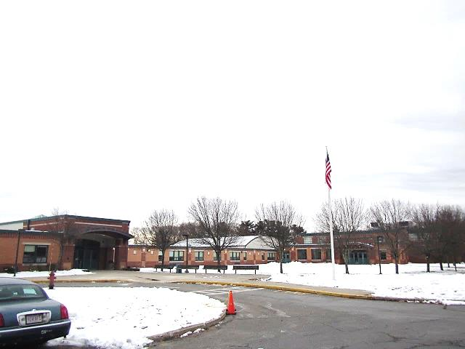

Prepared by:
Massachusetts Department of Public Health
Bureau of Environmental Health
Indoor Air Quality Program
December 2019

BACKGROUND
Building: | Community Middle School (CMS)
Address: | 225 High Street, Randolph, MA
Assessment Requested by: | Randolph School Department coordinated via the Randolph Board of Health
Reason for Request: | Mold concerns as a result of roof leaks and general indoor air quality (IAQ), mainly due to aging mechanical ventilation components and outdated/malfunctioning control systems
Date of Assessment: | December 6, 2019
Massachusetts Department of Public Health/Bureau of Environmental Health (MDPH/BEH) Staff Conducting Assessment: | Cory Holmes, Environmental Analyst/Inspector, IAQ Program
Building Description: | The CMS is a sprawling, one-story, brick school building currently housing grades 6 through 8 with approximately 680 students and 60 faculty. It was originally built in the late 1960s as a junior high school. An addition was built in 1999 at which point the existing building was also renovated, which make the roof and heating, ventilation and air conditioning (HVAC) components about 20 years old and approaching the end of their life cycle. Only select areas (some offices, computer rooms, cafeteria, media center) are equipped with air-conditioning (AC).
Windows: | Openable in most areas

METHODS
Please refer to the IAQ Manual and appendices for methods, sampling procedures, and interpretation of results (MDPH, 2015).

RESULTS and DISCUSSION
The following is a summary of indoor air testing results (Table 1).
- Carbon dioxide levels were above the MDPH recommended level of 800 parts per million (ppm) in a little over half the areas surveyed, which indicates a lack of air exchange. This is most likely due to deactivated/malfunctioning mechanical ventilation components as well as limitations on outside air introduction. This is explained further in the Ventilation section of this report.
- Temperature measurements were both above and below the MDPH recommended range of 70°F to 78°F in a number of areas, mostly related to mechanical ventilation/thermostat control issues. It is important to note that many of the classroom thermostats were broken/in a state of disrepair.
- Relative humidity measurements were below the MDPH recommended range of 40 to 60% in almost all areas tested at the time of assessment, which is typical in New England during the heating season. Low relative humidity can lead to common symptoms such as: dry skin, lips, and scalp; dry/scratchy throats and noses (nose bleeds); exacerbation of asthma, eczema, or allergies; dry/irritated eyes; and irritation of respiratory tract.
- Carbon monoxide levels were non-detectable (ND) in all areas tested.
- Particulate matter (PM2.5) concentrations measured were below the National Ambient Air Quality (NAAQS) level of 35 μg/m³ in all areas tested.

Ventilation
A heating, ventilating and air conditioning (HVAC) system has several functions. First it provides heating and, if equipped, cooling. Second, it is a source of fresh air. Finally, an HVAC system will dilute and remove normally-occurring indoor environmental pollutants by not only introducing fresh air, but by filtering the airstream and ejecting stale air to the outdoors via exhaust ventilation. Even if an HVAC system is operating as designed, point sources of respiratory irritation may exist and cause symptoms in sensitive individuals. Carbon dioxide is not a problem in and of itself. It is used as an indicator of the adequacy of the fresh air ventilation. It is important to note that a number of areas tested were sparsely populated or had open windows, which would be expected to reduce carbon dioxide levels. The MDPH approach to resolving IAQ problems in schools is generally two-fold: 1) improving ventilation to dilute and remove environmental pollutants and 2) reducing or eliminating exposure opportunities from materials that may be adversely affecting IAQ.
Fresh air in classrooms is supplied by unit ventilators (univents, Pictures 1 and 2). Univents draw air from the outdoors through a fresh air intake located on the exterior wall of the building (Picture 3) and return air through an air intake located at the base of the unit. Fresh and return air are mixed, filtered, heated or cooled and provided to rooms through an air diffuser located in the top of the unit (Figure 1). In several rooms, univents were deactivated by or at the request of occupants due to noise or lack of temperature control, mainly due to damaged/inoperable thermostats (Pictures 4a and 4b). Some rooms had excessive heat issues (Table 1). With univents deactivated no mechanical supply of fresh air was being introduced at the time of the assessment. A few rooms had the top and/or front of univents blocked by classroom items. In order for univents to provide fresh air as designed, intakes/returns must remain free of obstructions. Importantly, these units must remain on and be allowed to operate while rooms are occupied.
Classroom exhaust vents are located in walls (Picture 5) or ceilings (Picture 6) and are connected via ducts to exhaust fans on the roof. A number of these exhaust vents were not drawing air during the assessment (Table 1). Note that exhaust vents work best with the doors to the hallway closed, otherwise the exhaust vents tend to draw air from the hallway rather than the room which reduces the effectiveness of air circulation. Without adequate supply and exhaust ventilation, excess heat/humidity and environmental pollutants can build up and lead to indoor air/comfort complaints.
Mechanical ventilation in common areas (cafeteria, media center, gym) and interior rooms is provided by air handling units (AHUs) located on the roof or in mechanical rooms. Air is drawn in through air intakes, filtered, heated/cooled and distributed via ceiling or wall-mounted diffusers. Air is drawn back to AHUs via ceiling or wall-mounted return vents. Room 282, which is windowless, currently has no working mechanical ventilation. A source of fresh/outside air should be restored in this area, if possible, either from the roof or from the adjacent Media Center.
Many of the HVAC units and their controls are beyond/near the end of their life cycle. Efficient function of equipment of this age is difficult to maintain, since compatible replacement parts are often unavailable. According to the American Society of Heating, Refrigeration, and Air-Conditioning Engineering (ASHRAE), the service life of this type of unit is 15-20 years, assuming routine maintenance of the equipment (ASHRAE, 1991). It appears the optimal operational lifespan of this equipment has been exceeded, particulary components such as software, controls and thermostats.
To maximize air exchange, the IAQ program recommends that both supply and exhaust ventilation operate continuously during periods of occupancy. In order to have proper ventilation with a mechanical ventilation system, the systems must be balanced after installation to provide an adequate amount of fresh air to the interior of a room while removing stale air from the room. It is recommended that HVAC systems be re-balanced every five years to ensure adequate air systems function (SMACNA, 1994). However, in its current state, the HVAC system cannot be properly balanced.

Microbial/Moisture Concerns
In order for building materials to support mold growth, a source of water exposure is necessary. Identification and elimination of the source of water moistening building materials is necessary to control mold growth. As previously mentioned, the CMS is a sprawling one-story building with thousands of square feet of roof area that has been patched/repaired over the years (~20 years old). At the time of the assessment a number of water-damaged materials were observed in classrooms and other locations (Table 1).
- Ceiling tiles – Pictures 7 and 8, water-stained ceiling tiles can indicate current/historic roof/plumbing leaks or other water infiltration. As active leaks are reported, the facilities department works with a local roof contractor to investigate and repair. Water-damaged ceiling tiles can provide a source of mold and should be replaced after a water leak is discovered and repaired;
- Gypsum wallboard (GW) - water-damaged GW ceilings were noted in a number of areas (Pictures 9 through 11), most in areas where roof leaks have reportedly been repaired. MDPH/IAQ Program staff conducted moisture measurements of water-damaged GW in a number of areas and all were found dry at the time of the assessment, with the exception of room 105 (Picture 12). It was recommended that this GW be removed/replaced.
- The sink/countertop in room 201A was warped and had a gap between the backsplash and countertop, which can lead to further water damage and microbial growth (Picture 12).
The US Environmental Protection Agency (US EPA) and the American Conference of Governmental Industrial Hygienists (ACGIH) recommend that porous materials (e.g., ceiling tiles, carpet) be dried with fans and heating within 24 to 48 hours of becoming wet (US EPA, 2008; ACGIH, 1989). If not dried within this time frame, mold growth may occur. Once mold has colonized porous materials such as cardboard, books, or ceiling tiles, they are difficult to clean and should be removed. Frequently solid/non-porous items can be cleaned to remove water stains and microbial growth.
Musty odors of unknown origin were reported/detected in three areas: Room 305, Room 307, and the hallway outside Room 301. There were no obvious signs of water damage/leaks or visible mold growth in these areas. The two rooms are former science rooms with little used/abandoned fixtures that could be a potential source of moisture/odors including: emergency eye wash stations/showers (Picture 13), numerous sinks (Picture 14), and auxiliary exhaust units in the ceiling (used during science experiments, Picture 6). The seal of traps on sink drains that are not used often can dry out and allow sewer gases into occupied areas, which may account for the reported odors. Water damage may also have occurred in areas such as behind univents, above ceilings and beneath wooden windowsills (Pictures 15 and 16). Each of these building components should be examined to rule out sources of the odor, and, if needed, be repaired.
In addition, all areas with drains (e.g. eyewash stations, safety showers and classroom sinks) should be evaluated periodically for proper function. These fixtures should be properly removed or abandoned if no longer needed.
Plants were present in some classrooms and other areas. Plants, soil, and drip pans can serve as sources of mold/bacterial growth. Plants should be properly maintained, over-watering of plants should be avoided (Picture 17), and drip pans should be inspected periodically for mold growth. In addition, plants should not be placed on top of or in the airstream of HVAC equipment such as univents.
Another potential source of odors and allergens is grass/plant debris lodged in univent fresh air intakes when grass is mowed. The design of the metal intakes makes them conducive to collecting debris (Picture 3), which if, wetted repeatedly, can become moldy and be a source of irritation and odors. During lawn mowing, debris should be aimed away from intakes. In addition, intakes should be inspected/cleaned out periodically as needed.
Several rooms contained aquariums (Table 1). Aquariums should be properly maintained and cleaned to prevent microbial growth and odors.
Several classrooms contained either portable or wall-mounted air conditioners (ACs). These devices must be properly cleaned/maintained, including the filters, to avoid particulates and microbial colonization. In addition, they should be monitored periodically for proper installation/drainage.

Other Conditions
Other conditions that can affect indoor air quality were observed during the assessment. The MDPH recommends pleated filters with a Minimum Efficiency Reporting Value (MERV) of 8, which are adequate in filtering out pollen and mold spores (ASHRAE, 2012). Filters should also be changed two to four times a year, or per the manufacturer’s recommendations. The AHU filters were labeled MERV 8 (Picture 18); filters for univents were labeled “pleated” with no MERV rating (Picture 19).
In some areas, exhaust vents, supply diffusers and personal fans had accumulated dust/debris (Table 1, Picture 20). This dust can be reaerosolized under certain conditions, and can also be a medium for mold growth. Univent and AHU cabinets can also accumulate dust and debris which should be cleaned when filters are changed (e.g., 2 to 4 times/year). The occupant in Room 206 reported dust/debris from the ceiling-mounted unit. Univents also typically have an insulation material adhered to the cabinet cover to reduce sound (Picture 21); this material can break down eventually and become a source of debris.

Carpeting
Some areas had wall to wall carpeting (Table 1). The service life of carpeting in schools is approximately 10-11 years (IICRC, 2002). Area rugs were also observed in a number of classrooms (Table 1). Carpets should be cleaned annually (or semi-annually in soiled/high traffic areas) in accordance with Institute of Inspection, Cleaning and Restoration Certification (IICRC) recommendations, (IICRC, 2012). Regular cleaning with a high efficiency particulate air (HEPA) filtered vacuum in combination with an annual cleaning will help to reduce accumulation and potential aerosolization of materials from carpeting. Area carpets too worn to be effectively cleaned should be replaced. Area rugs should be rolled up and stored in a clean, dry place when rooms are not occupied during the summer months to prevent moistening due to condensation.

Total Volatile Organic Compounds
Exposure to low levels of total volatile organic compounds (TVOCs) may produce eye, nose, throat, and/or respiratory irritation in some sensitive individuals. BEH/IAQ staff examined rooms for products containing VOCs. BEH/IAQ staff noted hand sanitizers, scented products, plug in air fresheners/diffusers (Pictures 22 and 23), home cleaning products, and dry erase materials in use within the building. All of these products have the potential to be irritants to the eyes, nose, throat, and respiratory system of sensitive individuals.
The Teacher’s workroom contained two large photocopiers (Picture 24), which can give off waste heat and irritating odors. VOCs and ozone can be produced by photocopiers, particularly if the equipment is older and in frequent use. Ozone is a respiratory irritant (Schmidt Etkin, D., 1992).

Other Conditions
In many classrooms and storage areas, large numbers of items were on floors, windowsills, tabletops, counters, bookcases and desks, which provide a source for dusts to accumulate. These items (e.g., papers, folders, boxes) make it difficult for custodial staff to clean. Items should be relocated and/or be cleaned periodically to avoid excessive dust build up. In addition, dust and debris can accumulate on flat surfaces (e.g., desktops, shelving and carpets) in occupied areas and subsequently be re-aerosolized causing further irritation.
Missing/broken ceiling tiles, open utility holes and/or breaches were observed in some areas (Table 1). These spaces can provide a pathway for odors and particulates from wall cavities/ceiling plenum into occupied areas.
Note that the Environmental Protection Agency (EPA) conducted a National School Radon Survey in which it discovered nearly one in five schools had “…at least one frequently occupied ground contact room with short-term radon levels above 4 [picocuries per liter] pCi/L” (US EPA 1993). The BEH/IAQ Program therefore recommends that every school be tested for radon, and that this testing be conducted during the heating season while school is in session in a manner consistent with USEPA radon testing guidelines. Radon measurement specialists and other information can be found at www.nrsb.org and http://aarst-nrpp.com/wp, with additional information at: http://www.mass.gov/eohhs/gov/departments/dph/programs/environmental-health/exposure-topics/iaq/radon.

RECOMMENDATIONS
The conditions related to IAQ problems at the CMS raise a number of issues. The general building conditions/design, maintenance, work hygiene practices, and the age/condition of HVAC equipment/controls, if considered individually, present conditions that could degrade IAQ. When combined, these conditions can serve to further degrade IAQ. Some of these conditions can be remedied by actions of building occupants. Other remediation efforts will require alteration to the building structure and equipment. For these reasons, a two-phase approach is recommended. The first consists of short-term measures to improve air quality and the second consists of long-term measures that will require capital planning and resources to adequately address overall IAQ concerns (mainly related to HVAC controls and the roof).

Short-term measures:
- Consider establishing a building-specific IAQ committee made up of teacher representatives, maintenance, facilities and administration to meet and conduct regular walk-throughs to identify on-going and/or potential issues.
- Operate the HVAC system (supply/exhaust) to provide for continuous fresh air ventilation during occupied hours. Make repairs to thermostats, where possible, and to univents as needed.
- If possible, restore a source of fresh/outside air in Room 282, either from the roof or from the adjacent Media Center.
- Remove furniture and items blocking the front and top of univents.
- Periodically assess whether exhaust vents (classrooms and restrooms) are drawing air and make repairs as needed.
- Use openable windows to supplement fresh air during temperate weather. Ensure all windows are closed tightly at the end of each day.
- Close classroom doors during occupancy to allow for more effective function of exhaust vents (once operating as designed).
- Work with staff to troubleshoot temperature control/ventilation problems.
- Utilize a system to report and track maintenance issues so that concerns can be reported by staff and maintenance staff can report when issues have been resolved.
- Consider adopting a balancing schedule of every 5 years for all mechanical ventilation systems, as recommended by ventilation industrial standards (SMACNA, 1994).
- Until capital funds can be obtained for full roof replacement, continue to work with roofing contractor to identify and repair leaks.
- Once roof leaks are repaired, replace water-damaged ceiling tiles and refinish areas where water damage has occurred. Inspect the area above the stained tiles for water damage or odors and remediate or clean as necessary.
- Remove and replace wet/water-damaged GW in Room 105.
- Continue to investigate source of musty odors in rooms 305, 307 and 301 hallway. Consider working with roofing contractor/building engineer, plumbing firm to investigate possible sources of odors, this may include but not limited to:
  - Dry drain traps;
  - Disused plumbing and/or components unique to former science classrooms (e.g., auxiliary ventilation, eye wash stations, emergency showers;
  - Water-damaged materials such as ceiling tiles and wooden windowsills. Examine areas to rule out hidden damage building envelope leaks (e.g., fenestrations, exterior flashing, roof/drainage, weep holes);
  - Plumbing and HVAC system piping and related condensation issues;
  - Breaches/leaks around univents, rooftop exhaust vents and/or other ventilation components; and
  - Restroom vent pipes.
- Until a source of odors can be identified/eliminated operate both supply and exhaust ventilation components continuously during occupied hours to facilitate air exchange.
- Keep classroom/office plants in good condition, avoid overwatering, and keep them away from the airstream of ventilation equipment.
- Ensure aquariums and terrariums are clean and odor free.
- Make repairs to sink countertop in room 201A and any others in need of caulking/re-sealing.
- Run water in sinks regularly to avoid dry drain traps and associated odors, if not feasible consider decommissioning/capping.
- During lawn mowing, aim debris away from air intakes. In addition, inspect/clean intakes of debris periodically as needed.
- Reduce or eliminate the use of air fresheners/diffusers, scented cleaners, hand sanitizers and dry erase materials to reduce irritation. Consult the MDPH IAQ Guidance “Clean Air is Odor Free”, https://www.mass.gov/lists/indoor-air-quality-guidelines for more information. In addition, spray bottles/cleaning products should be kept out of reach of children.
- Change filters in HVAC units 2-4 times a year with MERV 8 (or higher) filters.
- Clean supply/exhaust vents, univents (e.g., Room 206) and personal fans regularly to remove accumulated dust/debris.
- Ensure that condensation from AC equipment is draining properly.
- Seal open utility holes and breaches in walls/ceilings/floors.
- Replace missing/broken ceiling tiles.
- For buildings in New England, periods of low relative humidity during the winter are often unavoidable. Therefore, scrupulous cleaning practices should be adopted to minimize common indoor air contaminants whose irritant effects can be enhanced when the relative humidity is low. To control for dusts, a high efficiency particulate arrestance (HEPA) filter equipped vacuum cleaner in conjunction with wet wiping of all surfaces is recommended. Avoid the use of feather dusters. Drinking water during the day can help ease some symptoms associated with a dry environment (throat and sinus irritations).
- Clean supply/exhaust vents and personal fans regularly to remove accumulated dust/debris.
- Clean carpeting annually or semi-annually in soiled high traffic areas as per the recommendations of the Institute of Inspection, Cleaning and Restoration Certification (IICRC 2012). Area carpets too worn to be effectively cleaned should be replaced. Roll up and store area rugs in a clean, dry place during the summer.
- Relocate or consider reducing the amount of materials stored in classrooms to allow for more thorough cleaning of classrooms. Clean items regularly with a wet cloth or sponge to prevent excessive dust build-up.
- Consider utilizing the US EPA’s (2000), “Tools for Schools”, as an instrument for maintaining a good IAQ environment in the building available at: http://www.epa.gov/iaq/schools/index.html.
- For more information on mold refer to “Mold Remediation in Schools and Commercial Buildings” published by the US Environmental Protection Agency (US EPA, 2008). http://www.epa.gov/mold/mold-remediation-schools-and-commercial-buildings-guide. As well as the MDPH’s https://www.mass.gov/info-details/guidance-regarding-testing-for-mold-in-water-damaged-public-buildings
- The school should be tested for radon by a certified radon measurement specialist during the heating season when school is in session. Radon measurement specialists and other information can be found at: www.nrsb.org, and http://aarst-nrpp.com/wp.

Long-term Recommendations:
- Contact an HVAC engineering firm for an assessment of the ventilation system’s components and control systems (e.g., pneumatics/air intake louvers, thermostats). Based on the age, physical deterioration, and availability of parts for ventilation components, such an evaluation is necessary to determine the operability and feasibility of repairing/replacing the equipment.
- Consider full roof replacement.
- Install local exhaust ventilation for photocopiers in Teacher’s workroom.
- Replace mechanical ventilation unit in Room 282 and ensure unit provides adequate outside air exchange.

REFERENCES
ACGIH. 1989. Guidelines for the Assessment of Bioaerosols in the Indoor Environment. American Conference of Governmental Industrial Hygienists, Cincinnati, OH.
ASHRAE. 1991. ASHRAE Applications Handbook, Chapter 33 “Owning and Operating Costs”. American Society of Heating, Refrigeration and Air Conditioning Engineers, Atlanta, GA.
ASHRAE. 2012. American Society of Heating, Refrigeration and Air Conditioning Engineers (ASHRAE) Standard 52.2-2012 -- Method of Testing General Ventilation Air-Cleaning Devices for Removal Efficiency by Particle Size (ANSI Approved).
IICRC. 2002. Institute of Inspection, Cleaning and Restoration Certification. A Life-Cycle Cost Analysis for Floor Coverings in School Facilities.
IICRC. 2012. Institute of Inspection Cleaning and Restoration Certification. Institute of Inspection, Cleaning and Restoration Certification. Carpet Cleaning: FAQ.
MDPH. 2015. Massachusetts Department of Public Health. Indoor Air Quality Manual: Chapters I-III. Available at: http://www.mass.gov/eohhs/gov/departments/dph/programs/environmental-health/exposure-topics/iaq/iaq-manual/.
Schmidt Etkin, D. 1992. Office Furnishings/Equipment & IAQ Health Impacts, Prevention & Mitigation. Cutter Information Corporation, Indoor Air Quality Update, Arlington, MA.
SMACNA. 1994. HVAC Systems Commissioning Manual. 1st ed. Sheet Metal and Air Conditioning Contractors’ National Association, Inc., Chantilly, VA.
US EPA. 1993. Radon Measurement in Schools, Revised Edition. Office of Air and Radiation, Office of Radiation and Indoor Air, Indoor Environments Division (6609J). EPA 402-R-92-014. https://www.epa.gov/radon/radon-schools
US EPA. 2000. Tools for Schools. Office of Air and Radiation, Office of Radiation and Indoor Air, Indoor Environments Division (6609J). EPA 402-K-95-001, Second Edition. http://www.epa.gov/iaq/schools/index.html.
US EPA. 2008. Mold Remediation in Schools and Commercial Buildings. US Environmental Protection Agency, Office of Air and Radiation, Indoor Environments Division, Washington, D.C. EPA 402-K-01-001. http://www.epa.gov/mold/mold-remediation-schools-and-commercial-buildings-guide.
Picture 1
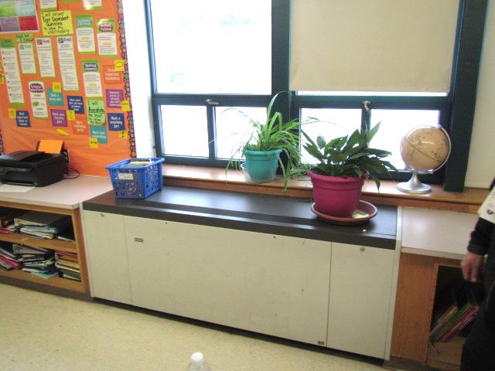
Typical classroom univent, note plants on/near supply diffuser
Picture 2
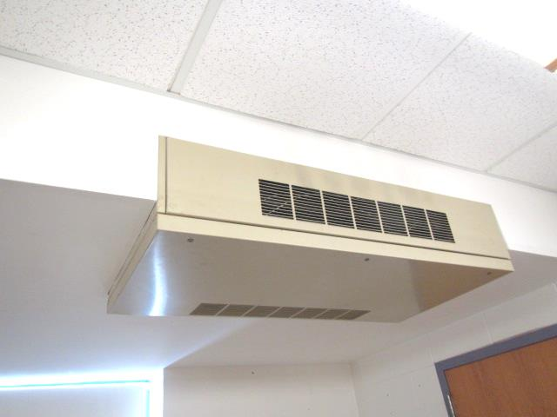
Ceiling-mounted univent
Picture 3
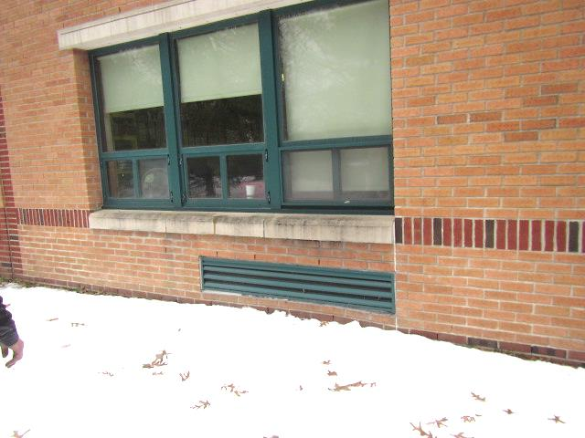
Univent fresh air intake
Pictures 4a and 4b
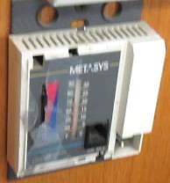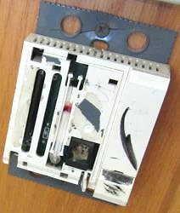
Severely damaged/inoperable classroom thermostats
Picture 5
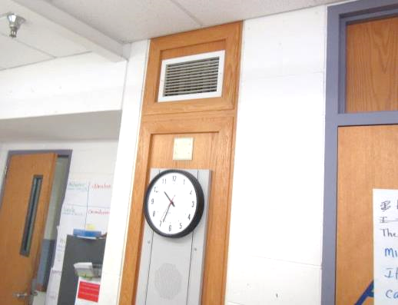
Wall-mounted exhaust vent
Picture 6
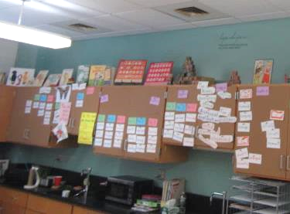
Ceiling-mounted exhaust vents (arrows)
Picture 7
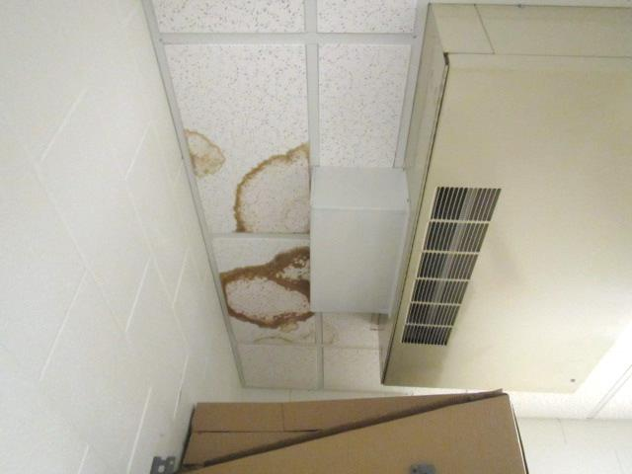
Water-damaged ceiling tiles
Picture 8
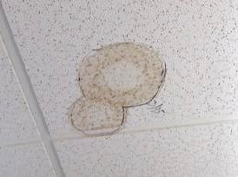
Water-damaged ceiling tiles, note outline around stain dated “3/15”
Picture 9
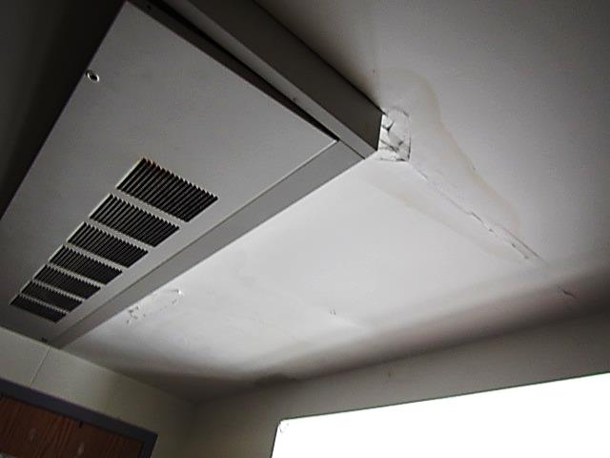
Water-damaged gypsum wallboard ceiling in Room 105 that was wet at the time of the visit
Picture 10
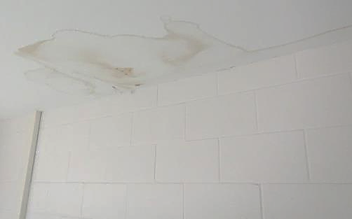
Water-damaged gypsum wallboard ceiling in Room 282 (adjacent to Media Center)
Picture 11
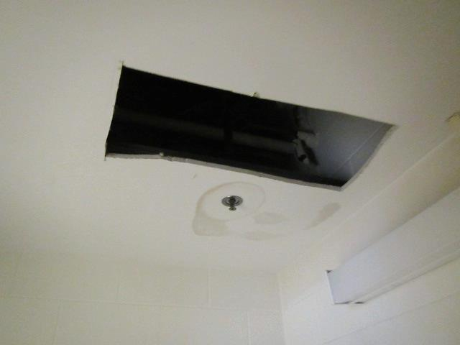
Water-damaged gypsum wallboard ceiling in men’s restroom near 301
Picture 12
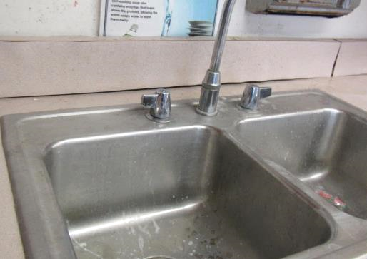
Water-damaged countertop and backsplash in Room 201A
Picture 13
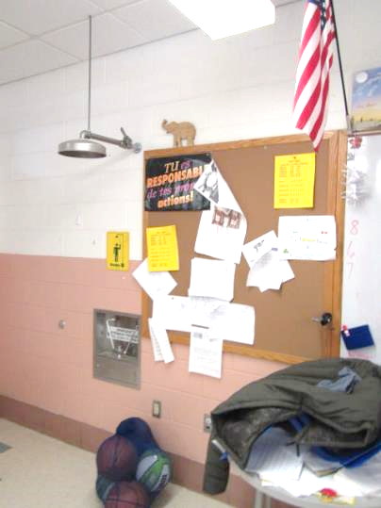
Emergency eye wash station and shower (arrows) in former science classroom
Picture 14
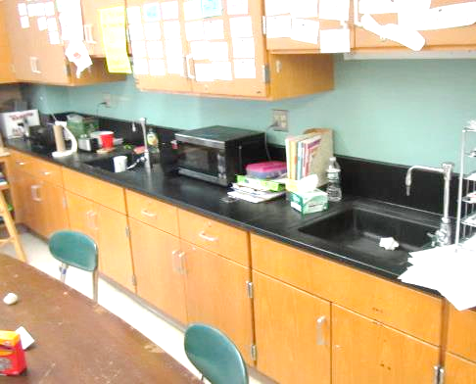
Sinks in former science room
Picture 15
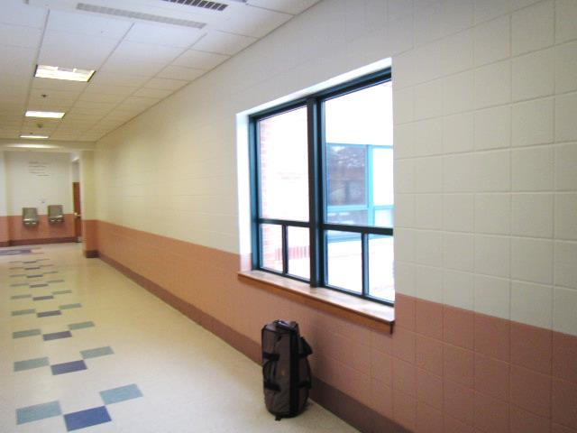
Wooden windowsill in Hallway outside Room 301
Picture 16
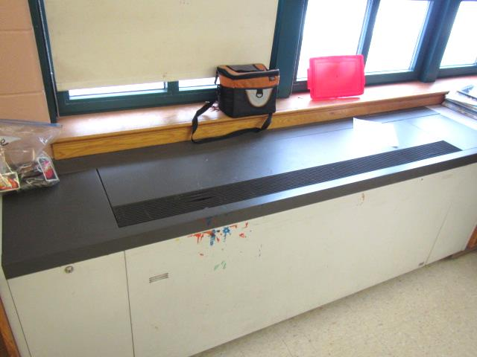
Univent and wooden windowsill in Room 305
Picture 17
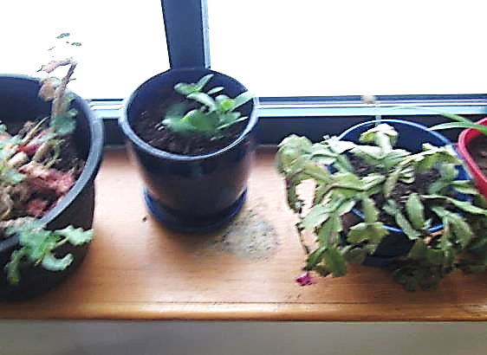
Plants and water-damaged wooden windowsill
Picture 18
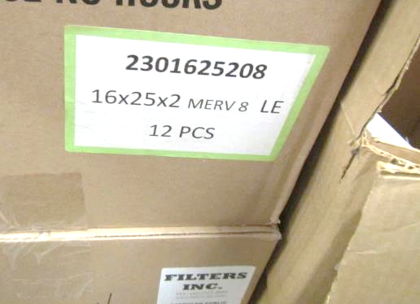
Box indicating MERV 8 filters
Picture 19
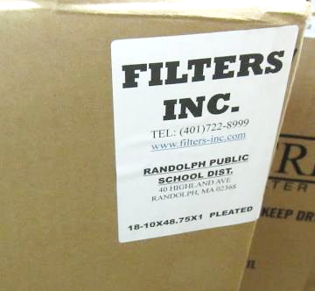
Label indicating “PLEATED” filters with no MERV rating
Picture 20
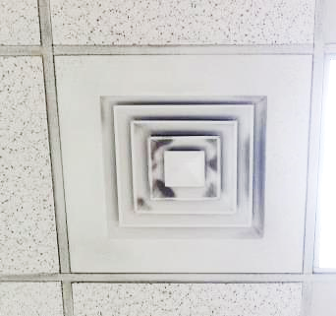
Accumulated dust/debris on supply diffuser
Picture 21
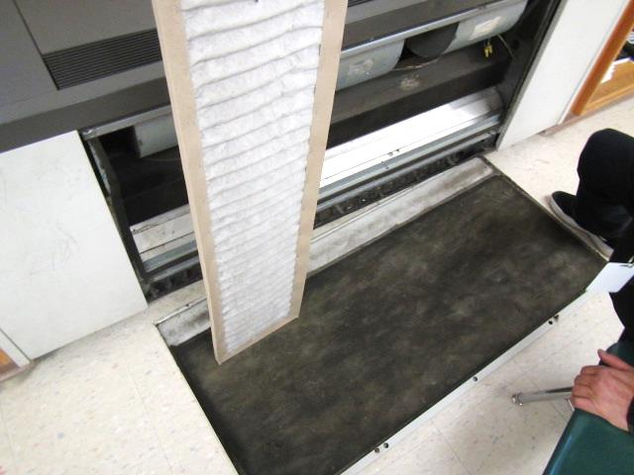
Pleated univent filter, also note insulation material on interior of cabinet cover
Picture 22
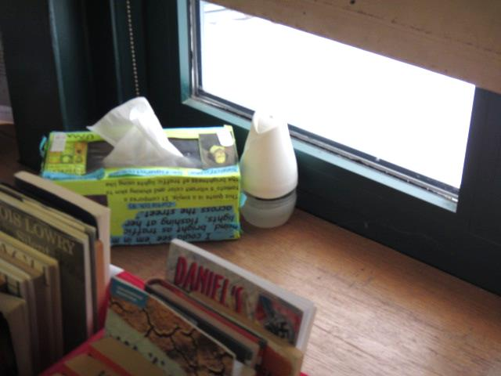
Air freshener in classroom
Picture 23
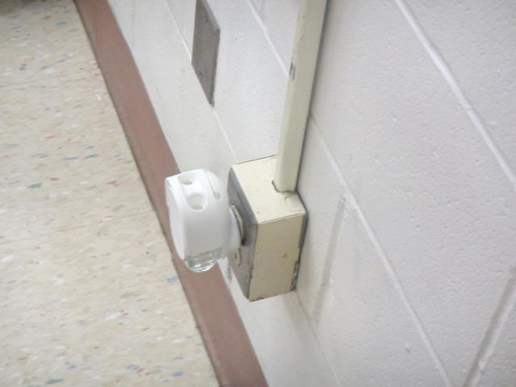
Plug-in air freshener in classroom
Picture 24
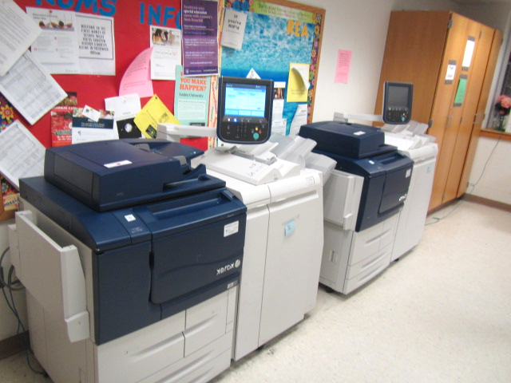
Two large photocopiers in Teacher’s Workroom
Location | Carbon  Dioxide  (ppm) | Carbon Monoxide  (ppm) | Temp  (°F) | Relative  Humidity  (%) | PM2.5  (µg/m³) | Occupants  in Room | Windows  Openable | Ventilation |  | Remarks
 |  |  |  |  |  |  |  | Supply | Exhaust
Background (outside) | 398 | 1.0 | <32 | 38 | 12 |  |  |  |  | Cold, overcast/cloudy
Main Office Conf Room | 1122 | ND | 69 | 40 | 3 | 4 | N | Y | Y | 2 WD CTs
100 Computer Lab | 757 | ND | 67 | 26 | 2 | 0 | Y | Y | Y | Wall-mounted AC, 2 WD CTs, WD GW-dry
Teacher’s Room | 670 | ND | 70 | 24 | 3 | 5 | Y | Y | N | 2 large PCs-no local exhaust, WD CT, thermostat damaged, restroom-dusty exhaust vent
101 | 704 | ND | 68 | 27 | 3 | 0 | Y | Y | Y | UV-rattling/noise
102 | 640 | ND | 66 | 25 | 3 | 0 | Y | Y | Y
103 | 1146 | ND | 68 | 30 | 2 | 22 | Y | Y | Y | PF-dusty, broken floor tile
104 | 933 | ND | 81 | 20 | 2 | 22 | Y  Open | Y | Y | Excessive heat-broken thermostat, DO, WD CT, HS
105 | 916 | ND | 72 | 25 | 3 | 21 | Y | Y | Y | Roof leak-reportedly repaired, WD GW ceiling-elevated moisture measurement-recommend replacing, MT, WD CT, broken tile, DO
106 | 1867 | ND | 72 | 31 | 9 | 23 | Y | Y  Off | Y | WD CT
107 | 1045 | ND | 73 | 24 | 4 | 1 | N | Y |  | WD GW-roof leak reportedly repaired -dry, 2 WD CTs, 3 MTs
108 | 996 | ND | 71 | 23 | 3 | 2 |  | Y  Off | Y  Off | Open hole in ceiling, PF
109 | 1746 | ND | 75 | 33 | 5 | 22 | Y | Y | Y | Plants, aquarium
110 | 1439 | ND | 72 | 26 | 6 | 23 | Y | Y | Y  Off | Broken thermostat, DO, PF
111 | 1292 | ND | 74 | 28 | 7 | 25 | Y | Y | Y
112 | 1683 | ND | 74 | 29 | 8 | 28 | Y | Y | Y  Off | PFs, 3 WD CT, broken tile, UV-return vent obstructed
Band Room | 819 | ND | 70 | 27 | 1 | 1 | Y | Y | Y | Dust/debris on vents, Rooftop AHU, roof leak- reportedly repaired, GW ceiling patched
Band Office | 816 | ND | 70 | 26 | 3 | 1 | N | Y | Y | 3 WD CTs, MTs
Choral | 1055 | ND | 69 | 28 | 3 | 8 | Y | Y | Y | Dust/debris on vents, roof leak reportedly repaired, GW ceiling patched
Media Center | 537 | ND | 69 | 20 | 8 | 8 | Y | Y | Y | Rooftop AHU, partially carpeted
200 Computer Lab | 452 | ND | 67 | 35 | 3 | 0 | Y | Y | Y | 9 WD CTs, MTs, wall AC, roof leak-reportedly repaired, drafts from windows (not locked/secured)
200A | 595 | ND | 69 | 24 | 4 | 5 | Y  Open | Y | N | PF
200B | 524 | ND | 67 | 29 | 3 | 0 | Y | N | Y | WD ceiling panels, plants, PF
200C (YMCA) | 587 | ND | 71 | 26 | 3 | 0 | Y | Y | Y | 3 WD CTs, plants
201A | 494 | ND | 75 | 16 | 3 | 0 | Y | Y | Y | WD sink/space between countertop and backsplash, 2 WD CT, broken floor tile
201B | 660 | ND | 70 | 22 | 2 | 0 | Y | Y  Off | Y | PF
202 | 788 | ND | 73 | 22 | 3 | 28 | Y | Y | Y  Off | DO, plants, PF, hole in GW
203 | 875 | ND | 71 | 24 | 3 | 21 | Y | Y  Off | Y  Off | DO
203B | 731 | ND | 71 | 19 | 3 | 2 | N | Y | Y | MT, 2 WD CTs
204 | 855 | ND | 75 | 21 | 4 | 1 | Y | Y | Y | 27 occupants gone ~ 20 mins, AF (2)
205 | 930 | ND | 75 | 21 | 12 | 6 | Y | Y | Y | PF
206 | 1000 | ND | 70 | 24 | 5 | 1 | Y | Y | Y  Off | Dust/debris reported from UV
207 | 994 | ND | 74 | 24 | 3 | 10 | Y | Y | Y  Off | PF, plants on UV, DO
208 | 999 | ND | 70 | 23 | 2 | 0 | N | Y  Off | Y
209 | 796 | ND | 70 | 23 | 3 | 1 | Y | Y  Off | Y
210 | 1486 | ND | 69 | 32 | 7 | 2 | Y | Y  Off | Y | PF, aquarium, UV deactivated due to cold complaints
211 | 1021 | ND | 71 | 23 | 3 | 0 | Y | Y | Y | 3 WD CT near window/corner, occupants at lunch
212 | 1453 | ND | 72 | 27 | 3 | 0 | Y | Y  Off | Y  Off | Plants, ajar ceiling tile, class just left for lunch
213 | 1847 | ND | 70 | 32 | 21 | 22 | Y | Y  Off | Y  Off | DO-kids in hallway (lunch rush), PF
282 (adjacent to Media Center) | 586 | ND | 71 | 21 | 2 | 1 | N | N | N | Ceiling AC-inoperable, 3 WD CT, WD GW-dry
Gym | 1104 | ND | 72 | 34 | 12 | ~60 | N | Y | Y | Air handling unit in mechanical room
300 | 788 | ND | 70 | 24 | 3 | 17 | Y  Open | Y | Y | WD CT
301 (SLP) | 626 | ND | 68 | 24 | 6 | 0 | Y | Y | Y | 4 WD CTs
301 | 655 | ND | 66 | 24 | 4 | 17 | Y  Open | Y  Off | Y | Plants, UV-reportedly inoperable
Hallway (outside 301) |  |  |  |  |  |  |  |  |  | Musty odors, restrooms nearby, custodial closet (wet mop), wooden windowsills
Men’s restroom |  |  |  |  |  |  | N | N | Y  off | Exhaust not operating, WD GW ceiling-dry
302 | 635 | ND | 72 | 22 | 3 | 1 | Y | Y | Y  Off
302A | 534 | ND | 69 | 22 | 4 | 0 | Y | Y  Off | Y  Off | WD CT, plug-in AF
303 | 496 | ND | 73 | 19 | 4 | 0 | Y | Y | Y  Off
304 | 676 | ND | 69 | 23 | 3 | 1 | Y | Y  Off | Y  Off | Area rug
305 | 697 | ND | 68 | 24 | 10 | 3 | Y | Y | Y  Off | Musty odor, auxiliary exhaust (former science room)
306 | 655 | ND | 69 | 33 | 4 | 14 | Y  Open | Y | Y | PF, auxiliary exhaust
307 | 871 | ND | 70 | 25 | 3 | 0 | Y | Y | Y | Musty odors (similar to 305)
308 | 1094 | ND | 68 | 33 | 6 | 0 | Y | Y | Y  Off
309 | 899 | ND | 69 | 25 | 3 | 1 | Y | Y | Y  Off | Plants
310 | 828 | ND | 72 | 24 | 4 | 1 | Y | Y | Y | WD CT, plants, plug-in AF, DO
311 | 1354 | ND | 72 | 29 | 11 | 26 | Y | Y | Y | UV-cycling off/on-broken thermostat
312 | 723 | ND | 73 | 21 | 7 | 3 | Y | Y | Y | DO, PF, HS
313 | 713 | ND | 73 | 20 | 4 | 1 | Y | Y | Y | DO
314 | 752 | ND | 72 | 22 | 3 | 5 | Y | Y | Y  Off | DO, PF
315 | 606 | ND | 72 | 18 | 6 | 7 | Y | Y | Y  Off | Plug-in AF, PF
316 | 1025 | ND | 73 | 26 | 4 | 27 | Y | Y  Off | Y | WD CT, HS
317 | 461 | ND | 69 | 18 | 5 | 2 | Y | Y | Y  Off | Plants
317A | 467 | ND | 69 | 21 | 3 | 0 | Y | Y | Y | 5 WD CTs, broken thermostat
318 | 610 | ND | 71 | 22 | 3 | 3 | Y | Y | Y | 2 WD CTs
319 | 906 | ND | 70 | 25 | 4 | 10 | Y | Y | Y  Off | WD CT
319A | 1139 | ND | 70 | 31 | 4 | 5 | N | Y | Y | Dust/debris on vents, 4 WD CTs
320 | 1716 | ND | 69 | 33 | 5 | 16 | Y | Y  Off | Y  Off | PF, WD CT

The service life is the median time during which a particular system or component of …[an HVAC]… system remains in its original service application and then is replaced. Replacement may occur for any reason, including, but not limited to, failure, general obsolescence, reduced reliability, excessive maintenance cost, and changed system requirements due to such influences as building characteristics or energy prices (ASHRAE, 1991).

