Background

INDOOR AIR QUALITY
ASSESSMENT

Randolph High School
70 Memorial Parkway
Randolph, MA

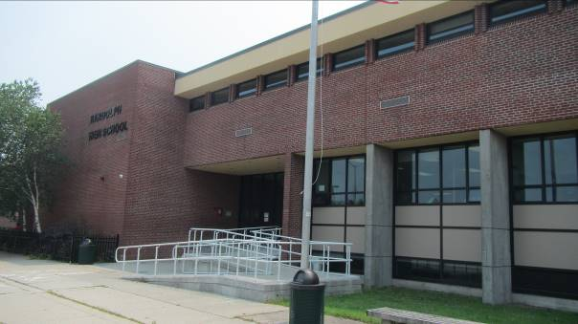

Prepared by:
Massachusetts Department of Public Health
Bureau of Environmental Health
Indoor Air Quality Program
January 2022
Building: | Randolph High School (RHS)
Address: | 70 Memorial Parkway, Randolph, MA
Assessment Requested by: | Steve Nesterak, Randolph Public Schools (RPS)
Dates of Assessment: | This building was visited on May 21, 2021, June 4, 2021, and July 20, 2021
Massachusetts Department of Public Health/Bureau of Environmental Health (MDPH/BEH) Staff Conducting Assessment: | Michael Feeney, Director, Indoor Air  Quality (IAQ) Program
Date of Building Construction/Renovation: | The RHS is a multi-story high school constructed in 1950 with an addition constructed in 1971.
Building Description: | The school has two enclosed courtyards and contains general classrooms, science classrooms, an auditorium, gymnasium, cafeteria, kitchen, library, computer room, art room, teachers’ room, music room, and office space.

INTRODUCTION
The IAQ Program conducted an assessment of the RHS to assist in identifying conditions that may adversely affect the IAQ of the building. These factors include water damage to building materials, physical condition of the heating, ventilating, air-conditioning (HVAC) system, and other conditions that may adversely impact IAQ. Please note this assessment was conducted when the building was minimally occupied. No air testing was conducted to assess the HVAC system operation. Such testing is done when a building is fully occupied and operating under normal conditions.

METHODS
MDPH IAQ staff conducted visual assessments of building components, water damage, and possible sources of materials that may cause respiratory irritation. Observations can be found in Table 1. Please refer to the IAQ Manual for methods, sampling procedures, and interpretation of results (MDPH, 2015).

RESULTS AND DISCUSSION

Ventilation
An HVAC system has several functions. First, it provides heating and, if equipped, cooling. Second, it is a source of fresh air. Finally, an HVAC system will dilute and remove normally occurring indoor environmental pollutants by not only introducing fresh air, but by filtering the airstream and ejecting stale air to the outdoors via exhaust ventilation. Even if an HVAC system is operating as designed, point sources of respiratory irritation may exist and cause symptoms in sensitive individuals.
Fresh air in the majority of classrooms is supplied by unit ventilators (univents). Univents manufactured by the Nesbitt Co. were installed in the 1950s wing (Picture 1). Univents in the 1971 wing were manufactured by Herman Nelson Co. (Picture 2). Univents draw air from the outdoors through a fresh air intake located on the exterior wall of the building and return air through an air intake located at the base of the unit. Fresh and return air are mixed, filtered, heated or cooled, and provided to rooms through an air diffuser located in the top of the unit (Figure 1).
Mechanical exhaust ventilation in classrooms is provided by wall-mounted exhaust vents connected to rooftop motors. The MDPH IAQ Program recommends that supply and exhaust ventilation operate continuously during occupied periods to provide air exchange and filtration. Without sufficient supply and exhaust ventilation, normally occurring environmental pollutants can build-up and lead to indoor air quality/comfort complaints.

It is also important to note that despite ongoing maintenance and replacement of parts/components by facilities staff, many of the HVAC units are at the end of their life cycle. Efficient equipment function of this age (the Nesbitt univents are almost 70 years old, the Hermann Nelson univents are about 50 years old) is difficult to maintain, since compatible replacement parts are often unavailable. According to the American Society of Heating, Refrigeration, and Air-Conditioning Engineering (ASHRAE), the service life of this type of unit is 15-20 years, assuming routine maintenance of the equipment (ASHRAE, 1991). However, during the course of this assessment, a project to replace some univents in below-grade space was initiated.

To maximize air exchange, the IAQ program recommends that both supply and exhaust ventilation operate continuously during periods of occupancy. To have proper ventilation with a mechanical ventilation system, the systems must be balanced after installation to provide an adequate amount of fresh air to the interior of a room while removing stale air from the room. It is recommended that HVAC systems be re-balanced every five years to ensure adequate air systems function (SMACNA, 1994). Based on the age and condition of the univents, balancing of the HVAC system may not be possible.
RHS has no means to provide chilled air/air conditioning from univents. Univents operating during warm weather directly introduce unconditioned outdoor air into classroom. Some areas are equipped with ceiling-mounted air-conditioning (AC) equipment (Picture 3). Other locations have window-mounted AC units (Table 1). Both types of equipment may be susceptible to excessive condensation generation when operated during periods of hot, humid weather. In the experience of IAQ staff, the operation of any equipment designed to chill air can result in:
- Building materials being chilled to a point were condensation gathers, or
- The AC capacity to drain condensation is exceeded, resulting in water pooling inside each unit.
The impact of condensation is further discussed in the Microbial/Moisture Concerns section of this report. AC units also have filters that should be cleaned or replaced on a regular basis to remove debris.

Microbial/Moisture Concerns
The RHS has experienced water damage from the following sources:
- Water backflow from a floor drain in the chorus room;
- The condition of the roof;
- Extreme weather conditions;
- Condensation on classroom floors during hot, humid weather;
- Other building materials prone to high relative humidity;
- Dry drain traps; and
- Poor drainage in the courtyard.

Water backflow from floor drain in chorus room
A chorus room (Picture 4) appears to be on the lowest level of the building designed for teacher/student use. Ventilation in this space appears to be a ceiling-mounted Nesbitt univent. Standing water on the floor was noted, the likely source being a floor drain (Picture 5). A piano was located near the floor drains. Standing water and wetted materials with possible origins from a drain system should be considered contaminated with black water (sewage) and be cleaned and disinfected. Any porous materials that may be contaminated with blackwater should be discarded.

Roof conditions
The roof appears to have several issues with drainage. Large pools of water were noted (Picture 6). Pooling water can be attributed to settling of the roof membrane as well as blockage of roof drains by leaves and other debris from overhang trees (Picture 7). Without adequate drainage, pooling water on the roof can also freeze during cold weather to cause degradation of the roof membrane.
In at least one instance, the roof is breached by a conduit installed through the roof membrane. If not properly sealed and flashed, the conduit can allow rainwater entry into the building. Bricks placed on the roof during installation of a satellite dish can also cause membrane degradation (Picture 8).

Extreme weather conditions
It is important to note that Massachusetts has experienced extended periods of relative humidity during the summer of 2021. July of 2021 was the wettest ever recorded in Massachusetts, and the three-month period from June through August, known as the meteorological summer, was the fourth wettest on record, according to the National Oceanic and Atmospheric Administration’s (NOAA) Centers for Environmental Information. The three-month period also was the third warmest ever in the state and was tied for the warmest on record across the United States (HG, 2021, NOAA, 2021).
Such conditions have occurred in New England prior to Summer 2021. During the summer of 2018, the Boston area also experienced an unprecedented period of extended hot, humid weather. According to the Washington Post, “[d]ata…show[s]…cities in the Northeast have witnessed such humidity levels for record-challenging duration...[i]ncluding Albany, Boston, Burlington Portland and Providence” during the summer of 2018 (WP, 2018). “Boston and nearby locations… [saw]…historic numbers of those warm nights with low temperatures at or above 70 degrees…Providence and Blue Hill Observatory have already broken their annual records” (WP, 2018).

During both summer 2018 and 2021, extended periods of outdoor relative humidity above 70% occurred. Under these excessively moist weather periods, public buildings experienced extended periods of water vapor exposure from high relative humidity. When exposed to these conditions, porous materials such as gypsum wallboard, cardboard, and other materials may become prone to developing mold colonization, particularly if located in areas that are prone to developing condensation on floors and walls (e.g., below grade space). According to the American Society of Heating, Refrigerating and Air-Conditioning Engineers (ASHRAE); if relative humidity exceeds 70%, mold growth may occur due to wetting of building materials (ASHRAE, 2019) even in the absence of liquid water.

Building materials prone to condensation

The lowest floor of the RHS has both floors and walls that are in direct contact with soil. Uninsulated floors and walls would be likely to have temperatures significantly (> 5°F) below air temperature. Given this, it is likely that the lowest levels of the building have both floors and walls that are prone to condensation during hot, humid weather. As reported by RPS staff, below grade spaces experience condensation on walls and floors during extended (> 24 hours) hot, humid weather.

The key to managing condensation is understanding dew point. The dew point is the temperature that air must reach for saturation to occur. When warm, moist air passes over a cooler surface, condensation can form. If a building material/component has a temperature below the dew point, condensation will accumulate on that material. Porous materials can be moistened by condensation or by droplets resulting from condensation on nearby surfaces, which creates conditions where mold may grow. Porous building materials such as gypsum wallboard, and stored materials such as cardboard, cloth, paper, and soft wood can all become water-damaged. If porous materials are exposed to water for longer than 24 to 48 hours, mold colonization can occur.

During extreme relative humidity, some building materials can absorb water to cause warping, but not enough moisture to result in mold colonization. As noted in Table 1, a significant number of rooms contained bowed ceiling tiles (Picture 9). Ceiling tiles tend to bow with increased water vapor exposure. This condition frequently indicates that ceiling tiles have been repeatedly exposed to high humidity. It is important to note that no water staining or mold growth on ceiling tiles was noted.

Dry drain traps

RHS has science laboratories with sink drains, some of which are not in regular use. It is highly likely that each of these drains has a dry trap, which can result in backflow of water vapor and odors into the building from the drainage system, particularly during times of heavy rains. The purpose of a drain trap is to prevent sewer gases from entering the building by having water fill the P- or U-shaped bend beneath the drain. Such an airtight seal also prevents water vapor from readily entering the building. All drains should be wet with water at least once a week, or if not used, sealed.

Poor drainage in courtyards
RHS has two large interior courtyards that have signs of poor water drainage. Accumulated rainwater likely pools against the foundation around the exterior perimeter. Over time, rainwater runoff from the exterior wall can compress soil to produce a furrow-like depression of ground adjacent to the foundation, which, in turn, can result in water pooling. This condition can result in univents drawing water vapor from these pools, which can corrode the univent cabinet, wet cardboard-framed filters to cause mold growth, and increase relative humidity inside the building, particularly if exhaust ventilation is not working as designed. Such pooling can also result in excessive water exposure to foundation walls and floor, which can then lead to water penetrating into below grade space. One courtyard also appears to have a slope towards below-grade space. The slope can direct water towards the courtyard walls, especially during extreme rainfall, which can create conditions for water pooling and damage to exterior walls.
Enhancing water retention and likely affecting courtyard drainage is the presence of large trees in both courtyards that also overhang the roof (Picture 10). These trees pose a number of issues/hazards:
- Leaves and other tree debris accumulate around roof drains, which inhibits rainwater drainage. This can also lead to ice accumulation blocking drains. Ineffective drains can lead to water running off the roof to moisten exterior walls.
- Trees prevent sunlight from drying courtyard exterior walls and soil.
- The trees are a possible danger to the RHS due to the distance from exterior walls.
  - The recommended safe distance that any tree should be planted is the minimum of the expected maximum growth height of the species from the exterior of a building (BI, 2015).
  - Soil subsidence may also be caused by tree roots, which can undermine the structure of a building to cause wall and floor cracking as well as other related damage. To prevent subsidence, a sufficient distance appropriate for the trees species is recommended (Williams, 2006).
  - Even within the recommended distance, severe weather may result in trees falling onto the RHS or having roots damage the foundation. Due to the height of the trees, each is likely located well within recommended distances.
  - Also of note is resistance of trees to uprooting during high wind events accompanied by rain. In general, a tree root system will spread out in all directions from its trunk. In some cases, tree roots can extend for over 100 feet from its trunk. Any structure disrupting the root structure may make the tree unstable if subjected to high winds from a certain direction. Based on the location, the foundation walls likely disrupt the roots of a number of trees.
The Federal Emergency Management Agency (FEMA) provides a number of recommendations in order to prepare for severe thunderstorms. Of note, FEMA recommends “Cut down or trim trees that may be in danger of falling on your [building]” (FEMA, 2018). Given the proximity to the RHS exterior walls, removal of trees from the courtyard should be strongly considered.

Blocked weep holes
An inspection was conducted of the building exterior to identify other issues which could lead to water penetration. Some weep holes were found buried. Weep holes should be kept clear to allow the free draining of water from the interior drainage plane (Figures 2 and 3).

Other Conditions
RHS has an indoor pool. Based on observations during the assessment, the pool does not appear to be a source of water vapor or odors in any location outside the pool wing and its adjacent hallway.
The science wing has fireproofed chemical cabinets. Based on the age of the building, these cabinets may be fireproofed using materials that may contain asbestos. These materials appear to be intact, however shelf supports, fasters and other fixtures, appear to be heavily corroded (Picture 11). A licensed asbestos inspector should examine these materials prior to any repair or removal of these materials. A storage room containing broken floor tiles was noted (Picture 12). These types of floor tiles may contain asbestos and should be examined by a licensed asbestos inspector and if containing asbestos, remediated in a manner consistent with state and federal asbestos laws and regulations.
Exposure to low levels of total volatile organic compounds (TVOCs) may produce eye, nose, throat, and/or respiratory irritation in some sensitive individuals. BEH/IAQ staff examined rooms for products containing VOCs. BEH/IAQ staff noted dry erase materials, spray cleaners and air fresheners in use within the building. One room contained an operating plug-in air freshener. These products have the potential to be irritants to the eyes, nose, throat, and respiratory system of sensitive individuals.
The old gymnasium ceiling appears to be covered with a material that contains fiberglass insulation (Picture 13). The exterior covering of this material appears to be delaminating, resulting in exposure of the underlying insulation. While the old gymnasium appears to be minimally used. Delaminating insulation materials may be a source of fiberglass fragments which can provide a source of eye, skin, and respiratory irritation.
The Environmental Protection Agency (EPA) conducted a National School Radon Survey in which it discovered nearly one in five schools had “…at least one frequently occupied ground contact room with short-term radon levels above 4 [picocuries per liter] pCi/L” (US EPA, 1993). The BEH/IAQ Program therefore recommends that every school be tested for radon, and that this testing be conducted during the heating season while school is in session in a manner consistent with USEPA radon testing guidelines. Radon measurement specialists and other information can be found at www.nrsb.org and http://aarst-nrpp.com/wp, with additional information at: http://www.mass.gov/eohhs/gov/departments/dph/programs/environmental-health/exposure-topics/iaq/radon.

RECOMMENDATIONS
RHS has a number of issues related to moisture in the building. Management of buildings in such weather without air conditioning can be challenging during periods of extended hot, humid weather. The following documents can provide guidance that can be used to reduce the impact of hot, humid weather in buildings.

- Mold Growth Prevention During Hot, Humid Weather https://www.mass.gov/service-details/preventing-mold-growth-in-massachusetts-schools-during-hot-humid-weather
- Remediation and Prevention of Mold Growth and Water Damage in Public Schools https://www.mass.gov/service-details/remediation-and-prevention-of-mold-growth-and-water-damage-in-public-schools-and
- Methods for Increasing Comfort in Non-air-conditioned Schools https://www.mass.gov/doc/methods-for-increasing-comfort-in-non-air-conditioned-schools/download

To remedy building problems, two sets of recommendations are made: short-term measures that may be implemented as soon as practicable and long-term measures that will require planning and resources to address overall IAQ concerns:

Short Term Recommendations

HVAC system
- Consult with a building and/or HVAC engineer concerning the operation of ceiling and window-mounted ACs when univents are operating during hot, humid weather and evaluate methods for reducing condensation-generation in these rooms.
- Operate all supply and exhaust ventilation equipment continuously during occupied periods.
- Ensure all exhaust vents are operating, make repairs as necessary. Check exhaust vents for air draw periodically.
- Consider adopting a balancing schedule of every 5 years for all mechanical ventilation systems, as recommended by ventilation industrial standards (SMACNA, 1994).

Water damage recommendations
- Avoid using the chorus room until the flooding issue is resolved, and materials are appropriate cleaned/disinfected.
- It is recommended that porous material be dried with fans and heating within 24 to 48 hours of becoming wet (US EPA, 2008, ACGIH, 1989). If porous materials are not dried within this time frame, mold growth may occur. Water-damaged porous materials cannot be adequately cleaned to remove mold growth. If porous materials are not dried within this time frame, they should be removed and discarded.
- Ensure that all sink and floor drains have sufficiently wetted traps. Pour water into each drain a minimum of once a week to maintain trap integrity. Consider sealing or properly abandoning any sinks and drains that are no longer needed.
- Ensure all AC units are draining properly; inspect periodically.
- Do not store porous items or other materials in the basement level of the building during summer months in direct contact with floors or exterior walls. Such materials include band uniforms (even in racks), musical instruments made of wood, carpets, throw pillows, cardboard, paper, and other porous materials.
- Examine exterior walls to identify where weep holes exist and if below soil level, unblock as needed.
- Regularly remove debris from in and around roof drains and inspect the condition of the roof. Repair roof membrane as needed.

Other recommendations
- Have the chemical cabinets and storeroom floors inspected by a Massachusetts licensed asbestos inspector to determine if materials contain asbestos. If so, remediate these materials in a manner consistent with federal and state asbestos laws and regulations.
- Clean/change filters of AC units per manufacturers’ recommendations.
- Regularly clean/vacuum supply/exhaust/return vents and personal fans to avoid aerosolizing accumulated particulate matter.
- Reduce use of products and equipment that create irritating VOCs and only use in well-ventilated areas. Minimize the use of air fresheners (e.g., plug-ins), deodorizers and scented products.
- Keep spray bottles/cleaning products out of the reach of children. Ensure that products are compatible with one another. It is suggested that only school-supplied products be used to avoid product interactions.
- Clean carpeting annually (or semi-annually in soiled high traffic areas) per the recommendations of the Institute of Inspection, Cleaning and Restoration Certification (IICRC, 2012).
- Consider replacing any carpeting that is beyond its service life (i.e., > 11yrs.).
- The school should be tested for radon by a certified radon measurement specialist during the heating season when school is in session. Radon measurement specialists and other information can be found at: www.nrsb.org, and http://aarst-nrpp.com/wp.
- To learn more about radon, review the MDPH’s Radon in Schools and Child Care Programs factsheet, with additional information at: http://www.mass.gov/eohhs/gov/departments/dph/programs/environmental-health/exposure-topics/iaq/radon.
- Consider forming an IAQ committee in each school building district wide. Committees should have an IAQ liaison/teacher representative, a member of maintenance/facilities, and a member of administration that conduct regular walk-throughs to identify on-going and/or potential environmental issues.
- The U.S. Department of Education has released new guidance encouraging the use of American Rescue Plan (ARP) funds to improve ventilation systems and make other indoor air quality improvements in schools. More information can be found at this link https://www.ed.gov/coronavirus/improving-ventilation.
- Consider adopting the US EPA (2000) document, “Tools for Schools”, as an instrument for maintaining a good IAQ environment in the building available at: https://www.epa.gov/iaq-schools/indoor-air-quality-tools-schools-action-kit
- Refer to resource manual and other related IAQ documents located on the MDPH’s website for further building-wide evaluations and advice on maintaining public buildings. These documents are available at: http://mass.gov/dph/iaq.

Long Term Recommendations
- Consider removing all trees from the courtyard.
- Consider regrading the courtyard to drain water away from the building.
- Consider other activities to improve water drainage from courtyards.
- Determine if the roof is still under warranty by the manufacturer. If not, consideration should be given to replace the roof.
- Seal or replace the damaged fiberglass insulation on the gym ceiling.
- Since the HVAC system is likely beyond its service life, contact an HVAC engineering firm for advice regarding conditions noted at the RHS. This should include a building-wide HVAC equipment assessment to determine:
  - Whether the existing HVAC system can be balanced as recommended
  - The operability and feasibility of repairing the existing equipment
  - If the equipment should be replaced due to age, physical deterioration and availability of parts for ventilation components

REFERENCES
ACGIH. 1989. Guidelines for the Assessment of Bioaerosols in the Indoor Environment. American Conference of Governmental Industrial Hygienists, Cincinnati, OH.
ASHRAE. 1991. ASHRAE Applications Handbook, Chapter 33 “Owning and Operating Costs”. American Society of Heating, Refrigeration and Air Conditioning Engineers, Atlanta, GA.
ASHRAE, 2019. American Society of Heating, Refrigeration and Air Conditioning Engineers (ASHRAE) Ventilation for Acceptable Indoor Air Quality. ANSI/ASHRAE Standard 62.1-2019. Atlanta, GA.
BI. 2015. A List of Trees and the Recommended Safe Distance from Buildings. Bickers Insurance, Littlehampton, West Sussex, UK. https://www.bickersinsurance.co.uk/about-us/latest-news/property-owners-news/a-list-of-trees-and-the-recommended-safe-distance-from-buildings/
FEMA. 2018. How to Stay Safe When a Thunderstorm Threatens. Federal Emergency Management Agency, Washington, DC. FEMA V-1009/May 2018.
HG. 2021. Mold keeps South Hadley High School shuttered. Hampshire Gazette. https://www.gazettenet.com/South-Hadley-High-School-still-closed-amid-mold-remediation-42413519.
IICRC. 2012. Institute of Inspection, Cleaning and Restoration Certification. Carpet Cleaning: FAQ.
MDPH. 2015. Massachusetts Department of Public Health. Indoor Air Quality Manual: Chapters I-III. Available at: https://www.mass.gov/lists/indoor-air-quality-manual-and-appendices.
NOAA. 2021. Summer 2021 neck and neck with Dust Bowl summer for hottest on record. National Oceanic and Atmospheric Administration, 1401 Constitution Avenue NW, Room 5128, Washington, DC 20230 https://www.noaa.gov/news/summer-2021-neck-and-neck-with-dust-bowl-summer-for-hottest-on-record
SMACNA. 1994. HVAC Systems Commissioning Manual. 1st ed. Sheet Metal and Air Conditioning Contractors’ National Association, Inc., Chantilly, VA.
US EPA. 2000. Tools for Schools. Office of Air and Radiation, Office of Radiation and Indoor Air, Indoor Environments Division (6609J). EPA 402-K-95-001, Second Edition. http://www.epa.gov/iaq/schools/index.html.
US EPA. 1993. Radon Measurement in Schools, Revised Edition. Office of Air and Radiation, Office of Radiation and Indoor Air, Indoor Environments Division (6609J). EPA 402-R-92-014.
US EPA. 2008. “Mold Remediation in Schools and Commercial Buildings”. Office of Air and Radiation, Indoor Environments Division, Washington, DC. EPA 402-K-01-001. September 2008. Available at: http://www.epa.gov/mold/mold-remediation-schools-and-commercial-buildings-guide
Williams, A. 2006. The Distance at Which Trees Can Affect a Building is Quite Significant. The Architects’ Journal. https://www.architectsjournal.co.uk/home/the-distance-at-which-trees-can-affect-a-building-is-quite-significant/130858.article
WP. 2018. ‘It’s been relentless’: Smothering summer humidity in the Northeast has crushed records. Washington Post, Washington, DC. https://www.washingtonpost.com/news/capital-weather-gang/wp/2018/08/30/its-been-relentless-smothering-summer-humidity-in-the-northeast-has-crushed-records/

Figure 1

Unit Ventilator (Univent)

Mixed Air

Air Diffuser

Outdoors Indoors

Fan

Heating/Cooling Coil

Air Mixing Plenum

Filter

Outdoor Return
Air Air

Air
Flow
Control
Louvers

Air Flow

= Fresh Air/Return Air

= Mixed Air

Figure 2

Drainage Plane Function: Weep Holes Drain Water from the Wall System to

Prevent Moisture Penetration into the Interior

Drainage Plane

Driving Rain

Water
Movement

Exterior Curtain Wall

Weep Hole

Figure 3

Blocked Weep Hole and Water Accumulation in the Drainage Plane

Drainage Plane

Exterior Curtain Wall

Accumulate Water

Moisture Weep Hole Blocked with Wick

Picture 1

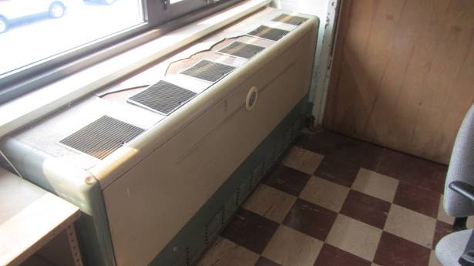

Univents in the 1952 wing, manufactured by the Nesbitt Company

Picture 2

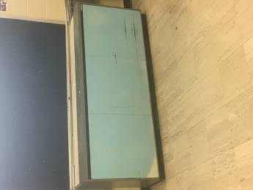

Univents in the 1971 wing, manufactured by Herman Nelson Company

Picture 3
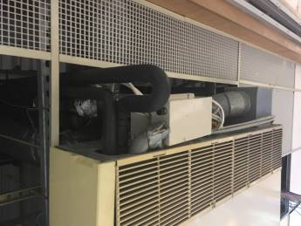

Ceiling-mounted air conditioner

Picture 4

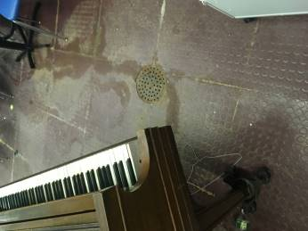

Chorus room floor drain (note water staining of floor around piano)
Picture 5

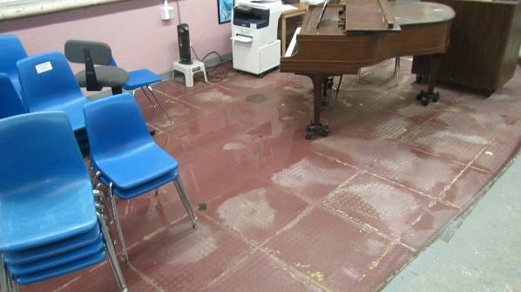

Standing water on chorus room floor
(Note drain beneath water puddle as well as piano legs in water)

Picture 6

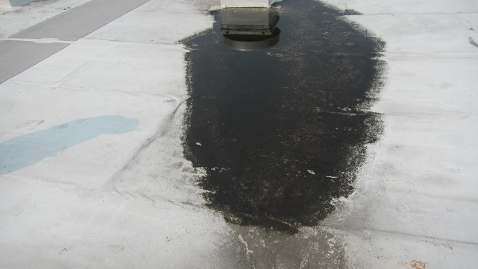

Pooling water on roof

Picture 7

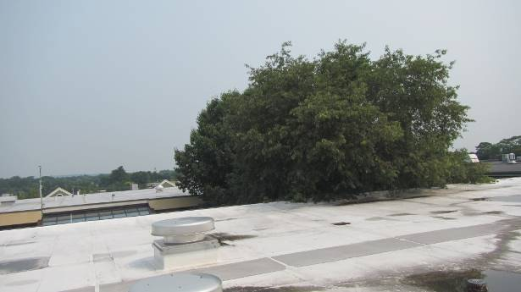

Courtyard tree overhanging, and in contact with roof membrane

Picture 8

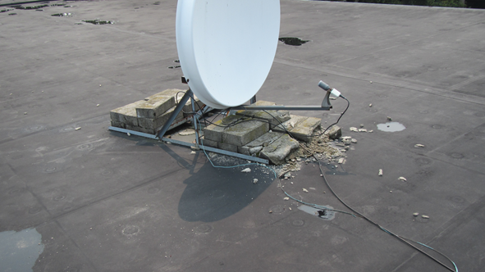

Bricks in direct contact with roof membrane, note hole in roof

Picture 9
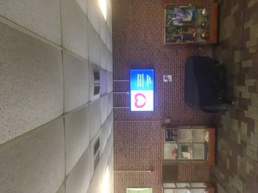

Bowing ceiling tiles

Picture 10

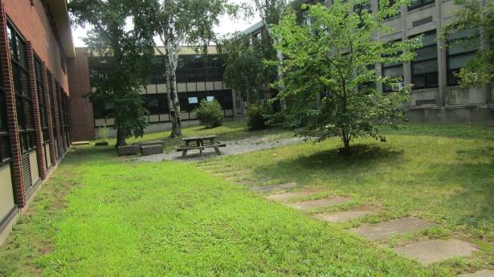

Trees in interior courtyard
Picture 11

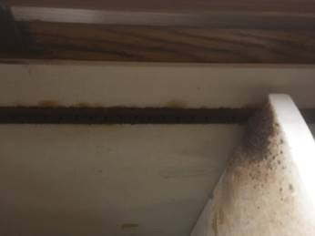

Corroded metal shelf support in disused flammables storage cabinet

Picture 12

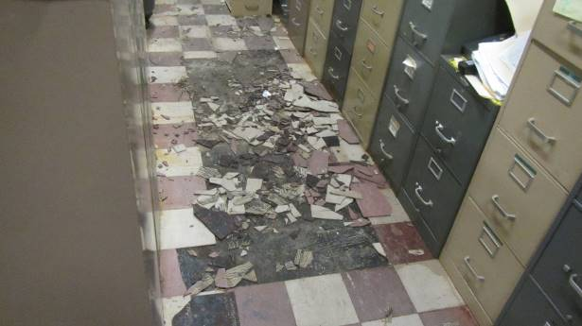

Broken floor tiles

Picture 13

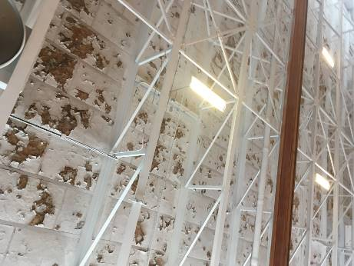

Exposed fiberglass insulation in old gym ceiling

Location | Water-Damaged Ceiling Tiles-stained  (#) | Water-Damaged  Bowed Ceiling Tile | Ventilation |  |  | Comments
 |  |  | Windows openable | Supply | Exhaust
263 | 9 | Y | Y | Y | Y | 1 missing ceiling tile
261 | 2 | Y | Y | Y | Y | Supply blocked by desk
259 |  | Y | Y | Y | Y
257 |  | Y | Y | Y | Y
255 |  |  | Y | Y | Y
Lecture hall #2 |  | Y | N | Y | Y | Ceiling-mounted air conditioner, 3 missing ceiling tiles
Tech Center |  | Y | N | N | Y
253 |  |  | Y | Y | Y | Photocopier
251 |  | Y | Y | Y | Y
249 |  | Y | Y | Y | Y
247 |  | Y | Y | Y | Y
245 | 1 | Y | Y | Y | Y | 2 missing ceiling tiles
243 |  | Y | Y | Y | Y
241 | 1 | Y | Y | Y | Y
241 storage | 1 | Y | Y | N | Y | Floor drain dry trap
239 | 1 | Y | Y | Y | Y
239-237 storeroom | 1 |  | N | N | Y
Chemical storage room | 10+ | Y | N | N | Y
235 |  |  | N | Y | Y | 10+ missing ceiling tiles
233 |  | Y | N | Y | N | 10+ missing ceiling tiles
233-231 storeroom |  | Y | N | Y | Y
231 |  | Y | N | Y | Y
231-229 storeroom |  | Y | Y | Y | Y
229 |  | Y | Y | Y | Y
226 |  | Y | Y | Y | Y
228 |  | Y | Y | Y | Y | Plug-in air freshener
230 | 2 | Y | Y | Y | Y
226-224 storeroom | 6 | Y | Y | N | N | 1 missing ceiling tiles
232 | 1 | Y | Y | Y | Y
234 |  | Y | Y | Y
238 | 6 |  | N | Y | Y
236 | 1 | Y | Y | Y | Y
234 | 1 | Y | Y | Y | Y
232 |  |  | Y | Y | Y
230 |  |  | Y | Y | Y | Wall-to-wall carpeting
230 storeroom | 7 | Y | Y | N | N | Wall-to-wall carpeting
244A | 4 |  | Y | N | N
244B | 3 | Y | Y | N | N
246 | 3 |  | Y | Y | Y
248 |  | Y | Y | Y | Y
271 |  | Y | Y | Y | Y
269 |  | Y | Y | Y | Y
265 |  | Y | Y | Y | Y
224 |  | Y | Y | Y | Y
223 |  | Y | Y | Y | Y
221 |  | Y | Y | Y | Y
219 |  | Y | Y | Y | Y
217 |  | Y | Y | Y | Y
Track room |  | Y | N | N | N
215 |  | Y | N | Y | N
213 |  | Y | Y | Y | Y
211 |  | Y | Y | Y | Y
209 |  | Y | Y | Y | Y
207 |  | Y | Y | Y | Y
205 |  | Y | Y | Y | Y
203 |  | Y | Y | Y | Y
201 |  | Y | Y | Y | Y
204 |  | Y | Y | Y | Y
202 | 1 | Y | Y | Y | Y
206 |  | Y | Y | Y | Y
209 | 1 | Y | Y | Y | Y
211 |  | Y | Y | Y | Y | Exhaust vent missing covering
208 |  | Y | Y | Y | Y | Window-mounted air conditioner
210 |  | Y | Y | Y | Y
212 |  | Y | Y | Y | Y | 4 missing ceiling tiles
214 |  | Y | Y | Y | Y | Heat detector hanging from ceiling
216 |  | Y | Y | Y | Y
218 |  | Y | Y | Y | Y | Water-damaged ceiling
220 |  | Y | Y | Y | Y
222 |  | Y | Y | Y | Y
118 |  | Y | Y | Y | Y | Window-mounted air conditioner
116A |  | Y | Y | Y | Y | Window-mounted air conditioner
116 |  | Y | Y | Y | Y
114 |  | Y | Y | Y | Y
112 |  | Y | Y | Y | Y | Window-mounted air conditioner
111 |  | Y | Y | Y | Y | Window-mounted air conditioner
113 | 2 | Y | Y | Y | Y | Window-mounted air conditioner
Boiler room |  | N |  |  |  | Standing water on floor
151 |  | Y | Y | Y | Y
147 |  | Y | Y | Y | Y
145 |  | Y | Y | Y | Y
143 |  | Y | Y | Y | Y
141 |  | Y | Y | Y | Y
139 |  | Y | Y | Y | Y
137 |  | Y | Y | Y | Y
135 |  | Y | Y | Y | Y
134 |  | Y | Y | Y | Y
133 |  | Y | Y | Y | Y
Audio room |  |  | y | Y | Y
Lecture hall | 4 | Y | Y | Y | Y | Outdoor light through exterior door frame
Main office |  | Y | Y | Y | N | Window-mounted air conditioner
Principal’s office |  |  | Y | N | N
131 |  | Y | Y | Y | Y | Unblocked abandoned sink drains
129 |  | Y | Y | Y | Y
127 |  | Y | Y | Y | Y
127 storeroom |  |  | Y | N | N
125 |  | Y | Y | Y | Y | Outdoor light through exterior door frame
123 |  |  | Y | Y | Y
122 storeroom |  |  | N | N | N | Unblocked abandoned sink drain
122 |  |  | Y | Y | Y
128 |  |  | Y | Y | Y
130 |  | Y | Y | N | Y | Door vent air supply
Health office |  | Y | Y | Y | Y
Path room |  |  | Y | Y | N
Library |  | Y | Y | Y | Y | Carpet odor
B31 |  | Y | Y | Y | Y | 1 missing ceiling tile
B23 |  | Y | Y | Y | Y
B25 |  | Y | Y | Y | Y | Refrigerator
B27 |  | Y | Y | Y | Y | Band uniform storage
B29 |  | Y | Y | Y | Y
Chorus room |  |  | N | Y | Y | Standing water on floor, floor drain under piano
B22 |  |  |  | Y | Y
Old gym |  |  | Y | Y | Y

The service life is the median time during which a particular system or component of …[an HVAC]… system remains in its original service application and then is replaced. Replacement may occur for any reason, including, but not limited to, failure, general obsolescence, reduced reliability, excessive maintenance cost, and changed system requirements due to such influences as building characteristics or energy prices (ASHRAE, 1991).

