INDOOR AIR QUALITY ASSESSMENT

Raymond K-8 Elementary School
125 Oak Street
Brockton, Massachusetts

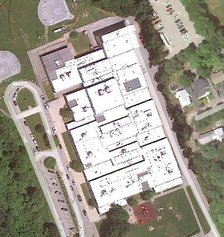

Prepared by:
Massachusetts Department of Public Health
Bureau of Environmental Health
Indoor Air Quality Program
March 2011

Background/Introduction
At the request Ms. Mary Jane Butler, Sanitary Inspector for the Brockton Health Department (BHD), the Massachusetts Department of Public Health (MDPH), Bureau of Environmental Health (BEH) conducted an indoor air quality (IAQ) assessment at the Raymond K-8 Elementary School (RES) located at 125 Oak Street, Brockton, Massachusetts. On January 12, 2011, an assessment of the RES was made by Cory Holmes, Environmental Analyst/Regional Inspector within BEH’s IAQ Program. The assessment was prompted by concerns of roof leaks, potential mold growth and general IAQ conditions in the building. Accompanying BEH staff for the assessment was Ms. Butler, Sanitary Inspector, BHD, and for portions of the assessment Mr. Alexander Suarez, Energy Management Director, Brockton Public Schools (BPS) and Ms. Carol McGrath, RES Principal.
The RES is a one-story, slab-on-grade, cinder block building that was completed in 1975. The school contains general classrooms set up in an open “Pod” configuration, computer rooms, a kitchen/cafeteria, music rooms, art room, library, main gymnasium, a small gymnasium currently used as a classroom, and office space. Windows are openable throughout the building.
At the time of the assessment, the city of Brockton was reportedly in the process of securing funds for capital repairs, including a new roof. In addition, plans were in place to replace water-damaged carpeting over the February 2011 vacation break in the Pod 1 area, which was the focal area of complaints.

Methods
Air tests for carbon monoxide, carbon dioxide, temperature and relative humidity were conducted with the TSI, Q-Trak, IAQ Monitor, Model 7565. Air tests for airborne particle matter with a diameter less than 2.5 micrometers were taken with the TSI, DUSTTRAK™ Aerosol Monitor Model 8520. MDPH staff also performed a visual inspection of building materials for water damage and/or microbial growth.

Results
The school houses approximately 990 kindergarten through eighth grade students and approximately 145 staff. Tests were taken during normal operations. Results appear in Table 1.

Discussion

Ventilation
It can be seen from Table 1 that carbon dioxide levels were above 800 parts per million (ppm) in 23 of 28 areas at the time of the assessment, indicating a lack of air exchange in the majority of areas surveyed. Mechanical ventilation is provided by a computer-controlled heating, ventilating and air conditioning (HVAC) system, which utilizes rooftop air-handling units (AHUs), or ceiling-mounted units in the case of the gymnasium. AHUs draw air in via fresh air intakes through a bank of pleated filters and heated/cooled before it is distributed to occupied areas via ceiling or wall-mounted air diffusers (Pictures 1 and 2). Exhaust air is drawn into ceiling or wall-mounted return vents and ducted back to the AHUs (Pictures 3 and 4).
To maximize air exchange, the MDPH recommends that both supply and exhaust ventilation operate continuously during periods of occupancy. In order to have proper ventilation with a mechanical supply and exhaust system, the systems must be balanced to provide an adequate amount of fresh air to the interior of a room while removing stale air from the room. It is recommended that HVAC systems be re-balanced every five years to ensure adequate air systems function (SMACNA, 1994). The date of the last balancing of these systems was not available at the time of the assessment.
The Massachusetts Building Code requires that each room have a minimum ventilation rate of 15 cubic feet per minute (cfm) per occupant of fresh outside air or openable windows (SBBRS, 1997; BOCA, 1993). The ventilation must be on at all times that the room is occupied. Providing adequate fresh air ventilation with open windows and maintaining the temperature in the comfort range during the cold weather season is impractical. Mechanical ventilation is usually required to provide adequate fresh air ventilation.
Carbon dioxide is not a problem in and of itself. It is used as an indicator of the adequacy of the fresh air ventilation. As carbon dioxide levels rise, it indicates that the ventilating system is malfunctioning or the design occupancy of the room is being exceeded. When this happens, a buildup of common indoor air pollutants can occur, leading to discomfort or health complaints. The Occupational Safety and Health Administration (OSHA) standard for carbon dioxide is 5,000 parts per million parts of air (ppm). Workers may be exposed to this level for 40 hours/week, based on a time-weighted average (OSHA, 1997).
The MDPH uses a guideline of 800 ppm for publicly occupied buildings. A guideline of 600 ppm or less is preferred in schools due to the fact that the majority of occupants are young and considered to be a more sensitive population in the evaluation of environmental health status. Inadequate ventilation and/or elevated temperatures are major causes of complaints such as respiratory, eye, nose and throat irritation, lethargy and headaches. For more information concerning carbon dioxide, consult Appendix A.
Indoor temperatures ranged from 68º F to 74º F, which were within or close to the lower end of the MDPH recommended comfort range in areas surveyed the day of the assessment (Table 1). The MDPH recommends that indoor air temperatures be maintained in a range of 70º F to 78º F in order to provide for the comfort of building occupants. In many cases concerning indoor air quality, fluctuations of temperature in occupied spaces are typically experienced, even in a building with an adequate fresh air supply.
Relative humidity measurements in the building ranged from 11 to 21 percent, which were below the MDPH recommended comfort range in all areas surveyed (Table 1). The MDPH recommends a comfort range of 40 to 60 percent for indoor air relative humidity. Relative humidity levels in the building would be expected to drop during the winter months due to heating. The sensation of dryness and irritation is common in a low relative humidity environment. Low relative humidity is a very common problem during the heating season in the northeast part of the United States.

Microbial/Moisture Concerns
In order for building materials to support mold growth, a source of water exposure is necessary. Identification and elimination of the source of water moistening building materials is necessary to control mold growth. Signs of roof leaks were observed in many areas throughout the school (primarily in Pod 1) as evidenced by severely water-damaged carpeting, ceiling tiles and stains on walls and furnishings (Pictures 5 through 8/Table 1). As stated, this water-damaged carpeting was scheduled for removal over the February 2011 vacation break. Other areas of chronic leaks and water-damaged carpet should be removed including the center of the library (Pictures 9 and 10) and the corner of the “Quiet Room” (Picture 11).
The US Environmental Protection Agency (US EPA) and the American Conference of Governmental Industrial Hygienists (ACGIH) recommend that porous materials (e.g., GW) be dried with fans and heating within 24 to 48 hours of becoming wet (US EPA, 2001; ACGIH, 1989). If not dried within this time frame, mold growth may occur. Once mold has colonized porous materials, they are difficult to clean and should be removed.
Carpeting was noted in close proximity to restrooms and beneath water fountains in hallways (Pictures 12 and 13). Overflow of toilets, sinks and/or water fountains that often occur can moisten carpeting and be a source of mold growth.
Open seams between sink countertops and backsplashes were observed in some rooms (Picture 14/Table 1). If not watertight, moisture can penetrate through seams, causing damage. Improper drainage or sink overflow can lead to water penetration into countertops, cabinet interiors and areas behind cabinets. Water penetration and chronic exposure of porous and wood-based materials can cause these materials to swell and show signs of water damage. Repeated moistening of porous materials can result in mold growth.
The teachers’ faculty lunch room contained two refrigerators that appeared to have not been cleaned for some time, as evidenced by expired food/milk. Visible mold growth and food spillage was observed within the refrigerators (Pictures 15 and 16).

Other IAQ Evaluations
Indoor air quality can be negatively influenced by the presence of respiratory irritants, such as products of combustion. The process of combustion produces a number of pollutants. Common combustion emissions include carbon monoxide, carbon dioxide, water vapor and smoke (fine airborne particle material). Of these materials, exposure to carbon monoxide and particulate matter with a diameter of 2.5 micrometers (μm) or less (PM2.5) can produce immediate, acute health effects upon exposure. To determine whether combustion products were present in the indoor environment, BEH staff obtained measurements for carbon monoxide and PM2.5.

Carbon Monoxide
Carbon monoxide is a by-product of incomplete combustion of organic matter (e.g., gasoline, wood and tobacco). Exposure to carbon monoxide can produce immediate and acute health effects. Several air quality standards have been established to address carbon monoxide and prevent symptoms from exposure to these substances. The MDPH established a corrective action level concerning carbon monoxide in ice skating rinks that use fossil-fueled ice resurfacing equipment. If an operator of an indoor ice rink measures a carbon monoxide level over 30 ppm, taken 20 minutes after resurfacing within a rink, that operator must take actions to reduce carbon monoxide levels (MDPH, 1997).
The American Society of Heating Refrigeration and Air-Conditioning Engineers (ASHRAE) has adopted the National Ambient Air Quality Standards (NAAQS) as one set of criteria for assessing indoor air quality and monitoring of fresh air introduced by HVAC systems (ASHRAE, 1989). The NAAQS are standards established by the US EPA to protect the public health from six criteria pollutants, including carbon monoxide and particulate matter (US EPA, 2006). As recommended by ASHRAE, pollutant levels of fresh air introduced to a building should not exceed the NAAQS levels (ASHRAE, 1989). The NAAQS were adopted by reference in the Building Officials & Code Administrators (BOCA) National Mechanical Code of 1993 (BOCA, 1993), which is now an HVAC standard included in the Massachusetts State Building Code (SBBRS, 1997). According to the NAAQS, carbon monoxide levels in outdoor air should not exceed 9 ppm in an eight-hour average (US EPA, 2006).
Carbon monoxide should not be present in a typical, indoor environment. If it is present, indoor carbon monoxide levels should be less than or equal to outdoor levels. On the day of the assessment, outdoor carbon monoxide concentrations were non-detect (ND) (Table 1). No measurable levels of carbon monoxide were detected inside the building (Table 1).

Particulate Matter
The US EPA has established NAAQS limits for exposure to particulate matter. Particulate matter is airborne solids that can be irritating to the eyes, nose and throat. The NAAQS originally established exposure limits to particulate matter with a diameter of 10 μm or less (PM10). According to the NAAQS, PM10 levels should not exceed 150 micrograms per cubic meter (μg/m³) in a 24-hour average (US EPA, 2006). These standards were adopted by both ASHRAE and BOCA. Since the issuance of the ASHRAE standard and BOCA Code, US EPA established a more protective standard for fine airborne particles. This more stringent PM2.5 standard requires outdoor air particle levels be maintained below 35 μg/m³ over a 24-hour average (US EPA, 2006). Although both the ASHRAE standard and BOCA Code adopted the PM10 standard for evaluating air quality, MDPH uses the more protective PM2.5 standard for evaluating airborne particulate matter concentrations in the indoor environment.
Outdoor PM2.5 concentrations were measured at 7 μg/m³ (Table 1). PM2.5 levels measured indoors ranged from 4 to 7 μg/m³ (Table 1), which were below the NAAQS PM2.5 level of 35 μg/m³. Frequently, indoor air levels of particulates (including PM2.5) can be at higher levels than those measured outdoors. A number of activities that occur indoors and/or mechanical devices can generate particulate during normal operations. Sources of indoor airborne particulates may include but are not limited to particles generated during the operation of fan belts in the HVAC system, use of stoves and/or microwave ovens in kitchen areas; use of photocopiers, fax machines and computer printing devices; operation of an ordinary vacuum cleaner and heavy foot traffic indoors.

Volatile Organic Compounds
Indoor air quality can also be negatively influenced by the presence of materials containing volatile organic compounds (VOCs). VOCs are carbon-containing substances that have the ability to evaporate at room temperature. Frequently, exposure to low levels of total VOCs (TVOCs) may produce eye, nose, throat and/or respiratory irritation in some sensitive individuals. For example, chemicals evaporating from a paint can stored at room temperature would most likely contain VOCs. In an effort to identify materials that can potentially increase indoor VOC concentrations, BEH staff examined classrooms and common areas for products containing these respiratory irritants.
The majority of classrooms contained dry erase boards and related materials. Materials such as dry erase markers and dry erase board cleaners may contain VOCs, such as methyl isobutyl ketone, n-butyl acetate and butyl-cellusolve (Sanford, 1999), which can be irritating to the eyes, nose and throat. Cleaning products were also observed in several classrooms under sink cabinets and on countertops (Table 1). Like dry erase materials, cleaning products and air deodorizers contain VOCs and other chemicals that can be irritating to the eyes, nose and throat and should be kept out of reach of students.

Other Conditions
Other conditions that can affect indoor air quality were observed during the assessment. In many classrooms, items were observed on the floor, windowsills, tabletops, counters, bookcases and desks (Picture 17). The large number of items stored in classrooms provides a source for dusts to accumulate. These items (e.g., papers, folders, boxes) make it difficult for custodial staff to clean. Items should be relocated and/or be cleaned periodically to avoid excessive dust build up. In addition, these materials can accumulate on flat surfaces (e.g., desktops, shelving and carpets) in occupied areas and subsequently be re-aerosolized causing further irritation.
A number of air diffusers, exhaust/return vents and personal fans were observed to have accumulated dust/debris (Pictures 1, 3 and 4). If exhaust vents are not functioning, backdrafting can occur, which can re-aerosolize accumulated dust particles. Re-activated supply vents and fans can also aerosolize dust accumulated on vents/fan blades.
The majority of floor surfaces in the school are covered by wall to wall carpeting, some of which appears to be original to the building (>35 years old). The Institute of Inspection, Cleaning and Restoration Certification (IICRC), recommends that carpeting be cleaned annually (or semi-annually in soiled high traffic areas) (IICRC, 2005). Since the average service time of carpeting in a school environment is approximately eleven years (Bishop, 2002), consideration should be given to planning for the installation of new flooring as funds become available.
Missing/damaged fiberglass insulation was observed along ceiling-mounted ductwork in Pod 1 Room 106 (Picture 18). Fiberglass insulation can provide a source of skin, eye and respiratory irritation.
Finally, pipe insulation around a roof drain in the cafeteria was found damaged, exposing a white chalky material that may be asbestos (Picture 19). Upon discovery, BEH staff recommended that the insulation be inspected and remediated by a licensed member of the Brockton Public Works Department or an asbestos abatement contractor. In subsequent correspondence with Mr. Suarez, it was reported that the material was confirmed to be asbestos and was remediated by New England Surface Maintenance, LLP, a licensed asbestos abatement contractor.

Conclusions/Recommendations
Major roof repairs/replacement will require capital funding and planning. At the time of the assessment, plans were in place to obtain funding for roof replacement. In the interim, maintenance staff should continue to make minor roof repairs and monitor building materials for water damage. In view of the findings at the time of the visit, the following additional recommendations are provided:
- In addition to carpeting removal that occurred over February vacation in Pod 1, carpeting in areas of chronic leakage should also be removed including the center of the library and corner of quiet room.
  - Deactivate mechanical ventilation system and seal vents during carpet removal.
  - Water-damaged carpeting should be removed and sealed in plastic bags for transport through the building.
  - If mold is present, clean concrete flooring with anti-microbial agent or mild detergent followed by rinse with clean water.
- Remove carpeting in close proximity to restrooms and beneath water fountains to prevent damage due to flooding/back-ups and/or plumbing failures.
- Remove/discard any water-damaged/mold-colonized ceiling tiles. Examine the area above these tiles for mold growth. Disinfect areas of water leaks with a mild detergent or an appropriate antimicrobial, as needed.
- Operate all ventilation systems throughout the building (e.g., gym, cafeteria, classrooms) continuously during periods of occupancy to maximize air exchange.
- Examine if fresh air supply can be increased/intake adjusted in areas that measured over 800 ppm carbon dioxide.
- Use openable windows in conjunction with mechanical ventilation to facilitate air exchange. Care should be taken to ensure windows are properly closed at night and weekends to avoid the freezing of pipes and potential flooding.
- Consider adopting a balancing schedule of every 5 years for all mechanical ventilation systems, as recommended by ventilation industrial standards (SMACNA, 1994).
- For buildings in New England, periods of low relative humidity during the winter are often unavoidable. Therefore, scrupulous cleaning practices should be adopted to minimize common indoor contaminants whose irritant effects can be enhanced when the relative humidity is low. To control dusts, a high efficiency particulate arrestance (HEPA) filter equipped vacuum cleaner in conjunction with wet wiping of all surfaces is recommended. Avoid the use of feather dusters. Drinking water during the day can help ease some symptoms associated with a dry environment (throat and sinus irritations).
- Refrain from storing porous items (boxes, papers, books, etc.) in areas prone to water leaks.
- Seal areas around sinks to prevent water damage to the interior of cabinets and adjacent wallboard.
- Clean food spillage and mold growth from faculty refrigerator with mild detergent or antimicrobial agent. Discard expired food items and clean out on a regular schedule.
- Store cleaning products properly and out of reach of students. All cleaning products used at the facility should be approved by the school department with MSDS’ available at a central location.
- Relocate or consider reducing the amount of materials stored in classrooms to allow for more thorough cleaning of classrooms. Clean items regularly with a wet cloth or sponge to prevent excessive dust build-up.
- Clean accumulated dust and debris periodically from the surface of air diffusers, exhaust vents and blades of personal and ceiling fans.
- Repair/replace damaged fiberglass duct insulation in Pod 1 Room 106.
- Clean carpeting annually or semi-annually in soiled high traffic areas as per the recommendations of the Institute of Inspection, Cleaning and Restoration Certification (IICRC). Copies of the IICRC fact sheet can be downloaded at: http://www.cleancareseminars.com/carpet_cleaning_faq4.htm (IICRC, 2005)
- Consider a long-term plan to replace all carpeting in the building as funds become available. Consider replacing carpeting with a non-porous surface such as vinyl tile.
- Ensure compliance with the US EPA’s Asbestos Hazard Emergency Response Act (AHERA) to address asbestos containing materials in schools (US EPA, 1986), which requires inspections every 3-year and documentation in accordance with establishing a current asbestos management plan.
- For more information on mold/remediation consult “Mold Remediation in Schools and Commercial Buildings” published by the US Environmental Protection Agency (US EPA, 2001) for more information on mold. This document can be downloaded from the US EPA website at: http://www.epa.gov/iaq/molds/mold_remediation.html.
- Consider adopting the US EPA (2000) document, “Tools for Schools”, as an instrument for maintaining a good indoor air quality environment in the building. This document is available at: http://www.epa.gov/iaq/schools/index.html.
- Refer to resource manual and other related indoor air quality documents located on the MDPH’s website for further building-wide evaluations and advice on maintaining public buildings. These documents are available at: http://mass.gov/dph/iaq.

References
ACGIH. 1989. Guidelines for the Assessment of Bioaerosols in the Indoor Environment. American Conference of Governmental Industrial Hygienists, Cincinnati, OH.
ASHRAE. 1989. Ventilation for Acceptable Indoor Air Quality. American Society of Heating, Refrigeration and Air Conditioning Engineers. ANSI/ASHRAE 62-1989.
Bishop, J. & Institute of Inspection, Cleaning and Restoration Certification. 2002. A Life Cycle Cost Analysis for Floor Coverings in School Facilities.
BOCA. 1993. The BOCA National Mechanical Code/1993. 8th ed. Building Officials and Code Administrators International, Inc., Country Club Hill, IL.
IICRC. 2005. Carpet Cleaning FAQ 4 Institute of Inspection, Cleaning and Restoration Certification. Institute of Inspection Cleaning and Restoration, Vancouver, WA.
MDPH. 1997. Requirements to Maintain Air Quality in Indoor Skating Rinks (State Sanitary Code, Chapter XI). 105 CMR 675.000. Massachusetts Department of Public Health, Boston, MA.
OSHA. 1997. Limits for Air Contaminants. Occupational Safety and Health Administration. Code of Federal Regulations. 29 C.F.R 1910.1000 Table Z-1-A.
Sanford. 1999. Material Safety Data Sheet (MSDS No: 198-17). Expo® Dry Erase Markers Bullet, Chisel, and Ultra Fine Tip. Sanford Corporation. Bellwood, IL.
SBBRS. 1997. Mechanical Ventilation. State Board of Building Regulations and Standards. Code of Massachusetts Regulations. 780 CMR 1209.0
SMACNA. 1994. HVAC Systems Commissioning Manual. 1st ed. Sheet Metal and Air Conditioning Contractors’ National Association, Inc., Chantilly, VA.
US EPA. 1986. Asbestos Hazard Emergency Response Act. Hazard Emergency Response Act of 1986 (AHERA) Public Law 99-519, Oct 22, 1986. 15 USC Section 2651.
US EPA. 2000. Tools for Schools. Office of Air and Radiation, Office of Radiation and Indoor Air, Indoor Environments Division (6609J). EPA 402-K-95-001, Second Edition. http://www.epa.gov/iaq/schools/tools4s2.html.
US EPA. 2001. “Mold Remediation in Schools and Commercial Buildings”. Office of Air and Radiation, Indoor Environments Division, Washington, DC. EPA 402-K-01-001. March 2001. Available at: http://www.epa.gov/iaq/molds/mold_remediation.html.
US EPA. 2006. National Ambient Air Quality Standards (NAAQS). US Environmental Protection Agency, Office of Air Quality Planning and Standards, Washington, DC. http://www.epa.gov/air/criteria.html.
Picture 1

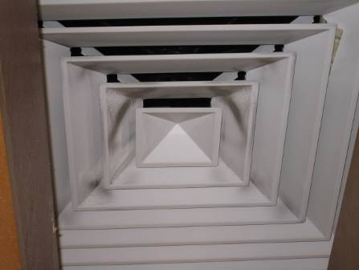

Ceiling-Mounted Supply Diffuser, Note Dust/Debris Accumulation on Louvers

Picture 2

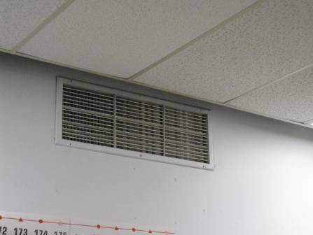

Wall-Mounted Supply Diffuser

Picture 3

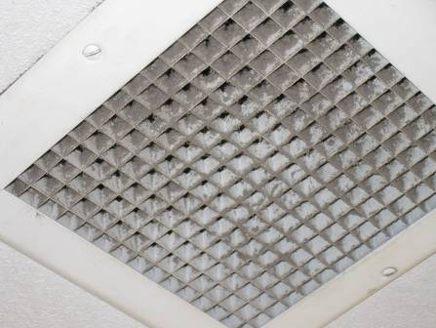

Ceiling-Mounted Exhaust/Return Vent, Note Dust/Debris Accumulation on Grate

Picture 4

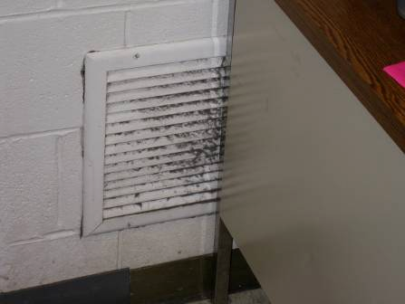

Wall-Mounted Exhaust/Return Vent, Note Dust/Debris Accumulation on Louvers

Picture 5

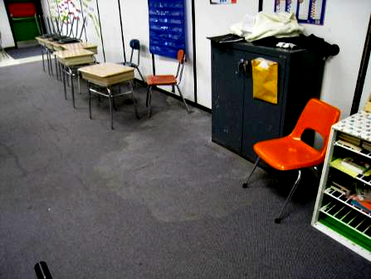

Water-Damaged Carpeting in Pod 1

Picture 6

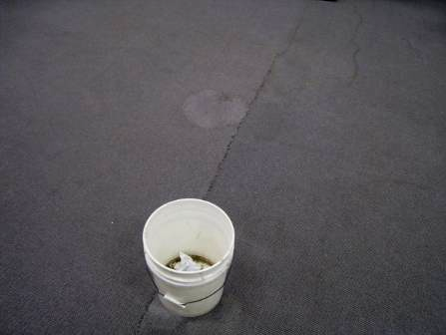

Water-Damaged Carpeting and Bucket Used to Catch Leaks in Pod 1

Picture 7

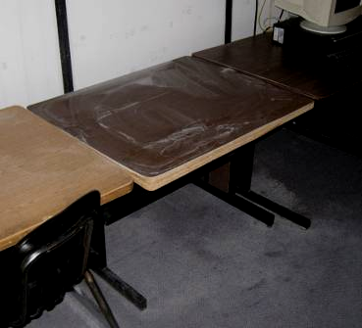

Water-Damaged Furniture in Pod 1

Picture 8

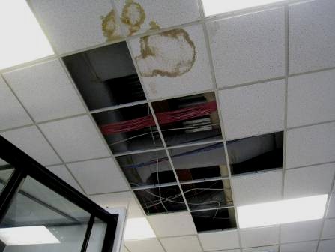

Missing/Water-Damaged Ceiling Tiles
Picture 9

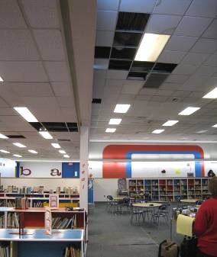

Missing/Water-Damaged Ceiling Tiles and Carpeting in Center of Library

Picture 10

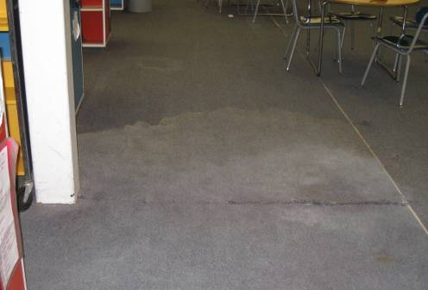

Water-Damaged Carpeting in Center of Library

Picture 11

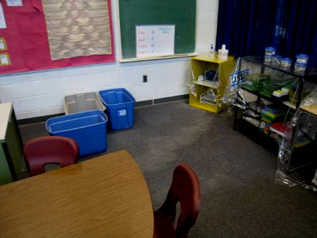

Water-Damaged Carpeting in Quiet Room

Picture 12

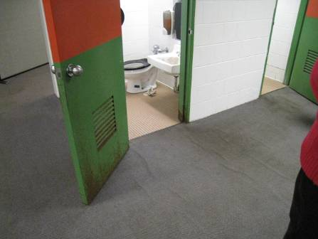

Wall-to-Wall Carpeting Directly outside Restrooms

Picture 13

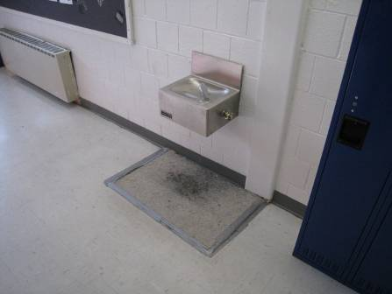

Carpet Square beneath Water Fountain

Picture 14

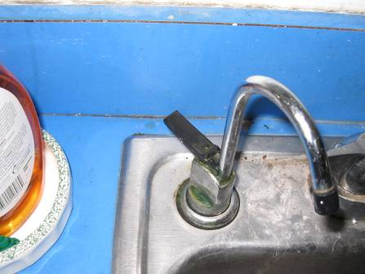

Open Seam between Sink Countertop and Backsplash

Picture 15

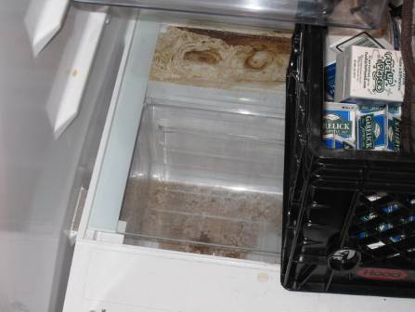

Mold Growth and Food Spillage in Teachers’ Lounge Refrigerator

Picture 16

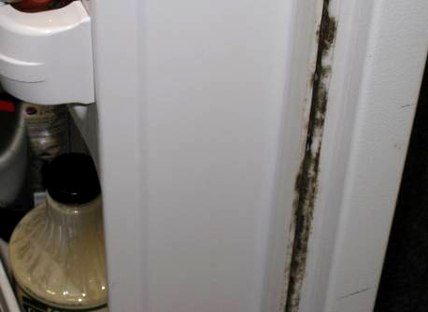

Mold Growth on Door/Gasket in Teachers’ Lounge Refrigerator

Picture 17

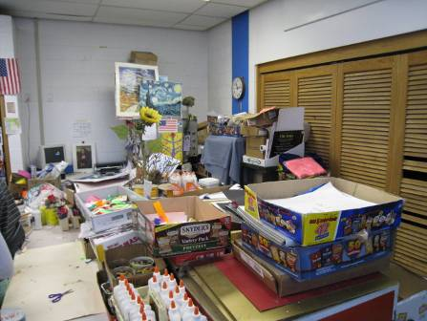

Accumulated Classroom Items

Picture 18

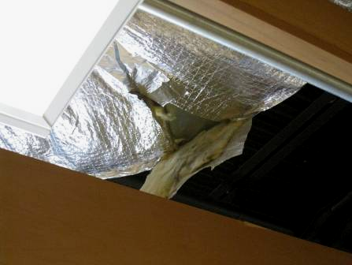

Missing/Damaged Fiberglass Insulation around Ductwork in Pod 1 Room 106

Picture 19

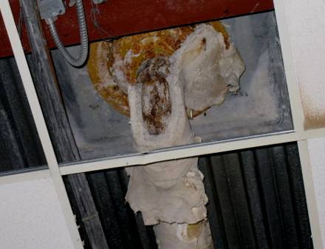

Damaged Insulation Material in Cafeteria (Removed by Licensed Asbestos Remediation Firm on January 13, 2011)
Location | Carbon  Dioxide  (ppm) |  | Temp  (°F) |  |  | Relative  Humidity  (%) |  | Carbon Monoxide  (ppm) |  | PM2.5  (µg/m³) |  | Occupants  in Room |  | Windows Openable | Ventilation |  |  |  | Remarks
 |  |  |  |  |  |  |  |  |  |  |  |  |  |  | Supply |  | Exhaust
Background |  | 349 |  | <32 | 34 |  | ND |  | 7 |  |  |  |  |  |  |  |  |  |  | Cold, cloudy, winds NNW 13-22 mph, gusts up to 36 mph
Pod 1 Room 102 |  | 1003 |  | 73 | 16 |  | ND |  | 5 |  | 19 |  | Y |  |  | Y |  | Y |  | Severely WD carpeting, water stained ceiling and furnishings, numerous WD CT, active roof leaks
Pod 1 Room 101 |  | 1030 |  | 74 | 16 |  | ND |  | 7 |  | 1 |  | Y |  |  | Y |  | Y |  | Severely WD carpeting, sink reported clogged, active roof leaks
Pod 1 Room 106 |  | 1004 |  | 72 | 16 |  | ND |  | 5 |  | 10 |  | Y |  |  | Y |  | Y |  | Exposed fiberglass insulation around ceiling duct, CP/flammable materials under sink
Pod 1 Room 104 |  | 980 |  | 74 | 16 |  | ND |  | 5 |  | 16 |  | Y |  |  | Y |  | Y |  | Leaking sink, WD CT
Pod 1 Room 105 |  | 904 |  | 74 | 15 |  | ND |  | 5 |  | 0 |  | Y |  |  | Y |  | Y |  | WD walls/bubbling paint/stains, carpeting outside restrooms
Pod 2 |  | 971 |  | 73 | 16 |  | ND |  | 6 |  | ~100 |  | Y |  |  | Y |  | Y |  | WD CT/MT
Pod 2 Room 5 |  | 937 |  | 72 | 16 |  | ND |  | 6 |  | 22 |  | N |  |  | Y |  | Y |  | Roof leaks-buckets, WD CT/MT
Pod 3 |  | 970 |  | 73 | 16 |  | ND |  | 7 |  | ~100 |  | Y |  |  | Y |  | Y |  | WD CT/MT
Pod 4 |  | 1076 |  | 72 | 17 |  | ND |  | 6 |  | 0 |  | Y |  |  | Y |  | Y |  | Chronic leaks-buckets, ~100 occupants at lunch
Pod 5 |  | 985 |  | 72 | 15 |  | ND |  | 5 |  | 0 |  | Y |  |  | Y |  | Y |  | ~100 occupants at lunch
Pod 5 Room 505 |  | 1051 |  | 72 | 16 |  | ND |  | 6 |  | 5 |  | N |  |  | Y |  | Y |  | WD CT/MT
Pod 6 |  | 1120 |  | 72 | 18 |  | ND |  | 5 |  | ~100 |  | Y |  |  | Y |  | Y
Pod 6 Room 601 |  | 1190 |  | 74 | 18 |  | ND |  | 5 |  | 25 |  | N |  |  | Y |  | Y
Pod 7 |  | 970 |  | 72 | 18 |  | ND |  | 7 |  | ~100 |  | Y |  |  | Y |  | Y |  | WD CT, occasional leaks reported
Small Gym |  | 626 |  | 68 | 14 |  | ND |  | 5 |  | 0 |  | N |  |  | Y |  | Y |  | Chronic roof leak corner
Gym |  | 434 |  | 69 | 12 |  | ND |  | 7 |  | 0 |  | N |  |  | Y |  | Y
Room G |  | 938 |  | 72 | 16 |  | ND |  | 6 |  | 25 |  | N |  |  | Y |  | Y |  | WD CT/MT, WD/stained carpet-buckets to catch water from leaks
Library |  | 848 |  | 72 | 14 |  | ND |  | 5 |  | 5 |  | N |  |  | Y |  | Y |  | Severely WD carpeting center (rec removal)
Quiet Room |  | 776 |  | 70 | 15 |  | ND |  | 5 |  | 0 |  | N |  |  | Y |  | Y |  | Severely WD carpeting in corner (rec removal), active leaks/buckets to catch water
Title 1 |  | 984 |  | 73 | 16 |  | ND |  | 5 |  | 2 |  | N |  |  | Y |  | Y
Room D |  | 1128 |  | 71 | 18 |  | ND |  | 6 |  | 25 |  | Y |  |  | Y |  | Y |  | Missing fluorescent light cover, leaks-items covered with plastic
Room B |  | 1231 |  | 72 | 19 |  | ND |  | 7 |  | 28 |  | Y |  |  | Y |  | Y |  | Items covered with plastic, WD CT
Guidance |  | 1090 |  | 72 | 19 |  | ND |  | 6 |  | 0 |  | N |  |  | Y |  | Y |  | PCs/Risograph
Main Office |  | 1310 |  | 73 | 21 |  | ND |  | 5 |  | 11 |  | Y |  |  | Y |  | Y |  | Dusty wall/ceiling vents
Nurse |  | 1343 |  | 74 | 21 |  | ND |  | 5 |  | 5 |  | N |  |  | Y |  | Y |  | WD CT/MT
Cafeteria |  | 650 |  | 73 | 15 |  | ND |  | 4 |  | ~75 |  | N |  |  | Y |  | Y |  | WD CT/MT, buckets to catch leaking water, exposed insulation material (ceiling drain pipe)
Teacher’s Lounge |  | 487 |  | 71 | 11 |  | ND |  | 5 |  | 1 |  | N |  |  | Y |  | Y |  | Refrigerators on carpeting, visible mold growth/spillage in refrigerators, stained/worn carpeting, expired milk/food products
Art Room |  | 860 |  | 74 | 16 |  | ND |  | 5 |  | 29 |  | N |  |  | Y |  | Y |  | 2 WD CT, dusty vents
Hallway (outside Art Room) |  |  |  |  |  |  |  |  |  |  |  |  |  |  |  |  |  |  |  | Carpeting under water fountain

