INDOOR AIR QUALITY ASSESSMENT

Raynham Middle School
420 Titicut Road
Raynham, Massachusetts 02767

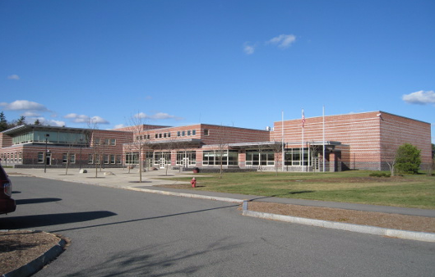
Figure 1

Prepared by:
Massachusetts Department of Public Health
Bureau of Environmental Health
Indoor Air Quality Program
January 2009

Background/Introduction
At the request of Mr. Al Baroncelli, Facilities Director for the Bridgewater-Raynham Regional School District, the Massachusetts Department of Public Health (MDPH), Bureau of Environmental Health (BEH) provided further assistance and consultation in monitoring and improving indoor air quality in all Bridgewater-Raynham Regional schools. On October 24, 2008, Cory Holmes and James Tobin, Environmental Analysts/Inspectors for BEH’s Indoor Air Quality (IAQ) Program conducted an assessment at the Raynham Middle School (RMS), 420 Titicut Road, Raynham, Massachusetts.
The RMS is a two-story, red-brick building constructed in 2001. The school consists of general classrooms, science classrooms, a gymnasium, auditorium, kitchen/cafeteria, media center, art rooms, music/band rooms, teacher work rooms and office space. Windows are openable throughout the building.

Methods
Air tests for carbon dioxide, carbon monoxide, temperature and relative humidity were conducted with the TSI, Q-TRAK™ IAQ Monitor, Models 7565/8554. Air tests for airborne particulate matter with a diameter less than 2.5 micrometers were taken with the TSI, DUSTTRAK™ Aerosol Monitor Model 8520. BEH staff also performed a visual inspection of building materials for water damage and/or microbial growth.

Results
The RMS currently houses grades 5 through 8 with a student population of approximately 700 and a staff of approximately 80. Tests were taken under normal operating conditions and results appear in Table 1.

Discussion

Ventilation
It can be seen from Table 1 that carbon dioxide levels were above 800 parts per million (ppm) in twenty-five of sixty-one area surveyed, indicating a lack of air exchange in a number of areas in the building on the day of the assessment. It is important to note that the assessment occurred on a day where outside temperatures were below freezing (<32º F). It was reported by school maintenance staff that rooftop air handling units were operating on 100% recycled air; therefore, outside air intake/exhaust was unusually limited (Picture 1), leading to increased carbon dioxide levels. During such temperature extremes, outdoor air intake is typically minimized to maintain thermal comfort as well as to protect HVAC equipment (e.g., freezing of pipes/flooding). It is also important to note that several areas with carbon dioxide levels below 800 ppm were sparsely populated or unoccupied, which can greatly reduce carbon dioxide levels. Carbon dioxide levels would be expected to be higher with full occupancy.
Mechanical ventilation is provided by rooftop air handling units (Picture 2). AHUs draw in air through fresh air intakes, and then filter, heat and/or cool the air. It is then distributed to occupied areas via ceiling-mounted air diffusers (Pictures 3 and 4). Exhaust air is returned back to the AHUs via ceiling-mounted return vents. Some exhaust/return vents are located near classroom doors (Picture 5). Due to their location, the exhaust capabilities of these vents can be diminished when the doors are left open. With the classroom door open, the return/exhaust vent tends to draw air from the hallway into the classroom instead of stale air out of the classroom.
Fresh air for common areas such as the gymnasium, cafeteria, library and administrative areas is provided by rooftop or ceiling-mounted air handling units (AHUs). These systems appeared to be operating during the assessment.
To maximize air exchange, the MDPH recommends that both supply and exhaust ventilation operate continuously during periods of school occupancy. In order to have proper ventilation with a mechanical supply and exhaust system, the systems must be balanced to provide an adequate amount of fresh air to the interior of a room while removing stale air from the room. It is recommended that existing ventilation systems be re-balanced every five years to ensure adequate air systems function (SMACNA, 1994).
The Massachusetts Building Code requires a minimum ventilation rate of 15 cubic feet per minute (cfm) per occupant of fresh outside air or have openable windows in each room (SBBRS, 1997; BOCA, 1993). The ventilation must be on at all times that the room is occupied. Providing adequate fresh air ventilation with open windows and maintaining the temperature in the comfort range during the cold weather season is impractical. Mechanical ventilation is usually required to provide adequate fresh air ventilation.
Carbon dioxide is not a problem in and of itself. It is used as an indicator of the adequacy of the fresh air ventilation. As carbon dioxide levels rise, it indicates that the ventilating system is malfunctioning or the design occupancy of the room is being exceeded. When this happens a buildup of common indoor air pollutants can occur, leading to discomfort or health complaints. The Occupational Safety and Health Administration (OSHA) standard for carbon dioxide is 5,000 parts per million parts of air (ppm). Workers may be exposed to this level for 40 hours/week based on a time weighted average (OSHA, 1997).
The MDPH uses a guideline of 800 ppm for publicly occupied buildings. A guideline of 600 ppm or less is preferred in schools due to the fact that the majority of occupants are young and considered to be a more sensitive population in the evaluation of environmental health status. Inadequate ventilation and/or elevated temperatures are major causes of complaints such as respiratory, eye, nose and throat irritation, lethargy and headaches. For more information concerning carbon dioxide, please see Appendix A.
Indoor temperature readings on the day of the assessment ranged from 70º F to 76º F, which were within the MDPH comfort guidelines. The MDPH recommends that indoor air temperatures be maintained in a range of 70 º F to 78 º F in order to provide for the comfort of building occupants. In many cases concerning indoor air quality, fluctuations of temperature in occupied spaces are typically experienced, even in a building with an adequate fresh air supply.
The relative humidity measurements ranged from 13 to 32 percent, which were below the MDPH recommended comfort range the day of the assessment. The MDPH recommends a comfort range of 40 to 60 percent for indoor air relative humidity. Relative humidity levels in the building would be expected to drop during the winter months due to heating. The sensation of dryness and irritation is common in a low relative humidity environment. Low relative humidity is a very common problem during the heating season in the northeast part of the United States.

Other IAQ Evaluations
Indoor air quality can be negatively influenced by the presence of respiratory irritants, such as products of combustion. The process of combustion produces a number of pollutants. Common combustion emissions include carbon monoxide, carbon dioxide, water vapor and smoke (fine airborne particle material). Of these materials, exposure to carbon monoxide and particulate matter with a diameter of 2.5 micrometers (μm) or less (PM2.5) can produce immediate, acute health effects upon exposure. To determine whether combustion products were present in the building, BEH staff obtained measurements for carbon monoxide and PM2.5.
Carbon Monoxide
Carbon monoxide is a by-product of incomplete combustion of organic matter (e.g., gasoline, wood and tobacco). Exposure to carbon monoxide can produce immediate and acute health affects. Several air quality standards have been established to address carbon monoxide and prevent symptoms from exposure to these substances. The MDPH established a corrective action level concerning carbon monoxide in ice skating rinks that use fossil-fueled ice resurfacing equipment. If an operator of an indoor ice rink measures a carbon monoxide level over 30 ppm, taken 20 minutes after resurfacing within a rink, that operator must take actions to reduce carbon monoxide levels (MDPH, 1997).
The American Society of Heating Refrigeration and Air-Conditioning Engineers (ASHRAE) has adopted the National Ambient Air Quality Standards (NAAQS) as one set of criteria for assessing indoor air quality and monitoring of fresh air introduced by HVAC systems (ASHRAE, 1989). The NAAQS are standards established by the US EPA to protect the public health from six criteria pollutants, including carbon monoxide and particulate matter (US EPA, 2006). As recommended by ASHRAE, pollutant levels of fresh air introduced to a building should not exceed the NAAQS levels (ASHRAE, 1989). The NAAQS were adopted by reference in the Building Officials & Code Administrators (BOCA) National Mechanical Code of 1993 (BOCA, 1993), which is now an HVAC standard included in the Massachusetts State Building Code (SBBRS, 1997). According to the NAAQS, carbon monoxide levels in outdoor air should not exceed 9 ppm in an eight-hour average (US EPA, 2006).
Carbon monoxide should not be present in a typical, indoor environment. If it is present, indoor carbon monoxide levels should be less than or equal to outdoor levels. On the day of assessment, outdoor carbon monoxide concentrations were non-detect (ND). No levels of carbon monoxide were detected inside the building (Table 1).
Particulate Matter (PM2.5)
The US EPA has established NAAQS limits for exposure to particulate matter. Particulate matter is airborne solids that can be irritating to the eyes, nose and throat. The NAAQS originally established exposure limits to particulate matter with a diameter of 10 μm or less (PM10). According to the NAAQS, PM10 levels should not exceed 150 microgram per cubic meter (μg/m³) in a 24-hour average (US EPA, 2006). These standards were adopted by both ASHRAE and BOCA. Since the issuance of the ASHRAE standard and BOCA Code, US EPA established a more protective standard for fine airborne particles. This more stringent PM2.5 standard requires outdoor air particle levels be maintained below 35 μg/m³ over a 24-hour average (US EPA, 2006). Although both the ASHRAE standard and BOCA Code adopted the PM10 standard for evaluating air quality, MDPH uses the more protective PM2.5 standard for evaluating airborne particulate matter concentrations in the indoor environment.
Outdoor PM2.5 concentrations were measured at 4 μg/m³ (Table 1). PM2.5 levels measured indoors ranged from 1 to 12 μg/m³ (Table 1), which were below the NAAQS PM2.5 level of 35 μg/m³. Frequently, indoor air levels of particulates (including PM2.5) can be at higher levels than those measured outdoors. A number of mechanical devices and/or activities that occur in schools can generate particulate during normal operations. Sources of indoor airborne particulates may include but are not limited to particles generated during the operation of fan belts in the HVAC system, cooking in the cafeteria stoves and microwave ovens; use of photocopiers, fax machines and computer printing devices; operation of an ordinary vacuum cleaner and heavy foot traffic indoors.
Volatile Organic Compounds
Indoor air quality can also be impacted by the presence of materials containing volatile organic compounds (VOCs). VOCs are substances that have the ability to evaporate at room temperature. Frequently, exposure to low levels of total VOCs (TVOCs) may produce eye, nose, throat and/or respiratory irritation in some sensitive individuals. For example, chemicals evaporating from a paint can stored at room temperature would most likely contain VOCs. In an effort to identify materials that can potentially increase indoor VOC concentrations, BEH staff examined classrooms for products containing these respiratory irritants.
The majority of classrooms contained dry erase boards and related materials. Materials such as dry erase markers and dry erase board cleaners may contain VOCs, such as methyl isobutyl ketone, n-butyl acetate and butyl-cellusolve (Sanford, 1999), which can be irritating to the eyes, nose and throat.
Other Conditions
A number of classrooms contained personal fans that had accumulated dust (Picture 13). If exhaust vents are not functioning, backdrafting can occur, which can re-aerosolize dust particles. In addition, these materials can accumulate on flat surfaces (e.g., desktops, shelving and carpets) in occupied areas and subsequently be re-aerosolized causing further irritation. Dust can be irritating to eyes, nose and the respiratory tract.

Conclusions/Recommendations
In view of the findings at the time of the visit, the following recommendations are made to improve indoor air quality:
- Continue to operate all ventilation systems throughout the building (e.g., gym, cafeteria, classrooms) continuously during periods of occupancy independent of thermostat control to maximize air exchange.
- Adjust the percentage of fresh air supplied and/or adjust exhaust by the HVAC system to improve air exchange.
- Close classroom doors to facilitate air exchange.
- Use openable windows (weather permitting) in conjunction with mechanical ventilation to supplement air exchange. Care should be taken to ensure windows are properly closed at night and on weekends to avoid the freezing of pipes and potential flooding.
- Consider adopting a balancing schedule of every 5 years for all mechanical ventilation systems, as recommended by ventilation industrial standards (SMACNA, 1994).
- For buildings in New England, periods of low relative humidity during the winter are often unavoidable. Therefore, scrupulous cleaning practices should be adopted to minimize common indoor air contaminants whose irritant effects can be enhanced when the relative humidity is low. To control for dusts, a high efficiency particulate arrestance (HEPA) filter equipped vacuum cleaner in conjunction with wet wiping of all surfaces is recommended. Avoid the use of feather dusters. Drinking water during the day can help ease some symptoms associated with a dry environment (throat and sinus irritations).
- Clean accumulated dust and debris periodically from supply diffusers, return/exhaust vents and personal fans.
- Consider adopting the US EPA (2000) document, “Tools for Schools”, to maintain a good indoor air quality environment on the building. This document can be downloaded from the Internet at: http://www.epa.gov/iaq/schools/index.html.
- Refer to resource manuals and other related indoor air quality documents for further building-wide evaluations and advice on maintaining public buildings. Copies of these materials are located on the MDPH’s website: http://mass.gov/dph/indoor_air

References
ASHRAE. 1989. Ventilation for Acceptable Indoor Air Quality. American Society of Heating, Refrigeration and Air Conditioning Engineers. ANSI/ASHRAE 62-1989
BOCA. 1993. The BOCA National Mechanical Code/1993. 8th ed. Building Officials & Code Administrators International, Inc., Country Club Hills, IL.
MDPH. 1997. Requirements to Maintain Air Quality in Indoor Skating Rinks (State Sanitary Code, Chapter XI). 105 CMR 675.000. Massachusetts Department of Public Health, Boston, MA.
OSHA. 1997. Limits for Air Contaminants. Occupational Safety and Health Administration. Code of Federal Regulations. 29 C.F.R 1910.1000 Table Z-1-A.
Sanford. 1999. Material Safety Data Sheet (MSDS No: 198-17). Expo® Dry Erase Markers Bullet, Chisel, and Ultra Fine Tip. Sanford Corporation, Bellwood, IL.
SBBRS. 1997. Mechanical Ventilation. State Board of Building Regulations and Standards. Code of Massachusetts Regulations. 780 CMR 1209.0.
SMACNA. 1994. HVAC Systems Commissioning Manual. 1st ed. Sheet Metal and Air Conditioning Contractors’ National Association, Inc., Chantilly, VA.
US EPA. 2000. Tools for Schools. Office of Air and Radiation, Office of Radiation and Indoor Air, Indoor Environments Division (6609J). EPA 402-K-95-001, Second Edition. http://www.epa.gov/iaq/schools/tools4s2.html
US EPA. 2006. National Ambient Air Quality Standards (NAAQS). . US Environmental Protection Agency, Office of Air Quality Planning and Standards, Washington, DC. http://www.epa.gov/air/criteria.html.
Picture 1

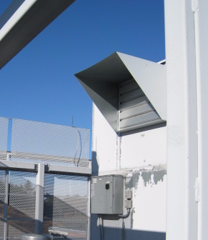

Exhaust Vent of Rooftop Air Handling Unit Shut to Provide 100% Recycled Air

Picture 2

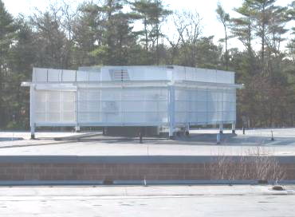

Rooftop Air Handling Unit

Picture 3

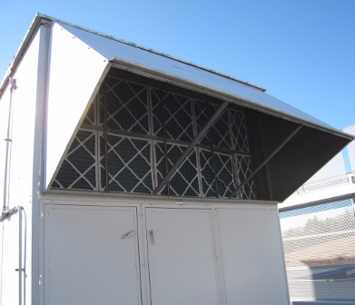

Fresh Air Intake and Pleated Filter Bank for Rooftop AHU

Picture 4

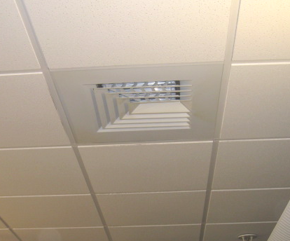

Ceiling-Mounted Supply Diffuser

Picture 5

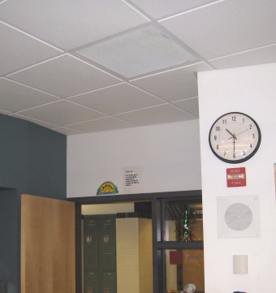

Ceiling-Mounted Return Vent, Note Proximity to Classroom/Hallway Door
Location/ Room | Occupants  in Room | Temp  (°F) | Relative  Humidity  (%) | Carbon  Dioxide  (ppm) | Carbon Monoxide  (ppm) | PM2.5  (µg/m³) | Windows  Openable | Ventilation |  | Remarks
 |  |  |  |  |  |  |  | Supply | Exhaust | Remarks
background |  | <32 | 37 | 360 | ND | 4 |  |  |  | Cold, dry, winds: NW 5-15 mph
224 | 24 | 73 | 31 | 1478 | ND | 7 | Y | Y | Y | DEM; DO
223 | 21 | 73 | 29 | 1363 | ND | 8 | Y | Y | Y | DO
222 | 26 | 74 | 30 | 1455 | ND | 4 | N | Y | Y | DO
2nd Floor ‘A’  Teacher Prep | 1 | 75 | 24 | 907 | ND | 5 | N | Y | Y | AD in bathroom; microwave; mini-refrigerator; toaster oven
215 | 0 | 74 | 23 | 898 | ND | 6 | Y | Y | Y | DO
218 | 20 | 72 | 28 | 900 | ND | 5 | Y | Y | Y | Window open, DO, PF
219 | 4 | 73 | 22 | 690 | ND | 2 | Y | Y | Y | DO, PF
220 | 21 | 73 | 25 | 950 | ND | 5 | Y | Y | Y | DO
225 | 20 | 74 | 29 | 1242 | ND | 4 | Y | Y | Y | DO, PF
221 | 0 | 75 | 25 | 1044 | ND | 4 | Y | Y | Y
217 | 1 | 74 | 23 | 810 | ND | 3 | N | Y | Y
216 | 4 | 74 | 24 | 980 | ND | 9 | Y | Y | Y | PF-dusty, DO, 23 occupants gone 30 mins, black out curtains to reduce heat
226 | 24 | 74 | 21 | 711 | ND | 1 | N | Y | Y | DO
227 | 24 | 74 | 20 | 715 | ND | 1 | N | Y | Y | Heat complaints, DO
228 | 0 | 72 | 18 | 516 | ND | 3 | Y | Y | Y | DO
212 | 25 | 73 | 18 | 746 | ND | 11 | Y | Y | Y
211 | 27 | 73 | 18 | 808 | ND | 6 | Y | Y | Y | DO
213 | 21 | 74 | 25 | 1088 | ND | 8 | Y | Y | Y | DO
214 | 0 | 74 | 19 | 709 | ND | 4 | Y | Y | Y
201 | 1 | 73 | 16 | 537 | ND | 6 | Y | Y | Y | 26 occupants gone 5 minutes
204 | 0 | 73 | 17 | 607 | ND | 8 | Y | Y | Y
205 | 0 | 72 | 16 | 548 | ND | 10 | N | Y | Y | DO
208 | 1 | 73 | 17 | 670 | ND | 5 | N | Y | Y
209 | 26 | 74 | 22 | 989 | ND | 8 | Y | Y | Y | Plants
210 | 24 | 73 | 17 | 798 | ND | 5 | Y | Y | Y | PF
206 | 1 | 72 | 13 | 441 | ND | 3 | Y | Y | Y | 10 occupants gone 30 mins, DO
207 | 7 | 72 | 15 | 551 | ND | 3 | Y | Y | Y | Plants
202 | 0 | 72 | 16 | 547 | ND | 4 | Y | Y | Y | ~26 occupants gone 15 mins, DO
203 | 0 | 72 | 15 | 526 | ND | 4 | Y | Y | Y | ~25 occupants gone 10 mins
Library | 0 | 76 | 18 | 578 | ND | 4 | Y | Y | Y
102 | 1 | 73 | 15 | 447 | ND | 4 | Y | Y | Y | DO
101 | 24 | 73 | 18 | 717 | ND | 5 | Y | Y | Y | DO
106 | 3 | 72 | 15 | 449 | ND | 4 | Y | Y | Y | DO
108 | 3 | 72 | 19 | 687 | ND | 9 | N | Y | Y | DO
109 | 9 | 72 | 20 | 693 | ND | 6 | Y | Y | Y | DO
110 | 12 | 72 | 17 | 592 | ND | 6 | Y | Y | Y
113 | 24 | 72 | 27 | 1148 | ND | 7 | Y | Y | Y | DO
114 | 19 | 73 | 26 | 1128 | ND | 7 | Y | Y | Y | PF – off
119 | 1 | 74 | 24 | 957 | ND | 7 | Y | Y | Y | 20 computers; DO
122 | 6 | 73 | 23 | 959 | ND | 6 | Y | Y | Y | DO; PF
121 | 4 | 73 | 22 | 815 | ND | 4 | Y | Y | Y | DO
120 | 0 | 73 | 23 | 705 | ND | 5 | N | Y | Y
130 | 0 | 72 | 18 | 551 | ND | 4 | Y | Y | Y
132 | 20 | 72 | 20 | 677 | ND | 10 | Y | Y | Y | DO
103 | 21 | 72 | 18 | 662 | ND | 5 | Y | Y | Y | DO, PF
104 | 0 | 72 | 18 | 604 | ND | 4 | Y | Y | Y | DO
105 | 2 | 71 | 18 | 743 | ND | 5 | Y | Y | Y | 1 CT, DO
107 | 2 | 71 | 16 | 466 | ND | 4 | Y | Y | Y | 25 occupants gone 40 mins, DO
111 | 22 | 71 | 18 | 719 | ND | 5 | Y | Y | Y | DO
112 | 23 | 71 | 18 | 710 | ND | 5 | Y | Y | Y | PF
108 | 3 | 71 | 19 | 702 | ND | 3 | N | Y | Y
Gym | 50 | 70 | 18 | 602 | ND | 3 | N | Y | Y
117 | 6 | 71 | 32 | 1650 | ND | 12 | N | Y | Y
116 | 20 | 73 | 25 | 1087 | ND | 3 | Y | Y | Y | DO
115 | 27 | 73 | 26 | 1100 | ND | 5 | Y | Y | Y | DO, PF
118 | 6 | 73 | 21 | 874 | ND | 4 | N | Y | Y
124 | 26 | 74 | 27 | 1260 | ND | 9 | Y | Y | Y | DO
123 | 25 | 73 | 26 | 1300 | ND | 6 | Y | Y | Y
129 | 19 | 72 | 20 | 737 | ND | 3 | Y | Y | Y
131 | 1 | 70 | 20 | 742 | ND | 2 | Y | Y | Y | DO
Cafeteria | ~170 | 71 | 22 | 798 | ND | 6 | Y | Y | Y

