INDOOR AIR QUALITY ASSESSMENT

Raynham Middle School
420 Titicut Road
Raynham, MA

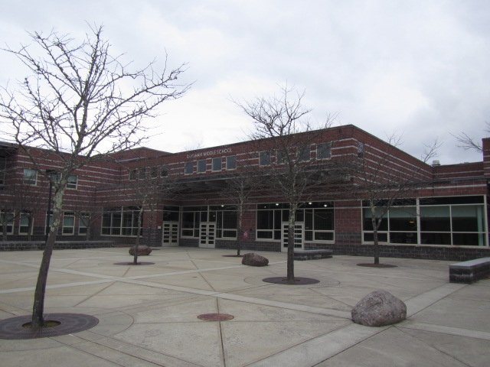

Prepared by:
Massachusetts Department of Public Health
Bureau of Environmental Health
Indoor Air Quality Program
January 2019

Background

Building: | Raynham Middle School (RMS)
Address: | 420 Titicut Road, Raynham, MA
Assessment Requested by: | Paul Fox Jr., Director of Facilities, Bridgewater-Raynham Regional School District
Reason for Request: | Specific request to perform general indoor air quality (IAQ) testing/evaluation in classrooms 109 and 111.
Date of Assessment: | January 10, 2019
Massachusetts Department of Public Health/Bureau of Environmental Health (MDPH/BEH) Staff Conducting Assessment: | Cory Holmes, Environmental Analyst, IAQ Program
Date of Building Construction/Description: | The RMS is a two-story, red-brick building constructed in 2001. Rooms 109 and 111 are general classrooms located on the ground floor and have tile floors, gypsum wallboard walls and a suspended ceiling.
Windows: | Openable

IAQ Testing Results
Please refer to the IAQ Manual for methods, sampling procedures, and interpretation of results (MDPH, 2015). The following is a summary of indoor air testing results (Table 1).
- Carbon dioxide levels were below the MDPH guideline of 800 parts per million (ppm) in both classrooms, however occupants had just vacated for lunch, which can reduce carbon dioxide levels.
- Temperature was within the recommended range of 70°F to 78°F.
- Relative humidity was below the recommended range of 40 to 60% in the areas tested, which is typical of New England during the heating season. Low relative humidity can lead to common symptoms such as: dry skin, lips, and scalp; dry/scratchy throats, exacerbation of asthma, eczema, or allergies; dry/irritated eyes; and irritation of respiratory tract.
- Carbon monoxide levels were non-detectable (ND) in all areas tested.
- Fine particulate matter (PM2.5) concentrations measured were below the National Ambient Air Quality (NAAQS) limit of 35 μg/m³ in all areas tested.

Ventilation
A heating, ventilating and air conditioning (HVAC) system has several functions. First it provides heating and, if equipped, cooling. Second, it is a source of fresh air. Finally, an HVAC system will dilute and remove normally occurring indoor environmental pollutants by not only introducing fresh air, but by filtering the airstream and ejecting stale air to the outdoors via exhaust ventilation. Even if an HVAC system is operating as designed, point sources of respiratory irritation may exist and cause symptoms in sensitive individuals.
Mechanical ventilation is provided by rooftop air handling units (AHUs). AHUs draw air through fresh air intakes, and then through a bank of pleated filters before they heat and/or cool the air. It is then distributed to occupied areas via ceiling-mounted air diffusers (Picture 1). Exhaust air is returned back to the AHUs via ceiling-mounted return vents. Some exhaust/return vents are located near classroom doors (Picture 2). Due to their location, the exhaust capabilities of these vents can be diminished when the doors are left open. With the classroom door open, the return/exhaust vent tends to draw air from the hallway into the classroom instead of stale air out of the classroom.
In order to have proper ventilation with a mechanical supply and exhaust system, these systems must be balanced to provide an adequate amount of fresh air while removing stale air from a room. It is recommended that existing ventilation systems be re-balanced every five years to ensure adequate air systems function (SMACNA, 1994).

Microbial/Moisture Concerns
A small stain was noted on a ceiling tile in classroom 109 (Picture 3). BEH/IAQ staff removed the ceiling tiles to observe conditions and found that the insulation around pipes appeared to have been removed (Picture 4), most likely for repairs/maintenance, which has resulted in condensation/water damage on the tiles below. Tiles should be replaced once leaks are found and repaired.

Other IAQ Evaluations
The MDPH recommends pleated filters with a Minimum Efficiency Reporting Value (MERV) of 8, which are adequate in filtering out pollen and mold spores (ASHRAE, 2012). Filters should also be changed two to four times a year, or per the manufacturer’s recommendations. Filters at the RMS are reportedly MERV 8 and changed three times a year.
Classrooms had personal fans, some of which had dusty blades. Some supply and exhaust vents were also observed to be dusty (Picture 1, Table 1). This dust can be reaerosolized when the equipment is activated and provide a source of eye and respiratory irritation.
Exposure to low levels of total VOCs (TVOCs) may produce eye, nose, throat, and/or respiratory irritation in some sensitive individuals. To determine if VOCs were present, BEH/IAQ staff examined rooms for products containing VOCs. BEH/IAQ staff noted hand sanitizers, cleaners/spray bottles, and dry erase materials in use (Table 1). These products have the potential to be irritants to the eyes, nose, throat, and respiratory system of sensitive individuals.

Conclusions/Recommendations
The following recommendations are made to assist in improving IAQ:
- Continue to operate all supply and exhaust ventilation equipment continuously during occupied periods.
- Use openable windows to supplement fresh air during temperate weather. Ensure all windows are tightly closed at the end of the day.
- Close classroom doors to facilitate exhaust function.
- Consider adopting a balancing schedule of every 5 years for all mechanical ventilation systems, as recommended by ventilation industrial standards (SMACNA, 1994).
- For buildings in New England, periods of low relative humidity during the winter are often unavoidable. Therefore, scrupulous cleaning practices should be adopted to minimize common indoor air contaminants whose irritant effects can be enhanced when the relative humidity is low. To control dusts, a high efficiency particulate arrestance (HEPA) filter equipped vacuum cleaner in conjunction with wet wiping of all surfaces is recommended. Avoid the use of feather dusters. Drinking water during the day can help ease some symptoms associated with a dry environment (throat and sinus irritations).
- Ensure that procedures are in place for occupants to report leaks, wet tiles, and other maintenance conditions so that they can be logged and dried/repaired promptly.
- Make repairs/replace missing insulation above water-damaged ceiling tile in classroom 109 (Picture 4).
- Continue to change filters for HVAC equipment 2-4 times a year. The MDPH recommends using pleated filters of Minimum Efficiency Reporting Value (MERV) of 8, which are adequate in filtering out pollen and mold spores (ASHRAE, 2012).
- Regularly clean AHU cabinets, supply/return/exhaust vents and personal fans to avoid aerosolizing accumulated particulate matter.
- Consider adopting the US EPA (2000) document, “Tools for Schools”, as an instrument for maintaining a good IAQ environment in the building available at: http://www.epa.gov/iaq/schools/index.html.
- Refer to resource manual and other related IAQ documents located on the MDPH’s website for further building-wide evaluations and advice on maintaining public buildings. These documents are available at: http://mass.gov/dph/iaq.

References
ASHRAE. 2012. American Society of Heating, Refrigeration and Air Conditioning Engineers (ASHRAE) Standard 52.2-2012 -- Method of Testing General Ventilation Air-Cleaning Devices for Removal Efficiency by Particle Size (ANSI Approved).
MDPH. 2015. Massachusetts Department of Public Health. “Indoor Air Quality Manual: Chapters I-III”. Available at: http://www.mass.gov/eohhs/gov/departments/dph/programs/environmental-health/exposure-topics/iaq/iaq-manual/.
SMACNA. 1994. HVAC Systems Commissioning Manual. 1st ed. Sheet Metal and Air Conditioning Contractors’ National Association, Inc., Chantilly, VA.
US EPA. 2000. Tools for Schools. Office of Air and Radiation, Office of Radiation and Indoor Air, Indoor Environments Division (6609J). EPA 402-K-95-001, Second Edition. http://www.epa.gov/iaq/schools/index.html.
Picture 1
Supply diffuser, note dust/debris accumulation on louvers
Picture 2
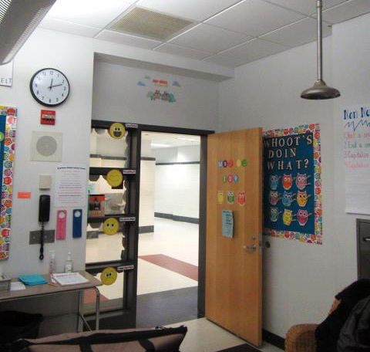
Ceiling-mounted return vent, note proximity to open classroom door (arrows)
Picture 3
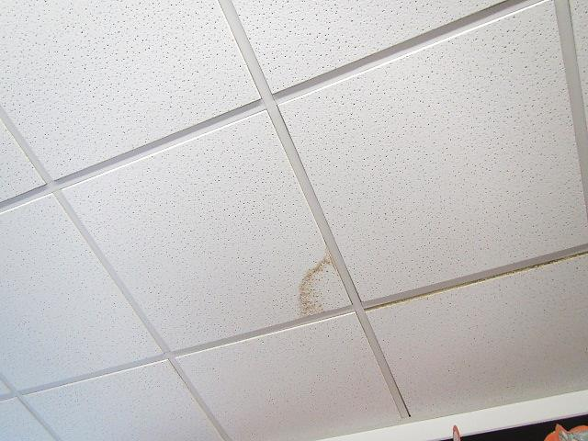
Stained ceiling tile in classroom 109
Picture 4
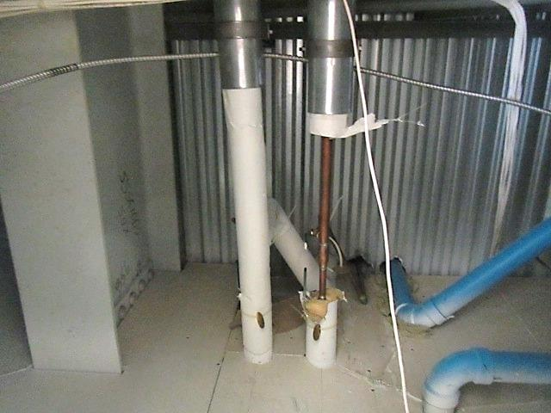
Missing insulation on pipes above water-damaged ceiling tile in classroom 109
Location | Carbon  Dioxide  (ppm) | Carbon Monoxide  (ppm) | Temp  (°F) | Relative  Humidity  (%) | PM2.5  (µg/m³) | Occupants  in Room | Windows  Openable | Ventilation |  | Remarks
 |  |  |  |  |  |  |  | Supply | Exhaust
Background (outdoors) | 390 | ND | 34 | 24 | ND |  |  |  |  | Cloudy, cold, snow flurries, windy
109 | 667 | ND | 71 | 22 | ND | 0 | Y | Y | Y | Door open-near exhaust vent, dusty vents, hand sanitizer, water-damaged ceiling tile-lack of pipe insulation above, dry erase materials, occupants at lunch
111 | 649 | ND | 70 | 21 | 3 | 0 | Y | Y | Y | Dusty vents, hand sanitizer, dry erase materials, door open, personal fan, occupants at lunch

