INDOOR AIR QUALITY ASSESSMENT

Raynham Middle School
420 Titicut Road
Raynham, MA

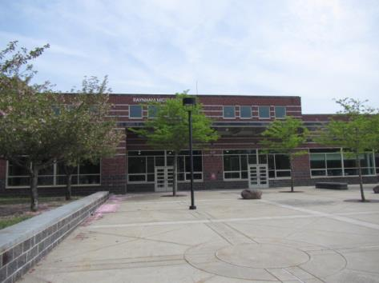

Prepared by:
Massachusetts Department of Public Health
Bureau of Environmental Health
Indoor Air Quality Program
June 2018

Background

Building: | Raynham Middle School (RMS)
Address: | 420 Titicut Road, Raynham, MA
Assessment Requested by: | Paul Fox Jr., Director of Facilities, Bridgewater-Raynham Regional School District
Reason for Request: | Ongoing collaborative effort to perform general indoor air quality (IAQ) assessments throughout the Bridgewater-Raynham Regional School District.
Date of Assessment: | May 18, 2018
Massachusetts Department of Public Health/Bureau of Environmental Health (MDPH/BEH) Staff Conducting Assessment: | Cory Holmes, Environmental Analyst, IAQ Program
Date of Building Construction/Description: | The RMS is a two-story, red-brick building constructed in 2001. The school consists of general classrooms, science classrooms, a gymnasium, auditorium, kitchen/cafeteria, media center, art rooms, music/band rooms, teacher work rooms and office space.
Building Population: | Approximately 680 students in grades pre-K, 5-8 with a staff of approximately 75
Windows: | Openable

IAQ Testing Results
Please refer to the IAQ Manual for methods, sampling procedures, and interpretation of results (MDPH, 2015). The following is a summary of indoor air testing results (Table 1).
- Carbon dioxide levels were below 800 parts per million (ppm) in the large majority of areas tested, indicating adequate air exchange in most areas of the building. However, some areas were empty/sparsely populated due to field trips and other specialists/activities, which can reduce carbon dioxide levels.
- Temperature was within or close to the recommended range of 70°F to 78°F the day of assessment.
- Relative humidity was below the recommended range of 40 to 60% and reflective of outdoor conditions the day of assessment.
- Carbon monoxide levels were non-detectable in all areas tested.
- Fine particulate matter (PM2.5) concentrations measured were below the National Ambient Air Quality (NAAQS) limit of 35 μg/m³ in all areas tested.

Ventilation
A heating, ventilating and air conditioning (HVAC) system has several functions. First it provides heating and, if equipped, cooling. Second, it is a source of fresh air. Finally, an HVAC system will dilute and remove normally occurring indoor environmental pollutants by not only introducing fresh air, but by filtering the airstream and ejecting stale air to the outdoors via exhaust ventilation. Even if an HVAC system is operating as designed, point sources of respiratory irritation may exist and cause symptoms in sensitive individuals.
Mechanical ventilation is provided by rooftop air handling units (AHUs, Picture 1). AHUs draw air through fresh air intakes, and then through a bank of pleated filters (Picture 2) before they heat and/or cool the air. It is then distributed to occupied areas via ceiling-mounted air diffusers (Picture 3). Exhaust air is returned back to the AHUs via ceiling-mounted return vents. Some exhaust/return vents are located near classroom doors (Picture 4). Due to their location, the exhaust capabilities of these vents can be diminished when the doors are left open. With the classroom door open, the return/exhaust vent tends to draw air from the hallway into the classroom instead of stale air out of the classroom.
In order to have proper ventilation with a mechanical supply and exhaust system, these systems must be balanced to provide an adequate amount of fresh air while removing stale air from a room. It is recommended that existing ventilation systems be re-balanced every five years to ensure adequate air systems function (SMACNA, 1994). It is unknown the last time these systems were balanced.

Microbial/Moisture Concerns
Occupants reported leaks in several areas, including Rooms 119, 121, 214, and the boy’s locker room (Table 1). Water-damaged ceiling tiles and other building materials (e.g., walls in 119) were observed in these and a number of other areas (Table 1, Pictures 5 through 8). Moldy ceiling tiles were observed in classrooms 122 and 123; these were reported to school maintenance personnel, who reportedly removed and replaced them that evening.
Mold growth was also observed on refrigerator/gaskets in room 129 (Pictures 9 through 11). Refrigerators should be cleaned on a regular schedule, including disinfection of gaskets and the interior with an antimicrobial solution. Mold growth on gaskets can be an indication that the gaskets are too worn to seal properly and should be replaced.
Indoor plants were observed in a few areas (Table 1). Plants can be a source of pollen and mold, which can be respiratory irritants to some individuals. Plants should be properly maintained and equipped with drip pans and should be located away from air diffusers to prevent the aerosolization of dirt, pollen and mold.
A few areas had portable or window-mounted air conditioners (ACs, Table 1). These units must be able to drain condensation away from the building or to an appropriate drain. In addition, these units are equipped with filters that should be cleaned or changed regularly in accordance with manufacturer’s instructions to prevent the build-up of dust and debris.

Other IAQ Evaluations
Exposure to low levels of total VOCs (TVOCs) may produce eye, nose, throat, and/or respiratory irritation in some sensitive individuals. To determine if VOCs were present, BEH/IAQ staff examined rooms for products containing VOCs. BEH/IAQ staff noted hand sanitizers, cleaners/spray bottles, plug-in air fresheners and dry erase materials in use (Table 1). All of these products have the potential to be irritants to the eyes, nose, throat, and respiratory system of sensitive individuals. In addition, spray bottles/cleaning products should be kept out of reach of children.
Most classrooms had personal fans or fans mounted on walls to provide circulation. Some of these had dusty blades/housing (Picture 12, Table 1). Some supply diffusers and exhaust/return vents were also observed to be dusty (Pictures 3, 13 and 14). This dust can be reaerosolized when the equipment is activated.
In many areas, items, including books, papers, toys and decorative items were observed on floors, windowsills, tabletops, counters, bookcases, and desks. These items can make it difficult for custodial staff to clean.
A number of areas had carpeting. Carpeting should be cleaned annually or semi-annually in soiled high traffic areas as per the recommendations of the Institute of Inspection, Cleaning and Restoration Certification (IICRC, 2012). The carpeting in the Teacher’s Prep Room (near room 108) was worn/damaged (Picture 15), which can be a safety/tripping hazard as well as a source of potentially irritating fibers. The service life of carpeting is approximately 10-11 years (IICRC, 2002). Many classrooms had area rugs, which should also be cleaned regularly and discarded when too worn out or soiled to be cleaned.
Note that the Environmental Protection Agency (EPA) conducted a National School Radon Survey in which it discovered nearly one in five schools had “…at least one frequently occupied ground contact room with short-term radon levels above 4 [picocuries per liter] pCi/L” (US EPA 1993). The BEH/IAQ Program therefore recommends that every school be tested for radon, and that this testing be conducted during the heating season while school is in session in a manner consistent with USEPA radon testing guidelines. Radon measurement specialists and other information can be found at www.nrsb.org and http://aarst-nrpp.com/wp, with additional information at: http://www.mass.gov/eohhs/gov/departments/dph/programs/environmental-health/exposure-topics/iaq/radon.

Conclusions/Recommendations
The following recommendations are made to assist in improving IAQ:
- Operate all supply and exhaust ventilation equipment continuously during occupied periods.
- Work with staff to monitor/adjust computerized HVAC system for fresh air intake/comfort.
- Use openable windows to supplement fresh air during temperate weather. Ensure all windows are tightly closed at the end of the day.
- Close classroom doors to facilitate exhaust function.
- Consider adopting a balancing schedule of every 5 years for all mechanical ventilation systems, as recommended by ventilation industrial standards (SMACNA, 1994).
- For buildings in New England, periods of low relative humidity during the winter are often unavoidable. Therefore, scrupulous cleaning practices should be adopted to minimize common indoor air contaminants whose irritant effects can be enhanced when the relative humidity is low. To control dusts, a high efficiency particulate arrestance (HEPA) filter equipped vacuum cleaner in conjunction with wet wiping of all surfaces is recommended. Avoid the use of feather dusters. Drinking water during the day can help ease some symptoms associated with a dry environment (throat and sinus irritations).
- Ensure that procedures are in place for occupants to report leaks, wet tiles, and other maintenance conditions so that they can be logged and dried/repaired promptly.
- Ensure building envelope/exterior and plumbing leaks (e.g., rooms 119, 121, 122, 123, 214, and the boy’s locker room) are repaired and replace any remaining water-damaged ceiling tiles and wall materials (room 119). Examine the area above these tiles for mold growth. Disinfect areas of water leaks with an appropriate antimicrobial, as needed.
- Clean and disinfect interior of refrigerators and freezers with mild detergent or antimicrobial agent (e.g., 129). Consider replacing poorly-sealed or mold-contaminated gaskets. Clean spilled food promptly, and clean out the refrigerator of expired items on a regular schedule.
- Properly maintain plants, including drip pans, to prevent water damage to porous materials. Plants should also be located away from air diffusers to prevent the aerosolization of dirt, pollen, and mold.
- Reduce use of products and equipment that create VOCs (e.g., air fresheners).
- Keep spray bottles/cleaning products out of reach of children (e.g., in cabinets over sinks).
- Continue to change filters for HVAC equipment 2-4 times a year. The MDPH recommends using pleated filters of Minimum Efficiency Reporting Value (MERV) of 8, which are adequate in filtering out pollen and mold spores (ASHRAE, 2012).
- Regularly clean AHU cabinets, supply/return/exhaust vents and personal fans to avoid aerosolizing accumulated particulate matter.
- Clean window-mounted/portable AC filters prior to the start of the cooling season and according to the manufacturer’s instructions.
- Ensure condensate is draining appropriately from AC units.
- Consider reducing the amount of items stored in classrooms to make cleaning easier. Periodically move items to clean flat surfaces.
- Clean carpeting annually (or semi-annually in soiled high traffic areas) as per the recommendations of the Institute of Inspection, Cleaning and Restoration Certification (IICRC). Clean area rugs similarly.
- Replace old, worn/damaged carpeting (e.g. Teacher’s Prep Room near room 108) past its useful life (> 10-11 years). If not removed, clean carpeting annually or semi-annually in soiled high traffic areas as per the recommendations of the Institute of Inspection, Cleaning, and Restoration Certification (IICRC, 2012).
- The school should be tested for radon by a certified radon measurement specialist during the heating season when school is in session. Radon measurement specialists and other information can be found at: www.nrsb.org, and http://aarst-nrpp.com/wp.
- Consider adopting the US EPA (2000) document, “Tools for Schools”, as an instrument for maintaining a good IAQ environment in the building available at: http://www.epa.gov/iaq/schools/index.html.
- Refer to resource manual and other related IAQ documents located on the MDPH’s website for further building-wide evaluations and advice on maintaining public buildings. These documents are available at: http://mass.gov/dph/iaq.

References
ASHRAE. 2012. American Society of Heating, Refrigeration and Air Conditioning Engineers (ASHRAE) Standard 52.2-2012 -- Method of Testing General Ventilation Air-Cleaning Devices for Removal Efficiency by Particle Size (ANSI Approved).
IICRC. 2002. Institute of Inspection, Cleaning and Restoration Certification. A Life-Cycle Cost Analysis for Floor Coverings in School Facilities.
IICRC. 2012. Institute of Inspection, Cleaning and Restoration Certification. Carpet Cleaning: FAQ.
MDPH. 2015. Massachusetts Department of Public Health. “Indoor Air Quality Manual: Chapters I-III”. Available at: http://www.mass.gov/eohhs/gov/departments/dph/programs/environmental-health/exposure-topics/iaq/iaq-manual/.
SMACNA. 1994. HVAC Systems Commissioning Manual. 1st ed. Sheet Metal and Air Conditioning Contractors’ National Association, Inc., Chantilly, VA.
US EPA. 1993. Radon Measurement in Schools, Revised Edition. Office of Air and Radiation, Office of Radiation and Indoor Air, Indoor Environments Division (6609J). EPA 402-R-92-014. https://www.epa.gov/sites/production/files/2014-08/documents/radon_measurement_in_schools.pdf
US EPA. 2000. Tools for Schools. Office of Air and Radiation, Office of Radiation and Indoor Air, Indoor Environments Division (6609J). EPA 402-K-95-001, Second Edition. http://www.epa.gov/iaq/schools/index.html.
Picture 1
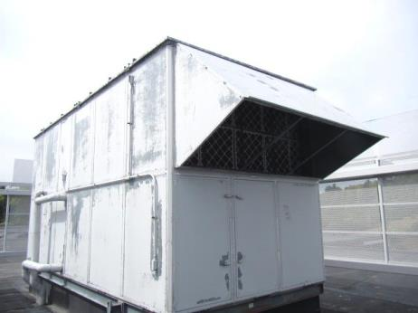
Rooftop AHU
Picture 2
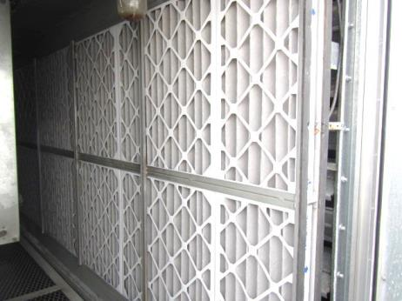
Bank of pleated filters in AHU
Picture 3
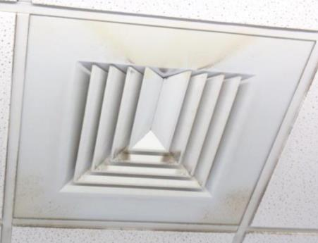
Ceiling-mounted supply diffuser, note dust/debris accumulation on louvers
Picture 4
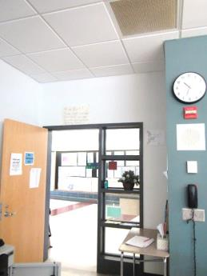
Proximity of exhaust/return vent to open classroom/hallway door (arrows)
Picture 5
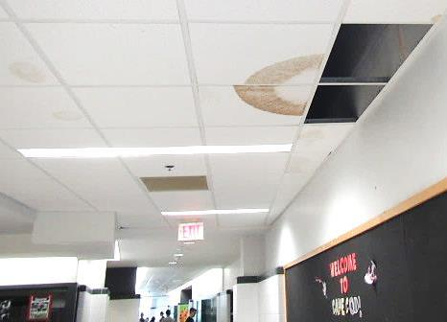
Missing/water-damaged ceiling tiles
Picture 6
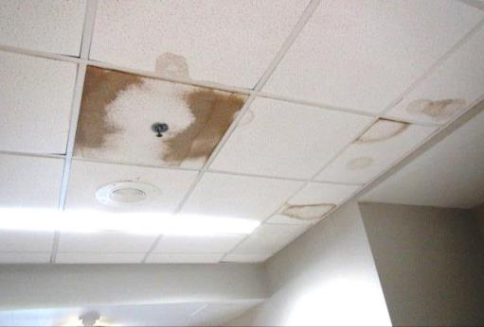
Water-damaged ceiling tiles
Picture 7
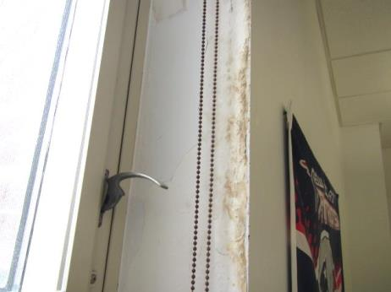
Water-damaged wall around window in room 119
Picture 8
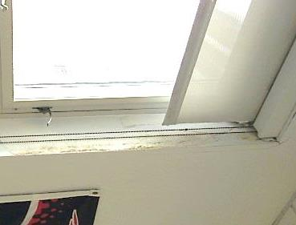
Water-damaged wall around window in room 119
Picture 9
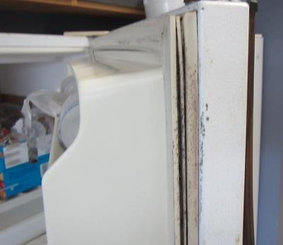
Mold growth (dark staining) on refrigerator/gaskets in room 129
Picture 10
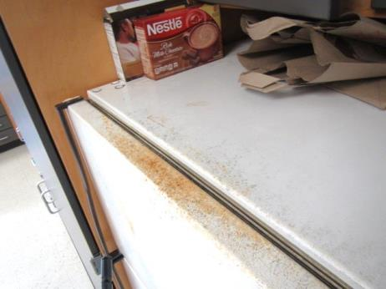
Mold growth (dark staining) on refrigerator/gaskets in room 129
Picture 11
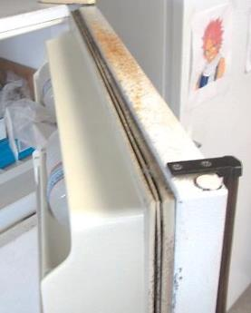
Mold growth (dark staining) on refrigerator/gaskets in room 129
Picture 12
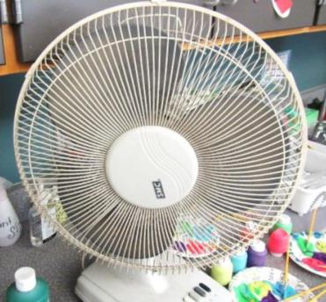
Personal fan with accumulated dust/debris on blades/housing
Picture 13
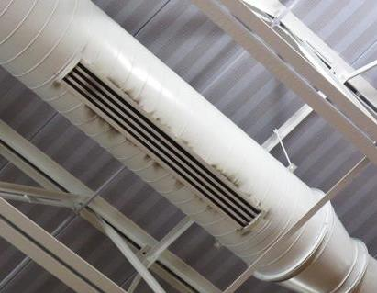
Dust/debris on vents in gym
Picture 14
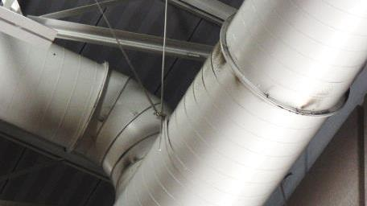
Dust/debris on vents in gym
Picture 15
Worn/damaged carpeting in Teacher's Prep Room near room 108

Location | Carbon  Dioxide  (ppm) | Carbon Monoxide  (ppm) | Temp  (°F) | Relative  Humidity  (%) | PM2.5  (µg/m³) | Occupants  in Room | Windows  Openable | Ventilation |  |  | Remarks
 |  |  |  |  |  |  |  | Intake | Exhaust
Background | 380 | ND | 63 | 37 | 14 |  |  |  |  |  | Partly sunny
Second Floor
201 | 379 | ND | 69 | 29 | 6 | 0 | Y  2/4 | Y |  | Y
202 | 390 | ND | 69 | 31 | 4 | 0 | Y  0/4 | Y |  | Y | PF
203 | 381 | ND | 70 | 30 | 4 | 0 | Y  0/4 | Y |  | Y | Dust/debris on vents
204 | 456 | ND | 69 | 36 | 4 | 0 | Y  0/4 | Y |  | Y | HS
205 | 420 | ND | 69 | 32 | 4 | 0 | N | Y |  | Y | 2 WD CT, PF
206 | 603 | ND | 71 | 32 | 4 | 15 | Y  0/3 | Y |  | Y | Dust/debris on vents, portable AC, area rugs
207 | 468 | ND | 71 | 29 | 4 | 9 | Y  0/4 | Y |  | Y | PF-dusty, area rugs
Teacher’s Prep Room | 471 | ND | 70 | 33 | 4 | 0 | N | Y |  | Y | PFs
208 | 503 | ND | 70 | 34 | 4 | 1 | N | Y |  | Y | 2 WD CTs
208 B | 384 | ND | 68 | 30 | 3 | 0 | Y  2/4 | Y |  | Y | Plants, DO, HS
209 | 428 | ND | 70 | 34 | 4 | 0 | Y  2/4 | Y |  | Y | PF
211 | 597 | ND | 70 | 33 | 6 | 19 | Y  0/4 | Y |  | Y | PF, DO, area rug, dust/debris on vents
212 | 410 | ND | 70 | 30 | 5 | 0 | Y  2/4 | Y |  | Y | Dust/debris on vents
213 | 460 | ND | 71 | 31 | 5 | 1 | Y  0/4 | Y |  | Y | 27 occupants gone~40 mins, DO, PF
214 | 511 | ND | 71 | 31 | 4 | 1 | Y  0/4 | Y |  | Y | 22 occupants gone ~40 mins, DO, occasional window leak reported
215 | 466 | ND | 70 | 30 | 4 | 1 | Y  0/4 | Y |  | Y | 20 occupants gone ~30mins, DO, PF
216 | 582 | ND | 71 | 35 | 4 | 1 | Y  0/4 | Y |  | Y | Occupants at lunch, PF, DO
2nd Floor Hallway (outside 216) |  |  |  |  |  |  |  |  |  |  | MT, WD CTs
217 | 557 | ND | 71 | 35 | 6 | 0 | N | Y |  | Y | DO
218 | 425 | ND | 71 | 31 | 3 | 1 | Y  0/4 | Y |  | Y | 9 occupants gone ~35 mins, plants
219 | 426 | ND | 71 | 30 | 5 | 0 | Y  0/3 | Y |  | Y | Portable AC
220 | 566 | ND | 71 | 30 | 5 | 13 | Y  1/3 | Y |  | Y | Area rug, portable AC
Teacher’s Prep Room | 557 | ND | 72 | 34 | 13 | 2 | N | Y |  | Y | PF-dusty, carpet, WD CT
221 | 825 | ND | 72 | 36 | 6 | 2 | N | Y |  | Y | Dust/debris on vents
222 | 1065 | ND | 72 | 43 | 7 | 23 | N | Y |  | Y | DO, 2 WD CT, exhaust near door
223 | 819 | ND | 72 | 37 | 16 | 24 | Y  2/4 | Y |  | Y | DO, AD, PF, WD CT
224 | 797 | ND | 71 | 39 | 6 | 19 | Y  2/4 | Y |  | Y | DO, exhaust near door
225 | 856 | ND | 72 | 38 | 8 | 24 | Y  0/4 | Y |  | Y | DO, PF-dusty
Library | 452 | ND | 71 | 29 | 2 | 1 | Y  0/10 | Y |  | Y | Carpeting
226 Computer Room | 474 | ND | 72 | 26 | 2 | 0 | N | Y |  | Y | DO
227 Computer Room | 617 | ND | 72 | 30 | 7 | 33 | N | Y |  | Y | DO, 2 WD CT
Library Office | 427 | ND | 72 | 28 | 2 | 0 | N | Y |  | Y | Carpeting
First Floor
101 | 835 | ND | 71 | 34 | 6 | 24 | Y  0/4 | Y |  | Y | Dust/debris on vents, HS
102 | 711 | ND | 71 | 32 | 7 | 21 | Y  0/4 | Y |  | Y | Dust/debris on vents
104 | 500 | ND | 70 | 33 | 4 | 0 | Y  0/4 | Y |  | Y | HS, CP, 5 WD CT
105 | 495 | ND | 70 | 31 | 4 | 0 | N | Y |  | Y | WD CT
106 | 455 | ND | 70 | 30 | 5 | 5 | Y  0/4 | Y |  | Y | Carpet, portable AC, plants, dust/debris on vents
107 | 441 | ND | 69 | 29 | 6 | 11 | Y  2/4 | Y |  | Y | Area rug, CP, portable AC, dust/debris on vents
108 | 583 | ND | 70 | 32 | 5 | 1 | N | Y |  | Y | DO
Teacher’s Prep Room | 491 | ND | 70 | 32 | 4 | 0 | N | Y |  | Y | Worn/damaged carpet, dust/debris on vents
113 | 593 | ND | 71 | 29 | 6 | 22 | Y  0/4 | Y |  | Y | DO, PF
114 | 650 | ND | 71 | 30 | 5 | 20 | Y  ¼ | Y |  | Y | PF, dust/debris on vents
115 | 606 | ND | 68 | 27 | 5 | 1 | Y  2/4 | Y |  | Y | PF, dust/debris on vents
116 | 414 | ND | 69 | 29 | 4 | 0 | Y  2/4 | Y |  | Y
117 | 407 | ND | 69 | 28 | 4 | 0 | N | Y |  | Y
118 | 668 | ND | 70 | 30 | 4 | 24 | N | Y |  | Y | PF, WD CT
119 | 539 | ND | 70 | 26 | 4 | 15 | Y  0/8 | Y |  | Y | Leak reported around windows, water staining/efflorescence, 2 WD CT
120 | 450 | ND | 70 | 28 | 4 | 0 | N | Y |  | Y
121 | 852 | ND | 70 | 38 | 4 | 23 | Y  0/4 | Y |  | Y | Periodic leak reported (plumbing?), DO, exhaust vent near door
122 | 708 | ND | 71 | 32 | 4 | 21 | Y  0/4 | Y |  | Y | Moldy CT (reportedly removed/replaced), plumbing leak
123 | 669 | ND | 71 | 31 | 4 | 28 | Y  0/4 | Y |  | Y | WD CT corner, PF, MT, moldy CT (reportedly removed/replaced)
124 | 591 | ND | 71 | 29 | 6 | 21 | Y  0/4 | Y |  | Y | DO
126 | 405 | ND | 71 | 27 | 2 | 0 | N | Y |  | Y | DO, 4 WD CT, dust/debris on vents
127 | 475 | ND | 71 | 29 | 3 | 3 | N | Y |  | Y | DO
Conference Room 1 | 422 | ND | 70 | 27 | 4 | 0 | N | Y |  | Y | Carpeting
128 Computer Room | 425 | ND | 71 | 27 | 2 | 0 | N | Y |  | Y
129 | 453 | ND | 69 | 31 | 3 | 0 | Y  0/4 | Y |  | Y | Dust/debris on vents, mold growth fridge
130 | 474 | ND | 69 | 32 | 4 | 7 | Y  0/4 | Y |  | Y | DO, PF, plants, dust/debris on vents
131 | 473 | ND | 71 | 31 | 4 | 18 | Y  0/4 | Y |  | Y | PF
132 | 389 | ND | 72 | 27 | 4 | 1 | Y  0/4 | Y |  | Y | PFs, accumulated items
Kiln Room |  |  |  |  |  |  |  |  |  |  | Recommend door sweep, cardboard stored near kiln, reportedly not used in ~ year
Nurse’s Suite | 445 | ND | 71 | 28 | 3 | 3 | Y  ¼ | Y |  | Y | Carpet in office, dust/debris on vents
Guidance Suite | 478 | ND | 71 | 29 | 9 | 5 | Y  0/3 | Y |  | Y | Carpeting, dust/debris on vents
Teacher’s Work Room | 444 | ND | 72 | 29 | 2 | 0 | N | Y |  | Y | 2 photocopiers, dust/debris on vents
Main Office | 440 | ND | 72 | 27 | 3 | 3 | Y  ¼ | Y |  | Y | Carpeting, plants
134 Band | 439 | ND | 71 | 31 | 4 | 0 | Y  0/4 | Y |  | Y | Area carpet, WD CT, DO
Cafeteria | 498 | ND | 69 | 31 | 2 | ~150 | Y  0/5 | Y |  | Y | PFs
Auditorium | 396 | ND | 69 | 34 | 2 | 0 | N | Y |  | Y
Cafeteria/Auditorium Hallway |  |  |  |  |  |  |  |  |  |  | 5 WD CTs
135 Music | 483 | ND | 71 | 34 | 4 | 1 | Y  0/5 | Y |  | Y | Carpeting, dust/debris on vents
Boys Locker Room | 394 | ND | 70 | 30 | 4 | 0 | N | Y |  | Y | WD ceiling leak (corner restroom), dust/debris on vents
Gym | 494 | ND | 69 | 30 | 4 | ~40 | N | Y |  | Y | Dust/debris on vents

