WATER DAMAGE ASSESSMENT

Raynham Middle School
420 Titicut Road
Raynham, MA

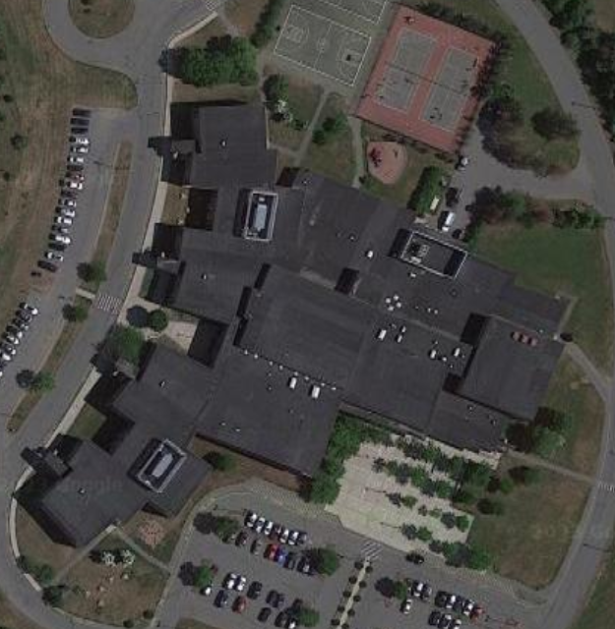

Prepared by:
Massachusetts Department of Public Health
Bureau of Climate and Environmental Health
Indoor Air Quality Program
October 2023

BACKGROUND
Building: | Raynham Middle School (RMS)
Address: | 420 Titicut Road, Raynham, MA
Requestor: | Thomas Killgoar, Facilities Department, Bridgewater-Raynham Regional School District
Reason for Request: | Concerns about mold in a classroom
Date of Assessment: | September 27, 2023
Massachusetts Department of Public Health/Bureau of Environmental Health (MDPH/BCEH) Staff Conducting Assessment: | Ruth Alfasso, Environmental Engineer/Inspector, Indoor Air Quality (IAQ) Program
Building Description: | The RMS is a two-story, red-brick building constructed in 2001. Room 114 is a general classroom located on the ground floor and has tile floors, gypsum wallboard walls, and a suspended ceiling. Only this one area of the school was assessed during this visit.
Windows: | Openable

METHODS
Please refer to the IAQ Manual for methods, sampling procedures, and interpretation of results (MDPH, 2015). Note that this school was visited previously by the IAQ Program. Reports from those visits can be found at: https://www.mass.gov/info-details/indoor-air-quality-reports-cities-and-towns-r#raynham-.

RESULTS AND DISCUSSION
The following is a summary of indoor air testing results (Table 1):
- Carbon Dioxide was below the MDPH recommended guideline of 800 parts per million (ppm) in room 114.
- Temperature was within the MDPH recommended range of 70°F to 78°F in the area tested.
- Relative Humidity was within the MDPH recommended range of 40 to 60% in the area tested.
- Carbon Monoxide was not detected (ND) in the area tested.
- Particulate matter (PM2.5) concentrations measured were below the National Ambient Air Quality (NAAQS) level of 35 μg/m³ in the area tested.

Ventilation
Mechanical ventilation is provided by rooftop air handling units (AHUs). AHUs draw air through fresh air intakes, and then through a bank of pleated filters before they heat and/or cool the air. It is then distributed to occupied areas via ceiling-mounted air diffusers (Picture 1). Exhaust air is returned back to the AHUs via ceiling-mounted return vents (Picture 2). In this room, as with many in the building, exhaust vents are located near the classroom door. Due to their location, the exhaust capabilities of these vents can be diminished when the doors are left open. With the classroom door open, the return/exhaust vent would draw air from the hallway into the classroom instead of stale air out of the classroom.
Since the AHU does not supply cooled air to this classroom during warm weather, an air conditioner is placed in the window during the warm season. This unit had been removed by the time of the visit. Windows can also be opened for additional fresh air.
As noted above, measurements of carbon dioxide in this classroom were below the MDPH guideline of 800 ppm, however the room had been vacant for part of the day before the visit.

Microbial/Moisture Concerns
It is important to note that Massachusetts experienced extended periods of high relative humidity during the summers of 2018, 2021, and 2023. July of 2021 was the wettest ever recorded in Massachusetts, and the three-month period from June through August, known as the meteorological summer, was the fourth wettest on record, according to the National Oceanic and Atmospheric Administration’s (NOAA) Centers for Environmental Information. The three-month period also was the third warmest ever in the state and was tied for the warmest on record across the United States (HG, 2021, NOAA, 2021). Data for 2023 may show similar if not more extreme conditions.

Under these weather conditions, public buildings experienced extended periods of water vapor exposure from high relative humidity. When exposed to these conditions, porous materials such as gypsum wallboard, cardboard, and other materials may become moistened and colonized with mold, particularly if located in areas that are prone to developing condensation, such as floors and walls in contact with the ground (e.g., below grade space). According to the American Society of Heating, Refrigerating and Air-Conditioning Engineers (ASHRAE); if relative humidity exceeds 70%, mold growth may occur due to wetting of building materials (ASHRAE, 2022) even in the absence of liquid water.

No water-damaged, moldy, or musty materials were found in room 114 during the visit. Occupants of this room had reported mold growth on a window frame. The window frame is a non-porous material and is not itself able to support mold growth (Pictures 3 and 4). Mold can, however, grow on a layer of dust or debris accumulated on the window frame. This material can be removed through cleaning, and the window frame had reportedly been cleaned twice since the start of the school year.

To support mold growth, a surface needs to be exposed to water. This particular area of the window frame may be more likely to become moistened by condensation than other areas due to its location. At the time of the visit, and likely during most of the year, this corner of the room is shaded by an adjacent wall (Picture 4). This would lead to that area of the window and frame being a cooler temperature than adjacent areas. During periods of high humidity, this area would be the first to experience condensation. Keeping the window frame free of dust and debris would reduce the impact of any condensation leading to mold growth in this area.

The exterior of the building was also examined in the area of room 114 for any additional factors that may impact IAQ in the room. Room 114 is located on a corner, giving it two walls exposed to the exterior. This may make temperature control more difficult, particularly if windows or window frames are not sufficiently insulated. Chronic shading of portions of the window and wall are also demonstrated by staining on the exterior of the windows and brick that indicates water exposure, and the growth of moss (Pictures 5 and 6). Because the shading is due to the building design which cannot be changed, care should be taken to reduce additional moisture exposure to the building. For example, mulch was noted beneath windows (Pictures 5 and 6), which can hold moisture against the building. Mulch can also have a strong odor, and may be a fire hazard. Trees and other plants were also noted near the building (Picture 7), increasing water retention and shade. Watering these plants may moisten the building exterior further. While the brick is in good condition and no signs of water infiltration were noted or reported in classroom 114, water exposure to the exterior may increase humidity inside, particularly near the wall, and increase the likelihood of condensation.

The guideline “Preventing Mold Growth In Schools During Hot, Humid Weather” https://www.mass.gov/info-details/preventing-mold-growth-in-massachusetts-schools-during-hot-humid-weather should be used to minimize the impact of such weather on classroom materials. This includes use of air conditioning and dehumidifiers, ensuring exhaust vents are on and operable, keeping windows closed, and ensuring air can circulate around porous materials.

Other conditions

An air purifier was noted in room 114 (Picture 8). This model of air purifier appears to use high-efficiency particulate arrestance (HEPA) and carbon filters, which are good choices to remove dust, other particles, and odors from the indoor air. These units should be cleaned and maintained, including filter changes, in accordance with manufacturer’s instructions.

AHU filters should be changed 2-4 times a year or per the manufacturer’s recommendations. Filters should be at least a Minimum Efficiency Rating Value (MERV) of 8 or higher, if they fit and the equipment can handle the pressure reductions caused by more restrictive filters. Filters at the RMS are reportedly changed 2-4 times a year. AHUs should also be vacuumed/cleaned whenever the filters are changed.

CONCLUSIONS/RECOMMENDATIONS
The following are recommendations to improve and maintain IAQ:

Ventilation Recommendations
- Check exhaust vents for draw periodically and repair when needed. Consider keeping classroom doors closed to improve exhaust effectiveness.
- Continue with regular filter changes for HVAC equipment using the best quality/highest minimum efficiency rating value (MERV) that can be used. During filter changes, vacuum debris from univent and AHU cabinets.

Water Damage Recommendations
- Management of buildings in extreme relative humidity and rain can be challenging. The following documents can provide guidance that can be used to reduce the impact of hot, humid weather in buildings; Mold Growth Prevention During Hot, Humid Weather https://www.mass.gov/service-details/preventing-mold-growth-in-massachusetts-schools-during-hot-humid-weather and Remediation and Prevention of Mold Growth and Water Damage in Public Schools https://www.mass.gov/service-details/remediation-and-prevention-of-mold-growth-and-water-damage-in-public-schools-and.
- Ensure that all windows are closed when any air conditioning is operating, particularly during periods of hot, humid weather.
- Avoid storing porous materials in contact with the floors, particularly during periods of high humidity.
- Trim bushes and plants at least five feet away from the building, particularly near windows. Consider replacing mulch near the building with stone or other alternative.
- For more information on mold consult with the US EPA’s “Mold Remediation in Schools and Commercial Buildings”. Available at: http://www.epa.gov/mold/mold-remediation-schools-and-commercial-buildings-guide (US EPA, 2008).

Other Recommendations
- Maintain air purifiers in accordance with manufacturer's instructions. Avoid using any air purifiers that may produce ozone (e.g., ionizers). Consider locating air purifiers so the outlet of the units is in the breathing zone of occupants.
- Use only school-supplied or compatible cleaning and sanitizing products, keep tightly closed when not in use, and keep away from children. Avoid using any scented products such as air fresheners.
- Refer to resource manual and other related IAQ documents located on the MDPH’s website for further building-wide evaluations and advice on maintaining public buildings. These documents are available at: http://mass.gov/dph/iaq.

REFERENCES
ASHRAE. 2022. American Society of Heating, Refrigeration and Air Conditioning Engineers (ASHRAE) Ventilation for Acceptable Indoor Air Quality. ANSI/ASHRAE Standard 62.1-2022. Atlanta, GA.
HG. 2021. Mold keeps South Hadley High School shuttered. Hampshire Gazette. https://www.gazettenet.com/South-Hadley-High-School-still-closed-amid-mold-remediation-42413519.
MDPH. 2015. Massachusetts Department of Public Health. Indoor Air Quality Manual: Chapters I-III. Available at: https://www.mass.gov/lists/indoor-air-quality-manual-and-appendices#indoor-air-quality-manual-.
NOAA. 2021. Summer 2021 neck and neck with Dust Bowl summer for hottest on record. National Oceanic and Atmospheric Administration, 1401 Constitution Avenue NW, Room 5128, Washington, DC 20230 https://www.noaa.gov/news/summer-2021-neck-and-neck-with-dust-bowl-summer-for-hottest-on-record.
US EPA. 2008. “Mold Remediation in Schools and Commercial Buildings”. Office of Air and Radiation, Indoor Environments Division, Washington, DC. EPA 402-K-01-001. September 2008. Available at: http://www.epa.gov/mold/mold-remediation-schools-and-commercial-buildings-guide.
Picture 1
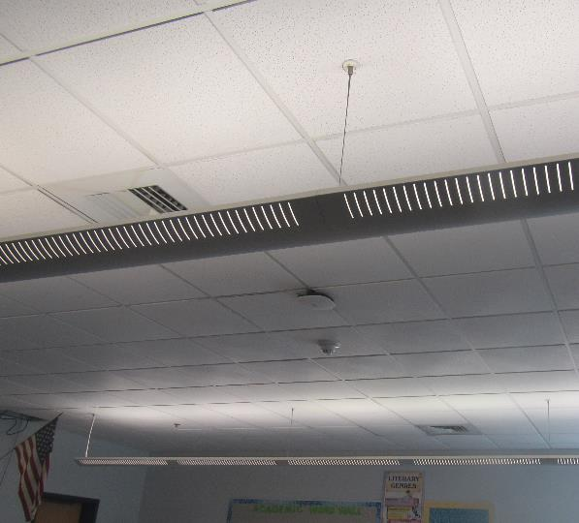
Ceiling tiles and supply vents in classroom 114
Picture 2
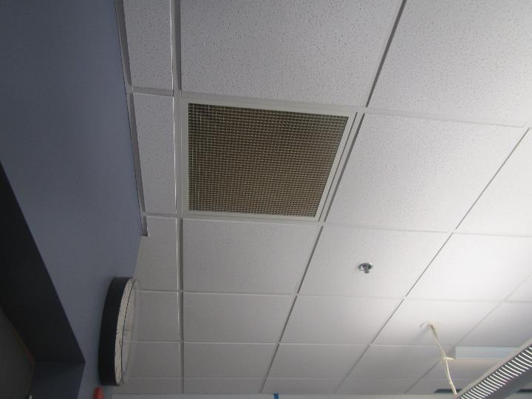
Classroom return vent

Picture 3
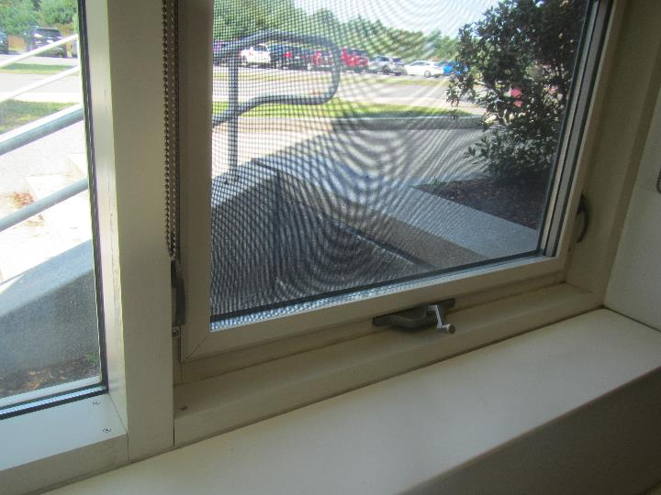
Window frame where mold growth had been reported
Picture 4
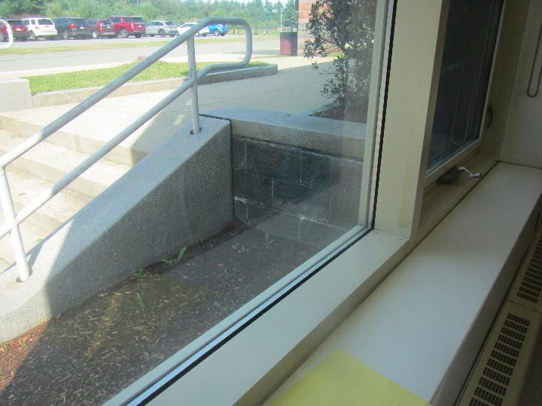
Window frame where mold growth had been reported; note shadow outside shading lower part of window

Picture 5
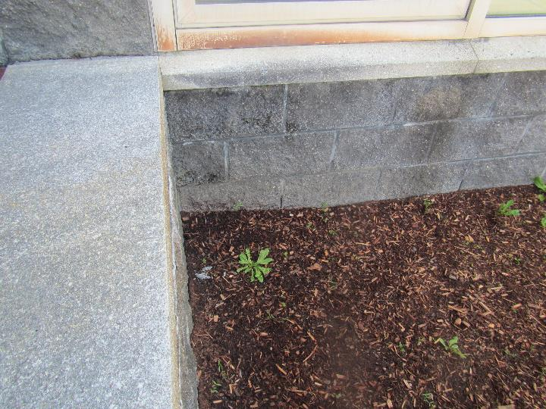
Staining on exterior of window and moss growth on brick
Picture 6
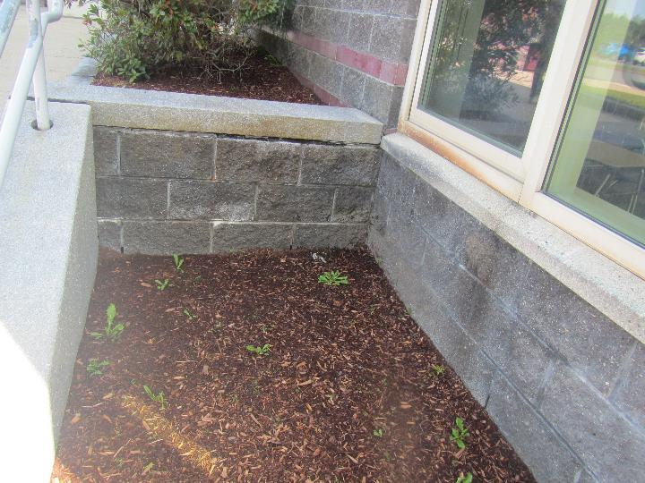
Staining on exterior of window and moss growth on brick; note mulch next to building

Picture 7
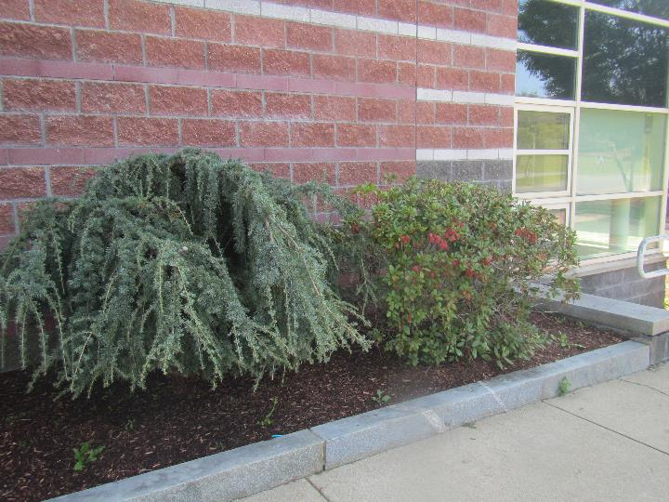
Plants next to the building
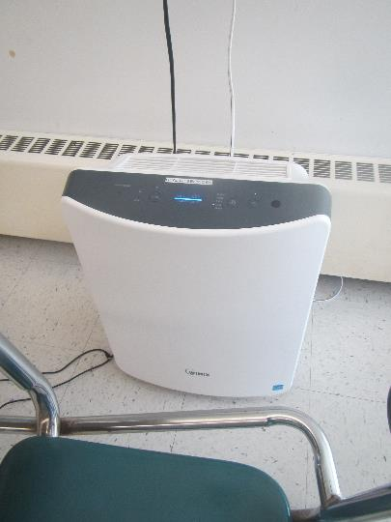
Picture 8

Air purifier

Location | Carbon  Dioxide  (ppm) | Carbon Monoxide  (ppm) | Temp  (°F) | Relative  Humidity  (%) | PM2.5  (µg/m³) | Occupants | Windows  Openable | Ventilation |  | Remarks
 |  |  |  |  |  |  |  | Supply | Exhaust
Background | 380 | ND | 70 | 51 | 8 |  |  |  |  | Partly sunny
114 | 469 | ND | 71 | 51 | 5 | 0 | Y | Y | Y | Air purifier, non-carpeted floor

