INDOOR AIR QUALITY ASSESSMENT

Raynham Town Hall
558 S. Main St, Raynham, MA

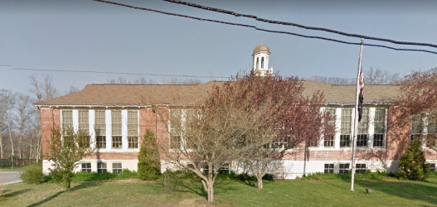

Prepared by:
Massachusetts Department of Public Health
Bureau of Environmental Health
Indoor Air Quality Program
September 2018

BACKGROUND
Building: | Raynham Town Hall (RTH)
Address: | 558 S. Main St, Raynham, MA 02767
Reason for Request: | General indoor air quality (IAQ)
Date of Assessment: | August 2, 2018
Massachusetts Department of Public Health/Bureau of Environmental Health (MDPH/BEH) Staff Conducting Assessment: | Sharon Lee, Environmental Analyst, IAQ Program  Surya Narayanan-Pandit, Intern, IAQ Program
Date of Building Construction: | Built in 1919 as a school, remodeled as Town Hall in 2007.
Building/Site Description: | One-story brick building with occupied basement. The building has a peaked roof with shingles.
Windows: | Openable

Methods
Please refer to the IAQ Manual for methods, sampling procedures, and interpretation of results (MDPH, 2015).

Results
The following is a summary of indoor air testing results (Table 1).
- Carbon dioxide levels were below the MDPH guideline of 800 parts per million (ppm) in all areas.
- Temperature was within the MDPH recommended range of 70°F to 78°F in the majority of occupied areas.
- Relative humidity was above the MDPH recommended range of 40 to 60% in the majority of occupied areas.
- Carbon monoxide levels were non-detect (ND) throughout all areas surveyed.
- Fine particulate matter (PM2.5) concentrations measured were below the National Ambient Air Quality Standard (NAAQS) level of 35 μg/m³ in all areas assessed.

Ventilation
It can be seen from Table 1 that carbon dioxide levels were below 800 ppm in all areas surveyed. A heating, ventilation, and air-conditioning (HVAC) system was retrofitted into the attic space of the school when the building was renovated in 2007. Air-handling units (AHU) are located in the attic (Picture 1), while condensers are located on the building exterior (Picture 2). Filtered air is supplied to occupant areas via ceiling-mounted diffusers (Picture 3); air is brought back to the AHUs via ceiling-mounted return vents (Picture 4). BEH/IAQ Program staff could not identify a fresh air source to the AHUs. If the AHUs do not have a fresh air source, they will recirculate air within the building. Without a fresh air source, normally occurring indoor air pollutants tend to accumulate.
Dust was observed on a number of air supply and return diffusers (Table 1). Dust can be attracted to air supply vents because of the charge transferred to the metal diffuser when air is propelled out of the vent at high velocity. Dust can accumulate on return vents as air is being removed from a room. Accumulated dust can dislodged and recirculate in the air, becoming a source for respiratory irritation, so vents should be cleaned of dust periodically.
The HVAC system is equipped with filters. The MDPH recommends using pleated filters in AHUs with a Minimum Efficiency Reporting Value (MERV) of 8 or higher, which are adequate in filtering out pollen and mold spores (ASHRAE, 2012). Filters should be changed regularly, two to four times a year.

Microbial/Moisture Concerns
BEH/IAQ Program staff noted rust stains on air diffusers on the ground floor of the building (Picture 5). These stains suggest water is condensing on the metal diffusers when the air conditioning is in use. Condensation occurs when humid air comes in contact with a surface that is lower than the dew point, which can occur when the air conditioning system chills the supply diffusers which are in contact with humid basement air. In some basement offices, paper items hanging on walls had curling edges (Table 1), further indicating high humidity in these areas. Below-grade spaces are more likely to experience elevated relative humidity levels. Relative humidity in excess of 70 percent for extended periods of time, even in the absence of other sources of water, can provide an environment for mold and fungal growth (ASHRAE, 1989).
As mentioned, dust was observed on some supply diffusers. Over time, water condensing on the supply vents can cause mold to grow on the dust. RTH staff reported that this condition occurred previously on the ground floor space. No mold growth was observed at the time of the assessment.
To reduce humidity in below-grade spaces it is recommended that dehumidifiers are used during hot, humid weather or as needed. A dehumidifier operating in the Board of Health office is successful in reducing humidity below 70% in the area, which is important in preventing water damage and mold growth. Dehumidifiers must be maintained in accordance with manufacturer’s instructions including drainage and cleaning. Note that papers and other items were found stored on the floor in the basement. Because of humidity and the potential for condensation on the floor, no porous items such as papers, boxes or clothing should be stored on the floor. Any items should be placed in cabinets or on shelving.
Water-damaged ceiling tiles were observed throughout the McKinnon meeting room (Picture 6). Plumbing leaks are likely the source of this water damage. Leaks should be repaired, and water-damaged ceiling tiles should be replaced once the leaks have been fixed. During the replacement, the area above the ceiling tile system should be checked for any additional water damage or odors and cleaned or repaired as needed.
Indoor plants were observed in a few areas (Picture 7; Table 1). Plants can be a source of pollen and mold, which can be respiratory irritants to some individuals. Plants should be properly maintained and equipped with drip pans and should be located away from air diffusers to prevent the aerosolization of dirt, pollen and mold. Plants should not be placed on porous materials such as paper towels or cloth, as these items are likely to become moistened and lead to microbial growth.
Several sinks in the building had gaps between the countertop and the backsplash (Picture 8). This gap can allow moisture to penetrate into the wood and lead to deterioration or mold growth. Sink backlashes should be sealed with caulking or replaced with a single-piece backsplash unit with no gap.
Plants were also noted growing close to the foundation (Pictures 2 and 9) which can hold water against the bricks and lead to deterioration. Roots growing into the foundation can also damage building materials and lead to increased chances of water penetration. In addition, leaves from overhanging trees can clog drainage gutters and downspouts on the roof. Plants should be trimmed away from the side of the building.

Other IAQ Evaluations
Exposure to low levels of volatile organic compounds (VOCs) may produce eye, nose, throat, and/or respiratory irritation in some sensitive individuals. BEH/IAQ staff examined spaces for products containing VOCs, noting cleaning products, and hand sanitizers in a number of areas in the building (Table 1). All of these products have the potential to be irritants to the eyes, nose, throat, and respiratory system of sensitive individuals.
David Flaherty, Town Administrator, reported that a breaker for one AHU trips during extended periods of high temperature. Areas impacted are along the front of the building that receives sunlight during the day. Several measures can be taken to reduce both solar heat gain and glare into these areas, including the use of adjustable blinds, installation of tinted film on the windows, or the use of awnings or overhangs on the outside to shade the window areas. These measures should improve thermal comfort, reduce energy use, and decrease glare that can be a source of headaches and eye irritation. If measures to reduce solar heating do not prevent the electrical system breakers from tripping, repairs to the air conditioning and electrical systems may be needed as well.
Cooking equipment and food were found in the building, which can attract pests. To prevent rodent issues, the principles of integrated Pest Management (IPM) should be followed, which include the sealing of entry holes, removal of food and water access, and the elimination of areas where they can nest. Note that rodent infestation can result in IAQ related symptoms due to materials in their wastes. Mouse urine contains a protein that is a known sensitizer (US EPA, 1992). A sensitizer is a material that can produce symptoms (e.g., running nose or skin rashes) in sensitive individuals after repeated exposure.
An insect nest was observed hanging from the outside of the building in a back corner (Picture 10). A licensed pest contractor should be engaged to assist with identification and removal of the nest to prevent deterioration of the building as well as potential stings.

Recommendations
In view of the findings at the time of the visit, the following recommendations are made:
- Operate the HVAC system during all occupied hours. During hot weather, periodically check the HVAC unit to ensure continued delivery of conditioned air.
- If no fresh air source exists for the HVAC system, use openable windows to increase fresh air circulation when air does not need chilling. Ensure all windows are closed when the air-conditioning is operating. Using air-conditioning or the HVAC system in chilling mode when windows are open can cause condensation to form on surfaces on the building, which can lead to mold growth
- Use filters with a MERV rating of at least 8, and change them 2 to 4 times a year.
- Clean dust from supply and exhaust vents perioridically.
- Use dehumidifiers in all occupied areas on the lower level. Ensure condensate from these units is drained properly or emptied regularly to prevent stagnant water or spills and units are maintained and cleaned in accordance with manufacturer’s instructions.
- Avoid storing any porous materials on the floor on the lower level to prevent water damage.
- Repair roof or plumbing leaks that are leading to water-damaged ceiling tiles. Then replace stained tiles after inspecting above the ceiling tile system, and cleaning as necessary.
- Ensure indoor plants are properly maintained and not overwatered, and ensure each has a waterproof drip pan to prevent damage to porous materials.
- Repair sink backsplashes with appropriate caulking material, or replace with a single-piece unit.
- Trim plants and trees away from the building to prevent damage to the foundation and potential water infiltration. Trim trees from overhanging the roof.
- Reduce the use of products that contain VOCs such as cleaners and hand sanitizers.
- Consider the use of adjustable blinds, tinted film, or other measures to reduce solar heating in the front of the building and reduce stress on the air conditioning system. If such measures do not prevent the electrical system from becoming overloaded, the air conditioning system and the electrical systems will need to be adjusted.
- Use the principles of integrated pest management (IPM) to rid this building of pests. Activities that can be used to eliminate pest infestation may include the following activities.
  - Do not use recycled food containers. Seal recycled containers in a tight fitting lid to prevent rodent access.
  - Remove non-food items that rodents are consuming.
  - Stored foods in tight fitting containers.
  - Avoid eating at workstations. In areas were food is consumed, vacuum periodically to remove crumbs.
  - Regularly clean crumbs and other food residues from toasters, toaster ovens, microwave ovens and other food preparation equipment;
  - Examine each room and the exterior walls of the building for means of rodent access and seal appropriately. Holes as small as ¼” is enough space for rodents to enter an area. If doors do not seal at the bottom, install a weather strip as a barrier to rodents
  - Reduce harborages (e.g., cardboard boxes) where rodents may reside.
  - Refer to the IPM Guide, which can be obtained at the following Internet address: https://www.mass.gov/files/documents/2016/08/wk/ipm-kit-for-bldg-mgrs.pdf.
- Consult with a licensed pest contractor to identify and safely remove the insect nest from the eaves of the building.
- Refer to resource manual and other related indoor air quality documents located on the MDPH’s website for further building-wide evaluations and advice on maintaining public buildings. These documents are available at http://mass.gov/dph/iaq.

REFERENCES
ACGIH. 1989. Guidelines for the Assessment of Bioaerosols in the Indoor Environment. American Conference of Governmental Industrial Hygienists, Cincinnati, OH.
ASHRAE. 2012. American Society of Heating, Refrigeration and Air Conditioning Engineers (ASHRAE) Standard 52.2-2012 -- Method of Testing General Ventilation Air-Cleaning Devices for Removal Efficiency by Particle Size (ANSI Approved). 2012.
Burge, H.A. 1995. Bioaerosols. Lewis Publishing Company, Boca Raton, FL.
MDPH. 2015. Massachusetts Department of Public Health, Indoor Air Quality Manual: Chapters I-III. Available at: http://www.mass.gov/eohhs/gov/departments/dph/programs/environmental-health/exposure-topics/iaq/iaq-manual/.
US EPA. 1992. Indoor Biological Pollutants. US Environmental Protection Agency, Environmental Criteria and Assessment Office, Office of Health and Environmental Assessment, research Triangle Park, NC. EPA 600/8-91/202. January 1992.

Picture 1
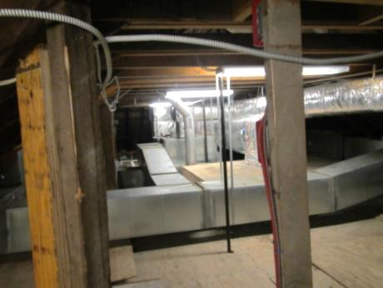
Air-handling units and ductwork in the attic
Picture 2
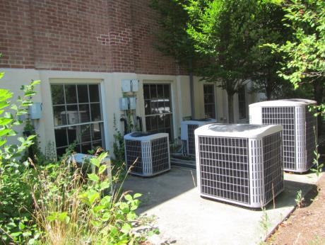
Air conditioning condensers on the outside of the building, also note trees close to building
Picture 3
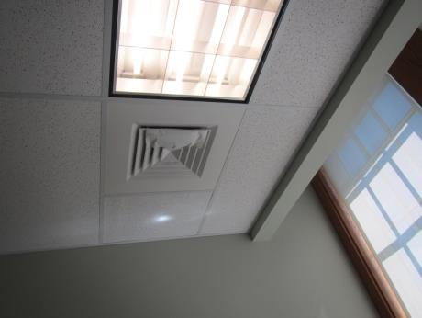
Typical supply vent
Picture 4
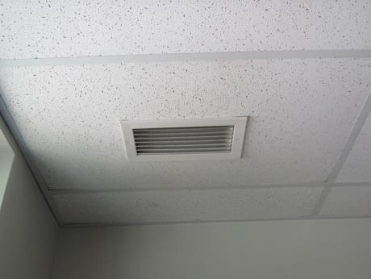
Return vent
Picture 5
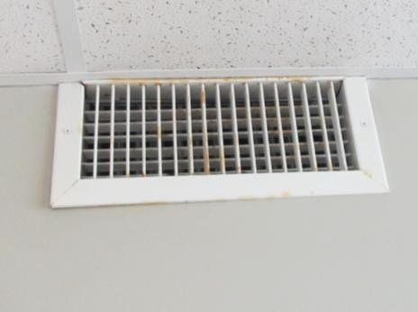
Rust stains on ground floor supply vent indicating chronic moisture
Picture 6
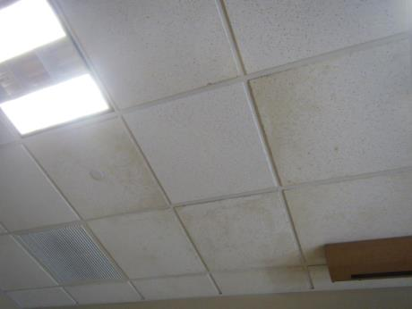
Water-damaged ceiling tiles
Picture 7
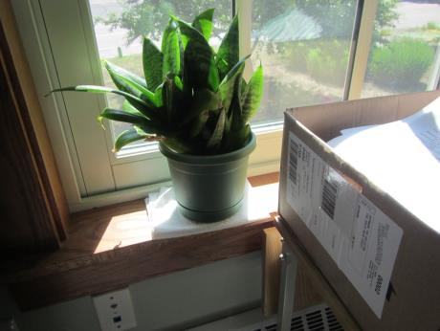
Plant on porous material
Picture 8
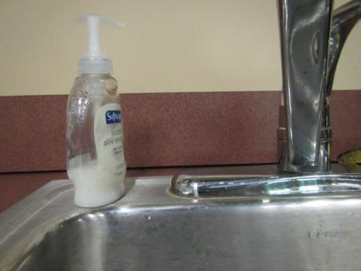
Gap in sink backsplash
Picture 9
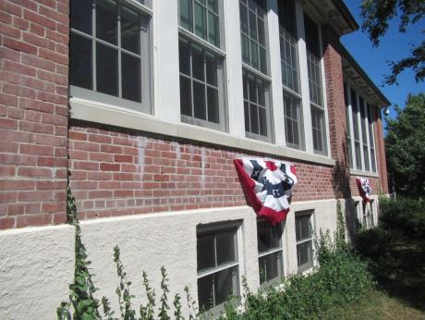
Plants against foundation
Picture 10
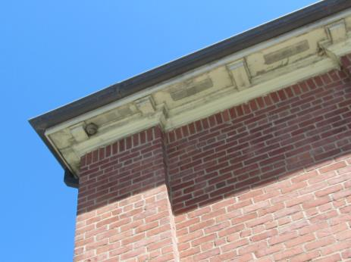
Insect nest under eaves of building
Location | Carbon  Dioxide  (ppm) | Carbon Monoxide  (ppm) | Temp  (°F) | Relative  Humidity  (%) | PM2.5  (µg/m3) | Occupants  in Room | Windows  Openable | Ventilation |  | Remarks
 |  |  |  |  |  |  |  | Supply | Exhaust
Outdoor (background) | 293 | ND | 84 | 80 | 19 |  |  |  |  | Sunny
2nd Floor
Accounting main | 329 | ND | 74 | 64 | 5 | 2 | Y | Y  Dusty | Y | DO, plants
Accounting office | 391 | ND | 74 | 68 | 5 | 0 | Y | Y | Y | DO, HS
Copy room | 348 | ND | 73 | 69 | 5 | 0 | N | Y | Y | DO, 1 copier
Treasurer/Collector Main | 402 | ND | 73 | 67 | 5 | 2 | Y | Y | Y | Plants
Treasurer’s office | 311 | ND | 73 | 67 | 5 | 0 | Y | Y | Y | DO
McKinnon meeting room | 358 | ND | 72 | 75 | 6 | 0 | Y | Y | Y | WD CT, DO, gap between sink backsplash and countertop
Conference room | 323 | ND | 72 | 74 | 7 | 0 | Y | Y | Y | Sun, WD CT, plant
Assessor’s main | 228 | ND | 73 | 74 | 7 | 0 | Y | Y | Y  Dusty | PF
Assessor’s office | 325 | ND | 73 | 76 | 7 | 1 | Y | Y | Y | DO
Selectmen’s office | 439 | ND | 75 | 64 | 4 | 2 | Y | Y | Y | Plants
Town Administrator’s office | 463 | ND | 73 | 64 | 4 | 1 | Y | Y | Y | DO
Town Clerk main | 427 | ND | 73 | 67 | 5 | 2 | Y | Y | Y
Town Clerk’s office | 367 | ND | 72 | 66 | 6 | 0 | Y | Y | Y | Food storage, refrigerator
1st Floor
Inspectional Services main | 374 | ND | 72 | 75 | 7 | 0 | Y | Y  Rusty | Y
Inspectional Services office | 362 | ND | 71 | 72 | 7 | 1 | Y | Y | Y
Planning office | 382 | ND | 71 | 67 | 6 | 0 | Y | Y  Rusty | Y | WD CT, DO
Planning office main | 392 | ND | 71 | 72 | 7 | 1 | Y | Y  Rusty | Y
Copy room | 323 | ND | 71 | 72 | 6 | 0 | N | Y | Y | DO, copier
Lunch room | 295 | ND | 71 | 63 | 5 | 0 | Y | Y | Y | Refrigerator, toaster, gap between sink backsplash and counter top, DO
Board of Health main | 361 | ND | 71 | 56 | 5 | 2 | Y | Y | N | PF, dehumidifier
Board of Health office | 452 | ND | 71 | 57 | 5 | 1 | Y | Y | N
Conservation office | 315 | ND | 71 | 58 | 5 | 0 | Y | Y | Y | Curling paper on walls
Electrical/storage | 331 | ND | 72 | 66 | 5 | 0 | N | Y | N | Paper items stored on floor

