Websites and Resources:
Massachusetts Department of Public Health School Health Unit
School Health Related Laws, Regulations and Guidelines, and Mandates
Medication Administration Program Information for Schools
https://www.mass.gov/orgs/school- health-services
Massachusetts Department of Public Health Immunization Program
School Immunization Requirements MIIS Registry Information www.mass.gov/dph/imm
State Epidemiologist line: (617) 983-6800
Massachusetts Department of Elementary and Secondary Education
MA School Nurse Licensure Information Education Laws, Regulations, and Mandates Updates Related to PreK-12 Institutions http://www.doe.mass.edu/
Boston University: School Health Institute for Education and Leadership Development
(BU SHIELD)
Professional Development and CEUs/CNEs Mandated Programs for New and Experienced School Nurses
Resources for School Nurses, School Health Professionals, and School Administrators https://shield.bu.edu/
Massachusetts School Nurse Organization
State affiliate of the National Association of School Nurses (NASN) http://www.msno.org/ https://www.nasn.org/
Massachusetts Department
of Public Health School Health Unit Staff
Karen Robitaille, MBA, MSN, RN, NCSN
she/her/hers
Director of School Health Phone: (781) 675-0463
Email: karen.robitaille3@mass.gov
Caitlin Pettengill, DNP, RN
she/her/hers
Assistant Director of School Health Phone: (781) 493-4260
Email: caitlin.pettengill@mass.gov
Janet Guertin-Moruzzi, MEd, BSN, RN, NCSN
she/her/hers
Public Health Nurse Advisor: Non-Public Schools Phone: (857) 319-1408
Email: janet.moruzzi@mass.gov
Jill Connolly, MEd, BSN, RN, NCSN Medication Program Coordinator Nursing Advisor
Phone: (781)506-2149 (781) 540-6095
Email: jill.e.connolly@mass.gov
Evelyn Rodriguez she/her/hers Program Coordinator
Phone: (617) 994-9813
Email: evelyn.l.rodriguez@mass.gov
Lauren Augustin, BA she/her/hers Operations Coordinator Phone: (781) 540-6255
Email: Lauren.Augustin@mass.gov
Robert Leibowitz, Ph.D. he/him/his Epidemiologist
Email: robert.leibowitz@mass.gov
Kathrine A. Mansfield, MPH
she/her/hers
Child/Adolescent School-Based Health Epidemiologist
Email: Kathrine.A.Mansfield@mass.gov
Massachusetts Department of Public Health
School Health Services

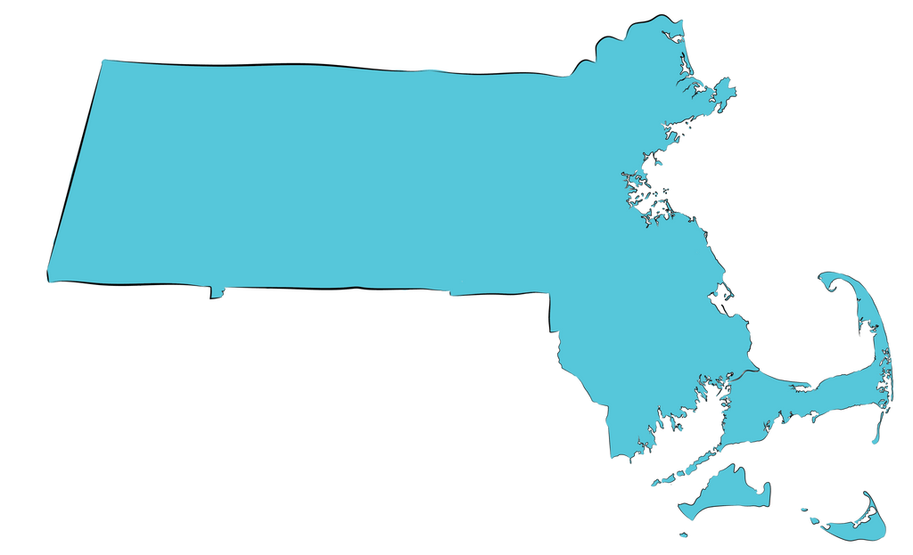

Regional Consultation Program

Regional School Nurse Consultant Contact Information:

Boston
Mary Jane O'Brien, PhD, RN, CPNP, NCSN mobrien@bostonpublicschools.org
(617) 635-6788

Central
Tracy Rowe, MEd, BSN, RN, NCSN rowet@weston.org
(781) 392-7726

Metro-West
TBD
*************@braintreeschools.org (781) 848-4000 x7841

Northeast
Shanyn A. Toulouse, DNP, MEd, RN, NCSN shanyn.toulouse@haverhill-ps.org
(978) 420-1919

Southeast
Ann M. Linehan, DNP, MSN, RN annlinehan@bpsma.org
(508) 580-7363

Western (Hampden, Hampshire)
Veronica Webb Barrett, MSN, MA Ed Psych, RN, HNB-BC
webbv@springfieldpublicschools.com
(413) 896-8100

Western (Berkshire, Franklin) Margaret Burch, MS, RN, NCSN margaret.burch@frsu38.org
413-665-1155 ext. 7740

Healthy Kids Learn Better

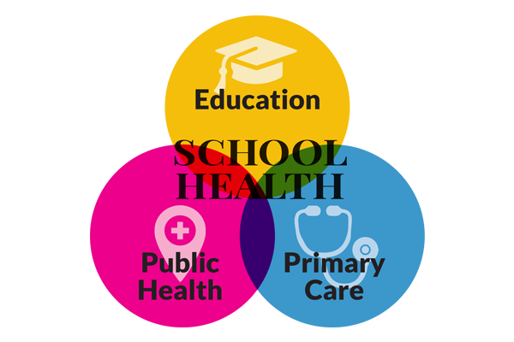
Aim of the MDPH School Health Services Regional Consultation Program:
To improve professional school nursing practice and develop school nursing leadership through:
Expert consultation and technical assistance services provided by highly qualified and experienced school nurses in your region
Regional networking, collaborative projects, planning, and research
Providing communication and support related to important practice updates relevant to all aspects of school health services
Q&A

What services does the Regional Consultation Program offer?
The Regional Consultant in your area hosts educational and networking programs for ALL school nurses to keep you up to date on important school health related requirements and resources.
Your Regional Consultant develops and maintains communication systems such as newsletters, e-mail lists, or other tools to share updates and information relevant to your practice setting.

Who can utilize this program?
ALL school nurses, school health staff, school administrators, school physicians, or anyone who has questions regarding school health related services, programs, laws, regulations, or mandates.

When should I contact my Regional Consultant?
Your Regional Consultant is available to help you with any question or concern that you, or your school’s administration may have related to school nursing practice, regulations, and other guidance.

Where else can I find help?
Your Regional Consultant will be able to direct you to the most appropriate resource based on your unique questions and needs. If they don’t have the answer they will find it for you! Be sure to utilize all of the online resources available to you. Please see the “Websites and Resources” section of this brochure.

