MASSACHUSETTS RARE DISEASE ADVISORY COUNCIL (RDAC)
Remote meeting May 22, 2025
9:00 am – 11:00 am
Meeting Minutes – Approved July 24, 2025

9:00 Dr. Dylan Tierney welcomed all to the meeting. He let all know that the public was welcome to attend any RDAC meeting however only guests on the agenda would be allowed to speak at the meeting. He asked all guests not on the agenda to turn off their camera and microphones and to please refrain from using the chat.
He then introduced a new member to the council, Olaide Adekanbi. He let all know that Olaide was filling the seat previously held by Guadalupe Hayes-Mota, who moved out of state and resigned from the council. He welcomed Olaide and added that she grew up in an immigrant household with sickle cell disease. She was an ambassador for the Massachusetts Sickle Cell Association and she was excited to join the council. He then asked her to introduce herself.
Olaide Adekanbi let all know that she was excited to join the council.

D Tierney then stated that he would hold a roll call to establish a quorum and bring the meeting to order.
Roll Call to establish a quorum
 | Member | Present
1. | Olaide Adekanbi | X
2. | Olaf Bodamer, MD, PhD, FACMG | X
3. | Stacey Cook, MD, PhD | X
4. | Eric Crombez, MD | X
5. | Andrew A. Dwyer, PhD, FNP-BC | X
6. | Christelle Moufawad El Achkar, MD | X
7. | Senator Paul Feeney (Maya Rabinovitz) | -
8. | Julie Gortze, RN | X
9. | Heather Gray-Edwards DVM, PhD | X
10. | Alison Griffin, MS, RD, CSO, CNSc, LDN | X
11. | Yue Huang, MS | X
12. | Lena Joseph, RN | X
13. | Representative Jay Livingstone (Cassidy Trabilcy) | X
14. | Valarie Molyneaux | X
15. | Alexsandra Mahady | X
16. | Representative Joseph McKenna | X
17. | Jenn McNary | -
18. | Tai Pasquini, MPA, PhD | X
19. | Shivang Patel, PharmD | -
20. | Asma Rashid MS CGC | X
21. | Gail Ryan, PharmD | X
22. | Robert Schultz | X
23. | Kristen Shannon, MS, LCGC | X
24. | Glenda Thomas | X
25. | Ryan Thompson, MD, MPH | -
26. | Ross Zafonte, DO | -
27. | Dylan Tierney, MD | X

D Tierney noted that a quorum was reached and he called the meeting to order at 9:07 am.
He then conducted a roll call vote to accept the meeting minutes from the last meeting. He asked all if they received the minutes, all acknowledged yes. He asked if there were any edits or corrections to the minutes. Then stating, hearing none, he asked for a motion to accept the minutes as presented. T Pasquini made a motion to accept the minutes as presented, A Dwyer seconded. D Tierney then conducted a Roll Call vote to approve minutes from the last meeting (3.27.25)
 | Member | Approved
1. | Olaide Adekanbi | abstained
2. | Olaf Bodamer, MD, PhD, FACMG | X
3. | Stacey Cook, MD, PhD | X
4. | Eric Crombez, MD | X
5. | Andrew A. Dwyer, PhD, FNP-BC | X
6. | Christelle Moufawad El Achkar, MD | X
7. | Senator Paul Feeney (Maya Rabinovitz) | -
8. | Julie Gortze, RN | X
9. | Heather Gray-Edwards DVM, PhD | X
10. | Alison Griffin, MS, RD, CSO, CNSc, LDN | X
11. | Yue Huang, MS | X
12. | Lena Joseph, RN | abstained
13. | Representative Jay Livingstone (Cassidy Trabilcy) | X
14. | Valarie Molyneaux | X
15. | Alexsandra Mahady | X
16. | Representative Joseph McKenna | X
17. | Jenn McNary | abstained
18. | Tai Pasquini, MPA, PhD | X
19. | Shivang Patel, PharmD | X
20. | Asma Rashid MS CGC | X
21. | Gail Ryan, PharmD | X
22. | Robert Schultz | X
23. | Kristen Shannon, MS, LCGC | X
24. | Glenda Thomas | X
25. | Ryan Thompson, MD, MPH | -
26. | Ross Zafonte, DO | -
27. | Dylan Tierney, MD | X

D Tierney then introduce Speaker: Nicole Johnson
He let all know that Nicole Johnson was the former caregiver of her husband Chuck Johnson who passed away on April 17th, 2025 due to complications from amyotrophic lateral sclerosis (ALS). Her husband was diagnosed with ALS when she was 6 months pregnant with her 3rd child. He let all know that Chuck's journey with ALS lasted 14 months. He let all know that Nicole has a passion for advocacy and has been touched by rare disease neuromuscular disorders both personally and professionally and she will continue to raise awareness for ALS - especially fast progressors like her husband. He then asked Nicole if she would share her story.
N Johnson first thanked the council for allowing her to speak to the council. Nicole proceeded to share her story. She let all know that Chuck’s 14 month journey was challenging and overwhelming. On his one year anniversary from diagnosis, Chuck was 100% dependent on caregivers and equipment support. She praised her family for their support. She stated that the logistics of scheduling appointments and arranging for therapists was daunting.
Nicole then went on to talk about things that could have made their journey a little easier or that could improve the lives of those with a rare disease. She expressed a need for more research, finding qualified caregivers, and innovation. She stated that it was very challenging to find caregiver that were educated or knowledgeable about neuromuscular disorders or diseases. She expressed that they had to find help on care.com and train them verses using a home care agency. She then thanked all for the opportunity to speak and asked if there were any questions.
D Tierney expressed his and the council sincere condolences and thanked her for her bravery to come to the meeting today. He then asked if there were any support groups that were helpful.
N Johnson expressed that there were three powerhouse organizations that were very helpful for her and her family.
- Pete Frates Foundation who provided grants to use for Chuck’s care
- Compassionate Care ALS who provided equipment and support groups
- ALS One who helped bring all ALS together
She expressed that all three organizations were very helpful. She also stated that she found a support group on Instagram that was helpful as well.

D Tierney then stated that care transitions from pediatrics to adult care can be challenging for all families but for rare disease patients, it can be a lot more difficult. As rare disease patients approach adulthood, they face a care transition from parent-supervised pediatric care to more independent adult care model.
At the last meeting we heard from Andrew Dwyer, who gave us an overview of his work on the topic and today we are going to learn more. Our first speaker is Erica Barnes, MA, CCC-SLP, who is the Executive Director of the Minnesota Rare Disease Advisory Council. She is going to share some of the work her council has done related to the topic.
Erica then shared the following slides:

E Barnes shared that Minnesota’s focus is on policy. She shared that there were ways they plan to work with the state to revise ACO and MCO contracts to better capture the elements of the transition of care.

D Tierney introduced Margaret McManus, President of The National Alliance to Advance Adolescent Health and Co-Director of Got Transition/Center for Health Care Transition Improvement, has directed numerous federal, state and private foundation projects on child and adolescent health. She has authored publications on a broad range of topics including health care transition, ACA implementation, primary and preventive care, payment innovations, and quality improvement.
Peggy shared the following slides.

Slide: Learning Objectives
- Review health care transition (HCT) definition, gaps, and outcome evidence
- Discuss clinical recommendations on transition and Got Transition’s Six Core Elements approach and implementation resources
- Describe one successful HCT Implementation example
- Identify key recommendations to move HCT forward

Slide: What is Pediatric to Adult Health Care Transition?
- Definition: Health care transition is the process of moving from a child to an adult model of health care with or without a transfer to a new clinician
- Transition Goals for Youth/Young Adults and Clinicians:
  - To improve the ability of youth and YAs to manage their own health and effectively use health services
  - To have an organized clinical process in pediatric and adult practices to facilitate transition preparation, transfer of care, and integration into adult-centered care

Slide: TRANSITION = planning, transfer, and integration into adult care
TRANSITION ≠ TRANSFER or PLANNING alone
She shared that the transition period includes planning, transferring and the integration into adult care. It is not just the transfer or the planning.

Slide: Setting the Stage: Who Are the Youth and Young Adults Moving into the Adult Health System?
In the US:
- 65 million youth and young adults between ages 12 and 26
  - Among this group, 4.1 million adolescents are turning 18 this year
- Approximately 25-35% of this transition age group have chronic conditions
  - Between 6-7% have a chronic condition with a functional limitation
- Youth and young adults face several other transitions between ages 18-20, in this aging out process
  - Medicaid age 19-21, CHIP age 19, SSI redetermination at age 18

Slide: How are US clinicians doing in transition planning?
Receipt of Transition Planning Guidance from Health Care Providers (HCPs) among youth, ages 12-17
- National US Survey of Children’s Health, 2022-2023 combined*
  - 21.8% US youth with special health care needs (YSHCN) received guidance from HCP
  - 18.1% US youth without SHCN received guidance from HCP
- NSCH HCT performance is based on parent’s report of whether:
- Youth had time alone with health care provider (HCP) at last medical visit
- HCP actively worked to help youth gain self-care skills or understand changes in health care at age 18
- HCP discussed shift to provider who treats adults

*Data source: Child and Adolescent Health Measurement Initiative. 2022-2023 National Survey of Children’s Health (NSCH) data query. Data Resource Center for Child and Adolescent Health supported by the U.S. Department of Health and Human Services, Health Resources and Services Administration (HRSA), Maternal and Child Health Bureau (MCHB). Retrieved 10/05/2022 from www.childhealthdata.org.

Slide 7: % of YSHCN, Ages 12-17, Receiving HCT Preparation from their Health Care Providers: US, 2016-2023

Slide: Safety and Quality Adverse Outcomes for YSHCN with Lack of a Planned HCT Process*
- Medical complications, increased mortality
- Lower self-reported health and wellbeing
- Problems with treatment and medication adherence
- Discontinuity of care and loss to follow-up
- Youth/young adult/family worry and dissatisfaction
- Poor communication between pediatric and adult systems of care and clinicians
- Increased hospitalizations and ER use
*White PH, Cooley WC, Transitions Clinical Authoring Group, American Academy of Pediatrics, American Academy of Family Physicians, American College of Physicians. Supporting the health care transition from adolescence to adulthood in the medical home. Pediatrics. 2018; 142:85-104 updated 2023.

Slide: Outcome Evidence for a Structured Transition Process Statistically Significant Improvement in:

Sources: Gabriel et al., Outcome evidence for structured pediatric to adult health care transition interventions: A systematic review. Journal of Pediatrics. 2017;188:263-269.; Schmidt, A., Ilango, S., McManus, M., Rogers, K., & White, P. Outcomes of Pediatric to Adult Health Care Transition Interventions: An Updated Systematic Review. J. Pediatr Nurs 2020: 51: 92-107.

Slide: Clinician Experience Survey in 6 Health Systems with 6 Core Elements Approach
- HCT improves patient experience 91% of the time
  - This was true regardless of clinical role, experience with HCT process, specialty or role in the HCT process
- HCT improves clinician experience 87% of the time
  - A structured HCT process statistically improved clinician experience along with patient experience, population health and utilization.
* Lie, A et al JAH, 2024
Slide: Medical Professional Societies’ Guidance for Transition
- 2011 joint AAP/AAFP/ACP Report Clinical Report (CR) on HCT*
- 2018 AAP/AAFP/ACP updated CR with guidance on evidence informed processes**
  - CR target all youth, beginning at age 12
  - Algorithmic structure with emphasis on planning:
    - Branching for YSHCN
    - Application to primary and specialty practices
- Extends through transfer of care to adult medical home and adult specialists

2023 Updated Recommendations: Focus on all three aspects of transition: planning, transfer and integration into adult care using a QI approach utilizing the Six Core Elements

Supporting the Health Care Transition from Adolescence to Adulthood in the Medical Home (Pediatrics, July 2011)
**White PH, Cooley WC, Transitions Clinical Authoring Group, American Academy of Pediatrics, American Academy of Family Physicians, American College of Physicians. Supporting the health care transition from adolescence to adulthood in the medical home. Pediatrics. 2018; 142:85-104.

Slide:
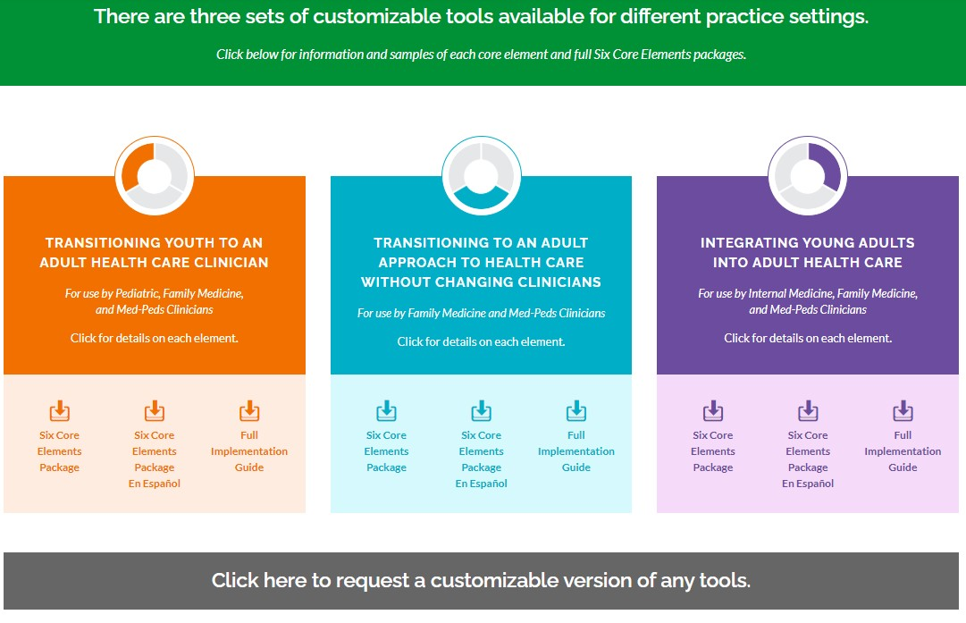

Peggy talked about some of the challenges with implementing care transitions successfully in our current healthcare environment.

She expressed shortages in pediatricians and primary care have exacerbated the problems.

She talked about some of the data challenges. She stated that it’s difficult for insurance companies, specifically ACOs and MCOs to identify patients that are complex or will be required to receive additional support to manage their complex medical condition. Often times, patients with a rare disease fall into this category.
She added that there may need to be a system change to improve transitions.

Managed care plans may provide some of the best options for coordinating care for patients with a rare disease.

Slide: Summary of Six Core Elements of Transition Approach
Roles for Pediatric and Adult Practices*

Practice/  Provider | #1  Transition Policy | #2  Tracking and Monitoring | #3  Transition Readiness/  Orientation to Adult Practice | #4  Transition Planning/  Integration into  Adult Care | #5  Transfer of Care/Initial Visit | #6  Transition Completion/  Ongoing Care
Pediatric* | Create and discuss with youth/family | Track progress of youth/family readiness for transition | Transition readiness assessment (RA) | Develop transition plan including needed RA skills | Transfer of care with information and communication to adult clinician | Obtain feedback on the transition process
Adult* | Create and discuss with young adult (YA)/ guardian, if needed | Track progress to increase YA’s knowledge of health and adult health care system | Share/discuss Welcome and FAQs letter with YA and guardian, if needed | Pre visit planning with referring clinician/ receipt transfer package | Communication with pediatric clinician/ Agree on content of the 1-2 initial adult visits/Self-care assessment | Ongoing care/referrals, as needed, with continued self-care skill building
Slide: Measurement Option: Current Assessment of HCT Activities (top score 32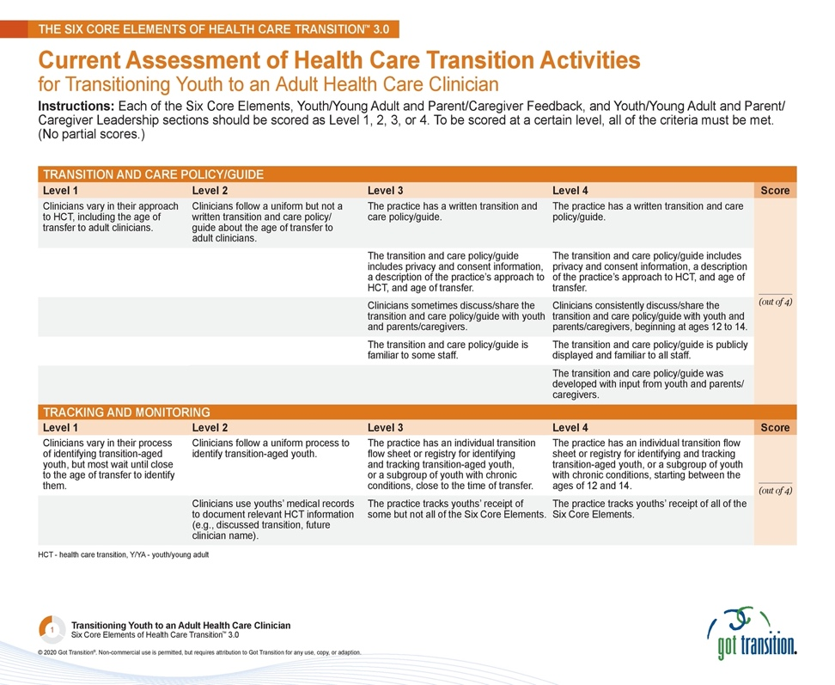

Slide: Measurement Options: Youth/parent/caregiver feedback survey
(Includes summary questions on the Youth/Young Adult Feedback survey)
  - How ready did you feel to move to an adult doctor or other health care provider?
  - Answer: Very, Somewhat, Not at all
  - Do you have any ideas for your past doctor or other health care provider about making the move to an adult health care easier?

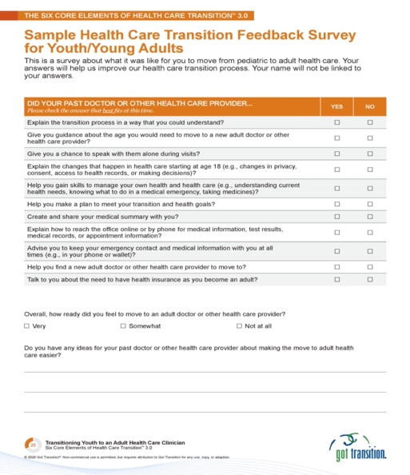
Slide: Measurement Options: HCT Feedback Surveys
- Clinician survey adapted from the Medical Home Feedback Survey
“In Your Practice” section offers 4 answer choices that range from “strongly disagree” to “strongly agree” or “don’t know”

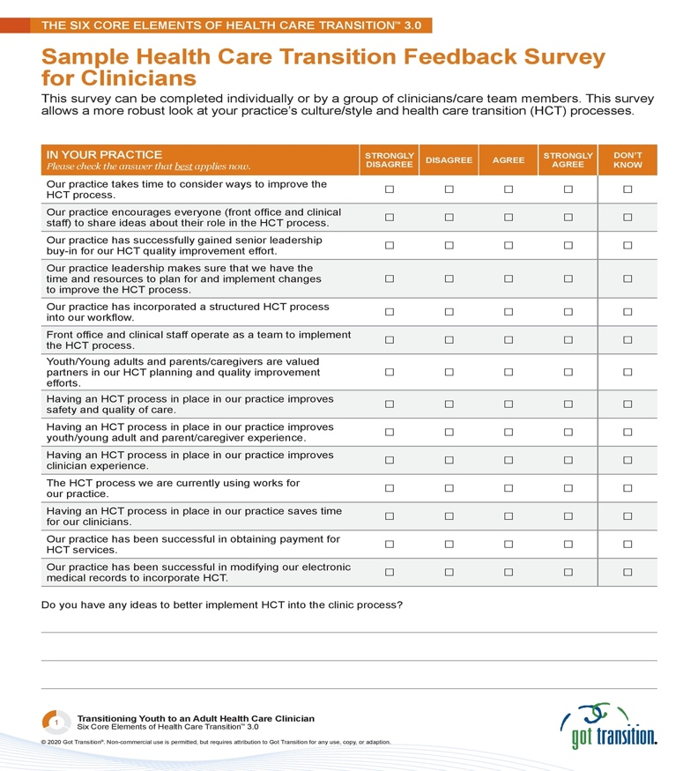

Slide: Getting Started on HCT Improvement Activities
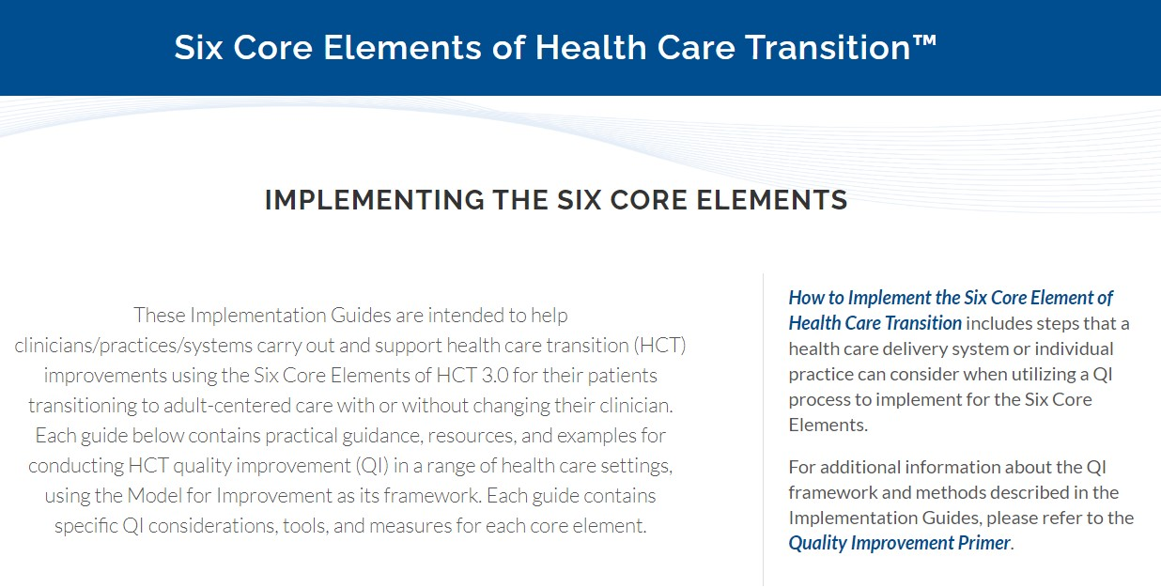
Slide: Youth and Young Adult Resources at GotTransition.org
Got Transition and its National Family Advisory Group (10 representatives from National Family groups) have developed a new Family HCT Toolkit to help families throughout the transition process.
The resource help to answer questions families may have about transition:
  - When should my child and I start to think and talk about transition?
  - What are the recommended HCT services?
  - What questions can my child and I ask our doctor about transitioning to adult care?
  - How does my role and my child’s role change throughout the transition process?
  - How can I learn if my child needs help with decision-making?
  - What are some of the legal changes in health care that happen at age 18?
  - What are the differences between pediatric and adult care?
  - How ready is my child to transition to adult care and manage their own health and health care

Slide: Example: HCT Implementation Subspecialty Multi-Site Project
- PCORI 5-year Grant (2018-2023) to Atrium (NC) in underserved population of youth/young adults with Sickle Cell Disease.
- Sites: Partnership between pediatric and adult practices and community-based organizations in 14 sites (250 patients ages 16-25) in the southeast US
- To demonstrate a structured HCT approach utilizing the 6 CE improve HCT
  - Process measurement: Utilized HCT Process Measurement tool every 6 mo. (top score is 100) with education on the Six Core Elements of Health Care Transition and use of QI methodologies at monthly QI collaborative meetings, biannual site visits and annual conferences.
Goal: average score across all clinics 90 on the PMT

Slide: Process Measurement Score Comparison by Site at 24 months

Slide: Key Features of Successful Transition Efforts
- Involvement of senior leadership and clinic/institution support
- Engagement of key players, including youth & families and adult clinicians,
from outset
- Champion(s) to guide process
- Use of QI methods, with measurable aims, clarity on “what success looks like”
- Hard-wiring HCT into clinic process following tests of change
- Aligning EHR
- Utilize standardized transition process such as Six Core Elements approach, which are free and can be customized with your own logos
- Connect with other transition improvement efforts regionally and/or
nationally to learn and share best practices.
- Share successes and lessons learned to maintain traction and spread
- Publish what you learn

Slide: Got Transition HCT Learning Community: Current Members
Representatives from the health systems below are working together to improve HCT patient outcomes in all or some of the clinics within their systems.
Over the past 10 years the learning community has had monthly calls to share challenges and opportunities and to collaborate on finding best practices, presentations and publishing papers.

- Cleveland Clinic, Cleveland, OH
- Colorado Kaiser Permanente Medical Group,
Denver, CO
- Children’s Hospital of Colorado, Denver, CO
- Children’s Hospital of Orange County, CA
- Children’s Hospital of Philadelphia,
Philadelphia, PA
- Children’s Mercy Kansas City, Kansas City, MO
- Henry Ford Health System, Detroit, MI
- Intermountain Health, Salt Lake City, UT
- Medical University of South Carolina,
Charleston, SC
- NIH Clinical Center
- Oregon Health & Science University, Portland, OR
- Stanford Ravenswood Family Health Center,
East Palo Alto, CA
- University of Rochester, Rochester, NY
Slide: Some Initial Recommendations to Improve the Delivery of HCT Services
- Financial incentives
- Infrastructure investments to support collaborative pediatric and adult transition care processes
- Upgrade EHRs
- Support collaborative peds/adult training
- Build care coordination supports for adult practices accepting YAs with chronic/complex/rare conditions
- Support QI networks to advance pediatric/adult transition processes
- Combination of value-based and fee-for-service payments
- VBP example: Bonus to peds and adult practices when evidence of exchange/updating of medical summary, evidence of communication between peds/adult, timely appointment
- FFS examples: Recognize and adequately pay for education/counseling on self-care skill-building, preparation/updating medical summary, transfer care management, consultation between peds/adult, joint telehealth visits

- Policy recommendations
- Develop and implement MCO and ACO HCT strategies
- Individualized transition of care plan, with medical summary
- Transition time frames
- Collaborative mechanisms for transfer between peds and adult care
- Mechanisms for HCT payment, incl. application of EPSDT benefit and targeted case management
- Out-of-network protections for youth and young adults with rare diseases and other complex conditions
- Mechanisms to track receipt of HCT services, including last pediatric appointment, initial adult appointment, exchange of medical information, patient and family experience
- Timely notification of aging out of pediatric care and insurance coverage as a child, with assistance in identifying options for continuity in care and coverage
- Measurement of HCT processes as well as outcomes
- HCT performance improvement opportunities between pediatric and adult systems
Slide: MassHealth and Dept of Public Health(DPH) and HCT
Peggy talked about the “got transitions” partnership with MassHealth and DPH Division of Children with Special Health Care Needs
- MassHealth Transition to Adulthood Website, with resources on health insurance and finding an adult doctor.
- Division of CYSHCN Services, Dept. of Public Health, has an array of HCT resources on its website. https://www.mass.gov/health-transition-for-youth-and-young-adults-with-special-health-needs. Also, in process, Dept. of Public Health Toolkit.
- CARES provider requirements include important HCT requirements, including individualized care plan, with specific supports for member supports for transition, starting at age 16.
Slide: Conclusions
- Transition from pediatric to adult care is a major concern for all youth/young adults; especially for those with rare diseases and they should be a key partner in the solutions
- A standardized transition process can and should be implemented in both pediatric and adult systems and clinics using quality improvement methods.
- Numerous policy and payment opportunities can be considered for ensuring access to recommended HCT supports
- Focused HCT quality and health system improvements can improve the outcomes of youth and young adults in the transition years to become adults who are healthier and more engaged in their health and health care.
Peggy concluded by sharing the following resources
- For more information on HCT, please visit: GotTransition.org.
My contact information: mmcmanus@thenationalalliance.org
She then asked if there were any questions

T Pasquini asked if it would help if the responsibilities were spread across disciplines? She also asked if there was any ideas on how to shift the progression of care coordination
P McManus answered by sharing that providers and payers are often unaware of who may need care coordination due a complex medical condition.
O Bodamer added that when he worked in Europe, it was very different. He added the in the US there is a desire to have super specialties and that could be part of the problem. He then added that NORD had Centers of Excellence and BCH was one of them. Even at these centers, we struggle with the adult portion of the HCT.
P McManus stated that it may not be realistic to look for an adult provider counterpart as they may not exist.
O Bodamer stated that BCH tries to deal with this through their triage process but have more generalists may be helpful.
N. Grant – added that his brother has been very challenged to find an adult provider that would accept him. He asked if it was possible to expand the possibility of telehealth visits. He added that this was allowed during COVID and it was really helpful for his brothers care and a huge support to his caregivers.
He also added that there needs to be more support for caregivers. He wondered if it would be possible to create a caregiver center.
P McManus added that another area of challenge is seeing out of network providers. She mentioned that Minnesota was able to pass legislation specifically about this.
C Achkar asked if Peggy heard of providers that say “I can’t take this patient because they are too complicated” She then expressed that this shouldn’t be allowed.
She then offered a possible solution: She thought that a fellowship that is specific to HCT and complex patients.
P McManus thought that was a good idea. She added that one other are is Emergency Care Plans. She feels that this is even more important for rare disease patients but it seems to be rarely done.
H Gray-Edwards added that she has experience the shortage of clinicians. She offered that she is in central Massachusetts and it was real. She wondered if it may be possible to figure out a way to incentivize providers to go into general practice. She offered a thought of some kind of loan forgiveness program if they stay in rural areas for a certain period of time.
D Tierney thanked Peggy for her meaningful and thought provoking presentation. He then asked Dr. Bodamer to give all an update on newborn screening.

An update on the impact of the discontinuation of the Advisory Committee on Heritable Disorders in Newborns and Children (ACHDNC) – Dr. Olaf Bodamer

O Bodamer started by sharing the following interactive link.
hrsa-timeline-interactive.pdf
He shared that although the funding for the ACHDDNC ended in April, he felt that it would come back. He also stated that some states may be impacted more than others. Massachusetts has a strong newborn screening program and he didn’t think that this action would impact Massachusetts as much as other states.
He also shared another link about newborn screening in the US; https://acrobat.adobe.com/id/urn:aaid:sc:VA6C2:e2797379-7045-4995-a0e5-c4e46aa6409d

D Tierney thanked Dr. Bodamer for the update then asked Glenda Thomas if she could give an update on the Policy committee.
G Thomas shared a few updates on the work of the Policy Subcommittee. She let all know that the committee met on April 9th.
The committee discussed medical nutrition.
    - The bill #HR6892 was discussed at the full RDAC meeting in February by Congressman McGovern ended in 2024, and the new bill has not been submitted.
    - Rep. McKenna is in the process of scheduling a meeting with David Seltz of the Health Policy Commission (HPC). Currently, the HPC does not have any research or studies in this area.
The committee decided to agree on a definition of medical nutrition.
According to the Food and Drug Administration (FDA), a medical food is defined under The Orphan Drug Act as “a food which is formulated to be consumed or administered enterally under the supervision of a physician and which is intended for the specific dietary management of a disease or condition for which distinctive nutritional requirements, based on recognized scientific principles, are established by medical evaluation.”
Medical foods are not considered drugs by the FDA which, according to the National Organization for Rare Disorders, may lead to some insurers denying coverage. Medical foods may be utilized to address a number of conditions, including management of digestive and metabolic disorders.
The committee will meet next on July 9th.

D Tierney then asked Tai Pasquini, research subcommittee chair to give an update from the committee.
T Pasquini let all know that the last research subcommittee meeting was held on March 19th.
The committee agreed to the following:

The goal of the Research Subcommittee is to guide and support the research activities of the Massachusetts Rare Disease Advisory Council (RDAC). The subcommittee will be responsible for identifying and synthesizing existing research to inform RDAC initiatives. Additionally, the committee may launch and support new research projects or collaborations that seek to provide data related to the goals outlined by the RDAC legislative mandate.

Objectives:
- Identify opportunities to collect data related to the pressing challenges facing the rare disease community, including individuals who are undiagnosed, and their caregivers in the Commonwealth
- Collect or identify existing data to quantify and define the burden of rare diseases in the Commonwealth
- Provide recommendations for additional methods of data collection to further RDAC goals
All agreed to move forward with the Burden of disease study and are working on a 1-pager to share with the Department of Public Health and other internal state stakeholders to get buy-in for the proposed burden of disease study.

D Tierney gave an update on the steering committee. He shared that the committee was looking at ways to engage the full council on different topics and asked all to complete the survey. He let all know that T Pasquini has taken the lead on collecting the survey results and they will share the results at the next meeting.

He then acknowledged that it was 11 am and asked for a motion to adjourn.
T Pasquini made a motion to adjourn, H Gray-Edwards seconded.
D Tierney adjourned the meeting at 11:01 am.

- Steering Subcommittee – Dylan Tierney Provide an update on the work of the subcommittee and then lead into the discussion about council member participation.

10:50 – 10:55 Full council engagement survey results – Tai Pasquini

10:55 Announcements

NEXT FULL COUNCIL MEETING: Scheduled for July 24, 2025.

ADJOURN
Ask for a motion to adjourn.
Repeat the name of the person who makes the motion and the person who makes the second.
Ask all if they agree to adjourn.
Adjourn – State the time the meeting is adjourned for the minutes.

