**How Are the Children?**

Adapted from Patrick O’Neill

*Karibu!* (Welcome) *Hamjambo!* (hello in Swahili) You answer *Hatujambo* 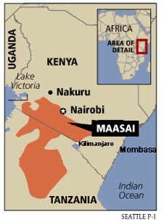!

Among the most accomplished and fabled tribes of Africa, no tribe was considered to have warriors more fearsome or more intelligent than the mighty, lion-hunting Maasai. It is perhaps surprising then, to learn the traditional greeting that passed between Maasai warriors:

"*Kasserian Ingera,"* one would always say to another. In Swahili this means, *"And how are the children?"* "*Sepati Ingera!"* one hoped to hear. *“The children are well!”*

It is still the traditional greeting among the Maasai, acknowledging the high value that the Maasai always place on their children's well-being. Even warriors with no children of their own would always give the traditional answer, "All the children are well." Meaning, of course, that peace and safety prevail, that the priorities of protecting the young, the powerless, are in place. That Maasai society has not forgotten its reason for being, its proper functions and responsibilities. "All the children are well" means that life is good. It means that the daily struggles for existence do not preclude proper caring for their young.

I wonder how it might affect our consciousness of our own children's welfare if in our culture we took to greeting each other with this daily question: "And how are the children?" I wonder if we heard that question and passed it along to each other a dozen times a day, if it would begin to make a difference in the reality of how children are thought of or cared about in our own country. I wonder if every adult among us, parent and non-parent alike, felt an equal weight for the daily care and protection of all the children in our community, in our town, in our state, in our country. . . . I wonder if we could truly say without any hesitation, "The children are well, yes, all the children are well."

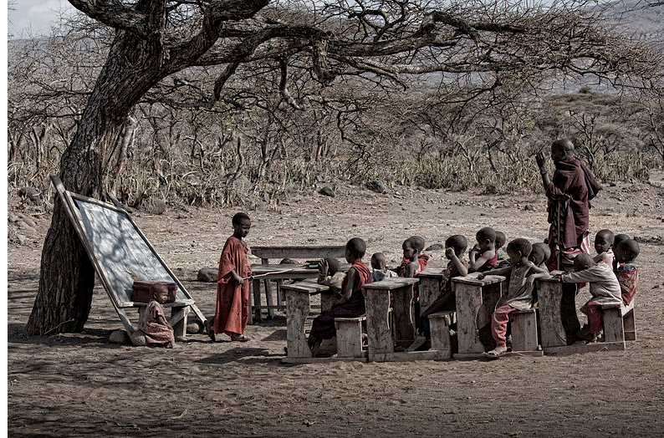What would it be like . . . if Congress started every session by answering the question, "And how are the children?" If every town leader had to answer the question at the beginning of every meeting: "And how are the children? Are they all well?" If the teachers and the administrators and the staff greeted each other in the halls and at meetings by asking, “How are the children?”

What would it be like?

“*Asante.” Thankyou*