.

REPORT ON DDS
SELF-DETERMINATION SERVICES

September 2018

The Department of Developmental Services (DDS) is submitting this report pursuant to the Real Lives Law, (An Act Relative to Real Lives, Ch. 255 of the Acts of 2014) (to be codified as amended to M.G.L. c. 19B, § 19 (e)(18)). This section requires DDS to:

provide, in consultation with the advisory board established in subsection (c), an annual report to the chairs of the house and senate committees on ways and means and to the house and senate chairs of the joint committee on children, families and persons with disabilities, not later than September 1; provided that said report shall (i) set forth any modifications or improvements made by the department to the administration of self-determination, (ii) specify any recommended legislation, (iii) provide an assessment of the performance of providers, vendors and persons who have received funds for the provision of services, supports and goods under this section, (iv) specify the number of participants utilizing self-determination during the previous fiscal year, (v) specify the number of participants per region in the commonwealth, (vi) specify types and amounts of services, supports or goods purchased under self-determination, in a manner that facilitates analyses and year to year comparisons, (vii) provide ranges and averages for expenditures from all individual budgets, inclusive of any adjustments to individual budgets made pursuant to subsection (i), and (viii) the number of participants who withdrew voluntarily from the option.

The Self-Determination Advisory Board was established as called for in sec. 1, § 19 (c) of the law, in December 2014. Annual reports were submitted in September of 2015 and 2016 and 2017. These reports are available on the DDS Self-Determination website.

In FY 2018, the Board met on September 6, 2017, December 6, 2017, March 7, 2018, and June 6, 2018. Meeting minutes as well as documents presented, reviewed and discussed are also on the DDS website.

The number of participants enrolled in self-directed services in June 2018 increased to 1,087 from 944 in June 2017. A review of the various work products, tasks, activities and ongoing efforts is provided below.

Subsection (i) – modifications and improvements made to the administration of self-determination;

- The Self-Determination Advisory Board (SDAB) held four meetings. The agendas, meeting notes, presentations and documents provided at the meetings are posted on the DDS Self-Determination website. Early in 2015, DDS developed a work plan to organize work required and monitor the status of requirements of the Real Lives Law. This document is referred to as the REAL LIVES LAW WORK PLAN. All 28 items requiring DDS action have been completed. Eight are categorized as “ongoing”. The Department has acted on these and continues to do so as appropriate. These are continuous activities that the Department is routinely involved with and has instituted into its operations

- Board members are appointed for a three-year term. The initial term expired for all appointed board members in December of 2017. Fifteen members were re-appointed for a second term. Six new members, including two individuals who receive DDS services, two family members of individuals receiving services, an Independent Facilitator and a citizen of the commonwealth representing taxpayers were appointed in the spring of 2018.

- Agency With Choice (AWC) has been a self-directed service choice since 2010. This is a co-employment model of service delivery in which a qualified provider shares employer responsibility with individuals and families. The AWC provider serves as the employer of record and the individual/family serves as the managing employer. This service has evolved over this period and much has been learned from the experiences of individuals/families and providers. This service was required to go out for procurement this past fiscal year and in the fall of 2017 a planning committee was formed to develop the specifications of the Request For Response (RFR). This committee held forums with AWC providers as well as multiple sessions statewide for individual and family participants, for input about their experiences and to hear their perspectives about what is working well and to identify areas that need to be addressed. Some changes made in the RFR were designed to simplify the AWC program model and enhance aspects of service delivery. Key elements included streamlining the menu of direct support service options to Individualized Home Supports and Individualized Day Supports, which aligned with current utilization and continues to offer flexibility for participants, increased clarity on the roles of individuals/families and providers related to their shared responsibilities in this co-employment arrangement, as well as the role and responsibilities of the Service Navigators. The RFR also addressed important concerns related to simplifying and consolidating the contracting process for providers. The RFR was posted in February 2018 and ultimately this process resulted in 55 agencies now qualified as AWC providers.

- To support increased understanding of the AWC program model among all parties, individuals/families, providers, and DDS staff, as well as increased consistency in expectations and implementation, an AWC program manual is under development in collaboration with experienced AWC providers. This will be rolled out in the fall of 2018 accompanied by training sessions. The regional Self-Direction managers will continue to serve as a resource for the AWC program and will provide opportunities for both participants and providers to come together to share information, experiences and best practices.

- A collaborative including Mass Advocates Standing Strong (M.A.S.S.), DDS and Community Providers developed a Public Speaking Skill Development curriculum for self-advocates. This is a four-week 16-hour course to help participants improve their public speaking skills. The first training was held in May 2018, the second training was held in July and a third is schedule for the fall. Course graduates will be invited to be part of a statewide Speakers Bureau that is being developed by M.A.S.S. Input for improvements and expansion of statewide training opportunities is being sought from self-advocate participants. Recommendations include inviting a self-advocate to be a cofacilitator in future trainings and adding an Intermediate level Public Speaking Class for participants to further increase skills. This effort is a platform for self-advocates to become a routine part of statewide training and outreach on self-determination and self-direction.

- DDS and M.A.S.S sponsored a I-Movie workshop for interested self-advocates to learn to create their own video to tell their stories. Twenty individuals attended, with some wanting to create a video to be part of an outreach or training in support of the self-directed service options provided to other self-advocates.

- DDS is developing a video series to profile seven participants self-directing their supports, to showcase a variety of personal success stories statewide. Two have been completed to date. One participant used their video story as part of their presentation at a national self-advocacy conference. The goal is to post the series on the DDS and other websites as a continued outreach and education activity. Other video projects are being planned.

- The Board developed written guidance, Self-Direction Program Budget Responsibilities Preventing Financial Abuse and Exploitation, for consumers participating in DDS self-directed programs regarding the responsibilities that come with managing and overseeing a budget. The guidance is intended to inform participants in self-directed services of the important role they play to ensure the allocated funds are used appropriately and thereby strengthen the integrity of these programs and secure their future in DDS. The guidance explains fraud and financial abuse, how to prevent and address it, and how to get help when needed. The written guidance is a first step to inform consumers of these services and will primarily be helpful with families and some individual participants. A more user-friendly video is being developed to communicate this information to the broader group of self-advocates and individuals considering and participating in self-directed services.

- The Human Services Research Institute (HSRI) conducted work related to year two of their three-year evaluation of self-direction program contract. Year two of the evaluation was scheduled to look at the infrastructure of self-direction including service coordination, budget development, service planning, and supports and services.

- The last three years’ Annual Reports detail the outreach, communication and training efforts related to the promotion and understanding the DDS self-directed service options. The target audiences have been wide ranged and include DDS Area Office staff, new service coordinators, self-advocates, individual and families, providers, and local advisory boards. The Regional Self-Direction managers also present on self-direction in DDS at conferences, Transition and Turning 22 Forums, and Family Support Center events, and DDS training events on related topics. These efforts have resulted in a great deal of engagement, networking and invitations to other outreach opportunities. The managers continue these ongoing efforts and events across the four regions throughout the year.

- The managers have conducted an annual support broker development training program. The initial three-day event covered in detail, the basics on the DDS self-direction service options systems. The second and third years addressed other topics in depth and Person Centered Planning. This work promotes skill development and support for the support brokers statewide.

- The DDS SD Leadership Team was established in October 2016 to improve cross department and statewide practice, address policy matters and make recommendations for improvements to the DDS Senior Staff and Commissioner on matters related to self-direction services. This team meets monthly to discuss ongoing items, assigns work groups to address project needs and develop work products and issues guidance to the field.

- Other ongoing management, oversight, and systems improvements developments have been detailed in previous reports. Central Office managers meet monthly with the four self-direction regional managers to provide statewide leadership, management, planning, coordination and monitoring aimed to achieve consistency across the regions. The self-direction managers participate monthly in their Regional Directors’ Management Meetings along with Area Directors and other key regional staff. They also hold regular meetings with their regions support brokers for ongoing communication, updates, planning, problem identification and solving, and work to develop consistent knowledge and practice across the region.

Subsection (ii) specify any recommended legislation;

There are no recommended changes to the legislation proposed by DDS and the Self-Determination Advisory Board at this time.

Subsection (iii) provide an assessment of the performance of providers, vendors and persons who have received funds for the provision of services, supports and goods under this section;

Participant Directed Program

Public Partnership LLC (PPL) is the current fiscal intermediary under contract to provide fiscal services for the Participant Directed Program. The Participant Directed Program is the service option that provides the individual or the family the greatest control over
their services. It also requires significant time and responsibility by the person or their family.

Prior to last year, PPL conducted a satisfaction survey, shared the results with DDS, and developed and implemented action steps to increase survey response rates and address areas of concern. In September 2016, Human Services Research Institute (HSRI) began a three-year contract to evaluate self-direction in DDS, per the Real Lives
statute. HSRI included the satisfaction survey for fiscal intermediary services for FY 17 in their first year of the assessment. They added questions and conducted the fiscal intermediary satisfaction survey. The results were shared with DDS, PPL and the Self-Determination Advisory Board. HSRI followed this same process for FY 18. PPL and DDS will identify actions to improve areas of concern noted in the survey results.

Agency With Choice

The other self-determination service option is referred to as Agency With Choice. This option allows individuals and families to self-direct services through a contracted DDS agency. In this option, the individual or family maintains control over design and delivery of services but they also receive assistance or support in management of staff, budgeting, accounting, and many other administrative needs. The agency is responsible for all accounting, personnel/payroll management and assuring adherence to regulations and DDS requirements.

In FY 18 there were 31 provider agencies with contracts to provide services in the Agency With Choice program. To be a qualified AWC provider, agencies are required to complete an initial qualification process for the specific services they are offering to provide in the AWC service model, and then complete a re-qualification process every two years. Each of these agencies conduct annual satisfaction surveys for the services they provide. The information received is to be generally collected and summarized for the agency and is shared with DDS and other stakeholders and the feedback is used to improve identified areas of concern. By design, the Agency With Choice model requires close collaboration between the vendor and the participant. This ongoing, frequent communication ensures that problems, concerns and general satisfaction issues can be discussed and addressed as such matters arise.

Additionally, at the end of each fiscal year, staff from the agency and the Support Broker assists the participant in planning for the coming year. It is an opportunity to review the performance of staff and the effectiveness of the service plan and to make changes accordingly.

Subsection (iv) specify the number of participants utilizing self-determination during the previous fiscal year.

On June 30, 2018 there were a total of 1,087 participants enrolled in self-direction.

Subsection (v) specify the number of participants per region in the commonwealth;

The 1,087 enrolled on June 30, were from the following regions:
- Central West (229)
- Metro (264)
- Northeast (444)
- Southeast (150)

Subsection (vi) specify types and amounts of services, supports or goods purchased under self-determination, in a manner that facilitates analyses and year to year comparisons;

The Department keeps data on the categories of self-determination services used each month, the year-to-date total and lists the yearly total for the previous three fiscal years. Below are the two charts with this detail for FY 2018. The numbers in these charts represent the total enrollments in each service category. Many people are enrolled in more than one service category. The total number of people enrolled in self-determination is provided in sub section (iv) above.

The first chart lists all the service enrollments for participants enrolled in self-determination through the Participant Directed Program option. As noted in section (iii) above, this option allows the participant the greatest control over their services, staff and budget and requires the greatest responsibility to manage the services, staff and services choices made. In this option the fiscal intermediary, PPL, is responsible for all the payroll, accounting and adherence to expenditure qualification/requirements and regulations.

The second chart provides service enrollment information regarding participants who choose the Agency With Choice option. This option requires the agency, chosen by the participant, to work closely with the participant on the design and delivery of services. The participant chooses the staff and the agency and participant jointly supervise and evaluate the staff. In this option, the provider agency is responsible for all personnel/payroll needs, accounting and adherence to expenditure regulations and DDS requirements.

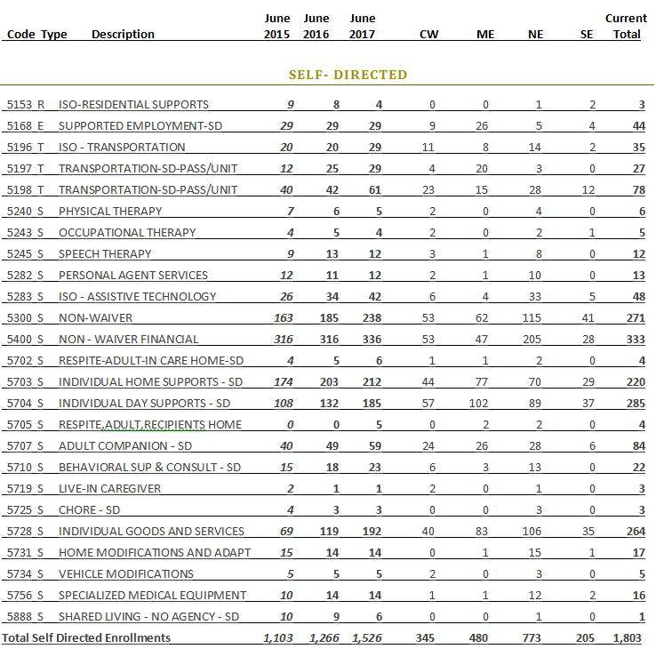

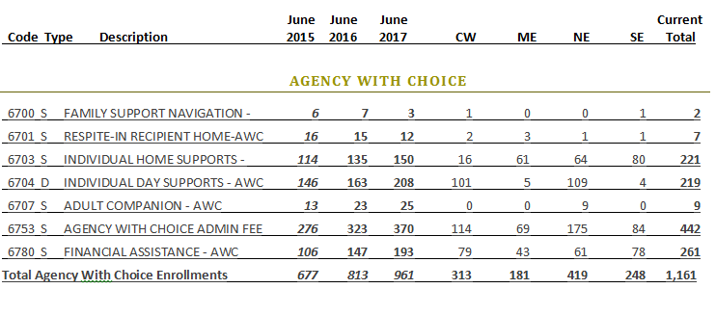

Based on Total Enrollments 7/6/18

Subsection (vii) provide ranges and averages for expenditures from all individual budgets, inclusive of any adjustments to individual budgets made pursuant to subsection (i);

In the FY 2018 Participant Directed Program with PPL, the smallest allocation spent was $55. The smallest allocations are typically for a partial year, new enrollment program or short-term expenditures appropriate for this service model. The largest two allocations were at $222,205 and $204,429; however, these cases represent unique circumstances. Other than these two outliers, the highest allocation spent was $158,000. The average allocation was $17,299.65.

In the FY 2018 Agency With Choice program, the lowest allocation was $1,511.39, the highest allocation was $124,765, and the statewide average was $23,295.07.

Subsection (viii) the number of participants who withdrew voluntarily from the option;

During FY 2018, 24 individuals voluntarily moved out of the Self-Determination program. This number does not include withdrawals due to deaths, people who were enrolled with the specific purpose to receive short term (defined as less than a year) services, supports or goods, and other technical or administrative reasons. Fifteen of the 24 individuals moved to a traditional model due to needs of the individual or family requiring more intensive services, often 24/7 residential services. Four preferred a traditional model, three moved out of state and two withdrew from services.

DDS continues to increase enrollments in self-directed services, make improvements to the service models and systems, expand and enhance our communication efforts most recently via user promotion videos, address internal alignment needs and use feedback and evaluation input to improve self-directed service. We are committed to make every effort to increase participation in self-directed service options within DDS and fully expect the enrollment numbers, system improvements and service enhancements to continue in the coming year.

.

