Recreational Risk Management of Surface Waterbodies: Cyanobacteria Surveillance in Massachusetts

Michael Celona*, Vanessa Curran, Irena Draksic,
Michael Beattie, Rachel Wilson, & Marc Nascarella
*Presenting Author:
Chief, Water Toxics Unit
617-624-5757
mike.celona@state.ma.us
Environmental Toxicology Program
Bureau of Environmental Health
Massachusetts Department of Public Health

Outline

Harmful Algae Blooms

MDPH Guidelines
- Environmental Monitoring Program
- Lessons Learned
- Future Efforts
Harmful Algae Blooms

Blue-green algae/cyanobacteria occur in aquatic ecosystems

Highly concentrated in water: harmful algae bloom (HAB)

Ability to produce toxins

Human and animal health concerns

MDPH Guidelines

Established cyanobacteria guidelines in 2008

MDPH recommends an advisory when:

A cyanobacteria scum is present

A cell count exceeds 70,000 cells per milliliter of water

A microcystin level exceeds 14 parts per billion

Advisories remain in place until levels remain below guidelines

MDPH Guidelines

(PICTURE OF Public Health Advisory Poster for Cynobacteria Bloom Present
Waterbody Unsafe for People and Pets

Environmental Monitoring

MDPH established an environmental monitoring program for recreational waterbodies:

Monitoring strategy

Sampling and analysis protocol

Data evaluation

Recommendations

Monitoring Strategy

Two types of HAB monitoring:

Routine

Response

Once detected, samples collected weekly until advisory rescinded

Sampling and Analysis

Sample collection:

Chose location based on likelihood of exposure

Fill 1L amber bottle at a location 6 inches below the water surface, in 3 feet of water

Water quality parameters collected in the field included:

- Air and water temp. | - Salinity
- Secchi disk depth | - pH
- Dissolved oxygen | - Turbidity

Sampling and Analysis

Photographs are taken to record surface water observations

Samples are shipped to a private laboratory for analyses:

Genera identification

Genera cell count

Microcystin level

Results

From 2009-2014, 1,075 samples were collected from 75 waterbodies in 58 municipalities

One-third of samples exceeded the cell count guideline

The dominant genera in the exceeding samples were primarily Anabaena, Aphanizomenon, and Microcystis

Less than 1% exceeded the microcystin guideline

Advisories
- MDPH recommended a total of 97 public health advisories

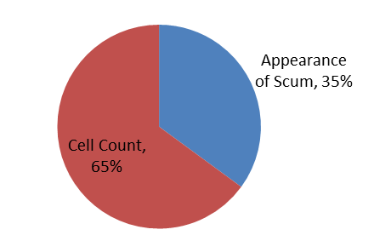

Advisory Length
- In general, these advisories lasted less than 60 days

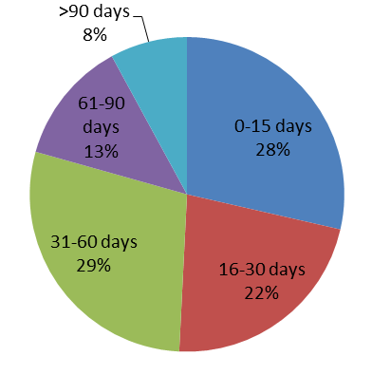
Advisory Issuance by Month
- Majority of advisories issued in July and August

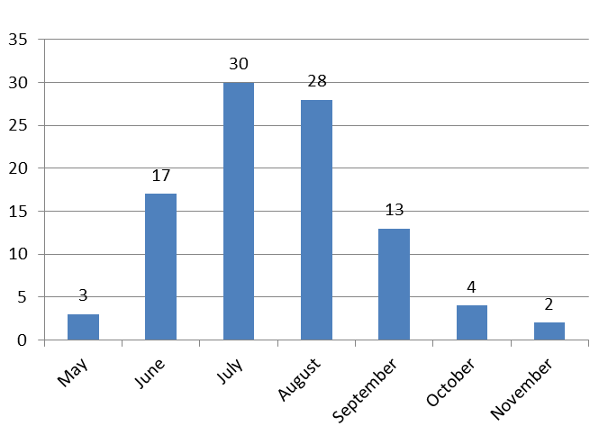

Advisory Locations

- Locations tend to be in Eastern Massachusetts

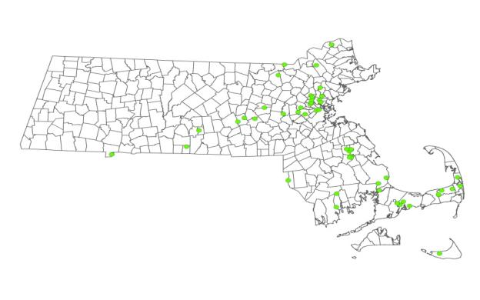

Lessons Learned

HABs are a common in Massachusetts

Tend to be concentrated in eastern Massachusetts

Most frequently occur in the summer months

May continue into the fall

Mutual reliance

MDPH relies on local officials/residents to report blooms

Local officials rely on MDPH to provide technical and analytical support

Monitoring is resource intensive

Lessons Learned

Photographs are important!

A significant number of blooms are identified by photographed scums

Helps to limit responding to issues that are clearly not HAB-related

Lessons Learned

- Great deal of public interest in this issue

Sampling of media reports from 2015

Future Efforts

Harmonize MDPH guidelines with evolving federal guidance

Use data for development of predictive models

Continue to provide analytical and technical assistance to local health officials, requesting agencies, and others

Acknowledgments

This work was partially supported by a US Centers for Disease Control and Prevention cooperative agreement and a US Environmental Protection Agency BEACH grant.

The content of this presentation and the views expressed by the authors do not necessarily reflect the official views of our federal partners.

State partners: MA Department of Environmental Protection, MA Department of Conservation and Recreation, local health officials, and watershed organizations

