Massachusetts Department of Public Health
Recreational Use of Waterbodies
Near Joint Base Cape Cod (JBCC)

Community Fact Sheet 2023
This community fact sheet discusses environmental health concerns related to recreational use of selected Upper Cape Cod fresh waterbodies and the results of recent chemical testing. Based on the available data, waterbodies tested near JBCC are safe for swimming, wading, boating, and recreational fishing.

The Massachusetts Department of Public Health (MDPH) has issued fish consumption advisories primarily due to raised mercury levels in many waterbodies across Massachusetts, including several waterbodies near JBCC.

This fact sheet does not address potential health risks posed by microbes such as cyanobacteria (algae) and fecal indicator bacteria, both of which are sampled at many of the waterbodies near JBCC during the summer months. For specific information about microbial water quality measurements, contact your local health department or visit: www.mass.gov/dph/beaches

Can I safely swim, wade, or boat in the surface waterbodies near JBCC?
Yes, all of the surface waterbodies (including marine beaches, lakes, ponds, and rivers) in Table 1 are safe for swimming, wading, and boating. Table 1 summarizes safe recreational use for 35 surface waterbodies near JBCC (JBCC waterbodies) where environmental sampling data are available.

Low levels of chemicals associated with JBCC were sometimes detected in the surface water. These low levels of chemicals do not pose a health concern for recreational activities, including for potentially susceptible or vulnerable populations (e.g., pregnant or nursing mothers, infants, and the elderly).

Can I safely fish in waters near JBCC?
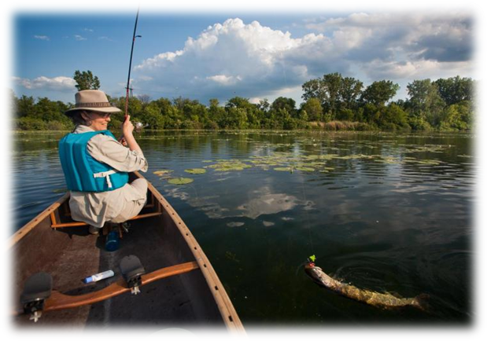Yes, fishing for recreation is safe for all waterbodies near JBCC as long as you release the fish once caught, and don’t eat the fish.
However, contaminants such as mercury have been detected in fish throughout Massachusetts at levels that, for certain people, may be unsafe to eat, including in several waterbodies near JBCC. Nine ponds (Ashumet, Flax, Grews, Jenkins, Johns, Mashpee-Wakeby, Peters, Shubael, and Snake) each have public health fish consumption advisories. Table 2 has more information about the fish advisories for waterbodies near JBCC.

What is the MDPH statewide fish consumption advisory for mercury?
The MDPH has issued a statewide advisory for mercury recommending that certain people should not eat fish that are recreationally caught in Massachusetts until new information shows it is specifically safe to eat fish from a particular waterbody or waterbodies.

Women who are pregnant, women of childbearing age who may become pregnant, nursing mothers, and children under 12 years old should not eat fish caught from a local waterbody that hasn’t been evaluated by MDPH. Please be aware that this advisory does not apply to fish stocked in freshwater lakes and ponds or the retail sale of fresh fish. MDPH has issued other important recommendations for eating locally caught fish. These can be viewed at the fish advisories web page listed below.
For more information on fish consumption advisories, please contact the MDPH Bureau of Environmental Health’s Environmental Toxicology Program: 617-624-5757
DPHToxicology@state.ma.us or visit: www.mass.gov/dph/fishadvisories

Where do mercury and PFAS come from? How can the ponds be safe to swim in but contain fish that are not safe to eat?
Mercury enters the environment naturally when rocks are worn down, and through industrial incineration and power generation. Mercury travels through the air and settles onto waterbodies. PFAS are present in JBCC waterbodies primarily due to historical use of firefighting foam, which contaminated groundwater near the JBCC waterbodies. Fish ingest the mercury and PFAS in the water and sediment, which then builds up inside the fish over time.

While there are warnings about eating fish, there are no health concerns related to activities such as swimming, boating, or recreational fishing (release fish once caught) in these ponds. This is because the health advisories are based on chemical levels in the fish. Some chemicals, such as mercury and certain PFAS, accumulate in fish at levels that are much greater than the surrounding waters. Only by eating the fish will someone be exposed to these chemicals. Recreational activities like swimming, wading, boating, and touching fish are not likely to expose individuals to high levels of mercury, PFAS, or other chemicals.

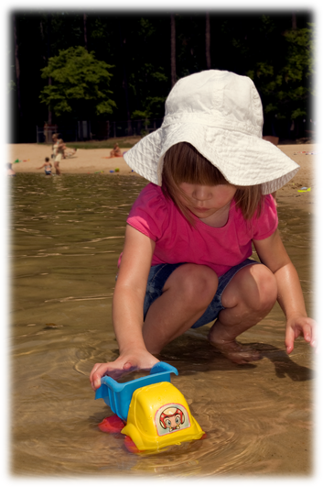In the past, ethylene dibromide (EDB) was detected in the groundwater below Snake Pond and in the Coonamessett River surface water. Snake Pond surface water has also been tested for compounds found in explosives. Are there possible health impacts from recreational use of either Snake Pond or the Coonamessett River?
No, adverse health effects are not expected from recreational use of either Snake Pond or the Coonamessett River. EDB was found in surface water of the Coonamessett River in 1996 and in the groundwater below Snake Pond in 2001. The surface waters of Snake Pond (both the public and private beach areas) and multiple locations on the Coonamessett River are regularly tested for EDB. EDB has not been detected in either waterbody since 2011. Also, in Snake Pond, explosives have not been detected above risk-based cleanup standards and perchlorate has not been detected above the Massachusetts Drinking Water Standard since 2010.

Should I be concerned about trichloroethylene (TCE) or tetrachloroethylene (PCE) in groundwater associated with JBCC activities?
No, the surface waters of Ashumet Pond, Johns Pond, Deep Pond, Backus River, Red Brook Harbor, and Squeteague Harbor have been regularly checked for these chemicals since the early 2000s. Neither TCE nor PCE have been detected above the drinking water standard since 2009. Using any of these waterbodies for recreation is not expected to have any effects on your health.

Should I be concerned about detections of 1,4-dioxane?
1,4-Dioxane is an industrial chemical found in solvents, paints, and waxes, which has been detected at low levels in the Backus River, Pond 14, Coonamessett River, Deep Pond, and Johns Pond. All detections are below the MassDEP drinking water guideline. Adverse health effects from exposure to 1,4-dioxane associated with recreational activity in these waterbodies are not a concern.

Should I be concerned about per- and polyfluoroalkyl substances (PFAS) that have been detected in surface water at JBCC waterbodies?
These contaminants have not been detected in waterbodies near JBCC at levels that present a health risk to people using them for recreational activities, such as swimming, wading or boating.

PFAS are a group of fluorinated organic chemicals that have been used to make carpets, clothing, fabrics for furniture, paper packaging for food, and other materials (e.g., cookware) that are resistant to water, grease, and stains. They are also used in some firefighting foams and industrial processes. Because PFAS have been used in a range of consumer products, most people have been exposed to them. Perfluorooctanoic acid (PFOA) and perfluorooctane sulfonate (PFOS) have been the most extensively produced and studied of these chemicals. Research on these and other PFAS is ongoing.

In May 2016, the United States Environmental Protection Agency issued a drinking water health advisory for PFOA and PFOS, at a level that EPA considered to be protective for an individual’s drinking water over an entire lifetime. In June 2018, the Massachusetts Department of Environmental Protection (MassDEP) issued its own public health guideline for five PFAS compounds in drinking water. In October 2020, MassDEP finalized a maximum contaminant level (MCL) that is lower than the initial guideline. MassDEP’s MCL is applicable to six PFAS, including PFOA, PFOS, perfluorohexane sulfonate (PFHxS), perfluoroheptanoic acid (PFHpA), perfluorononanoic acid (PFNA), and perfluorodecanoic acid (PFDA). Potential exposure to PFAS associated with swimming, wading, boating or recreational fishing would be much less than potential exposure from drinking water containing PFAS. This is because the amount of water ingested during recreational activities is much less than the amount ingested as drinking water, and because very little PFAS are absorbed through the skin.

PFAS have been detected above the MassDEP MCL at: Ashumet Pond, Backus River, Childs River, Hen Cove, Grassy Pond, Johns Pond, Moody Pond, Quashnet River, Red Brook Pond, and Wilson Bog Pond. However, exposure to PFAS from swimming, wading, boating, or fishing in these waterbodies is not expected to result in adverse health effects. As noted above, these recreational activities would not result in significant exposure over a long period of time, such as would occur with daily ingestion of drinking water.

In March 2023, US EPA proposed MCLs for PFOA and PFOS; and health advisories for PFHxS, PFNA, perfluorobutane sulfonic acid, and hexafluoropropylene oxide dimer acid and its ammonium salt (referred to as GenX chemicals). MassDEP is evaluating US EPA’s proposed MCLs and health advisories as part of the normal review process for updating the Massachusetts MCL and will adopt US EPA’s MCLs when these are finalized.
Table 1
Recreational waterbodies near JBCC evaluated as safe for swimming, wading, or boating.
Note: numbers refer to fish consumption advisories for specific water bodies, described in Table 2.
COMMUNITY |  | WATERBODY*
Barnstable |  | Shubael Pond*⁷
Bourne |  | Cuffs Pond
 |  | Flax Pond (Picture Lake)*²
 |  | Hen Cove*
 |  | Lily Pond
 |  | Long Pond
 |  | Red Brook Pond
 |  | Red Brook Harbor
 |  | Squeteague Harbor*
 |  | Wilson Bog Pond
Falmouth |  | Backus River (Bogs)
 |  | Bournes Pond River (Bogs)
Childs River
Coonamessett Pond
 |  | Collins Bog
 |  | Coonamessett River (Bogs)
 |  | Crooked Pond*
 |  | Deep Pond
 |  | Flax Pond*
 |  | Fresh Pond
 |  | Frog Pond
 |  | Grassy Pond
 |  | Jenkins Pond^{*4}
 |  | Mares Pond*
 |  | Round Pond*
 |  | Pond 14
Mashpee |  | Algonquin (Cataquin) Pond
 |  | Ashumet Pond¹
 |  | Flashy Pond
 |  | Johns Pond*⁵
 |  | Lakeside Estates Pond
 |  | Martha Pond
 |  | Mashpee-Wakeby Pond*⁶
 |  | Moody Pond
 |  | Quashnet River (Bogs)
 |  | Santuit Pond*
Sandwich |  | Peters Pond*⁷
 |  | Pimlico Pond
 |  | Snake Pond*⁸
 |  | Triangle Pond*
 |  | Weeks Pond
*Indicates waterbody has a permitted swimming beach
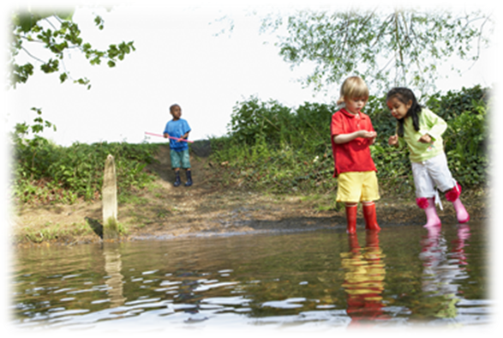 | 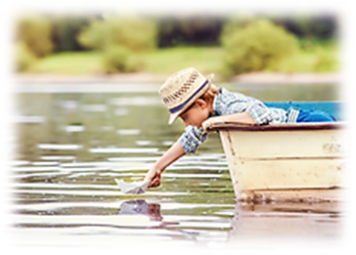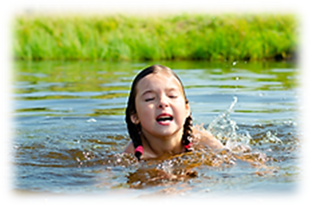
For more information and resources related to PFAS in drinking water, visit:
MassDEP: https://www.mass.gov/info-details/per-and-polyfluoroalkyl-substances-pfas
US Agency for Toxic Substances and Disease Registry (ATSDR): https://www.atsdr.cdc.gov/pfas/

Table 2. MDPH fish advisories for mercury and PFAS
(Fish consumption recommendations are based on available data or statewide advisory for mercury concentrations in fish tissues)
 | POND |  | AMOUNT |  | SPECIES (contaminant)
 | 1. Ashumet Pond
 | Children younger than 12 years, pregnant women, nursing mothers, and women who may become pregnant |  | Do not eat |  | Any fish (mercury, PFAS)
 | General public |  | Do not eat
 | 2. Flax Pond (Picture Lake)
Children younger than 12 years, pregnant women, nursing mothers, and women who may become pregnant |  | Do not eat |  | Any fish (PFAS, mercury*)
General public |  | One meal per week
3. Grews Pond
Children younger than 12 years, pregnant women, nursing mothers, and women who may become pregnant |  | Do not eat |  | Any fish (PFAS, mercury*)
General public |  | Two meals per week
4. Jenkins Pond
Children younger than 12 years, pregnant women, nursing mothers, and women who may become pregnant |  | Do not eat |  | Any fish (PFAS, mercury*)
General public |  | One meal per week
5. Johns Pond
Children younger than 12 years, pregnant women, nursing mothers, and women who may become pregnant |  | Do not eat |  | Any fish (mercury, PFAS)
 | General public |  | Do not eat |  | Smallmouth bass (mercury, PFAS)
 |  |  | One meal per year |  | All other fish (PFAS)
 | 6. Mashpee-Wakeby Pond
 | Children younger than 12 years, pregnant women, nursing mothers, and women who may become pregnant |  | Do not eat |  | Largemouth bass (mercury, PFAS)  Smallmouth bass (mercury, PFAS)
 |  |  | One meal per week |  | All other fish (PFAS)
 | General public |  | Two meals per month |  | Largemouth bass (mercury, PFAS)  Smallmouth bass (mercury, PFAS)
 |  |  | One meal per week |  | All other fish (PFAS)
 | 7. Peters and Shubael Ponds
 | Children younger than 12 years, pregnant women, nursing mothers, and women who may become pregnant |  | Do not eat |  | Any fish (mercury)
General public |  | Two meals per month
8. Snake Pond
Children younger than 12 years, pregnant women, nursing mothers, and women who may become pregnant |  | Do not eat |  | Any fish (mercury)
General public |  | Do not eat |  | Smallmouth bass (mercury)
 |  | Two meals per month |  | All other fish (mercury)
 | All other waterbodies near JBCC (no waterbody-specific fish data have been evaluated by DPH)
 | Children younger than 12 years, pregnant women, nursing mothers, and women who may become pregnant should not eat any fish
 | *This waterbody has not been evaluated for mercury. Per DPH’s statewide fish consumption advisory for mercury, sensitive populations should not eat fish from this waterbody until more information on mercury levels is available.
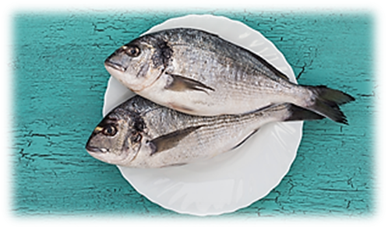
WHERE CAN I GET MORE INFORMATION?
Serving Size

8 oz.

4 oz.

An adult’s uncooked serving size is about 8 ounces (the size of an adult’s hand)

A child’s uncooked serving size is about 4 ounces (the size of an adult’s palm)
Bureau of Environmental Health
Environmental Toxicology Program
Massachusetts Department of Public Health
250 Washington Street, Boston, MA 02108
Phone: 617-624-5757 | DPHToxicology@state.ma.us
http://www.mass.gov/dph/environmental_health

SOURCES OF ADDITIONAL INFORMATION
Air Force Civil Engineer Center  Douglas Karson  (508) 968-4678, x2  douglas.karson@us.af.mil | MassDEP  Ellie Donovan  (508) 946-2866  ellie.donovan@mass.gov |  | Environmental Protection Agency – Region 1  Darriel Swatts  (617) 918-1065  swatts.darriel@epa.gov
Impact Area Groundwater Study Program  Pam Richardson  (339) 202-9360  pamela.j.richardson.nfg@mail.mil |  | Agency for Toxic Substances and Disease Registry – Region 1  Tarah S. Somers  (617) 918-1493  tvs4@cdc.gov
LOCAL AND TRIBAL CONTACTS
Town of Bourne  Terri Guarino  (508) 759-0600, x1513  TGuarino@townofbourne.com | Town of Falmouth  Scott McGann  (508) 495-7485  Scott.McGann@falmouthma.gov | Town of Mashpee  Zackary Seabury  (508) 539-1426  zseabury@mashpeema.gov
Town of Sandwich  Heather L Gallant  (508) 888-4200  hgallant@sandwichmass.org | Barnstable County Dept. of Health and the Environment  Sean O’Brien  (508) 375-6618  sobrien@barnstablecounty.org | Mashpee Wampanoag Tribe  Jason Steiding  (508) 477-0208, x126  jason.steiding@mwtribe-nsn.gov
Recreational Water Bodies Near Joint Base Cape Cod with Available Chemical Data
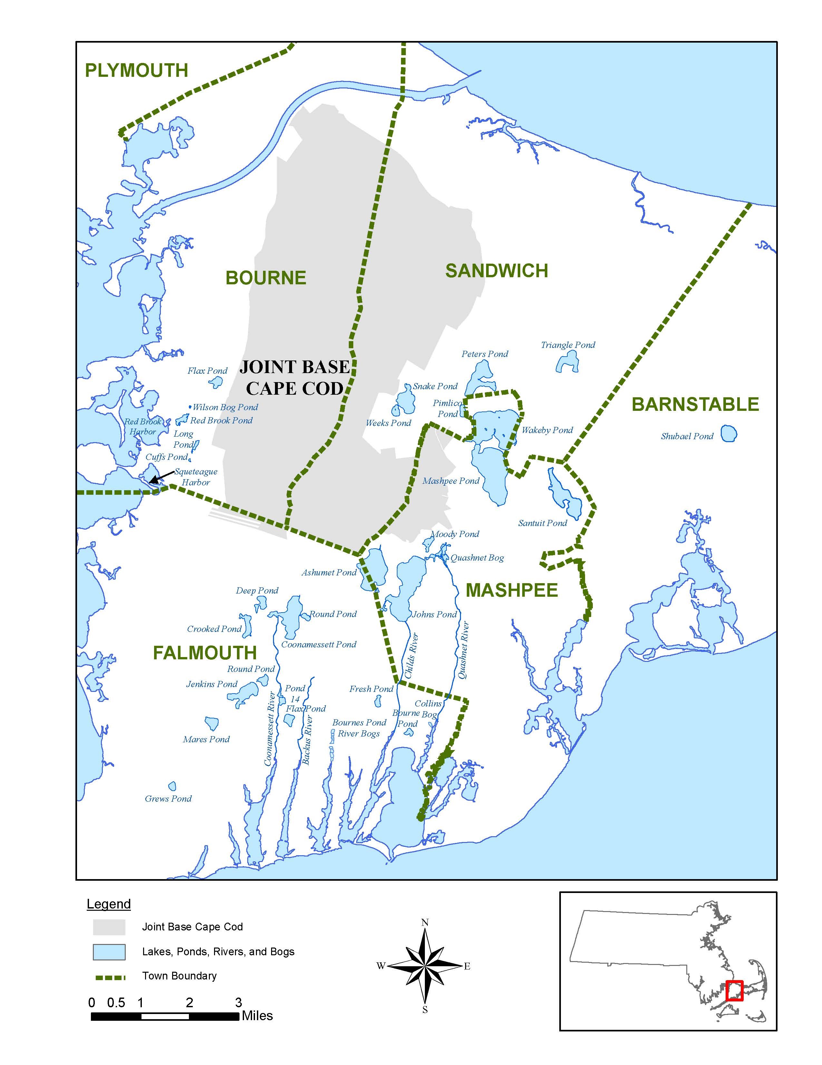
The following small ponds, which are all near Ashumet Pond and Johns Pond, are not shown on the map: Algonquin (Cataquin), East, Flashy, Frog, Grassy, Lakeside Estates, Martha, and West ponds.

