The Commonwealth of Massachusetts
Executive Office of Health and Human Services
Department of Public Health
Bureau of Infectious Disease and Laboratory Sciences
305 South Street, Jamaica Plain, MA 02130

KATHLEEN E. WALSH
Secretary
ROBERT GOLDSTEIN, MD, PhD Commissioner

Tel: 617-624-6000
www.mass.gov/dph

MAURA T. HEALEY
Governor
KIMBERLEY DRISCOLL
Lieutenant Governor

Date: Fall 2023
To: Health Care Providers
From: Massachusetts Influenza Surveillance Team
Subject: Expanded Influenza-like Illness* Surveillance in Massachusetts

Thank you for your interest in the US Outpatient Influenza-like Illness Surveillance Network (ILINet) in Massachusetts. The Massachusetts Department of Public Health (MDPH) Epidemiology Program is recruiting outpatient medical practices to participate in ILINet, a national surveillance system for influenza-like illness (ILI)*. This volunteer program is an invaluable component of influenza surveillance, allowing real-time examination of the ever-changing epidemiology of influenza. Tracking and real time reporting of the flu season in Massachusetts is conducted through the volunteer participants in this program. We cannot conduct this important surveillance without your help.

ILINet participation has two components:
• Submission of specimens (usually nasopharyngeal (NP) swabs) to the Massachusetts State Public Health Laboratory (MA SPHL) for influenza surveillance testing. Results are provided to the submitting provider/practice. If negative for influenza and SARS-CoV-2, our BioFire FilmArray** will test for several other viruses and bacterial organisms. The kits and the testing, as well as the transportation of specimens to MA SPHL, are provided at no charge to the provider.
• Weekly data collection and reporting, of patient visits due to influenza-like illness in five age groups, and the total number of patients seen in all age groups for any reason during the week. Most ILINet participants find that this takes less than an hour each week. Reporting is done electronically. Your reports are summarized weekly, both nationally from the Centers for Disease Control and Prevention CDC FluView and at MDPH Weekly Flu Reports.

Goals
The goals for improved national influenza surveillance are two-fold.
- ILINet provides useful real-time epidemiologic information about both novel (or variant) influenza and seasonal influenza and allows for the rapid detection of changes in severity and/or age-distribution of affected individuals as measured by reports of influenza like illness (ILI).
- It also enables states and the CDC to monitor antigenic changes in circulating viruses in order to provide information for the formulation of vaccine for the subsequent season. In addition, influenza surveillance within Massachusetts can help to rapidly detect outbreaks and assist disease control through timely preventive action.

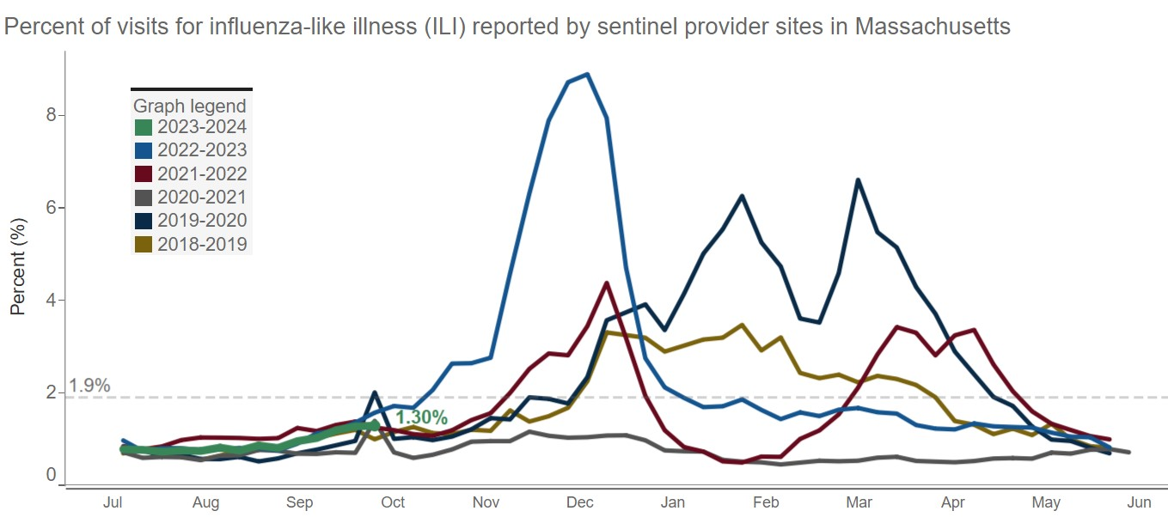

What We Are Asking of You

1) Specimen collection for influenza testing
Collect and submit specimens for laboratory isolation of influenza virus (NP swabs preferred – although other specimen sources are acceptable); We are encouraging sites to submit specimens every week for influenza testing so that we can detect increases in influenza activity and identify which strains of influenza are circulating. (NP swabs are required for additional BioFire FilmArray Respiratory Panel testing.)

MDPH will supply the flu kits free of charge and will ensure the kits are returned to MA SPHL in a timely manner at no cost to your facility. We use UPS for this purpose, and occasionally use a private courier service. Should you need additional flu kits during the season, please contact one of our Research Analysts at (617) 983-6800.

2) Reporting ILI every week
In addition to submitting specimens, we ask that you also report ILI directly to the CDC by Internet or fax beginning with the first week of the new season (this is usually the first week in October). Internet-based reporting of weekly ILI data to the CDC is the preferred method. The weekly data transmission consists of the following two items:

1. The number of patients seen for ILI during a given week in each of the following five age categories:
a) 0 through 4 years
b) 5 through 24 years
c) 25 through 49 years
d) 50 through 64 years
e) >64 years
2. and the total number of patients seen for any reason at your health care setting during the course of a given week.

Weekly reports should be submitted even if you have had no patient visits for ILI during that week. We need to know when you are NOT seeing influenza, too. This is especially significant during the early and late parts of the surveillance period.

Benefits for Sentinel Sites
As mentioned, each site is provided with respiratory kits to test patients throughout the season. Test results are returned through electronic reporting, fax, or mail to the submitting facility. Beyond influenza results, it may be useful to learn which additional respiratory pathogens are circulating in your community as flu-negative specimens (NP swabs only) will be tested using the BioFire FilmArray respiratory panel.

You will receive regular e-mails and reports from MDPH during influenza season showing the latest flu activity in the state and your region, as well as important announcements related to influenza and the vaccine. (Additional information can be found on the MDPH website at: http://www.mass.gov/flu.) Each participating site is also offered one free registration to our annual adult and pediatric immunization conferences. Lastly, all actively participating sites will receive a certificate of appreciation from the Centers for Disease Control and Prevention.

Next Steps
We want to work closely with you to facilitate your active participation in the ILINet. Please feel free to contact Joyce Cohen, Influenza Coordinator, at joyce.cohen@mass.gov with further questions or to enroll.

Again, thank you for your interest and we look forward to partnering with you in influenza surveillance efforts in Massachusetts.

*For reporting purposes, ILI is defined as an illness consisting of a fever (>100ºF [37.8ºC], oral or equivalent) AND a cough or sore throat.
**BioFire FilmArray includes testing for Influenza, Adenovirus, Coronavirus, Human Metapneumovirus, Human Rhinovirus/Enterovirus, Parainfluenza, RSV, Bordetella pertussis, Chlamydophila pneumoniae, and Mycoplasma pneumoniae.

