Chapter 93 of the Acts of 2020

Elder Facilities Reporting User Guide
Updated November 2020
Contents
Getting Started with REDCap 2
Navigating the REDCap Application 2
Page 1: Choose Facility Type 3
Page 2: User Information 4
Page 3: Reporting Data on Behalf of Facility 5
Page 4: Demographics 6
Pages 5-7: Follow-up Information from Page 4 7
Submitting data 8
Ending Your REDCap Session 8

Getting Started with REDCap
To access the updated REDCap application, visit: (https://www.mass.gov/redcap/chapter-93. From there you can access the REDCap tool. Please do not bookmark the REDCap link directly.

Navigating the REDCap Application
This portal was designed to be responsive to every selection you make. Therefore, answers or selections are required for every question. If a mistake is made on the current page, simply change your answer and proceed accordingly; if a mistake was made on a previous page, click the “Previous Page” button and update your answer(s) as needed.
At the top-right of each page are options to resize the font or enable speech. Simply click on the plus or minus icons to increase or decrease the font, respectively.
Clicking on “Enable speech” will add a speaker icon next to each question.
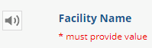
You can click on the speaker icon to have the question read aloud.

You will be prompted with an error message if you click submit and leave a required question blank. Required questions are indicated by “*must provide value” in red text.

Page 1: Choose Facility Type
On the first page, you will be prompted to choose the facility type for which you are reporting. Answers include: Nursing Home, Rest Home, Assisted Living Residence, and Intermediate Care Facility.
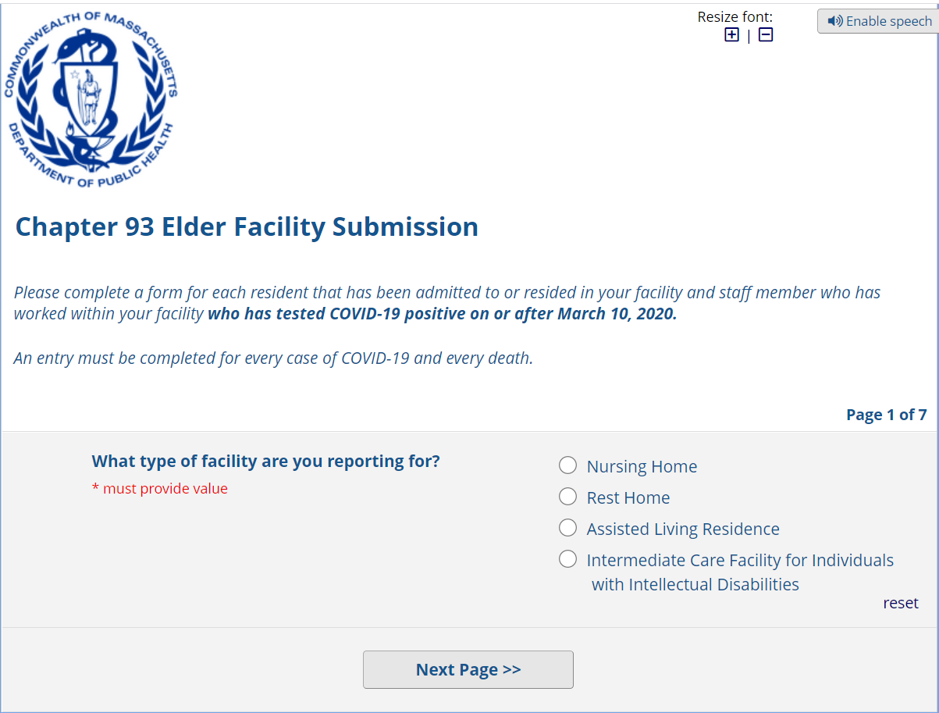
You will then be prompted to select your facility name from a drop-down list of nursing homes, rest homes, or assisted living residences. If you do not see your facility name on the list, select “OTHER” from the drop-down list. If you select “OTHER”, you will be prompted to write in the name of your facility.

Page 2: User Information
On the second page, you will be prompted to provide your name and select if you've entered data into this updated V3 application previously.
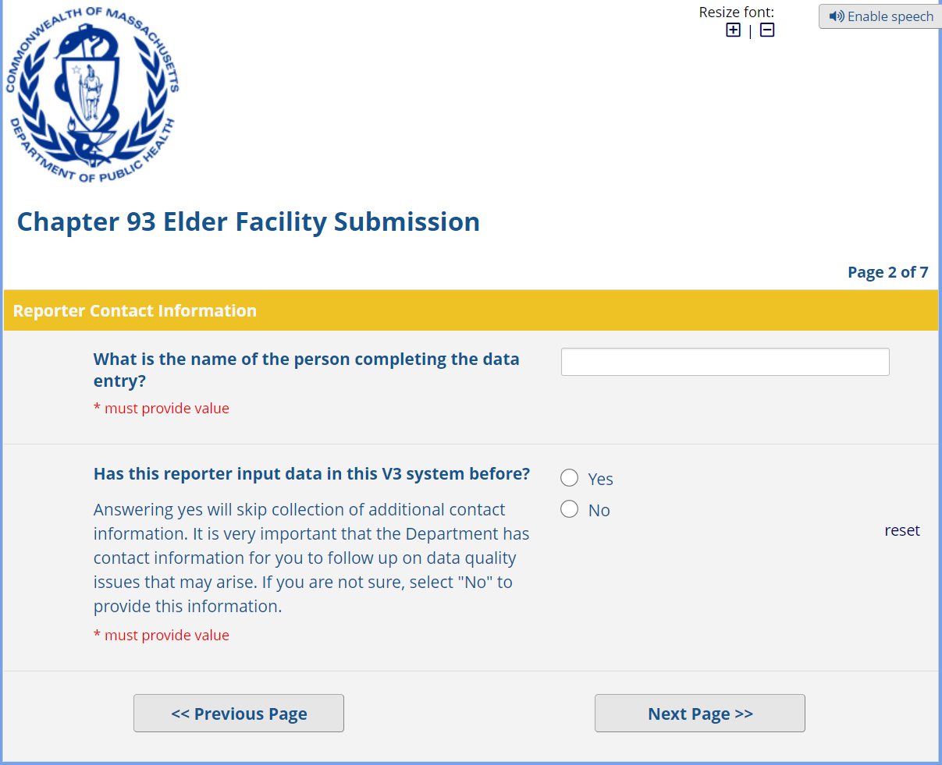
If this is your first time accessing this V3 application, click “No”. You’ll then be prompted to provide your email address and phone number. It is critical that you provide this information so that the Department of Public Health can follow up with you if an issue arises.
If you've accessed this V3 application before and provided your contact information already, click “Yes”.

Page 3: Reporting Data on Behalf of Facility
The third page elaborates upon the questions asked on the second page. Specifically, you will be prompted to choose if you've entered data on behalf of your facility in any version of the Chapter 93 REDCap systems previously.
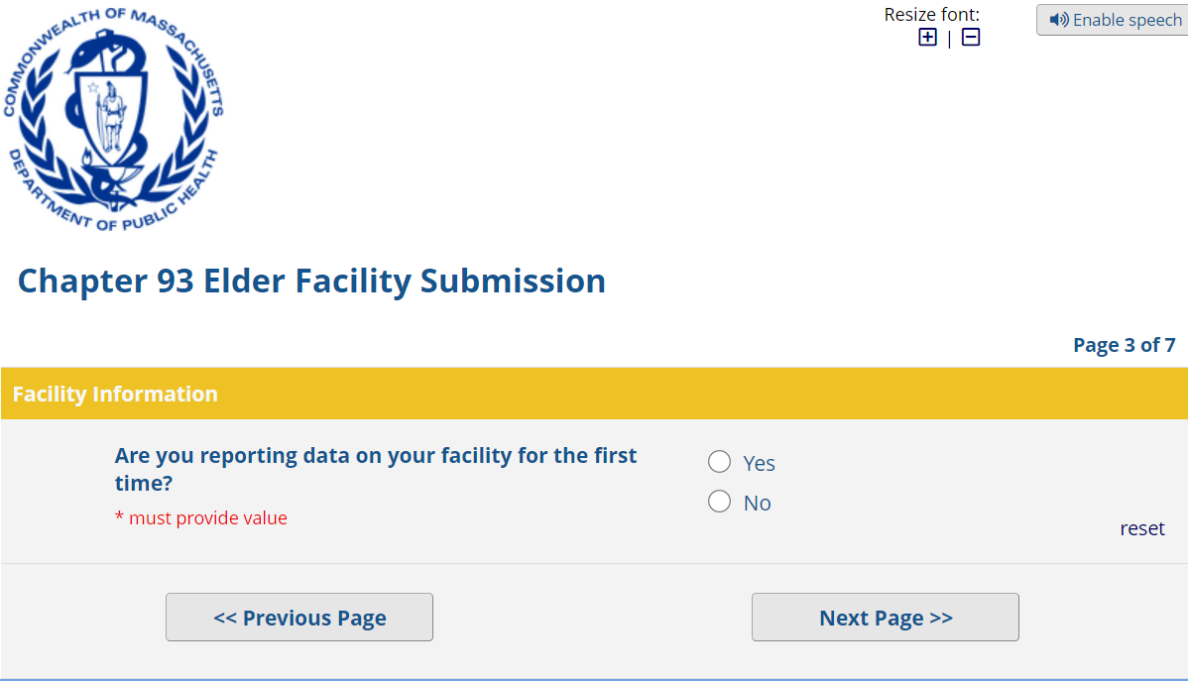
If you've accessed REDCap for Chapter 93 before and reported data on behalf of your facility, click “No”.
If this is the first time you're reporting on your facility in this V3 system, click "Yes". You will then be prompted to answer if your facility had any COVID-19 cases among staff or residents.
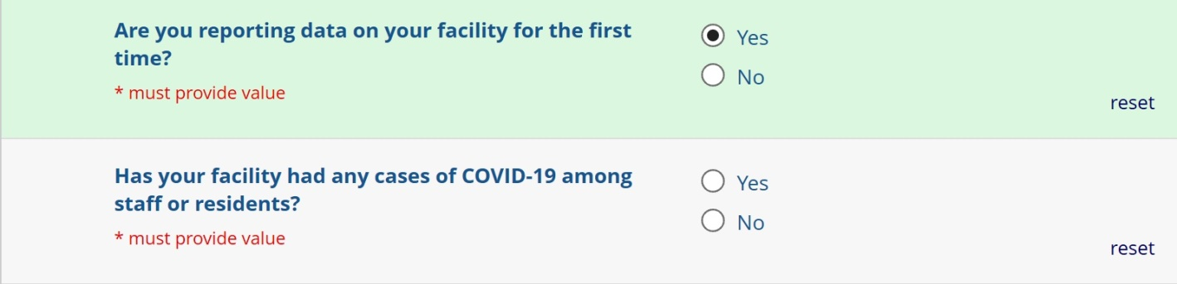
Please note that if your answer to the question about COVID-19 cases is “No” the system will automatically progress you to the end on Page 7. If you need to go back, click “Previous Page”.

Page 4: Demographics
The fourth page explores information about the data you are reporting. You'll first be prompted to select if you're reporting on a staff member or a resident along with that person's name, date of birth, if you've reported data for them previously, and the nature of the data you're reporting.
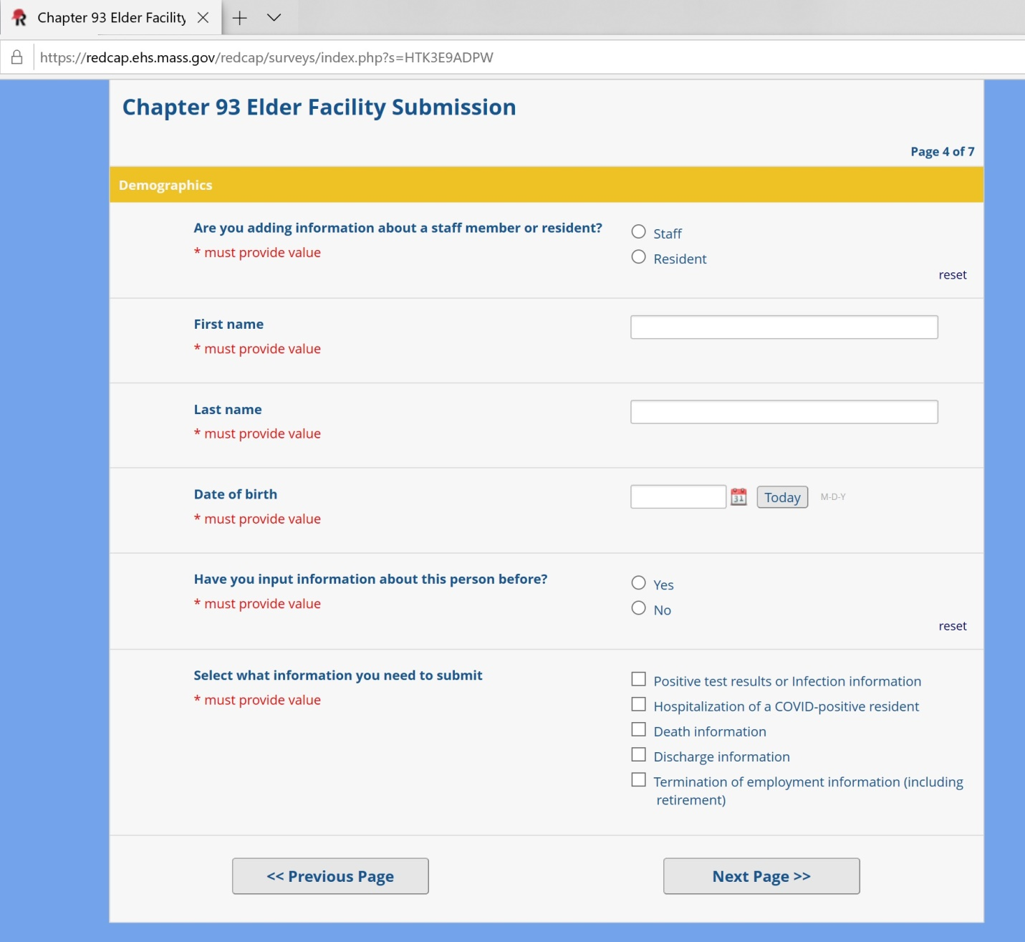
If you haven't reported data about this person before, you'll be prompted to enter information about the person's: admission date or staff start date, gender, race (note: if "Other" is chosen, you must write in their race), ethnicity, age, if they have any disability, and their primary language (note: if "Other" is chosen, you must write in their primary language). For staff you will also need to report town of residence and their occupation within your facility.

Pages 5-7: Follow-up Information from Page 4
Depending on your answer to the question on Page 4 about the nature of the data you’re reporting, the follow-up questions on the next page(s) will differ accordingly. If you selected multiple answers at the end of Page 4, you will see some combination of the follow-up questions below. Please remember that if you need to go back at any point, click “Previous Page”.
If you selected "Positive test results or Infection information" on Page 4

You will be taken to the fifth page that explores infection information, including: if the person for whom you're reporting data had symptoms of COVID-19, the date of their first positive test, and if their test was taken in the facility, at a hospital, or "Other" location. If you answer that the person did have symptoms of COVID-19, you will then be prompted to enter the date when they initially started to show signs/symptoms of COVID-19.
Following the completion of these questions, you will then be progressed to the end of Page 7.
If you selected "Hospitalization of a COVID-positive resident" on Page 4
You will be taken to a unique Page 7 that explores the date of the person’s admission to the hospital and reason for hospitalization before the conclusion of the questionnaire.
If you selected "Death information" on Page 4
You will be taken to Page 6, which elaborates upon your answer about the death of a staff member or resident. You will be prompted to enter the date when the person died as well as if the death was COVID-19-related. You will then be progressed to the end of Page 7.
If you selected "Discharge information" on Page 4
You will be taken to Page 6, which elaborates upon your answer about the discharge of a staff member or resident. You will be prompted to enter the date when the person was discharged. You will then be progressed to the end of Page 7.
If you selected "Termination of employment (including retirement)" on Page 4
You will be taken to Page 6, which elaborates upon your answer about the final date of employment of a staff member. You will then be progressed to the end of Page 7.

Submitting data
From page 7, you must click the Submit button to submit your data.
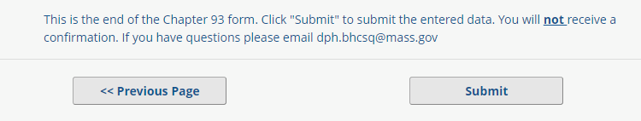

Ending Your REDCap Session
Unlike in previous versions of the REDCap reporting application, you do not need to re-submit data that you previously submitted. Upon completion of submitting data for one person, after progressing through Page 7 you have the option to close the page or to submit additional information for another person.
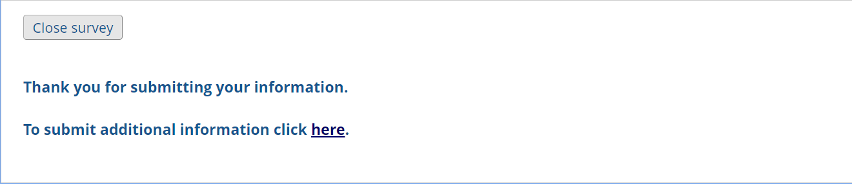
If you encounter issues navigating through the REDCap application please contact us.

