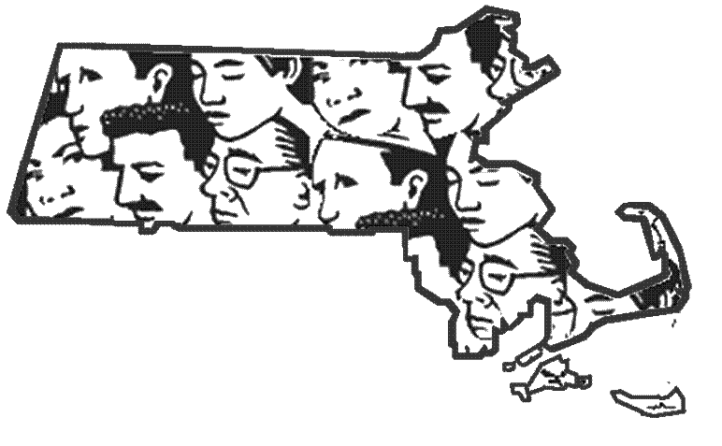
MA FACE
Occupational Fatality Report

Refuse Collector was Fatally Injured when Struck by a Backing Refuse Collection Truck - Massachusetts

Release Date: February 26, 2013 Massachusetts Department of Public Health
Investigation: # 11-MA-019-01 Occupational Health Surveillance Program

SUMMARY

On July 12, 2011 a 28-year-old male refuse collector (victim) was fatally injured when he was struck by a backing refuse collection truck. The victim had just finished stopping traffic on a main roadway to allow the truck to back down a dead-end side street. After stopping traffic, the victim ran along the driver’s side of the backing truck and then stepped behind the truck to climb onto the loading sill section of the hopper. While climbing onto the truck, he slipped off the truck, fell to the ground and then was struck by the driver’s side rear wheels. When the victim fell, the two co-workers, who were standing on the truck’s rear riding steps, yelled stop multiple times and the truck driver stopped the truck. Multiple co-workers called for emergency medical services (EMS). Personnel from the local and state police departments, fire department and EMS all arrived within minutes of the calls. The victim was pronounced dead at the incident location. The Massachusetts FACE Program concluded that to prevent similar occurrences in the future, employers should:
- Ensure that employees never climb onto a refuse collection truck, including the rear loading sill and riding steps, while the truck is backing;
- Develop, implement and enforce backing procedures that include designated spotters to direct backing trucks and prohibit employees from being located behind backing trucks;
- Provide and ensure that employees wear appropriate personal protective equipment, including high visibility vests, when working along roadways; and
- Develop, implement, and enforce a comprehensive safety and health program that addresses hazard recognition and avoidance of unsafe conditions.
In addition, municipalities should:
- Consider the feasibility of implementing automated processes for residential refuse collection.

INTRODUCTION

On July 13, 2011, the Massachusetts FACE Program was alerted by the local media that on the day before, July 12, 2011, a male laborer was fatally injured when he was struck by a backing refuse collection truck. An investigation was initiated. On August 23, 2011, the Massachusetts FACE Program Director traveled to the company’s office location and met with a company representative to discuss the incident. The police department report, death certificate, company information, and the OSHA fatality and catastrophe report were reviewed during the course of the investigation.

The employer is a waste management company that primarily provides residential waste management services to local municipalities. The company has been in business for 17 years and has 45 trucks used to collect waste and recyclable materials. The company has approximately 85 employees of which about 24 are collectors (shakers). The victim, a shaker, had been employed with the company for four months at the time of the incident. Employees worked five days per week, Monday through Friday. Work on Saturday only occurred if a holiday fell on a weekday. A typical workday started around 6:30 a.m. at the location where the company parked the trucks.

The company did not have a comprehensive written health and safety program, but did hold two safety meetings each year. The company reported that since the incident they are now holding safety meetings approximately every seven weeks. New employees are provided with in-house training / orientation that includes topics such as, proper lifting techniques, working safely around the truck, how to operate the truck’s hopper and the procedures to follow if stuck by a needle when collecting refuse. All new employees are assigned to a truck with an experienced driver and collector for two weeks of hands-on training. The company had workers’ compensation insurance as required by law in Massachusetts (G.L. c. 152, Sec. 25A). There was no union representation at the company.

INVESTIGATION

On the day of the incident, the victim and other employees arrived at the company’s truck yard at around 6:30 a.m. and then drove to the town where they were assigned to collect the refuse. The victim was part of a two person crew assigned to a refuse collection truck. The victim was the collector, the worker who does the majority of picking up the refuse and throwing it into the truck’s rear hopper. The second person of the crew was the truck driver who drives the truck and also helps with placing refuse into the truck’s hopper. The victim was assigned to one of four refuse collection trucks, with two person crews, in the town where the incident occurred. Some of the company’s recycling trucks were also in the same town on that day.

Prior to the incident, two of the four refuse collection trucks were full and were going to head to a landfill to empty their loads. Since the landfill was about a ten minute drive from town, the typical procedure was for the truck drivers to drop off the collectors with another collection truck. Once dropped off, the collectors would assist that truck’s collector. In this case, both collectors were dropped off with the incident truck. The victim was the second collector to be dropped off at the incident truck. This resulted in one refuse collection truck, the incident truck, having one driver and three laborers.

The refuse collection truck involved in the incident was manufactured and purchased by the company in 2002. The ten wheeled truck, with double dual rear wheels, was equipped with a rear loading hopper and a hydraulic powered compressing mechanism. The truck also had a functioning backup alarm (Figure #1).

On the day of the incident, the victim was wearing a white tank top, shorts, sneakers, and gloves and the temperature was 90 degrees Fahrenheit with no precipitation. The victim arrived at the incident location approximately 11:30 a.m., the refuse collection truck involved in the incident was about to start backing down a street. This street is an undivided dead-end side street that is approximately 25 feet wide. The street has no roadway markings, no sidewalks and the roadway edges are lined with residential homes.

The victim stopped traffic on the main roadway, which ran perpendicular to the dead-end side street, allowing the refuse collection truck to back onto the dead-end street. As the driver started to back the truck down the dead-end roadway, the victim started to run along the driver’s side of the truck towards the rear of the truck. At this same time, the other two collectors were each standing on one of the rear riding steps located on either side of the truck. When the victim reached the rear of the truck he stepped behind the truck while it was still backing to climb onto the loading sill section of the hopper (Figure #2). The victim then slipped and fell towards the left side of the truck. As the victim fell, the two co-workers started to yell stop multiple times. The victim landed on the asphalt and was struck by the driver’s side rear wheels. The truck then came to a stop.

Multiple co-workers called for emergency medical services (EMS). Personnel from the local and state police departments, fire department and EMS all arrived within minutes of the calls. The victim was pronounced dead at the incident location. After the incident the truck was examined by the state police and was found to be in good condition.

CAUSE OF DEATH

The medical examiner listed the cause of death as blunt force trauma of head and torso with fractures and visceral injuries.

RECOMMENDATIONS/DISCUSSION

Recommendation #1: Employers should ensure that employees never climb onto a refuse collection truck, including the rear loading sill and riding steps while, the truck is backing.

Discussion: In this incident, the refuse collection truck was backing down a dead-end roadway with two of the victim’s co-workers standing on the truck’s rear riding steps. As the truck backed, the victim attempted to climb onto the truck’s rear loading sill apparently to ride the truck to the end of the street. While climbing onto the truck’s sill the victim fell from the truck.

The Preventing Worker Injuries and Deaths From Moving Refuse Collection Vehicles publication released in 1997 by the National Institute for Occupational Safety and Health (NIOSH), recommends that collectors should not ride the steps when the vehicle is backing.¹ Employers should also develop and implement a policy that prohibits employees from climbing onto the riding steps or loading sill while a truck is backing. These policies should be part of a comprehensive safe backing procedure (Recommendation #2).

Recommendation #2: Employers should develop, implement and enforce safe backing procedures that include designated spotters to direct backing trucks and prohibit employees from being located behind backing trucks.

Discussion: In this case, the refuse collection truck routinely backed down this and other dead-end residential roadways in the area because these roadways were too narrow for the truck to turn around. Backing refuse collection trucks in residential areas is not only a hazard to the workers on foot, it is also a hazard to the general public who might be in proximity to the backing trucks.

Safe backing procedures should include, but not be limited to, the following, which were adapted from the National Solid Waste Management Association (NSWMA) procedures outlined in the NIOSH Preventing Worker Injuries and Deaths From Moving Refuse Collection Vehicles publication.¹

Safe backing procedures:
Before backing, drivers should:
- turn on the vehicle’s hazard lights and other strobe lights;
- roll down the cab windows;
- turn off all radios but two way radios;
- assign and use a co-worker as a spotter;
- know how many workers are on foot and visually locate all workers on foot (both workers normally part of the work crew and, as in this case, workers that are temporarily at the work location, to make sure that they are clear of the vehicle’s path; and
- make sure that no one is on the riding steps or behind the truck.

When backing, drivers should:
- use agreed upon hand signals to communicate with the spotter;
- start backing only when there is an understandable signal from the spotter that it is safe to start backing;
- stop backing immediately if visual contact is lost with workers on foot; and
- resume backing only after visual contact is restored with workers on foot and only once the spotter has signaled to the driver that it is safe to start backing again.

Other crew members should:
- step off the riding steps before the driver begins to back;
- remain inside the vehicle cab or in front of the truck unless assigned to act as a spotter; and
- never cross, step behind or climb onto the vehicle when it is backing or when its backup lights are on.
Spotters should:
- remain visible in the driver’s mirrors;
- maintain a clear view of the hazard area (driver’s blind spot) behind the vehicle;
- stay clear of the vehicle’s path;
- avoid walking backward;
- use agreed upon hand signals to communicate with the driver;
- be sure that no one is on the riding steps or behind the vehicle before signaling the driver to start backing;
- immediately signal the driver to stop if any person or object enters the area behind the truck; and
- signal the driver to stop if the spotter must change positions when the vehicle is backing; the spotter should then move to the new position and signal the driver to continue.

Recommendation #3: Employers should provide and ensure that employees wear appropriate personal protective equipment, including high visibility vests, when working along roadways.

Discussion: Both refuse collection truck drivers and the collectors face many hazards while working. These workers are routinely on foot working along roadways, bringing them close to motor vehicle traffic, typically with no barriers between them and the moving vehicles. At the time of the incident, the victim was not wearing a high visibility garment.

The Manual on Uniform Traffic Control Devices (MUTCD) states that all workers exposed to the risks of moving roadway traffic or construction equipment should wear high-visibility safety apparel.² The MUTCD refers to the American National Standard Institute’s (ANSI) standard for High–Visibility Safety Apparel (ANSI/ISEA 107-2004).³ This standard, published by the International Safety Equipment Association (ISEA), recommends specific types of reflective equipment while working in or near moving traffic. This standard specifies three classes of garments based on the workers’ activities. These classes are:

Class 3 garments provide the highest level of visibility for workers who face serious hazards with high task loads that require attention away from their work where traffic exceeds 50 miles per hour (mph).

Class 2 garments are intended for use where greater visibility is necessary during inclement weather conditions and when activities occur near roadways where traffic speeds exceed 25 mph.

Class 1 garments (not for use along highways and streets) are intended for use in activities that permit the wearer's full and undivided attention to approaching traffic. There should be ample separation of the worker from traffic, which should be traveling no faster than 25 miles per hour.

The ANSI standard also states that a competent person designated by the employer should be responsible for selecting the appropriate class of garment for the workers. A competent person, as defined by the Occupational Safety and Health Administration (OSHA), is a person who, through training or knowledge, is capable of identifying existing and predictable hazards in the surroundings or working conditions that are unsanitary, hazardous, or dangerous to employees, and who has authorization to take prompt corrective measures to eliminate them.

Recommendation #4: Employers should develop, implement, and enforce a comprehensive safety and health program that addresses hazard recognition and avoidance of unsafe conditions.

Discussion: At a minimum, a comprehensive safety and health program should include an explanation of the worker’s rights to protection in the workplace, safe work practices workers are expected to adhere to, specific safety protection for all tasks performed, ways to identify and avoid hazards, and who they should contact when safety and health issues or questions arise. Safe backing procedures should be one section of the overall health and safety program.

As part of the development of safety and health programs, employers should evaluate tasks performed by employees for all potential hazards and incorporate information about these identified hazards and their controls into the program.⁴ Employers should also use their employees’ expertise throughout the program development process by seeking employee input. Once the safety and health program is developed, employers should continue to seek employees’ input during the routine updating of the program. The program should be updated when safety concerns arise and when new equipment and new tasks are being introduced.

Employers should ensure that they have fully and effectively implemented their comprehensive safety and health programs by routinely performing assessments of tasks and immediately addressing any observed unsafe conditions. As part of the program’s implementation, training should be provided to all employees on program topics, including, in this case, the backing procedures and hazard recognition and the avoidance of unsafe conditions.⁵ All training provided to employees should be documented. Documentation should include: who provided the training and their qualifications, the content of the training, workers who were trained, and any assessments of workers’ comprehension of the training. When the safety and health program is updated, employers should then provide additional training on the new and updated safety and health program topics.

The Massachusetts Department of Labor Standards (DLS) offers free consultation services to help small employers improve their safety and health programs, identify hazards, and train employees. DLS can be contacted at 508-616-0461. More information about DLS can be found on their Web site at www.mass.gov/dos/consult.

The Massachusetts Department of Industrial Accidents (DIA) has grants available for providing workplace health and safety training to employers and employees. Any company covered by the Massachusetts Workers’ Compensation Insurance Law is eligible to apply for these grants. More information about these DIA grants can be found on their Web site at www.mass.gov/ lwd/workers-compensation/safety.

Recommendation #5: Municipalities should consider the feasibility of implementing automated processes for residential refuse collection.

Discussion: In this case, the company had reported that more communities in which they have contracts are switching to automated refuse and single stream recycling collection programs. Typically these programs implement the use of large wheeled carts that residents wheel to the street curb. Trucks for automated collection are equipped with an arm that hooks onto the carts and dumps the cart’s contents into the truck’s hopper. The crew size for an automated system is usually one to two workers.

Automated systems reduce the number of workers exposed to the hazards of a backing trucks and will limit the amount collectors are lifting each day. As with all new processes, a complete hazard analysis should be performed prior to and during the implementation stages of this program. ⁴

REFERENCES

1. CDC. NIOSH Alert: Preventing Worker Injuries and Deaths From Moving Refuse Collection Vehicles. DHHS NIOSH Publication No. 97-110. www.cdc.gov/niosh/docs/97-110/. Date accessed: October 4, 2011.

2. U.S. DOT 2009. Manual on Uniform Traffic Control Devices (MUTCD), 2009 Edition, U.S. Department of Transportation Federal Highway Administration.

3. ANSI/ISEA 2004. American National Standard for high-visibility safety apparel. New York, NY: American National Standards Institute, ANSI/ISEA 107-2004.

4. DOL. OSHA Draft Proposed Health and Safety Program, Docket No. S&H-0027. www.osha.gov/dsg/topics/safetyhealth/nshp.html. Date accessed: October 4, 2011.

5. Regulations, 29 CFR 1926.21 Safety training and education. Washington D.C.: U.S. Printing Office, Office of the Federal Register.

6. CDC. NIOSH Fact Sheet: Solid Waste Industry. DHHS NIOSH Publication No. 2012-140.
www.cdc.gov/niosh/docs/2012-140/. Date accessed: May 1, 2012.

Figure 1 – Refuse collection truck after the incident

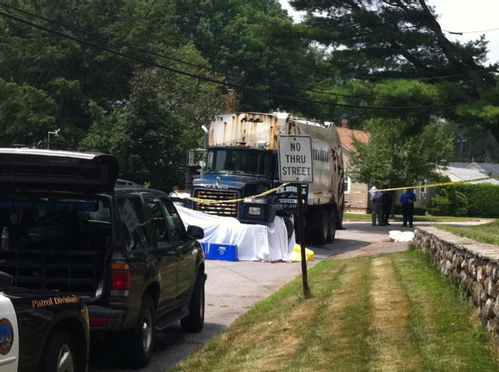

Figure 2 – Rear view of similar refuse collection truck

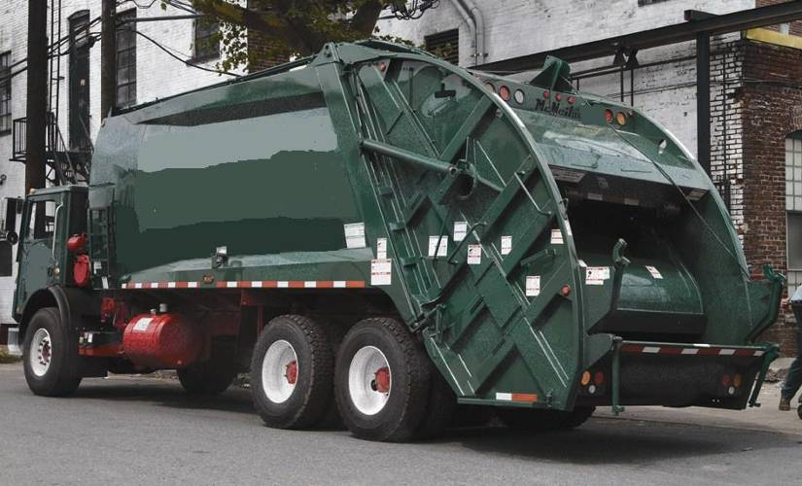
Loading Sill

Michael A. Fiore, MS, Director | Letitia Davis, Sc.D., Ed.M., Director
Massachusetts FACE Program | Occupational Health Surveillance Program
Occupational Health Surveillance Program | Massachusetts Department of Public Health
Massachusetts Department of Public Health

******************************************************************************

FATALITY ASSESSMENT AND CONTROL EVALUATION PROGRAM

The Massachusetts Department of Public Health, in cooperation with the National Institute for Occupational Safety and Health (NIOSH), conducts investigations on the causes of work-related fatalities. The goal of this program, known as Massachusetts Fatality Assessment and Control Evaluation (Massachusetts FACE) is to prevent future fatal workplace injuries. Massachusetts FACE aims to achieve this goal by identifying and studying the risk factors that contribute to workplace fatalities, by recommending intervention strategies, and by disseminating prevention information to employers and employees.

Massachusetts FACE also collaborates with engineering and work environment faculty at the University of Massachusetts at Lowell to identify technological solutions to the hazards associated with workplace fatalities.

NIOSH funded state-based FACE Programs currently include: California, Iowa, Kentucky, Massachusetts, Michigan, New Jersey, New York, Oregon, and Washington.

**********************************************************************************

Additional information regarding this report is available from:

Occupational Health Surveillance Program
Massachusetts Department of Public Health
250 Washington Street, 6th floor
Boston, Massachusetts 02108-4619
(617) 624-5627

Evaluate this report

We would appreciate your feedback on these reports so we may continue to improve the MA FACE project and our investigation reports. A feedback form can be found at: www.mass.gov/eohhs/docs/dph/occupational-health/report-evaluation.doc
The completed form may be returned by fax to (617) 624-5676, by mail to FACE, 250 Washington Street, 6th Floor, Boston, MA 02108, or by email to ma.face@state.ma.us.

