**INDOOR AIR QUALITY ASSESSMENT**

**Reggie Lewis Center**

**1350 Tremont Street**

**Roxbury, Boston, MA**

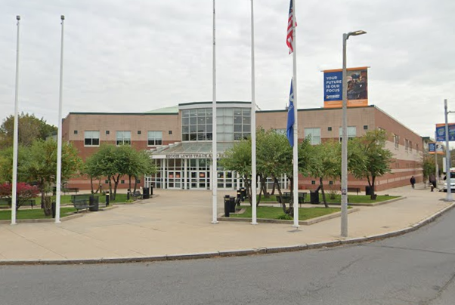

Prepared by:

Massachusetts Department of Public Health

Bureau of Climate and Environmental Health

December 2024

# BACKGROUND

|  |  |
| --- | --- |
| Building: | Reggie Lewis Center (RLC) |
| Address: | 1350 Tremont Street, Roxbury Community College (RCC), Boston, MA |
| Assessment Requested by: | Michael Turner, Executive Director, RLC |
| Reason for Request: | Reports concerning indoor air quality concerns and temperature control |
| Date of Assessments: | October 22, 2024, and October 29, 2024 |
| Massachusetts Department of Public Health/Bureau of Climate and Environmental Health (MDPH/BCEH) Staff Conducting Assessment: | Michael Feeney, Senior Bureau Advisor, BCEH |
| Building Description: | The RLC is a fieldhouse/indoor track facility that is located at the corner of Tremont Street and Malcolm X Boulevard. The building contains a gymnasium, meeting rooms, administration offices, locker rooms and a large front lobby entrance. |
| Windows: | Windows are not openable |

# METHODS

MDPH staff performed a visual inspection of building materials for water damage and/or microbial growth and examined the space for the presence of odors or other environmental concerns. Please refer to the IAQ Manual for methods, sampling procedures, and interpretation of results (MDPH, 2015).

# RESULTS AND DISCUSSION

## Ventilation

The RLC has multiple mechanical heating, ventilating, and air-conditioning (HVAC) systems: units in the field house, two air handling units (AHUs) located on the roof, and an AHU located in a mechanical room that contains the furnaces for the building. Each of these systems have different designs and service separate areas of the RLC. In addition, despite ongoing maintenance and replacement of parts/components by RLC facilities staff, many of the HVAC units are at or near at the end of their life cycle. Efficient function of equipment of this age (greater than 27 years old) is difficult to maintain, since compatible replacement parts are often unavailable. According to the American Society of Heating, Refrigeration, and Air-Conditioning Engineering (ASHRAE), the service life of this type of unit is 15-20 years, assuming routine maintenance of the equipment (ASHRAE, 1991). Given the age of the HVAC system, rebalancing the HVAC system is not recommended until after significant repairs, replacement, or redesign are completed. In its current condition, the fieldhouse HVAC system cannot be balanced.

### Fieldhouse

The Fieldhouse has a variety of components to provide fresh air and create air circulation. Four Hastings® ceiling-mounted AHUs (Picture 1) are connected to round ducts equipped with fresh air diffusers. A variety of large fans are installed on the ceiling to create air circulation. Unusually, no mechanical exhaust ventilation could be identified in the fieldhouse during this assessment or on blueprints for the fieldhouse.

Large louvers were noted in the east wall of the building (Picture 2) which are not equipped with mechanical ventilation fans (Picture 3). MDPH staff examined blueprints to determine the purpose of the passive vents in Picture 3. Original blueprints for the fieldhouse do not have these passive vents depicted or listed. Therefore, it appears that these vents were added after the original design was proposed or after construction.

In subsequent discussion with RCC staff, it was revealed that these vents were designed to open when the Hastings AHUs were operating. Each louver has a small motor that opens/closes them which is connected to the Hastings AHUs (labelled HV-1 through HV-4 on blueprints). As reported, the Hastings AHUs operate, fresh air pressurizes the fieldhouse interior, which in turn bleeds indoor air outdoors through these passive air vents. With this design, air and typical indoor air pollutants are not actively removed from the fieldhouse as would occur with a typical mechanical exhaust ventilation system.

Each Hasting AHU is equipped with air filters that would remove airborne particles. Replacement of filters in the Hasting AHUs is difficult due to the location over bleachers which requires using a mechanical scissor lift to gain access to each unit. Filters were being replaced during the second RLC visit. Prior to this, filters were labelled “10/30/2023” indicating their installation date, which was almost a year prior to the visit.

For a building space to use pressurization to bleed air through passive vents, the area must have a consistent fixed volume of air that can be adequately pressurized by the HVAC system. Without a fixed volume, pressurization likely would not occur, which results in indoor pollutants remaining in the space. The use of pressurization to push air from a building interior poses several problems:

1. If Hasting AHUs are not operating, no pressurization occurs.
2. If any interior doors to the fieldhouse from the lobby or hallways are propped open, pressurization by the Hasting AHUs is likely reduced.
3. If pressurization does not occur, the return vents (Picture 4) of the Hastings AHUs may draw air in from the east wall passive vents.
4. If the passive louvers are frozen open or are operating independent of the Hasting AHUs, uncontrolled amounts of cold air in the winter, or hot/humid air in the summer, can enter the fieldhouse.
5. If the Hasting AHUs do not have the capacity to over-pressurize the volume of air in the field house, uncontrolled amounts of cold air in the winter or hot/humid air in the summer can enter the fieldhouse.
6. If weather conditions create easterly winds that impinge on the RLC east wall, uncontrolled outdoor air and associated pollutants can enter the fieldhouse.

Based on these observations, it is likely that uncontrolled amounts of unconditioned and unfiltered outdoor air enter the fieldhouse via the passive vents even when the Hastings AHUs are operating. One means to prevent uncontrolled air movement would be if these vents were configured as backdraft dampers (also known as gravity dampers) which are used in ventilation systems to allow airflow in one direction and prevent airflow in the opposite direction. Such backdraft dampers are installed in the rooftop AHUs (Picture 5), which provide exhaust ventilation to each of these units. The fieldhouse passive vents are not backdraft dampers since outdoor light can be seen around louvers.

### Meeting rooms and administration offices

These areas are serviced by a Trane® AHU located in a mechanical room, labelled AHU-1 on blueprints. AHU-1 has a fresh air supply and is connected to a motorized exhaust vent motor, labelled RF-1. As reported by RLC staff, AHU-1 had a closed fire damper that caused the return ductwork to implode and create a large space in the return vent seam. The location of this breach of the return duct was identified (Picture 6). In addition, an open duct inspection opening missing its door exists above the duct breach (Picture 7).

These openings in the return duct allow mechanical room air to be drawn into AHU-1 to be distributed into meeting rooms and administrative offices. This condition likely explains the lack of air chilling in administrative offices which necessitated the use of portable air conditioning units.

If the mechanical room is depressurized several adverse conditions may occur.

* As AHU-1 operates, products of combustion for the furnaces may be drawn into the HVAC system and distributed to occupied spaces.
* The floor has a drain (Picture 8) for draining of condensation from AHU-1 when it is operating to provide chilled air during hot, humid weather. If this drain trap is dry, pollutants from the drain system, including water vapor, can be drawn into AHU-1 and distributed to occupied areas.

Sealing the duct breach and re-installing the dust inspection door should reduce the draw of air from the mechanical room.

During this assessment, a high-pitched whining noise appeared to be emanating from the RF-1 fan. Such noises may indicate a need for service of the fan, fan belt and/or motor of RF-1.

### Gymnasium HVAC systems

According to blueprints, rooftop AHU-2 and AHU-3 (Picture 9) are connected to ductwork servicing the gymnasium. Both AHUs do not have a typical fresh air intake vent with a hood usually seen in rooftop units. Fresh air may be drawn in by a side opening (Picture 10). AHUs are equipped with backdraft dampers, which provide exhaust ventilation when operating. Of note is that both AHUs are retrofitted with plastic vent louvers held in place with adhesive and foil tape (Picture 11). The purpose of these vents is not readily apparent. Each AHU is also equipped with a chimney-like structure (Picture 12), which would be consist with each unit providing heat by combusting fuel. Due to the location, this retrofitted vent may provide combustion air for fuel used by each AHU.

### Exhaust ventilation for restrooms, locker rooms and custodial closets

Exhaust ventilation is provided by rooftop exhaust vents (Picture 13). Several exhaust fans did not appear to be operating. Rooftop exhaust vents are usually connected by ductwork to locations where odors, chemicals, and water vapor need to be vented directly to the outdoors, which include showers, restrooms, custodial closets, and kitchen areas. As an example, due to the lack of exhaust ventilation, RLC staff placed a floor fan to direct odors to a hall door passive vent in a custodial closet (Picture 14). If the custodial room exhaust vent were operating, air would be drawn from the hallway into the custodial closet through the door vent, which would vent odors. Another sign of deactivated exhaust ventilation is the use of a plug-in air freshener. These fresheners can be irritants to the respiratory system, and only cover up odors, not remove them.

## Water Damage and Moisture

A significant moisture source was identified in the mechanical room: water vapor from the sewer system from floor drains with dry drain traps. This condition occurs when AHU-1 is not producing condensation during the heating season. The purpose of a drain trap is to prevent the backflow of sewer gas into a building. The watertight seal of the wetted drain trap seals the drain against backflow of air. This may have not been a significant issue until the return vent breach of AHU-1. The breach is drawing air from the mechanical room, which in turn may draw water vapor, odors and other materials from floor drains without wetted traps. Once drawn into ductwork, water vapors and odors can be distributed to occupied areas serviced by AHU-1.

Given the current HVAC structure, the operation of all mechanical exhaust vents is necessary to vent various pollutants from the interior of the building, such as water vapor from restrooms, kitchens, and showering facilities. If exhaust vents are not operating, water vapor is not removed from the building, which can then accumulate indoors to increase relative humidity.

In addition to these sources, a major source of excess indoor humidity in this building is from high outdoor relative humidity. It is important to note that Massachusetts has experienced extended periods of high relative humidity during the summer of 2024, as well as during previous summers (Appendix A). One sign of high relative humidity in the RLC is the presence of bowed ceiling tiles. If a building experiences high relative humidity (+70%) over an extended period, moisture exposure may cause ceiling tiles to sag or bow in the ceiling tile grid.

This humid air is drawn into the HVAC system where the functioning of the air conditioning can reduce humidity levels. However, due to the size of the building, the construction, and age of the HVAC system, only a small reduction in humidity can be achieved. When outdoor humidity is high for a significant period, like it has been over recent summers, indoor humidity can rise to uncomfortable levels and remain elevated.

# CONCLUSIONS/RECOMMDATIONS

The RLC has several issues related to the HVAC system and moisture in the building. The capacity of mechanical ventilation equipment to provide adequate chilled air and reduce relative humidity indoors is limited. It is important to note that with the extreme relative humidity and rain of the past few summers, management of the RLC in such weather can be challenging. The following documents can provide guidance which can be used to reduce the impact of hot, humid weather in buildings:

* Mold Growth Prevention During Hot, Humid Weather <https://www.mass.gov/service-details/preventing-mold-growth-in-massachusetts-schools-during-hot-humid-weather>
* Remediation and Prevention of Mold Growth and Water Damage in Public Schools <https://www.mass.gov/service-details/remediation-and-prevention-of-mold-growth-and-water-damage-in-public-schools-and>
* Methods for Increasing Comfort in Non-air-conditioned Schools <https://www.mass.gov/doc/methods-for-increasing-comfort-in-non-air-conditioned-schools/download>

To address the building’s problems, two sets of recommendations are made: **short-term** measures that may be implemented as soon as practicable and **long-term** measures that will require planning and resources to address overall IAQ concerns. In view of the findings at the time of assessment, the following recommendations are made:

## Short Term Recommendations

### Ventilation recommendations

1. Have the breach in the return vent for AHU-1 temporarily sealed using insulation and foil tape to create an airtight seal over opening until permanent repairs can be implemented.
2. Seal inspection opening above AHU-1 with the door.
3. Repair all exhaust vents fans and operate them when the RLC is occupied.
4. Have RF-1 examined to determine to source of whining sound. Repair as needed.
5. Determine the purpose of plastic vents on AHU-2 and AHU-3. If used for combustion air, consider replacing with metal louvers.
6. Change filters on AHUs regularly, a frequency of 2 to 4 times a year is recommended.
7. When possible, have the HVAC system balanced every 5 years in accordance with SMACNA recommendations (SMACNA, 1994).

### Water damage recommendations

1. Pour water into all floor drains in the mechanical room at least three times a week to maintain drain traps.
2. Work with an HVAC contractor to determine if the HVAC system can be operated or modified to provide additional dehumidification while in chilling mode.
3. Use dehumidifiers in the building during extreme outdoor relative humidity of greater than 70%.
4. Maintain all dehumidifiers and regularly remove water and clean receptacles to avoid stagnant water, odors, and the potential for leaks.

### Other Recommendations

1. Consider installing a carbon monoxide detector in the mechanical room.

## Long Term Recommendations

1. Examine the feasibility of installing a mechanical exhaust ventilation system to replace passive vents in the fieldhouse.
2. Consideration should be given to consulting a building engineering firm for advice and to conduct a building-wide ventilation systems assessment. Based on historical issues with air exchange/indoor air quality complaints, age, physical deterioration, and availability of parts for ventilation components, such an evaluation is necessary to determine the feasibility of replacing the equipment.

# REFERENCES

ASHRAE. 1991. ASHRAE Applications Handbook, Chapter 33 “Owning and Operating Costs”. American Society of Heating, Refrigeration and Air Conditioning Engineers, Atlanta, GA.

MDPH. 2015. Massachusetts Department of Public Health. Indoor Air Quality Manual: Chapters I-III. Available at: <https://www.mass.gov/lists/indoor-air-quality-manual-and-appendices>

SMACNA. 1994. HVAC Systems Commissioning Manual. 1st ed. Sheet Metal and Air Conditioning Contractors’ National Association, Inc., Chantilly, VA.

**Picture 1**

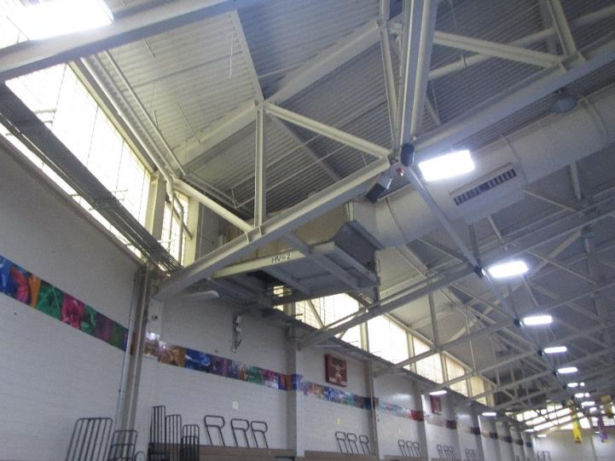

**Hasting AHU connected to round ductwork with fresh air diffusers in the fieldhouse ceiling**

**Picture 2**

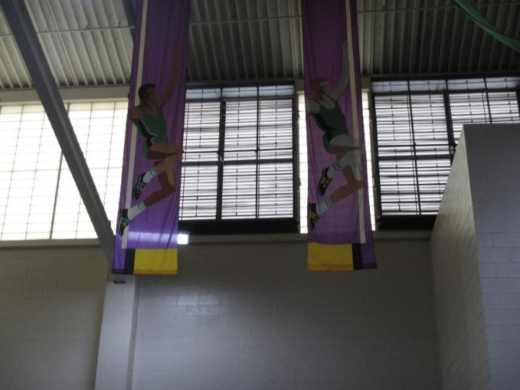

**Large louvers in east wall of fieldhouse which appear open to the outdoors when Hasting AHUs are deactivated**

**Picture 3**

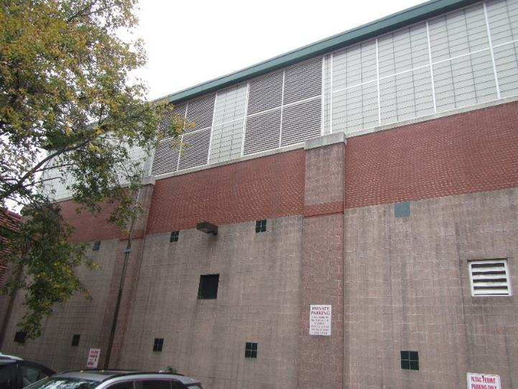

**Exterior of louvers in Picture 2; note no fans or other mechanical means to draw air are present**

**Picture 4**

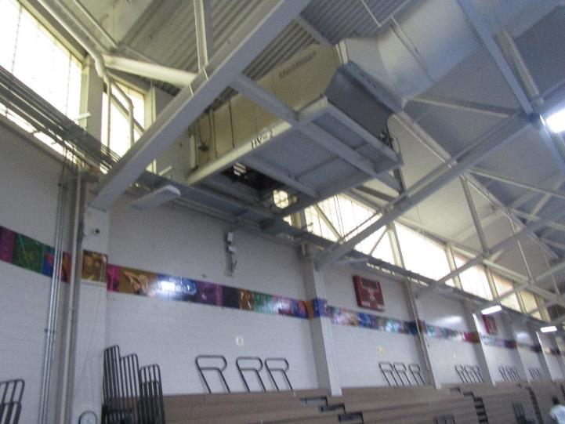

**Return vent of Hasting AHU (Arrow)**

**Picture 5**

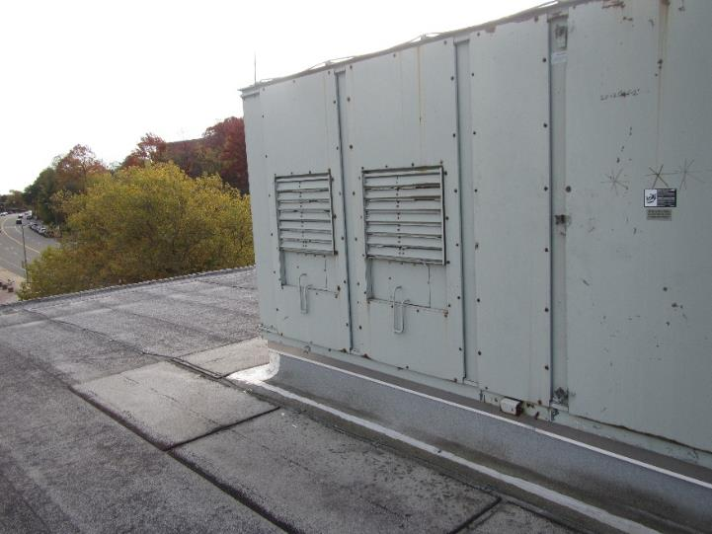

**Backdraft damper on AHU-2**

**Picture 6**

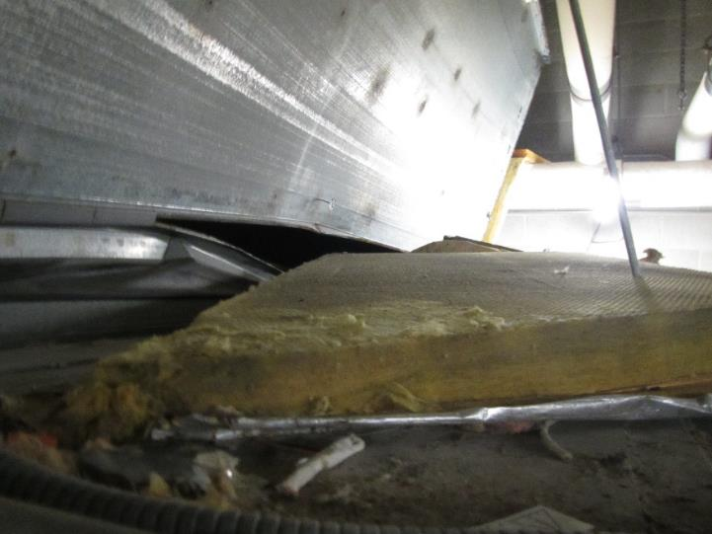

**Breach in Ductwork of AHU-1 (arrow)**

**Picture 7**

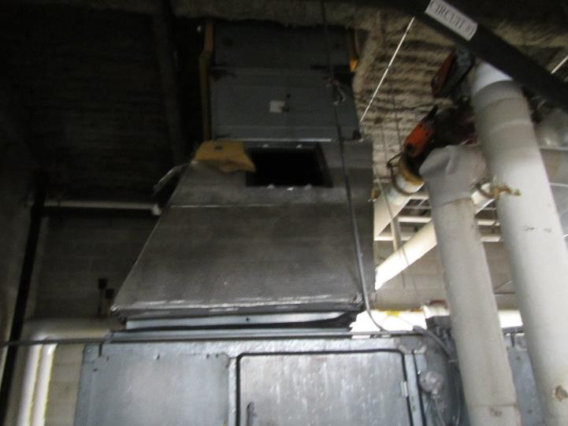

**Open inspection opening above duct breach**

**Picture 8**

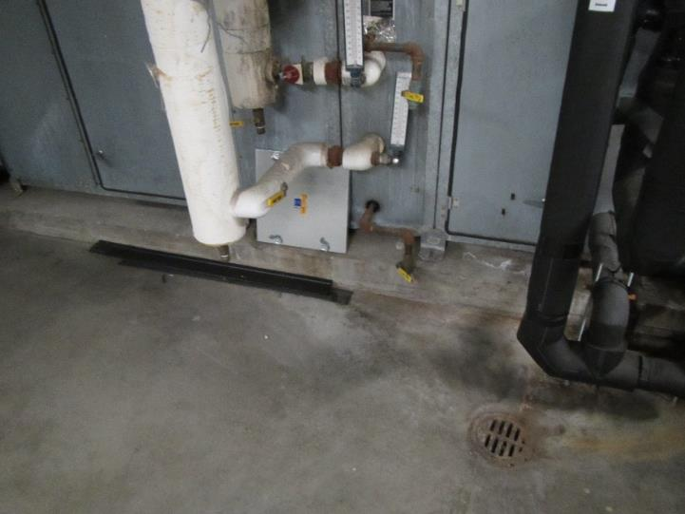

**Floor drain next to AHU-1 in mechanical room**

**Picture 9**

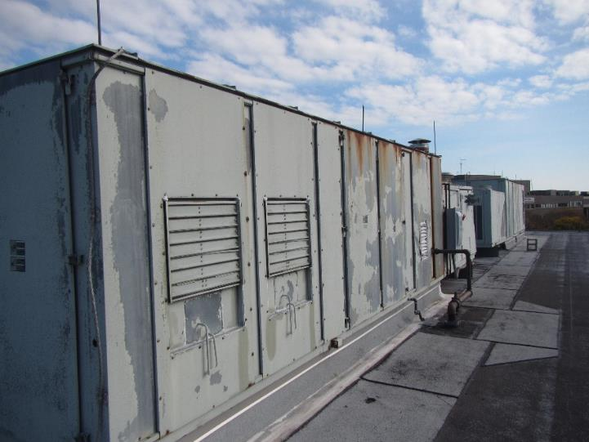

**AHU-2 & AHU-3**

**Picture 10**

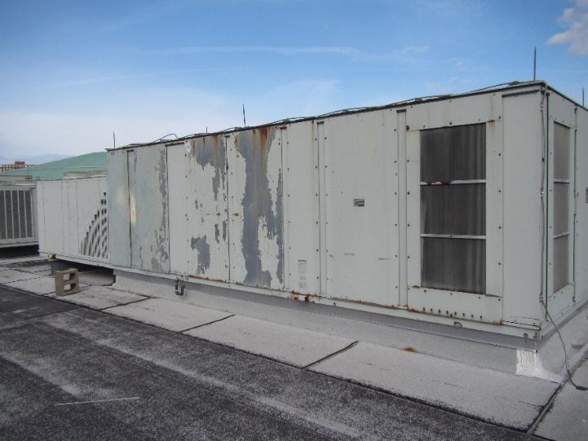

**Possible fresh air intake on the side of AHU (arrow)**

**Picture 11**

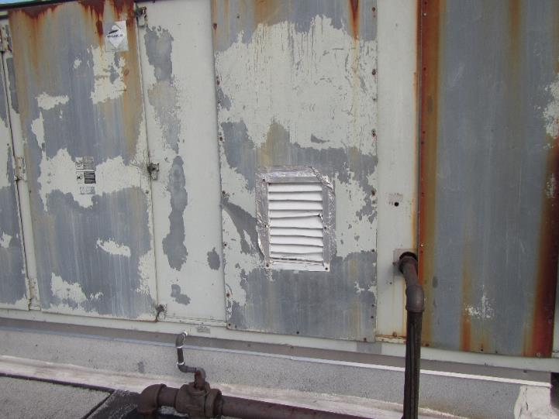

**Vent retrofitted with plastic louvers held in place with adhesive and foil tape**

**Picture 12**

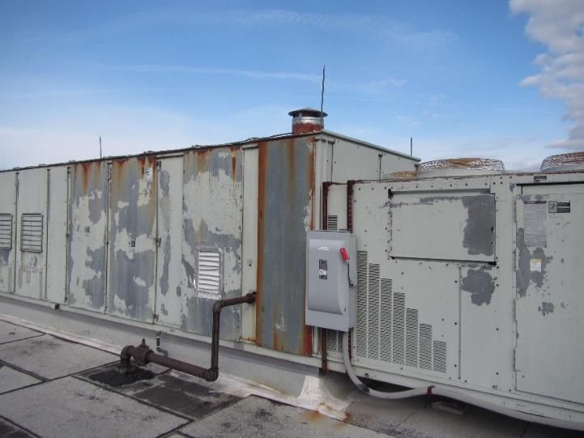

**AHU is equipped with a chimney-like structure (arrow)**

**Picture 13**

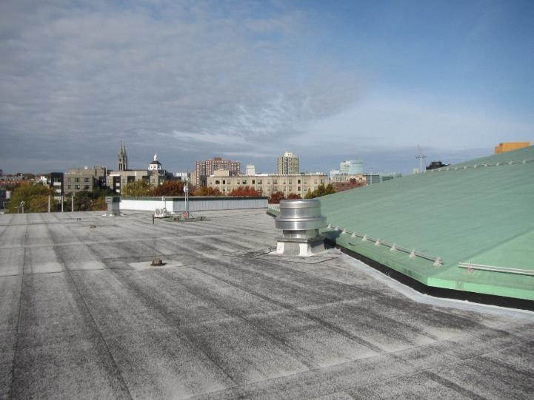

**Exhaust vent on roof**

**Picture 14**

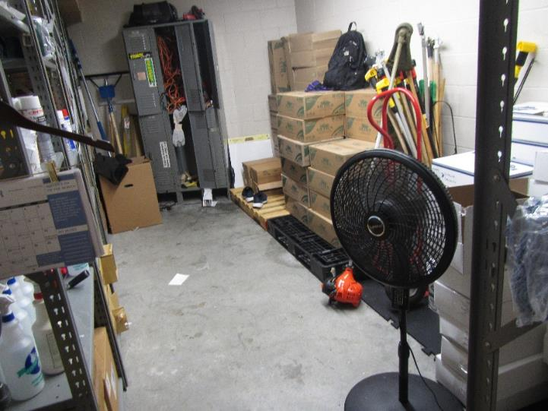

**Floor fan to direct odors to a hall door passive vent in a custodial closet**

Hot humid summers are becoming more frequent due to climate change. Massachusetts has experienced hot, humid, and rainy summers in 2018, 2021, 2023, and 2024. July of 2021 was the wettest ever recorded in Massachusetts, and the three-month period from June through August, known as the meteorological summer, was the fourth wettest on record, according to the National Oceanic and Atmospheric Administration’s (NOAA) Centers for Environmental Information (NOAA, 2021). The summer of 2023 was also hot, and wet, being measured as the second rainiest on record (WBUR, 2023). And the summer of 2024 has also had significant stretches of hot, humid weather. These conditions are challenging for buildings.

This weather resulted in condensation issues in many publicly owned or operated buildings, particularly those with below-grade space with walls or floors in direct contact with soil or cement slab floors. In these instances, the floors in direct contact with soil may have temperatures that would result in condensation wetting floors in high relative humidity conditions. When exposed to these conditions, porous materials such as gypsum wallboard, cork boards, cardboard, and other materials may become prone to developing mold colonization.

**References**

NOAA. 2021. Summer 2021 neck and neck with Dust Bowl summer for hottest on record. National Oceanic and Atmospheric Administration, 1401 Constitution Avenue NW, Room 5128, Washington, DC 20230 <https://www.noaa.gov/news/summer-2021-neck-and-neck-with-dust-bowl-summer-for-hottest-on-record>

WBUR. 2023. “It's been a summer of rain and flooding misery in Mass.” WBUR local news. September 12, 2023. <https://www.wbur.org/news/2023/09/12/summer-flooding-rain-massachusetts>