**Community Innovation Challenge (CIC) Grant**

**FY 2013 Final Report**

Project Title: Regional Highway Equipment Cooperative

Communities: Brookfield, Lead Community

Brimfield, East Brookfield, Hardwick, Warren, West Brookfield

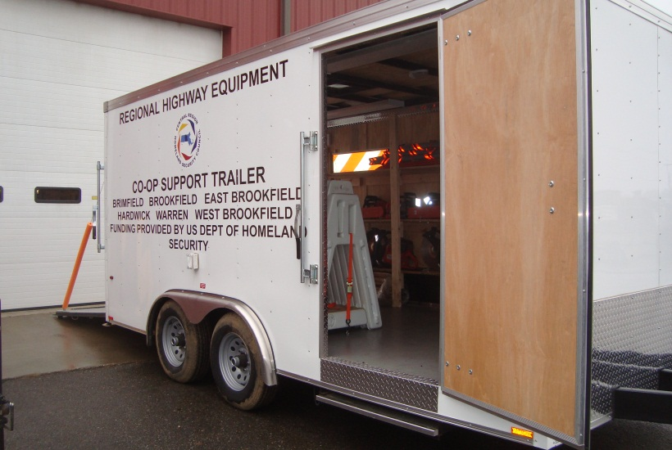

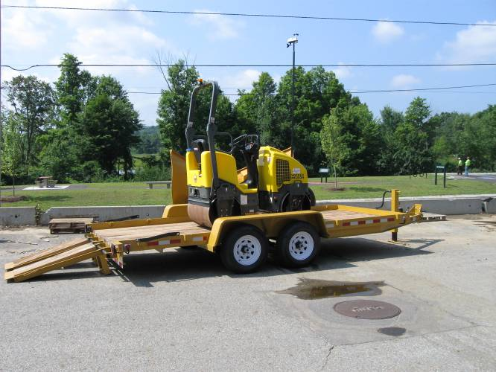

Date: April 15, 2014

**Table of Contents**

Introductory Letter 1

Executive Summary 2

Section 1: Partner Communities 4

Section 2: Goals 5

Section 3: Implementation Plan 6

Section 4: Budget 10

Section 5: Challenges and Solutions 11

Section 6: Outcomes 13

Section 7: Contact Information 16

Section 8: References 17

Appendix 1: Sample Invitation Letter 18

Appendix 2: Worcester Telegram & Gazette Article, June 10, 2013 21

Appendix 3: Scope of Services for Feasibility Study 23

Appendix 4: Shared Employee Feasibility Study 26

# Introductory Letter

April 15, 2014

Timothy Dodd, Local Government Program Manager

Community Innovation Challenge Grant Program

Executive Office for Administration and Finance

Massachusetts State House, Room 373

Boston, MA 01233

Dear Mr. Dodd:

I am pleased to submit this Final Report for the Regional Highway Equipment Cooperative (RHE COOP) project funded by the FY 2013 Community Innovation Challenge Grant Program. The grant enabled our participating communities to achieve greater operational efficiencies and to accomplish more work without budgetary increases. The project may serve as a model for other communities who desire to share resources as part of daily operations.

The purpose of the Cooperative is to enable Highway Departments in small towns to share equipment in order to perform road maintenance services more efficiently. Small highway departments are unable to afford all of the expensive equipment they need to keep roads in good repair and ensure the safety of the traveling public. In the first year, we devised a system for member towns to share equipment they do not use on a daily basis and to receive credit for loaning that equipment to other communities. We continue to monitor the lending and borrowing of equipment to ensure each community participates equally in the program.

The Cooperative utilized a second year of CIC funding to study the feasibility of hiring one or more shared employees who would work on behalf of all of the member towns. With limited financial resources, these towns have difficulty assigning staff to the time consuming tasks of cleaning catch basins, sweeping streets, and trimming trees. One or more shared employees would allow the departments to complete such tasks without compromising their ability to complete other necessary work. An independent consultant demonstrated the feasibility of this concept and identified the steps to implementation.

Originally created through the signing of an Inter-Municipal Agreement, the Regional Highway Equipment Cooperative has demonstrated its effectiveness to enable these capable highway departments to perform their duties under tight budgets in a cost effective manner. A Board of Directors oversees operations of the Cooperative, sets policies, and provides direction for establishing new shared services. This structure will allow the program to continue to provide valuable benefits to taxpayers.

Sincerely,



William Scanlan

RHE COOP Director

# Executive Summary

A $24,000 Community Innovation Challenge Grant allowed the towns of Brimfield, Brookfield, East Brookfield, Hardwick, Warren, and West Brookfield to continue their innovative highway equipment sharing program. The Regional Highway Equipment Cooperative (RHE COOP) came about through the signing of an Inter-Municipal Agreement (IMA) by five communities in 2012. The Town of Hardwick became the sixth member town later that year. The purpose of the RHE COOP is “to create a mechanism for sharing of public works equipment and personnel to make efficient use of existing resources and avoid purchasing of equipment that may be borrowed from a participating municipality subject to mutually agreed-upon protocols”.

A Board of Directors oversees the operations of the Cooperative. The membership consists of one member of the Board of Selectmen from each town and the Highway Superintendent/Surveyor of each town. The Directors set policy for how the communities will share resources, approve expenditures, authorize submission of grant applications, and determine new public works functions to regionalize under the COOP’s umbrella. The Directors meet on a quarterly basis and conform to requirements of the state’s Open Meeting Law.

The Highway Superintendents/Surveyors manage the day-to-day operations of the equipment sharing. The genesis of the program came from an informal sharing of equipment when East Brookfield borrowed Brookfield’s roadside mower, and Brookfield borrowed East Brookfield’s catch basin cleaner. From that beginning, neighboring towns joined and started exchanging equipment to accomplish a greater variety of tasks than was possible with the equipment in their separate inventories. They found that they could achieve lower costs than by contracting with private vendors.

FY 2013 grant funds enabled the COOP to continue to evolve with the assistance of a part-time Program Director and a part-time Coordinator. The principal activity for this year was to determine the feasibility of sharing one or more employees who would work on behalf of all of the member towns. Such an innovative approach would expand the sharing concept from just equipment to personnel. To accomplish this task, the RHE COOP required the expertise of a labor specialist who could analyze the complexities of hiring and managing a shared employee and identify an equitable method for allocating the costs and benefits. The COOP selected the law firm of Kopelman & Paige, P.C. to complete this analysis. The firm worked closely with the Highway Superintendents to understand local needs and the communities’ current personnel practices. The final report provides a “roadmap” for the member towns to follow to accomplish this noteworthy goal.

The key findings of the study are:

* Such a concept is indeed feasible and is a viable approach for small towns with limited financial resources to accomplish more work;
* No special authority is necessary. One community can serve as the employer and other communities can contribute a proportionate share of the cost; and
* The system will work best if the shared employee has clearly defined responsibilities that will enable the departments to complete important tasks with existing resources in order to avoid contracting with private vendors.

The Highway Cooperative continues to fulfill its original purposes of sharing equipment and saving costs through bulk purchasing of supplies. For equipment sharing, the Project Coordinator calculates the value of the borrowing based on FEMA equipment rates and an employee’s hourly rate. By tracking the borrowing the Cooperative ensures that each community participates on an equal footing and does not place a strain on the entire system.

Regionalizing services also allows the participants to purchase supplies and services at a lower price due to economies of scale. During the past year, the communities jointly procured crosswalk paint, road centerline painting services, street sweeper brooms, materials for the street-sign-making machine (poles, sign blanks, film), and street-sweeper brooms. Similarly, a regional entity benefits organizations that provide training by consolidating sessions for multiple communities to economize scarce resources. During the past year, the COOP coordinated training events for Certified Flagger, First Aid, and CPR, and continuing education classes for hydraulic licenses.

In summary, all communities report a high level of satisfaction. The program will evolve as the COOP continues to search for opportunities to purchase more commonly-owned equipment that departments can share. The COOP will continue to jointly procure supplies and services to achieve cost saving through larger quantities. Superintendents will freely loan equipment to enable their colleagues to avoid the expense of renting equipment from private vendors for road maintenance tasks. The Cooperative will present the case for sharing personnel to local financial officials for inclusion in next year’s operating budget. Finally, the Board of Directors will explore additional ways to improve services by expanding into other realms of public works functions.

# Section 1: Partner Communities

The Regional Highway Equipment Cooperative began in 2012 with five communities sharing highway equipment in order to accomplish their road responsibilities at a lower cost by using existing resources more efficiently. Brookfield, as the grant applicant, served as the lead community. The other original members were Brimfield, East Brookfield, West Brookfield, and Warren. Hardwick voted to join the COOP later in 2012, bringing to six the total number of participating communities. As the lead community, Brookfield had contractual responsibility for administering the grant on behalf of the COOP, procuring services of consultants, approving requests for payment, taking the lead on other grant applications, and overseeing the joint purchasing of supplies.

In the first year of operation, several surrounding communities had learned of the success of the COOP and expressed an interest in possibly becoming a member. At the onset of the second year, the Director prepared an invitation letter to offer the opportunity to join the COOP. (See Attachment A.) The letter went to the Board of Selectmen and Highway Superintendent in Barre, Holland, Monson, Oakham, New Braintree, and Wales. From this outreach, the Highway Superintendent in Oakham followed up by attending several superintendents’ meetings to learn about the program, and he concluded that it would be beneficial for Oakham to join. The Director attended a Board of Selectmen’s meeting in March 2014 to explain the program and discuss how Oakham could benefit. As of the grant deadline, the Board is strongly considering becoming the 7th member of the Cooperative.

The key stakeholders are comfortable with the existing number of towns and believe that there are no significant advantages to adding additional municipalities. The communities are in relatively close proximity to each other. This not only makes it convenient for meetings, but more importantly, distances between highway garages are not so great as to require long travel times to pick up and return borrowed equipment. Another programmatic model is to establish separate sub-regions of contiguous towns for purposes of borrowing equipment in order to minimize travel time, but such an arrangement would cause a loss of closeness among participants. One of the key factors in making the system work is the familiarity of the key people involved and the willingness to brainstorm solutions to common problems. This sense of trust is very important when giving permission to loan out a valuable piece of equipment. Manageable regional entities such as the COOP may also work together to share equipment if both will benefit. The COOP and the Regional Forestry Equipment Cooperative will share equipment that exists within the other’s inventory but not its own.

Significantly expanding membership would also cause greater administrative complexity. Superintendents and Selectmen alike agree it is important to minimize administrative burdens that increase management costs and take time away from core functions. The number of towns today seems about right; it achieves a proper balance between gaining benefits from sharing resources and procuring services without creating a heavy burden of administrative complexity.

# Section 2: Goals

The Goal of the second year of the Regional Highway Equipment Cooperative is:

*To continue to develop, expand, and sustain a regional highway equipment cooperative program.*

CIC funding in FY 2012 provided the seed money to study the concept of establishing a formal structure for communities to share highway equipment. The first year effort focused on developing an Inter-Municipal Agreement to establish the RHE COOP and formulating procedures for integrating the process into highway operations. The intent of the work program for year 2 was to assess the potential for expanding the geographic area of member towns and to explore the feasibility of hiring shared personnel.

Several core components of the program will insure the sustainability of the RHE COOP for years to come. These include:

* Creating a Board of Directors to oversee the COOP to make sure it continues to benefit member communities;
* Making the lending and borrowing of equipment among member towns a routine occurrence, and tracking the value of that service to demonstrate the savings in economic terms to the decision makers of the communities; and
* Combining the purchasing needs of member communities for necessary supplies and services to yield cost savings through economies of scale.

With these towns experiencing low economic growth and constantly escalating costs for education, the rationale for regional cooperation will grow stronger and will insure that these highway departments continue to explore ways to stretch limited dollars as far as possible.

While the first year solidified the procedures for sharing equipment and purchasing supplies, the second year work program focused on the potential for sharing personnel. Because it is unlikely that these highway departments will be able to hire additional full-time staff due to budgetary constraints, the RHE COOP decided to evaluate the novel approach of sharing one or more employees. A labor specialist analyzed the feasibility of sharing personnel across COOP communities, identified the benefits it would yield to the members, provided a workable framework to implement the concept.

# Section 3: Implementation Plan

1. Invitation to Surrounding Communities: Several communities expressed an interest in joining the RHE COOP as a way to improve the services of their highway departments without additional costs. The Director prepared an invitation letter to the Board of Selectmen and Highway Superintendents to towns that had expressed an interest in membership. These included Barre, Holland, Monson, Oakham, New Braintree, and Wales. The Oakham Highway Superintendent attended several meetings of the COOP and felt that his community would benefit from membership. At the Superintendent’s request, the Project Director attended a meeting with the Oakham Board of Selectmen to discuss the program near the end of the grant period. The Board seemed to concur that the RHE COOP would benefit the Town and at the close of the grant cycle was considering becoming the seventh a member.
2. Reconstitute the Board of Directors: The IMA calls for each community to appoint two representatives to the Board of Directors, the Highway Superintendent/Surveyor, and a member of the Board of Selectmen. Since Selectman is an elected office, every year there is likely to be some turnover as members choose not to run or do not win re-election. Several towns had changes to their Select Boards and appointed new members. The Board of Directors for the current year include:

|  |  |  |
| --- | --- | --- |
| **Community** | **Highway Representative** | **Selectman Representative** |
| Brimfield | Zachary Lemieux | Stephen Fleshman, Chairman |
| Brookfield | Herbert Chaffee | Nicholas Thomo |
| East Brookfield | Robert Allen | Larry Gordon |
| Hardwick | Michael Howe | Harry Comerford |
| Warren | Thomas Boudreau | Robert Downing |
| West Brookfield | James Daley | Diane Vayda |

1. Track Equipment Borrowing: The communities borrow equipment from the other member communities on a regular basis to expedite completion of highway-related tasks. The Director and Coordinator developed a spreadsheet to determine the value of this borrowing. Superintendents notify the Coordinator each time they either borrow or lend a piece of equipment. The Coordinator compiles the data into one town’s “borrowed” spreadsheet and another town’s “loaned” spreadsheet. The value of the service derives from the rates FEMA developed for reimbursement of clean-up tasks following disasters. If an employee accompanies the equipment, the spreadsheet includes the actual hourly rate of the employee.

Thus far, the member towns loaned and borrowed over $30,000 in equipment and assistance. This approach yields additional savings in administrative time since one simply has to ask to borrow another town’s equipment, and then drive to pick it up. On the other hand, hiring private contractors requires time and effort to bid for their services, enter into contracts or purchase orders, supervise the work, approve and pay invoices, and monitor expenses in accounting software. Thus, the simple sharing of equipment avoids numerous hours of procurement, supervision, and administrative time for each project.

1. Jointly Purchase Supplies and Services: One advantage of a regional organization is its ability to combine the purchasing power of multiple towns to achieve economies of scale that encourage bidders to offer lower prices. During the past year the Project Coordinator conducted joint procurements for crosswalk paint, line painting services, materials for the street-sign-making machine (poles, sign blanks, film), and street-sweeper brooms.

With funding from the first round of the CIC program, the COOP purchased a sign making machine that can produce street name signs, highway speed limit, and traffic control signs. Computer software designs signs to conform to standards of the Manual of Uniform Traffic Control Devices (MUTCD). The sign machine resides at the Brookfield Highway Garage, but personnel from any member community may use it. This has proven to be a great benefit as the departments have replaced numerous street name signs and have the ability to make and install speed limit signs, Stop and Yield signs, pedestrian crossing signs, etc. While departments used to be reluctant to purchase signs from private vendors due to the cost, they are now able to make these signs for the cost of materials plus a small surcharge to pay for capital expenses.

1. Conduct a Feasibility Study for Hiring Shared Employees: The principal activity funded by the FY ’13 CIC program was to conduct a feasibility study for hiring one full-time shared employee or one or more seasonal employees. The Cooperative retained the services of the law firm Kopelman & Paige, P.C. to perform the study. The firm has a significant amount of expertise in the field of municipal labor, it serves as Town Counsel to several of the member towns, and it provides human resources consulting services to several communities in the region. Attachment 2 provides the scope of services for the study, and Attachment 3 contains the final report and a job description for the position. Brian Maser served as the lead consultant on the project.

The Board of Directors and area Superintendents/Surveyors worked closely with Mr. Maser during the study and considered a wide range of factors that would come into play in implementing such a concept. The idea of sharing one or more employees is very appealing to these stakeholders, who are fully aware of the difficulty of performing essential road services in the face of shrinking budgets and rising costs. The principal conclusion of the report is that sharing employees is a viable way to accomplish routine tasks such as catch basin cleaning, roadside mowing, and tree maintenance without the need for each town to hire its own full time laborers. The difficulty will be in convincing local financial officials that the expenditure is important and the best way to address the need. The report notes that hiring a shared person would be much more cost effective than contracting out for services the shared employee could perform just as well.

The preference is to hire one full-time person rather than seasonal employees. Seasonal workers would require a higher level of supervision, and may be subject to unemployment compensation when work terminates in the fall. The Superintendents believe there is enough work even in winter to keep a full-time person gainfully employed.

Each community would contribute a proportional share of the cost, including salary and benefits. The employee would work an equal amount of time for each town. For example, if six communities contribute to the position, each town would receive approximately eight man-weeks of labor. The report recommends a salary in the range of $18-$20 per hour for a skilled operator, which would equate to an annual cost, with benefits, of about $55,000.

One community would assume the role of employer. Brookfield, as the lead community for the Cooperative, would be the most likely employer. The employee would be subject to the Town’s employment bylaw and classification schedule. The report contains a job description with qualifications and duties of the employee. The position would be a Highway Truck Driver/Laborer and involve the ability to operate heavy and light equipment, such as a backhoe, front end loader, and power tools. The person would perform a wide range of duties typically performed by highway personnel. Candidates should possess a valid Class B C.D.L. with general and airbrake endorsements, and a valid Hoisting Engineer’s license with 2A and 4E endorsements.

Each Highway Superintendent would supervise the worker when he/she was working in that town. The Brookfield Highway Superintendent would have overall management responsibility for the employee.

The position would enable the towns to catch up on a backlog of needed work, and once caught up, enable the community to keep pace with a busy schedule. The most pressing immediate task would be to clean out catch basins to enhance the water quality of storm water runoff. Because the RHE COOP does not have an operable catch basin cleaner, individual towns must contract out for this service from private vendors; however, communities are only able to afford to clean a small percentage of catch basins each year due to the high cost of private vendors.

Without an operable catch basin cleaner in the equipment inventory, the need to hire such a person is less urgent than would otherwise be the case. The COOP should explore all avenues for purchasing a new or used catch basin cleaner in order to gain the most benefits from the shared position. During the year, the COOP should prepare a compelling case to jointly purchase the catch basin cleaner as a piece of commonly owned equipment for its inventory and to seek approval for creating and funding the position of a shared employee.

1. Evaluate the Optimum Size for the RHE COOP: With six member communities working well together, the Board of Directors considered whether adding new members would provide even greater benefits. Increasing the number of towns would add more equipment to the region’s inventory available for sharing, and increasing the quantities of materials for purchasing would presumably lead to lower prices offered by vendors. However, new members at the fringes would increase the time and cost to obtain and return equipment for communities at opposite ends of the district and would negate the benefits of a larger number of participants. More communities will also increase the administrative complexity of managing the equipment sharing and cooperative purchasing components, which are the mainstays of the program. With limited funds available for administration, the COOP has reached the conclusion that additional expansion should be limited to near-by communities to minimize travel expenses. The Board of Directors would welcome Oakham if it decides to join since it is similar in area and population to the other communities and it has similar roadway needs and budget constraints. In short, it seems to be a good candidate for an equipment sharing program.
2. Outreach: The RHE COOP is willing to share the benefits gained and lessons learned from this experience with other community groups that are considering developing a similar program. The Chairman of the Board of Directors prepared a PowerPoint slide show to highlight the key components of the program; he made a presentation at the fifth annual *Massachusetts Regionalization & Innovation Conference* held on September 16, 2013 at the College of the Holy Cross. This provided an opportunity to showcase the success of the COOP and answer questions from those in attendance.

In addition, the Director discussed the program with a consortium of communities around Devens who were considering establishing their own regional highway cooperative, and they wished to learn more about how the COOP operates. The Director also met with the Town Administrator, a member of the Board of Selectmen, and the DPW Director of Millbury to explain the workings of the RHE COOP. Particularly for small communities with financially constrained budgets, the program offers a successful model of how a regional approach can help to keep costs in check.

# Section 4: Budget

The RHE COOP received a grant award of $24,500. The Project Manager received a stipend of $10,000, and the Project Coordinator received a stipend of $2,500. The budget included a lump sum fee of $12,000 for the shared employee Feasibility Study. The staffing needed to manage the program was relatively modest. The first year program answered many of the questions regarding establishing the COOP and formalizing operating procedures. The Superintendents are resourceful in developing new initiatives, and the CIC Program has relatively light administrative requirements for the Director and Coordinator. Kopelman & Paige completed the analysis for the shared employee. The firm was well suited to the task. It serves as Town Counsel for several of the communities in the Cooperative and is familiar with employment practices of Massachusetts towns. The project entailed several meetings with the Superintendents, review of existing employment policies, job descriptions, and salary scales, and independent analysis to determine the most effective way to implement the shared employee concept.

|  |  |  |  |
| --- | --- | --- | --- |
| **RHE COOP Budget, Final Report** | | | |
|  |  |  |  |
| **Line** | **Budget** | **Spent** | **Balance** |
| Project Director | 10,000.00 | 10,000.00 | 0.00 |
| Coordinator | 2,500.00 | 2,500.00 | 0.00 |
| Feasibility Study | 12,000.00 | 12,000.00 | 0.00 |
| Total | 24,500.00 | 24,500.00 | 0.00 |

# Section 5: Challenges and Solutions

Small town highway departments face the difficult challenge of maintaining public ways in a safe and functional order. Rural communities have extensive road mileages that are in a perpetual state of deterioration due to harsh New England winters. Yet a low population count and lack of a significant commercial tax base provides a recipe for a funding shortage. Municipal departments must compete with residents’ demands for a high quality education and other core services. Financial officials maintain local expenditures for road work at a minimum level. Highway Superintendents have come to rely on Chapter 90 funding to help complete necessary projects, but the aid is subject to state budget shortfalls, and it never seems adequate to the task even in good years.

Towns in the RHE COOP have hit upon an innovative solution to this problem: voluntary regional cooperation. Faced with level-funded or declining budgets, departments must think creatively about ways to accomplish the same tasks with fewer resources. RHE COOP towns cannot afford all of the expensive pieces of highway equipment they need, but now they can have access to a wider range of equipment by pooling resources from multiple communities. In a spirit of cooperation, one department freely lets other towns borrow its equipment, and in turn, it may borrow equipment that it cannot afford if it is available elsewhere in the regional inventory. Rather than contracting for services from private vendors, this approach can avoid expensive rental costs, and superintendents can complete vital tasks by using their own internal staffs. Similarly, as the costs of supplies escalate, the RHE COOP towns have increased their buying power by jointly purchasing larger quantities to achieve lower unit prices.

After two years of operation, the towns have worked out the borrowing protocols and receive substantial savings, yet the Superintendents continue to seek new ways to do more work in a less costly manner. This led to the next phase of sharing personnel as well as equipment. Because these small town departments have only a handful of employees, loaning staff to other towns is not a practical solution since it would leave the lending town without sufficient manpower to complete its own road work. Secondly, local financial officials look upon any requests for increases in staffing with a disdainful eye.

One possible solution is then to share new personnel. This is an infrequent occurrence in Massachusetts, although it has worked for regional health districts and building inspection services. For the RHE COOP, even modest increases in staffing would prove beneficial. Small town highway departments have to figure out a way to do important, yet somewhat repetitive tasks each year in addition to fixing serious roadway deterioration. Sharing an employee has several advantages:

* The cost is much lower than hiring a new full-time employee;
* The employee can perform routine tasks, such as cleaning catch basins, mowing roadsides, sweeping streets, etc. without creating a heavy oversight burden;
* Towns can avoid the cost of contracting with private vendors for such services;
* With a lower cost of using in-house personnel, the department can complete more work and remove backlogs that have accumulated over time; and
* Superintendents have a greater level of control over in-house employees than contracted workers and can ensure a higher quality standard of work.

The Feasibility Study prepared by Kopelman & Paige presents a compelling argument for moving forward with the concept. There are no significant legal or administrative burdens to overcome. Simply, one community needs to be the employer, and it will merely follow its own hiring and oversight procedures. Participating communities can appropriate a pro-rata share of the salary and benefits so that the host community does not bear a disproportionate share of the cost. Each community will receive an equal share of the employee’s time. The Superintendents can readily work out a week-to-week rotation in advance to plan for a productive use of the worker’s skills.

The difficult part, of course, is to convince a town’s hierarchy that the additional cost is well worth the effort, and is, in fact an effective way to accomplish more work without hiring a full-time person. The RHE Cooperative has a distinct advantage in this regard: it has already proven that regional cooperation works and has yielded substantial savings to their communities. The Board of Directors and Highway Superintendents need to make a convincing argument that sharing personnel, as well as equipment, is a logical way to improve service delivery at a low cost.

# Section 6: Outcomes

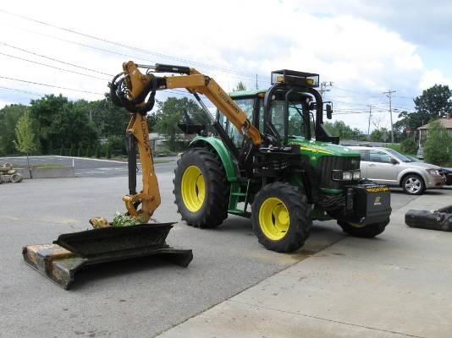Today, the highway departments not only share equipment purchased with the CIC grant but they also share many units owned individually by a community. In a sense, they have created a pool of highway equipment. For example, one town may borrow Brookfield’s roadside mower to expedite grass cutting during the summer. Each community does not have to buy expensive items that it uses infrequently. The community that owns the equipment receives credit for lending it to another town. The borrowing community realizes a cost savings by not having to buy a piece of equipment that may sit idle for long periods. It avoids costs by not having to rent the equipment from rental companies or hiring private vendors for the work. The Project Coordinator tracks the lending and borrowing of items and assigns costs. The RHE COOP decided to use the FEMA equipment rates and the actual salary of its operator, if applicable. Town leaders can easily track how their highway department has participated and how their community has benefitted from its involvement in the program. At the end of the year, a summary identifies the cumulative surplus or deficit for each town. A town in the red will have the opportunity to reduce its deficit by loaning equipment to other members or providing labor and equipment to accomplish a specific highway task in another town more quickly.

With two years of operation, it is clear the project is a success. Towns are taking advantage of equipment in the pool to perform road work that they would otherwise have to pay private contractors to complete. The program has demonstrated significant cost savings. Since these towns have very limited budgets for highway work and equipment purchases, the project has enabled the cash-strapped departments to perform more work at a lower cost than in previous years.

The RHE COOP established a Revolving Fund to deposit fees for use of commonly owned equipment. The intent of the fund is to cover upkeep of equipment purchased with grant receipts and to establish a capital fund to be able to replace expensive items when they reach the end of their useful life. The Board of Directors established a fee schedule for the equipment purchased with grant funds to-date, the sign-making-machine and the asphalt roller. As communities pay into the fund, sufficient reserves will accumulate to pay for repairs and eventual replacement when the equipment is no longer operable.

The principal activity undertaken with FY 2013 CIC funds was a planning study to assess the feasibility of hiring an employee who could split his/her time equally among member communities. The RHE COOP is merely a cooperative entity established by an Inter-Municipal Agreement and does not have contracting authority or the ability to hire employees. Thus, the stakeholders sought an analysis of the concept to determine if it is possible here, and if so, how best to design an implementable program.

The outcome of the study is that it is indeed possible and that it would provide a significant benefit to the members of the RHE COOP. It makes sense here because of the difficulty small towns have in establishing new full-time positions. As communities struggle to keep tax increases in check they are reluctant to raise staffing levels, which include not just salaries but expensive health benefits. However, by dispersing the cost of an employee among six communities, each community receives a significant boost in its work capacity at a relatively small price. A shared employee could help these manpower-strapped departments to eliminate some of the backlog of work in areas such as tree clearing and catch basin cleaning. Adding a part-time person will allow the departments to accomplish a great deal more work to get in front of their numerous responsibilities.

The study cautions that the Superintendents will need to prove the employee will perform vital services. It will be important to identify the tasks he/she will perform and how these will benefit the community. Perhaps the most important work the Superintendents have identified is catch basin cleaning. Basins need cleaning every year to remove sediments and harmful pollutants from storm water runoff. However, the RHE COOP towns have been unable to keep up with this work due to both a manpower shortage and lack of an operable catch basin cleaner. Superintendents have had to contract out for private cleaning services, but due to the high cost, have only been able to afford a small percentage each year. The shared employee could do this work at a fraction of the cost. However, the COOP communities must find a way to obtain a new or used cleaner in order to take advantage of the additional manpower from a shared employee.

An added benefit of a regional approach is the improved access to grant funds. The formal regional structure enables these communities to qualify for certain funding sources for which an individual community may not be eligible. In its first year, the COOP submitted an application to the Central Region Homeland Security Advisory Council for an emergency tree trimming trailer and associated equipment. Because of the regional nature of the request, the Council approved the application, which amounted to $18,626. (See cover photo.) The trailer now resides at the Brookfield Highway Garage and is ready to travel to an incident to provide the tools required to remove trees and brush that interfere with emergency response. The Highway Departments will be able to coordinate their manpower and equipment with local emergency management officials during severe storm events to keep major roadways open for travel. The RHE COOP next hopes to purchase a bucket truck to be able to perform tree pruning at greater heights to remove limbs above power lines before they disrupt service or present a danger to the public. The RHE COOP is searching for a funding program to pay for equipment, and its claim that one vehicle will benefit six communities is a key selling point in its favor.

The COOP also successfully applied to the Homeland Security Council for new radios to improve communications. The highway departments had antiquated systems and Superintendents had difficulty talking to emergency services within their own community as well as with their sister departments in other towns. Now the departments will be able to communicate easily with each other and will be able coordinate assistance across the region in time of need.

|  |  |  |  |  |  |  |  |  |  |
| --- | --- | --- | --- | --- | --- | --- | --- | --- | --- |
| **PROJECT GOAL** | **MEASURE** | | **CURRENT PERIOD** | **PRIOR PERIOD** | **TREND** | **TARGET** | **STATUS** | **COMMENTS** | |
| To develop a regional highway equipment cooperative | # of communities joining and participating in the RHE COOP and development of an analysis of the impacts of new communities | | cid:image003.png@01CEFBEE.69FF2480 | cid:image002.png@01CEFBEE.69FF2480 | cid:image003.png@01CEFBEE.69FF2480 | cid:image003.png@01CEFBEE.69FF2480 | cid:image003.png@01CEFBEE.69FF2480 | The Director met with the Oakham Board of Selectmen to discuss joining the COOP. The Board was considering the matter at the end of the grant period. | |
| Procurement of a consultant and development of a feasibility plan to hire a new employee to serve all of the member towns | | cid:image003.png@01CEFBEE.69FF2480 | cid:image002.png@01CEFBEE.69FF2480 | cid:image003.png@01CEFBEE.69FF2480 | cid:image003.png@01CEFBEE.69FF2480 | cid:image003.png@01CEFBEE.69FF2480 | Kopelman & Paige completed the feasibility study in the first quarter of 2014. | |
| # of dollars saved through regionally sharing equipment | | cid:image003.png@01CEFBEE.69FF2480 | cid:image003.png@01CEFBEE.69FF2480 | cid:image003.png@01CEFBEE.69FF2480 | cid:image003.png@01CEFBEE.69FF2480 | cid:image003.png@01CEFBEE.69FF2480 | RHE COOP communities have saved over $30,000 by borrowing equipment. | |
| # of applications submitted for other grant programs to purchase additional equipment to share among member municipalities | | cid:image003.png@01CEFBEE.69FF2480 | cid:image003.png@01CEFBEE.69FF2480 | cid:image003.png@01CEFBEE.69FF2480 | cid:image003.png@01CEFBEE.69FF2480 | cid:image002.png@01CEFBEE.69FF2480 | The RHE COOP applied for and additional CIC grant to purchase a catch basin truck. While unsuccessful, the towns will continue to pursue other funding sources. | |
| **STATUS LEGEND** | **OFF TARGET:** | cid:image001.png@01CEFBEE.69FF2480 | **CLOSE TO TARGET** | cid:image002.png@01CEFBEE.69FF2480 | **ON TARGET:** | cid:image003.png@01CEFBEE.69FF2480 | **NOT APPLICABLE:** | | cid:image004.png@01CEFBEE.69FF2480 |

# Section 7: Contact Information

|  |  |  |  |
| --- | --- | --- | --- |
| **Name** | **Position** | **Phone** | **Email** |
| Bill Scanlan | Director | 508-579-9975 | [wscanlan1@charter.net](mailto:wscanlan1@charter.net) |
| Cindy Thompson | Coordinator, Brook-field Highway Dept. Assistant | 508-867-8357 | [highway@brookfieldma.us](mailto:highway@brookfieldma.us) |
| Stephen Fleshman | Chairman, Brimfield Selectman | 413-245-4100 | [brimfieldbos@aol.com](mailto:brimfieldbos@aol.com) |
| Zach Lemieux | Brimfield Highway Surveyor | 413-245-4103 | [brimhighway@aol.com](mailto:brimhighway@aol.com) |
| Herb Chaffee | Brookfield Highway Superintendent | 508-867-8357 | [highway@brookfieldma.us](mailto:highway@brookfieldma.us) |
| Diane Vayda | West Brookfield Selectman | 528-867-1421 ext 300 | [bos@westbrookfield.com](mailto:bos@westbrookfield.com) |
| Jim Daley | West Brookfield Highway Superintendent | 508-867-1417 | [jdaley@wbrookfield.com](mailto:jdaley@wbrookfield.com) |
| Larry Gordon | East Brookfield Selectman | 508-867-6769, ext 300 | [ebbos@eastbrookfieldma.us](mailto:ebbos@eastbrookfieldma.us) |
| Bob Allen | East Brookfield Highway Superintendent | 508-867-6575 |  |
| Robert Downing | Warren Selectman | 413-436-5701 ext 2 | [warrenselectmen@comcast.net](mailto:warrenselectmen@comcast.net) |
| Tom Boudreau | Brimfield Highway Surveyor | 413-436-7677 | [tsbwarrenhighway@gmail.com](mailto:tsbwarrenhighway@gmail.com) |
| Michael Howe | Hardwick Highway Surveyor | 413-477-6705 | [admin@townofhardwick.com](mailto:admin@townofhardwick.com) |
| Harry Comerford | Hardwick Selectman | 413-477-6197 x101 | [admin@townofhardwick.com](mailto:admin@townofhardwick.com) |

# Section 8: References

[Commonwealth of Massachusetts, State Homeland Security Strategy, September 2007](http://www.mass.gov/eopss/docs/helpus-helpyou/state-homeland-security-strategy-092307.pdf)

[Regional Highway Equipment Cooperative, Final Report for the FY ‘12 CIC Grant Program](http://www.mass.gov/anf/docs/anf/cic/fy12-cic-final-report-town-of-brookfield.pdf)

Evich, Mitch, Mass. Municipal Association, The Beacon, “Mass Innovations, 5 Towns Form Equipment Cooperative”, October 2012.

[Federal Emergency Management Agency, Schedule of Equipment Rates](http://www.fema.gov/government/grant/pa/eqrates.shtm)

Massachusetts General Laws Governing Inter-Municipal Agreements, chapter 40, section 4A

Massachusetts General Laws, Public Works Municipal Aid Law, chapter 40, section 4K

Massachusetts General Laws Governing Revolving Funds, chapter 44, section 53E½

# Appendix 1: Sample Invitation Letter

**Regional Highway Equipment Cooperative**

June 30, 2013

Kathlyn Inman, Chairman Jason Pimental, Highway Superintendent

Board of Selectmen Highway Department

Henry Woods Building 441 Wheelwright Road

P.O. Box 697, 40 West Street Barre, MA 01005

Barre, MA 01005

Dear Ms. Inman and Mr. Pimental:

The purpose of this letter is to inform you of a unique road improvement program, known as the Regional Highway Equipment Cooperative, or RHE COOP, and determine whether Barre has an interest in becoming a member. The project began in 2012 with a grant award under the Community Innovation Challenge (CIC) grant program from the Executive Office of Administration and Finance.

The RHE COOP consists of six communities who work together to enhance local highway operations. The members are Brimfield, Brookfield, East Brookfield, Hardwick, Warren, and West Brookfield. We are assessing the feasibility of adding new members to improve the operations of the Cooperative. There is no cost to join, and the Town can participate as much or as little as it wishes.

The intent of the RHE COOP is to increase the efficiency of small highway departments by sharing equipment and expertise. Small towns cannot afford all of the expensive equipment needed to perform the variety of tasks necessary to keep many miles of roads in good repair for travelers. By creating a common inventory of all highway equipment, one town may borrow a vehicle owned by another town in order to complete a particular task. This often avoids the cost of contracting out the service with an expensive outside vendor and yields a savings to the town. Equipment that would otherwise sit idle is now used more efficiently.

The Coordinator of the RHE COOP keeps track of this lending and borrowing and records each event in a simple spreadsheet. No cash changes hands, but we calculate the value of the borrowing using FEMA’s Equipment Rates on an hourly basis, Towns freely share their equipment when another member town makes a request. In addition, if an employee accompanies the equipment to help expedite a project, the actual labor rate of the employee factors into the value of the borrowing. The table on the following page shows the computed value of borrowing during the RHE COOP’s first year of operation. Overall, the program saved members over $30,000.

Chart showing the amount of lending and borrowing of towns participating in the program.

A Board of Directors oversees the RHE COOP and meets on a quarterly basis. The Board sets policy for how the RHE COOP operates, makes decisions on new initiatives to explore, approves grant applications, and provides guidance to the Director and Coordinator on the management of the RHE COOP. Each Town has 2 members on the Board, the Highway Superintendent/Surveyor and a member of the Board of Selectmen. In addition, the Highway Superintendents and Surveyors generally meet monthly to discuss current activities, share information on best practices, and consider new ways of working together. These informal meetings have proven very valuable in assisting all member towns to increase their efficiencies.

In addition to improving daily operations, the RHE COOP enjoyed several notable accomplishments in the first year of operations:

* Purchased a street sign making machine. Each town is now able to make its own street name and traffic control signs at its convenience.
* Purchased a new one-ton asphalt roller and trailer for small paving jobs.
* Received two Homeland Security grants, one for portable radios and one for a fully-equipped brush cutting trailer. Member towns are able to use the brush equipment for a wide variety of tasks.
* Purchased street line paint in bulk quantities at a considerable discount.
* Jointly bid street centerline painting work and to obtained a favorable price on the cost per linear foot.

If you think this program would benefit Barre we would be happy to sit down with you to discuss it and answer any questions you may have. A Selectmen and a Highway official from the RHE COOP could provide their perspectives on the program. In addition, we invite the Highway Superintendent to attend the next monthly Superintendents meeting on Thursday, August 1 at 9:00AM in the Brookfield Highway Garage to get a sense of how the program might enhance his department’s operations.

Feel free to contact me at 508-579-9975 or [wscanlan1@charter.net](mailto:wscanlan1@charter.net) if you have any questions.

Sincerely

William Scanlan, Director

RHE COOP

# Appendix 2: Worcester Telegram & Gazette Article, June 10, 2013

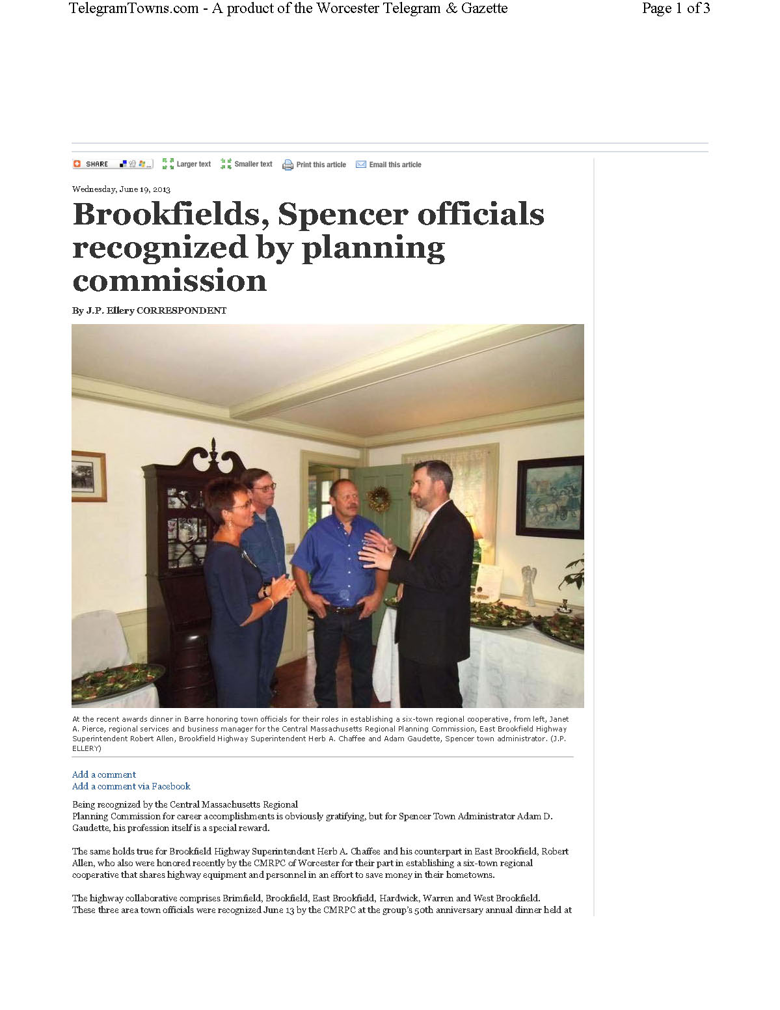



# Appendix 3: Scope of Services for Feasibility Study

Background

When one community borrows a piece of equipment from another, an employee of the lending town often goes with it because of his familiarity with its operation, and that additional worker helps to expedite completion of the job. However, that leaves the lending community short-handed for the duration the equipment is out on loan. A new, shared employee could rotate among the member communities and operate the borrowed equipment without compromising the work flow of the lending town. Secondly, a significant portion of the limited resources of these small town highway departments is restricted to routine, yet time-consuming tasks such as catch basin cleaning, road sweeping, and grass cutting. A shared employee could free up additional time of regular employees to catch up on the backlog of road repair projects. In summary, one new full-time employee, or perhaps one or two seasonal employees, shared among participating communities will enable all of the towns to complete more work and provide better road services to the residents than is possible today.

The study will assess the practical details of hiring personnel who will assist the highway departments of the six communities. At its present make-up of six members, each town would have approximately eight man-weeks of a shared, full-time employee’s labor. The preferred consultant should have expertise in the field of municipal employment and labor relations. The consultant will study procedural and legal concerns with hiring personnel who will provide services to all member communities. The consultant will analyze the costs and benefits of several scenarios, such as hiring one full-time person, hiring one or two part-time or seasonal employees, or contracting with an individual. Analyzing several scenarios will provide comparative data for the Board of Directors to select a preferred approach. The Consultant could also recommend a phased process that starts simply and grows in later years as the regional program expands.

The Consultant will identify a mechanism for the Cooperative to hire the employee for purposes of payroll and benefits. The Consultant will recommend a proposed salary and determine the anticipated cost with benefits. The Consultant will prepare a job description and preferred qualifications. Presumably the employee will have a commercial driver’s license, mechanical expertise, experience in highway operations, and other useful skills to complement the abilities of these small, yet skillful, highway departments.

The Consultant will work with the Superintendents to detail the advantages and disadvantages of the hiring on their operations and calculate the potential costs and savings. The Consultant will prepare a Final Report that discusses the administrative hurdles, quantifies costs and savings, and recommends a specific plan of action. The Board of Directors will review the Consultant’s findings and determine if the joint staffing proposal should proceed to the member communities to secure the necessary appropriations. Boards of Selectmen and Finance Committees will receive a copy of the report since they will have a voice in recommending implementation of the position. The members on the Board of Directors from each town will meet with their local finance officials to answer any questions and help to secure Town Meeting appropriation. The Consultant will respond to unanticipated arguments that arise during the public outreach process.

The study will include a cost analysis to determine the financial impact on the member communities. If there is a net positive impact, presumably the communities will move forward with establishing the position since it is in their best interest to do so. Identifying costs will be straightforward since one can readily determine the salary and fringe benefits for the employee, then assign these costs equitably to the communities. The savings side of the ledger will be more complex and may require a comparison of the cost of performing work in-house versus contracting for services. The analysis will need to clearly demonstrate the value of sharing an employee to justify the added expense on limited municipal budgets.

Feasibility Study Tasks

The scope of work associated with this project could entail the following tasks:

1. Research state laws and best practices for sharing personnel.
2. Attend at least one monthly Superintendents/Surveyors meeting to learn about the local highway department needs and potential uses of a regional employee. Interview these officials as necessary to obtain a clear understanding of local operations.
3. Determine an administrative or contractual structure that will allow an employee to work for multiple towns.
4. Identify one community to assume role of employer or contracting entity, if advisable.
5. Determine the costs of employing such an individual based upon anticipated salary, benefits, insurance, and other costs.
6. Determine a mechanism to allocate the employee’s salary, benefits, and other costs to the member towns.
7. Calculate the savings by having work performed in-house rather than out-sourced to a private vendor. Identify other savings that may accrue.
8. Prepare a cost analysis that compares the projected savings of several towns sharing full-time or seasonal employees with the anticipated costs, including items such as salaries, benefits, training, and incidental expenses.
9. Prepare job description, preferred qualifications, salary scale, duties, benefits, etc. in accordance with personnel standards of the sponsoring community.
10. Present the recommended approach at a Board of Directors meeting. Based on discussion, modify as appropriate.
11. Prepare draft report for review.
12. Provide a synopsis for local finance committees and officers that addresses possible questions and concerns (including coverage for benefits, insurance, pension, etc.).
13. Present concept at a regional select board meeting.
14. Prepare Final Report and submit to member towns for implementation.

**Contact Information**

William Scanlan, Project Manager Lucinda Thompson, Project Coordinator

RHE COOP RHE COOP

19 Metcalf Street Brookfield Highway Department

Worcester, MA 01609 56 Mill Street

Brookfield, Massachusetts 01506

Phone: 508-579-9975 508-867-8357

Email: [wscanlan1@charter.net](mailto:wscanlan1@charter.net) [highway@brookfieldma.us](mailto:highway@brookfieldma.us)

# Appendix 4: Shared Employee Feasibility Study