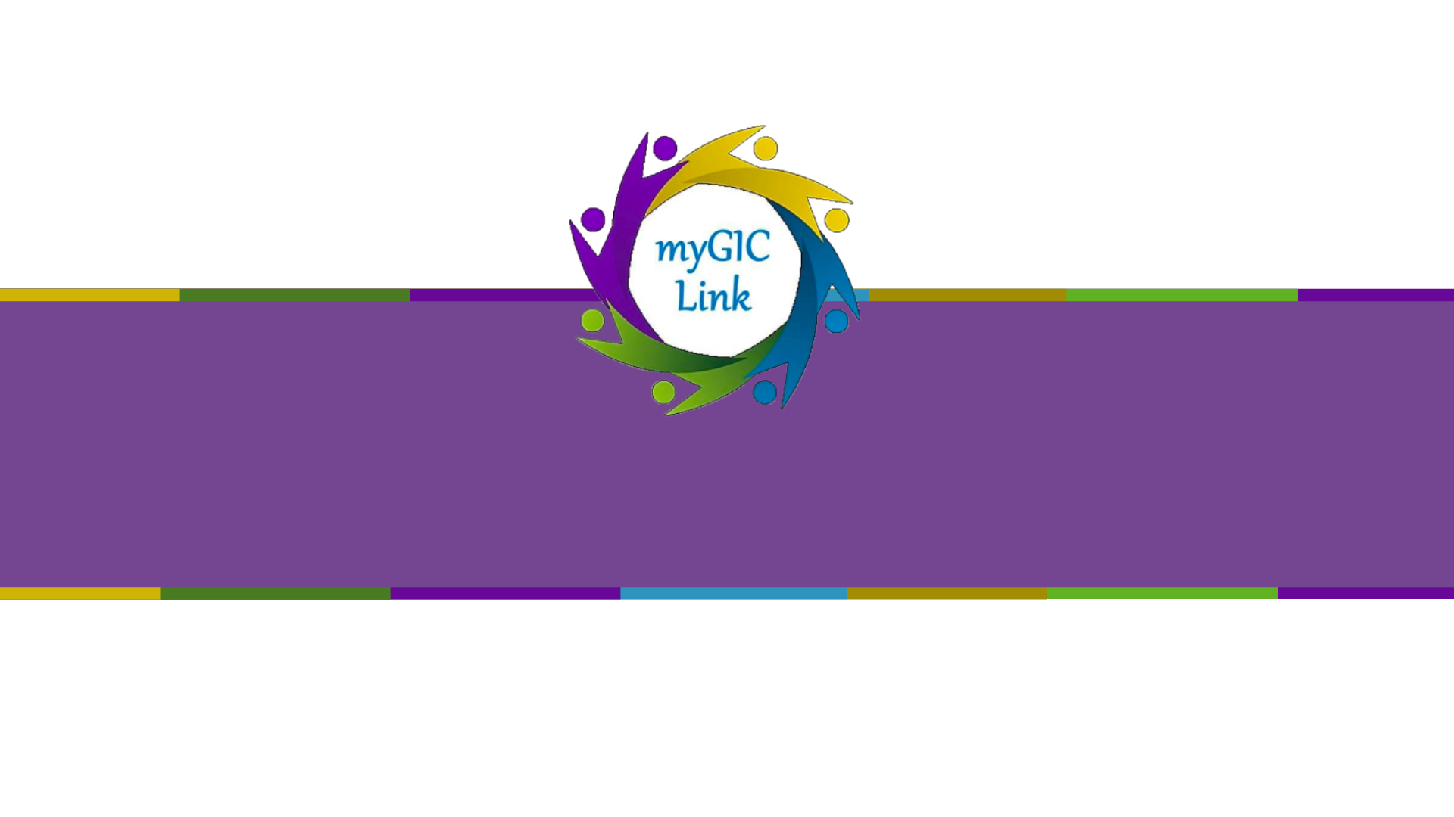
Registration User Guide

Table of Contents
First Time Registration 3
Portal Login 6
Reset Password 7
Forgot Email 9

Welcome to the GIC Member Registration user guide. This document will help you guide members on how to register through the application.

First Time Registration
Members will receive an email with a link to access the myGICLink Self Service Portal, the email they are to use to register, and a unique Pin Number that is used when registering for the portal.

Members should click the ‘Portal Link’.

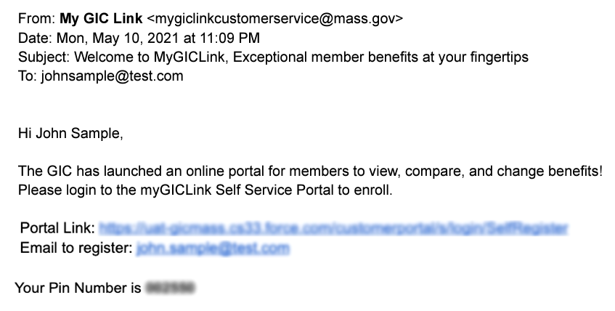

Members should enter their information in the fields and click ‘Register.’

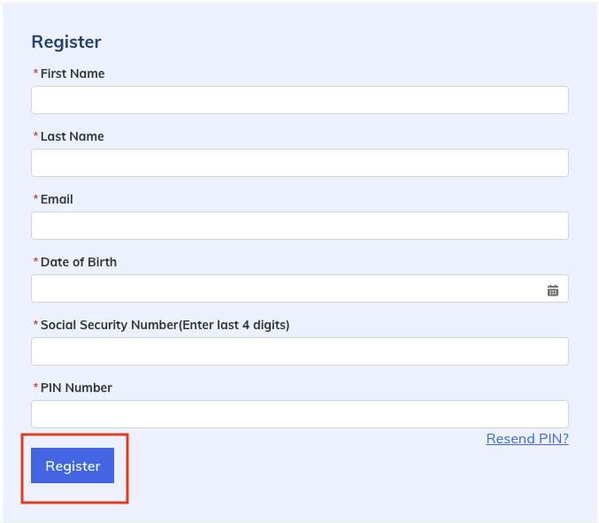

Please Note: After clicking ‘Register’, members will receive an email with a verification code.

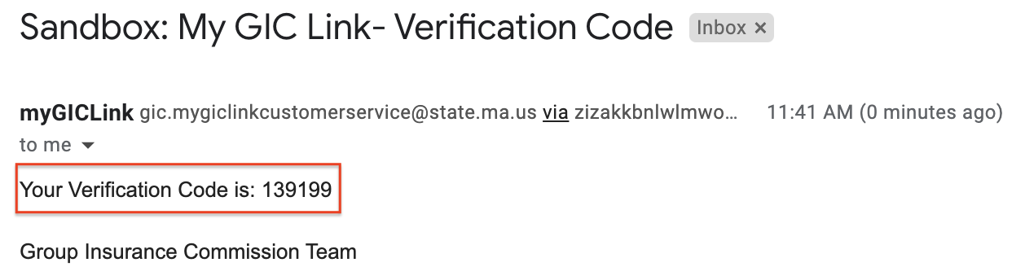

Members will need to enter the verification code on the ‘Verification Code’ page and Click ‘Confirm’ to access the GIC member portal.

Please Note: Members can click ‘Resend Code’ to receive a new verification code in their email.
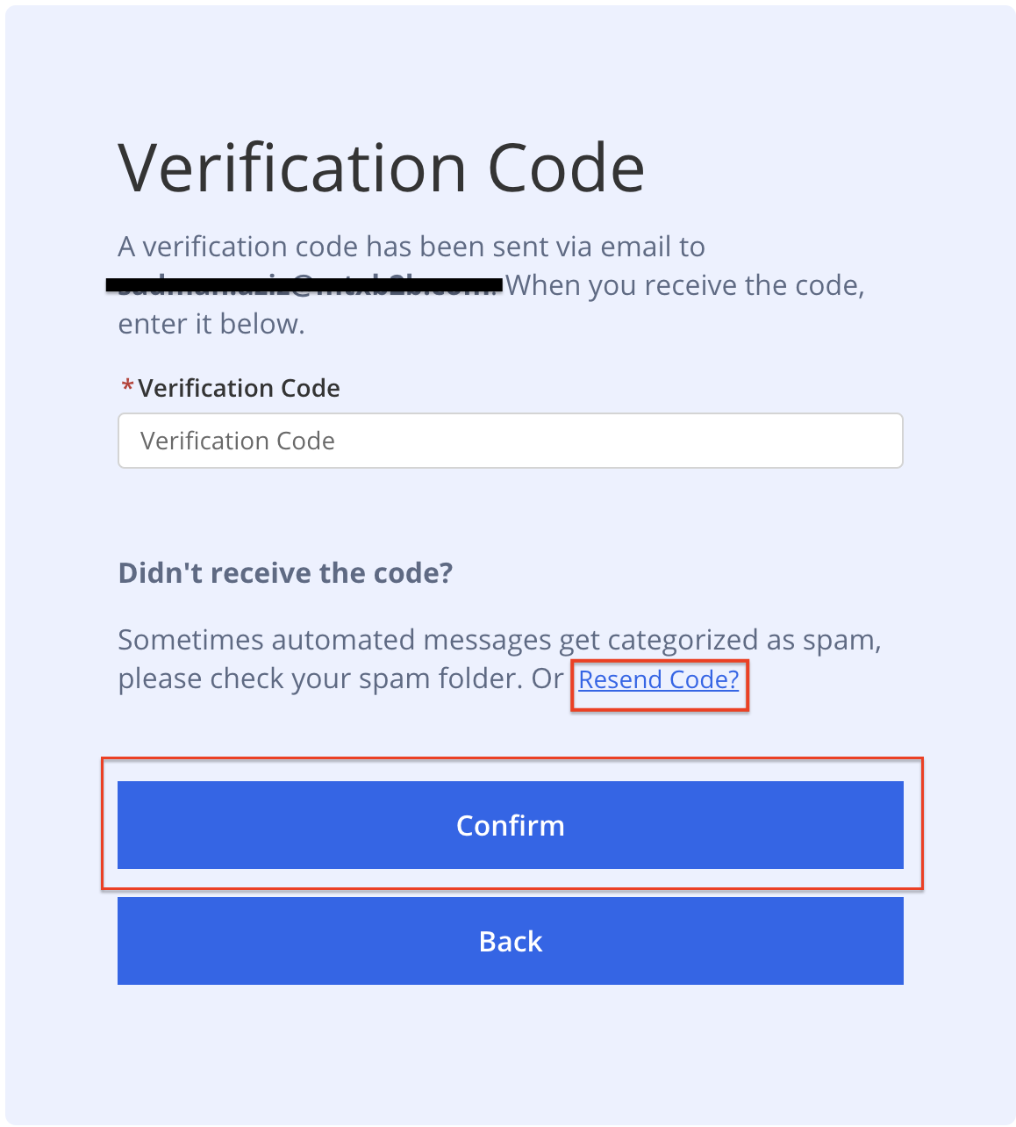

After clicking ‘Confirm’, Members will also receive a welcome email with the link to GIC member portal.

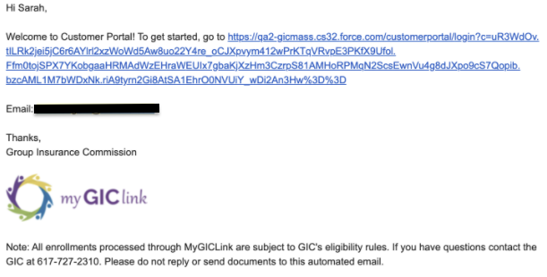

Portal Login
For logging in to the portal click the link from the welcome email or copy and paste the login link of the customer portal into a member's internet browser. Login link will be in the welcome email.

Enter the Email address used to register, Password, and click ‘Login.’

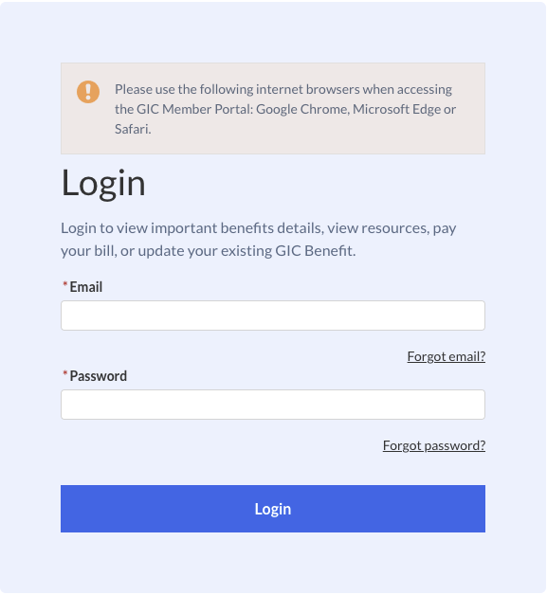

To reset a member's password, click ‘Forgot Password.’

Members will then be directed to the page below. Enter their email and click ‘Reset Password.’

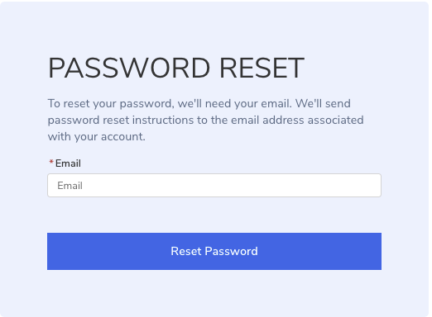

After clicking ‘Reset Password’, a success message will be displayed on the portal.

Members will receive an email with the password reset instructions. Click the password reset link and follow the instructions.

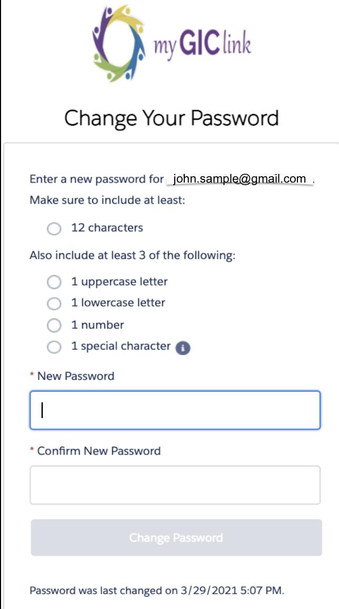

Portal Login
To resend members' email, click ‘Forgot email?’.
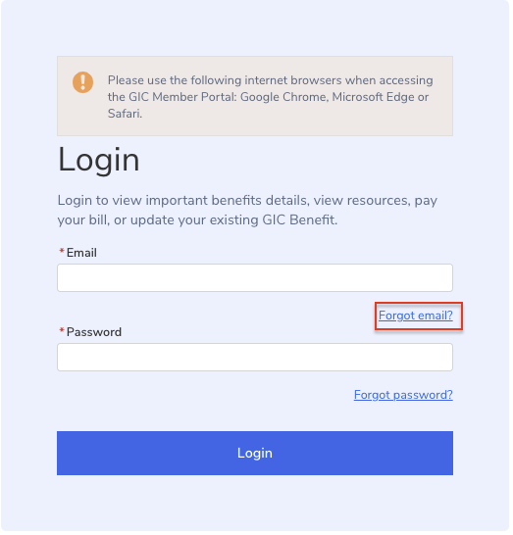

Members are directed to the page below. Enter their ‘First Name’, ‘Last Name’, ‘Date of Birth’, ‘Social Security Number (Enter last 4 digits)’ and click ‘Resend’.
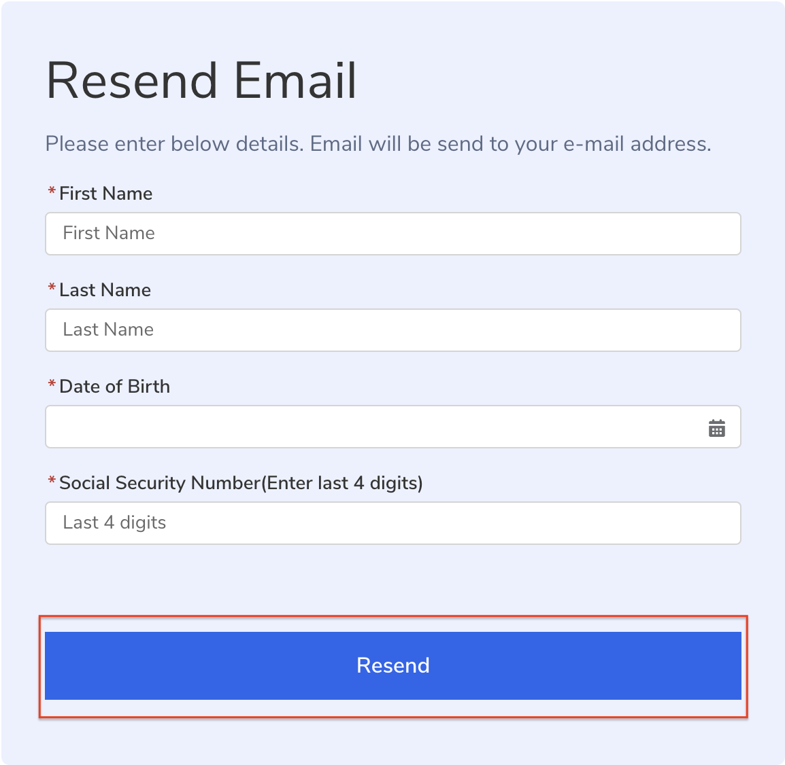

Members will receive the below message as a clue to indicate the email address on file for portal login.
