Background

INDOOR AIR QUALITY
POST-OCCUPANCY ASSESSMENT

Massachusetts Department of Transportation
Registry of Motor Vehicles
11 A Street
Edgartown, Massachusetts

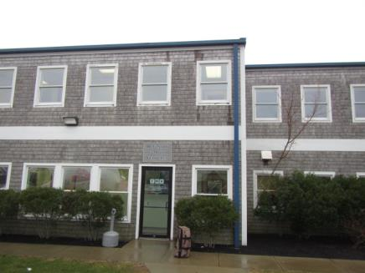

Prepared by:
Massachusetts Department of Public Health
Bureau of Environmental Health
Indoor Air Quality Program
April 2018
Building: | Massachusetts Registry of Motor Vehicles (RMV)
Address: | 11 A Street, Edgartown, MA
Assessment requested by: | Aric Warren, Transportation Program Planner, MassDOT
Reason for Request: | Odor complaints and general indoor air quality (IAQ) symptoms.
Date of Assessment: | April 19, 2018
Massachusetts Department of Public Health/Bureau of Environmental Health (MDPH/BEH) Staff Conducting Assessment: | Cory Holmes, Environmental Analyst/Inspector, Indoor Air Quality (IAQ) Program
Date of Building Construction | 2001-2002
Building Description: | The RMV is located on the ground floor of a two-story structure on slab. The space consists of a large, open waiting/service area, offices and storage rooms. Private offices are located above and to the right of the space. The Vineyard Transit Authority (VTA) fleet management facility is located to the left and separated by a hallway/electrical rooms.
Windows: | Windows are openable, however they are not screened, which can allow access for flying/biting insects.

Methods
Please refer to the IAQ Manual for methods, sampling procedures, and interpretation of results (MDPH, 2015).

IAQ Testing Results
The following is a summary of indoor air testing results (Table 1).
- Carbon dioxide levels were above the MDPH guideline of 800 parts per million (ppm) in areas tested, indicating a lack of fresh air introduction/air exchange.
- Temperature was below the recommended range of 70°F to 78°F.
- Relative humidity was within the recommended range of 40% to 60% in all areas the day of assessment.
- Carbon monoxide levels were non-detectable (ND) in all areas assessed.
- Fine particulate matter (PM2.5) concentrations measured were below the National Ambient Air Quality Standard (NAAQS) level of 35 micrograms per cubic meter (μg/m³) in all areas assessed.

Ventilation
A heating, ventilating, and air conditioning (HVAC) system has several functions. First it provides heating and, if equipped, cooling. Second, it is a source of fresh air. Finally, an HVAC system will dilute and remove normally occurring indoor environmental pollutants by not only introducing fresh air, but also filtering the airstream and ejecting stale air to the outdoors via exhaust ventilation. At the time of assessment, the digital thermostat was set to fan “auto” which deactivates the HVAC system once the temperature set point is met (Picture 1). Staff also deactivate the system at times, in an attempt to regulate thermal comfort and reduce drafts (Picture 2). While the system is deactivated, no outside air is being introduced or circulated. Given the dense population of clients at times, this likely contributes to thermal comfort and IAQ complaints experienced by RMV staff.
As mentioned previously, the elevated carbon dioxide levels (e.g., >800 ppm) shown in Table 1 indicate a lack of air exchange. The air handling unit (AHU) for the RMV space is located on the second floor. It appears that the RMV utilizes a high efficiency, sealed combustion AHU where combustion air and emissions are ducted via two PVC pipes that are installed through the roof (Picture 3). Conditioned air is delivered via ceiling diffusers (Picture 4) and returned to AHUs via wall-mounted return vents (Picture 5). At the time of the assessment, it could not be determined where the fresh air intake for the unit was located or whether the amount of fresh air introduction can be adjusted. Note that return vents have a toggle to adjust airflow (Picture 6); all vents were completely shut at the time of the assessment. These vents should be opened/adjusted to remove stale air/pollutants from occupied space.
AHUs were outfitted with pleated filters of a Minimum Efficiency Reporting Value (MERV) of 8 (Picture 7), which are adequate in filtering out pollen and mold spores (ASHRAE, 2012). In addition, filters should be changed 2-4 times a year or in accordance with the manufacture’s recommendations.

Microbial/Moisture Concerns
No evidence of water leaks or moisture to building materials was noted during within the RMV space during the assessment. Indoor plants were observed in several areas (Table 1). Plants, soil, and drip pans can serve as sources of mold/bacterial growth. Plants should be properly maintained, over-watering of plants should be avoided, and drip pans should be inspected periodically for mold growth.
Portable humidification devices were also in-use in the space. These devices (i.e., humidifiers and dehumidifiers), contain reservoirs with standing water that need to be cleaned/disinfected regularly to avoid becoming a medium for mold/bacteria and odors.

Other IAQ Evaluations

Odor Investigation
The primary reason for this visit was to investigate the source of a “decaying/chemical” odor. RMV staff have occupied the building since 2002 with no chronic odors occurring. At the time of the assessment, no odors were detected nor had any odors been noted by staff for several days, suggesting the odors were likely to have been transient. In addition, the ductwork was reportedly cleaned by a professional duct cleaning firm and the carpeting was scheduled for steam cleaning several days after the MDPH site visit.
The RMV is also adjacent to the Vineyard Transit Authority (VTA) maintenance facility, which staff have reported as a source of vehicle/chemical odors in the building in the past. MDPH/IAQ staff visited the maintenance garage and observed that the facility utilizes two types of local exhaust ventilation: a direct local exhaust system that fits right over a vehicle tailpipe, as well as a general exhaust fan installed in the exterior wall that works in conjunction with make-up air louvers. RMV occupants reported that past odors have dissipated quickly once these exhaust systems were activated.

Recommendations
Although no odors were detected/reported at the time of the assessment, the following recommendations are made to improve general IAQ:
- Promptly contact building management if odors reoccur so sources can be evaluated. Report vehicle exhaust/maintenance chemical odors to VTA personnel for prompt remediation.
- Do not deactivate HVAC system. Consider operating in fan “on” mode to provide continuous circulation/filtration.
- Contact HVAC engineer to confirm the location of the fresh air intake and determine if fresh air to RMV space can be adjusted/increased.
- Ensure wall-mounted return vents are adjusted to allow proper air exchange.
- Install window screens so that windows can be used to supplement fresh air to the space and avoid insects from entering the building. Windows should not be opened during the operation of air conditioning to avoid condensation.
- Consider adopting a balancing schedule of every 5 years for all mechanical ventilation systems, as recommended by ventilation industrial standards (SMACNA, 1994).
- Continue with plans to change HVAC filters (using MERV 8 or higher filters) quarterly or as per the manufacturer’s instructions.
- Clean carpeting annually or semi-annually in soiled high traffic areas as per the recommendations of the Institute of Inspection, Cleaning and Restoration Certification (IICRC, 2012).
- Keep plants in good condition, avoid overwatering, and avoid placing them on porous items such as carpets or paper.
- Portable humidifiers/dehumidifiers should be cleaned/disinfected regularly as per the manufacture’s recommendations to prevent mold/bacterial growth and odors.
- Refer to resource manual and other related indoor air quality documents located on the MDPH’s website for further building-wide evaluations and advice on maintaining public buildings. These documents are available at http://www.mass.gov/dph/iaq.

References
ASHRAE. 2012. American Society of Heating, Refrigeration and Air Conditioning Engineers (ASHRAE) Standard 52.2-2012 -- Method of Testing General Ventilation Air-Cleaning Devices for Removal Efficiency by Particle Size (ANSI Approved).
IICRC. 2012. Institute of Inspection, Cleaning and Restoration Certification. Carpet Cleaning: FAQ.
MDPH. 2015. Massachusetts Department of Public Health. Indoor Air Quality Manual: Chapters I-III. Available at: http://www.mass.gov/eohhs/gov/departments/dph/programs/environmental-health/exposure-topics/iaq/iaq-manual/.
SMACNA. 1994. HVAC Systems Commissioning Manual. 1st ed. Sheet Metal and Air Conditioning Contractors’ National Association, Inc., Chantilly, VA.
Picture 1
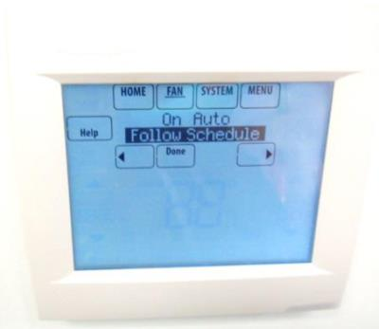
Digital thermostat note "on" and "auto" settings
Picture 2
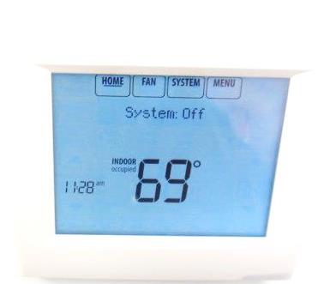
System deactivated “off” by RMV staff
Picture 3
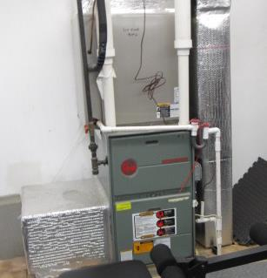
Air handling unit for RMV located in gym on 2nd floor, note two PVC pipes (arrows) for combustion air supply and exhaust emissions
Picture 4
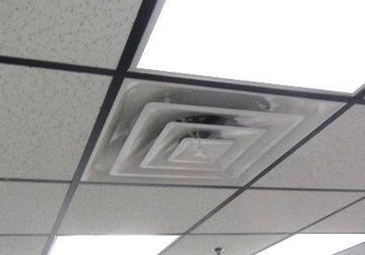
Typical supply diffuser
Picture 5
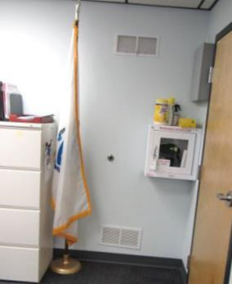
Wall-mounted return vents
Picture 6
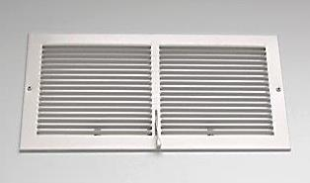
Close-up of return vent, note lever to adjust airflow
Picture 7
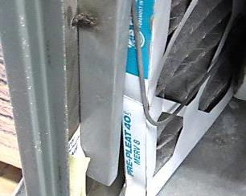
Pleated MERV 8 filter inside AHU for RMV

Location | Carbon  Dioxide  (ppm) | Carbon Monoxide  (ppm) | Temp  (°F) | Relative  Humidity  (%) | PM2.5  (µg/m³) | Occupants  in Room | Windows  Openable | Ventilation |  | Remarks
 |  |  |  |  |  |  |  | Supply | Exhaust
Background (outdoors) | 368 | ND | 42 | 100 | 12 |  |  |  |  | Cold, wet and rainy
Office | 1358 | ND | 65 | 51 | 6 | 0 | Y | Y | Y | Carpet squares, space under door to hallway, no screens on windows
Waiting Room/  Service Area | 1730 | ND | 66 | 48 | 9 | 12 | Y | Y | Y | Plants, no screens on windows
Men’s Restroom |  |  |  |  |  |  | N | Y | Y | Exhaust fan light switch activated
Women’s Restroom |  |  |  |  |  |  | N | Y | Y | Exhaust fan light switch activated
-

