# Background

**INDOOR AIR QUALITY/ODOR ASSESSMENT**

**Registry of Motor Vehicles Office**

**9c Everett Street**

**Revere**

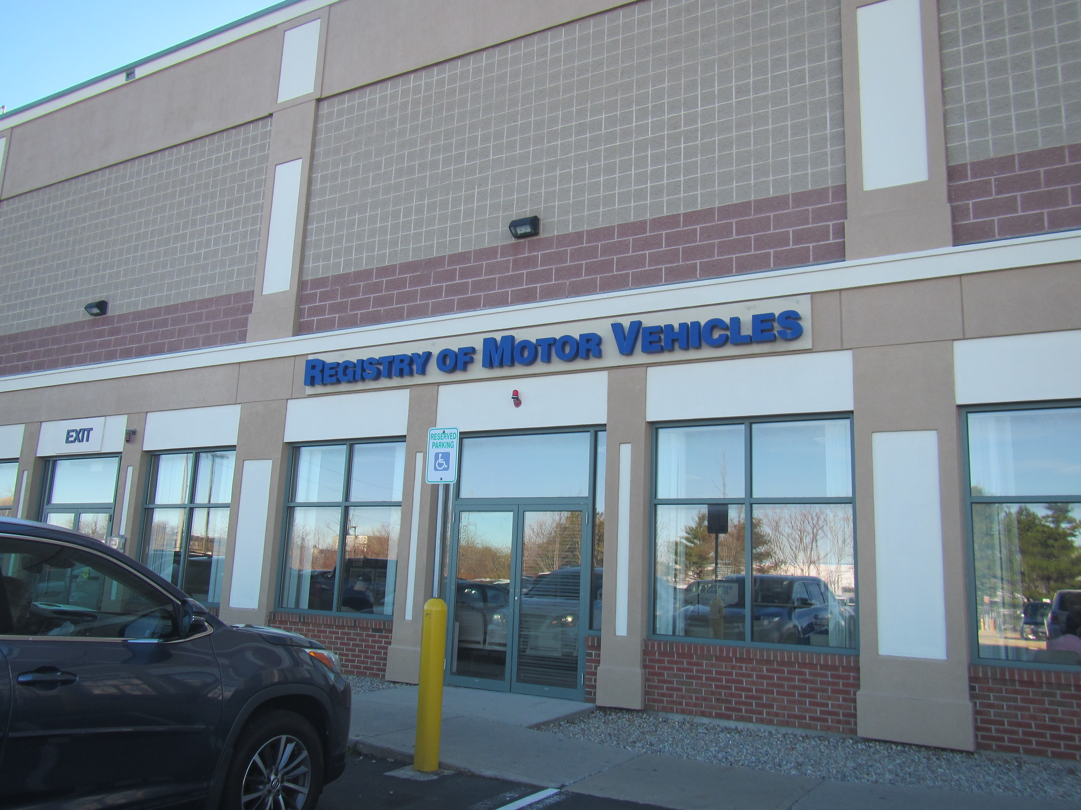

Prepared by:

Massachusetts Department of Public Health

Bureau of Climate and Environmental Health

Division of Environmental Health Regulations and Standards

December 2024

|  |  |
| --- | --- |
| Building: | Registry of Motor Vehicles (RMV) Service Center |
| Address: | 9c Everett Street, Revere |
| Assessment Requested by: | Nikki Kwok, Assistant Operations Manager,  MassDOT Property Services |
| Reason for Request: | Employee complaints of mold odors |
| Date of Assessment: | November 25, 2024 |
| Massachusetts Department of Public Health/Bureau of Climate and Environmental Health (MDPH/BCEH) Staff Conducting Assessment: | Ruth Alfasso, Environmental Engineer/Inspector, Division of Environmental Health Regulations and Standards |
| Building Description: | The RMV is located in a strip mall and occupies the lower floor of a two-level building with a flat roof. The upper level is an auto parts store which is accessed from a separate parking lot at grade level on the opposite side of the building. |
| Windows: | There are no openable windows in the space. |

**Background**

Several weeks before the visit, a complaint was received by RMV facility management regarding an odor of mold near one of the service desks. Facility staff promptly conducted investigation/remediation activities including examining carpeting and ceiling tiles in the affected area. No water source or odors were noted by facility personnel. An additional report of an odor was made on November 22, 2024, which prompted this visit. Note that only a few locations in the building were assessed during this visit.

Also note that the RMV will be leaving this location during 2025 to a new location, so significant changes to the building are unlikely.

# Methods

MDPH staff performed a visual assessment for water damage, leaks and associated mold growth that could result in odors. In addition, air tests for carbon dioxide, carbon monoxide, temperature, relative humidity, and airborne particle matter with a diameter less than 2.5 micrometers were taken with the TSI, Q-Trak XP.

## Air Testing Results

| **Media sampled** | | **MDPH Guideline/**  **Comparison Value** | | **Measured Range** | | | **Comments** | |
| --- | --- | --- | --- | --- | --- | --- | --- | --- |
| **Outdoors/**  **Background** | | **Indoors** |
| Carbon Dioxide (CO2) | | < 800 parts per million (ppm) is preferred | | 457 | | 931-1128 | Carbon dioxide was above MDPH guidance, particularly in the busy waiting room. | |
| Carbon Monoxide (CO) | | Non-detectable (ND) or equal to or below background level measured (ppm) | | 2.1 | | ND |  | |
| Particulate Matter 2.5 (PM2.5) | | US EPA National Ambient Air Quality Standards (NAAQS) 35 μg/m3 or less | | ND | | ND |  | |
| Temperature | | 70 to 78ºF | | 52 | | 69-71 | Within or close to MDPH comfort guidelines | |
| Relative Humidity (RH) | | 40% to 60% | | 36 | | 28-31 | Below MDPH comfort guidelines, which is typical during the heating season in New England | |
| ppm = parts per million | µg/m3 = microgram per cubic meter | | ND = non-detectable | |  | | |

**Ventilation**

Fresh air and heating/cooling for the RMV are supplied through vents in the suspended tile ceiling (Picture 1). The air handling units supplying these vents are likely on the roof of the building and could not be assessed. There are two thermostats in the RMV, one in the public area (Picture 2) and one in the private work area in the back. These thermostats are controlled remotely by the building owner. According to RMV facility staff, the lease requires that the fan be on to circulate fresh air during occupied periods, however there is no indication of this on the thermostat. As noted on the table above, carbon dioxide levels were above the MDPH guidance level of 800 ppm in the areas surveyed which indicates that the amount of fresh air is not sufficient to account for the high occupancy of the space, particularly the waiting room.

Return air is drawn through exhaust vents in the ceiling (Picture 3). There are relatively few of these in the open area for serving the public, and they are located over the staff side of the service desks. This may mean that stale air from the waiting room is drawn over the desk where employees are working. The frequent opening and closing of the exterior door where the entry line is located may also push air from the waiting room towards the service desks. Because of the presence of the clear plastic shields, this stale air would generally be directed up away from employees at the desks, however turbulence effects may allow this airflow into the employee-occupied spaces.

Restrooms are equipped with direct-vented exhaust vents that appeared to be functioning (Picture 4). These should be on during all occupied periods to remove odors and moisture from the restrooms.

**Microbial/Moisture Concerns**

No mold odors were noted in any of the spaces assessed. The area of primary concern is one of the service desks. No signs or history of water damage were noted in that area. Facility staff report that when this complaint first occurred, they took steps to find the issue, including looking above the ceiling tiles for any signs of water damage, and checking beneath carpeting, but no water damage was found.

Another area of concern is the janitor’s closet located several rooms away from the service desk where the complaint was registered. In August of 2024, a leak occurred in this space from a water heater located in the ceiling. Water had reportedly stained ceiling tiles, pooled in the light fixture (Picture 5), and run down the walls. Cleanup activities occurred at that time, including replacement of affected ceiling tiles. The janitor’s closet has a tile floor, which is resistant to water damage.

Examination of the adjacent office space showed that coving along the base of the wall had started peeling away (Picture 6) and coving glue along that entire wall had disintegrated to the point that coving could be peeled further with very little force. This is an indication that the wall was wet on this side, and because the coving is a water-impermeable material, it may have held moisture in the wallboard, preventing it from drying. It is recommended that porous material be dried with fans and heating within 24 to 48 hours of becoming wet (US EPA, 2008, ACGIH, 1989). If porous materials are not dried within this time frame, mold growth may occur.

Because this coving is on the opposite side of the wall from the janitor’s closet where the leak occurred, there may be mold on the interior of the wallboard. All the loose coving should be removed, and a small hole or holes should be cut into the wallboard to determine if there is mold growth on the hidden side of the wallboard, such as by inserting a camera. If mold or suspected mold is present, wallboard should be removed and replaced approximately 6 inches past any obvious water stains or mold growth to ensure all affected material has been removed. Replace coving only after this has been performed. If wallboard needs to be removed, these activities should be conducted when the adjacent areas are unoccupied. Remediation should follow the EPA guidance “Mold Remediation in Schools and Commercial Buildings” (US EPA, 2008), as well as the MDPH guidance “Construction and renovation generated pollutants in occupied buildings” (<https://www.mass.gov/info-details/construction-and-renovation-generated-pollutants-in-occupied-buildings>) to prevent mold and construction debris/odors from affecting occupants.

An additional potential source of water damage to carpeting was noted. The rear employee entrance is via a concrete hallway that reportedly gets wet along the exterior side (Picture 7) during rains. Employees coming in from outside may carry moisture from outside or from the hallway on shoes into the building. The floor directly inside this door is carpeted. A readily cleanable walk-off mat can protect carpeting from water damage and dust/dirt from outdoors.

**Other Issues**

An examination of the area where mold odors were reported showed a build-up of dust underneath the desk. This material could become a source of odors if disturbed, and should be cleaned. In addition, a personal fan on a desk in the area of concern had visible dust on the blades and housing (Picture 8). This material can be aerosolized when the fan is turned on, particularly in dry weather.

Portions of the RMV are carpeted. As a general rule, carpets should be cleaned annually (or semi-annually in soiled/high traffic areas) in accordance with Institute of Inspection, Cleaning and Restoration Certification (IICRC) recommendations, (IICRC, 2012). Regular cleaning with a high efficiency particulate air (HEPA) filtered vacuum in combination with an annual deep cleaning will help to reduce accumulation and potential aerosolization of materials from carpeting.

Air handling units were not examined during this assessment. The MDPH recommends using filters with a minimum efficiency rating value (MERV) rated 8 filter (or higher) in the building ventilation system. These are adequate to filter out pollen and *mold spores* (ASHRAE, 2012). Filters should be changed 2-4 times a year.

# Recommendations

No mold odor was noted during this assessment. Recommendations for improving indoor air quality are below:

## Ventilation Recommendations

1. Ensure that ventilation system fans are on during occupied periods to provide fresh air.
2. Ensure that all restroom exhaust vents are on and operating during occupied periods.
3. Air handling units should be equipped with MERV 8-rated filters (or higher), which are adequate to filter out pollen and mold spores. Filters should be changed 2-4 times a year, or as per the manufactures’ recommendations.
4. Consult a ventilation engineer (or similar) to determine if moving exhaust vents or adding them to the customer side would improve airflow and reduce the potential for stale air to be drawn into employee spaces.
5. If possible, increase fresh air percentage as necessary to reduce carbon dioxide and improve air exchange.

## Water Damage Recommendations

1. Remove all loose coving in the room adjacent to the janitor’s closet. Look under coving for mold and associated odors.
2. Cut one, or a few, small test holes along the bottom of the wallboard large enough to check for hidden mold using a camera. If any is seen, or mold odor is observed, remove all affected wallboard along with approximately 6 inches of wallboard above and to the sides to ensure all the damaged material has been removed. Wallboard can wick water up and become moistened significantly higher than the original flood level.
3. Perform remediation in accordance with the EPA guidance “Mold Remediation in Schools and Commercial Buildings”, located here: <http://www.epa.gov/mold/mold-remediation-schools-and-commercial-buildings-guide>.
4. Perform remediation that may produce dust, debris, or odors when the affected spaces are unoccupied whenever possible. Use the guidance in “Construction and renovation generated pollutants in occupied buildings” (<https://www.mass.gov/info-details/construction-and-renovation-generated-pollutants-in-occupied-buildings>) to avoid impacts on occupants during remediation.
5. Check any other spaces near the janitor’s closet that may have been impacted for loose coving and water-damaged wallboard.
6. Consider adding a walk-off mat to the employee entrance to protect carpeting. Ensure it is cleaned regularly.

## Other Recommendations

1. Clean dust from beneath desks regularly using methods that do not aerosolize dust, such as a HEPA-equipped vacuum or wet wiping.
2. Remove dust from fan blades and casings.
3. Clean carpeting annually or semi-annually in soiled high traffic areas as per the recommendations of the Institute of Inspection, Cleaning and Restoration Certification (IICRC, 2012).
4. Refer to the resource manual and other related indoor air quality documents located on the MDPH’s website for further building-wide evaluations and advice on maintaining public buildings. These documents are available at <http://mass.gov/dph/iaq>.

**References**

ACGIH. 1989. Guidelines for the Assessment of Bioaerosols in the Indoor Environment. American Conference of Governmental Industrial Hygienists, Cincinnati, OH.

ASHRAE. 2012. American Society of Heating, Refrigeration and Air Conditioning Engineers (ASHRAE) Standard 52.2-2012 -- Method of Testing General Ventilation Air-Cleaning Devices for Removal Efficiency by Particle Size (ANSI Approved).

IICRC. 2012. Institute of Inspection, Cleaning and Restoration Certification. Carpet Cleaning: FAQ.

US EPA. 2008. “Mold Remediation in Schools and Commercial Buildings”. Office of Air and Radiation, Indoor Environments Division, Washington, DC. EPA 402-K-01-001. September 2008. Available at: <http://www.epa.gov/mold/mold-remediation-schools-and-commercial-buildings-guide>.

**Picture 1**

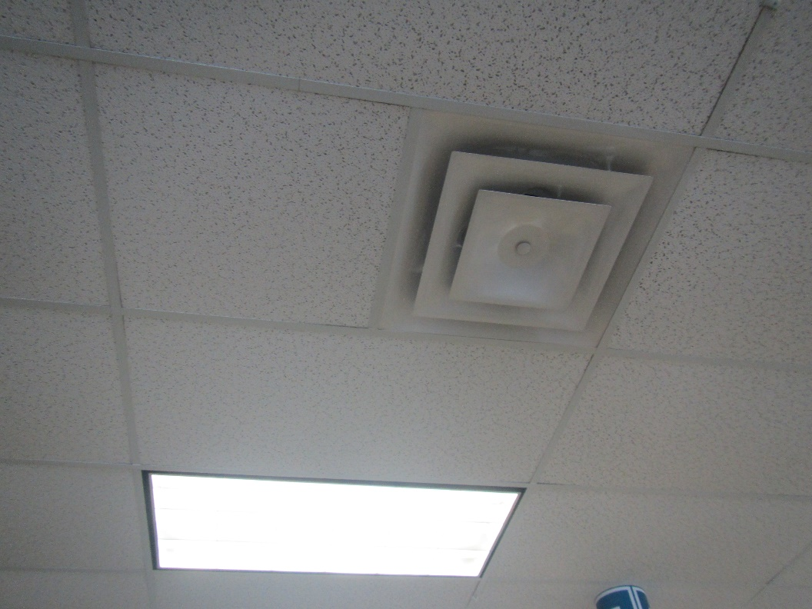

**Ceiling -mounted supply vent**

**Picture 2**

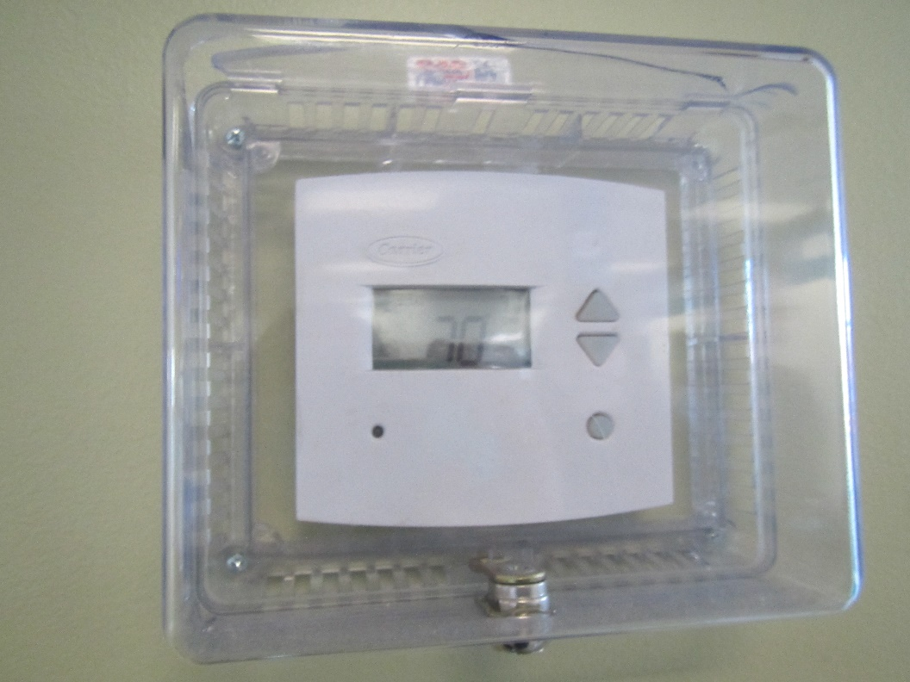

**Digital thermostat in the public side of the building**

**Picture 3**

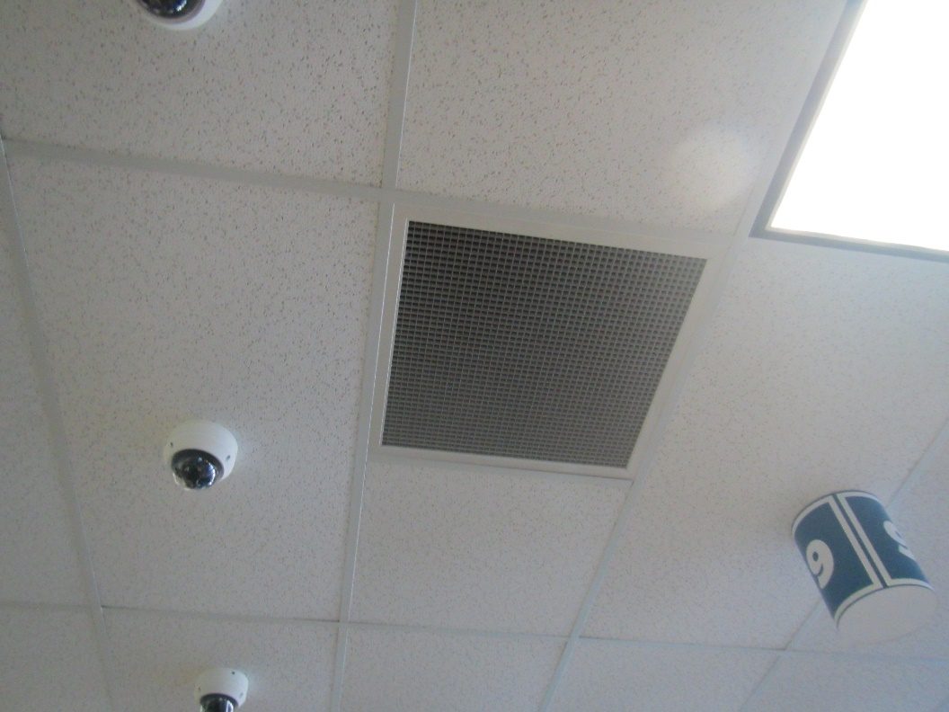

**Ceiling-mounted return vent**

**Picture 4**

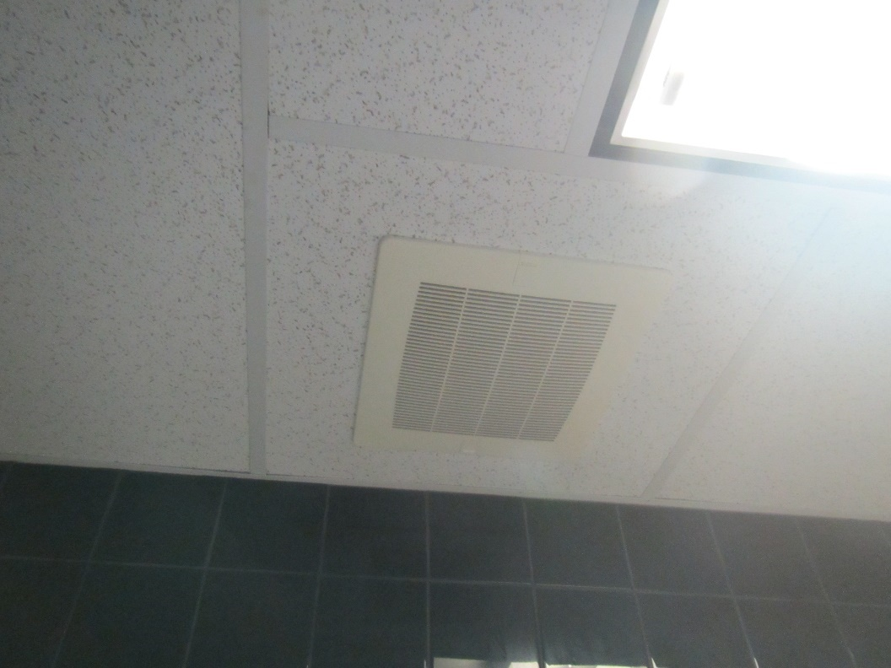

**Restroom exhaust vent**

**Picture 5**

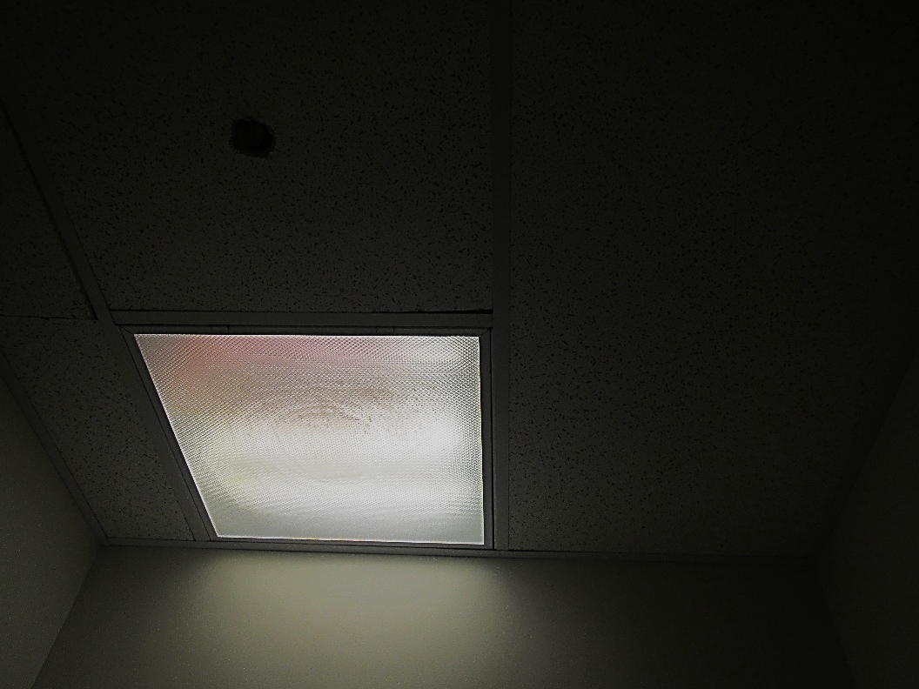

**Water stains in the light fixture in the janitorial closet**

**Picture 6**

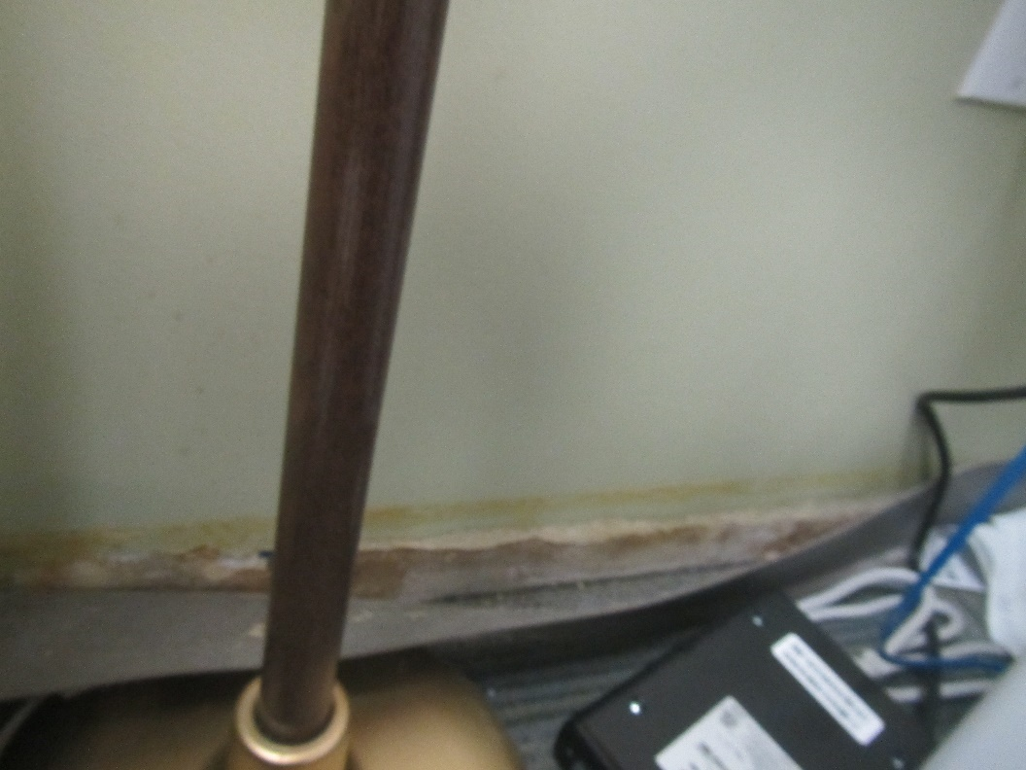

**Plastic coving peeling away from base of wall in office next to janitor’s closet**

**Picture 7**

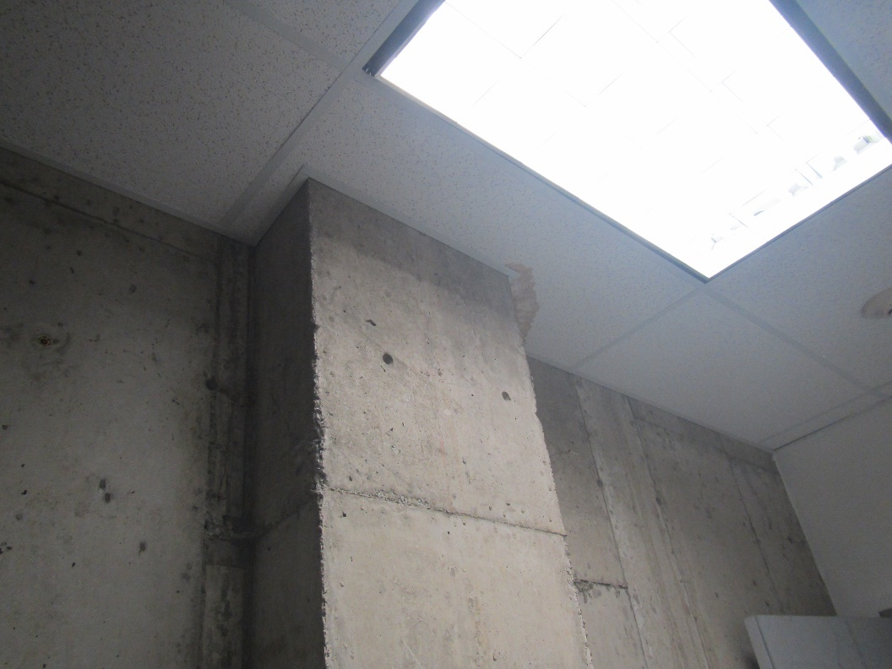

**Water-stained ceiling tiles in concrete hallway outside employee entrance**

**Picture 8**

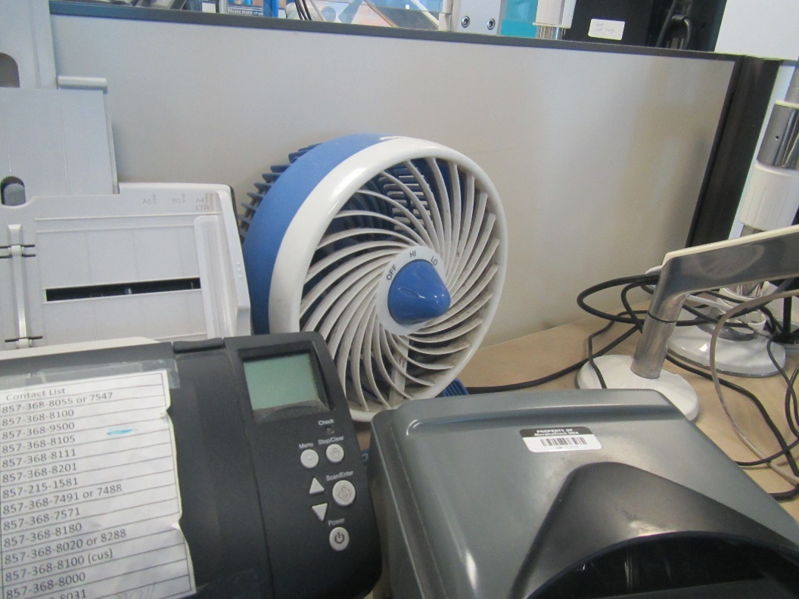

**Dusty fan on desk**