Background

INDOOR AIR QUALITYASSESSMENT

Massachusetts Department of Transportation
Registry of Motor Vehicles
Watertown Branch
550 Arsenal Street
Watertown, Massachusetts

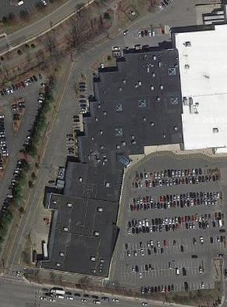

Prepared by:
Massachusetts Department of Public Health
Bureau of Environmental Health
Indoor Air Quality Program
February 2019
Building: | Massachusetts Registry of Motor Vehicles (RMV)
Address: | 550 Arsenal Street, Watertown (Watertown Mall)
Assessment requested by: | Aric Warren, Transportation Program Planner, MassDOT
Reason for Request: | Construction-related issues and general indoor air quality (IAQ) concerns.
Date of Assessment: | January 31, 2019
Massachusetts Department of Public Health/Bureau of Environmental Health (MDPH/BEH) Staff Conducting Assessment: | Ruth Alfasso, Environmental Engineer/Inspector, Indoor Air Quality (IAQ) Program
Date of Building Construction | 1970s
Building Description: | The RMV is located in a single-story indoor mall with access/entrance through the mall hallway. The space consists of a large, open waiting/service area, offices and storage rooms.
Windows: | There are no windows from this office space to outside.

Methods
Please refer to the IAQ Manual for methods, sampling procedures, and interpretation of results (MDPH, 2015).

IAQ Testing Results
The following is a summary of indoor air testing results (Table 1).
- Carbon dioxide levels were below the MDPH guideline of 800 parts per million (ppm) in all but one area tested, indicating adequate fresh air exchange.
- Temperature was below the recommended range of 70°F to 78°F in all areas tested.
- Relative humidity was below the recommended range of 40% to 60% in all areas the day of assessment which is reflective of outdoor conditions and common during the heating season in New England.
- Carbon monoxide levels were non-detectable (ND) in all areas assessed.
- Fine particulate matter (PM2.5) concentrations measured were below the National Ambient Air Quality Standard (NAAQS) level of 35 micrograms per cubic meter (μg/m³) in all areas assessed.
- Total Volatile Organic Compounds (TVOC) were ND in all areas tested.

Background
A new set of offices for this RMV location is being constructed in another area of the Watertown Mall across the hallway from the current location. Construction on the new offices started in December of 2018, including demolition work. Occupancy of the new offices is expected to occur in April of 2019. Occupants of the current RMV were concerned that construction activities were having an impact on their IAQ and health.

Ventilation
A heating, ventilating, and air conditioning (HVAC) system has several functions. First it provides heating and, if equipped, cooling. Second, it is a source of fresh air. Finally, an HVAC system will dilute and remove normally occurring indoor environmental pollutants by not only introducing fresh air, but also filtering the airstream and ejecting stale air to the outdoors via exhaust ventilation.
Fresh air for this space is provided by three rooftop air handling units (AHUs). Conditioned air is delivered via ceiling diffusers (Picture 1) and returned to AHUs via ceiling-mounted return grills (Picture 2). AHU filters are reportedly changed four times a year.
Exhaust vents for the staff-only restrooms in the space are controlled via a second switch next to the light switch. Although they appeared to be operating when this switch was turned on, no exhaust ventilation for the restrooms is provided with this switch off. It is recommended that exhaust ventilation be provided continuously in restrooms to remove odors and water vapor.
Note that the entry area of the RMV is completely open to the mall hallway during active hours. During the time of the assessment, the mall had low occupancy and the weather outside was very cold. This resulted in low indoor temperatures in the RMV and many occupants expressed temperature discomfort. RMV facility staff should work with the mall facility staff to ensure that temperatures in the mall hallway can allow comfortable conditions in the RMV.

Microbial/Moisture Concerns
Some water-damaged ceiling tiles were noted in the space (Picture 3; Table 1). These are reportedly due to roof leaks. Water-damaged ceiling tiles can be a source of mold and should be replaced after a leak is found and repaired. During replacement, the area above the ceiling tiles should be examined and cleaned/disinfected if necessary.
Water-damaged boxes were noted in the storage/electric room (Picture 4). It could not be determined if the water damage had occurred in this location or if the boxes had been transferred from another location. Water-damaged cardboard can be a source of mold growth and odors, so these boxes should be discarded. Porous items such as cardboard should not be stored in locations where leaks are known to occur.
A mop bucket with dirty water was noted in the rear hallway that is also used as a janitorial supply closet (Picture 5). Stagnant water can be a source of odors and damp mops can become colonized with mold. Buckets should be emptied and mops should be dried after use. Note that there is no apparent janitorial sink in this space, which may mean cleaning personnel need to travel a long distance through occupied areas to drain and clean equipment.
This hallway also had a door to the outside, which had a hole rusted in it (Picture 6). Exterior doors should be rendered weather-tight to prevent the entry of moisture, unconditioned air and pests.

Other IAQ Evaluations

Construction Impacts
As previously mentioned, concerns regarding the impact of construction on occupants in the RMV prompted this assessment. Note that at the time of the visit, there was no significant construction activity occurring. Previous activities included: demolition of existing walls, removal of fixtures, HVAC installation, installation of wallboard, plumbing and electrical work, and remediation of asbestos-containing floor tiles. The area under construction had been sealed off with a barrier made of plywood and plastic sheeting (Picture 7). At the time of the visit, this barrier was intact and taped to provide a tight seal. A single door from the construction area into the mall hallway is present and a small amount of light was visible around it (Picture 8). The construction manager reported that most construction materials are brought into/out of the area using exterior doors so materials are not moved through the mall.
No odors from the construction zone were notable in the mall hallway, suggesting that this barrier is providing effective isolation of occupied areas from construction activities. Note that because there is no HVAC system operational in the construction area, heaters using kerosene are in use. The combustion is creating carbon dioxide inside the construction zone even in the absence of workers. At the time of the visit, there were still numerous breaches in the envelope of the building around the area under construction allowing for fresh air exchange. When the building envelope is further sealed, use of these heaters should be stopped, to avoid a build-up of combustion-related pollutants. Also note that if odorous activities such as painting or use of glues/mastics are occurring, some form of exhaust ventilation should be provided inside the construction area (e.g., a fan in an exterior door) to remove irritating vapors to both protect workers and prevent construction pollutants from entering occupied spaces in the mall. For additional information on conducting renovations/construction in occupied buildings, please consult “Methods Used to Reduce/Prevent Exposure to Construction/Renovation Generated Pollutants in Occupied Buildings” which is attached as Appendix A.
Also note that other construction has occurred in the mall recently, although further away from the RMV office. In addition, there is a large construction project outside across the street on the site of the former Arsenal Mall, which has included a large amount of demolition. In order to protect indoor air from any issues from outside, including pollen, mold, dust, and construction-related issues, high-quality filters should be used with (a minimum efficiency reporting value [MERV] rating of 8 or better [ASHRAE, 2012]) and they should be well-fitted inside the cabinets with no gaps or holes that could allow air to short circuit around them.

Other Issues
To determine if VOCs were present in occupied areas, BEH/IAQ staff conducted sampling for TVOCS and examined rooms for products containing VOCs. While no TVOCs were measured (ND), BEH/IAQ staff noted hand sanitizers, cleaning products, and dry erase materials in use within the building (Table 1). All of these products have the potential to be irritants to the eyes, nose, throat, and respiratory system of sensitive individuals.
Photocopiers and printers were observed in many locations. Photocopiers can emit ozone and TVOCs, especially when they are older or heavily used. Exhaust ventilation can help reduce the accumulation of heat, odor, and pollutants.
An electrical/burning odor was noted in the back hallway near the door shown in Picture 5. This odor was traced to a small electric heater that had been discarded in the area. This item was removed from the building.
There was a build-up of dust on some exhaust vents (Picture 9). This dust can be reaerosolized and cause irritation. Occupants also reported concerns about dust on surfaces. Flat surfaces should be cleaned periodically with a damp cloth to remove dust.
Several areas were carpeted. Carpets should be cleaned annually (or semi-annually in soiled/high traffic areas) in accordance with Institute of Inspection, Cleaning and Restoration Certification (IICRC) recommendations, (IICRC, 2012). Regular cleaning with a high efficiency particulate air (HEPA) filtered vacuum in combination with an annual cleaning will help to reduce accumulation and potential aerosolization of materials from carpeting. Note that the vacuum cleaner present on site (Picture 10) does not have a HEPA filter.

Recommendations
Because the occupants of this office will be moving to the new offices being constructed across the hall in less than three months, these recommendations should be conducted to improve IAQ in the current space for the short time it is remaining as the RMV:
- Consider operating all HVAC systems in fan “on” mode to provide continuous circulation/filtration.
- Continue to change HVAC filters (using MERV 8 or higher) quarterly or as per the manufacturer’s instructions. Check that all filters are well-seated and that no gaps are present around them or elsewhere in the AHU cabinet that can allow air to short-circuit around the filters.
- Work with mall facility staff to mitigate indoor temperature complaints.
- For buildings in New England, periods of low relative humidity during the winter are often unavoidable. Therefore, scrupulous cleaning practices should be adopted to minimize common indoor air contaminants whose irritant effects can be enhanced when the relative humidity is low. To control for dusts, a high efficiency particulate arrestance (HEPA) filter equipped vacuum cleaner in conjunction with wet wiping of all surfaces is recommended. Avoid the use of feather dusters. Drinking water during the day can help ease some symptoms associated with a dry environment (throat and sinus irritations).
- Ensure leaks are repaired and replace water-damaged ceiling tiles. Check above tiles and clean/disinfect the area if needed.
- Discard any water-damaged porous materials such as cardboard. Avoid storing porous materials in areas where leaks occur.
- Ensure mop buckets are drained and cleaned after use.
- Repair damaged exterior doors or replace if needed.
- Ensure doors to the outside are tightly-fitted with weather-stripping to exclude moisture and pests.
- Keep the barriers between the construction area and other areas intact during construction. Follow the guidance in “Methods Used to Reduce/Prevent Exposure to Construction/Renovation Generated Pollutants in Occupied Buildings” (Appendix A).
- Minimize use of products containing VOCs and use in well-ventilated areas.
- Avoid the use of malfunctioning heaters. Broken equipment should be properly disposed of.
- Clean supply and exhaust vents, fans, and flat surfaces of dust periodically.
- Vacuum carpeting daily using a vacuum equipped with a HEPA filter.
- Clean carpeting annually or semi-annually in soiled high traffic areas as per the recommendations of the Institute of Inspection, Cleaning and Restoration Certification (IICRC, 2012).
- Refer to resource manual and other related indoor air quality documents located on the MDPH’s website for further building-wide evaluations and advice on maintaining public buildings. These documents are available at http://www.mass.gov/dph/iaq.

References
ASHRAE. 2012. American Society of Heating, Refrigeration and Air Conditioning Engineers (ASHRAE) Standard 52.2-2012 -- Method of Testing General Ventilation Air-Cleaning Devices for Removal Efficiency by Particle Size (ANSI Approved).
IICRC. 2012. Institute of Inspection, Cleaning and Restoration Certification. Carpet Cleaning: FAQ.
MDPH. 2015. Massachusetts Department of Public Health. Indoor Air Quality Manual: Chapters I-III. Available at: http://www.mass.gov/eohhs/gov/departments/dph/programs/environmental-health/exposure-topics/iaq/iaq-manual/.
Picture 1
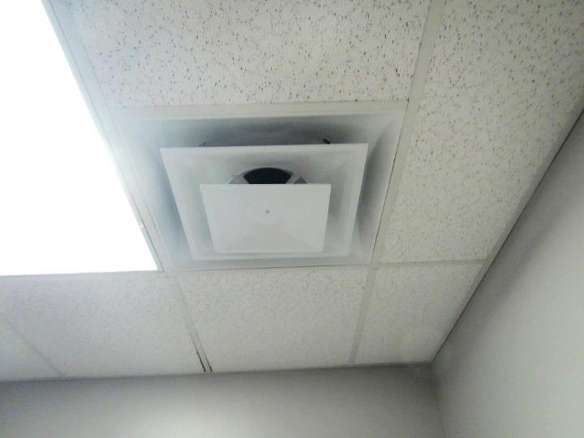
Typical supply diffuser
Picture 2
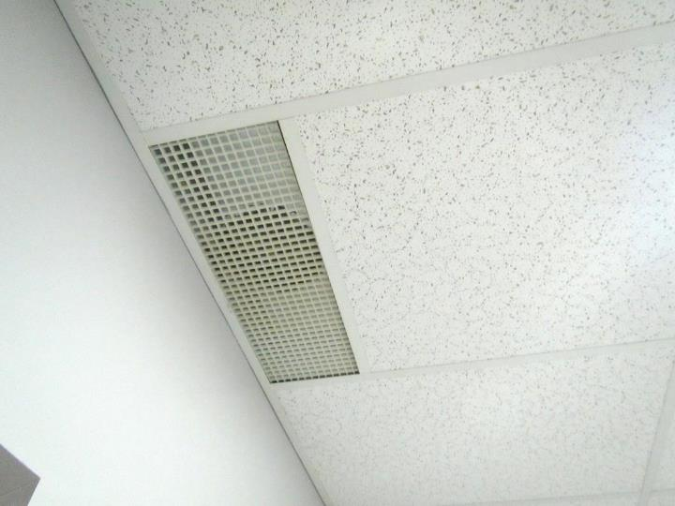
Typical exhaust/return grill
Picture 3
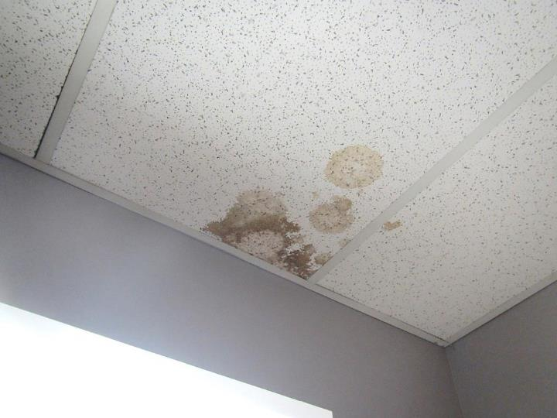
Water-damaged ceiling tiles
Picture 4
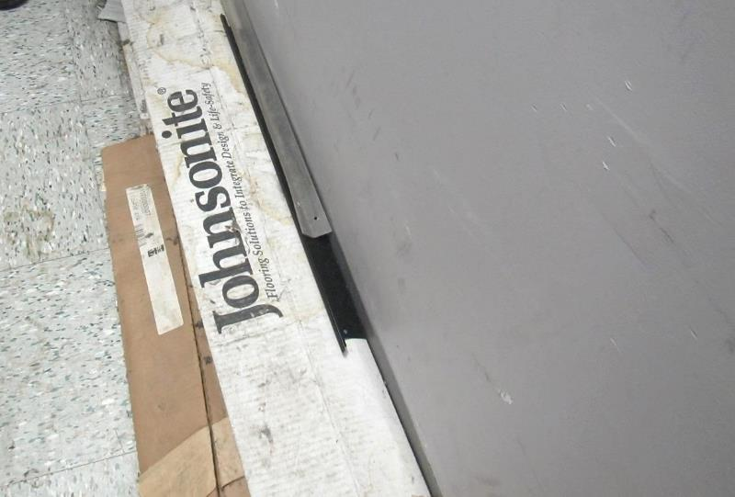
Water-damaged boxes in storeroom
Picture 5
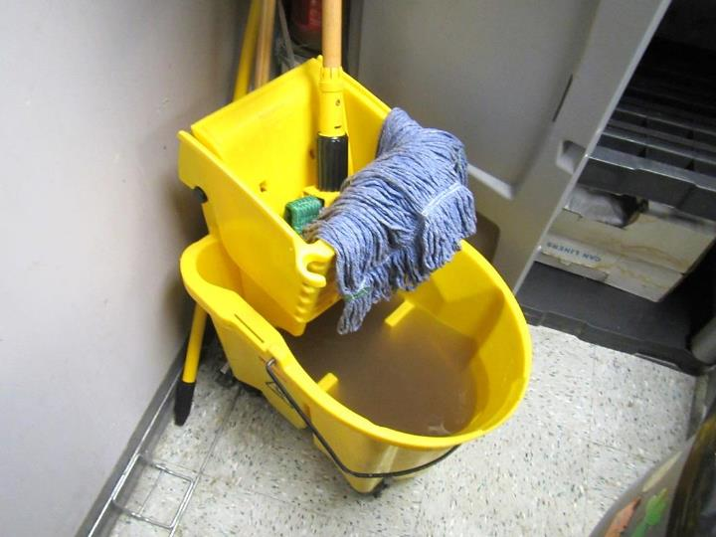
Mop bucket filled with dirty water
Picture 6
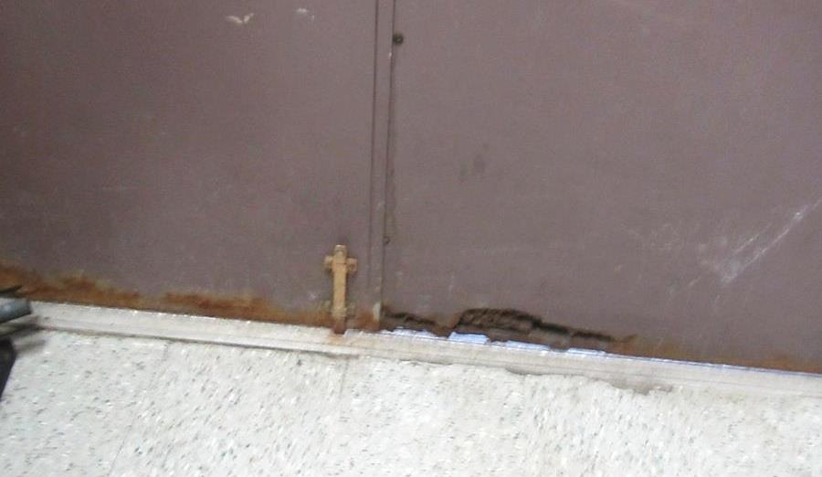
Hole in the bottom of rear door to outside
Picture 7
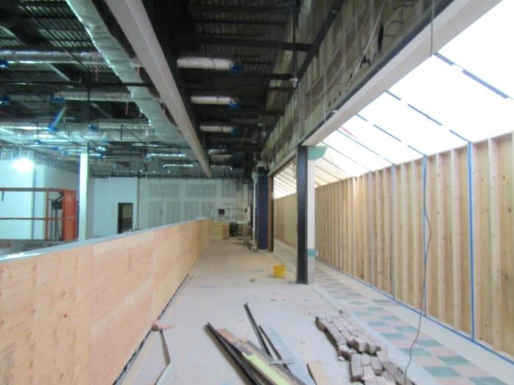
Barrier wall between construction area and mall hallway from inside construction zone (barrier on right side of picture)
Picture 8
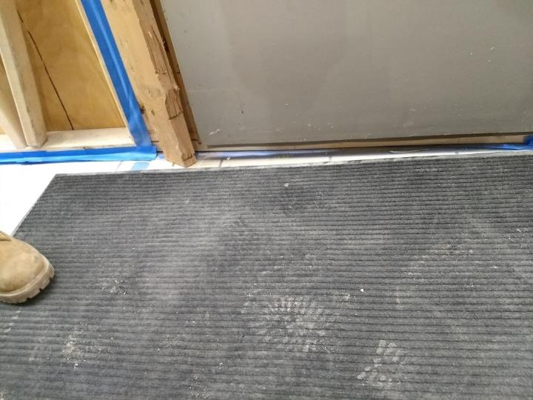
Construction door with light penetrating beneath
Picture 9
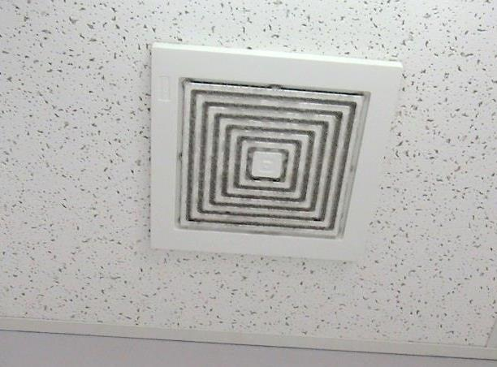
Dusty exhaust vent in a restroom
Picture 10
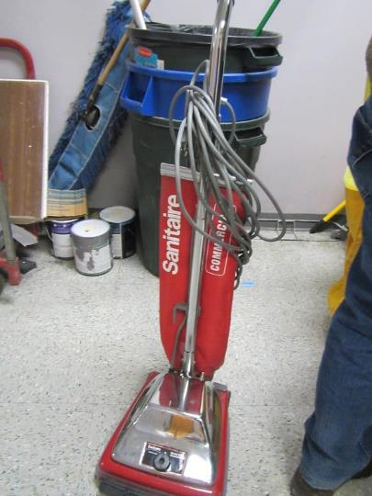
Non-HEPA vacuum cleaner used in the space
Location | Carbon  Dioxide  (ppm) | Carbon Monoxide  (ppm) | Temp  (°F) | Relative  Humidity  (%) | PM2.5  (µg/m³) | TVOC  (ppm) | Occupants  in Room | Windows  Openable | Ventilation |  | Remarks
 |  |  |  |  |  |  |  |  | Supply | Exhaust
Copy/office | 921 | ND | 64 | 12 | 9 | ND | 2 | N | Y | Y | Copier
Road test office | 663 | ND | 64 | 10 | 9 | ND | 1 | N | Y | Y | DEM, HS, door open
Waiting room, rear | 603 | ND | 65 | 9 | 9 | ND | ~15 | N | Y | Y
Testing room | 626 | ND | 65 | 9 | 9 | ND | 2 | N | Y | Y | NC
Janitor’s area/ back hallway | 566 | ND | 61 | 8 | 10 | ND | 0 | N | Y | Y | Hole in door, mop bucket full of water, cleaning supplies, broken smoke/odor heater
Storage | 575 | ND | 60 | 10 | 26 | ND | 0 | N | Y | Y
Desks 14-15 | 633 | ND | 63 | 10 | 10 | ND | 3 | N | Y | Y | HS
Desks 11-13 | 622 | ND | 64 | 10 | 13 | ND | 6 | N | Y | Y | HS, printers and copiers
Restrooms |  |  |  |  |  |  |  | N | Y | Y | WD CT in some restrooms, missing part of wall/heater, exhaust vents work, but are on separate switch
Kitchen | 650 | ND | 64 | 10 | 8 | ND | 2 | N | Y | Y | Old electric stove (unused), refrigerator, NC
Utility/electric |  |  |  |  |  |  |  | N | Y | Y | WD boxes on floor, dirty floor, NC
Audit office | 601 | ND | 65 | 8 | 11 | ND | 0 | N | Y | Y | DEM, boxes on floor, carpet, items on ceiling
Assistant Manager office | 620 | ND | 66 | 8 | 8 | ND | 0 | N | Y | Y | Carpeted, HS
Server room |  |  |  |  |  |  |  | N | Y | Y | Ductless AC with pump, NC
Desks 8-10 | 605 | ND | 67 | 7 | 7 | ND | 5 | N | Y | Y
Storage – files | 663 | ND | 67 | 8 | 7 | ND | 0 | N | Y | Y | WD CT (2)
Counting room 1 | 636 | ND | 67 | 7 | 7 | ND | 0 | N | Y | Y | Window to cash room
Desks 4-7 | 617 | ND | 67 | 7 | 7 | ND | 4 | N | Y | Y | Water cooler on carpet
Cash room | 712 | ND | 68 | 9 | 7 | ND | 1 | N | Y | Y | Cleaning product odor
Desks 1-3 | 627 | ND | 68 | 8 | 7 | ND | 7 | N | Y | Y | HS
Counting room 2 | 607 | ND | 68 | 7 | 5 | ND | 0 | N | Y | Y | Window to cash room
Manager | 617 | ND | 68 | 7 | 7 | ND | 1 | N | Y | Y | HS
Entry area | 642 | ND | 68 | 8 | 7 | ND | many | N | Y | Y | Open to mall

