WATER DAMAGE/MOLD INVESTIGATION

Registry of Motor Vehicles
490 Forest Avenue
Brockton, Massachusetts

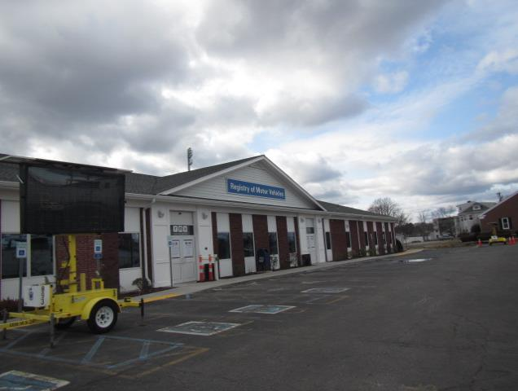

Prepared by:
Massachusetts Department of Public Health
Bureau of Environmental Health
Indoor Air Quality Program
January 2020

BACKGROUND
Building: | Registry of Motor Vehicles (RMV)
Address: | 490 Forest Ave., Brockton, MA
Assessment Requested by: | Aric Warren, Transportation Program Planner, Massachusetts Department of Transportation (MassDOT)
Reason for Request: | Mold/water damage concerns after flooding/burst pipe incident
Date of Assessment: | January 21 and 27, 2020
Massachusetts Department of Public Health/Bureau of Environmental Health (MDPH/BEH) Staff Conducting Assessment: | Cory Holmes, Environmental Analyst/Inspector, Indoor Air Quality (IAQ) Program

IAQ Testing Results
Please refer to the IAQ Manual for methods, sampling procedures, and interpretation of results (MDPH, 2015). The following is a summary of testing results.
- Moisture Measurements of walls/floors were all dry (i.e., within normal parameters) at the time of assessment.
- Relative Humidity Measurements indoors ranged from 24 to 27%, which was significantly lower than outdoors (38%), indicating drying of materials is occurring.

Background and Discussion
The BEH/IAQ Program was asked to examine the Brockton RMV office for the presence of water damage/mold growth, with a focus on areas that were damaged by a sprinkler pipe burst that occurred on Sunday January 19, 2020 due to freezing temperatures. The leak damaged gypsum wallboard (GW) ceilings/walls, insulation, and carpeting as well as electrical, communications, and smoke alarm systems, mainly in the east portion of the building.
At 1:54 PM an alarm was received at the Brockton Fire Department (BFD), Forest Ave. Station, who arrived at 1:59 PM. BFD shut down the sprinkler system and electric power to the building. Within the hour, a facilities representative was on-scene and a flooding/restoration contractor was notified. BFD turned over the building and departed at 2:52 PM (BFD, 2020). Building facilities and MassDOT representatives reported that BFD took measures to protect electronic equipment with tarps and began dewatering/drying operations after the leak was secured.
As mentioned, a flooding restoration/carpet cleaning firm (Master Clean Inc.) had been contacted to perform remediation activities several hours after discovery. These included:
- Use of fans and dehumidifiers to accelerate drying of carpeting and gypsum wallboard (GW);
- Removal of areas of GW and insulation;
- Removal of coving from impacted walls;
- Movement of objects from the floor such as cabinets and floor mats; and
- Measurement of moisture content of GW and carpeting to identify areas needing additional treatment.

At the time of the initial MDPH/IAQ visit on January 24th remediation activities (removal and drying of water-damaged building materials) were fully active (Pictures 1 through 5). At the time of the follow-up visit on January 27th, all water-damaged materials had been either removed or dried and no visible mold/associated odors were observed/detected (Pictures 6 through 10). In addition, relative humidity measurements indoors ranged from 24 to 27%, which was significantly lower than outdoors (38%), which shows that there were no lingering moisture issues within the building.
In general, the US Environmental Protection Agency (US EPA) and the American Conference of Governmental Industrial Hygienists (ACGIH) recommends that porous materials (e.g., wallboard, carpeting) be dried with fans and heating within 24 to 48 hours of becoming wet (US EPA, 2008; ACGIH, 1989). If porous materials are not dried within this time frame, mold growth may occur.

Conclusions/Recommendations
Based on the observations made during the visit, it appears that all affected water-damaged materials were thoroughly dried or removed with no further flooding remediation activities recommended. The following additional recommendations are made:
- Continue with restoration/reconstruction plans to replace all building materials (ceilings, walls, floors, pipes, electrical, etc.) damaged by the flooding incident.
- Prior to reoccupancy:
- Operate/flush out the HVAC system for 24 hours and change filters. The MDPH recommends pleated filters with a Minimum Efficiency Reporting Value (MERV) of 8, which are adequate in filtering out pollen and mold spores (ASHRAE, 2012).
- Once remediation activities are concluded, clean all items and surfaces with a high efficiency particulate arrestance (HEPA) filter equipped vacuum cleaner combined with wet wiping and have carpets professionally cleaned.
- For more information on mold refer to the US EPA’s “Mold Remediation in Schools and Commercial Buildings”. Available at: http://www.epa.gov/mold/mold-remediation-schools-and-commercial-buildings-guide.
- Refer to resource manuals and other related IAQ documents for further building-wide evaluations and advice on maintaining public buildings. Copies of these materials are located on the MDPH’s website: http://mass.gov/dph/iaq.
- If desired, contact the IAQ Program for a pre-reoccupancy assessment following the completion of remediation and reconstruction work.

REFERENCES
ACGIH. 1989. Guidelines for the Assessment of Bioaerosols in the Indoor Environment. American Conference of Governmental Industrial Hygienists, Cincinnati, OH.
ASHRAE. 2012. American Society of Heating, Refrigeration and Air Conditioning Engineers (ASHRAE) Standard 52.2-2012 -- Method of Testing General Ventilation Air-Cleaning Devices for Removal Efficiency by Particle Size (ANSI Approved).
BFD. 2020. Brockton Fire Department Incident Report. Incident #: 20-1314-IN Exp. 0. Call #: 20-7397. Mass RMV, 490 Forest Ave. Brockton, MA. Dated 01/24/2020.
MDPH. 2015. Massachusetts Department of Public Health. “Indoor Air Quality Manual: Chapters I-III”. Available at: http://www.mass.gov/eohhs/gov/departments/dph/programs/environmental-health/exposure-topics/iaq/iaq-manual/.
US EPA. 2008. Mold Remediation in Schools and Commercial Buildings. US Environmental Protection Agency, Office of Air and Radiation, Indoor Environments Division, Washington, D.C. EPA 402-K-01-001. http://www.epa.gov/mold/mold-remediation-schools-and-commercial-buildings-guide.
Picture 1
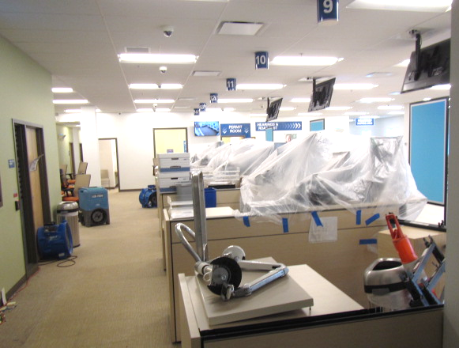
Drying equipment (fans, air movers) and equipment protected/covered with plastic
Picture 2
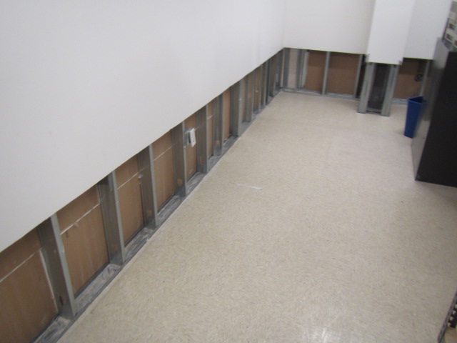
Wet drywall removed
Picture 3
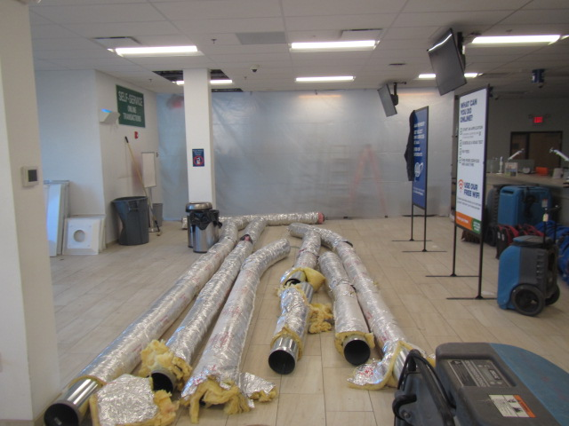
Ductwork removed, demolition (area where leak occurred) sealed off
Picture 4
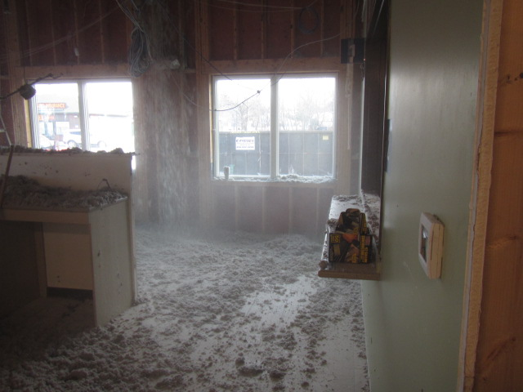
Complete ceiling/wall/insulation removal of affected (east side) area where leak occurred
Picture 5
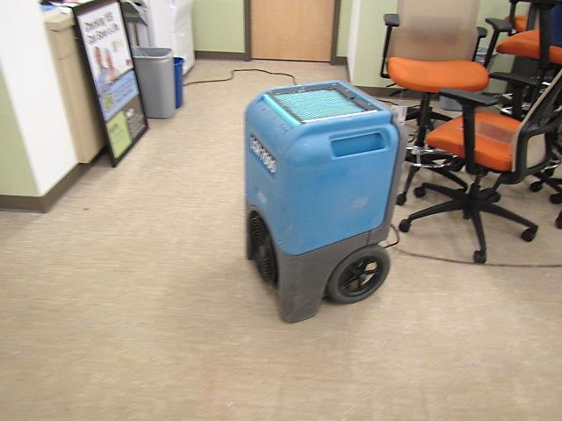
Industrial air mover drying carpeting
Picture 6
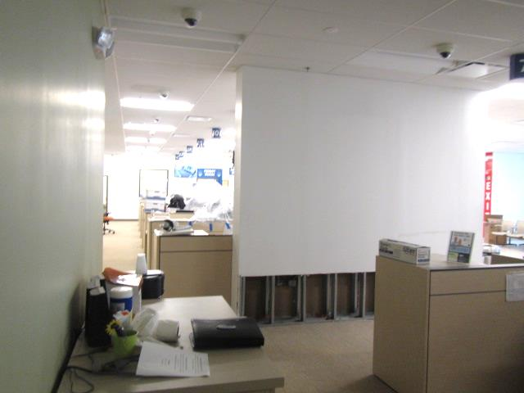
Main area with drywall/insulation removed/carpet dried
Picture 7
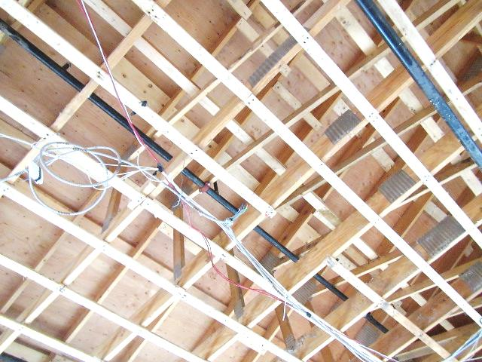
All water-damaged ceiling materials removed, arrow indicates area of pipe that froze causing the flooding (now repaired)
Picture 8
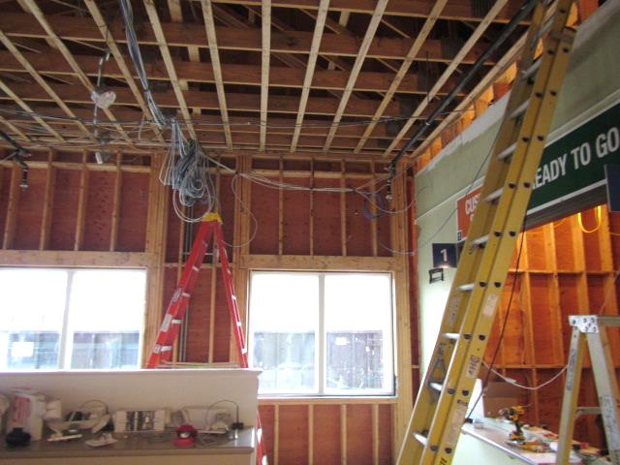
All water-damaged ceiling/wall materials removed
Picture 9
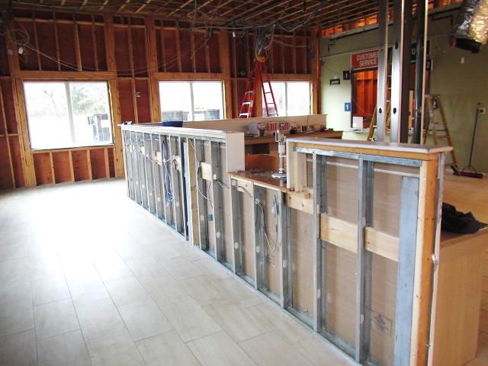
All water-damaged ceiling/wall materials removed
Picture 10
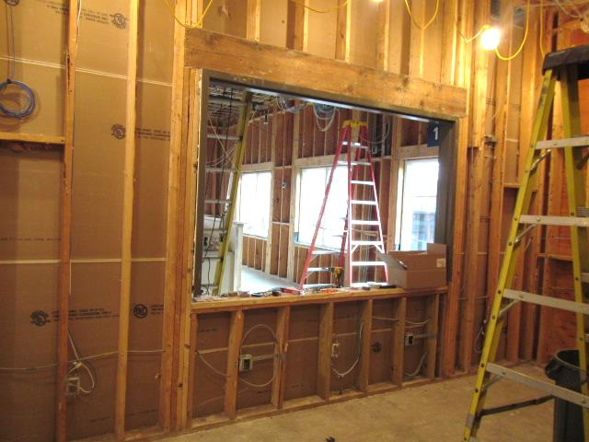
All water-damaged ceiling/wall materials removed

