INDOOR AIR QUALITY ASSESSMENT

Registry of Motor Vehicles Headquarters
25 Newport Avenue Extension
Quincy, Massachusetts

Prepared by:
Massachusetts Department of Public Health
Bureau of Environmental Health
Indoor Air Quality Program
June 2023

BACKGROUND
Building: | Registry of Motor Vehicles Headquarters (RMVHQ)
Address: | 25 Newport Avenue Extension, 3rd floor, Quincy, MA
Assessment Requested by: | Aric Warren, Transportation Program  Planner, Mass Department of  Transportation (DOT)
Reason for Request: | Post-occupancy indoor air quality (IAQ) assessment of the third-floor following renovations
Date of Assessment: | May 31, 2023
Massachusetts Department of Public Health/Bureau of Environmental Health (MDPH/BEH) Staff Conducting Assessment: | Ruth Alfasso, Environmental  Engineer/Inspector, IAQ Program
Building Description: | The RMVHQ occupies a four-story building in North Quincy originally constructed in the 1980s. The building has a flat roof with a large skylight leading to a central atrium inside the building. The third-floor houses offices, meeting rooms and workstations. The offices were recently remodeled including new furnishings and some new HVAC equipment.
Windows: | Windows are not openable

METHODS
Please refer to the IAQ Manual for methods, sampling procedures, and interpretation of results (MDPH, 2015).
Note that this building was visited by the IAQ Program in 2017 following a mulch fire next to the building and subsequent fire restoration/cleanup. That report is available on request.

RESULTS AND DISCUSSION
The following is a summary of indoor air testing results (Table 1).
- Carbon dioxide measurements were below the MDPH guideline of 800 parts per million (ppm) in all areas tested indicating adequate fresh air.
- Temperature was within the recommended range of 70°F to 78°F in all areas tested.
- Relative humidity was within the recommended range of 40% to 60% in all areas tested.
- Carbon monoxide levels were non-detectable (ND) in all areas tested.
- Fine particulate matter (PM2.5) concentrations were below the National Ambient Air Quality Standard (NAAQS) level of 35 μg/m³ in all areas tested.

Ventilation
Note that this office operates partly with a “hoteling” or “touchdown space” model for offices, where an individual checks out a desk for the day when they are in the office and has no set work location. Some offices and workstations appear to be permanently assigned. There are meeting spaces on this floor outside the secure area that can be used for other DOT employees as touchdown or meeting space.
A heating, ventilating, and air conditioning (HVAC) system has several functions. First, it provides heating and, if equipped, cooling. Second, it is a source of fresh air. Finally, an HVAC system will dilute and remove normally occurring indoor environmental pollutants by not only introducing fresh air, but also filtering the airstream and ejecting stale air to the outdoors via exhaust ventilation. Even if an HVAC system is operating as designed, point sources of respiratory irritation may exist and affect symptoms in sensitive individuals. The following analysis examines and identifies components of the HVAC system and likely sources of respiratory irritant/allergen exposure due to water damage, aerosolized dust, and/or chemicals found in the indoor environment.
Fresh air is provided by air handling units (AHUs) on the roof. Air from the AHUs is filtered, heated/cooled, and delivered to rooms via ducted supply vents. Air is drawn through exhaust grills into the ceiling plenum and returned to the AHUs.
The ventilation system should be on and operating to supply fresh air continuously during occupied periods. Without adequate fresh air supply and removal of stale air, common indoor air pollutants can build up and cause irritation.
Thermostats and other HVAC functions are computer controlled at a central location. Some thermostats appeared to be set too low; reportedly adjustments are still being made to the HVAC system since the renovations finished. Thermostat settings should be centrally coordinated to save energy, including setbacks for times when the space is unoccupied.
It is recommended that HVAC systems be re-balanced every five years to ensure adequate air systems function (SMACNA, 1994). According to facility staff, portions of the system were rebalanced during the renovations, mainly areas where walls and office locations were reconfigured.
Sunlight was noted streaming in from windows in a few areas (Table 1). This can lead to temperature complaints and concerns about glare. Adjustable blinds are present which can be used to block sunlight and reduce comfort impacts and should be used as needed.

Microbial/Moisture Concerns
A single water-damaged ceiling tile was noted on this floor. It was located in the Mailroom near a ceiling-mounted mini-split air conditioning unit (Picture 1). This water-damaged ceiling tile likely originated with a leak of condensation from the air conditioner. A portable air conditioner was also noted in the MDF room (Picture 2). These units generate condensation when operating, and typically have a hose drain, sometimes with a pump. Leaks in the hose or damage to the pump can lead to water damage to adjacent materials. Condensate drain pans, pumps, and hoses should be checked periodically for proper function and cleaned when needed. Water-damaged ceiling tiles should be replaced when the leaks are repaired.
Refrigerators and water dispensers were observed on carpeting in several areas (Pictures 3 and 4). Spills or leaks from these appliances can damage carpeting and lead to microbial growth and odors. Refrigerators in break rooms and other areas should be cleaned regularly to prevent odors caused by spills and spoiled food. Food preparation equipment such as microwaves and toasters should also be cleaned regularly.
Trees were noted up against the building (Picture 5). Trees can be a source of pollen and odors through windows if windows are not tightly sealed. They can also damage the exterior of the building, lead to water infiltration, and allow transport of pests to the building exterior. Trees and plants should be trimmed back at least five feet from the building.

Other IAQ Concerns
Testing was conducted for total volatile organic compounds (TVOCs) and all measurements were non-detectable (Table 1). An examination was conducted for products that may be a source of VOCs in indoor air. Products such as dry erase markers, hand sanitizers, and other cleaners were found in offices and common areas (Table 1). In the absence of adequate fresh air and exhaust ventilation, VOCs from these products can build up and lead to irritation of the mucous membranes or irritating odors.
Because of the hoteling design of this office, there are fewer personal items on desks and in offices; this can make it easier for custodial staff to clean. Large amounts of stored items were noted in a few rooms (Picture 6; Table 1), including some dusty items. Facility staff indicated that these are in the process of being sorted and properly discarded or stored. Stored items should be kept neatly, and items which may have been stored in dusty or damp conditions should be cleaned before being brought into the space to avoid transferring dust, mold spores, and pests.
The configuration of some workstations creates a space between workstation walls and room walls (Picture 7). Dust, debris, and items can accumulate in these spaces, as they are difficult to access for cleaning. This may become a source of odors or attractive to pests.
Lockers are present in this location for staff to store work-related and personal items. Lockers should be cleaned out periodically to prevent odors or pest issues due to storage of food or other items.
As mentioned above, most areas of this office are carpeted. Carpets should be cleaned regularly in accordance with Institute of Inspection, Cleaning and Restoration Certification (IICRC) recommendations (IICRC, 2012).

CONCLUSIONS/RECOMMENDATIONS
The following are recommendations made to maintain IAQ:

Ventilation recommendations
- Operate supply and exhaust ventilation in all areas during occupied periods.
- Ensure filters are replaced on HVAC units at least twice a year. Use filters with a minimum efficiency rating value (MERV) of 8 or better.
- Ensure thermostats office-wide are set in a consistent manner, including nighttime and weekend setbacks.
- Use adjustable blinds to control heating and glare due to sunlight.
- It is recommended that HVAC systems be re-balanced every five years to ensure adequate air systems function (SMACNA, 1994).

Water damage recommendations
- Check the condensation drain and associated hoses and pumps for the mini-split unit in the Mailroom shown in Picture 1 for adequate drainage and repair any leaks or clogs. Monitor periodically, particularly during hot, humid weather when excess condensation is more likely to be generated.
- Replace the water-damaged ceiling tile in the Mailroom.
- Ensure other portable or ductless air conditioners such as the one shown in Picture 2 also have adequate condensation drainage.
- Consider moving refrigerators and water dispensers to areas without carpeting or use a waterproof mat underneath.
- Keep refrigerators and other food-preparation appliances clean.
- Trim plants and tree limbs away from the building.

Other recommendations
- Use VOC-containing products in areas with good ventilation and keep tightly closed when not in use. Avoid products with strong scents and avoid mixing incompatible products.
- Ensure items brought in from storage or other locations are free of dust, odors, and pests.
- Continue to sort, discard, and properly store remaining items.
- Schedule periodic cleaning of hidden or hard-to-reach areas between workstation walls and room walls.
- Ensure lockers are cleaned out periodically.
- Clean carpeting in accordance with IICRC recommendations (IICRC, 2012).
- For buildings in New England, periods of low relative humidity during the winter are often unavoidable. Therefore, scrupulous cleaning practices should be adopted to minimize common indoor air contaminants whose irritant effects can be enhanced when the relative humidity is low. To control dust, a high efficiency particulate arrestance (HEPA) filter equipped vacuum cleaner in conjunction with wet wiping of all surfaces is recommended. Avoid the use of feather dusters. Drinking water during the day can help ease some symptoms associated with a dry environment (throat and sinus irritations).
- Refer to resource manual and other related IAQ documents located on the MDPH’s website for further building-wide evaluations and advice on maintaining public buildings. These documents are available at: http://mass.gov/dph/iaq.

REFERENCES
IICRC. 2012. Institute of Inspection, Cleaning and Restoration Certification. Carpet Cleaning: FAQ.
MDPH. 2015. Massachusetts Department of Public Health. Indoor Air Quality Manual: Chapters I-III. Available at: https://www.mass.gov/lists/indoor-air-quality-manual-and-appendices.
SMACNA. 1994. HVAC Systems Commissioning Manual. 1st ed. Sheet Metal and Air Conditioning Contractors’ National Association, Inc., Chantilly, VA.

Picture 1
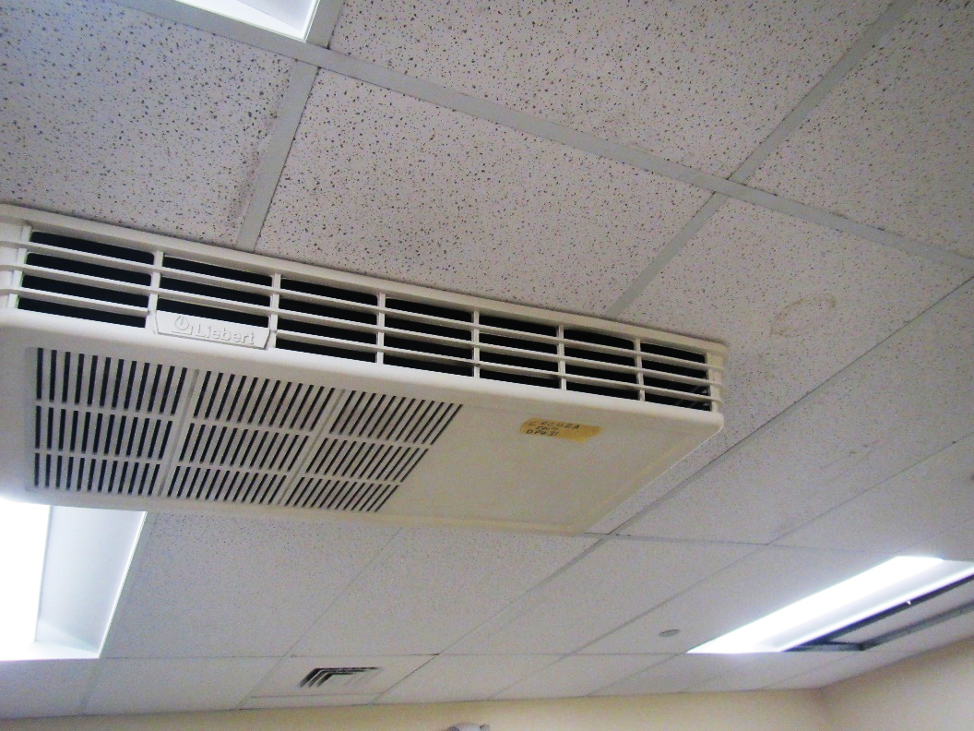
Ceiling-mounted mini-split air conditioner and water-damaged ceiling tile
Picture 2
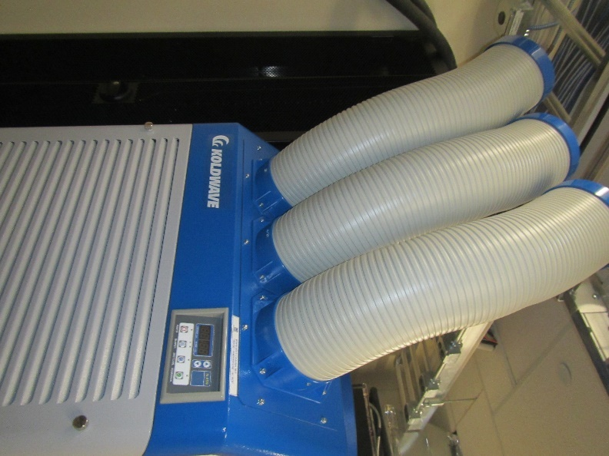
Portable air conditioner
Picture 3
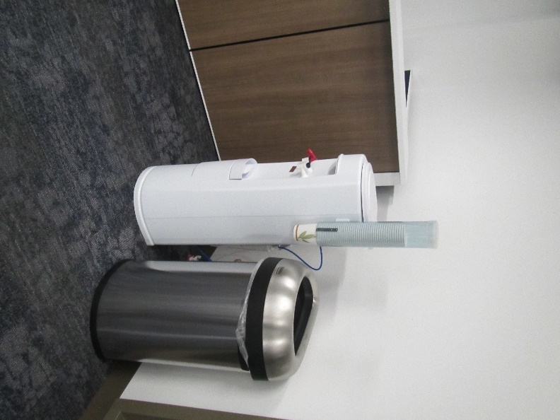
Water dispenser on carpet
Picture 4
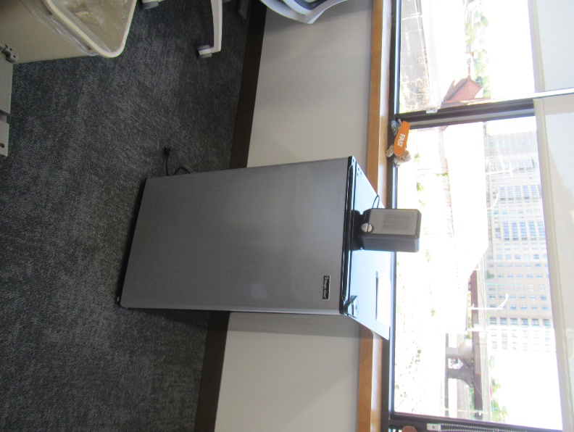
Small refrigerator on carpet
Picture 5
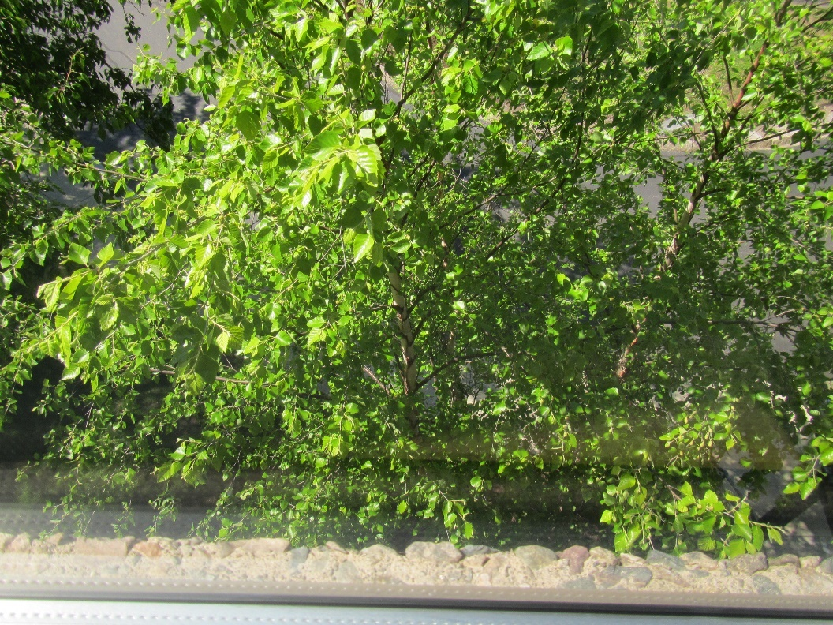
Tree up against the windows
Picture 6
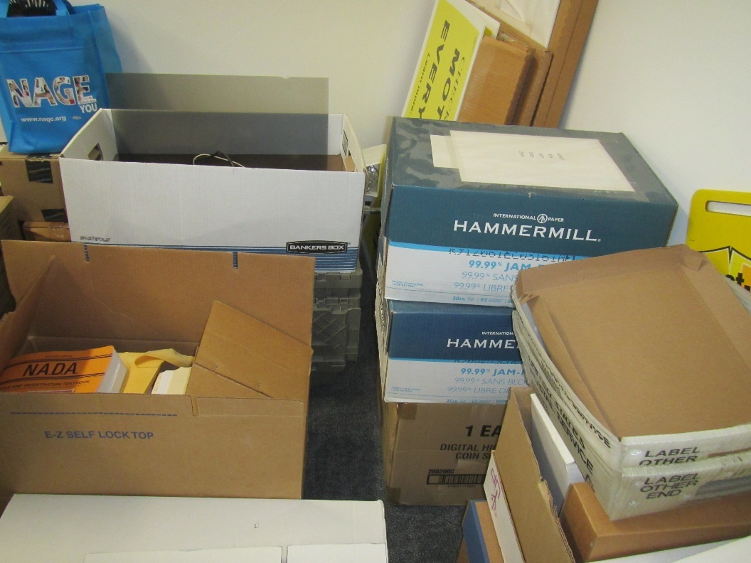
Boxes and other items stored in a conference room
Picture 7
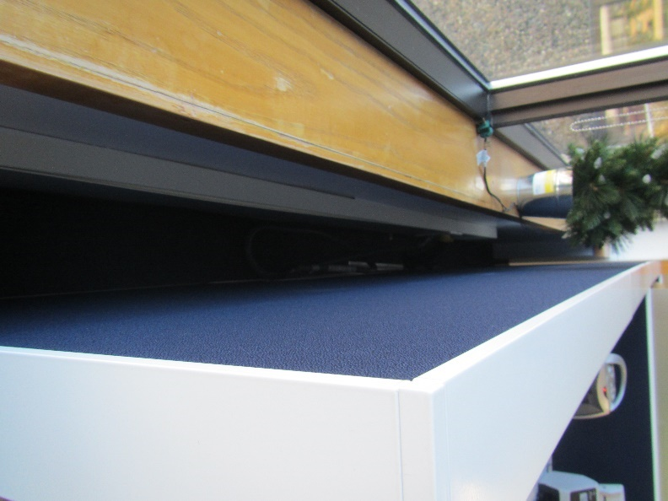
Gap between workstation and wall

Location | Carbon  Dioxide  (ppm) | Carbon Monoxide  (ppm) | Temp  (°F) | Relative  Humidity  (%) | PM2.5  (µg/m³) | TVOC  (ppm) | Occupants  in Room | Windows  Openable | Ventilation |  | Remarks
 |  |  |  |  |  |  |  |  | Supply | Exhaust
Background | 376 | ND | 72 | 43 | ND
Huddle room | 530 | ND | 74 | 43 | ND | ND | 0 | N | Y | Y | DEM
Registrar’s office | 442 | ND | 73 | 43 | ND | ND | 0 | N | Y | Y | Water cooler on carpet
Conference room | 444 | ND | 73 | 43 | ND | ND | 0 | N | Y | Y
Huddle Room | 475 | ND | 73 | 43 | ND | ND | 0 | N | Y | Y
3A63 | 452 | ND | 73 | 43 | ND | ND | 0 | N | Y | Y | Refrigerator on carpet
3A64 | 453 | ND | 73 | 44 | ND | ND | 0 | N | Y | Y | DEM
3A66 | 438 | ND | 73 | 43 | ND | ND | 0 | N | Y | Y
3A67 | 437 | ND | 73 | 41 | ND | ND | 0 | N | Y | Y | Boxes, plants, sunlight
3A70 | 561 | ND | 73 | 43 | ND | ND | 1 | N | Y | Y | Sunlight
3A72 cubes | 491 | ND | 74 | 42 | ND | ND | 0 | N | Y | Y | Sunlight
Kitchen | 450 | ND | 72 | 43 | ND | ND | 0 | N | Y | Y | Microwave, refrigerator, NC
Open meeting area | 428 | ND | 73 | 43 | ND | ND | 0 | N | Y | Y | Upholstered furniture, sunlight
3B03 cubes | 423 | ND | 73 | 42 | ND | ND | 3 | N | Y | Y | Sunlight
3B11 | 442 | ND | 73 | 43 | ND | ND | 4 | N | Y | Y | Sunlight
3B13 | 438 | ND | 73 | 42 | ND | ND | 0 | N | Y | Y | Fan, refrigerator, food
3B14 | 429 | ND | 73 | 42 | ND | ND | 0 | N | Y | Y | Boxes, plant, PF – on, HS
3B44 | 455 | ND | 73 | 41 | ND | ND | 3 | N | Y | Y | Upholstered furniture
Open area | 458 | ND | 73 | 43 | ND | ND | 0 | N | Y | Y
3B56 | 443 | ND | 72 | 42 | ND | ND | 0 | N | Y | Y
3B59 cubes | 442 | ND | 73 | 42 | ND | ND | 6 | N | Y | Y
3B65 cubes | 447 | ND | 73 | 43 | ND | ND | 4 | N | Y | Y | Food, upholstered furniture
3B77 cubes | 420 | ND | 73 | 42 | ND | ND | 2 | N | Y | Y | Food
3B84 huddle | 443 | ND | 73 | 42 | ND | ND | 0 | N | Y | Y
3B85 huddle | 416 | ND | 72 | 41 | ND | ND | 0 | N | Y | Y
Corner open area | 406 | ND | 71 | 44 | ND | ND | 0 | N | Y | Y
3B87 | 400 | ND | 72 | 43 | ND | ND | 0 | N | Y | Y | DEM, refrigerator
Conference room | 496 | ND | 72 | 43 | ND | ND | 0 | N | Y | Y
IT overflow cubes | 410 | ND | 72 | 43 | ND | ND | 2 | N | Y | Y
3B86 conference | 412 | ND | 71 | 42 | ND | ND | 0 | N | Y | Y | Storage items including old boxes
3B97 conference | 392 | ND | 70 | 43 | ND | ND | 0 | N | Y | Y | Boxes
IT Storage | 409 | ND | 71 | 43 | ND | ND | 0 | N | Y | Y | NC, items
Storage |  |  |  |  |  |  |  | N | Y | Y | NC
Cubes | 452 | ND | 72 | 43 | ND | ND | 8 | N | Y | Y | Boxes, humidifier
Office | 447 | ND | 73 | 42 | ND | ND | 1 | N | Y | Y | Boxes, DEM
3A18 cubes | 498 | ND | 73 | 42 | ND | ND | 0 | N | Y | Y
3A24 cubes | 438 | ND | 73 | 42 | ND | ND | 1 | N | Y | Y | Water cooler on carpet
3A41 cubes | 440 | ND | 73 | 42 | ND | ND | 2 | N | Y | Y
3A44 cubes | 429 | ND | 73 | 42 | ND | ND | 5 | N | Y | Y
Mail | 486 | ND | 72 | 42 | ND | ND | 0 | N | Y | Y | Mini-split in ceiling, WD CT
3A52 | 432 | ND | 73 | 42 | ND | ND | 0 | N | Y | Y | HS, DEM, HS, cleaning products
Outside secure area
3B23 cubes | 456 | ND | 72 | 42 | ND | ND | 2 | N | Y | Y
3B27 cubes | 425 | ND | 71 | 43 | ND | ND | 4 | N | Y | Y | PF, water cooler on carpet
332 huddle | 480 | ND | 71 | 43 | ND | ND | 0 | N | Y | Y | DEM
MDF |  |  |  |  |  |  |  |  |  |  | Missing and ajar ceiling tiles, portable air conditioner, NC

