INDOOR AIR QUALITY ASSESSMENT

Registry of Motor Vehicles Headquarters
25 Newport Avenue Extension
Quincy, Massachusetts

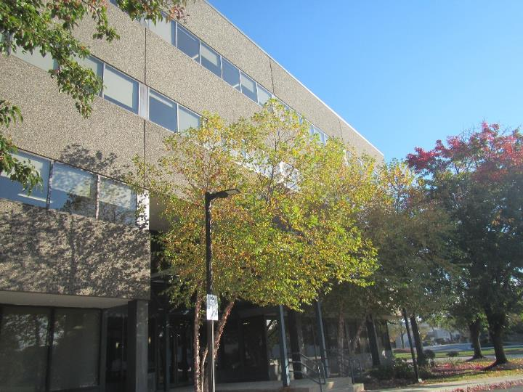

Prepared by:
Massachusetts Department of Public Health
Bureau of Climate and Environmental Health
Indoor Air Quality Program
November 2023

BACKGROUND
Building: | Registry of Motor Vehicles Headquarters (RMVHQ)
Address: | 25 Newport Avenue Extension, Quincy, MA
Assessment Requested by: | Aric Warren, Transportation Program  Planner, Mass Department of  Transportation (DOT)
Reason for Request: | General IAQ assessment following occupant complaints.
Date of Assessment: | November 2, 2023
Massachusetts Department of Public Health/Bureau of Environmental Health (MDPH/BEH) Staff Conducting Assessment: | Ruth Alfasso, Environmental  Engineer/Inspector, IAQ Program
Building Description: | The RMVHQ occupies a four-story building in North Quincy originally constructed in the 1980s. The building has a flat roof with a large skylight leading to a central atrium inside the building. The building has offices, meeting rooms, workstations, storage, and accessory areas. Note that portions of this office operate with a “hoteling” or “touchdown space” model for workstations, and others have permanently assigned seating.
Windows: | Windows are not openable

METHODS
Please refer to the IAQ Manual for methods, sampling procedures, and interpretation of results (MDPH, 2015).
Note that this building was visited by the IAQ Program in 2017 following a mulch fire next to the building and subsequent fire restoration/cleanup, and the third floor was visited in June of 2023. These reports are available at: https://www.mass.gov/info-details/indoor-air-quality-reports-cities-and-towns-q.

RESULTS AND DISCUSSION
The following is a summary of indoor air testing results (Table 1).
- Carbon dioxide measurements were below the MDPH guideline of 800 parts per million (ppm) in nearly all areas tested. The exception was the “service center” area on the second floor which consists of high-density occupied workstations. This is discussed further below.
- Temperature was within the recommended range of 70°F to 78°F in almost all areas, while a few were slightly below.
- Relative humidity was below the recommended range of 40% to 60% in all areas tested, which is typical of the heating season in New England.
- Carbon monoxide levels were non-detectable (ND) on floors 2-4. Low levels of CO were measured in some areas on the first floor.
- Fine particulate matter (PM2.5) concentrations were below the National Ambient Air Quality Standard (NAAQS) level of 35 μg/m³ in all areas tested.
- Total Volatile Organic Compounds were ND in nearly all areas tested, with a few slight detections which corresponded to an area with perfume odors and hand sanitizer.

Ventilation
A heating, ventilating, and air conditioning (HVAC) system has several functions. First, it provides heating and, if equipped, cooling. Second, it is a source of fresh air. Finally, an HVAC system will dilute and remove normally occurring indoor environmental pollutants by not only introducing fresh air, but also filtering the airstream and ejecting stale air to the outdoors via exhaust ventilation. Even if an HVAC system is operating as designed, point sources of respiratory irritation may exist and affect symptoms in sensitive individuals.
Fresh air is provided by air handling units (AHUs) on the roof. Air from the AHUs is filtered, heated/cooled, and delivered to rooms via ducted supply vents (Pictures 1 and 2). Air is drawn through exhaust grills into the ceiling plenum and returned to the AHUs (Picture 3).
The ventilation system should be on and operating to supply fresh air continuously during occupied periods. Without adequate fresh air supply and removal of stale air, common indoor air pollutants can build up and cause irritation.
Thermostats and other HVAC functions are computer controlled at a central location. Some thermostats appear to be set to fan “auto” which deactivates the fan once the temperature in the areas is satisfied. It is recommended that the fan be “on” during occupied periods to supply continuous fresh air. Thermostat settings should be centrally coordinated to save energy, including setbacks for times when the space is unoccupied.
The area on the second floor known as the “service center” had levels of carbon dioxide above 800 (Table 1). This area contains closely spaced workstations, most of which were occupied by employees actively on the phone. High density and activity can increase carbon dioxide levels. Building facility staff reported that the fresh air dampers in this section will be opened further to increase air exchange.
In some offices, the exhaust vent was noted to be very close to the door. With the door open, the exhaust system is more likely to draw air from the hall rather than from the room, particularly when it’s a larger room.
It is recommended that HVAC systems be re-balanced every five years to ensure adequate air systems function (SMACNA, 1994). According to facility staff, portions of the third floor’s systems were rebalanced during the renovations.
A few occupants reported uncomfortably cold temperatures. While most areas had temperatures within the MDPH comfort range, a few areas were cooler. Building occupants should work with facility staff to adjust thermostats within the allowable range.
Sunlight was noted streaming in from windows in a few areas (Table 1). This can lead to temperature complaints and concerns about glare. Adjustable blinds are present which can be used to block sunlight and reduce comfort impacts and should be used as needed.

Microbial/Moisture Concerns
A few water-damaged ceiling tiles were noted in the areas assessed (Picture 4; Table 1). Based on the locations of the stained tiles, these may originate from leaks or condensation in the HVAC or sprinkler system. None of the tiles appeared to be mold colonized. Water-damaged ceiling tiles should be replaced when the leaks are repaired. During the visit in June of 2023, a water-damaged ceiling tile was noted adjacent to a mini-split air conditioner in an equipment room. Some of the similar rooms in the building were not accessible during this visit, however, any ductless/portable air conditioning units should be periodically monitored to ensure condensation drains, pumps, and hoses are in good condition/not clogged to prevent leaks.
Plants were noted in many areas (Picture 5; Table 1), including some that were placed on porous materials. Plants should be well maintained and placed on waterproof drip pans to contain any spills and protect building materials.
Refrigerators and water dispensers were observed on carpet in several areas (Picture 6). Spills or leaks from these appliances can damage carpeting and lead to microbial growth and odors. Some of the water dispensers had mats underneath to protect carpeting. Refrigerators in break rooms and other areas should be cleaned regularly to prevent odors caused by spills and spoiled food. Food preparation equipment such as microwaves and toasters should also be cleaned regularly. All food should be stored in pest-proof containers.
A mist humidifier was noted on the third floor (Picture 7). It was not operating at the time of the assessment. These units may lead to IAQ issues, both due to the potential for stagnant water inside the unit, and due to deposition of minerals from tap water into the air which can then be inhaled. Use of these units can also lead to moistening of adjacent materials. In addition, because of the regular flow of fresh air from the HVAC system, the ability of these units to affect humidity is limited. If they are to be used, they should be kept scrupulously clean, and filled with low mineral water.
Low humidity indoors is a common problem during the heating season in the Northeast, may lead to discomfort from dry skin and mucous membranes, and may enhance the ability of dust to become airborne. The MDPH/IAQ program recommends drinking water during the day to mitigate issues associated with dry air, and to enhance cleaning/dust removal when the humidity is low.
As noted in the report from June 2023, trees were very close to the building (Picture 8). Trees can be a source of pollen and odors through windows if windows are not tightly sealed. They can also damage the exterior of the building, lead to water infiltration, and allow transport of pests to the building exterior. Trees and plants should be trimmed back at least five feet from the building.

Other IAQ Concerns
Testing was conducted for total volatile organic compounds (TVOCs). Most measurements were non-detect (ND). Low levels of TVOCs were noted in a few areas on the second and first floor (Table 1). In one area where TVOCs were detected, there was an odor of perfume or air freshener. An examination was conducted for products that may be a source of VOCs in indoor air. Products such as dry erase markers, hand sanitizers, air fresheners, candles, and other products were found in offices and common areas (Pictures 9 and 10; Table 1). In the absence of adequate fresh air and exhaust ventilation, VOCs from these products can build up and lead to irritation of the mucous membranes or irritating odors. Scented products such as air fresheners are not recommended to be used in offices, as many people are sensitive to components of fragrances. In addition, scented products do not remove odors, they merely cover them up with an additional odor. Odors should be dealt with through cleaning and adequate ventilation.
As noted in the results section above, low levels of carbon monoxide (CO) were measured on the first floor (Table 1). Additional outdoor measurements were taken following the assessment, and similar levels of CO were noted outside near the rear parking lot of the property. No equipment was noted that could be the source of the carbon monoxide, however the property is at the intersection of two roadways, where vehicle traffic may be a source of CO. CO may be entering the building either from outside through gaps in the building envelope, or from the rooftop AHUs. Note that the U.S. National Ambient Air Quality Standards for outdoor air are 9 ppm for 8 hours, and 35 ppm for 1 hour (US EPA, 2022). No current standards exist for indoor air, but levels should not be higher than outdoors.
One of the concerns prompting this assessment was related to dust attributed to the construction that took place on the third floor earlier in 2023 and was completed by June. No elevated levels of airborne dust (as PM2.5) was measured, and very little dust and debris was observed during the assessment. The best methods to control dust include using good quality filters on the HVAC equipment, changing them regularly, and performing adequate cleaning using wet wiping techniques and/or a high efficiency particulate arrestance (HEPA) filter equipped vacuum cleaner.
In some areas, large amounts of items were present, including boxes, decorations, papers, and other items (Picture 11; Table 1). Large amounts of items make it difficult for custodial staff to clean and can accumulate dust. Piles of stored items on the floor may also provide harborage for pests. Decorative items should be cleaned periodically using a method that does not aerosolize dust such as wet wiping, microfiber cloths, or the use of a HEPA-equipped vacuum cleaner.
As was noted during the previous visit to the third floor, the configuration of some workstations creates a space between workstation walls and room walls. Dust, debris, and items can accumulate in these spaces, as they are difficult to access for cleaning.
Air purifiers were in use in some areas (Table 1). These units should be well maintained and cleaned, including filter changes, in accordance with manufacturers’ instructions. Air purifiers that may produce ozone should not be used in occupied areas (US EPA 2008).
Lockers are present in this location for staff to store work-related and personal items. Lockers should be cleaned out periodically to prevent odors or pest issues due to storage of food or other items.
In one conference/huddle room, the walls were streaked with a blue dye (Picture 12). There was no odor, but the origin of the material could not be determined. This material should be cleaned to avoid occupant concerns.
As mentioned above, most areas of this office are carpeted. Carpets should be cleaned regularly in accordance with Institute of Inspection, Cleaning and Restoration Certification (IICRC) recommendations (IICRC, 2012).

CONCLUSIONS/RECOMMENDATIONS
The following are recommendations made to maintain IAQ:

Ventilation recommendations
- Operate supply and exhaust ventilation in all areas during occupied periods.
- Continue with plans to increase fresh air percentage in the “service center” area to account for high occupancy.
- In offices with exhaust vents close to the door, consider closing doors when occupied.
- Ensure filters are replaced on HVAC units at least twice a year. Use filters with a minimum efficiency rating value (MERV) of 8 or better.
- Ensure thermostats office-wide are set in a consistent manner, including nighttime and weekend setbacks.
- Encourage staff to report comfort issues such as low temperature, to an appropriate point person so that settings can be adjusted.
- Use adjustable blinds to control heating and glare due to sunlight.
- It is recommended that HVAC systems be re-balanced every five years to ensure adequate air systems function (SMACNA, 1994).

Water damage recommendations
- Replace water-damaged ceiling tiles, and check above the ceiling tile grid for the source of leaks. Repair or clean as needed.
- Ensure any portable or ductless air conditioners have adequate condensation drainage.
- Maintain indoor plants, and place them on waterproof drip pans that are cleaned periodically.
- Consider moving refrigerators and water dispensers to areas without carpeting or use a waterproof mat underneath.
- Keep refrigerators and other food-preparation appliances clean.
- If humidifiers are to be used, they should be kept scrupulously clean, filled with low-mineral water, and kept away from porous materials.
- For buildings in New England, periods of low relative humidity during the winter are often unavoidable. Therefore, scrupulous cleaning practices should be adopted to minimize common indoor air contaminants whose irritant effects can be enhanced when the relative humidity is low. To control dust, a high efficiency particulate arrestance (HEPA) filter equipped vacuum cleaner in conjunction with wet wiping of all surfaces is recommended. Avoid the use of feather dusters. Drinking water during the day can help ease some symptoms associated with a dry environment (throat and sinus irritations).
- Trim plants and tree limbs away from the building.

Other recommendations
- Use VOC-containing products in areas with good ventilation and keep tightly closed when not in use. Avoid products with strong scents and avoid mixing incompatible products.
- Sort, discard, and properly store items to keep them off the floor.
- Clean decorative items periodically to remove dust in a manner that does not aerosolize it.
- Clean and maintain air purifiers in accordance with manufacturer’s instructions including filter changes.
- Schedule periodic cleaning of hidden or hard-to-reach areas between workstation walls and room walls.
- Ensure lockers are cleaned out periodically.
- Clean carpeting in accordance with IICRC recommendations (IICRC, 2012).
- Consider adding identification numbers to rooms and areas without them to make reporting and tracking maintenance issues easier.
- Clean blue dye material from conference/huddle room walls.
- Refer to resource manual and other related IAQ documents located on the MDPH’s website for further building-wide evaluations and advice on maintaining public buildings. These documents are available at: http://mass.gov/dph/iaq.

REFERENCES
IICRC. 2012. Institute of Inspection, Cleaning and Restoration Certification. Carpet Cleaning: FAQ.
MDPH. 2015. Massachusetts Department of Public Health. Indoor Air Quality Manual: Chapters I-III. Available at: https://www.mass.gov/lists/indoor-air-quality-manual-and-appendices.
SMACNA. 1994. HVAC Systems Commissioning Manual. 1st ed. Sheet Metal and Air Conditioning Contractors’ National Association, Inc., Chantilly, VA.
US EPA. 2003. “Ozone Generators that are Sold as Air Cleaners: An Assessment of Effectiveness and Health Consequences”. United States Environmental Protection Agency, Office of Air and Radiation, Indoor Environments Division, Washington, DC. Last updated September, 2018. https://www.epa.gov/indoor-air-quality-iaq/ozone-generators-are-sold-air-cleaners
US EPA. 2022. What is the average level of carbon monoxide in homes? United States Environmental Protection Agency, Office of Air and Radiation, Indoor Environments Division, Washington, DC. Last updated December 2022. https://www.epa.gov/indoor-air-quality-iaq/what-average-level-carbon-monoxide-homes.
Picture 1
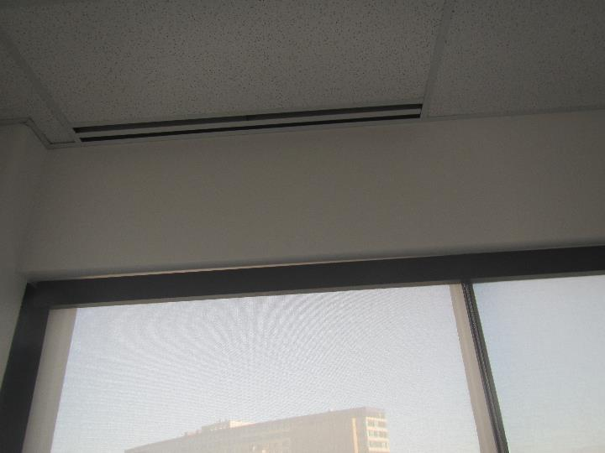
One style of supply vent
Picture 2
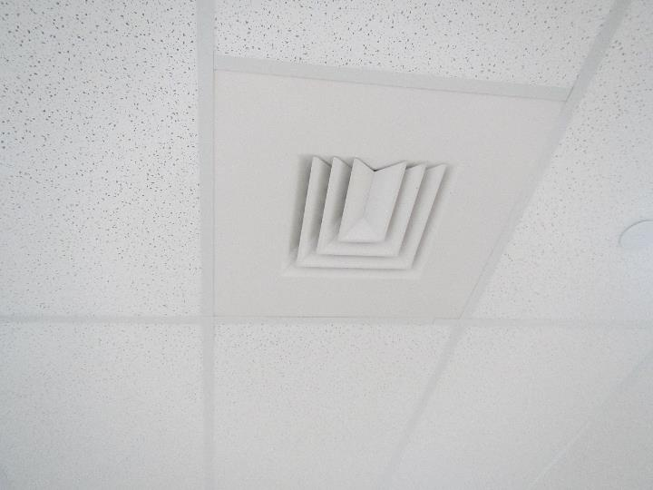
Another style of supply vent

Picture 3
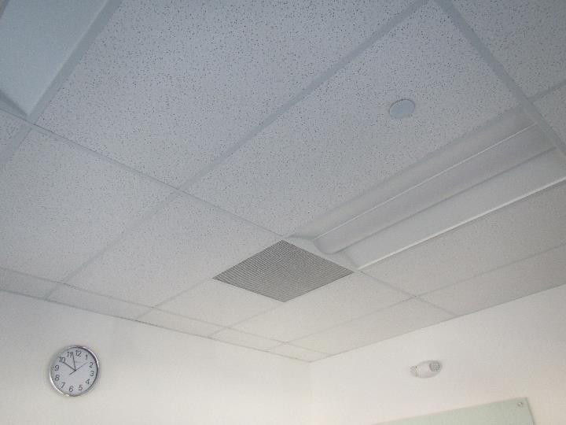
Return vent
Picture 4
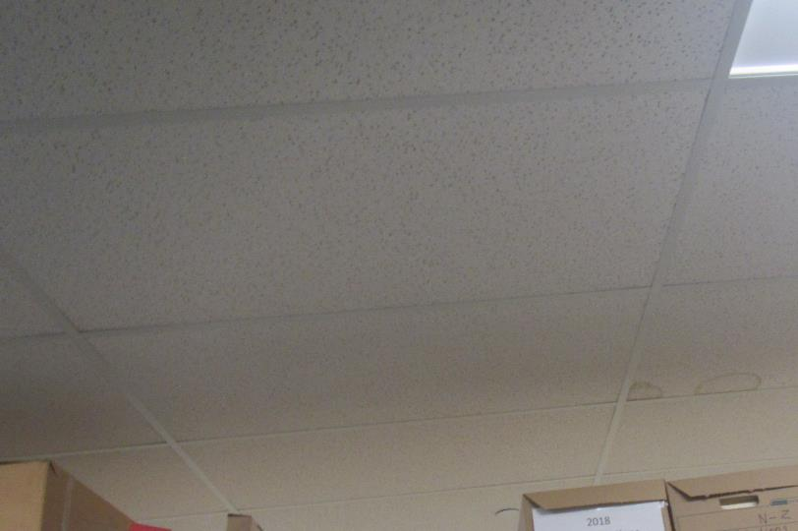
Water-damaged ceiling tiles in a storage area

Picture 5
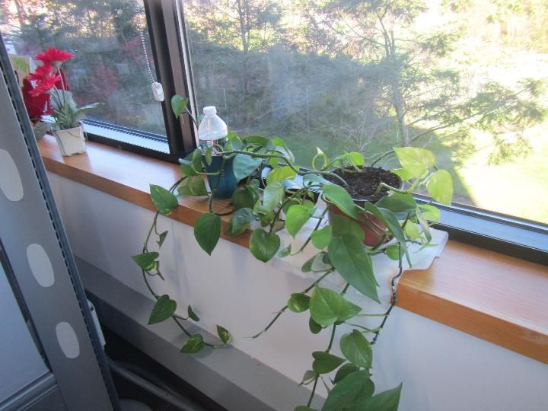
Plant on a windowsill, note paper towel under drip pan
Picture 6
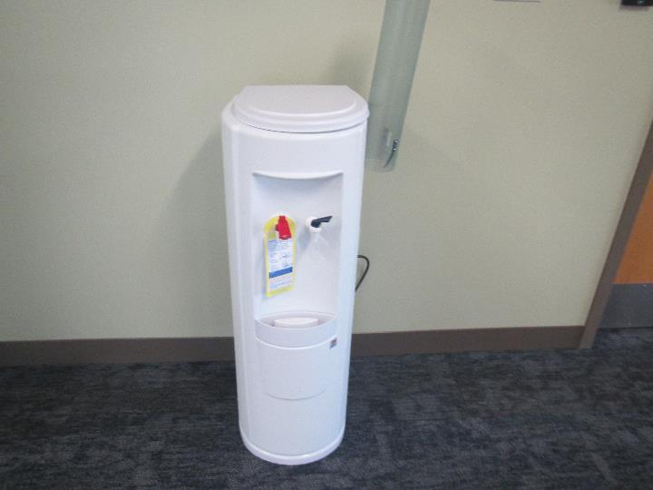
Water dispenser on carpet

Picture 7
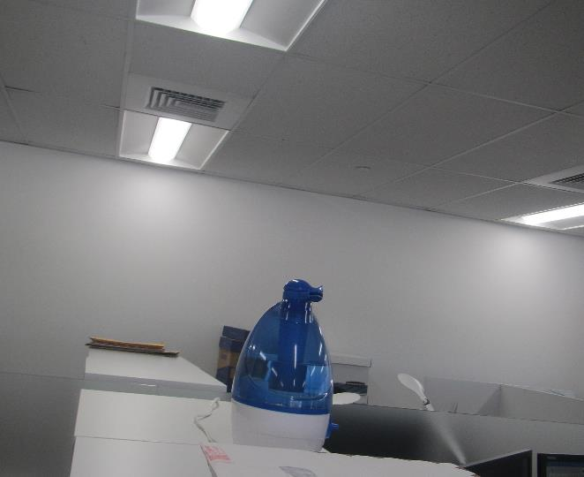
Mist humidifier
Picture 8
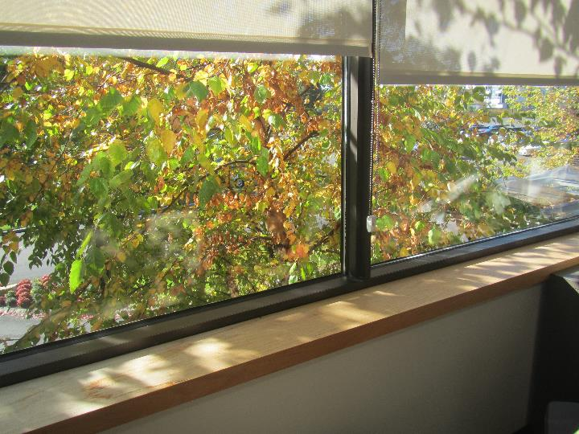
Tree outside touching the window

Picture 9
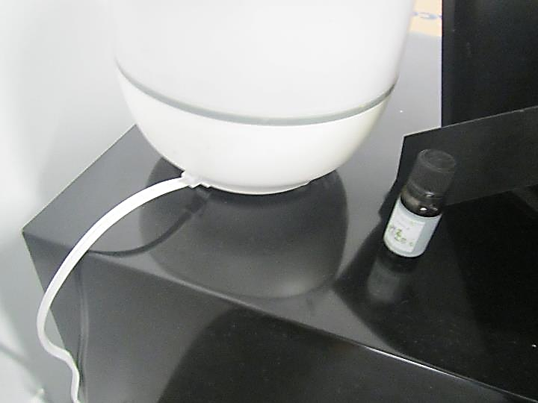
Essential oil and diffuser
Picture 10
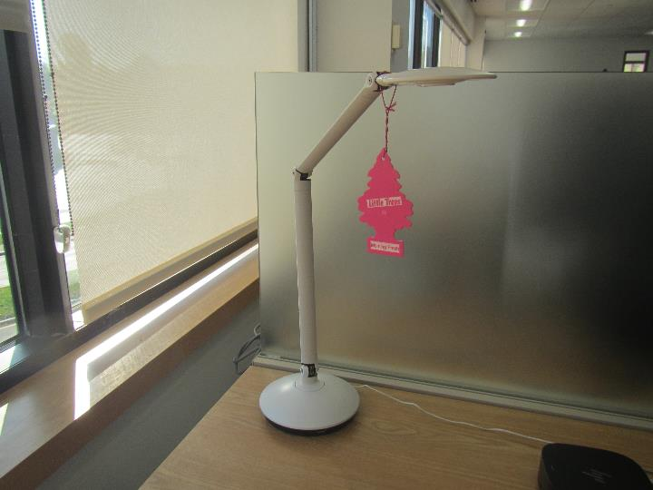
Hanging air freshener

Picture 11
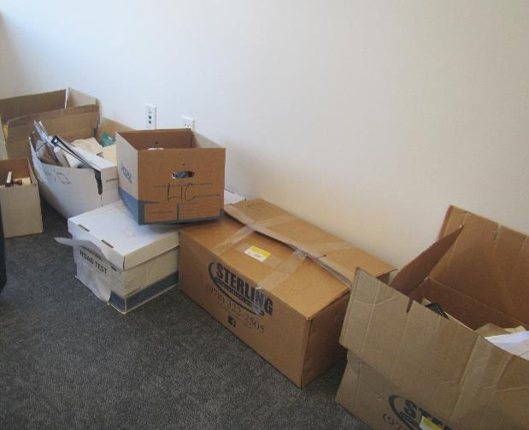
Boxes on an office floor
Picture 12
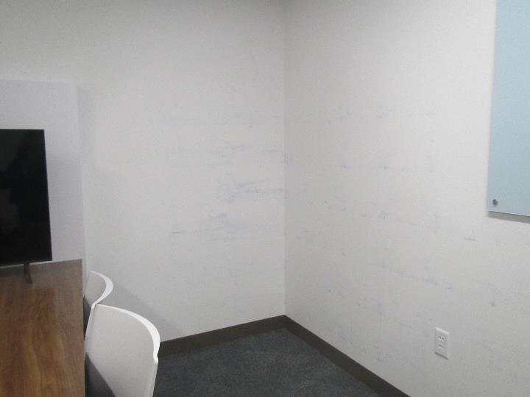
Blue dye streaking walls in a conference/huddle room
Location | Carbon  Dioxide  (ppm) | Carbon Monoxide  (ppm) | Temp  (°F) | Relative  Humidity  (%) | PM2.5  (µg/m³) | TVOC  (ppm) | Occupants  in Room | Windows  Openable | Ventilation |  | Remarks
 |  |  |  |  |  |  |  |  | Supply | Exhaust
Background | 352 | ND-2.2 | 42 | 38 | 5 | ND |  |  |  |  | Multiple CO readings taken before and after the assessment
Fourth Floor
Huddle | 551 | ND | 67 | 36 | 1 | ND | 3 | N | Y | Y
Cubes (Abbey) | 562 | ND | 71 | 34 | ND | ND | 1 | N | Y | Y
Open Lounge | 548 | ND | 71 | 33 | ND | ND | 0 | N | Y | Y
Mail | 522 | ND | 71 | 34 | ND | ND | 0 | N | Y | Y | NC
Office near training room | 502 | ND | 72 | 29 | ND | ND | 0 | N | Y | Y
Training room | 531 | ND | 72 | 31 | 1 | ND | 10 | N | Y | Y
Small computer room | 518 | ND | 72 | 30 | ND | ND | 0 | N | Y | Y | Eye test machines
Conference | 545 | ND | 72 | 31 | ND | ND | 0 | N | Y | Y
Conference | 521 | ND | 72 | 31 | ND | ND | 0 | N | Y | Y
Cubes near conference rooms | 555 | ND | 71 | 32 | ND | ND | 2 | N | Y | Y | Plant
Shackett office | 565 | ND | 71 | 33 | ND | ND | 2 | N | Y | Y
Huddle/phone room | 544 | ND | 70 | 33 | ND | ND | 0 | N | Y | Y
Cubes north side of building | 639 | ND | 71 | 34 | 2 | ND | 0 | N | Y | Y | HS
Cubes | 560 | ND | 71 | 33 | ND | ND | 2 | N | Y | Y | Plant
Kitchen | 549 | ND | 71 | 33 | ND | ND | 0 | N | Y | Y | NC, 2 microwaves, fridges, other appliances
Open area near kitchen | 562 | ND | 71 | 33 | ND | ND | 0 | N | Y | Y
Cubes west side of building | 541 | ND | 72 | 31 | ND | ND | 0 | N | Y | Y | Sunlight
Cubes “Jay/Matthew” | 540 | ND | 73 | 31 | ND | ND | 0 | N | Y | Y | Sunlight, trees against window outside
Cubes | 548 | ND | 73 | 31 | ND | ND | 3 | N | Y | Y
Office | 571 | ND | 73 | 31 | ND | ND | 1 | N | Y | Y | HS, CP
Big chair open area | 559 | ND | 73 | 31 | ND | ND | 1 | N | Y | Y
Office | 553 | ND | 73 | 31 | ND | ND | 0 | N | Y | Y | Fridge on carpet
Small conference/huddle | 561 | ND | 73 | 32 | ND | ND | 0 | N | Y | Y
Open area | 552 | ND | 73 | 31 | ND | ND | 0 | N | Y | Y
Cubes | 575 | ND | 73 | 31 | ND | ND | 1 | N | Y | Y
Office | 585 | ND | 73 | 31 | ND | ND | 1 | N | Y | Y
Cubes | 583 | ND | 73 | 31 | ND | ND | 5 | N | Y | Y
Office | 508 | ND | 73 | 31 | ND | ND | 0 | N | Y | Y
Cubes overlooking river | 556 | ND | 73 | 31 | ND | ND | 1 | N | Y | Y | PF
Corner office overlooking river | 547 | ND | 74 | 31 | ND | ND | 0 | N | Y | Y | Sunlight
Huddle | 540 | ND | 71 | 32 | ND | ND | 0 | N | Y | Y
Cubes | 553 | ND | 71 | 32 | ND | ND | 0 | N | Y | Y
Cubes, mail processing area | 553 | ND | 71 | 32 | ND | ND | 5 | N | Y | Y | Boxes, food, coffee maker
Third floor
IT testing | 561 | ND | 71 | 33 | ND | ND | 0 | N | Y | Y | Computers, items, boxes
329 office | 584 | ND | 71 | 34 | ND | ND | 0 | N | Y | Y | Boxes, food, DEM
327 conference | 571 | ND | 71 | 34 | ND | ND | 0 | N | Y | Y | Boxes, DEM
324 conference | 580 | ND | 71 | 34 | ND | ND | 0 | N | Y | Y | Storage items
IT overflow cubes area | 607 | ND | 71 | 34 | ND | ND | 4 | N | Y | Y | Coffee maker
321 cubes | 602 | ND | 70 | 34 | ND | ND | 4 | N | Y | Y
320 | 591 | ND | 71 | 34 | ND | ND | 0 | N | Y | Y
Lounge area | 568 | ND | 71 | 33 | ND | ND | 0 | N | Y | Y
323 huddle | 578 | ND | 71 | 34 | ND | ND | 0 | N | Y | Y | DEM
322 | 568 | ND | 71 | 33 | ND | ND | 0 | N | Y | Y | Walls stained with blue dye
Lounge area | 561 | ND | 72 | 33 | ND | ND | 0 | N | Y | Y | Sunlight
Office | 553 | ND | 72 | 32 | ND | ND | 0 | N | Y | Y
Cubes | 568 | ND | 72 | 33 | ND | ND | 1 | N | Y | Y
317 | 572 | ND | 73 | 32 | ND | ND | 1 | N | Y | Y | Fan or AP, DEM, CP
316 | 629 | ND | 73 | 31 | ND | ND | 0 | N | Y | Y | Sunlight
Cubes | 569 | ND | 74 | 31 | ND | ND | 3 | N | Y | Y | Sunlight, food, HS
Cubes near kitchen | 567 | ND | 73 | 31 | ND | ND | 6 | N | Y | Y | DEM
Kitchen | 591 | ND | 73 | 31 | ND | ND | 0 | N | Y | Y | NC, fridge, microwave
Cubes near 314 | 576 | ND | 73 | 31 | ND | ND | 3 | N | Y | Y | Sun, plant, CP, AF
314 office | 595 | ND | 73 | 31 | ND | ND | 0 | N | Y | Y | CP, DEM, fridge on carpet
313 office | 577 | ND | 72 | 31 | ND | ND | 0 | N | Y | Y | DEM
304 office | 593 | ND | 72 | 32 | ND | ND | 0 | N | Y | Y
Registrar | 574 | ND | 72 | 33 | ND | ND | 0 | N | Y | Y | Plant, food
310 | 585 | ND | 71 | 34 | ND | ND | 0 | N | Y | Y
309 | 601 | ND | 72 | 34 | 1 | ND | 0 | N | Y | Y
308 | 602 | ND | 71 | 34 | ND | ND | 0 | N | Y | Y
306 | 606 | ND | 71 | 33 | ND | ND | 0 | N | Y | Y
Reception | 601 | ND | 72 | 33 | ND | ND | 0 | N | Y | Y
303 huddle | 603 | ND | 72 | 33 | ND | ND | 0 | N | Y | Y
302 huddle | 600 | ND | 71 | 33 | ND | ND | 0 | N | Y | Y
397 office | 616 | ND | 72 | 34 | ND | ND | 0 | N | Y | Y
Cubes | 618 | ND | 72 | 33 | ND | ND | 4 | N | Y | Y
Mail workroom | 610 | ND | 73 | 34 | ND | ND | 4+ | N | Y | Y
Open area | 603 | ND | 73 | 32 | ND | ND | 0 | N | Y | Y
Cubes | 591 | ND | 72 | 32 | ND | ND | 2-4 | N | Y | Y | Water cooler on carpet
335 office | 630 | ND | 72 | 32 | ND | ND | 6 | N | Y | Y | NC
334 office | 540 | ND | 72 | 32 | ND | ND | 2 | N | Y | Y | Fake plants, PF
Cubes | 589 | ND | 72 | 31 | ND | ND | 5 | N | Y | Y | Humidifier, PF, boxes, food
333 | 625 | ND | 72 | 32 | ND | ND | 0 | N | Y | Y | DEM
332 | 595 | ND | 72 | 32 | ND | ND | 1 | N | Y | Y
Unused kitchen/wellness room | 570 | ND | 73 | 32 | ND | ND | 0 | N | Y | Y | Sink, dripping
Big cube area (empty) | 556 | ND | 72 | 33 | ND | ND | 0 | N | Y | Y
Second floor
Cubes | 569 | ND | 75 | 30 | ND | ND | 0 | N | Y | Y | Plants, food, PF, CP, sunlight
222 office | 580 | ND | 75 | 30 | ND | ND | 0 | N | Y | Y | Food, fridge, DEM
223 office | 583 | ND | 75 | 30 | ND | ND | 0 | N | Y | Y | Fridge, food, PF, plants
224 office | 573 | ND | 74 | 30 | ND | ND | 0 | N | Y | Y | AP (scented), fridge, PF, DEM
225 office | 583 | ND | 73 | 31 | ND | ND | 0 | N | Y | Y | Fridge, DEM, coffeemaker, plants
227 conference | 574 | ND | 73 | 31 | ND | ND | 0 | N | Y | Y | Tree at window outside
226 | 609 | ND | 72 | 31 | ND | ND | 0 | N | Y | Y | Items, holiday decorations, old vacuum cleaner
229 office | 565 | ND | 73 | 32 | ND | ND | 0 | N | Y | Y
Cubes | 553 | ND | 74 | 29 | ND | ND | 0 | N | Y | Y | Food, DEM
Cubes | 554 | ND | 75 | 30 | ND | ND | 0 | N | Y | Y | Fridge, food, PF, plants
Cubes | 585 | ND | 74 | 30 | ND | ND | 1 | N | Y | Y | AP, plant, fridge, PF
215 kitchen | 594 | ND | 74 | 30 | ND | ND | 0 | N | Y | Y | NC, fridge, microwave, etc.
Cubes | 578 | ND | 74 | 30 | ND | ND | 1 | N | Y | Y | Plants, sunlight, PF
IT office | 593 | ND | 74 | 30 | ND | ND | 1 | N | Y | Y | PF, items, toaster oven
Cubes | 580 | ND | 75 | 30 | ND | ND | 0 | N | Y | Y | Items and plants on windowsill, DEM,
Records room (large) |  |  |  |  |  |  |  | N | Y | Y | 1 WD CT, NC, broken CT
2139 cubes | 575 | ND | 74 | 31 | ND | ND | 0 | N | Y | Y
Cubes | 615 | ND | 74 | 31 | ND | ND | 3 | N | Y | Y | Food, plants
Cubes | 639 | ND | 73 | 32 | ND | ND | 1 | N | Y | Y | Plant
Cubes | 651 | ND | 73 | 32 | ND | ND | 2 | N | Y | Y
Second floor service center area (cube rows from left to right)
Cubes | 847 | ND | 72 | 35 | ND | 0.5 | 6 | N | Y | Y | Perfume odor
Cubes | 800 | ND | 72 | 34 | ND | ND | 7 | N | Y | Y
205 office | 790 | ND | 72 | 34 | ND | ND | 0 | N | Y | Y | Food, DEM
Cubes | 843 | ND | 73 | 35 | ND | ND | 4 | N | Y | Y
Cubes | 836 | ND | 73 | 34 | ND | ND | 4 | N | Y | Y
Cubes | 861 | ND | 72 | 35 | ND | 0.5 | 6 | N | Y | Y
Cubes | 889 | ND | 72 | 35 | ND | ND | 4 | N | Y | Y
Corner office | 872 | ND | 71 | 35 | ND | ND | 0 | N | Y | Y | Sunlight
Cubes | 861 | ND | 72 | 35 | ND | ND | 4 | N | Y | Y
Cubes | 821 | ND | 72 | 34 | ND | ND | 10 | N | Y | Y
Cubes | 774 | ND | 73 | 34 | ND | ND | 2 | N | Y | Y
Kitchen | 718 | ND | 72 | 31 | ND | ND | 1 | N | Y | Y
First floor
103 office | 574 | ND | 71 | 32 | ND | ND | 0 | N | Y | Y | DEM
106 | 597 | 1.4 | 71 | 32 | ND | ND | 1 | N | Y | Y
Cubes | 619 | 1.5 | 71 | 32 | ND | ND | 0 | N | Y | Y
Open area | 608 | 1.9 | 71 | 32 | ND | ND | 4 | N | Y | Y
Cubes | 595 | 2.0 | 72 | 32 | ND | ND | 2 | N | Y | Y
Office | 580 | 2.1 | 72 | 31 | ND | ND | 1 | N | Y | Y
Huddle | 579 | 2.2 | 72 | 32 | ND | ND | 0 | N | Y | Y
Reception | 588 | 2.2 | 72 | 32 | ND | ND | 2 | N | Y | Y | Flowers
Kitchen | 572 | 1.9 | 71 | 32 | ND | 1.0 | 0 | N | Y | Y
109 | 576 | 2.1 | 71 | 32 | ND | 0.5 | 0 | N | Y | Y
Mail workroom | 570 | 2.0 | 71 | 32 | ND | ND | 2 | N | Y | Y | NC, mail machines
Office | 586 | 2.0 | 71 | 33 | ND | ND | 1 | N | Y | Y | Water dispenser

